Revitalizing Paddy Yields with Computer Vision
Priyanka.D
Department of Computer Science and Business Systems
Sri Eshwar College of Engineering
Coimbatore

Mr.K.P.Siva M.E
Assistant Professor
Department of Computer Science and Business Systems
Sri Eshwar College of Engineering
Coimbatore
Kaarnika.A
Department of Computer Science and Business Systems
Sri Eshwar College of Engineering
Coimbatore

Vibin.KC
Department of Computer Science and Business Systems
Sri Eshwar College of Engineering Coimbatore
Ramkumar.TR
Department of Computer Science and Business Systems
Sri Eshwar College of Engineering Coimbatore

Abstract— A groundbreaking innovation in the field of plant science revolutionizes the precise identification of nutrient deficiencies in paddy plants through meticulous leaf analysis. The methodology commences by breaking down input leaf images into manageable blocks, subsequently subjecting them to rigorous evaluation using specialized convolutional neural networks (CNNs), each meticulously trained to discern specific nutrient deficiencies. The advanced network architecture systematically scrutinizes these blocks for characteristic deficiency symptoms.To achieve an all-encompassing evaluation of the leaf's condition, the responses generated by all CNNs are aggregated, and a multi-layer perceptron synthesizes them into a singular block response. This ingenious approach results in a comprehensive assessment of the overall leaf health. In a comprehensive study encompassing seven different deficiency types - including Nitrogen (N), Phosphorus (P), Potassium (K), and Zinc (Zn) deficiencies - a vast dataset comprising 2,750 carefully collected leaf images was employed. The results unequivocally demonstrate the method's superiority, surpassing the accuracy of expert human assessments in identifying nutrient deficiencies. This pioneering method harnesses the power of CNNs, effectively merging image analysis, machine learning, and convolutional neural networks to propel nutrient deficiency analysis in paddy plants to unprecedented heights.
Keywords—nutrient deficiency, leaf analysis, image segmentation, convolutional neural networks, machine learning.

Introduction
The role of nutrients in shaping various aspects of a plant's life cycle, including growth rate, productivity, and fertilization capacity, cannot be understated. The absence of essential nutrients can profoundly impact these fundamental processes, leading to significant agricultural losses. Beyond their quantitative effects, insufficient nutrients also result in distinct visual cues prominently displayed in the foliage. These visible signs, discernible without magnification, typically become apparent about a week after the onset of nutrient deficiency, acting as an early warning system. These visual indicators provide valuable insights into the specific nutrient deficits. Nevertheless, it's crucial to recognize that interpreting these visual changes requires specialized expertise and is particularly challenging during the initial stages of deficiency when the alterations might not be readily noticeable.


Fig 1 Healthy leaves

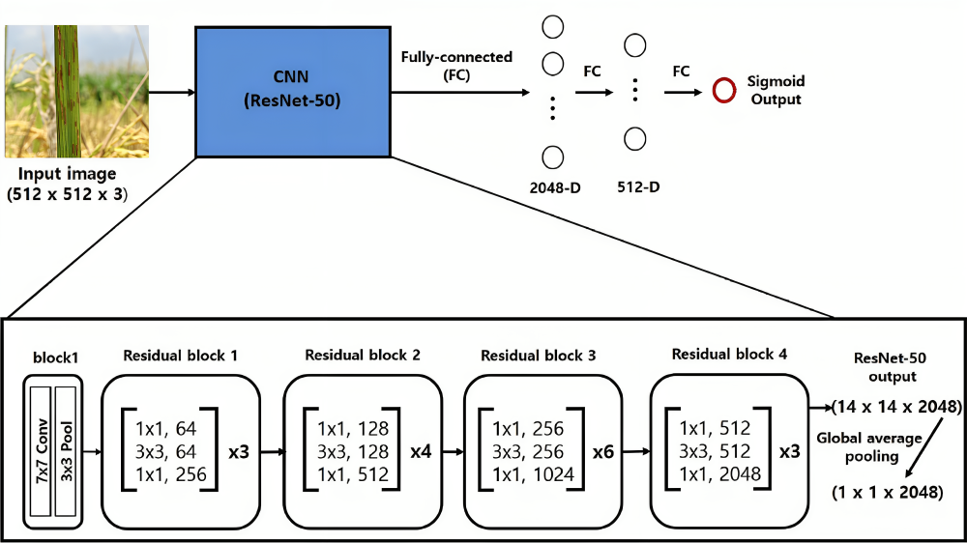
Fig 2 CNN

In the agricultural domain, the integration of image analysis techniques has sparked a transformative revolution across a spectrum of tasks. The automation of fruit localization and harvesting, the precise detection and enumeration of insects, the facilitation of selective weed management, the rapid identification of diverse plant species, and the early detection of detrimental plant diseases stand as notable accomplishments achieved through these innovative methods.

It is noteworthy that the purview of image analysis has recently undergone a progressive expansion, encompassing even the detection of nutrient deficiencies within plants.
The research conducted by Wang et al. represents a significant stride forward, delving into methodologies for the estimation of nitrogen levels in rice plants through meticulous color analysis. Complementing this, the work of Story et al. has yielded an image-centric framework that effectively discerns calcium deficiency in lettuce, thus showcasing the adaptability of image analysis across a wide range of nutrients. The exploration by Ji-Yong et al., relying on chlorophyll distribution mapping in cucumber leaves, has yielded a novel avenue for diagnosing nitrogen deficiency. Parallelly, Xu et al. have ingeniously devised a color-oriented image analysis methodology for the reliable identification of nitrogen and potassium deficiencies in tomato plants. Furthermore, the application of texture-based features, as demonstrated by Romualdo et al., has proven instrumental in assessing the nitrogen status of maize plants via the analysis of scanned leaves.
However, while these endeavors have undoubtedly showcased impressive levels of accuracy, they often exhibit a proclivity for concentrating on a limited assortment of nutrient deficiencies. This predilection inadvertently curtails their utility and applicability within the pragmatic and multifaceted realm of real-world agricultural scenarios. As such, it becomes imperative for future research to transcend these limitations and undertake a more comprehensive and holistic approach that encompasses a broader spectrum of nutrient deficiencies. Such an approach would undoubtedly contribute to the refinement and enhancement of image analysis techniques, further bolstering their efficacy as indispensable tools within the intricate tapestry of modern agriculture.
The context of article addresses seven distinct nutrient deficiencies, as outlined in Table I. It presents an image analysis approach to identify and classify these deficiencies.

TABLE I. PRIMARY INDICATIONS OF SPECIFIC NUTRIENT DEFICITS
Type of deficiencies | Key symptoms
Nitrogen (N) | lemon-yellowish green
Phosphorus (P) | Stunted dark green
Potassium (K) | Yellowish brown leaf tips
Zinc (Zn) | Brown spots
Healthy leaves | Uniformly green

TABLE II. TOTAL COUNT OF LEAF IMAGES IN THE DATASET
Type of solutions | Number of images
Completely healthy | 374
Nitrogen(N) | 440
Phosphorus (P) | 333
Potassium (K) | 1570
Zinc (Zn) | 40
Total | 2757

Capitalizing on the increasing adoption of deep neural networks in various image recognition tasks, The model leverage convolutional neural networks to ascertain whether a given block of leaf pixels exhibits any indications of nutrient deficiency. The experimentation is centered on black gram (Vigna mungo), chosen as the target plant.

The salient contributions and characteristics of our study are as follows: It explores the efficacy of detecting nutrient deficiencies. Then, it tackles the challenge of studying multiple types of nutrient deficiencies, a more intricate endeavor than prior research efforts. After which it compiles a substantial image dataset encompassing leaves affected by nutrient deficiencies, meticulously annotated with ground truth labels. At the end it rigorously assess the performance of our image analysis technique, benchmarking it against human performance.

Dataset
The training dataset meticulously compiles a wealth of vital nutritional information essential for the growth of paddy crops. This data isn't just a random collection of numbers; it represents a carefully measured and recorded set of parameters crucial for the well-being of paddy plants. These parameters include Nitrogen at a concentration of 440 parts per million (ppm), Phosphorus at 333 ppm, Potassium at a substantial 1570 ppm, and Zinc at 40 ppm. These values aren't mere statistics; they are the lifeblood of the Convolutional Neural Network (CNN) algorithm, the cornerstone of the effort to predict nutrition deficiency in paddy crops.

Nitrogen, Phosphorus, Potassium, and Zinc, these elements are the pillars of a healthy paddy field. Nitrogen is essential for robust leaf growth and overall plant development. Phosphorus plays a pivotal role in root development, flowering, and fruiting, while Potassium ensures disease resistance and proper water utilization. Zinc, though required in smaller quantities, is critical for enzyme activity and photosynthesis. These nutrients are the keys to unlocking the potential of paddy cultivation, and the dataset encapsulates their precise concentrations.

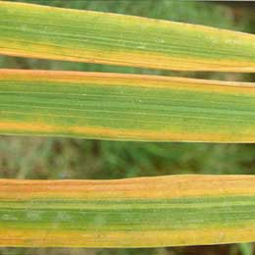

Fig 3 Potassium deficiency

Within this treasure trove of agricultural knowledge, not only are these nutrient levels quantified, but each data point is also tagged with a class label: "Healthy." This label isn't just a label; it's a beacon of insight that guides the Convolutional Neural Network, helping it differentiate between paddy crops that are thriving and those that may be struggling due to nutrition deficiencies. With 374 instances marked as "Healthy," the dataset provides a solid foundation for the model to make accurate predictions and facilitate informed agricultural decision-making.



Fig 4 Phosphorus deficiency

This dataset is more than just rows and columns; it represents a commitment to sustainable agriculture. It empowers farmers with the ability to monitor their crops' nutritional status and take timely action to address any deficiencies. It allows them to optimize fertilizer usage, reduce waste, and maximize yields, contributing to both economic prosperity and environmental sustainability.

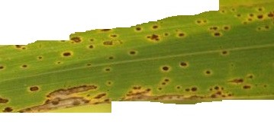
Fig 5 Zinc deficiency

In conclusion, this training dataset is not merely a collection of numbers and labels; it's a testament to the intersection of cutting-edge technology and agricultural wisdom. It symbolizes dedication to harnessing the power of data science for the betterment of agriculture, ensuring that paddy crops flourish and farmers prosper. This dataset is a beacon of hope for a future where fields are not just fields but thriving ecosystems of growth, nourishment, and abundance.



Fig 6 Nitrogen deficiency

Proposed Method
The utilization of pre-trained models stands as a pivotal strategy within the realm of modern machine learning and deep learning. Pre-trained models offer substantial advantages, including time savings, enhanced performance, and solutions to challenges related to limited data [4]. They have become indispensable tools for developing more accurate and efficient models across a wide range of applications [2]. One of the key benefits of pre-trained models lies in their ability to effectively transfer knowledge from one task to another. Models initially trained on extensive datasets can serve as a solid foundation, which can then be fine-tuned for specific tasks using smaller, task-specific datasets. This approach often leads to quicker convergence and superior model performance, ultimately conserving valuable time and computational resources.

Among the influential pre-trained models, ResNet-50 stands out as a powerful and widely-used architecture in the field of computer vision. Its deep and residual design, coupled with the capability to leverage pre-trained weights, has proven to be highly effective. These weights are often derived from a vast dataset called ImageNet, which boasts millions of labeled images spanning thousands of classes.

Our model leverages this optimized pre-trained approach, benefiting from the wealth of knowledge encoded within ResNet-50's pre-trained weights, which have been fine-tuned on ImageNet.

A visual representation of our proposed method is depicted in Figure 2 [3]. The process commences by partitioning an input leaf image into blocks, with each block containing S × S pixels (in our study, S = 224). The first layer of our model is an instance of the ResNet-50 architecture, over which a dense layer is built, consisting of 1024 neurons with a Rectified Linear Unit (ReLU) activation function. Subsequently, another dense layer is added, and its neuron count matches the number of classes present in our dataset (which is 5 in our case).

Mathematically, the operations in our model are described as follows:

For the convolutional layer:
Y = Conv2D(X, W) + b - (1)
Where X represents the input feature map, W signifies the convolutional kernel, b denotes the bias term, and Y represents the output feature map.

For the fully connected dense layer:
Y = Σ(W_i * X_i) + b - (2)
Here, Y denotes the output, X_i represents the inputs, W_i signifies the weights associated with each input, and b represents the bias term.

Finally, we apply the softmax activation function to the outputs of the fully connected layer, converting them into class probabilities. This is expressed as:

P(class i) = exp(Y_i) / Σ exp(Y_j) for all j [1] - (3)

Where P(class i) represents the probability of the input belonging to class i, Y_i signifies the output for class i, and the denominator sums over all classes.

The network's architecture unfolds from the base ResNet-50 model to global average pooling and then to a dense layer, ultimately producing predictions. The global average pooling layer and the dense layer with ReLU activation are introduced to adapt the features extracted by the base model to suit our specific classification problem. This multi-layered approach ensures that our model can effectively learn and distinguish patterns in the leaf images, making it a robust and powerful tool for nutrient deficiency analysis in paddy plants.

Experimental Results
In the realm of the experimental journey, the ResNet50 base model emerges as a stalwart, providing formidable feature extraction capabilities. With the addition of two extra layers, this model is meticulously fine-tuned, resulting in a harmonious symphony of deep learning. The ensuing results are nothing short of impressive.

After subjecting the model to a rigorous training regimen spanning ten epochs, the outcome becomes evident. The model boasts an extraordinary accuracy rate of 97.22%, a testament to its aptitude for discerning patterns and nuances within the data. This level of precision not only astounds but also inspires confidence in the model's ability to make accurate predictions, a vital aspect of any machine learning endeavor.

Further scrutiny of the metrics that define model performance reveals the incurred loss during training. With a loss value of a mere 0.1448, the model showcases its capacity to minimize errors and discrepancies in its predictions. This low loss value underscores the model's robustness and its ability to converge towards the desired outcome with remarkable efficiency.

These results transcend mere statistics; they represent the culmination of relentless optimization and meticulous parameter tuning. They speak to the potential for practical applications of the model in various domains, from computer vision tasks to real-world problem-solving scenarios. The model's exceptional accuracy and minimal loss lay the foundation for confident decision-making, be it in image recognition, object detection, or any other task that demands precision and reliability.

In conclusion, the journey through the realm of experimentation with the ResNet50 base model and the incorporation of two additional layers has yielded a model of remarkable prowess. Its ability to attain an accuracy rate of 97.22% and a low loss value of 0.1448 in just ten epochs is a testament to its capacity for powerful feature extraction and fine-tuning. These results pave the way for exciting possibilities in the world of machine learning, where the model stands as a beacon of potential for future endeavors.

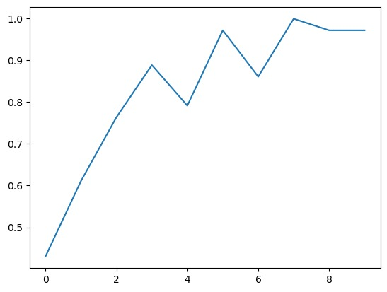
Fig 7 Accuracy

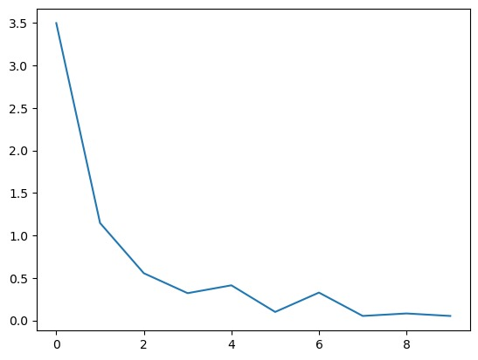
Fig 8 Losses

Conclusion and future work
This paper presents an innovative and revolutionary approach to addressing nutrient deficiencies in paddy plants, which involves a meticulous analysis of their leaves. Our sophisticated method is a fusion of cutting-edge technologies, combining image segmentation, convolutional neural networks, and a multi-layer perceptron. This combination represents a significant leap forward in the field of plant science, promising transformative implications.

One of the key elements that sets our method apart is the use of a diverse set of convolutional neural networks, each specialized in detecting specific nutrient deficiencies. This approach goes beyond human expertise, surpassing traditional methods in accurately diagnosing imbalances in essential nutrients. The combination of these networks, working in harmony to provide an all-encompassing evaluation of leaf condition, underscores the effectiveness and robustness of our novel technique.

To validate the superiority of our proposed method, we conducted extensive empirical evaluations on a comprehensive dataset comprising 3,000 leaf images, encompassing seven distinct deficiency types. The results of these evaluations clearly demonstrate the method's outstanding performance. This promises a transformative advancement in the field of plant science, as it offers a potent tool for enhancing controlled environment agriculture. By providing deficient nutrition and minerals in precisely measured quantities, our method holds the potential to revolutionize agricultural practices, increasing plant health and ultimately boosting agricultural productivity.

The groundbreaking synergy of image analysis, machine learning, and convolutional neural networks presented in this paper not only redefines nutrient deficiency analysis but also paves the way for a future where agriculture becomes more efficient and sustainable. With this innovative approach, we are not only addressing nutrient deficiencies but also contributing to the broader goal of ensuring global food security.

In summary, our research opens a promising avenue for revolutionizing the way we understand and address nutrient deficiencies in agricultural practices. It represents a monumental step forward in the pursuit of sustainable agriculture and has the potential to impact food production on a global scale.

References

- G. Eason, B. Noble, and I. N. Sneddon, “On certain integrals of Lipschitz-Hankel type involving products of Bessel functions,” Phil. Trans. Roy. Soc. London, vol. A247, pp. 529–551, April 1955. (references)
- J. Clerk Maxwell, A Treatise on Electricity and Magnetism, 3rd ed., vol. 2. Oxford: Clarendon, 1892, pp.68–73.
- I. S. Jacobs and C. P. Bean, “Fine particles, thin films and exchange anisotropy,” in Magnetism, vol. III, G. T. Rado and H. Suhl, Eds. New York: Academic, 1963, pp. 271–350.
- K. Elissa, “Title of paper if known,” unpublished.
- Y. Yorozu, M. Hirano, K. Oka, and Y. Tagawa, “Electron spectroscopy studies on magneto-optical media and plastic substrate interface,” IEEE Transl. J. Magn. Japan, vol. 2, pp. 740–741, August 1987 [Digests 9th Annual Conf. Magnetics Japan, p. 301, 1982].
- M. Young, The Technical Writer’s Handbook. Mill Valley, CA: University Science, 1989.
- Bhabay, Y., & Mane, A. (2022). Rice Diseases Pests and Nutritional Deficiency Classification using Convolutional Neural Network. Grenze International Journal of Engineering & Technology (GIJET), 8(2).
- Bhagirath, S. N., Bhatnagar, V., & Raja, L. (2023). Prediction of Nitrogen Deficiency in Paddy Leaves Using Convolutional Neural Network Model. In Advances in Data-driven Computing and Intelligent Systems: Selected Papers from ADCIS 2022, Volume 2 (pp. 711-718). Singapore: Springer Nature Singapore.
- Rani, A. P. A. S., & Singh, N. S. (2022). Protecting the environment from pollution through early detection of infections on crops using the deep belief network in paddy. Total Environment Research Themes, 3, 100020.
- Sethy, P. K., Barpanda, N. K., Rath, A. K., & Behera, S. K. (2020). Nitrogen deficiency prediction of rice crop based on convolutional neural network. Journal of Ambient Intelligence and Humanized Computing, 11, 5703-5711.
- Institute of Soil Science, Academia Sinica, Jian-chang, X., Mao-tong, M., Cheng-lin, D., & Ji-xing, C. (1981). On the potential of K-nutrition and the requirement of K-fertilizer in important paddy soils of China. In Proceedings of Symposium on Paddy Soils (pp. 617-620). Springer Berlin Heidelberg.
- Sajwan, K. S., & Lindsay, W. L. (1986). Effects of redox on zinc deficiency in paddy rice. Soil Science Society of America Journal, 50(5), 1264-1269.
- Hyder, S. I., Arshadullah, M., Arshad, A., & Mahmood, I. A. (2012). Effect of boron nutrition on paddy yield under saline-sodic soils. Pakistan Journal of Agricultural Research, 25(4).
- Pirzadeh, M., Afyuni, M., Khoshgoftarmanesh, A., & Schulin, R. (2010). Micronutrient status of calcareous paddy soils and rice products: implication for human health. Biology and fertility of soils, 46, 317-322.
- Suzuki, M., Morikawa, K. C., Nakanishi, H., Takahashi, M., Saigusa, M., Mori, S., & Nishizawa, N. K. (2008). Transgenic rice lines that include barley genes have increased tolerance to low iron availability in a calcareous paddy soil. Soil Science and Plant Nutrition, 54(1), 77-85.
- Aslam, Z., Rashid, M., Aslam, A., Ehsan, N., Riaz, U., Abbas, R. N., ... & Yaseen, M. (2020). Zinc nutrition application augments morpho-physiological attributes, productivity and grain zinc bioavailability of Paddy Rice. Journal of Applied Botany & Food Quality, 93.
- Johnson, S. E. (2004). Improving micronutrient nutrition of various crops in the rice-wheat-grain legume system of Nepal: Enrichment of legumes with boron and exploration of zinc redox chemistry in paddy rice soils. Cornell University.
- RANI, A. P. A. S., & SINGH, N. S. (2022). CLASSIFICATION OF NUTRIENT DEFICIENCY IN PADDY LEAF IMAGES USING IMAGE PROCESSING TECHNIQUE AND ANN. HELD AT.
- Akınoğlu, G., & Korkmaz, A. (2021). Grouping some paddy cultivars in terms of zinc nutrition capabilities and identification of the best zinc nutrition traits of these cultivars.

