Data Ingestion in RAW Layer

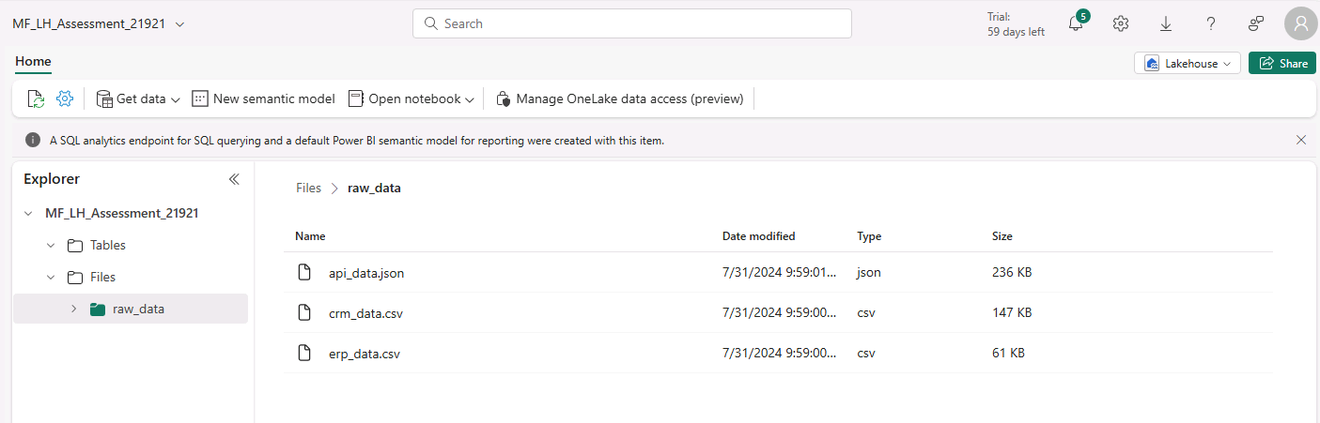

Data load from Files to Tables using Data Pipelines

Data cleanup and data load to silver layer in LH

