 

**INSTITUTE FOR ADVANCED**

**COMPUTING AND SOFTWARE**

**DEVELOPMENT AKURDI,**

**PUNE**

Documentation On

**“ONLINE MESS SERVICE”**

PG-DAC SEP 2022

*Submitted By:*

**Group No: 83**

**Rambhau T. Manjare (229172)**

**Sagar G. Satav (229195)**

**Mr. Rohit Puranik Mrs. Rupali Thorat** **Centre Coordinator Project Guide**

**ACKNOWLEDGEMENT**

I take this occasion to thank God, almighty for blessing us with his grace and taking our endeavour to a successful culmination. I extend my sincere and heartfelt thanks to our esteemed guide, **Mrs. Rupali Thorat** for providing me with the right guidance and advice at the crucial juncture sand for showing me the right way. I extend my sincere thanks to our respected Centre Co-Ordinator **Mr. Rohit Puranik**, for allowing us to use the facilities available. I would like to thank the other faculty members also, at this occasion. Last but not the least, I would like to thank my friends and family for the support and encouragement they have given me during the course of our work.

**Rambhau T. Manjare (229172)**

**Sagar G. Satav (229195**

**Table of Contents**

**1. Introduction 6**

* 1. Purpose 6
  2. Project Background 6
  3. Goals of the project 6

**2. Overall Description 7**

Proposed Methodology 7

S/W and H/W Requirements 7

Technology platform used for project 8

**3. Requirements Specification 9**

External Interface Requirements 9

**4. System Diagram 10**

Activity Diagram 10

Data Flow Diagram 13

ER Diagram (MySQL Auto Generated) 14

Use Case Diagram 15

ER Diagram 16

Sequence diagram for login 17

Project Diagrams 18

**5. Table Structure 29**

user_type **29**

user_info **29**

subscription_status **29**

registered_mess **29**

ratings 30

payments 30

mess_type 30

mess_subscription 30

mess_owner 31

mess_membership_status 31

menu_table 31

**6. Conclusion 32**

Future Scope 32

**7. References 33**

**List of Figures**

Figure 1 Admin Activity Diagram 9

Figure 2 Activity Diagram of Mess Owner 10

Figure 3 Activity Diagram of Customer 11

Figure 4 Level 0 Data Flow Diagram 12

Figure 5 Level 1 Data Flow Diagram 12

Figure 6 Level 2 Data Flow Diagram 12

Figure 7 ER Diagram (MySQL Auto Generated) 13

Figure 8 Use Case Diagram 14

Figure 9 ER Diagram 15

Figure 10 Sequence diagram for login 16

Figure 11 Project Diagrams 18

**1. INTRODUCTION.**

1.1 Purpose

The Food-Home is an online mess service system that locates nearby messes and their menus. The mess owners can register and share their mess menus with the consumers through this portal. Consumers can register to the portal and can be a member of a specific mess of their choice. Consumers can search messes as per locality, category, prices, ratings, reviews. Consumer searching efforts are reduced and increases the scope of business for mess owners.

* 1. Project Background

In the current competitive world, many youths travel to different unknown locations for their basic education or jobs. The main problem they face is the food they get, and they crave for homemade food, but it is difficult to find it. On the other hand, some housewives wish to work and earn money to gain financial independence. It is difficult for these ladies to reach customers and market their products.

1.3 Goals of the project

The main objective of this project is to give a common platform for the customers and service provider. This system will help consumers from various places to communicate with various providers (mess owners) and ease their searching efforts. The main interest of the Project is to create a central service system that will act as a bridge between providers and consumers.

**2. OVERALL DESCRIPTION.**

Proposed Methodology:

* Online Mess Service System is a web application.
* There are mainly two types of users. One is the provider (Mess Owner) and the other is the consumer.
* Consumers can search for mess menus, and special dishes at their convenience.
* Mess owners can search for consumers available and their interests.
* Online Mess Service System provides the functions which connect the consumers and the mess owners through the portal.
* The online Mess Service System will be administrated by Admin.

S/W and H/W Requirements

**Server Side:**

HDD: 500 GB or above

Processor: Intel core i5 or above

RAM: 4GB or above

Database: MySQL

**Client Side (minimum requirement):**

Processor: Intel Dual Core

HDD: Minimum 80GB Disk Space

RAM: Minimum 2GB

OS: Windows 7, Linux

Technology platform used for project

* HTML , Bootstrap
* JavaScript
* ReactJS
* Spring Boot REST API
* Hibernate
* JPA
* MySQL
* GITHUB

Reason for using specific technology:

* HTML and Bootstrap basic formatting and rendering on browser
* JavaScript makes web pages dynamic
* ReactJS allowed us to manage routing, state, components ,html pages ,toggling, navigation with ease
* Spring boot REST API allows us to create REST APIs with minimal configurations
* Hibernate helped my mapping entities , their state and deals with database
* JPA managed relational data in entities
* MySql allowed to store data and perform CRUD operations in them
* Github Helped us to store, maintain version control ,and manage the source code between the team.

**3. Requirements Specification.**

External Interface Requirements:

**User Interfaces:**

• All the users will see the same page when they enter in this website. This page asks the users a username and a password.

• After being authenticated by correct username and password, user will be redirect to their corresponding profile where they can do various activities.

• The user interface will be simple and consistence, using terminology commonly understood by intended users of the system. The system will have simple interface, consistence with standard interface, to eliminate need for user training of infrequent users.

**Hardware Interfaces**:

• No extra hardware interfaces are needed.

• The system will use the standard hardware and data communication resources. This includes, but not limited to, general network connection at the server/hosting site, network server and network management tools.

**Application Interfaces:**

**Web Browser:**

The system is a web-based application; clients need a modern web browser such as Mozilla Firebox, Internet Explorer, Opera, and Chrome. The computer must have an Internet connection in order to be able to access the system.

Communications Interfaces:

• This system uses communication resources which includes but not limited to, HTTP protocol for communication with the web browser and web server and TCP/IP network protocol with HTTP protocol.

• This application will communicate with the database that holds all the booking information. Users can contact with server side through HTTP protocol by means of a function that is called HTTP Service. This function allows the application to use the data retrieved by server to fulfil the request fired by the user.

**4. System Diagrams.**

 **Activity Diagram:**

**Admin Activity:**

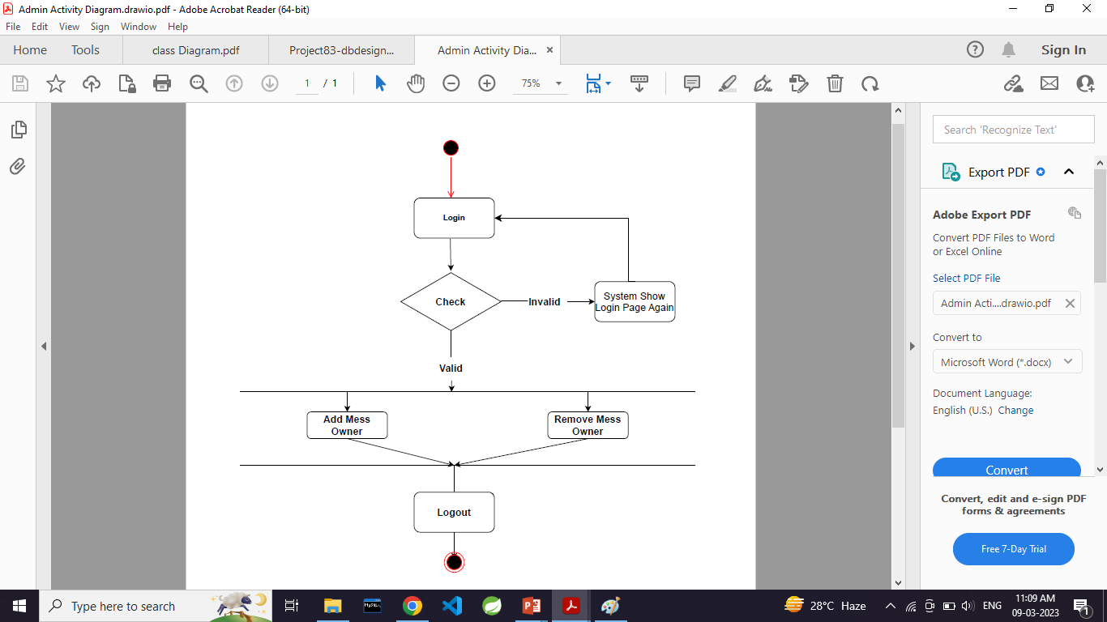

**Activity Diagram of Mess Owner**

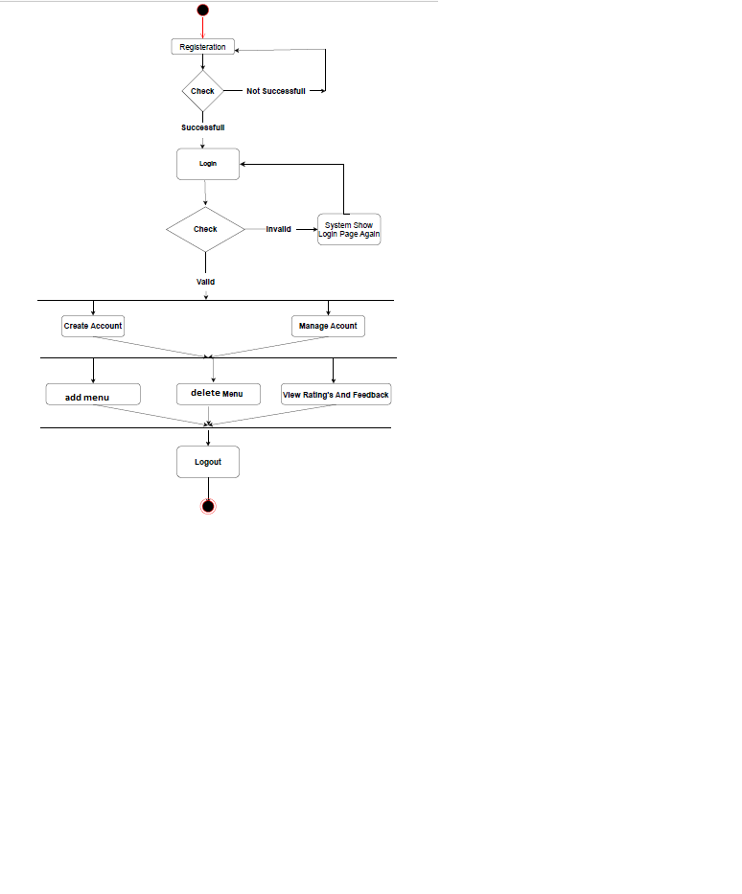

**Activity Diagram of Customer**

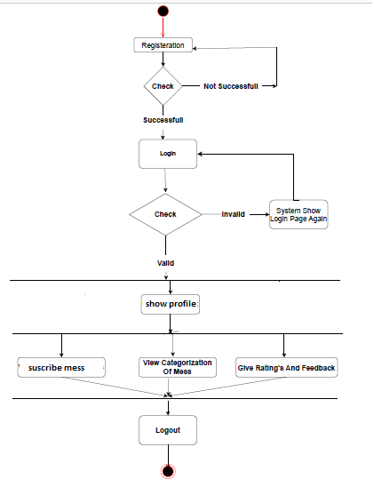

 **Data Flow diagram:**

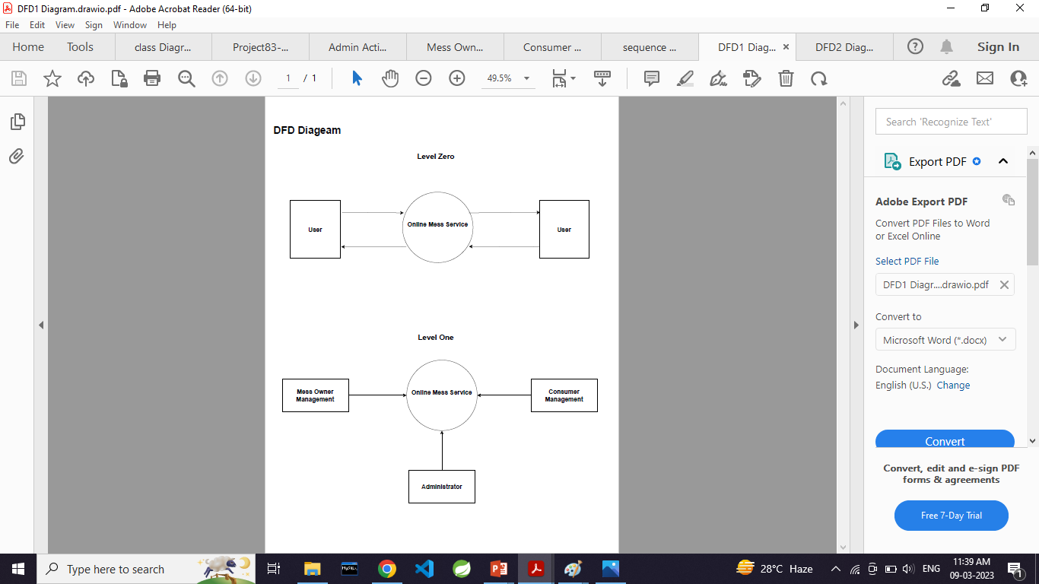

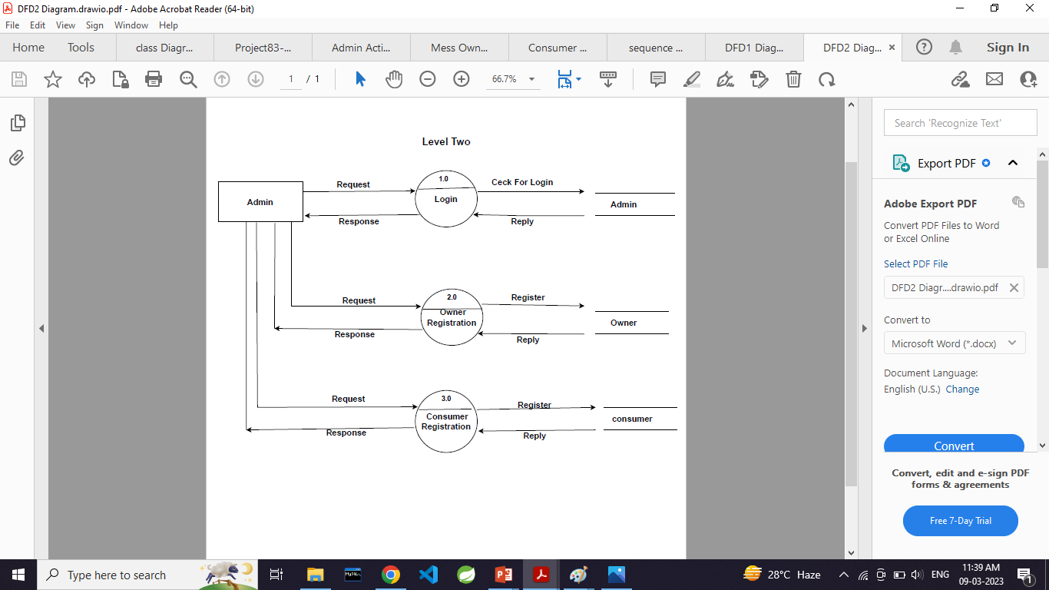

**  ER Diagram**

(system generated) 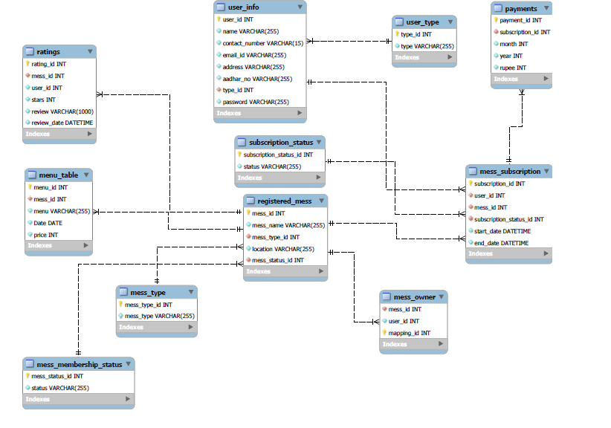

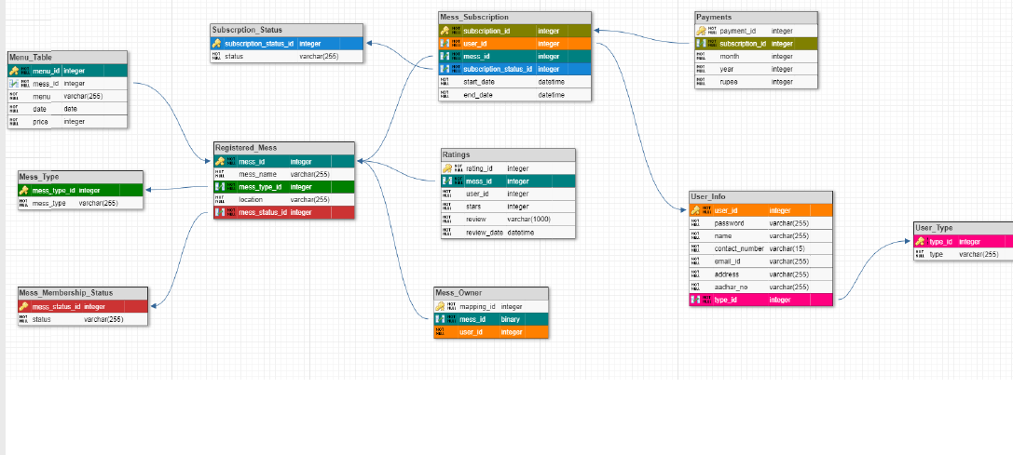

 **Use Case Diagram:**

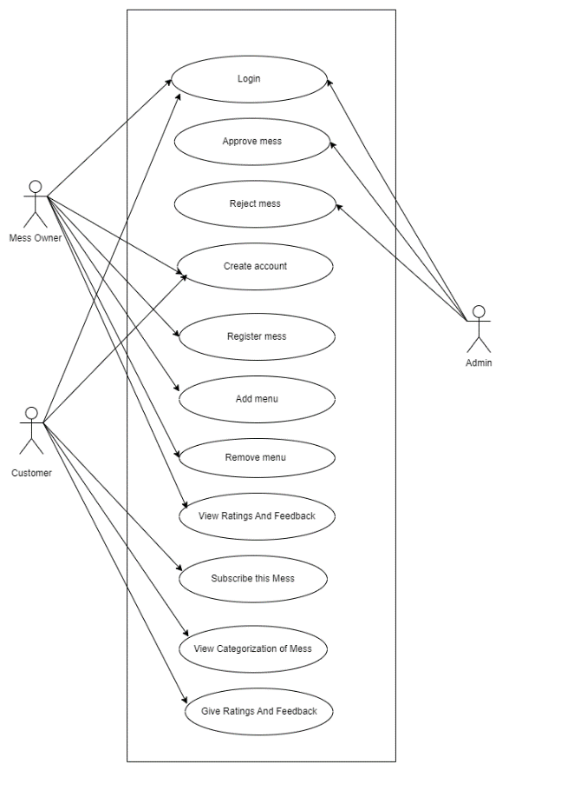

 **ER Diagram:**

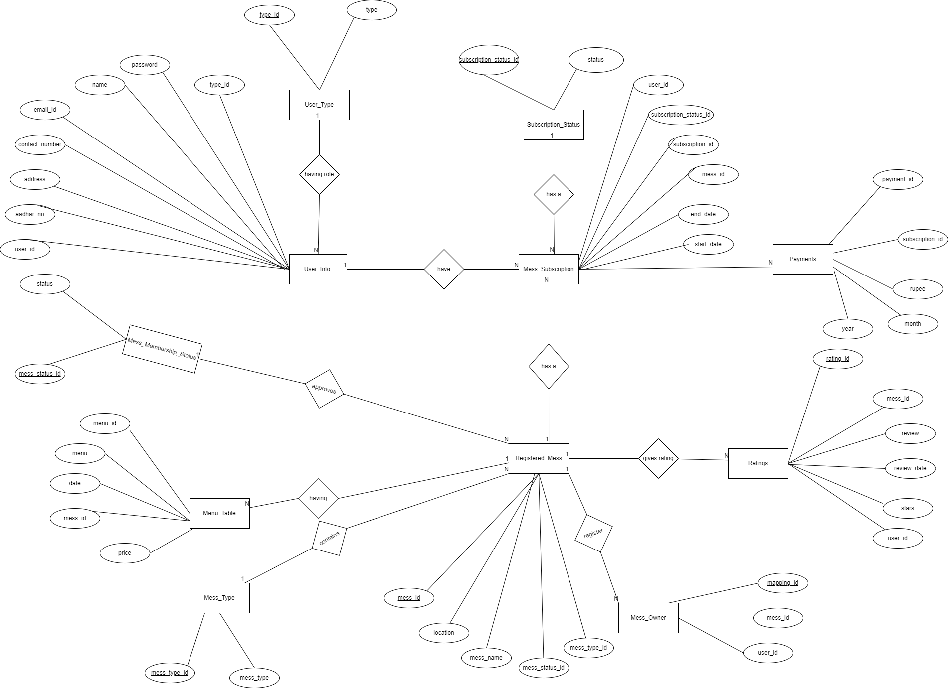

  **Sequence diagram for login:**

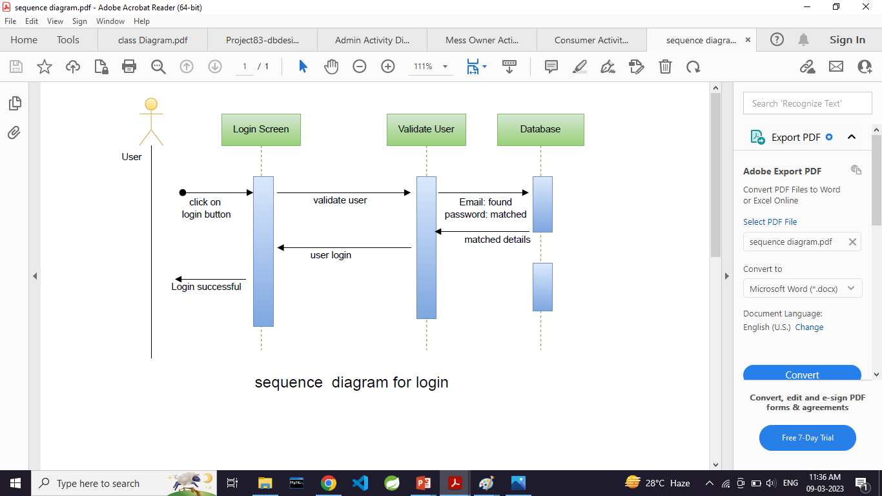

**PROJECT DIAGRAMS**

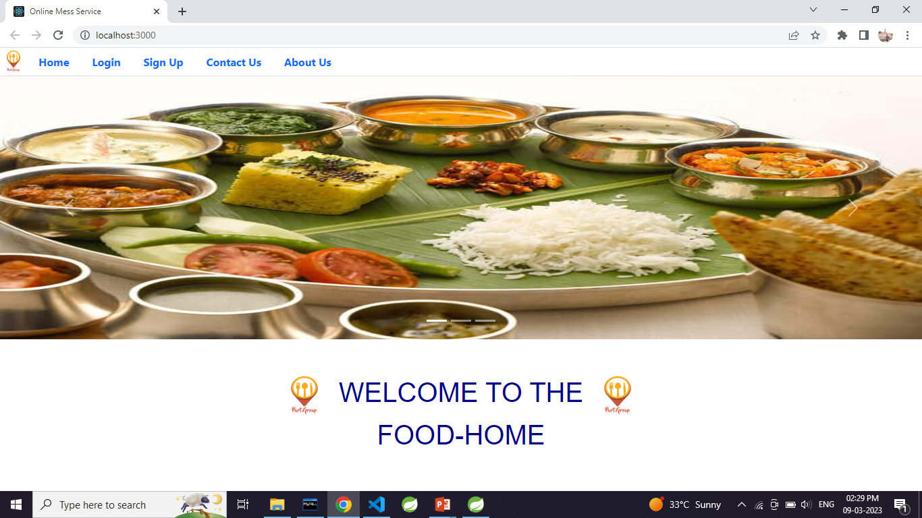

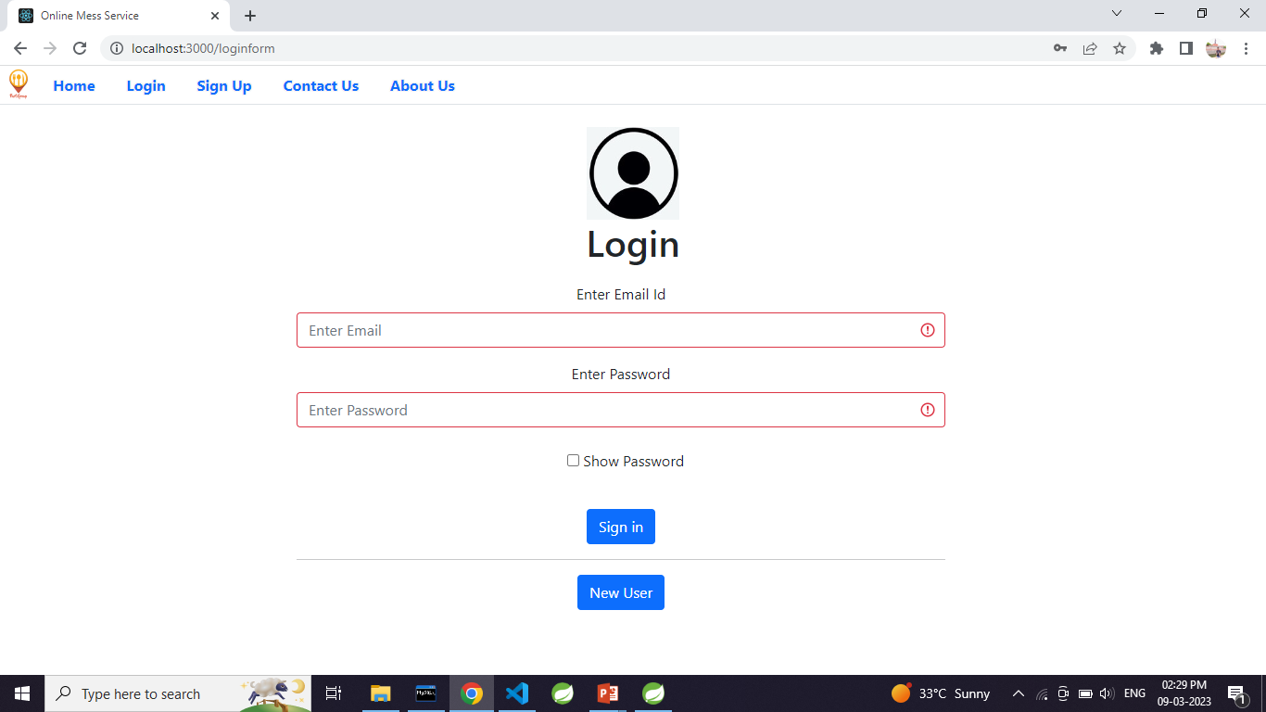

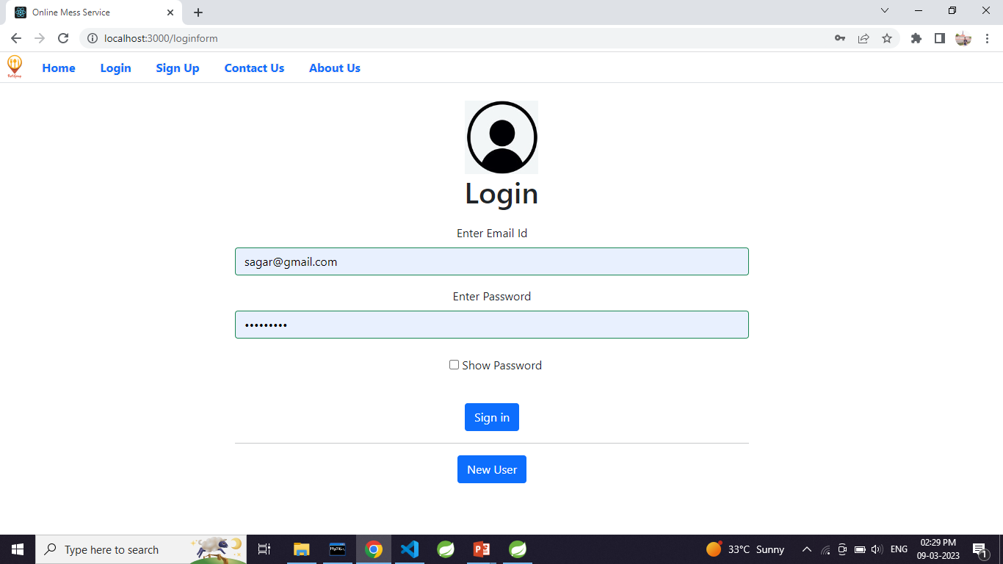

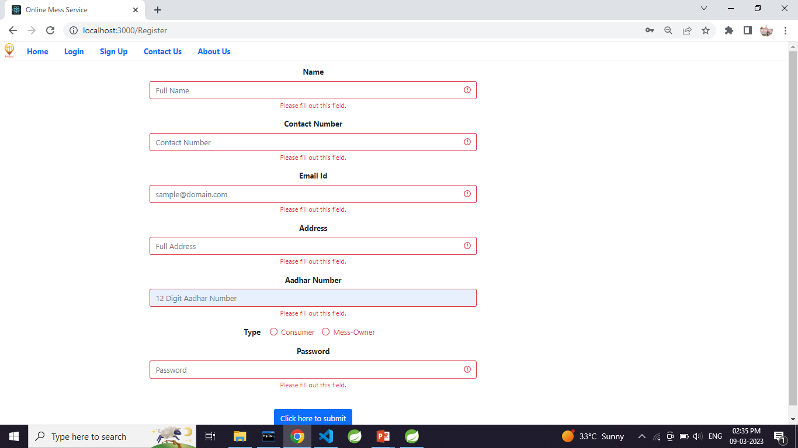

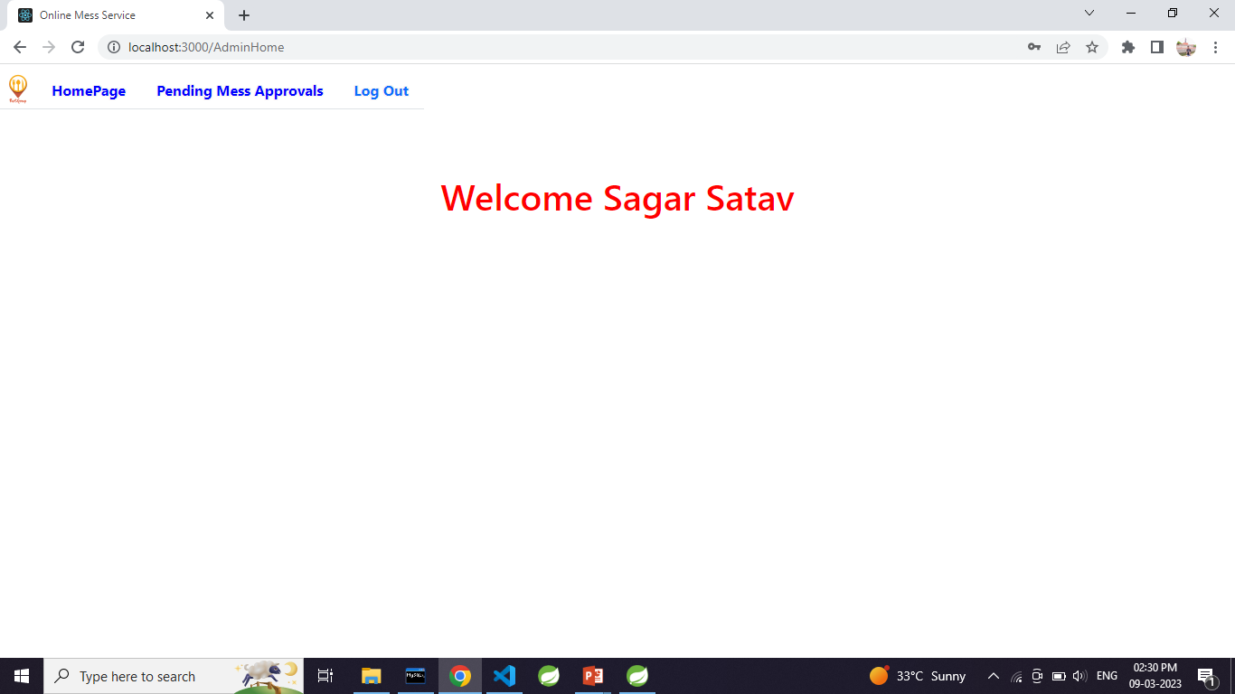

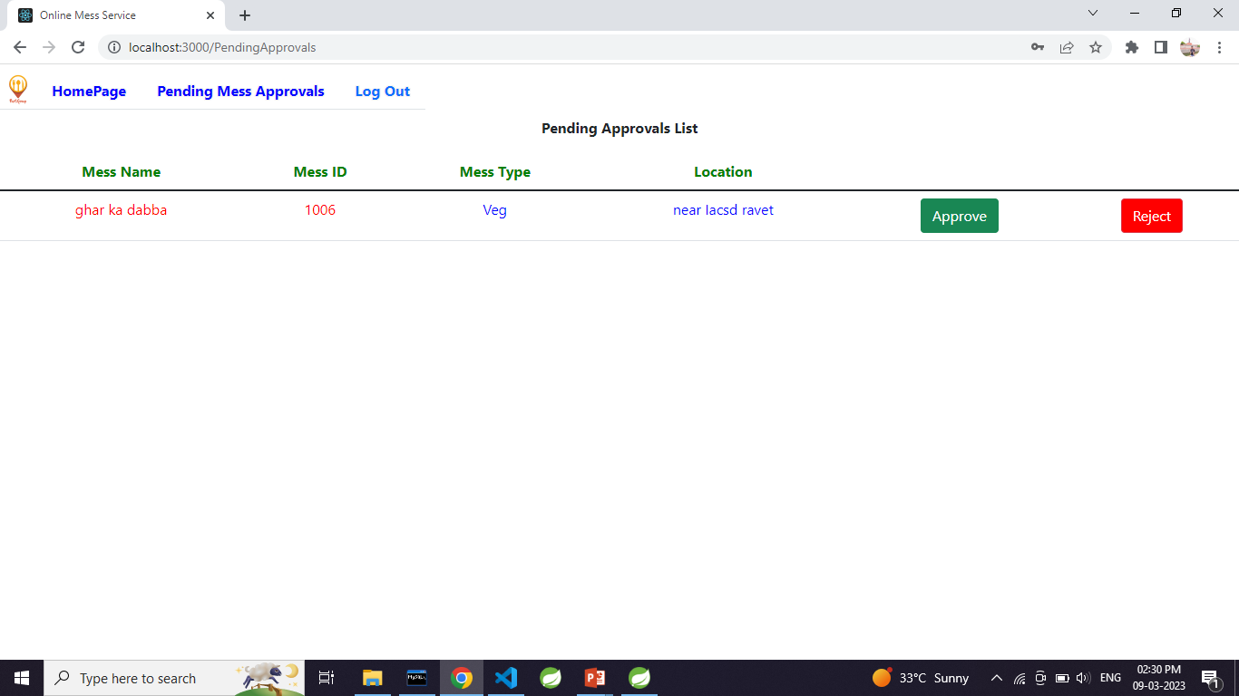

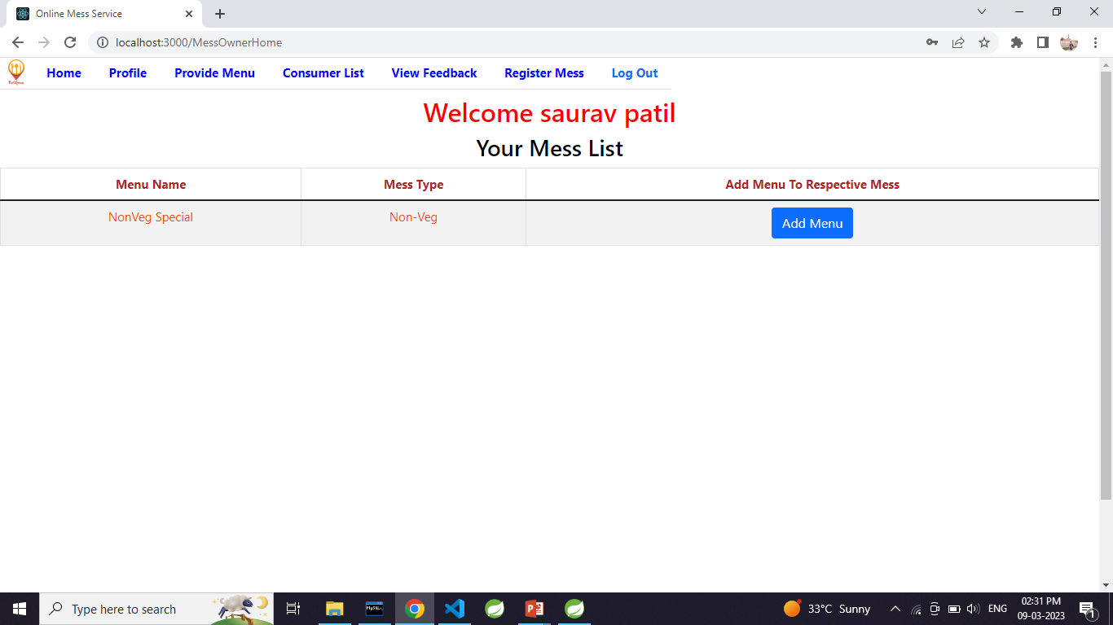

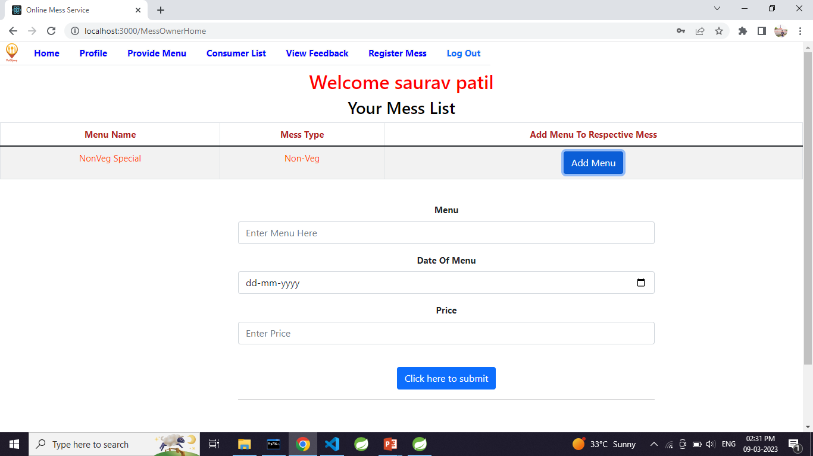

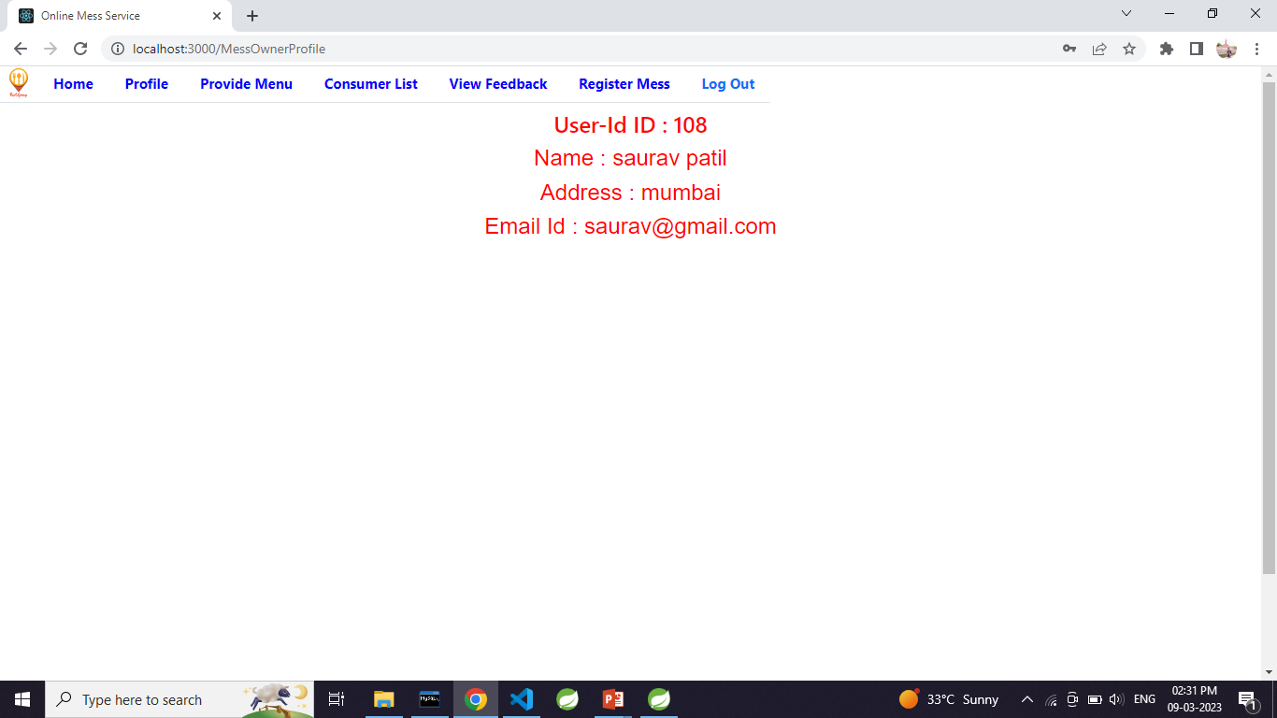

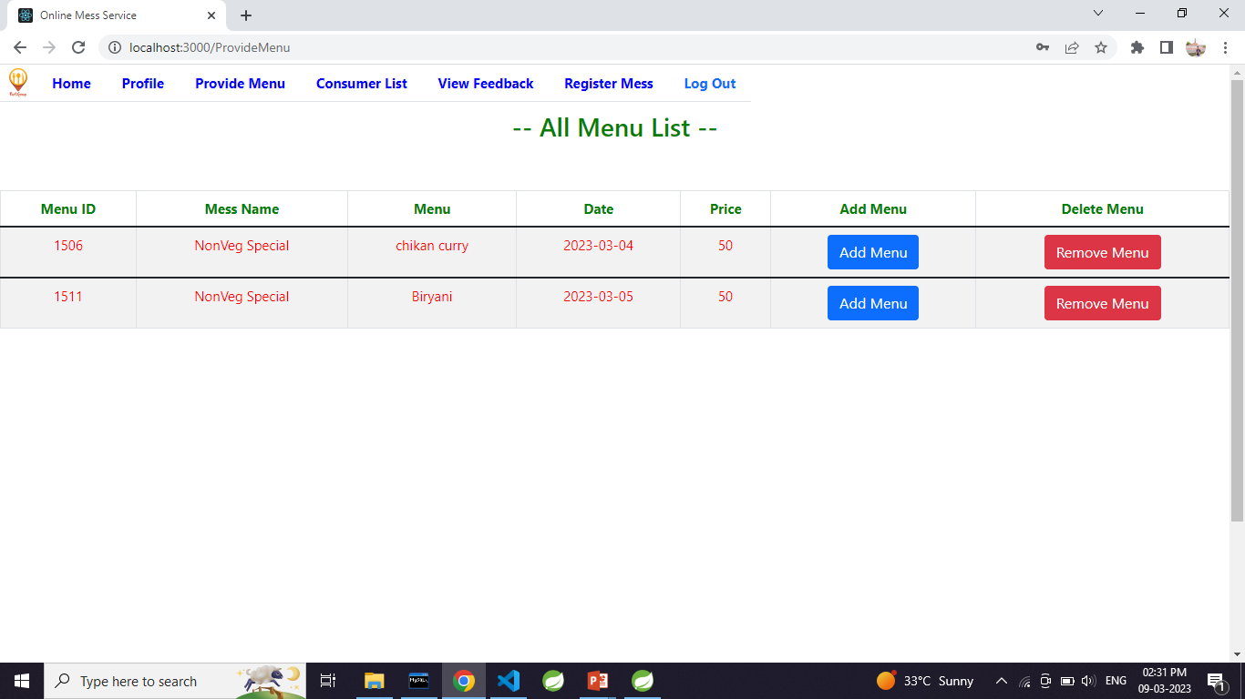

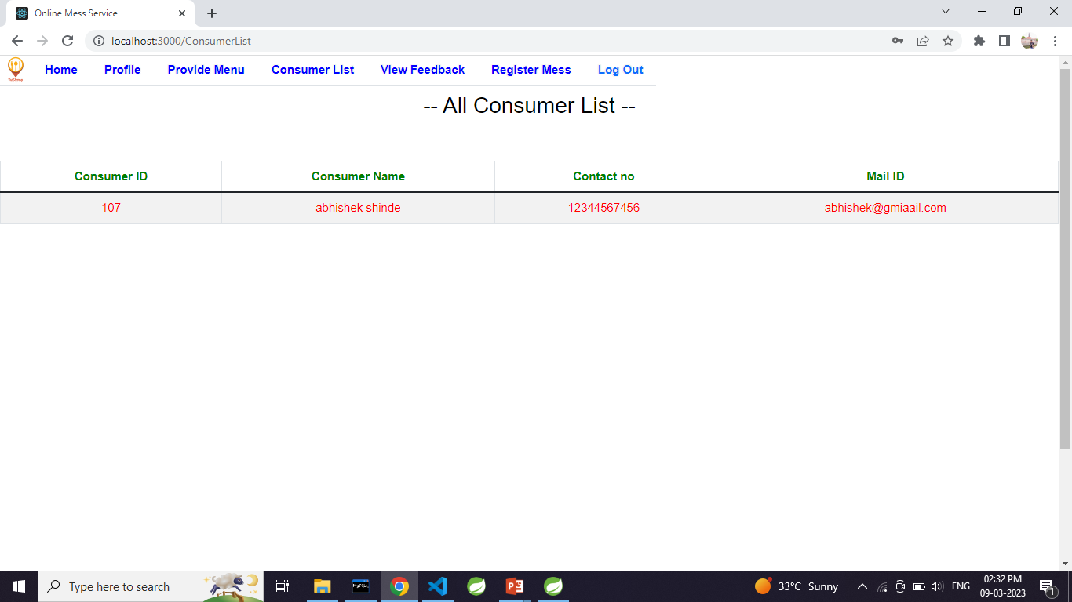

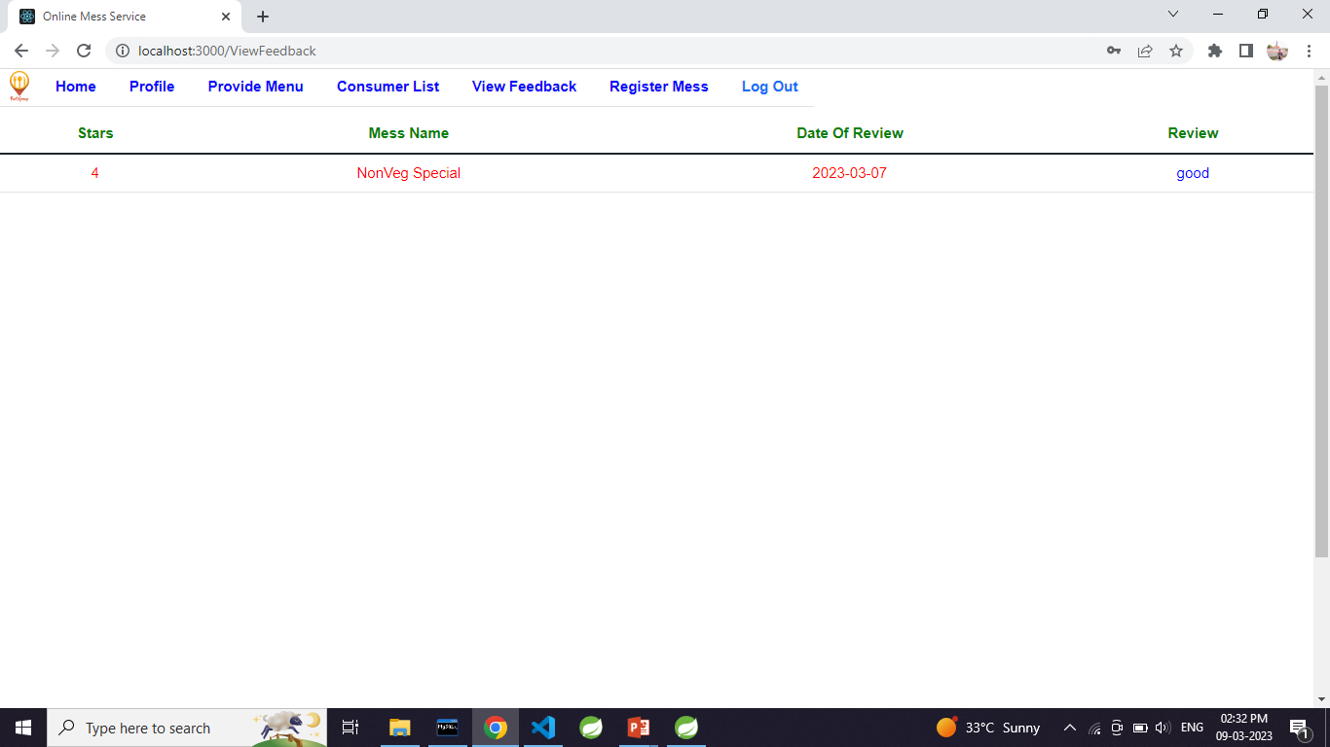

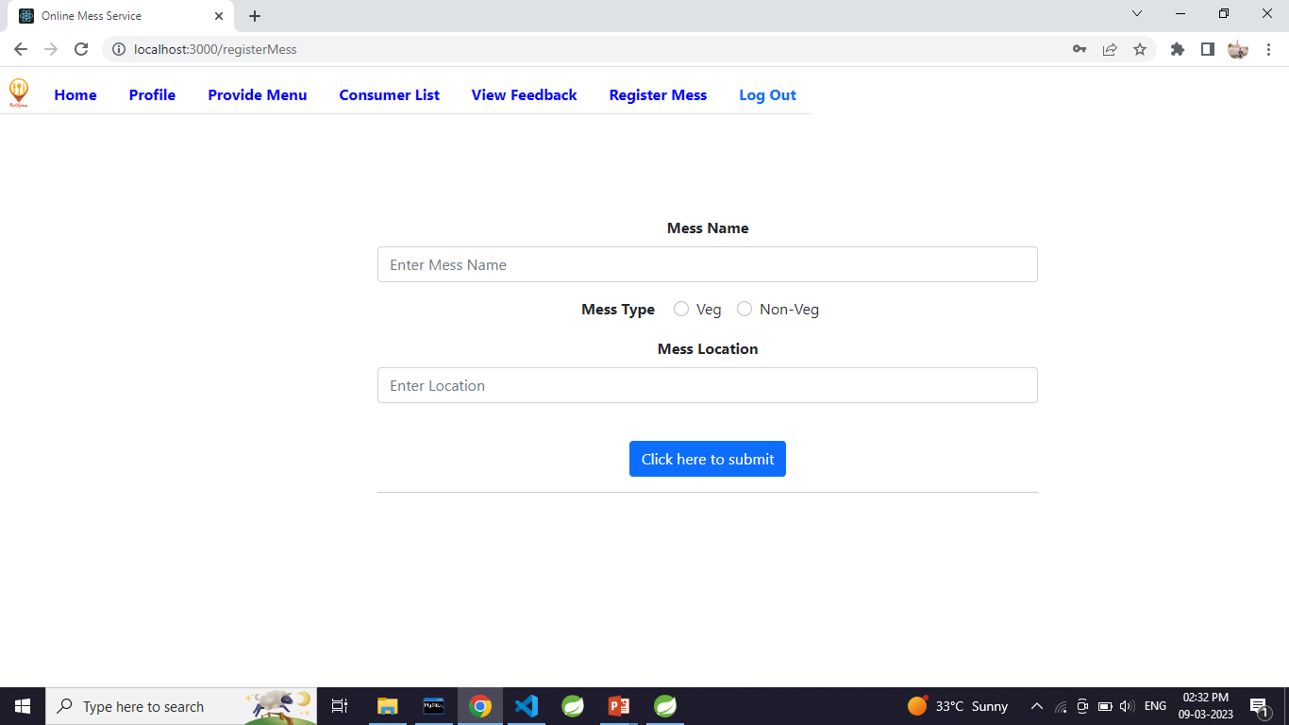

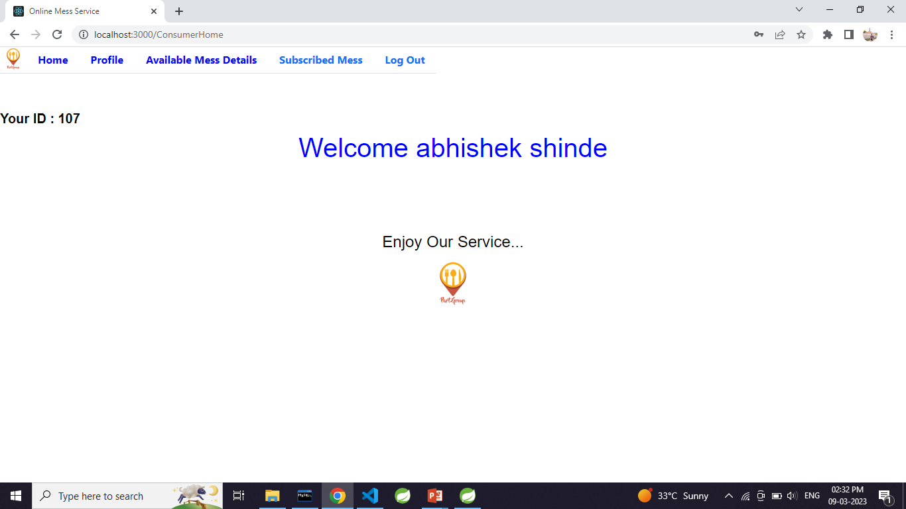

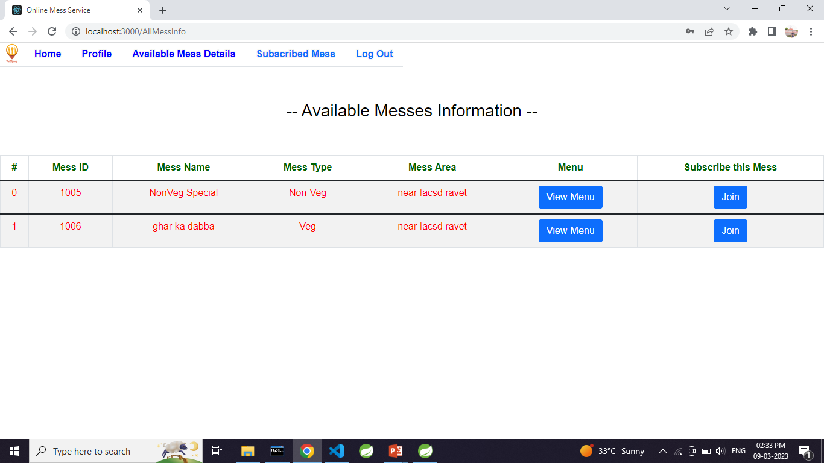

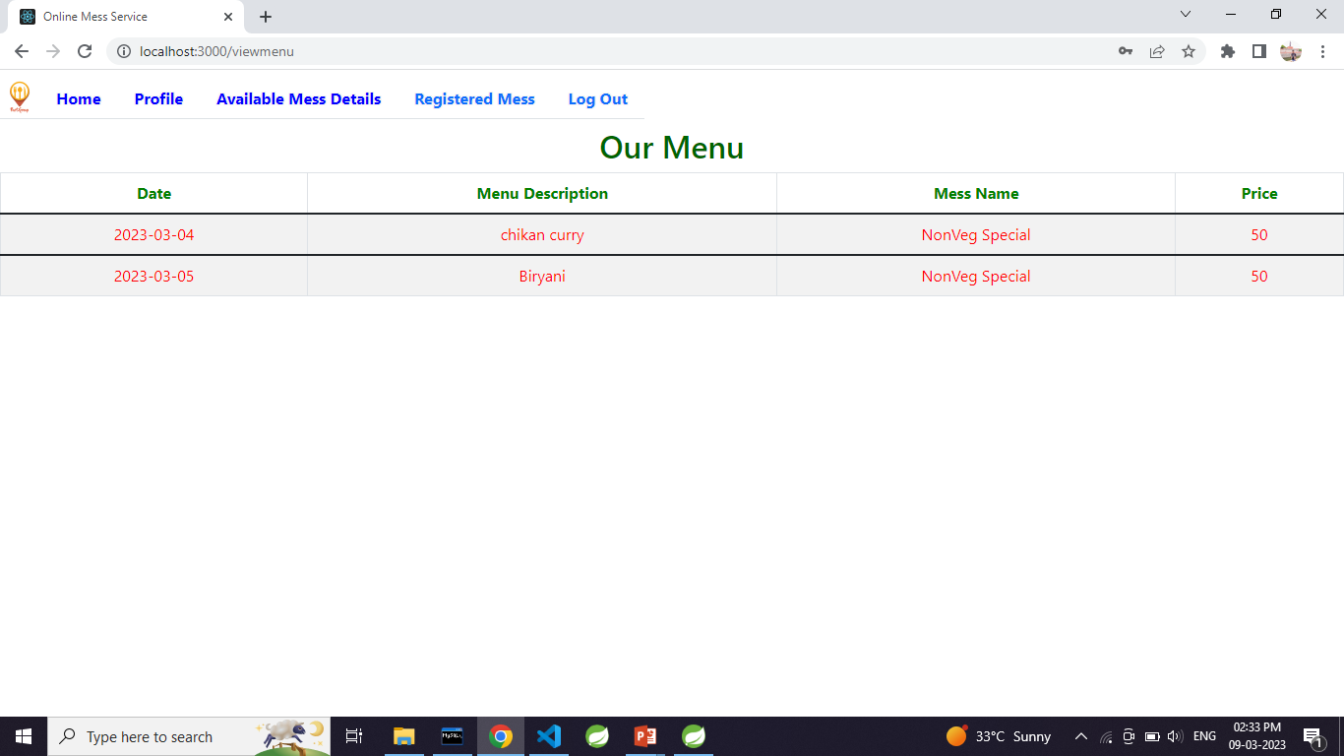

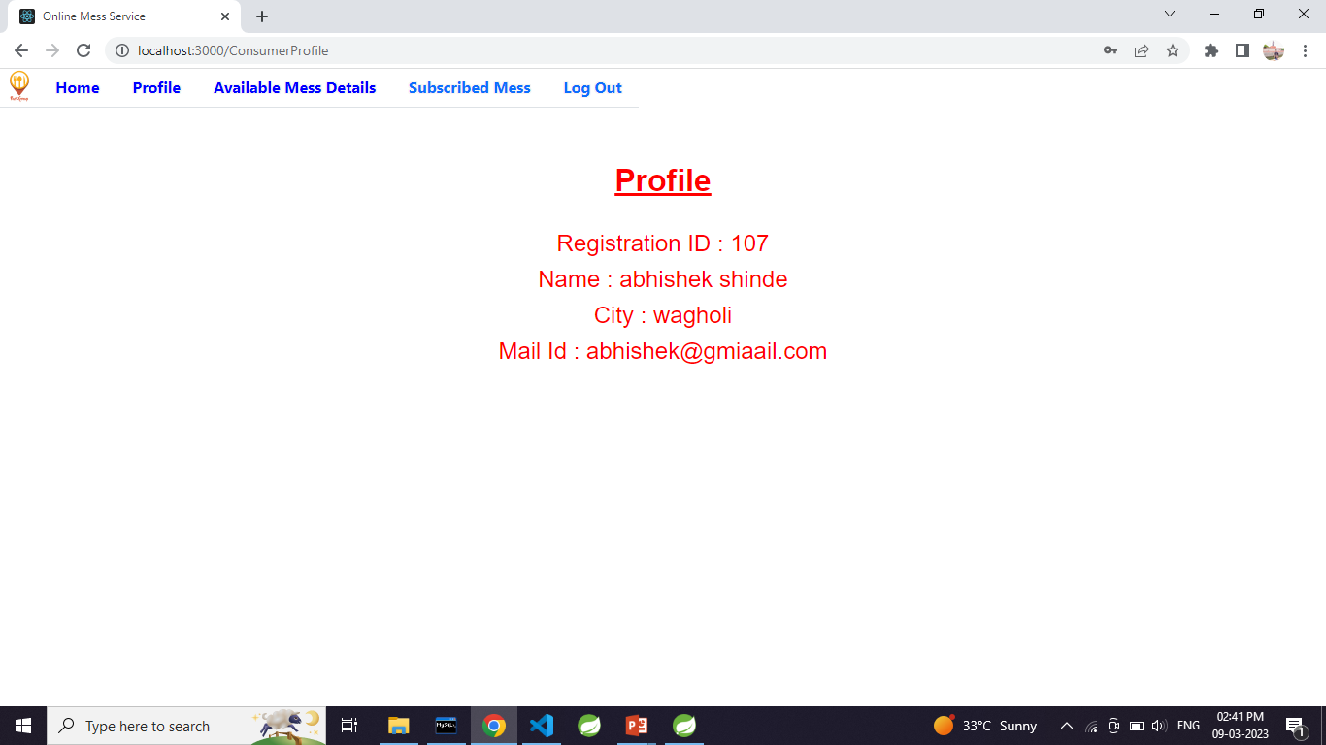

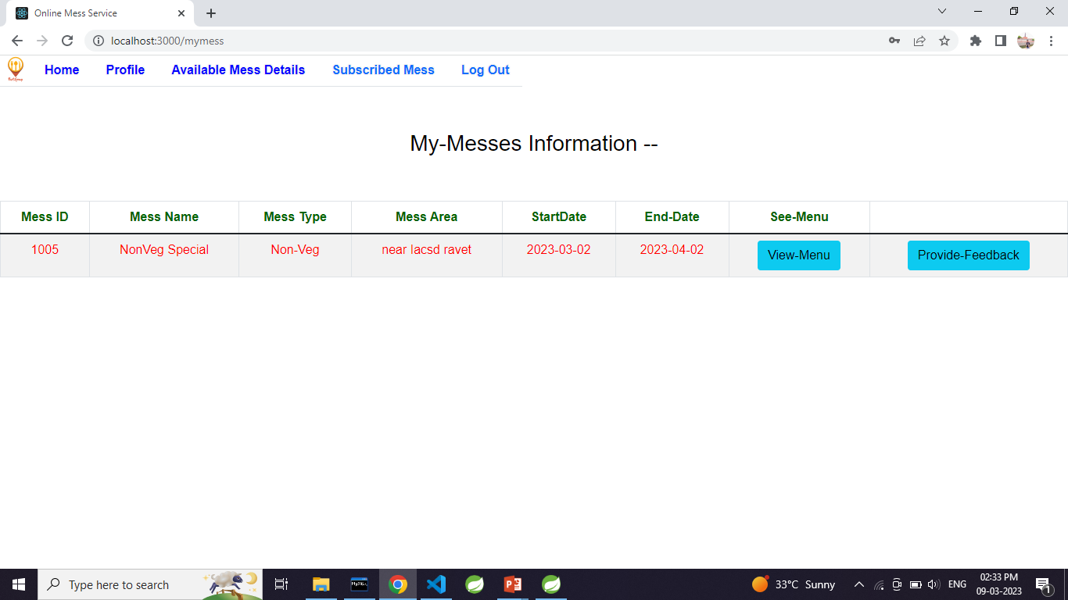

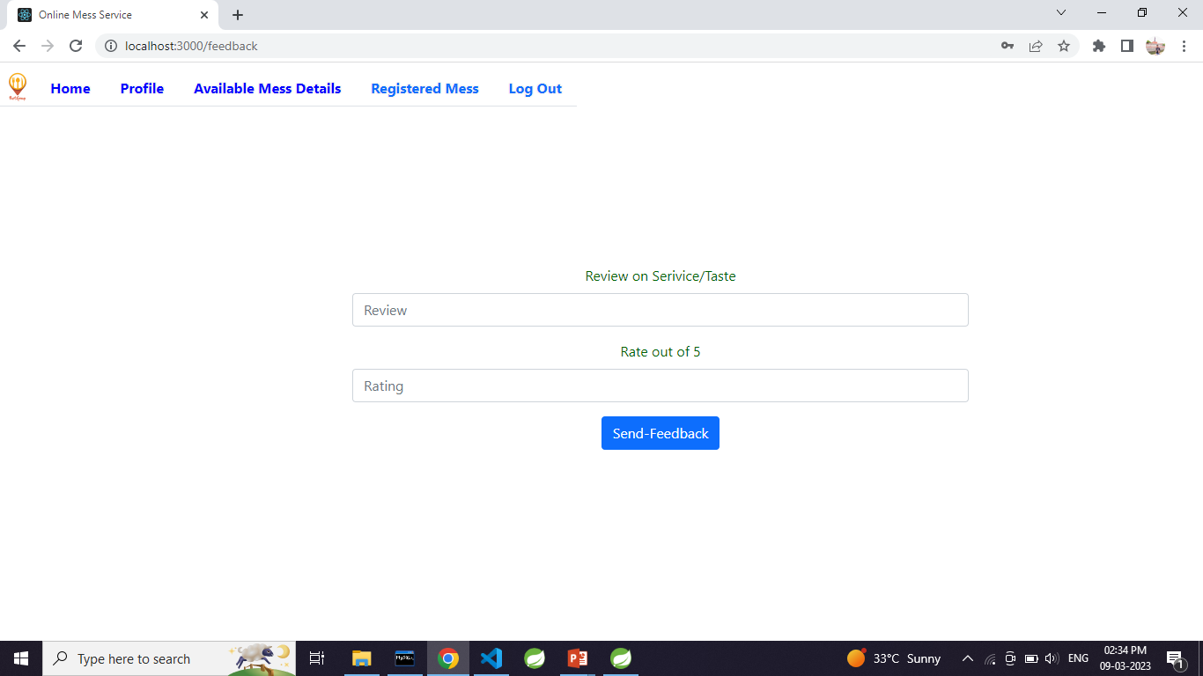

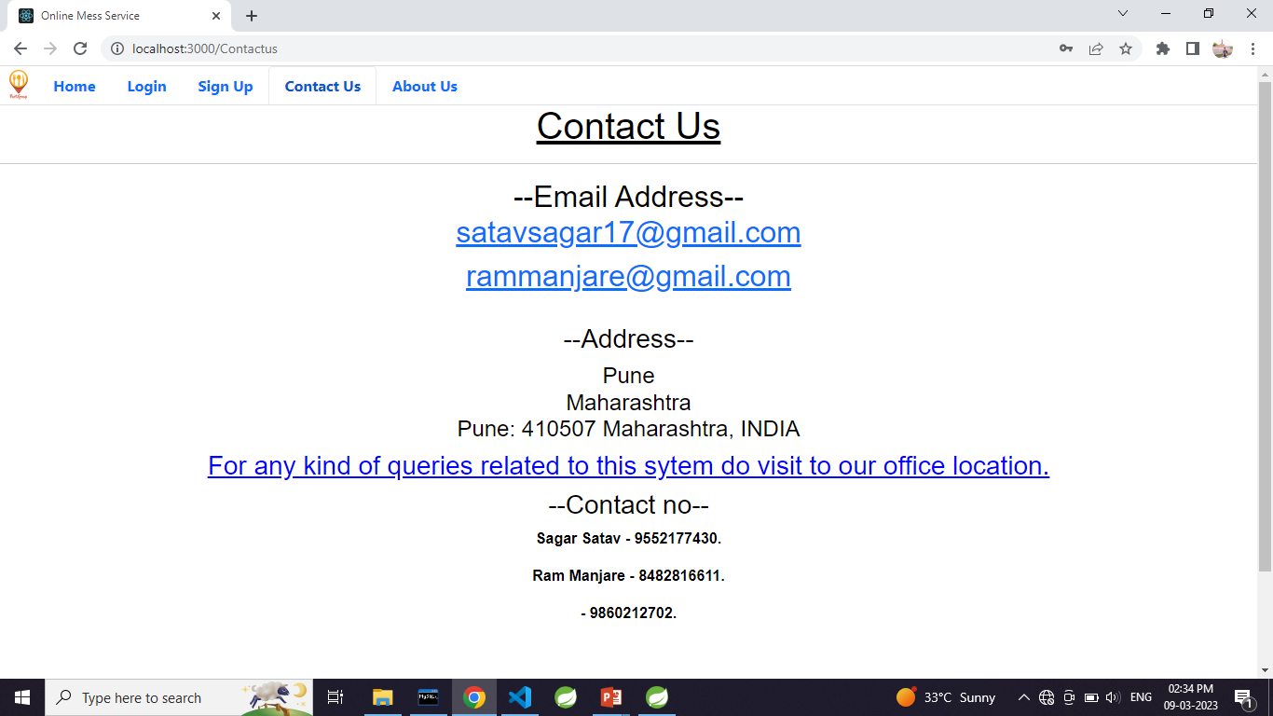

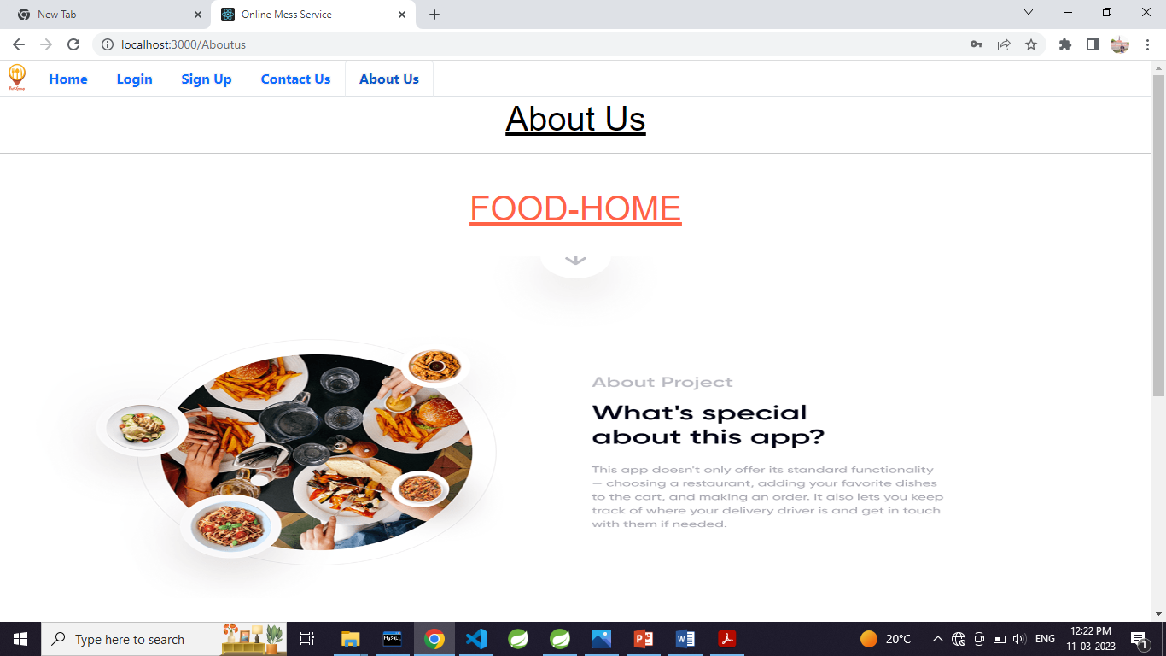

**5. Table Structure.**

user_type

|  |  |  |  |  |  |
| --- | --- | --- | --- | --- | --- |
| Field | Type | Null | Key | Default | Extra |
| type_id | int | NO | PRI | NULL | auto_increment |
| type | varchar(255) | NO |  | NULL |  |

user_info

|  |  |  |  |  |  |
| --- | --- | --- | --- | --- | --- |
| Field | Type | Null | Key | Default | Extra |
| user_id | int | NO | PRI | NULL | auto_increment |
| aadhar_no | varchar(255) | YES |  | NULL |  |
| address | varchar(255) | YES |  | NULL |  |
| contact_number | varchar(255) | YES |  | NULL |  |
| email_id | varchar(255) | YES |  | NULL |  |
| name | varchar(255) | YES |  | NULL |  |
| password | varchar(255) | YES |  | NULL |  |
| type_id | int | YES | MUL | NULL |  |

subscription_status

|  |  |  |  |  |  |
| --- | --- | --- | --- | --- | --- |
| Field | Type | Null | Key | Default | Extra |
| subscription_status_id | int | NO | PRI | NULL | auto_increment |
| status | varchar(255) | YES |  | NULL |  |

registered_mess

|  |  |  |  |  |  |
| --- | --- | --- | --- | --- | --- |
| Field | Type | Null | Key | Default | Extra |
| mess_id | int | NO | PRI | NULL | auto_increment |
| location | varchar(255) | YES |  | NULL |  |
| mess_name | varchar(255) | YES |  | NULL |  |
| mess_status_id | int | YES | MUL | NULL |  |
| mess_type_id | int | YES | MUL | NULL |  |

ratings

|  |  |  |  |  |  |
| --- | --- | --- | --- | --- | --- |
| Field | Type | Null | Key | Default | Extra |
| rating_id | int | NO | PRI | NULL | auto_increment |
| mess_id | int | YES | MUL | NULL |  |
| review | varchar(255) | YES |  | NULL |  |
| review_date | date | YES |  | NULL |  |
| stars | int | YES |  | NULL |  |
| user_id | int | YES |  | NULL |  |

Payments

|  |  |  |  |  |  |
| --- | --- | --- | --- | --- | --- |
| Field | Type | Null | Key | Default | Extra |
| payment_id | int | NO | PRI | NULL | auto_increment |
| month | int | YES |  | NULL |  |
| rupee | int | YES |  | NULL |  |
| subscription_id | int | YES | MUL | NULL |  |
| year | int | YES |  | NULL |  |

mess_type

|  |  |  |  |  |  |
| --- | --- | --- | --- | --- | --- |
| Field | Type | Null | Key | Default | Extra |
| mess_type_id | int | NO | PRI | NULL | auto_increment |
| mess_type | varchar(255) | YES |  | NULL |  |

mess_subscription

|  |  |  |  |  |  |
| --- | --- | --- | --- | --- | --- |
| Field | Type | Null | Key | Default | Extra |
| subscription_id | int | NO | PRI | NULL | auto_increment |
| end_date | date | YES |  | NULL |  |
| mess_id | int | YES | MUL | NULL |  |
| start_date | date | YES |  | NULL |  |
| subscription_status_id | int | YES | MUL | NULL |  |
| user_id | int | YES | MUL | NULL |  |

mess_owner

|  |  |  |  |  |  |
| --- | --- | --- | --- | --- | --- |
| Field | Type | Null | Key | Default | Extra |
| mapping_id | int | NO | PRI | NULL | auto_increment |
| mess_id | int | YES | MUL | NULL |  |
| user_id | int | YES |  | NULL |  |

mess_membership_status

|  |  |  |  |  |  |
| --- | --- | --- | --- | --- | --- |
| Field | Type | Null | Key | Default | Extra |
| mess_status_id | int | NO | PRI | NULL | auto_increment |
| status | varchar(255) | YES |  | NULL |  |

menu_table

|  |  |  |  |  |  |
| --- | --- | --- | --- | --- | --- |
| Field | Type | Null | Key | Default | Extra |
| menu_id | int | NO | PRI | NULL | auto_increment |
| date | date | YES |  | NULL |  |
| menu | varchar(255) | YES |  | NULL |  |
| mess_id | int | YES | MUL | NULL |  |
| price | int | YES |  | NULL |  |

**6. CONCLUSION**

 **Conclusion:**

In the current competitive world, many youths travel to different unknown locations for their basic education or jobs. The main problem they face is the food they get, and they crave for homemade food, but it is difficult to find it. On the other hand, some housewives wish to work and earn money to gain financial independence. It is difficult for these ladies to reach customers and market their products. So this online mess service will provide the common platform for those mess owner and students or youths to register mess and spend money according to service provided by owner. And also reduces the searching efforts of messes for youths and also giving financial help to mess owner.

** Future Enhancement:**

Future extensions for step-up of project.

* + - Association with Google maps
    - Payment mode
    - Discount /offer management
    - Billing

Estimated time of implementation.

* + - 4 weeks

Benefits of future extension.

* + - Growth for registered messes through advertisements
    - Attractive UI
    - Richer user experience
    - Robustness in application

**7. References**

* <https://www.w3schools.com/>
* <https://react-bootstrap.github.io/components/carousel/>
* <https://www.geeksforgeeks.org/reactjs-tutorials/>
* <https://javaee.github.io/javaee-spec/javadocs/>
* <https://reactjs.org/docs/getting-started.html>