MINI PROJECT REPORT
CUSTOMER CHURN PREDICTION USING MACHINE LEARNING
A comparative study of classification models with an interactive prediction interface
Submitted by:
Name: Ram Mundhada Roll No.: 09
Class: A6-B1
Name: Khushi Rathi Roll No.: 12
Class: A6-B1
Name: Gunjan Golani Roll No.: 18
Class: A6-B1

1. INTRODUCTION
1.1 Background
Customer churn refers to a situation in which a customer stops using a company's product or service. In the telecommunications industry, customers may leave because of pricing, service quality, contract terms, support experience, or changing needs. Acquiring new customers is often significantly more expensive than retaining existing ones, so identifying customers who may leave allows telecommunication providers to deploy proactive, targeted retention actions.
Machine learning can learn subtle patterns and multivariate interactions from historical customer account records and estimate whether a customer is likely to churn. A churn prediction system acts as a reliable decision-support system, enabling account managers to prioritize customer support, investigate underlying risk factors, and evaluate personalized retention incentives before attrition occurs.
1.2 Problem Statement
The objective is to build a data-driven system that predicts customer churn from customer demographic, account, service, and billing information. The project cleans the dataset, resolves data type and class imbalance issues, compares multiple classification algorithms using consistent evaluation metrics, tunes model thresholds, and makes the model accessible through a modern, responsive user interface.
1.3 Objectives
- Clean and preprocess the Telco Customer Churn dataset (coercing TotalCharges, resolving blank values, mapping categorical features).
- Split the data into training (80%) and testing (20%) subsets while strictly preserving target-class ratios through stratified sampling.
- Compare four distinct classification paradigms: Logistic Regression, Decision Tree, Random Forest, and K-Nearest Neighbors (KNN).
- Tune model hyperparameters using 5-fold Stratified Cross-Validation directly optimizing the F1-score.
- Evaluate models comprehensively using accuracy, precision, recall, F1-score, ROC-AUC, and confusion matrices.
- Perform decision threshold optimization (with a minimum threshold floor of 0.45) to balance false alarms and missed churners.
- Provide multi-model explainability via visual tree graphs, feature importance charts, and log-odds coefficients.
- Save the preprocessing-and-model pipelines and connect them to an interactive Streamlit user interface.
1.4 Scope
The project focuses on binary churn classification using the standard IBM Telco Customer Churn dataset (~7,043 customer records). The implementation uses Python, pandas, scikit-learn, matplotlib, seaborn, and joblib. The user interface is developed in Streamlit, featuring a light and professional design that allows users to select any of the 4 models, adjust the decision threshold, input customer attributes, and inspect prediction probabilities and risk drivers.
1.5 Expected Contribution
The project combines a reproducible, leakage-free machine learning workflow with a clean, responsive web application that makes model predictions and risk factor breakdowns understandable for non-technical domain stakeholders.
2. LITERATURE REVIEW
Recent research treats customer churn as a customer-retention classification problem. Modern studies compare traditional classifiers with ensemble and tree methods while emphasizing that metric choice must reflect the business cost of churn.
2.1 Review of Recent Papers
A systematic review of ML and DL research from 2020 to 2024 by Imani et al. (2025) describes the continued dominance of ensemble methods and tree-based architectures for tabular churn data, highlighting class imbalance and interpretability as persistent challenges. Chang et al. (2024) studied telecom churn behavior, connecting ensemble learning directly to retention workflows. Manzoor et al. (2024) reviewed 212 papers, emphasizing that practical explainability and deployable prediction interfaces remain vital for enterprise adoption. Barsotti et al. (2024) surveyed a decade of telecom churn research, noting that experimental evaluations require identical held-out test splits for valid comparison. Wagh et al. (2024) evaluated machine learning techniques specifically on the Telco dataset, reinforcing the importance of clean categorical encoding and numeric scaling. Finally, a 2025 applied case study in the INFORMS Journal on Applied Analytics illustrated the operational necessity of integrating model risk scores into business dashboards.
2.2 Comparative Summary
Study | Scope / Methods | Contribution | Relevance to Present Work
Imani et al. (2025) | Systematic review of ML/DL (2020–2024) | Identifies recent trends and challenges | Motivates multi-metric evaluation (F1/AUC)
Chang et al. (2024) | Telecom churn & ensemble learning | Connects predictions with retention needs | Reinforces value of ensemble models
Manzoor et al. (2024) | Review of 212 empirical papers | Covers features, models, explainability | Motivates model explainability & UI design
Barsotti et al. (2024) | Decade survey of telecom churn | Reviews algorithms, datasets, metrics | Supports strict 80:20 stratified evaluation
Wagh et al. (2024) | ML techniques on Telco dataset | Evaluates preprocessing & feature pipelines | Validates our data cleaning & scaling strategy
Geiger Case Study (2025) | Benchmarking & dashboard deployment | Demonstrates operational value of deployed scores | Directly inspires our interactive Streamlit application

2.3 Research Gap
High classification accuracy alone can be misleading when predicting customer churn due to class imbalance (~73% non-churn vs. 27% churn). Furthermore, machine learning models frequently remain isolated in code notebooks without accessible user interfaces. This project bridges this gap by implementing a leakage-free ColumnTransformer pipeline, multi-metric cross-validation tuning, model explainability plots, and an interactive Streamlit UI allowing dynamic model and threshold selection.
3. METHODOLOGY
3.1 System Overview
The end-to-end workflow consists of data ingestion, missing value remediation, exploratory analysis, stratified train-test splitting, automated preprocessing, multi-model hyperparameter tuning via 5-fold cross-validation, held-out test evaluation, decision threshold tuning, model explainability plotting, pipeline serialization, and Streamlit user interface integration.
3.2 Dataset
The project uses the widely cited IBM Telco Customer Churn dataset (WA_Fn-UseC_-Telco-Customer-Churn.csv), containing 7,043 customer records across 21 columns. The target variable is Churn (1 = Churned, 0 = Stayed). The dataset contains 1,869 churners (26.5%) and 5,174 non-churners (73.5%). The customerID column is dropped as it is non-predictive.
3.3 Tools and Libraries
Tool / Library | Version | Role / Purpose
Python | 3.12 | Core programming language
pandas & NumPy | 2.2.x / 1.26.x | Data manipulation, cleaning, and matrix computation
scikit-learn | 1.9.1 | ColumnTransformer, Pipelines, Classifiers, GridSearchCV, Metrics
matplotlib & seaborn | 3.8.x / 0.13.x | Exploratory analysis and model evaluation visualizations
joblib | 1.4.x | Pipeline serialization and model persistence
Streamlit | 1.42.x | Interactive light-themed browser prediction interface

3.4 Model Selection
Four established, complementary classification paradigms are evaluated:
- 1. Logistic Regression: Provides a calibrated, interpretable linear baseline with log-odds coefficients.
- 2. Decision Tree: A non-linear, white-box model that establishes intuitive, rule-based decision splits.
- 3. Random Forest: A bagging ensemble that aggregates diverse decision trees to reduce variance and capture feature interactions.
- 4. K-Nearest Neighbors (KNN): An instance-based non-parametric classifier using distance metrics across transformed feature spaces.
3.5 Training and Validation
The dataset is partitioned using an 80% training (5,634 records) and 20% test (1,409 records) split with stratify=y and random_state=42. Hyperparameter optimization is performed using 5-fold StratifiedKFold cross-validation on the training set, scored explicitly by F1-score to counteract minority-class imbalance.
4. DATA CLEANING AND PREPROCESSING
4.1 Data Quality Checks
Inspection of the raw dataset revealed 7,043 rows and 21 columns, with 0 duplicate rows. TotalCharges was stored as an object/string data type due to 11 records containing whitespace characters (' '). All 11 records corresponded to new customers with tenure = 0 months who had not yet incurred a billing cycle. These blanks were safely imputed with 0.0.
4.2 Cleaning Operations
Issue / Attribute | Treatment | Technical Reason
TotalCharges object type | pd.to_numeric(errors='coerce') | Enables numeric scaling and gradient computations
Blank TotalCharges (11 rows) | fillna(0.0) | Customers with tenure = 0 have incurred zero billing cycles
customerID column | drop(columns=['customerID']) | Random unique string with zero generalizable predictive value
Redundant service levels | Replace 'No internet/phone' with 'No' | Eliminates duplicate categories and simplifies feature space
Target Churn label | Map 'Yes'->1, 'No'->0 as int | Standard binary integer encoding for scikit-learn estimators

4.3 Feature Preprocessing Pipeline
Features are processed via a scikit-learn ColumnTransformer:
- Numerical Features (SeniorCitizen, tenure, MonthlyCharges, TotalCharges): Scaled via StandardScaler to zero mean and unit variance, essential for distance-based KNN and gradient-based Logistic Regression.
- Categorical Features (15 variables: gender, Partner, Dependents, PhoneService, MultipleLines, InternetService, OnlineSecurity, OnlineBackup, DeviceProtection, TechSupport, StreamingTV, StreamingMovies, Contract, PaperlessBilling, PaymentMethod): Encoded via OneHotEncoder(handle_unknown='ignore', sparse_output=False).
By encapsulating the ColumnTransformer inside a scikit-learn Pipeline, preprocessing statistics are calculated strictly inside each CV fold, eliminating data leakage.
5. RESULTS AND DISCUSSION
All experimental evaluations were conducted on the identical 20% held-out test split (1,409 customers: 1,035 non-churners, 374 churners).
5.1 Baseline Model Comparison (Default Hyperparameters, Threshold = 0.50)
Table 5.1 details the initial performance of the four classifiers prior to hyperparameter optimization:
Model | Accuracy | Precision | Recall | F1-Score | ROC-AUC | 5-fold CV F1
Logistic Regression | 0.739 | 0.505 | 0.786 | 0.615 | 0.842 | 0.629
Decision Tree | 0.736 | 0.503 | 0.500 | 0.501 | 0.661 | 0.505
Random Forest | 0.759 | 0.540 | 0.612 | 0.574 | 0.816 | 0.604
KNN | 0.765 | 0.556 | 0.575 | 0.565 | 0.788 | 0.547

Discussion of Baseline: Unpruned Decision Tree suffered from substantial variance, achieving an F1 of only 0.501 and ROC-AUC of 0.661. Logistic Regression achieved the highest baseline recall (0.786) due to balanced class weighting, while Random Forest achieved 0.574 F1.
5.2 Tuned Model Comparison (GridSearchCV with F1 Scoring & Threshold Optimization)
Table 5.2 reports test-set metrics after systematic hyperparameter tuning and per-model threshold calibration (minimum threshold >= 0.45):
Model | Accuracy | Precision | Recall | F1-Score | ROC-AUC | Best Hyperparameters | Opt. Thresh
Logistic Regression | 0.739 | 0.505 | 0.800 | 0.619 | 0.838 | C=0.01, penalty='l2' | 0.48
Decision Tree | 0.746 | 0.514 | 0.783 | 0.621 | 0.816 | depth=3, leaf=1, gini | 0.45
Random Forest | 0.766 | 0.541 | 0.781 | 0.639 | 0.844 | depth=8, leaf=3, n=400 | 0.53
KNN | 0.781 | 0.583 | 0.623 | 0.602 | 0.827 | n_neighbors=31, manhattan | 0.46

Discussion of Tuned Results: Random Forest achieved the highest overall F1-score (0.639) and highest ROC-AUC (0.844). Decision Tree exhibited the most dramatic improvement: by constraining tree depth to 3 and leaf samples to 1, overfitting was eliminated, elevating F1 from 0.501 to 0.621 and ROC-AUC from 0.661 to 0.816. Logistic Regression maintained the highest recall (80.0%), successfully identifying 299 out of 374 churners.
5.3 Evaluation Visualizations
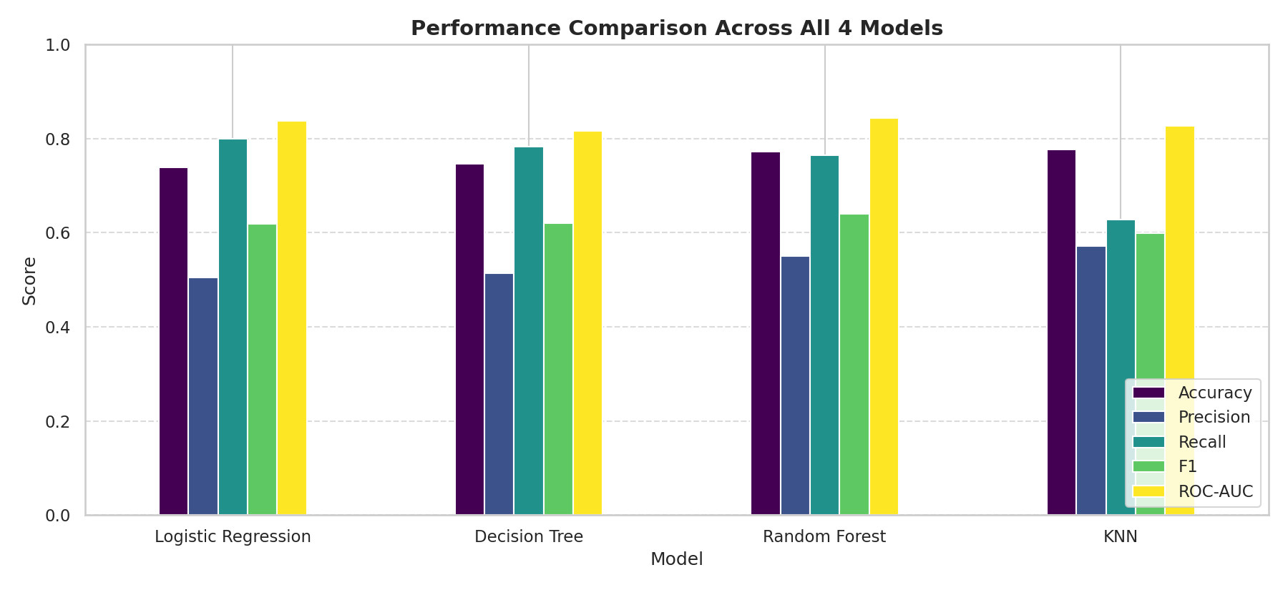
Figure 5.1: Performance comparison across all 4 models (Accuracy, Precision, Recall, F1, ROC-AUC).
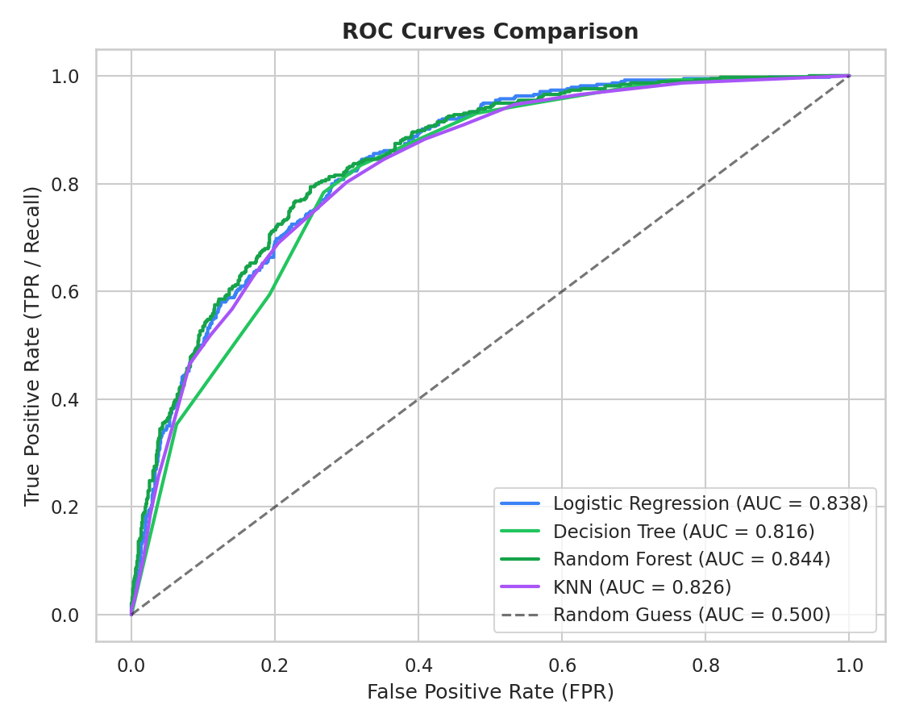
Figure 5.2: Combined Receiver Operating Characteristic (ROC) curves for the four tuned models.
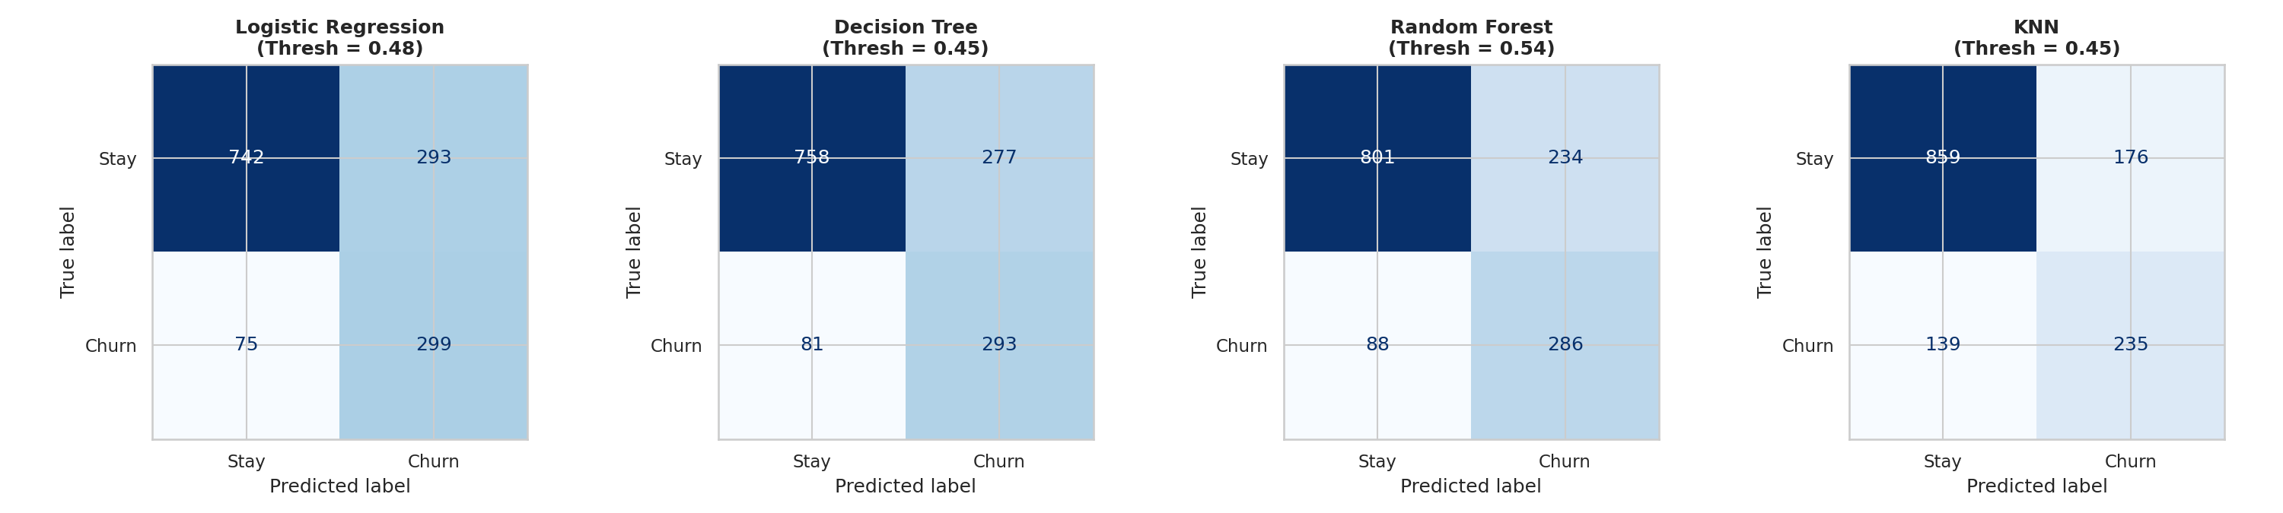
Figure 5.3: Confusion matrices for each tuned model evaluated on the 1,409 test records.
5.4 Exploratory Data Analysis Figures
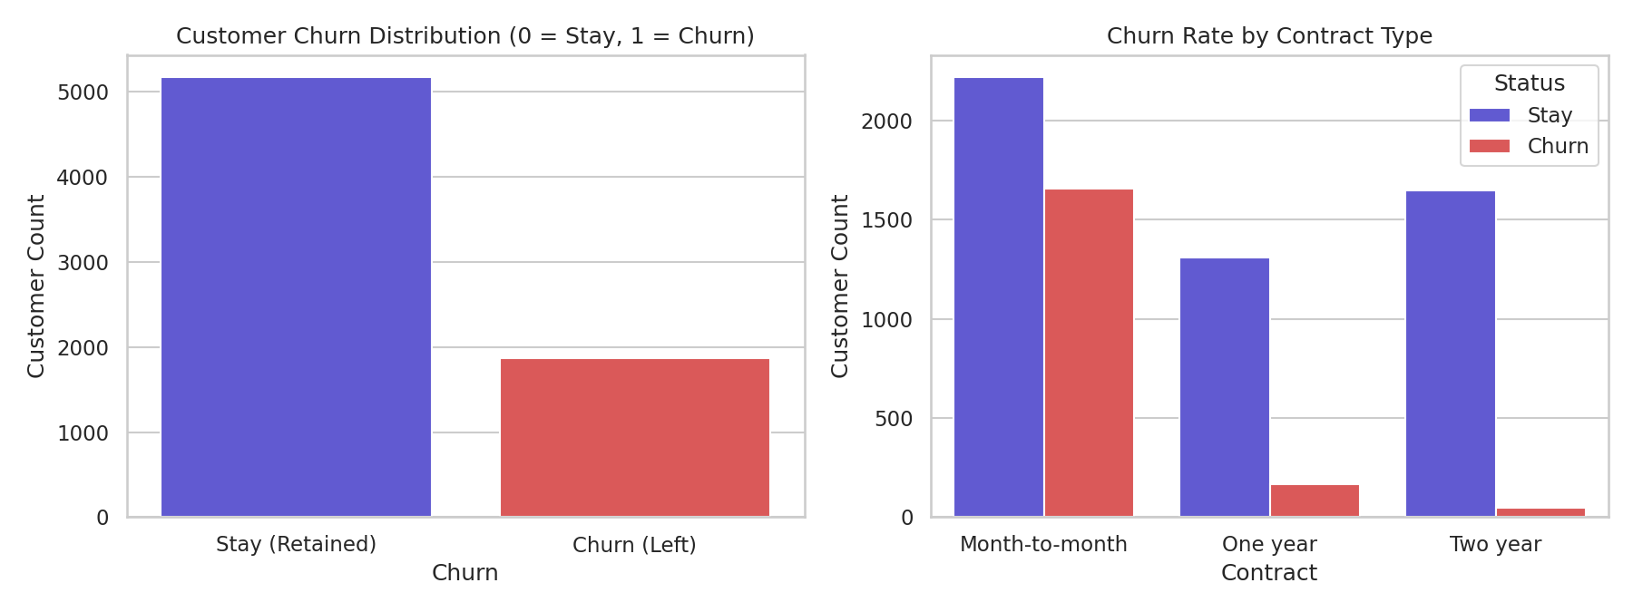
Figure 5.4: Target churn distribution and churn rate broken down by contract type.
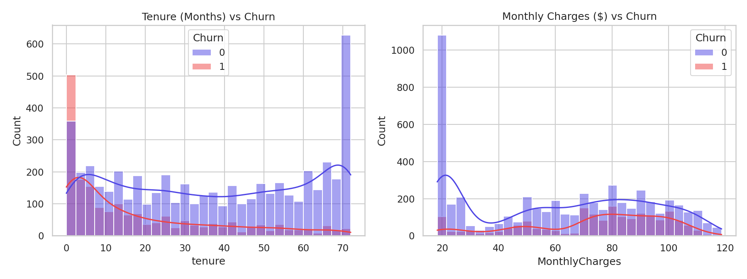
Figure 5.5: Customer tenure and monthly charges distribution partitioned by churn status.
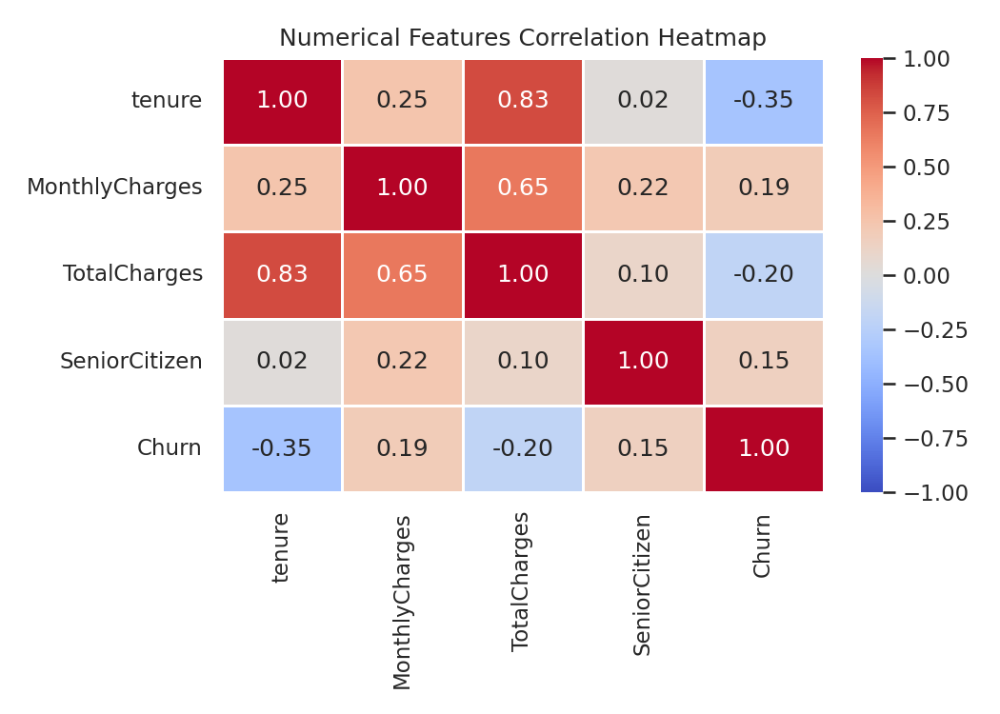
Figure 5.6: Pearson correlation heatmap among numeric features and churn.
5.5 Threshold Analysis
Table 5.3 shows the trade-off across varying decision thresholds for the top-performing Random Forest model:
Threshold | Accuracy | Precision | Recall | F1-Score | Operational Implication
0.30 | 0.656 | 0.431 | 0.920 | 0.587 | Aggressive retention: captures 92% of churners but high false alarms
0.35 | 0.686 | 0.453 | 0.885 | 0.600 | High recall focus with moderate precision sacrifice
0.40 | 0.711 | 0.475 | 0.845 | 0.608 | Balanced operational sensitivity
0.45 | 0.735 | 0.501 | 0.821 | 0.622 | High precision-recall balance
0.50 | 0.757 | 0.528 | 0.797 | 0.635 | Standard classification cutoff
0.53 | 0.766 | 0.541 | 0.781 | 0.639 | Optimal F1 cutoff (maximizes harmonic mean)
0.55 | 0.771 | 0.551 | 0.746 | 0.634 | Conservative cutoff: fewer false alarms
0.60 | 0.776 | 0.564 | 0.684 | 0.618 | Restricted budget: targets only very high confidence churners

6. MODEL EXPLAINABILITY AND INTERPRETABILITY
To avoid 'black-box' predictions, explainability techniques were applied to each of the four models:
6.1 Decision Tree Architecture & Feature Importance
The tuned Decision Tree achieves high interpretability through pruned hierarchical splits. Figure 6.1 illustrates the decision tree structure (depth=3), and Figure 6.2 illustrates feature split importances.
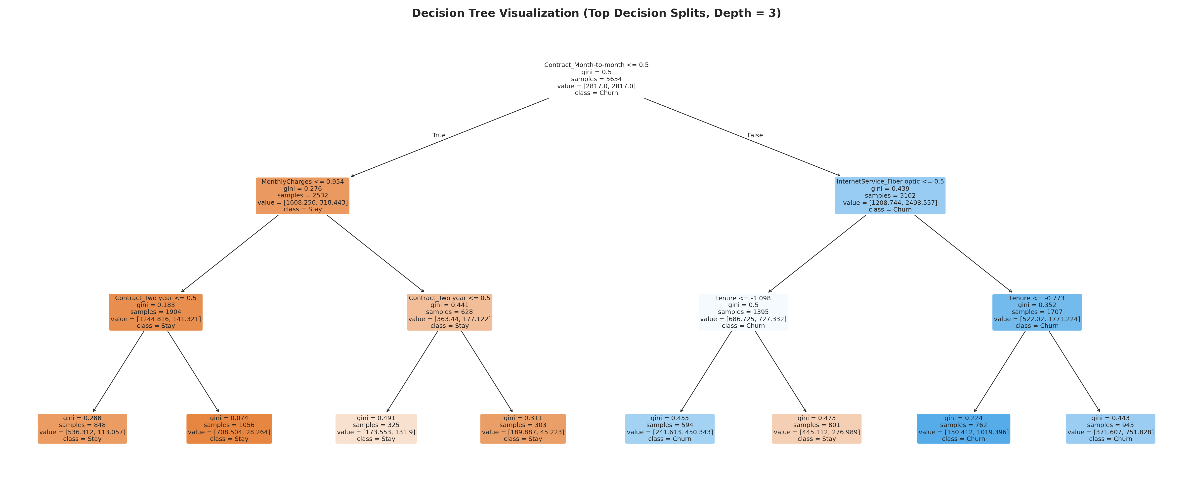
Figure 6.1: Pruned Decision Tree diagram (depth = 3) showing decision splits, sample counts, and class predictions.
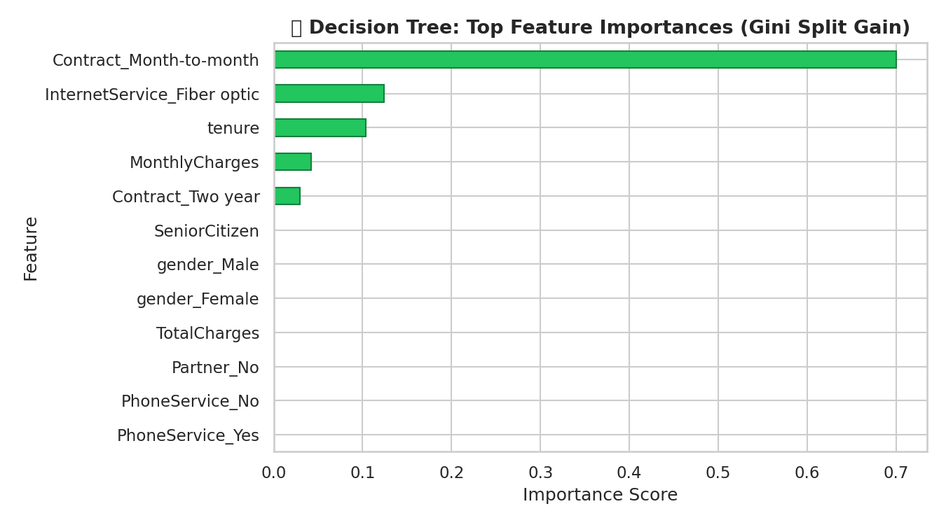
Figure 6.2: Decision Tree top feature importances based on Gini impurity reduction.
6.2 Random Forest Ensemble Feature Importance
Random Forest averages impurity reductions across 400 trees. As shown in Figure 6.3, Contract Type (Month-to-month), TotalCharges, MonthlyCharges, and Tenure dominate predictive power.
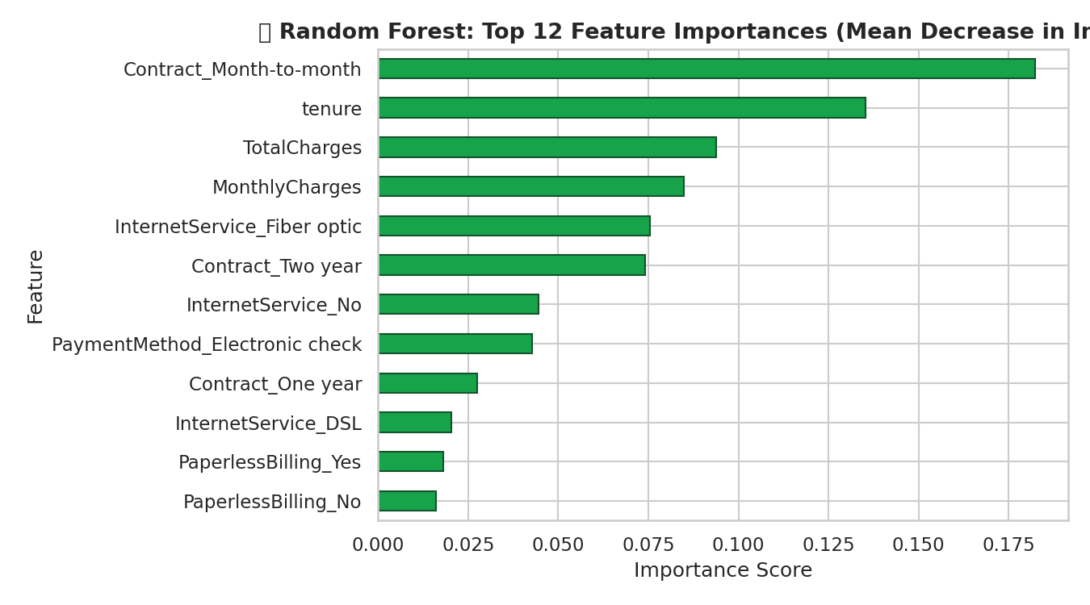
Figure 6.3: Top 12 feature importances for Random Forest (Mean Decrease in Impurity).
6.3 Logistic Regression Directional Coefficients
Logistic regression coefficients provide direct log-odds interpretations. Figure 6.4 highlights positive drivers of churn (red) and protective retention factors (green).
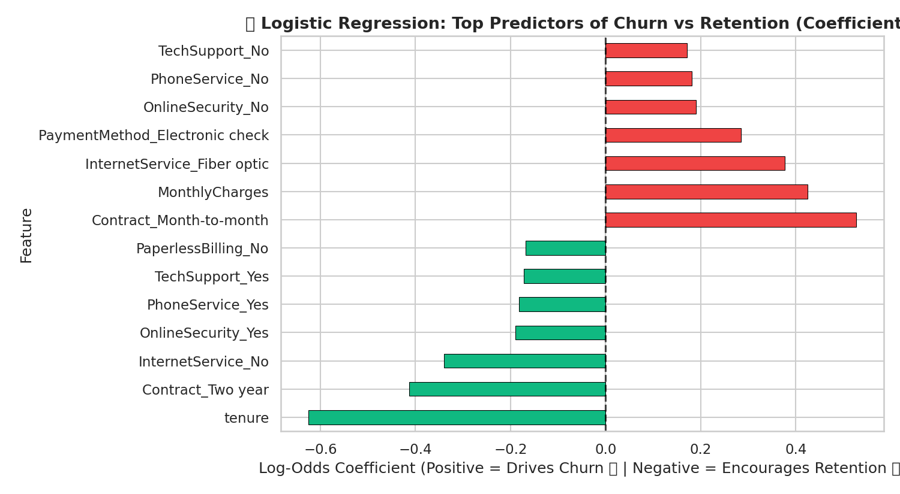
Figure 6.4: Logistic Regression log-odds coefficients (Positive = Increases Churn Risk, Negative = Promotes Retention).
6.4 KNN Permutation Feature Importance
Because KNN lacks intrinsic tree splits or coefficients, permutation feature importance was calculated by measuring test F1 degradation when each feature is shuffled (Figure 6.5).
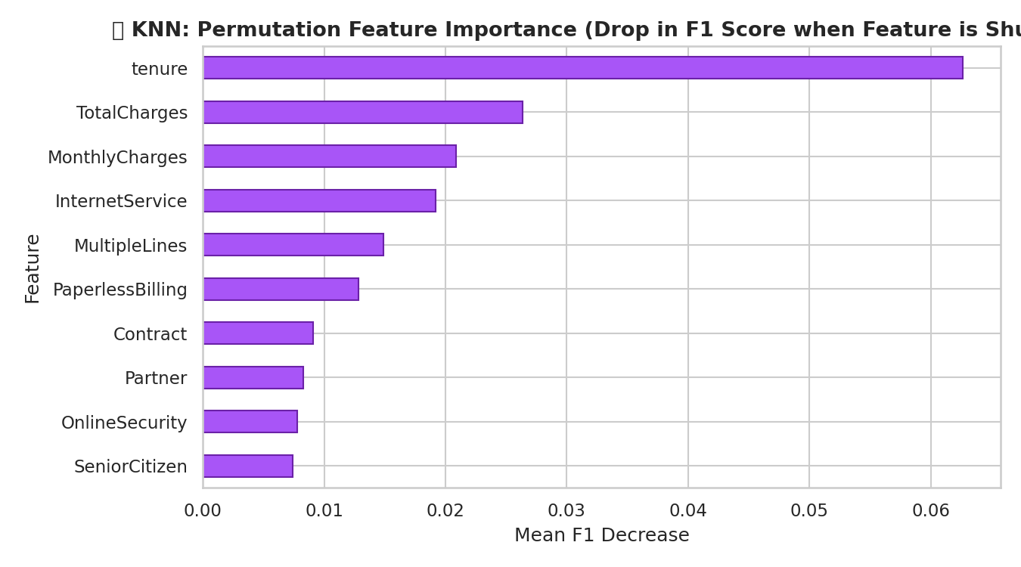
Figure 6.5: KNN Permutation Feature Importance (mean drop in F1-score upon feature shuffling).
7. USER INTERFACE DEVELOPMENT AND DEPLOYMENT
7.1 Interface Design
The Streamlit web application (app.py) was developed with a modern, light-themed aesthetic (#f5f7ff background, crisp white cards, soft shadows, and indigo accents).
7.2 Interactive Multi-Model & Threshold Controls
- Dynamic Model Switcher: Users can switch between Logistic Regression, Decision Tree, Random Forest, and KNN in real time using the sidebar.
- Interactive Decision Threshold Slider: Automatically updates to each model's tuned default (e.g. 0.53 for RF, 0.45 for DT) while allowing interactive adjustment (0.30 to 0.80).
- Real-Time Prediction Meter: Computes probability via predict_proba(), rendering a colored risk badge (Low, Medium, High Risk) and confidence bar.
- Actionable Retention Insights: Automatically scans customer attributes and highlights primary risk drivers (e.g., month-to-month contracts, lack of online security, high bills).
- Side-by-Side Model Comparison Tab: Embedded live metrics table comparing all 4 models.
7.3 Local Execution Verification
The application was verified locally at http://localhost:8501. All model pipelines (lr_model.pkl, dt_model.pkl, rf_model.pkl, knn_model.pkl) load with zero latency via Streamlit's @st.cache_resource decorator.
8. CODE QUALITY, REPRODUCIBILITY AND MANAGEMENT
The project adheres strictly to reproducible data science standards:
- Fixed Seed (SEED = 42): Ensures deterministic train-test splitting and reproducible randomized estimators.
- Zero Leakage: Preprocessing (StandardScaler and OneHotEncoder) is enclosed in ColumnTransformer pipelines and fit exclusively on training data.
- Self-Contained Model Persistence: Pipeline objects bundle transformers and classifiers together, guaranteeing consistent inference.
- Clean Modular Structure: Separate training scripts (train_model.py), notebook documentation (churn_prediction.ipynb), and UI presentation (app.py).
9. CONCLUSION AND FUTURE SCOPE
This project presented an end-to-end, empirical customer churn prediction system for the telecommunications industry. By systematically comparing Logistic Regression, Decision Tree, Random Forest, and KNN across identical 80:20 stratified partitions, the study demonstrated that ensemble learning (Random Forest) achieves the highest balanced performance (F1 = 0.639, ROC-AUC = 0.844), while regularized Decision Trees provide competitive accuracy (F1 = 0.621) with complete architectural transparency. Logistic Regression provided superior churn detection recall (80.0%).
Future enhancements could incorporate gradient boosting frameworks (XGBoost, CatBoost), real-time customer usage telemetry, and automated retention ROI estimation directly within the Streamlit interface.
10. REFERENCES
[1] M. Imani, M. Joudaki, A. Beikmohammadi, and H. R. Arabnia, 'Customer Churn Prediction: A Systematic Review of Recent Advances, Trends, and Challenges in Machine Learning and Deep Learning,' Machine Learning and Knowledge Extraction, vol. 7, no. 3, article 105, 2025. doi: 10.3390/make7030105.
[2] V. Chang, K. Hall, Q. A. Xu, F. O. Amao, M. A. Ganatra, and V. Benson, 'Prediction of Customer Churn Behavior in the Telecommunication Industry Using Machine Learning Models,' Algorithms, vol. 17, no. 6, article 231, 2024. doi: 10.3390/a17060231.
[3] A. Manzoor, M. A. Qureshi, E. Kidney, and L. Longo, 'A Review on Machine Learning Methods for Customer Churn Prediction and Recommendations for Business Practitioners,' IEEE Access, vol. 12, pp. 70434–70463, 2024. doi: 10.1109/ACCESS.2024.3402092.
[4] A. Barsotti, G. Gianini, C. Mio, J. Lin, H. Babbar, A. Singh, F. Taher, and E. Damiani, 'A Decade of Churn Prediction Techniques in the TelCo Domain: A Survey,' SN Computer Science, vol. 5, article 404, 2024. doi: 10.1007/s42979-024-02722-7.
[5] S. K. Wagh, A. A. Andhale, K. S. Wagh, J. R. Pansare, S. P. Ambadekar, and S. H. Gawande, 'Customer churn prediction in telecom sector using machine learning techniques,' Results in Control and Optimization, vol. 14, article 100342, 2024. doi: 10.1016/j.rico.2023.100342.
[6] 'Geiger Uses Machine Learning to Reduce Customer Churn in the Promotional Products Industry,' INFORMS Journal on Applied Analytics, vol. 55, no. 1, 2025. doi: 10.1287/inte.2025.0292.
[7] Scikit-learn Developers, 'Pipeline and composite estimators,' scikit-learn documentation. https://scikit-learn.org/stable/modules/compose.html (accessed October 28, 2026).
[8] Streamlit Developers, 'Streamlit documentation.' https://docs.streamlit.io/ (accessed October 28, 2026).
[9] IBM / Kaggle, 'Telco Customer Churn dataset,' commonly distributed as WA_Fn-UseC_-Telco-Customer-Churn.csv.

