|  |
| --- |
|  |
| Fee Collection Module |
|  |

Contents

1 Introduction to the Business Requirements Document (BRD) 2

1.1 Purpose 2

1.2 Scope 2

1.3 Overview of the Problem Statement 3

1.4 Key Assumptions and Constraints 3

2 Analysis of Proposed Solution 3

2.1 Workflow process model of Fee collection module 4

2.2 Use Case Diagram of the Proposed System (High-Level): 6

3 Business Requirements 8

3.1 Features/ User Modules 8

3.2 System Requirements/ System Modules 8

3.2.1 Cloud & Mobile Infrastructure 9

3.2.2 Data Management 9

3.2.3 User Management 9

3.2.4 Configuration & Customization 9

# Introduction to the Business Requirements Document (BRD)

## Purpose

This document aims to understand and analyze the case for an organization-wide process automation system that can efficiently automate the fee structure designing and fee collection system of an Educational Institution. It also aims to capture and define the high-level requirements of the proposed system.

This document can be used as the basis for the following activities in the future:

* Creating low-level designs (e.g. feature lists) for the proposed system
* Developing test plans, test scripts, and test cases
* Determining project completion and assessing project status

## Scope of the document

This document aims to analyze the given business case from a high-level, systems-oriented perspective. The overall analysis and supporting diagrams showcase a conceptual design of the overall system from a business standpoint and provides, only to a limited level, details about all functional and non-functional requirements. Analysis of technical requirements, hardware and software resources are not discussed. Also, considering the wide array of business processes in an educational institution, we have taken the Fee collection process for detailed analysis and as a way to deliberate on the overall system design.

## Overview of the Problem Statement

Traditional fee collection systems in educational institutions is a laborious manual process for issuing fee receipts and fee register updating, leading to data inaccuracy and reconciliation.

Thus, there is a need for an organization-wide, integrated BPM system with automated workflows in order to meet or solve the challenges, such as

* Providing timely, accurate and up-to-date data on various queries concerning any stage of a business process to multiple stakeholders/users in the institution, especially to students and faculty.
* Elimination of various manual, repetitive and unproductive tasks involved in many of the business processes in the institution by means of automation.
* Centralized repository for data and ability to generate reports from the streams.
* Ready and secure access to required information through different modes/media of access such as web and mobile.
* Streamlining of various approval procedures in different departments.
* Customization and configuration of various modules or workflows according to the needs of the institution ability to adapt business rules according to evolving needs.

## Key Assumptions and Constraints

While the proposed system is suitable for educational institutions of any kind, the requirements elicited are primarily derived, keeping in mind the needs of a higher educational institution, such as a college or university with already existing disparate information systems. It is also assumed that there is still much manual processing and paperwork (such as refund request forms, fee receipt generation etc). The proposed system is also assumed to gather & feed data to and is interoperable with existing databases, interfaces, if any.

# Analysis of Proposed Solution

Fee Collection System is a support processes which help the institution to collect fee from students

All these processes involve different workflows which involve a sequence of operations/activities, carried out as ‘work’ by a single or a group of persons or machines. Such actions or activities would also span different departments and involve certain waiting times for approval or compliance with defined business rules. They may also trigger other sub-workflows.

## Workflow process model of Fee collection module

Before we come up with a use case for an organization-wide, integrated BPM system with automated workflows, let us analyze the Fee Collection process using the workflow approach.

Figure 1: Proposed system of Fee collection module

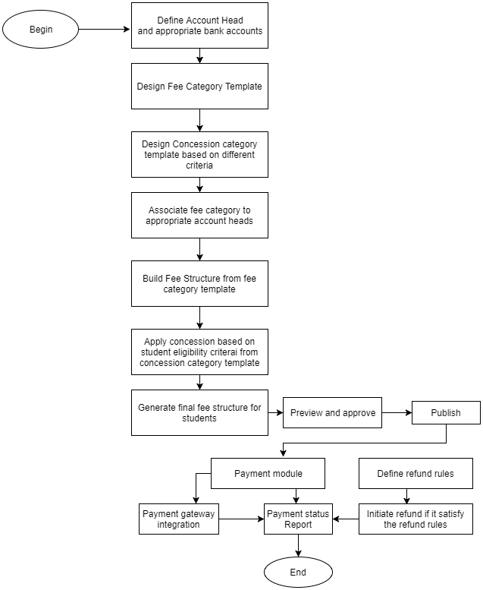

As we can observe, implementation of the Fee Collection process will reduce staff time for more productive work. For instance, the sheer number of calls from applicants wanting to know the status of their application apart from the myriad queries on filling the form can be eliminated thus freeing up the concern department office for other useful work. Manual logging of heavy documents (of each applicant) from the Filing room can be eliminated.

Electronic storage of applicant information enables single-point storage of each students about the payment status, category concession etc.

One can also automate fee structure (by automatically allocating creating fee structure for department, category wise), eliminating the need for manual setting of collecting the details of students who applicable for concession or may opt additional elective course. Reports can also be generated to know the student payment status.

To enable such a model, it is necessary to create an organization-wide BPM system with automated workflows (designed to be customizable and configurable according to each business) which can sit on top of the existing disparate information systems (or replace them with a central repository of data) which can remodel the existing business processes enabling efficiency, saving time, costs and increasing productivity.

## Use Case Diagram of the Proposed System (High-Level):

A cloud-based integrated ERP solution with customisable modules (refer *Fig. 3*) which can help automate and streamline entire processes replacing legacy systems is what is suggested through the high-level Use Case diagram. Each Use Case stands for a bundle of applications (capturing and triggering multiple workflows and automating recurring activities in a business process and designed to incorporate different business rules). Fee Collection Module helps in automating various workflows that can interface with legacy Systems already present and these are integrated with the overall BPM system so as to enable access for any application within it.

One of the key requirements for such a system in today’s environment is the ability to access information on-the-go and thus needs solutions for mobile platforms and remote access via the web. A mobile application provides convenient access to pertinent information about the students, prospective students, faculty and management anytime and anywhere it is needed and developed as an app for multiple platforms like iOS or Android. It can provide ready access to course information and student/faculty self-service portals apart from the Fee Payment Process. Another key requirement is the ability to easily handle requests from thousands of concurrent users, in case of a large educational institution, service reliability, security and 24/7 availability and thus the reason to host the solution on the public or private cloud.

Figure 2: High-level Overview of the BPM System with Automated Workflows

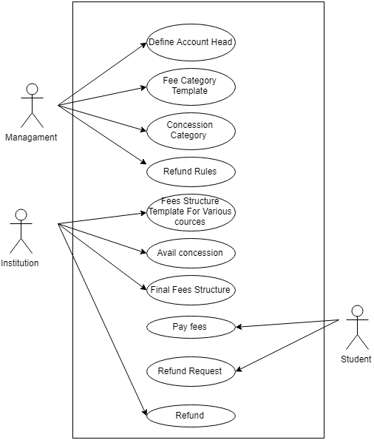

The details of the individual modules within the system are discussed in the next section.

# Business Requirements

The proposed system requires the following customisable modules with a high level of automation wherever the business process allows. First, we look at some of the essential client deliverables.

## Features/ User Modules

* **Accounts Head**

To create a account head like Management A/c (Self Financing and Aided), Fee A/c (Aided) and Deposit A/c (Caution Deposit) and integrate with respective bank accounts.

* **Fee Category template**

To create a template for all categories of fee amount associated with different accounts head.

* **Fee Structure**

To create a fee structure using fee template and add some optional fee (fee for electives, supplementary etc).

* **Fee Collection**

To manage fee payment process by associate with payment gateway to pay through online and save the payment receipt. Payment status of each student will be updated once they paid the fee and list of transaction are recorded each day.

* **Refund Process**

To initiate a refund if any refund request is raised by the student. Refund will be processed only if it satisfy the refund rules which are defined by the institution.

* **Report**

To get report of transaction details and number of students paid the fees, by the management and administrative staff to get periodic as well as on-demand reports which give a picture of the overall functioning and use of the system.

To effectively make use of the above user modules, certain other system-level modules which help in automating many workflow processes are necessary. Some of these are:

## System Requirements/ System Modules

### Cloud & Mobile Infrastructure

As mentioned before, a cloud-based education ERP software is necessary to build user applications. The various user functions are accessed through Self-service portals including secure access to data, remote logging, real-time data updates, push notifications, calendar and event scheduling and self-provisioning tools to seamlessly provide necessary resources or integrate third party applications without the help of dedicated IT staff. Deployment support can be done on the premises and the generic BPM solution can be configured and customized as required by the institution.

### Data Management

This covers the Storage and Retrieval system and provides features such as seamless import and export of data in various formats, automatic data backup and syncing of data seamlessly with third party applications, and authorized and secure access control. A content generation, management and delivery system accessible via web and mobile is also necessary.

### User Management

This involves tasks related to creation, configuration and maintenance of user accounts/profiles for multiple types of users like students, faculty, staff and parents; advanced query, search and filtering of user profiles; creating and managing user groups and permissions and finally, information directories.

### Configuration & Customization

This involves system modules for custom deployment and detachment of modules based on-demand and performance considerations; creation of online tools like Menu and Form Builders to quickly create, build and deploy custom menus, fields and forms.

Other system-level requirements include modules for Security of User applications, mobile application development tools, messaging and collaborative tools etc.