Experiment No. 2

Experiment Title | To perform Data Preprocessing using Python.
Course  Outcomes | CO2: Organize and prepare the data needed for data mining using pre preprocessing techniques.
Date of Preparation |  | Date of Submission
Signature & Grade

Name: Ram Panjwani
Roll no: 32

Experiment 2 - To perform Data Preprocessing using Python.
Aim
To perform data preprocessing on the real Uber India NCR ride-booking dataset using Python by handling missing values and duplicate records, encoding categorical attributes, and standardizing numerical features.
Objective
• Load and inspect the original 150,000-record CSV dataset.
• Identify null values and detect exact duplicate records.
• Handle missing categorical and numerical values appropriately.
• Apply one-hot encoding and label encoding to categorical fields.
• Standardize selected numerical attributes and export the cleaned data.
Software/Tools Required
Python 3.11, Pandas, Scikit-learn, PowerShell or a Python-compatible IDE. Dataset: ncr_ride_bookings.csv (original Kaggle Uber India NCR ride-booking CSV, 150,000 rows and 21 columns).
Theory
Data preprocessing transforms raw data into a consistent format suitable for analysis or modelling. Missing-value analysis, duplicate removal, categorical encoding and feature scaling are common steps.
This dataset includes cancelled and incomplete bookings. Missing fare or ride-distance values in those records may be structurally meaningful, not random errors. The program therefore creates missing-value indicator fields before median imputation. Numerical imputed values are placeholders for modelling, not actual fares or completed distances.
Vehicle Type and Payment Method are nominal categories; one-hot encoding avoids imposing an artificial category order. Booking Status is encoded as a separate target label. StandardScaler transforms numeric features using (value - mean) / standard deviation.
This is a preprocessing demonstration fitted on the full dataset. For prediction tasks, imputation and scaling should instead be fitted on the training partition only to prevent information leakage.
Code
Python Program - Complete Source Code
"""DMBI Experiment 2: Data preprocessing using the original Uber NCR CSV.
Input: ncr_ride_bookings.csv (same folder, or supply --csv PATH).
Outputs: exp2_outputs/ (processed data, missing-value report and summary).
"""
from pathlib import Path
import argparse

import pandas as pd
from sklearn.preprocessing import LabelEncoder, StandardScaler

parser = argparse.ArgumentParser()
parser.add_argument("--csv", default="ncr_ride_bookings.csv")
args = parser.parse_args()
input_path = Path(args.csv)
if not input_path.exists():
input_path = Path(__file__).resolve().parent / args.csv
if not input_path.is_file():
raise FileNotFoundError(f"Dataset not found: {args.csv}")

out = Path(__file__).resolve().parent / "exp2_outputs"
out.mkdir(exist_ok=True)

df = pd.read_csv(input_path, low_memory=False)
df.columns = df.columns.str.strip()
print("EXPERIMENT 2 - DATA PREPROCESSING")
print("Dataset:", input_path.name)
print("Original shape:", df.shape)
print("\nMissing values in original dataset:")
missing_before = df.isna().sum().sort_values(ascending=False)
print(missing_before.to_string())
missing_before.rename("missing_count").to_csv(out / "missing_values_original.csv")

duplicates = int(df.duplicated().sum())
df = df.drop_duplicates().reset_index(drop=True)
print("\nExact duplicate rows removed:", duplicates)

numeric_cols = ["Avg VTAT", "Avg CTAT", "Booking Value", "Ride Distance"]
cat_cols = ["Vehicle Type", "Payment Method", "Booking Status"]
required = numeric_cols + cat_cols
not_found = [c for c in required if c not in df.columns]
if not_found:
raise ValueError(f"Missing expected columns: {not_found}")

clean = df[required].copy()
for col in cat_cols:
clean[col] = clean[col].astype("string").str.strip()
clean[col] = clean[col].replace("", pd.NA).fillna("Unknown")

# Missing numeric values often reflect non-completed rides.
# Retain missingness flags before median imputation for a modelling example.
imputation = {}
for col in numeric_cols:
clean[col] = pd.to_numeric(clean[col], errors="coerce")
clean[col + "_was_missing"] = clean[col].isna().astype("int8")
median = clean[col].median()
if pd.isna(median):
raise ValueError(f"Column has no observed numeric values: {col}")
imputation[col] = float(median)
clean[col] = clean[col].fillna(median)

# Encode nominal categories without introducing an artificial ordering.
features = pd.get_dummies(
clean, columns=["Vehicle Type", "Payment Method"], dtype="int8"
)
# Encode booking status as a separate label, NOT an input feature.
label_encoder = LabelEncoder()
features["Booking_Status_Code"] = label_encoder.fit_transform(
clean["Booking Status"]
)
features = features.drop(columns=["Booking Status"])

# Scale numerical measurements; preserve indicator and one-hot columns.
scaler = StandardScaler()
features[numeric_cols] = scaler.fit_transform(features[numeric_cols])

features.to_csv(out / "uber_preprocessed_features.csv", index=False)
clean.to_csv(out / "uber_cleaned_unscaled.csv", index=False)
features.head(10).to_csv(out / "first_10_preprocessed_rows.csv", index=False)

report = [
"EXPERIMENT 2 - DATA PREPROCESSING RESULTS",
f"Input: {input_path.name}",
f"Original records: {len(df) + duplicates}",
f"Exact duplicates removed: {duplicates}",
f"Final records: {len(df)}",
f"Features in processed CSV: {features.shape[1]}",
"Numeric missingness flags are preserved before imputation.",
"Numeric medians used for imputation:",
]
report.extend(f" {k}: {v:.4f}" for k, v in imputation.items())
report.append("Status labels: " + repr(dict(zip(
label_encoder.classes_.tolist(), range(len(label_encoder.classes_))
))))
report.append("Note: Imputed fares/distances for non-completed bookings are modelling placeholders, not real charges or distances.")
(out / "summary.txt").write_text("\n".join(report) + "\n", encoding="utf-8")
print("\n".join(report))
print("\nFirst five processed records:")
print(features[["Avg VTAT", "Avg CTAT", "Booking Value",
"Ride Distance", "Avg VTAT_was_missing",
"Booking Value_was_missing", "Booking_Status_Code"]].head().to_string(index=False))
print("\nOutput folder:", out.resolve())
Output
Executed command: py -3.11 exp2.py --csv ncr_ride_bookings.csv
The following screenshot is the actual PowerShell output provided after execution.
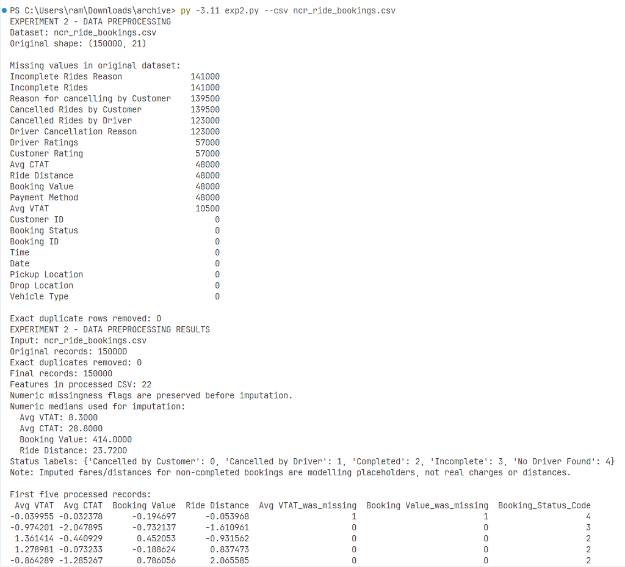
Figure 1. Experiment 2 - actual preprocessing terminal output.
Observed dataset summary
Parameter | Observed value
Original dataset size | 150,000 rows x 21 columns
Exact duplicate records | 0
Final records | 150,000
Processed output columns | 22
Booking Value missing | 48,000
Ride Distance missing | 48,000
Avg CTAT missing | 48,000
Avg VTAT missing | 10,500

Median values used for imputation
Feature | Median
Avg VTAT | 8.30
Avg CTAT | 28.80
Booking Value | 414.00
Ride Distance | 23.72

Output files saved by the program: summary.txt, missing_values_original.csv, first_10_preprocessed_rows.csv, uber_cleaned_unscaled.csv, and uber_preprocessed_features.csv. All are included in the experiment folder.
Result
The original Uber NCR dataset was successfully preprocessed in Python. The 150,000 records were retained because no exact duplicates were found. A 22-column encoded and standardized feature dataset was produced and saved.
Inference
The large number of missing booking-value and distance entries reflects that not all bookings resulted in completed rides. Median imputation permits a numeric feature matrix while missing-value flags preserve this distinction. One-hot encoding makes the nominal attributes usable without giving their categories a false numeric order.
Conclusion
Data preprocessing was completed on the original 150,000-record Uber cab-booking dataset using missing-value assessment, duplicate detection, imputation, categorical encoding and numerical standardization. The processed files are suitable for demonstration and further analysis, with care needed when interpreting imputed values.
GitHub Link
https://github.com/RamPanjwani/DMBI/tree/main/Experiment-02-Preprocessing

