Experiment No. 3

Experiment Title | To perform Exploratory Data Analysis and visualization using python
Course  Outcomes | CO3: Perform exploratory analysis of the data to be used for mining.
Date of Preparation |  | Date of Submission
Signature & Grade

Name: Ram Panjwani
Roll no: 32

Experiment 3 - To perform Exploratory Data Analysis and visualization using python
Aim
To perform exploratory data analysis and statistical visualization on real Uber India NCR ride-booking data using Python, Pandas, Matplotlib and Seaborn.
Objective
• Load and inspect dataset size, attributes, missing values and sample records.
• Analyze the booking-status distribution across all 150,000 bookings.
• Compute measures of central tendency and dispersion on completed rides.
• Evaluate numerical relationships with Pearson correlation.
• Visualize booking status, ride distance, booking value, correlation and feature relationships.
Software/Tools Required
Python 3.11, Pandas, Matplotlib, Seaborn, PowerShell or a Python IDE. Dataset: ncr_ride_bookings.csv (original Kaggle Uber India NCR CSV; 150,000 records, 21 columns).
Theory
Exploratory Data Analysis (EDA) summarizes the structure, quality, distribution, variability and relationships of recorded observations. Mean, median and mode describe central tendency; standard deviation, variance, range and interquartile range (IQR) describe dispersion.
Pearson correlation describes the direction and strength of a linear relationship, with values between -1 and 1. A value near zero indicates little linear association, not necessarily complete independence.
Booking-status counts are calculated for all 150,000 records. Numerical statistics for ride distance, booking value, arrival times and ratings are based on the 93,000 Completed bookings. Plots include a bar chart, histogram, boxplot, heatmap and a scatter plot. The scatter plot uses a reproducible 4,000-record sample for readability; numerical statistics use all completed rides.
Code
Python Program - Complete Source Code
"""DMBI Experiment 3: EDA on the real Uber NCR booking dataset.
Input: ncr_ride_bookings.csv (same folder, or supply --csv PATH).
Outputs: exp3_outputs/ (summary, statistics, correlation matrix, five charts).
"""
from pathlib import Path
import argparse

import pandas as pd
import matplotlib
matplotlib.use("Agg") # Save plots without blocking the terminal.
import matplotlib.pyplot as plt
import seaborn as sns

parser = argparse.ArgumentParser()
parser.add_argument("--csv", default="ncr_ride_bookings.csv")
args = parser.parse_args()
input_path = Path(args.csv)
if not input_path.exists():
input_path = Path(__file__).resolve().parent / args.csv
if not input_path.is_file():
raise FileNotFoundError(f"Dataset not found: {args.csv}")

out = Path(__file__).resolve().parent / "exp3_outputs"
out.mkdir(exist_ok=True)
sns.set_theme(style="whitegrid")

df = pd.read_csv(input_path, low_memory=False)
df.columns = df.columns.str.strip()
print("EXPERIMENT 3 - EXPLORATORY DATA ANALYSIS")
print("Original dataset shape:", df.shape)
print("\nFirst five rows:")
print(df[["Booking Status", "Vehicle Type", "Booking Value",
"Ride Distance", "Avg VTAT", "Avg CTAT"]].head().to_string(index=False))
print("\nMissing values:")
print(df.isna().sum().sort_values(ascending=False).to_string())

# Count ALL booking statuses, including cancellations.
status_counts = df["Booking Status"].value_counts()
status_counts.rename("count").to_csv(out / "booking_status_counts.csv")

# Ride fares, distances and ratings are meaningful for completed rides.
completed = df[df["Booking Status"] == "Completed"].copy()
num_cols = [
"Ride Distance", "Booking Value", "Avg VTAT", "Avg CTAT",
"Driver Ratings", "Customer Rating"
]
completed[num_cols] = completed[num_cols].apply(pd.to_numeric, errors="coerce")

stats = pd.DataFrame({
"Count": completed[num_cols].count(),
"Mean": completed[num_cols].mean(),
"Median": completed[num_cols].median(),
"Mode": completed[num_cols].mode().iloc[0],
"Standard Deviation": completed[num_cols].std(),
"Variance": completed[num_cols].var(),
"Min": completed[num_cols].min(),
"Max": completed[num_cols].max(),
"Range": completed[num_cols].max() - completed[num_cols].min(),
"IQR": completed[num_cols].quantile(.75) - completed[num_cols].quantile(.25),
})
corr = completed[num_cols].corr(method="pearson")
stats.round(4).to_csv(out / "eda_statistics.csv")
corr.round(4).to_csv(out / "eda_correlations.csv")
print("\nBooking status counts:\n", status_counts.to_string())
print("\nCompleted rides:", len(completed))
print("\nStatistics (completed rides):\n", stats.round(3).to_string())
print("\nPearson correlation (completed rides):\n", corr.round(3).to_string())
print("\nModes: Vehicle Type =", completed["Vehicle Type"].mode().iloc[0],
"; Payment Method =", completed["Payment Method"].mode().iloc[0])

# 1. Status distribution (all bookings).
plt.figure(figsize=(10, 5))
sns.barplot(x=status_counts.index, y=status_counts.values, color="steelblue")
plt.xticks(rotation=18, ha="right")
plt.ylabel("Number of bookings")
plt.title("Uber Booking Status Distribution (All Bookings)")
plt.tight_layout()
plt.savefig(out / "01_booking_status_bar.png", dpi=160)
plt.close()

# 2. Histogram (completed rides).
plt.figure(figsize=(9, 5))
sns.histplot(completed["Ride Distance"].dropna(), bins=30, kde=True, color="steelblue")
plt.xlabel("Ride distance")
plt.title("Ride Distance Distribution (Completed Bookings)")
plt.tight_layout()
plt.savefig(out / "02_distance_histogram.png", dpi=160)
plt.close()

# 3. Boxplot of booking value by vehicle type.
plt.figure(figsize=(11, 5))
sns.boxplot(data=completed, x="Vehicle Type", y="Booking Value",
showfliers=False, color="lightblue")
plt.xticks(rotation=25, ha="right")
plt.title("Booking Value by Vehicle Type (Completed Bookings)")
plt.tight_layout()
plt.savefig(out / "03_value_boxplot.png", dpi=160)
plt.close()

# 4. Pearson correlation heatmap.
plt.figure(figsize=(9, 7))
sns.heatmap(corr, annot=True, fmt=".2f", cmap="coolwarm",
vmin=-1, vmax=1, square=True)
plt.title("Pearson Correlation (Completed Bookings)")
plt.tight_layout()
plt.savefig(out / "04_correlation_heatmap.png", dpi=160)
plt.close()

# 5. Scatterplot: sample for readability; stats above use every completed ride.
sample = completed.sample(n=min(4000, len(completed)), random_state=42)
plt.figure(figsize=(9, 5))
sns.scatterplot(data=sample, x="Ride Distance", y="Booking Value",
hue="Vehicle Type", alpha=.55, s=20)
plt.title("Ride Distance vs Booking Value (Sample of Completed Bookings)")
plt.tight_layout()
plt.savefig(out / "05_distance_vs_value_scatter.png", dpi=160)
plt.close()

summary = [
"EXPERIMENT 3 - EDA RESULTS",
f"Dataset: {input_path.name}",
f"All booking records: {len(df)}",
f"Completed ride records used for numeric EDA: {len(completed)}",
"Counts by booking status:", status_counts.to_string(),
"Statistics for completed rides:", stats.round(3).to_string(),
"Pearson correlation:", corr.round(3).to_string(),
"Important: These are actual recorded observations, not synthesized values.",
]
(out / "eda_summary.txt").write_text("\n\n".join(summary), encoding="utf-8")
print("\nSaved 5 charts, 3 CSV tables, and summary to:", out.resolve())
Output
Executed command: py -3.11 exp3.py --csv ncr_ride_bookings.csv
The following two screenshots show the actual PowerShell output provided after the run.
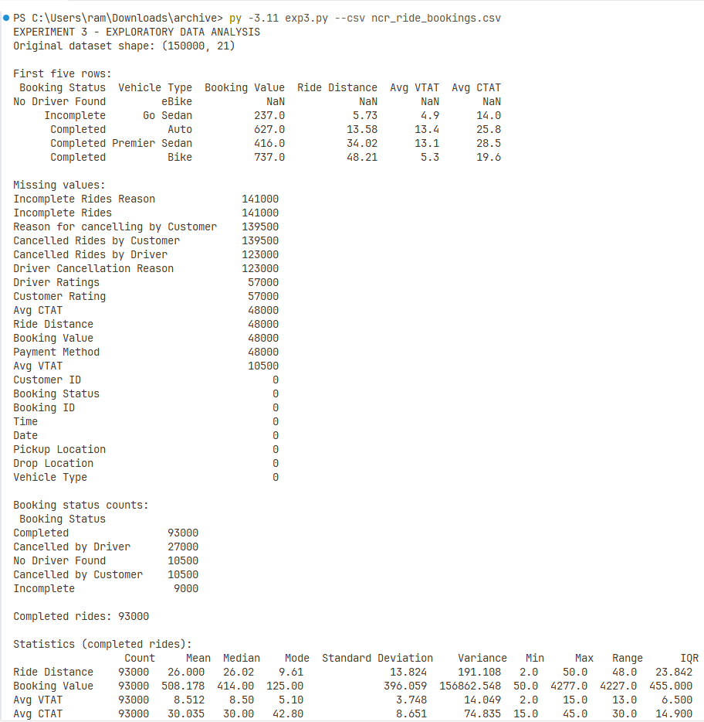
Figure 1. Dataset overview, missing values, booking-status frequencies and summary statistics.
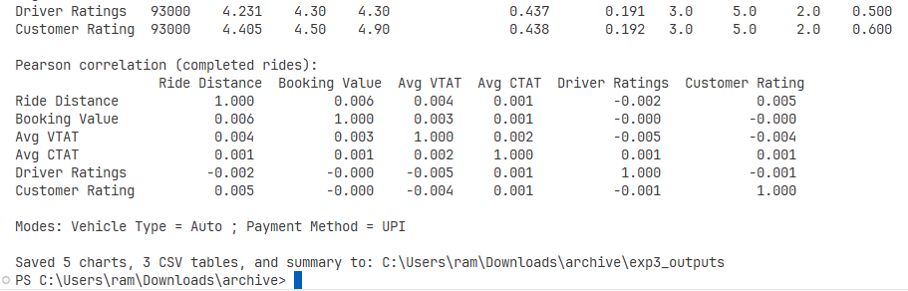
Figure 2. Pearson correlations and saved-output confirmation.
Booking statuses - all 150,000 bookings
Booking status | Count
Completed | 93,000
Cancelled by Driver | 27,000
Cancelled by Customer | 10,500
No Driver Found | 10,500
Incomplete | 9,000

Descriptive statistics - 93,000 completed rides
Numeric attribute | Mean | Median | Std. dev. | IQR
Ride Distance | 26.000 | 26.02 | 13.824 | 23.842
Booking Value | 508.178 | 414.00 | 396.059 | 455.000
Avg VTAT | 8.512 | 8.50 | 3.748 | 6.500
Avg CTAT | 30.035 | 30.00 | 8.651 | 14.900
Driver Ratings | 4.231 | 4.30 | 0.437 | 0.500
Customer Rating | 4.405 | 4.50 | 0.438 | 0.600

Pearson correlation between Ride Distance and Booking Value = 0.006 (rounded). The full correlation matrix and statistics table are included as CSV output files.
Visualizations produced by the program
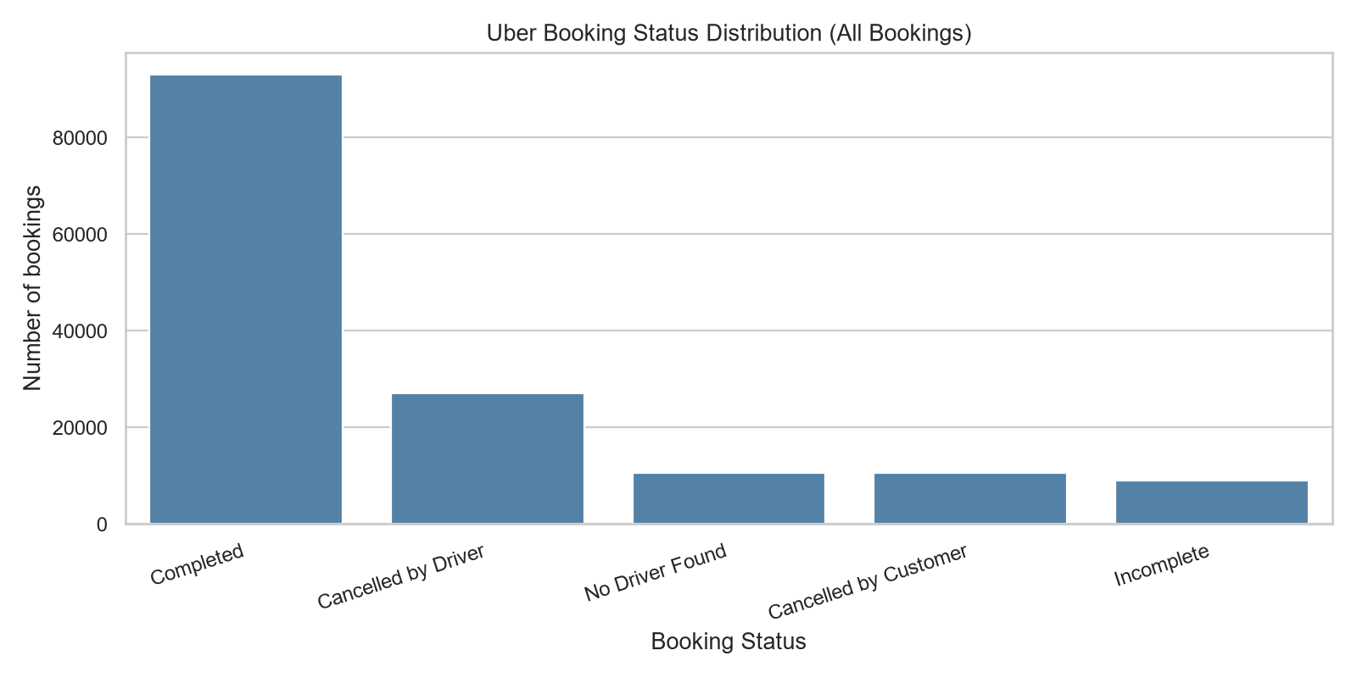
Figure 3. Booking Status Distribution - all bookings.
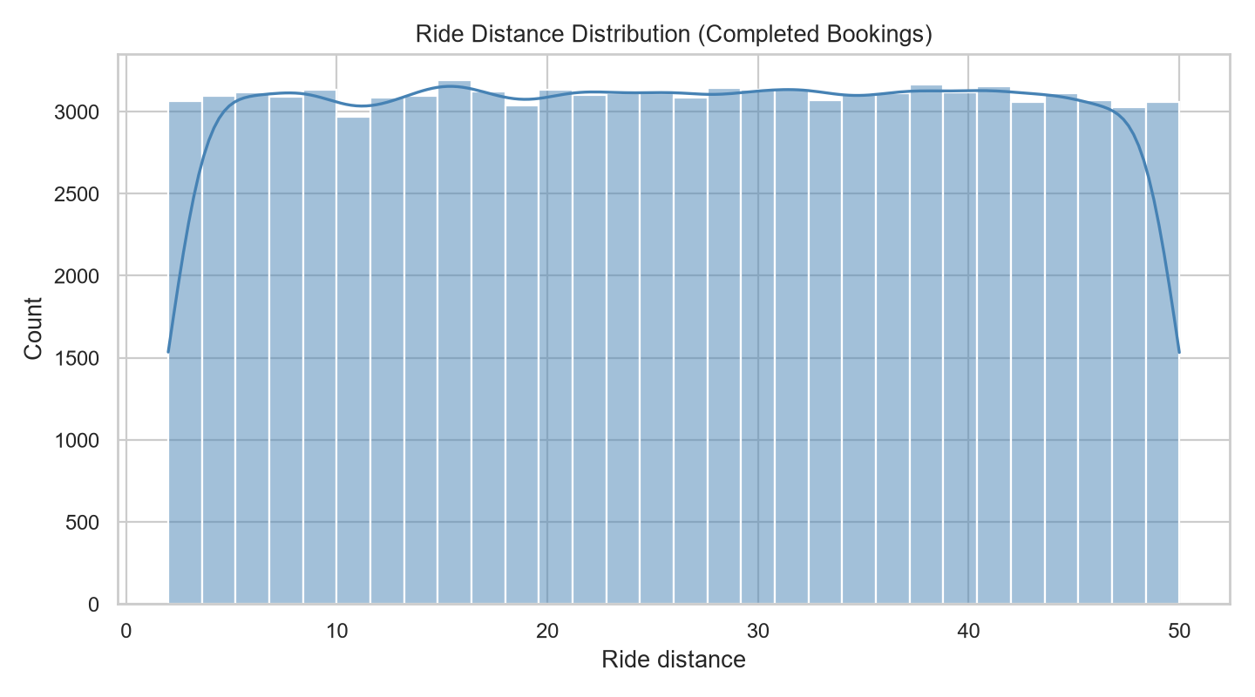
Figure 4. Ride Distance Histogram - completed bookings.
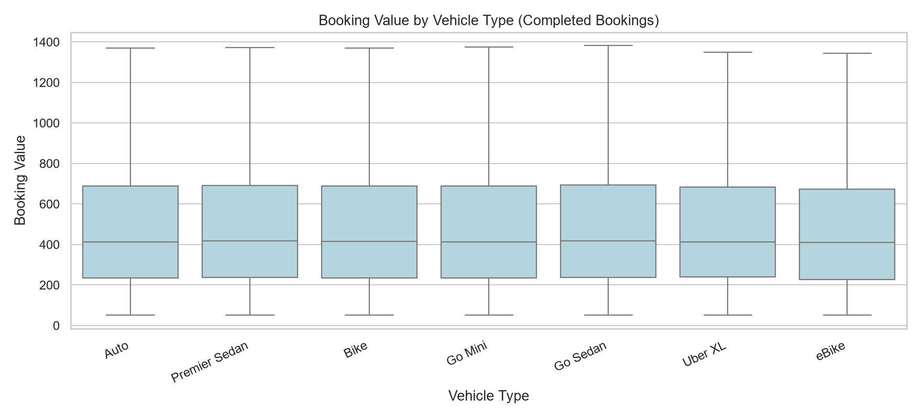
Figure 5. Booking Value by Vehicle Type - completed bookings.
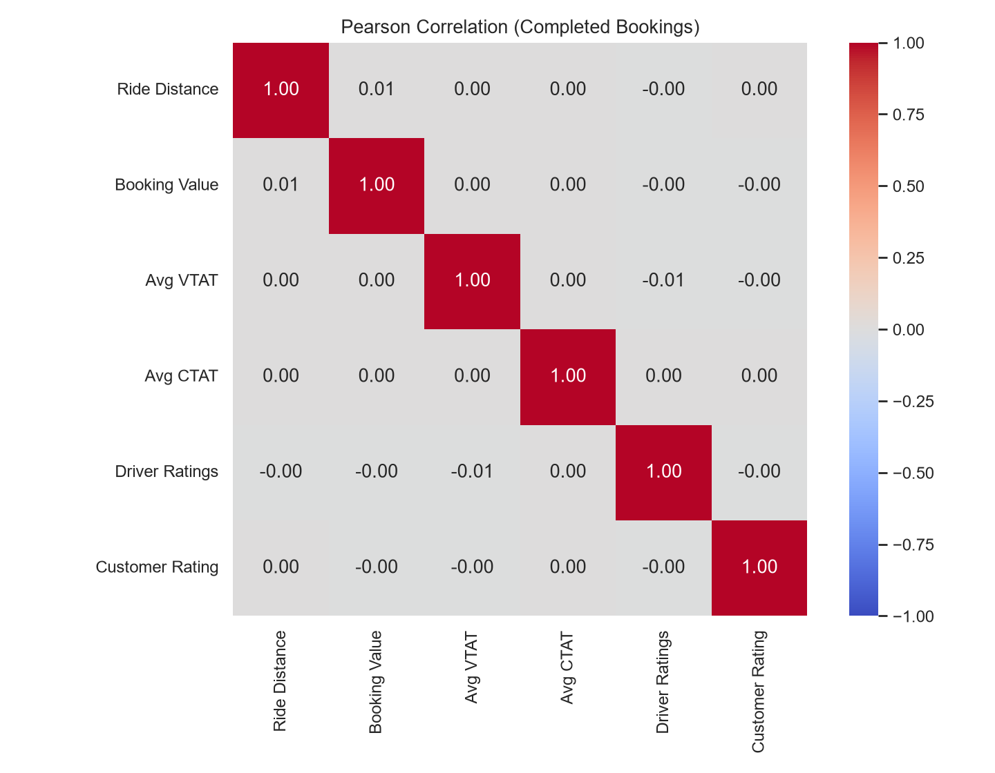
Figure 6. Pearson Correlation Heatmap - completed bookings.
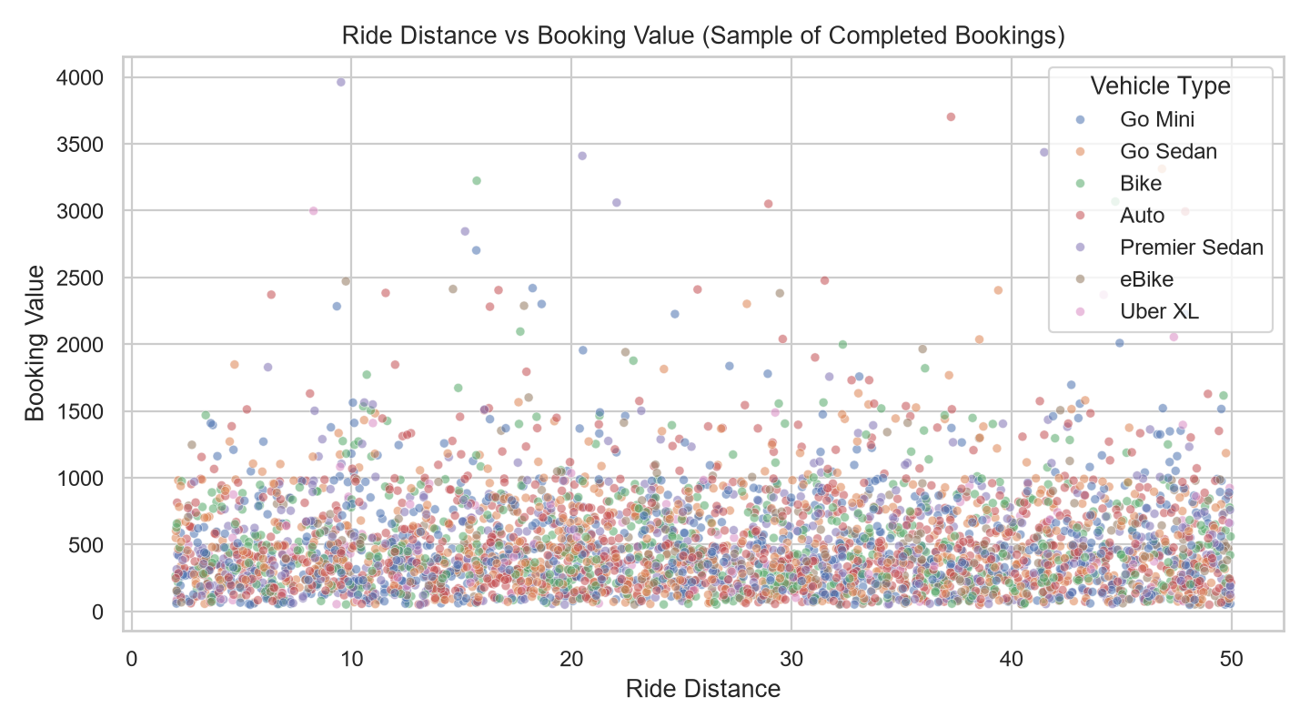
Figure 7. Ride Distance vs Booking Value - 4,000 completed bookings.
Generated output files: eda_summary.txt, booking_status_counts.csv, eda_statistics.csv, eda_correlations.csv, and five PNG visualizations. These are included in the experiment folder.
Result
EDA was successfully performed on the original 150,000 Uber booking records. The analysis identified 93,000 completed bookings, summarized six numerical attributes for those completed rides, computed a Pearson correlation matrix and generated five visualizations.
Inference
Completed bookings account for 62% of all records. Mean completed-ride distance is approximately 26.00, while mean booking value is approximately 508.18. The Pearson correlation between ride distance and booking value is approximately 0.006, indicating virtually no linear relationship within this dataset. This contrasts with the earlier synthetic example and should not be interpreted as a universal property of real ride fares.
Conclusion
Exploratory Data Analysis was completed using authentic records from the user-supplied Uber India NCR dataset. Descriptive statistics, booking-status frequencies, correlations and visualizations were generated to support data-driven interpretation of cab-booking operations.
GitHub Link
https://github.com/RamPanjwani/DMBI/tree/main/Experiment-03-EDA

