Experiment No. 4

Experiment Title | To implement Classification algorithms (Decision tree and Naïve Bayes' algorithms) using RapidMiner/Weka tool
Course  Outcomes | CO4: Implement the appropriate data mining methods like classification, clustering or Frequent Pattern mining on large data sets.  CO5: Define and apply metrics to measure the performance of various data mining algorithms.
Date of Preparation |  | Date of Submission
Signature & Grade

Name: Ram Panjwani
Roll no: 32

Experiment 4 - To implement Classification algorithms (Decision tree and Naïve Bayes' algorithms) using RapidMiner/Weka tool
Aim
To implement and compare Decision Tree and Naïve Bayes classification algorithms using the Weka tool on an Uber cab-booking dataset.
Objective
• To import and preprocess an Uber ride-booking dataset in Weka.
• To apply J48 Decision Tree and Naïve Bayes classification using an 80:20 holdout split.
• To compare classifier accuracy, confusion matrices and class-wise limitations.
Software/Tools Required
Computer with Windows, Weka 3.8.7, and the prepared Uber ride-booking CSV dataset.
Theory

Weka
Weka (Waikato Environment for Knowledge Analysis) is an open-source machine-learning tool. It provides a graphical interface to preprocess datasets, train classifiers, test predictions and view evaluation metrics.

Classification
Classification predicts a category or class label from input attributes. In this experiment, the target label is Booking Status, with five categories: Completed, Cancelled by Driver, Cancelled by Customer, No Driver Found and Incomplete.

Decision Tree (J48)
A Decision Tree classifies records using a sequence of attribute-based decisions. Weka’s J48 is an implementation of the C4.5 decision-tree algorithm. The resulting tree can be inspected to understand decision rules.

Naïve Bayes
Naïve Bayes is a probabilistic classifier based on Bayes’ theorem. It estimates the probability of each class from attribute values while assuming conditional independence of features given the class. Bayes’ theorem: P(Y | X) = [P(X | Y) × P(Y)] / P(X)

Dataset Description
The dataset contains 150,000 Uber-themed ride-booking records. A prepared classification CSV was used with four fields: Vehicle Type, Pickup Location, Drop Location, and Booking Status. Booking Status is the nominal target label. Identifiers, cancellation reasons, and post-outcome information were excluded from the input features.
Attribute | Description
Vehicle Type | Type of cab selected
Pickup Location | Pickup point
Drop Location | Destination point
Booking Status | Class label / prediction target
- Open Weka GUI Chooser and select Explorer.
- Go to Preprocess → Open file and select uber_weka_classification.csv.
- Confirm that the dataset contains 150,000 instances and four attributes.
- Open the Classify tab and select Booking Status as the nominal class.
- Choose trees → J48. Select Percentage split = 80, so 80% is used for training and 20% for testing.
Click Start.
- Save or capture the classifier output, including accuracy and confusion matrix.
- Select bayes → NaiveBayes without changing the 80% percentage split or target attribute. Click Start.
- Compare the accuracy, class-wise performance and confusion matrices of both classifiers.
Output
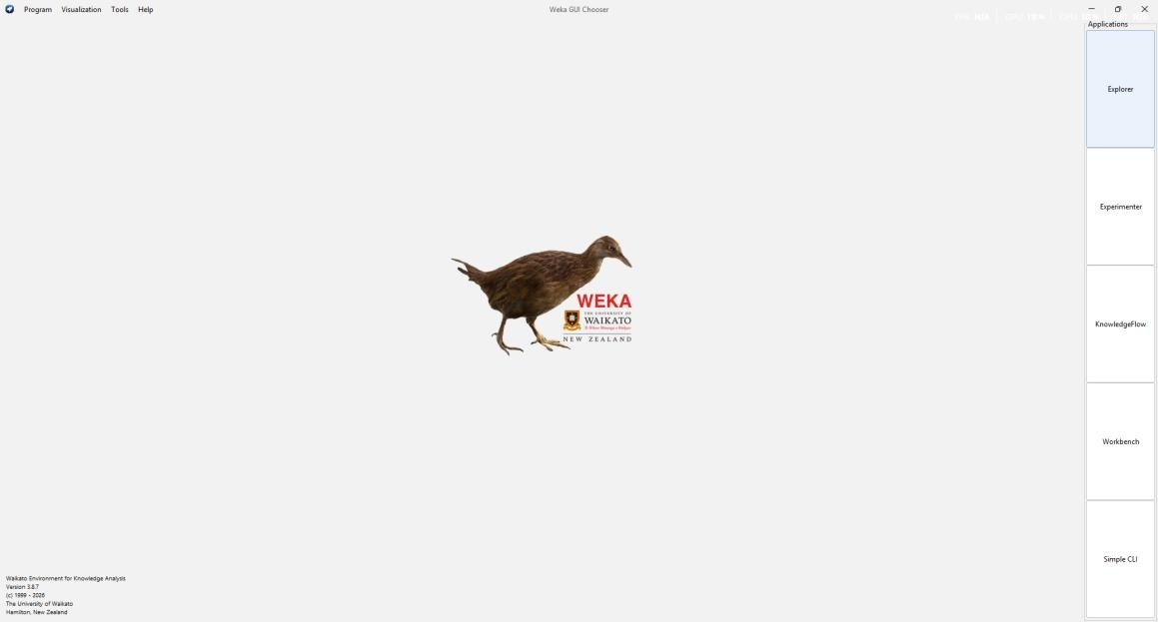
Figure 1: Weka GUI Chooser at the start of the experiment.
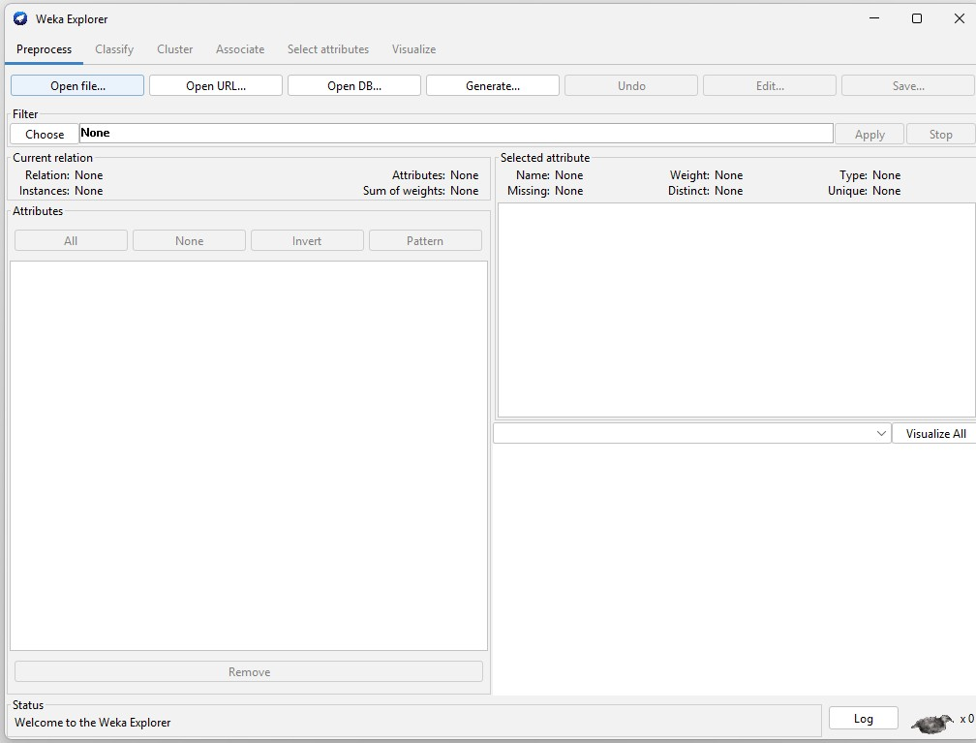
Figure 2: Weka Explorer – dataset import in the Preprocess tab.
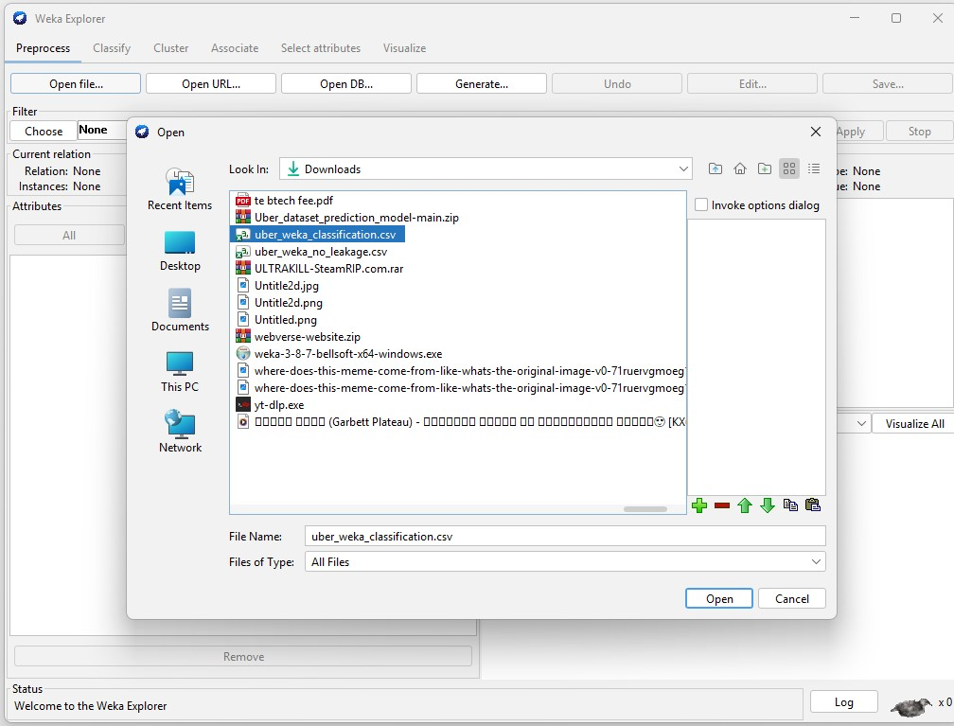
Figure 3: Loading the prepared Uber classification CSV dataset.
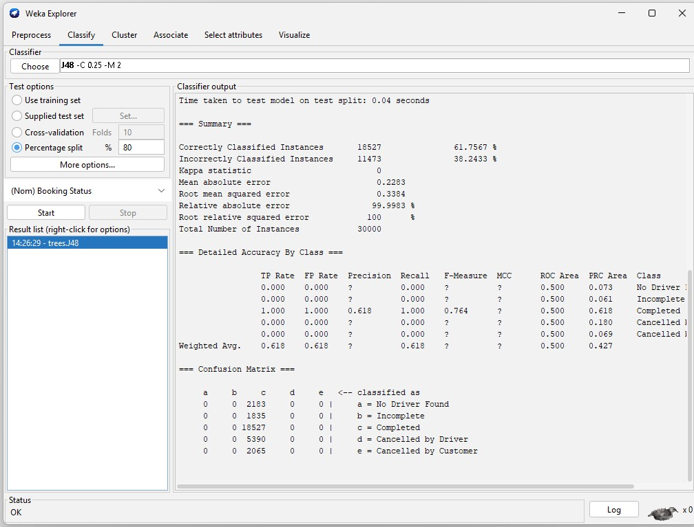
Figure 4: J48 classification output with an 80/20 split, accuracy and confusion matrix.
J48 correctly classified 18,527 out of 30,000 test instances (61.7567%). The confusion matrix shows that every test instance was predicted as Completed.
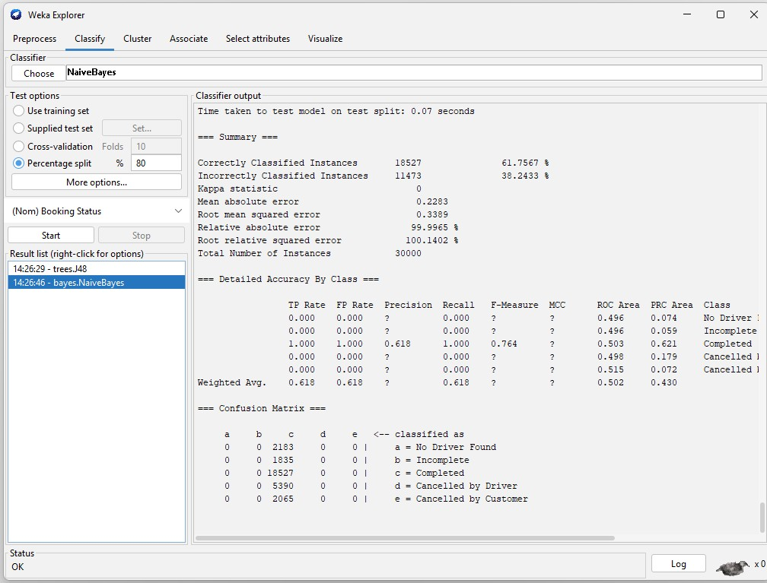
Figure 5: Naïve Bayes output with the same test split, accuracy and confusion matrix.
Naïve Bayes also correctly classified 18,527 out of 30,000 test instances (61.7567%). As with J48, all test instances were predicted as Completed.
Result
Metric | J48 Decision Tree | Naïve Bayes
Test instances | 30,000 | 30,000
Correctly classified | 18,527 | 18,527
Incorrectly classified | 11,473 | 11,473
Accuracy | 61.7567% | 61.7567%
Kappa statistic | 0 | 0
Weighted ROC area | 0.500 | 0.502

Confusion Matrix Interpretation
Actual test classes were: No Driver Found (2,183), Incomplete (1,835), Completed (18,527), Cancelled by Driver (5,390), and Cancelled by Customer (2,065). In both outputs every record was assigned to Completed. Thus recall is 100% for Completed and 0% for the other four categories. The accuracy is equivalent to predicting the most common class for every booking.
Inference
Both classification algorithms produced identical accuracy on the selected features. However, neither model separated cancelled, incomplete, and no-driver bookings from completed bookings. Therefore the observed 61.76% accuracy should not be interpreted as strong prediction performance. Better prebooking predictors or additional data would be needed to build a practically useful model.
Conclusion
The Decision Tree (J48) and Naïve Bayes classifiers were successfully implemented in Weka for Uber cab-booking status classification using an 80% training and 20% testing split. Both achieved 61.7567% accuracy. The experiment demonstrated the classification workflow, evaluation measures and importance of inspecting the confusion matrix rather than accuracy alone.
GitHub Link
https://github.com/RamPanjwani/DMBI/tree/main/Experiment-04-Weka-Classification

