Experiment No. 10

Experiment Title | Develop a Business Intelligence application using Data Mining for a real-world business problem.
Course  Outcomes | CO4: Implement appropriate data mining methods like classification, clustering, or Frequent Pattern mining on large data sets.  CO5: Define and apply metrics to measure the performance of various data mining algorithms.  CO6: Apply BI to practical business problems and provide data-supported decision assistance.
Date of Preparation |  | Date of Submission
Signature & Grade

Name: Ram Panjwani
Roll no: 32

Experiment 10 - Develop a Business Intelligence application using Data Mining for a real-world business problem.
Aim
To develop and demonstrate RideLens, an interactive Business Intelligence application that uses data mining to analyze a real-world ride-booking operations problem.
Objective
- Load and validate an Uber-themed NCR booking dataset, with an optional compatible CSV upload.
- Display bookings, completion, cancellations, recorded completed booking value, and operational trends.
- Provide interactive filtering by date, vehicle type, booking status, pickup, and drop locations.
- Apply K-Means clustering to completed rides and evaluate clusters using inertia, Silhouette Score, and Davies-Bouldin Index.
- Apply Apriori association mining to categorical booking records using support, confidence, and lift.
- Generate descriptive business insights and allow CSV export of appropriate analysis results.
Software/Tools Required
Windows PC; Python 3.11; Streamlit; Pandas; Plotly; Scikit-learn; Mlxtend; web browser; a locally stored Uber NCR CSV dataset.
Theory
Business Intelligence (BI)
Business Intelligence converts stored operational data into understandable measures, charts, and reports that support decisions. Here, the business problem is understanding ride-booking completion, cancellation outcomes, vehicle usage, and booking-value patterns.
Data Mining
Data mining identifies patterns in large datasets. RideLens integrates unsupervised K-Means clustering for numerical ride characteristics and Apriori frequent-pattern mining for categorical booking associations. These are exploratory techniques, not causal explanations or guaranteed predictions.
K-Means Clustering
K-Means partitions numerical records into k groups by assigning observations to centroids and updating those centroids. Standardized ride features support distance-based comparison. Inertia measures within-cluster squared distance; Silhouette and Davies-Bouldin scores describe separation and overlap.
Apriori Association Mining
Apriori identifies frequent itemsets and association rules such as Vehicle Type = Bike => Booking Status = Completed. Support measures occurrence frequency; confidence measures how often the consequent occurs when the antecedent occurs; lift compares that conditional frequency with the consequent base rate. Lift near 1 indicates weak association.
Data and Analytical Scope
Input: ncr_ride_bookings.csv, an Uber-themed NCR historical booking dataset with 150,000 rows and 21 original attributes. In the demonstrated run, 93,000 bookings were Completed. The application treats each CSV row as a booking record because Booking IDs may repeat. Recorded booking value is not labeled confirmed collected revenue.
Built-in CSV location: Experiment-10-BI-Application/RideLens/data/raw/ncr_ride_bookings.csv
Application Architecture and Procedure
Component | Purpose
Streamlit app.py | User navigation, filters, KPI cards, charts, model controls, and downloads
src/data | CSV loading, validation, and filter processing
src/analytics | Metrics, clustering, association mining, and insights
src/ui | Reusable charts and CSV exports
data/raw | Local read-only default booking dataset

- Open a terminal in Experiment-10-BI-Application/RideLens, activate the Python environment, and run streamlit run app.py.
- Open http://localhost:8501. The app loads the built-in CSV by default or accepts a compatible uploaded CSV.
- Use the sidebar filters and navigate through Overview, Booking analytics, Value & operations, and Cancellations.
- In K-Means clustering, choose k and select Run K-Means to inspect cluster profiles and evaluation metrics.
- In Apriori rules, set support, confidence, and lift thresholds, then run mining and inspect frequent itemsets and rules.
- Review the Insights & methods page and use export buttons for appropriate result tables.
Code - Complete Supplied app.py
The following is the complete app.py entry-point source provided for this practical. Its imports reference additional local modules under src/, which were not attached with this submission. The full working application requires those supporting modules and dependencies.
from __future__ import annotations
from pathlib import Path
import pandas as pd
import streamlit as st
import plotly.express as px
from src.config import DEFAULT_DATASET, DATE, STATUS, VEHICLE, PICKUP, DROP
from src.data.load import read_csv
from src.data.filters import apply_filters
from src.analytics.metrics import overview_metrics, grouped_counts, safe_rate
from src.analytics.clustering import run_kmeans
from src.analytics.association import run_apriori
from src.analytics.insights import generate_insights
from src.ui.charts import bar, line, COLORS
from src.ui.exports import safe_csv

st.set_page_config(page_title="RideLens", page_icon="◈", layout="wide")
st.markdown("""<style>.block-container{padding-top:1.6rem}.rl-title{font-size:2.2rem;font-weight:750;color:#172033}.rl-sub{color:#526075;margin-top:-.7rem}.stMetric{background:#fff;border:1px solid #E2E8F0;border-radius:12px;padding:10px}</style>""",unsafe_allow_html=True)

@st.cache_data(show_spinner="Loading local bookings…")
def load_default(path: str): return read_csv(path)
@st.cache_data(show_spinner="Reading uploaded CSV…")
def load_upload(contents: bytes):
import io
return read_csv(io.BytesIO(contents))

def dataframe_download(frame, label, name):
st.download_button(label, safe_csv(frame), file_name=name, mime="text/csv")

def empty(): st.info("No bookings match these filters. Adjust your selection or reset filters.")

def sidebar(frame):
st.sidebar.title("RideLens")
st.sidebar.caption("Local ride operations intelligence")
dates=frame[DATE].dropna()
if dates.empty: return frame
default=(dates.min().date(),dates.max().date())
dr=st.sidebar.date_input("Date range",value=default,min_value=default[0],max_value=default[1])
if not isinstance(dr,tuple) or len(dr)!=2: dr=default
options=lambda c: sorted(frame[c].dropna().unique().tolist())
vehicle=st.sidebar.multiselect("Vehicle type",options(VEHICLE))
statuses=st.sidebar.multiselect("Booking status",options(STATUS))
pickups=st.sidebar.multiselect("Pickup location",options(PICKUP))
drops=st.sidebar.multiselect("Drop location",options(DROP))
st.sidebar.caption("Descriptive pages use these filters. Mining uses them only when enabled.")
return apply_filters(frame,*dr,vehicle,statuses,pickups,drops)

def metric_cols(m):
a,b,c,d=st.columns(4)
a.metric("Booking records",f"{m['total']:,}")
b.metric("Completed",f"{m['completed']:,}",None if m['completion_rate'] is None else f"{m['completion_rate']:.1%} of visible")
c.metric("Cancellation outcomes",f"{m['cancelled']:,}",None if m['cancellation_rate'] is None else f"{m['cancellation_rate']:.1%} of visible")
d.metric("Recorded completed value","—" if m['completed_value'] is None else f"{m['completed_value']:,.0f}","Completed rows only")

def overview(data):
m=overview_metrics(data); metric_cols(m)
if data.empty: return empty()
left,right=st.columns(2)
status=grouped_counts(data,STATUS)
left.plotly_chart(bar(status,"Bookings",STATUS,"Booking status distribution","h"),use_container_width=True)
daily=data.groupby(DATE).size().rename("Bookings").reset_index()
right.plotly_chart(line(daily,DATE,"Bookings","Bookings over time"),use_container_width=True)
st.caption("All metrics use visible booking records. Recorded value excludes non-completed rows and missing values; it is not confirmed revenue.")
dataframe_download(status,"Download status summary","ridelens_status_summary.csv")

def bookings(data):
if data.empty: return empty()
a,b=st.columns(2)
a.plotly_chart(bar(grouped_counts(data,VEHICLE),VEHICLE,"Bookings","Bookings by vehicle type"),use_container_width=True)
b.plotly_chart(bar(grouped_counts(data,PICKUP,12),"Bookings",PICKUP,"Top pickup locations","h"),use_container_width=True)
c,d=st.columns(2)
c.plotly_chart(bar(grouped_counts(data,DROP,12),"Bookings",DROP,"Top drop locations","h"),use_container_width=True)
table=data.groupby([VEHICLE,STATUS]).size().rename("Bookings").reset_index()
d.plotly_chart(bar(table,VEHICLE,"Bookings","Vehicle/status comparison",STATUS),use_container_width=True)
dataframe_download(table,"Download vehicle-status table","ridelens_vehicle_status.csv")

def values(data):
rides=data[data[STATUS].eq("Completed")].copy()
if rides.empty: return st.info("No completed rides in the visible selection; value analysis is unavailable.")
for c in ["Booking Value","Ride Distance","Avg VTAT","Avg CTAT"]: rides[c]=pd.to_numeric(rides.get(c),errors="coerce")
a,b,c=st.columns(3); a.metric("Average recorded value",f"{rides['Booking Value'].mean():,.2f}" if rides['Booking Value'].notna().any() else "—"); b.metric("Mean ride distance",f"{rides['Ride Distance'].mean():.2f}" if rides['Ride Distance'].notna().any() else "—"); c.metric("Value observations",f"{rides['Booking Value'].notna().sum():,}")
x,y=st.columns(2)
x.plotly_chart(px.histogram(rides,x="Booking Value",nbins=35,title="Completed booking value distribution",color_discrete_sequence=COLORS).update_layout(template="plotly_white"),use_container_width=True)
y.plotly_chart(px.scatter(rides.sample(min(10000,len(rides)),random_state=42),x="Ride Distance",y="Booking Value",color=VEHICLE,title="Distance versus recorded value",opacity=.45,color_discrete_sequence=COLORS).update_layout(template="plotly_white"),use_container_width=True)
dataframe_download(rides[[VEHICLE,"Booking Value","Ride Distance","Avg VTAT","Avg CTAT"]],"Download completed-rides analysis","ridelens_completed_value.csv")

def cancellations(data):
if data.empty: return empty()
cancel=data[data[STATUS].isin(["Cancelled by Driver","Cancelled by Customer","No Driver Found"])]
st.caption(f"Cancellation rates below use all visible booking records as denominators (n={len(data):,}).")
rate=data.groupby(VEHICLE).apply(lambda g: pd.Series({"Bookings":len(g),"Cancellation outcomes":g[STATUS].isin(["Cancelled by Driver","Cancelled by Customer","No Driver Found"]).sum()}),include_groups=False).reset_index()
rate["Cancellation rate"]=rate["Cancellation outcomes"]/rate["Bookings"]
a,b=st.columns(2); a.plotly_chart(bar(rate,VEHICLE,"Cancellation rate","Cancellation rate by vehicle"),use_container_width=True)
reason_cols=[("Reason for cancelling by Customer","Customer cancellation reasons"),("Driver Cancellation Reason","Driver cancellation reasons"),("Incomplete Rides Reason","Incomplete ride reasons")]
b.write("#### Outcome mix"); b.dataframe(grouped_counts(cancel,STATUS),hide_index=True,use_container_width=True)
for col,title in reason_cols:
if col in data and data[col].notna().any(): st.plotly_chart(bar(grouped_counts(data[data[col].notna()],col,12),"Bookings",col,title,"h"),use_container_width=True)
dataframe_download(rate,"Download cancellation rates","ridelens_cancellation_rates.csv")

def clustering(data):
use=st.toggle("Apply current filters to clustering",False,key="cluster_filter"); source=data if use else st.session_state.full_data
k=st.slider("Number of clusters",2,6,3)
if st.button("Run K-Means",type="primary"):
try: st.session_state.cluster_result=run_kmeans(source,k)
except ValueError as e: st.error(str(e)); return
r=st.session_state.get("cluster_result")
if not r: return st.info("K-Means runs only on completed rides with valid arrival times, value, and distance. Choose settings and run it.")
a,b,c,d=st.columns(4); a.metric("Eligible completed rides",f"{r['sample_size']:,}"); b.metric("Inertia",f"{r['inertia']:,.0f}"); c.metric("Silhouette",f"{r['silhouette']:.3f}" if r['silhouette'] is not None else "—"); d.metric("Davies–Bouldin",f"{r['davies_bouldin']:.3f}")
if r['silhouette'] is not None and r['silhouette'] < .25: st.warning("The silhouette score indicates weak separation. Treat these as exploratory profiles, not natural or ranked groups.")
plot=r['data'].sample(min(8000,len(r['data'])),random_state=42)
st.plotly_chart(px.scatter(plot,x="Ride Distance",y="Booking Value",color="Cluster",hover_data=["Avg VTAT","Avg CTAT"],title="Exploratory projection: distance versus value",color_discrete_sequence=COLORS).update_layout(template="plotly_white"),use_container_width=True)
st.dataframe(r['profile'],hide_index=True,use_container_width=True); dataframe_download(r['profile'],"Download cluster profiles","ridelens_cluster_profiles.csv")

def associations(data):
use=st.toggle("Apply current filters to association mining",False,key="assoc_filter"); source=data if use else st.session_state.full_data
a,b,c=st.columns(3); support=a.slider("Minimum support",.005,.10,.02,.005); confidence=b.slider("Minimum confidence",.10,.90,.30,.05); lift=c.slider("Minimum display lift",1.0,3.0,1.0,.05)
if st.button("Run Apriori",type="primary"):
try: st.session_state.assoc_result=run_apriori(source,support,confidence,lift)
except ValueError as e: st.error(str(e)); return
result=st.session_state.get("assoc_result")
if not result: return st.info("Apriori mines categorical co-occurrence from booking records. It does not establish causation.")
items,rules,n=result; st.caption(f"Analyzed {n:,} booking transactions (deterministic sample when input exceeds 50,000).")
st.write("#### Frequent itemsets"); st.dataframe(items.assign(itemsets=items['itemsets'].map(lambda s:" • ".join(sorted(s)))) if not items.empty else items,hide_index=True,use_container_width=True)
st.write("#### Association rules")
if rules.empty: st.info("No rules meet these thresholds. Lower support or confidence cautiously."); return
show=rules[["antecedents","consequents","support","confidence","lift"]]; st.dataframe(show,hide_index=True,use_container_width=True)
st.plotly_chart(px.scatter(show,x="support",y="confidence",size="lift",color="lift",hover_data=["antecedents","consequents"],title="Rule support and confidence").update_layout(template="plotly_white"),use_container_width=True)
st.caption("Lift close to 1 indicates little association beyond base rates; association is not causation."); dataframe_download(show,"Download association rules","ridelens_association_rules.csv")

def insights(data):
for t in generate_insights(data): st.info(t)
st.markdown("""### Methods and boundaries
RideLens is a local, descriptive educational application using a supplied historical Uber-themed NCR dataset. One CSV row is retained as one record because Booking IDs repeat. Date, vehicle, status, pickup, and drop filters affect descriptive pages. Mining uses the full dataset unless explicitly toggled. No identifiers are shown or exported by default, no data is sent externally, and neither clustering nor rules prove causes or make predictions.""")

try:
upload=st.sidebar.file_uploader("Use a compatible CSV instead",type="csv")
frame, report = load_upload(upload.getvalue()) if upload else load_default(str(DEFAULT_DATASET))
except ValueError as exc:
st.error(f"Dataset validation failed: {exc}"); st.stop()
except FileNotFoundError:
st.error("Default dataset was not found. Place ncr_ride_bookings.csv in data/raw or upload a compatible CSV."); st.stop()
st.session_state.full_data=frame
filtered=sidebar(frame)
st.markdown("<div class='rl-title'>RideLens</div><div class='rl-sub'>Ride operations intelligence • historical local data • no external services</div>",unsafe_allow_html=True)
st.caption(f"Source: {'uploaded CSV' if upload else 'built-in NCR CSV'} · {len(frame):,} rows · {frame[DATE].min().date() if frame[DATE].notna().any() else 'unknown'} to {frame[DATE].max().date() if frame[DATE].notna().any() else 'unknown'} · visible: {len(filtered):,}")
for warning in report.warnings: st.warning(warning)
page=st.radio("Navigate",["Overview","Booking analytics","Value & operations","Cancellations","K-Means clustering","Apriori rules","Insights & methods"],horizontal=True,label_visibility="collapsed")
{"Overview":overview,"Booking analytics":bookings,"Value & operations":values,"Cancellations":cancellations,"K-Means clustering":clustering,"Apriori rules":associations,"Insights & methods":insights}[page](filtered)
Output - Actual Application Screenshots
The figures below are the actual running RideLens screenshots supplied for Experiment 10. They demonstrate the built-in dataset, descriptive analytics, data mining, and insights screens.
Observed overview measure | Displayed value
Booking records | 150,000
Completed | 93,000 (62.0%)
Cancellation outcomes | 48,000 (32.0%)
Recorded completed value | 47,260,574

Overview dashboard
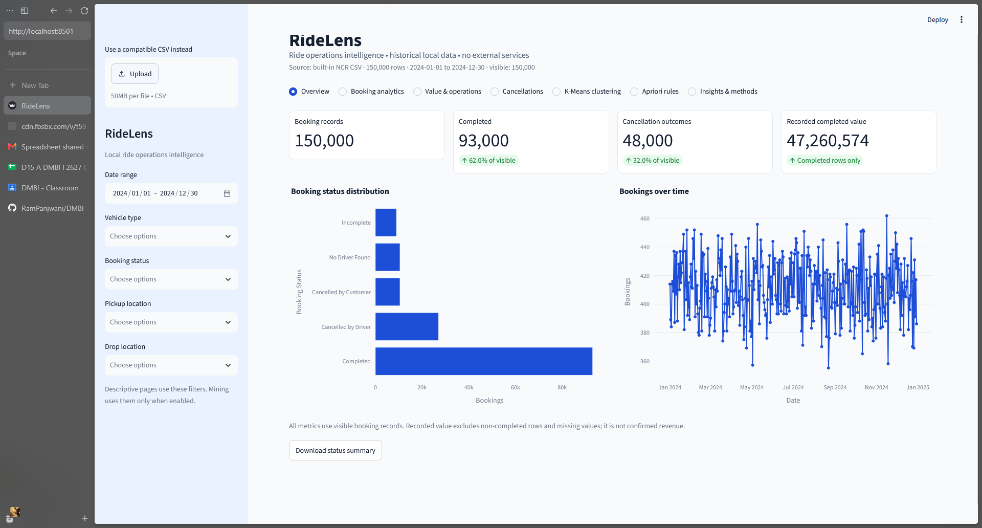
Figure 1. Overview: 150,000 booking records, 93,000 completed bookings, 48,000 cancellation outcomes, and daily booking trends.
Booking analytics
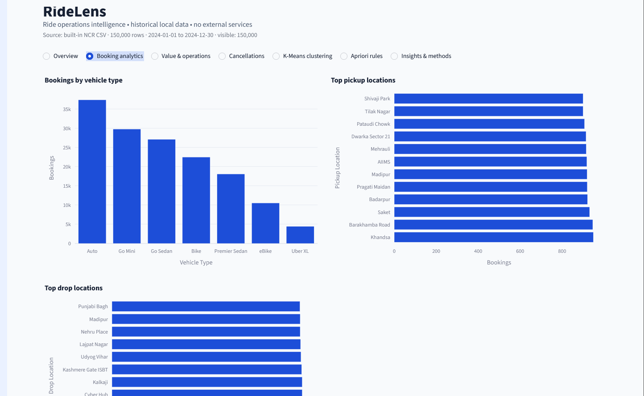
Figure 2. Booking analytics: vehicle-type counts and the most frequent pickup and drop locations.
Value and operations
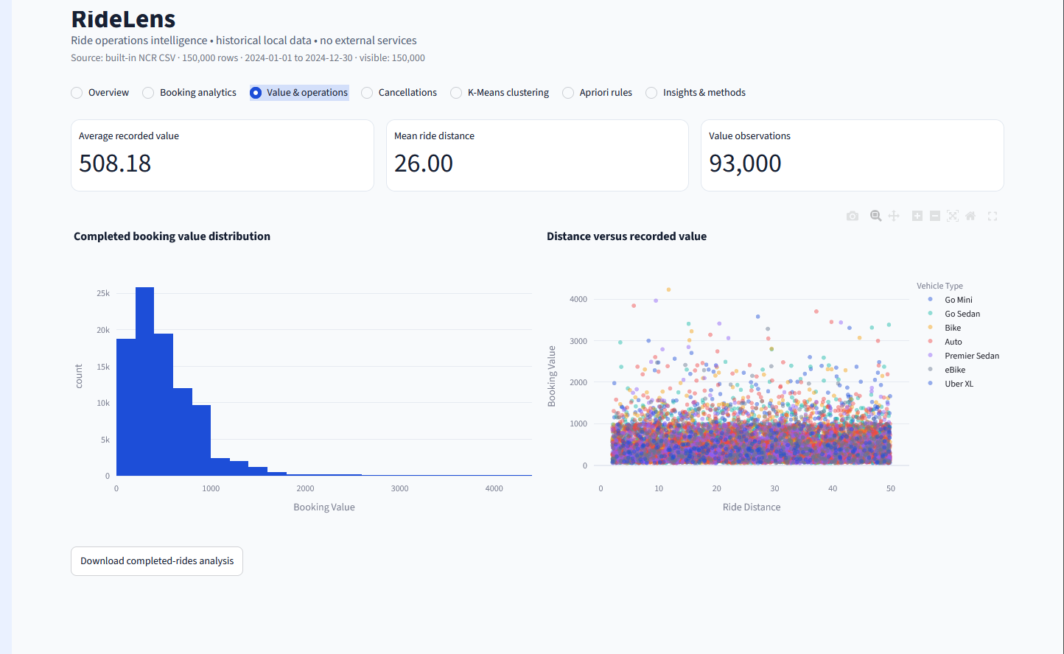
Figure 3. Value analytics: average completed booking value 508.18, mean ride distance 26.00, and distribution plots.
Cancellations
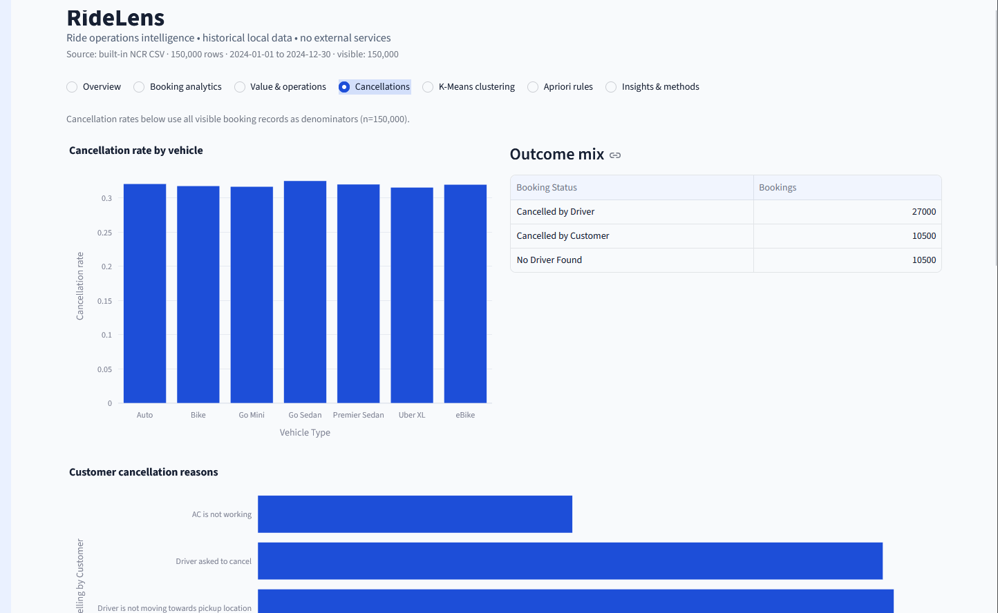
Figure 4. Cancellations: cancellation rate by vehicle, outcome breakdown, and recorded cancellation reasons.
K-Means clustering
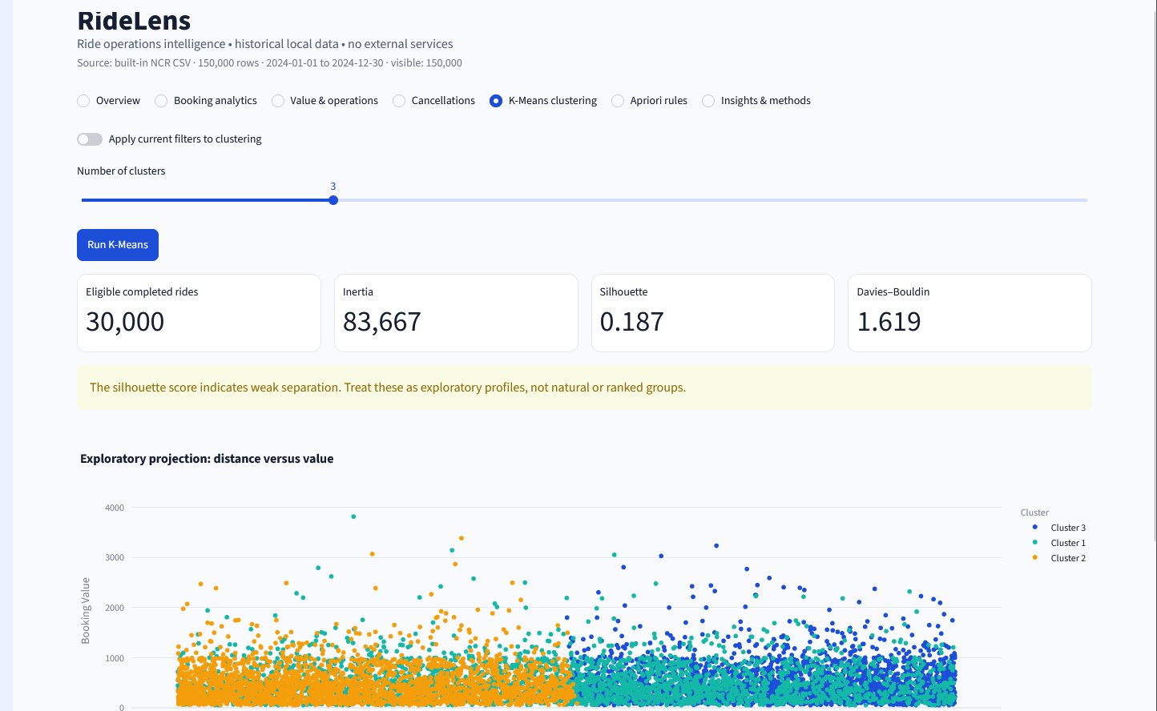
Figure 5. K-Means: 30,000 analyzed completed rides, k = 3, inertia about 83,667, Silhouette 0.187, and Davies-Bouldin 1.619.
Apriori rules
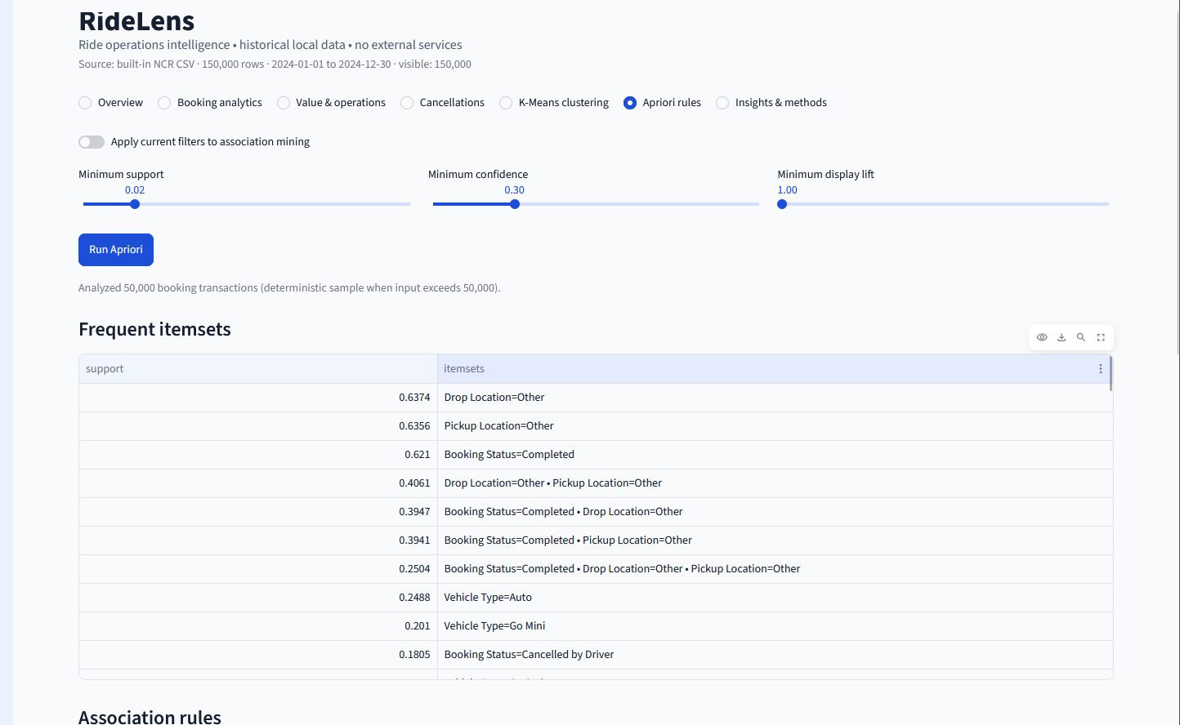
Figure 6. Apriori: deterministic 50,000-transaction sample with frequent itemsets and association-rule table.
Insights and methods
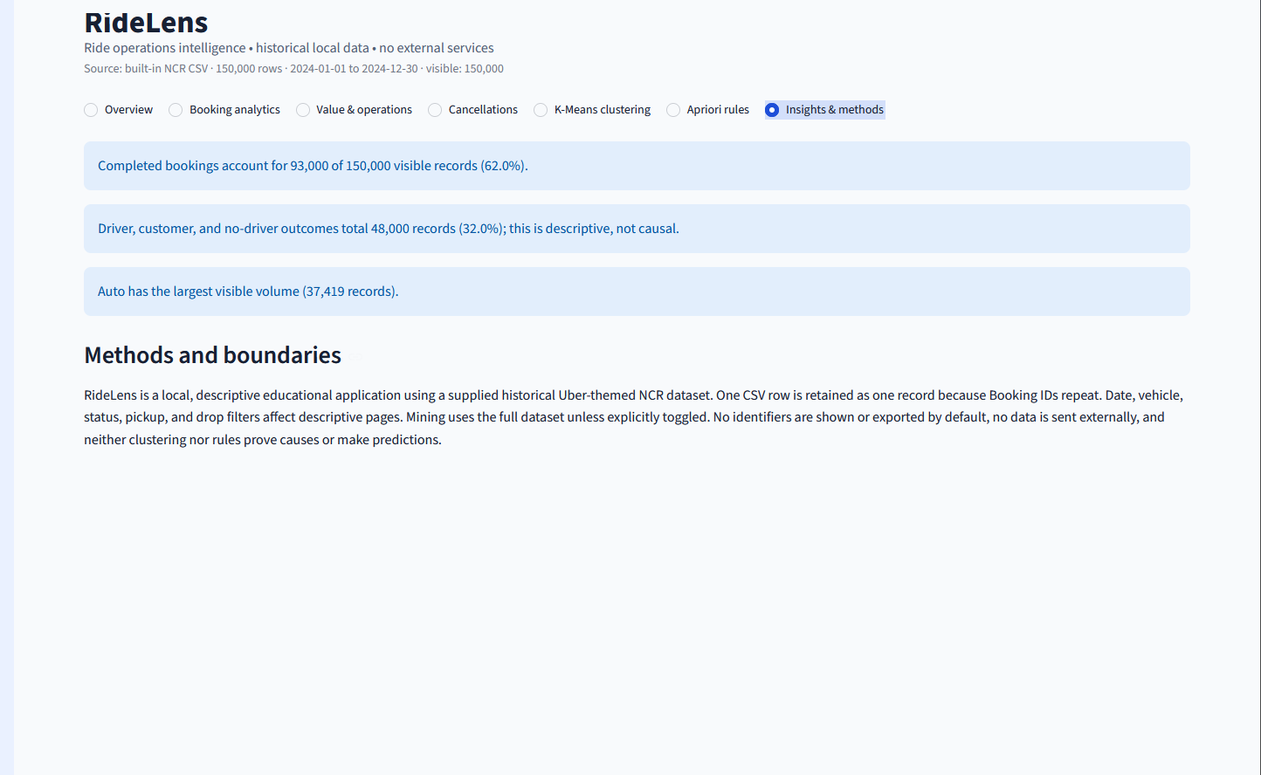
Figure 7. Data-derived insights and explanation of analytical limitations and data-handling boundaries.
Result (To Be Completed by Hand)
Write the observed operation of the application, actual key outputs, and completed data-mining runs.

Inference (To Be Completed by Hand)
Interpret the dashboard observations and comment on cluster separation and association-rule strength.

Conclusion (To Be Completed by Hand)
Summarize how RideLens supports business analysis using data mining and mention the limits of the available data.

GitHub Repository Link
https://github.com/RamPanjwani/DMBI/tree/main/Experiment-10-BI-Application

