Experiment No. 1

Experiment Title | Design a Star and Snowflake Schema for the given system.
Course  Outcomes | CO1: Demonstrate an understanding of the importance of data warehousing and data mining and the principles of business intelligence.
Date of Preparation |  | Date of Submission
Signature & Grade
Name: Ram Panjwani
Roll no: 32

Experiment 1 - Design a Star and Snowflake Schema for the given system.
Aim
To design Star Schema and Snowflake Schema for a given system using a suitable fact table and dimension tables.
Objective
- To understand the concept of Data Warehouse Schema.
- To design a Star Schema.
- To design a Snowflake Schema.
Software/Tools Required
Data warehouse / dimensional modeling diagrams; Word document editor.
Theory

1. Star Schema
A Star Schema is a data warehouse design where a central Fact Table is directly linked to multiple Dimension Tables. In this experiment, two Star Schemas are designed for an Uber-style enterprise data warehouse: one for Rider Trip Analytics and another for Driver Performance and Payouts.

Star Schema 1: Rider Trip Analytics (Customer Focus)
This schema models the demand side of the business by tracking rider trips, fares, distance travelled, and surge information.

Fact Table – RIDER_TRIPS
Column | Description
DateID | Foreign key referencing TIME dimension.
RiderID | Foreign key referencing RIDER dimension.
LocationID | Foreign key referencing LOCATION dimension.
PaymentID | Foreign key referencing PAYMENT dimension.
TotalFare | Total fare collected for the trip.
DistanceMiles | Distance travelled during the trip in miles.
SurgeMultiplier | Multiplier applied during surge pricing.

Time Dimension – TIME
Column | Description
DateID | Primary key.
Trip Date | Date on which the trip occurred.
Year | Year of the trip.
Quarter | Quarter of the year.
Month | Month of the year.

Rider Dimension – RIDER
Column | Description
RiderID | Primary key.
Rider Name | Name of the rider.
Email | Email address of the rider.
CityID | Foreign key referencing CITY in the snowflake model.
Rating | Rider rating.

Location Dimension – LOCATION
Column | Description
LocationID | Primary key.
Address | Address associated with the location.
ZoneName | Name of the operational zone.
CityID | Foreign key referencing CITY.

Payment Dimension – PAYMENT
 | Column | Description
PaymentID |  | Primary key.
PaymentType |  | Type of payment method used.
Provider |  | Payment service provider.
PromoCode |  | Promotional code applied, if any.

Diagram 1 – Star Schema 1: Rider Trip Analytics
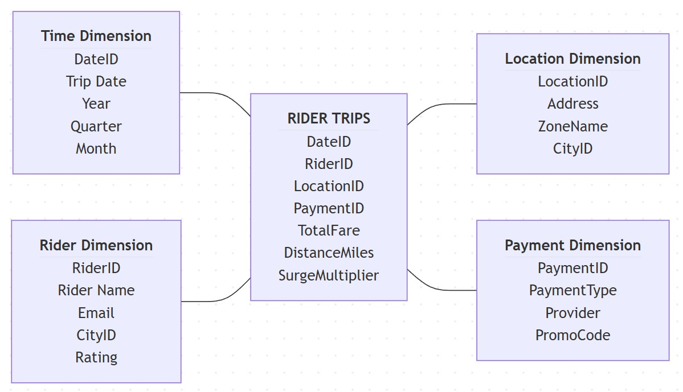

Star Schema 2: Driver Performance & Payouts (Driver Focus)
This schema models the supply side of the business by tracking driver payouts, completed trips, hours online, assigned vehicles, and duty shifts.

Fact Table – DRIVER_PAYOUTS
Column | Description
DateID | Foreign key referencing TIME dimension.
DriverID | Foreign key referencing DRIVER dimension.
VehicleID | Foreign key referencing VEHICLE dimension.
ShiftID | Foreign key referencing SHIFT dimension.
GrossPayout | Total payout generated for the driver.
TripsCompleted | Number of trips completed.
HoursOnline | Total hours the driver was online.

Time Dimension – TIME
Column | Description
DateID | Primary key.
Activity Date | Date of driver activity.
Year | Year of activity.
Quarter | Quarter of the year.
Month | Month of the year.

Driver Dimension – DRIVER
Column | Description
DriverID | Primary key.
Driver Name | Name of the driver.
LicenseNumber | Driver license number.
DepartmentID | Foreign key referencing DEPARTMENT.
Rating | Driver rating.

Vehicle Dimension – VEHICLE
Column | Description
VehicleID | Primary key.
LicensePlate | Vehicle registration number.
Make | Vehicle manufacturer or make.
VehicleCategoryID | Foreign key referencing VEHICLE TYPE.

Shift Dimension – SHIFT
Column | Description
ShiftID | Primary key.
ShiftName | Name of the work shift.
StartTime | Shift start time.
EndTime | Shift end time.

Diagram 2 – Star Schema 2: Driver Performance & Payouts
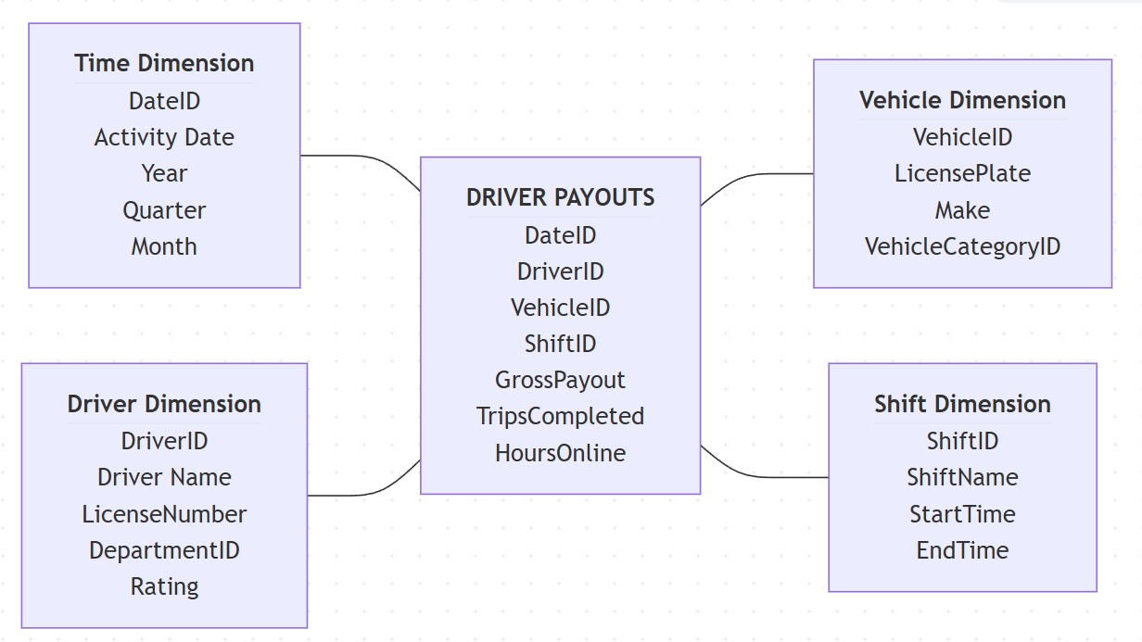

2. Snowflake Schema
A Snowflake Schema is an extension of the Star Schema where Dimension Tables are further divided into smaller, normalized tables. In this experiment, the two business domains are integrated into a combined Uber Enterprise Warehouse and repeated descriptive attributes are separated into normalized sub-dimensions.

Combined Snowflake Schema: Uber Enterprise Warehouse
The combined schema connects the rider and driver business domains through a unified enterprise fact table. The main dimensions are normalized into sub-dimensions to reduce redundancy and improve data integrity.

Fact Table – UBER_ENTERPRISE_FACT
Column | Description
DateID | Foreign key referencing TIME dimension.
RiderID | Foreign key referencing RIDER dimension.
LocationID | Foreign key referencing LOCATION dimension.
DriverID | Foreign key referencing DRIVER dimension.
VehicleID | Foreign key referencing VEHICLE dimension.
TotalFare | Total fare generated from trips.
GrossPayout | Total payout due to drivers.
DistanceMiles | Distance travelled in miles.
HoursOnline | Driver hours online.

Time Dimension – TIME
Column |  | Description
DateID | Primary key.
Date | Calendar date.
Year | Year value.
Quarter | Quarter value.
Month | Month value.

Rider Dimension – RIDER
Column | Description
RiderID | Primary key.
RiderName | Name of the rider.
CityID | Foreign key referencing CITY.

Location Dimension – LOCATION
 | Column | Description
LocationID |  | Primary key.
ZoneName |  | Operational zone name.
CityID |  | Foreign key referencing CITY.

Driver Dimension – DRIVER
 | Column | Description
DriverID |  | Primary key.
DriverName |  | Name of the driver.
DepartmentID |  | Foreign key referencing DEPARTMENT.

Vehicle Dimension – VEHICLE
Column | Description
VehicleID | Primary key.
LicensePlate | Vehicle registration number.
VehicleCategoryID | Foreign key referencing VEHICLE TYPE.

City Dimension – CITY
Column | Description
CityID | Primary key.
CityName | Name of the city.
Zipcode | Postal code.
State | State or region.
Country | Country name.

Vehicle Type Dimension – VEHICLE TYPE
Column | Description
VehicleCategoryID | Primary key.
CategoryName | Vehicle category name.
BaseRate | Base rate for the vehicle category.

Department Dimension – DEPARTMENT
 | Column | Description
DepartmentID |  | Primary key.
DepartmentName |  | Department name.
Location |  | Department location.

Diagram 3 – Combined Snowflake Schema: Uber Enterprise Warehouse
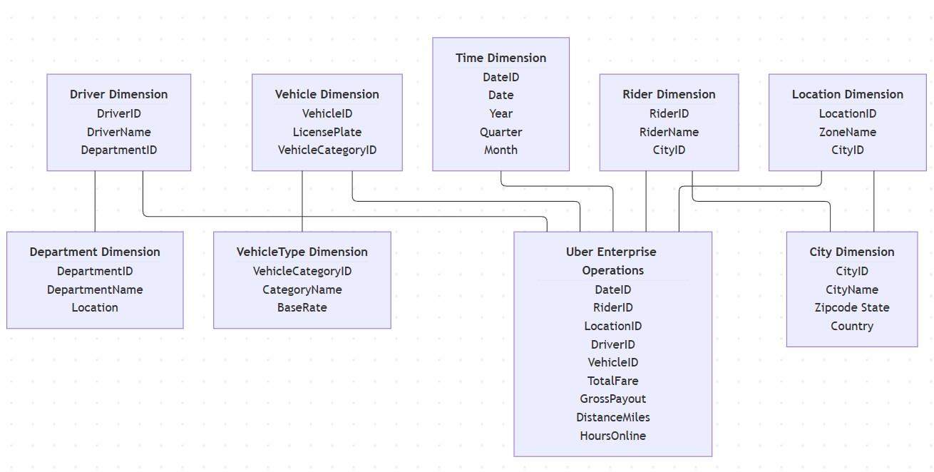

Main Difference
Star Schema | Snowflake Schema
Dimensions are generally denormalized. | Dimensions are normalized.
Fewer tables. | More tables.
Simple structure. | More complex structure.
Faster querying in many analytical cases. | May require more joins.
Requires more storage. | Can reduce data redundancy and storage.

Explanation of the Designs

1. Rider Trip Analytics
The RIDER_TRIPS fact table is placed at the center of the first Star Schema. It stores measurable trip information and foreign keys to the TIME, RIDER, LOCATION, and PAYMENT dimensions. This structure allows analysis of fare, distance, and surge multiplier by rider, location, payment method, and time.

2. Driver Performance & Payouts
The DRIVER_PAYOUTS fact table is placed at the center of the second Star Schema. It stores measurable driver performance information and foreign keys to the TIME, DRIVER, VEHICLE, and SHIFT dimensions. This supports analysis of payouts, completed trips, and hours online by driver, vehicle, shift, and date.

3. Combined Snowflake Schema
The Snowflake Schema combines customer-side and driver-side operational information in a unified enterprise model. CITY, VEHICLE TYPE, and DEPARTMENT are normalized sub-dimensions. This reduces repeated descriptive values and improves consistency, although analytical queries may require additional JOIN operations.
Result
Thus, the Star Schema and Snowflake Schema for the given Uber enterprise sales and operations system were successfully designed by identifying suitable fact tables, dimension tables, and normalized sub-dimensions. Two separate Star Schemas were designed for Rider Trip Analytics and Driver Performance & Payouts, and a combined Snowflake Schema was designed for the Uber Enterprise Warehouse.
Inference
The star schemas allow direct analysis of trip fares and driver payouts through descriptive dimensions. The snowflake design separates city, vehicle type and department information, reducing duplication but requiring more joins. The fact-table grain should be specified before physical implementation to prevent double counting.
Conclusion
Thus, two star schemas and a combined snowflake schema were designed for the Uber-style enterprise system, illustrating fact tables, dimension tables and normalization trade-offs.
GitHub Link
https://github.com/RamPanjwani/DMBI/tree/main/Experiment-01-Star-Snowflake

