Experiment No. 5

Experiment Title | To implement Classification algorithms (Decision tree and Naïve Bayes' algorithms) using Python.
Course  Outcomes | CO4: Implement the appropriate data mining methods like classification, clustering or Frequent Pattern mining on large data sets.  CO5: Define and apply metrics to measure the performance of various data mining algorithms.
Date of Preparation |  | Date of Submission
Signature & Grade
Name: Ram Panjwani
Roll no: 32

Experiment 5 - To implement Classification algorithms (Decision tree and Naïve Bayes' algorithms) using Python.
Practical performed: Categorical Naïve Bayes (library and student-defined versions).
Aim
To implement a classification technique using an inbuilt Python library and a student-defined function; preprocess the dataset, split it into training and testing sets, and evaluate both classifiers on the same test records.
Objective
- Preprocess Uber booking data and perform an 80:20 stratified train-test split.
- Train a Naïve Bayes classifier using an inbuilt library function.
- Calculate accuracy, precision, recall, F1-score and confusion matrix on test data.
- Implement categorical Naïve Bayes probability estimation in a student-defined function without using a prebuilt classifier.
- Evaluate and compare predictions of both approaches.
Software/Tools Required
Python 3, pandas, NumPy, scikit-learn and Matplotlib. The same 120,000 training records and 30,000 test records are used by both methods (test_size = 0.20, random_state = 42, stratify = target).
Theory
Classification is supervised machine learning in which input features are used to predict a categorical target. Naïve Bayes is a probabilistic classifier based on Bayes’ theorem. It assumes that features are conditionally independent given the target class.
P(Class | Features) P(Class) × P(Feature 1 | Class) × P(Feature 2 | Class) × P(Feature 3 | Class)
Categorical Naïve Bayes estimates probabilities for discrete attribute values. Laplace smoothing (α = 1) reduces zero-probability problems for infrequent categories. The custom implementation sums logarithms of probabilities to avoid numerical underflow.

Dataset Description
Dataset: Uber India / NCR ride-booking records (publicly shared Uber-themed data). The experiment uses uber_weka_classification.csv, created from the original ride dataset for Experiment 4. This is not verified as an official Uber data release.
Field | Role
Vehicle Type | Categorical predictor
Pickup Location | Categorical predictor
Drop Location | Categorical predictor
Booking Status | Target label: five possible statuses
There are 150,000 records. Booking identifiers, cancellation reasons, final fare, ratings and other outcome-related fields are excluded to avoid target leakage. Class distribution is imbalanced: 62% of records are Completed.
Implementation / Procedure
- Load the CSV and select vehicle type, pickup location, drop location and booking status.
- Handle missing predictors and divide records into stratified training and testing sets.
- Fit the ordinal encoder on training data only; use a reserved code for unknown test categories.
- Train sklearn.naive_bayes.CategoricalNB with Laplace smoothing, then obtain predictions.
- Define custom_categorical_naive_bayes(): calculate class priors, count feature values per class, apply Laplace smoothing, compute log-posterior scores and select the highest-scoring class.
- Calculate accuracy, classification report and confusion matrices using sklearn.metrics.
- Save the terminal results and two confusion-matrix figures in exp5_outputs/.

How to Run
Save Experiment_5_Uber_Naive_Bayes.py and uber_weka_classification.csv in the same folder, open PowerShell there, and run:
py -m pip install numpy pandas scikit-learn matplotlib py Experiment_5_Uber_Naive_Bayes.py
Outputs: exp5_outputs/results.txt, library_confusion_matrix.png and custom_confusion_matrix.png.
Code
"""Experiment 5: Naive Bayes (library and student-defined algorithm).

Run: python Experiment_5_Uber_Naive_Bayes.py
Requires: pandas, numpy, scikit-learn, matplotlib
Input: uber_weka_classification.csv in the same folder (or --csv PATH).
"""
from pathlib import Path
import argparse
import numpy as np
import pandas as pd
import matplotlib.pyplot as plt
from sklearn.model_selection import train_test_split
from sklearn.preprocessing import OrdinalEncoder
from sklearn.naive_bayes import CategoricalNB
from sklearn.metrics import (
accuracy_score, classification_report, confusion_matrix,
ConfusionMatrixDisplay,
)

FEATURES = ['Vehicle Type', 'Pickup Location', 'Drop Location']
TARGET = 'Booking Status'

def custom_categorical_naive_bayes(X_train, y_train, X_test, alpha=1.0):
"""Calculate categorical NB predictions without a prebuilt classifier.

Feature values must be nonnegative integer category codes.
Laplace smoothing is applied to the categorical likelihood tables.
"""
classes, y_codes = np.unique(y_train, return_inverse=True)
n = len(y_train)
n_classes = len(classes)
class_counts = np.bincount(y_codes, minlength=n_classes)
log_prior = np.log(class_counts / n)
likelihood_tables = []

for col in range(X_train.shape[1]):
# Code 0 is reserved for categories unseen in the training data.
count_of_values = int(max(X_train[:, col].max(), X_test[:, col].max())) + 1
table = np.empty((n_classes, count_of_values), dtype=float)
for class_index in range(n_classes):
vals = X_train[y_codes == class_index, col]
counts = np.bincount(vals, minlength=count_of_values)
table[class_index] = np.log(
(counts + alpha) /
(class_counts[class_index] + alpha * count_of_values)
)
likelihood_tables.append(table)

scores = np.tile(log_prior, (len(X_test), 1))
for col, table in enumerate(likelihood_tables):
scores += table[:, X_test[:, col]].T
return classes[np.argmax(scores, axis=1)]

def main():
parser = argparse.ArgumentParser()
parser.add_argument('--csv', default='uber_weka_classification.csv')
parser.add_argument('--output', default='exp5_outputs')
args = parser.parse_args()

csv_path = Path(args.csv)
if not csv_path.is_file():
csv_path = Path(__file__).resolve().parent / args.csv
if not csv_path.is_file():
raise FileNotFoundError(
'Place uber_weka_classification.csv beside this script, or pass --csv FILE'
)

output_dir = Path(args.output)
output_dir.mkdir(parents=True, exist_ok=True)
df = pd.read_csv(csv_path, usecols=FEATURES + [TARGET])
df = df.dropna(subset=[TARGET]).copy()
for col in FEATURES:
df[col] = df[col].fillna('Unknown').astype(str)
df[TARGET] = df[TARGET].astype(str)
print(f'Dataset: {csv_path.name}; records: {len(df)}')
print('Classes:', df[TARGET].value_counts().to_dict())

X_train_raw, X_test_raw, y_train, y_test = train_test_split(
df[FEATURES], df[TARGET], test_size=0.20, random_state=42,
stratify=df[TARGET]
)

# Fit the encoder only on the training set to avoid leakage.
encoder = OrdinalEncoder(handle_unknown='use_encoded_value', unknown_value=-1)
X_train = encoder.fit_transform(X_train_raw).astype(int) + 1
X_test = encoder.transform(X_test_raw).astype(int) + 1

# Method 1: inbuilt classifier.
library_model = CategoricalNB(alpha=1.0)
library_model.fit(X_train, y_train)
predictions_library = library_model.predict(X_test)

# Method 2: student-defined classifier.
predictions_custom = custom_categorical_naive_bayes(
X_train, y_train.to_numpy(), X_test
)

report_lines = [
f'Training samples: {len(X_train)}',
f'Testing samples: {len(X_test)}',
]
for title, predictions, filename in [
('Library CategoricalNB', predictions_library, 'library_confusion_matrix.png'),
('Student-defined Categorical Naive Bayes', predictions_custom, 'custom_confusion_matrix.png'),
]:
acc = accuracy_score(y_test, predictions)
report = classification_report(y_test, predictions, zero_division=0)
print(f'\n=== {title} ===')
print(f'Accuracy: {acc:.4%}')
print(report)
report_lines.extend([f'\n=== {title} ===', f'Accuracy: {acc:.4%}', report])
labels = sorted(y_test.unique().tolist())
cm = confusion_matrix(y_test, predictions, labels=labels)
fig, ax = plt.subplots(figsize=(10, 8))
ConfusionMatrixDisplay(cm, display_labels=labels).plot(
ax=ax, xticks_rotation=35, values_format='d', colorbar=False
)
ax.set_title(title + ' - Confusion Matrix')
fig.tight_layout()
fig.savefig(output_dir / filename, dpi=180)
plt.close(fig)

agree = np.mean(predictions_library == predictions_custom)
report_lines.append(f'Prediction agreement: {agree:.2%}')
print(f'\nPrediction agreement: {agree:.2%}')
(output_dir / 'results.txt').write_text('\n'.join(report_lines), encoding='utf-8')
print(f'\nSaved report and 2 confusion matrices to: {output_dir.resolve()}')

if __name__ == '__main__':
main()
Output
Output 1–3. Dataset summary, library CategoricalNB evaluation, and student-defined Naïve Bayes evaluation (terminal output; inverted for printing).
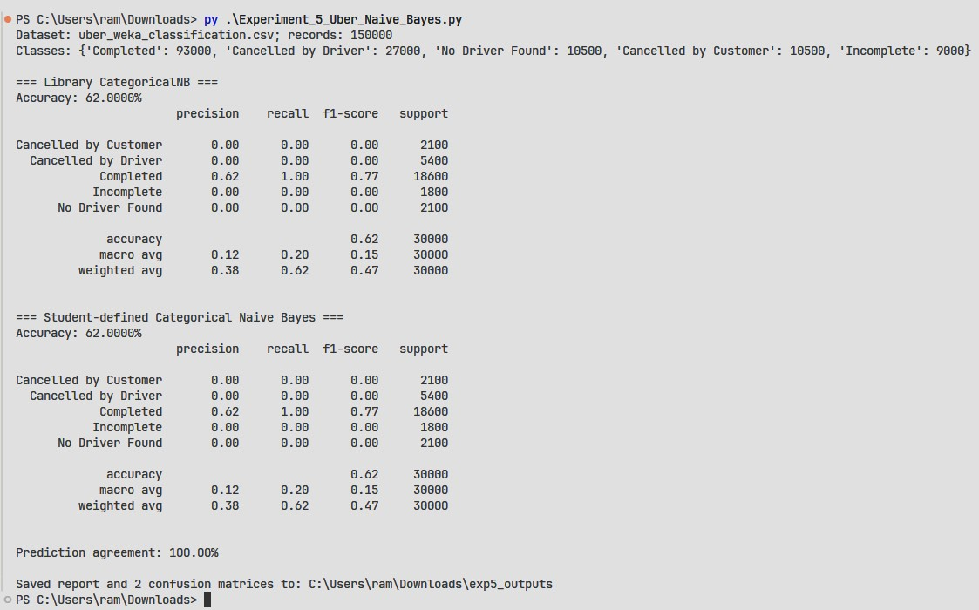
Output 4. Confusion matrix — library classifier
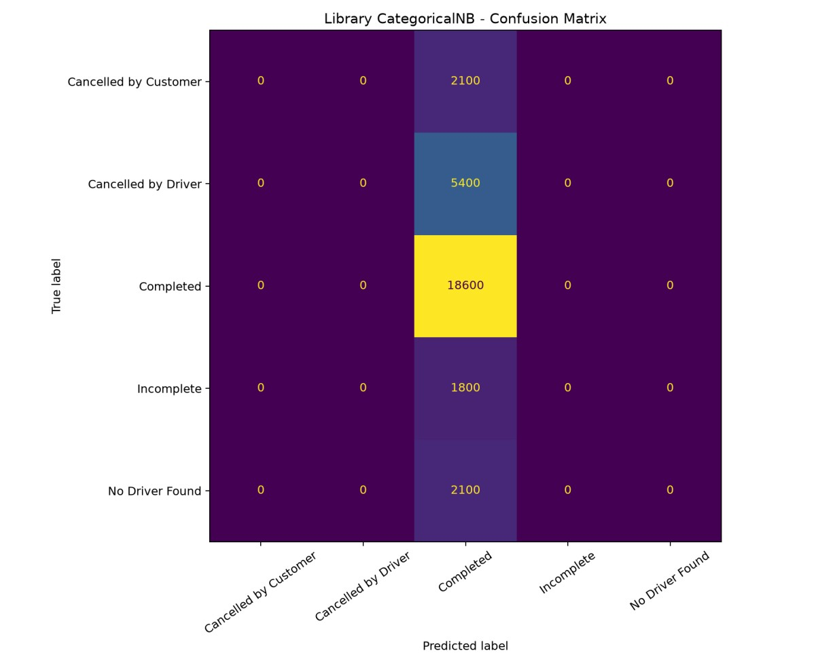
Output 5. Confusion matrix — student-defined classifier
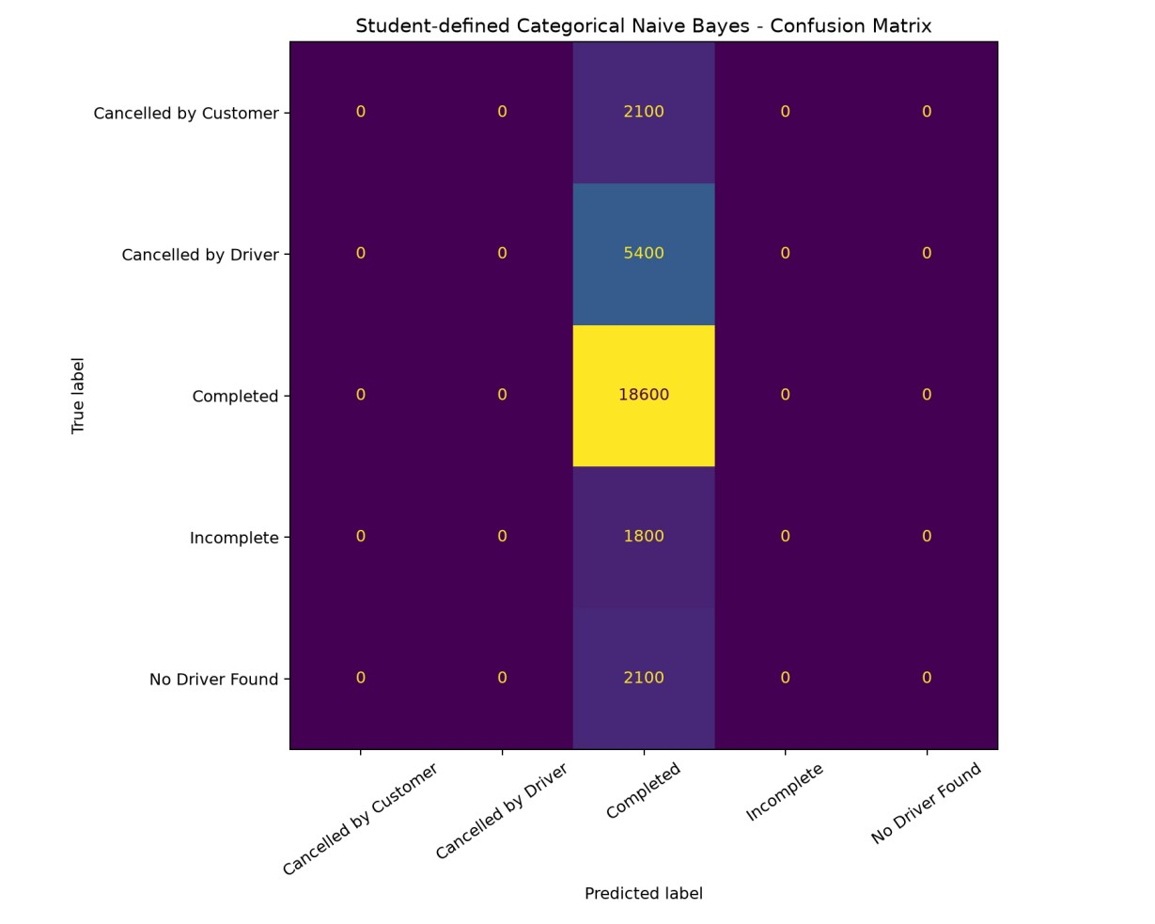
Result
The built-in CategoricalNB and student-defined categorical Naïve Bayes both achieved 62.00% accuracy, macro F1 of 0.15 and weighted F1 of 0.47 on 30,000 test records, with 100% prediction agreement. Both assigned all test records to Completed.
Inference
The two implementations generate identical predictions for this dataset. Since every test sample is classified as Completed, evaluation beyond accuracy is essential. The safe pre-outcome predictors available in the dataset have insufficient demonstrated signal to distinguish cancellations and incomplete bookings using these models. The study demonstrates the method correctly without claiming high-quality prediction.
Conclusion
Categorical Naïve Bayes classification was implemented using both an inbuilt Python library and a student-defined function on Uber ride-booking data. Data preprocessing, stratified splitting, model training, accuracy evaluation, class-wise metrics and confusion matrices were completed. Both implementations achieved 62.00% accuracy, reflecting the majority class and highlighting the limits of the available predictors.
GitHub Link
https://github.com/RamPanjwani/DMBI/tree/main/Experiment-05-Python-Classification

