Experiment No. 6

Experiment Title | To implement the Clustering algorithms (k-means, Agglomerative, DBSCAN) using RapidMiner/Weka tool.
Course  Outcomes | CO4: Implement the appropriate data mining methods like classification, clustering or Frequent Pattern mining on large data sets.  CO5: Define and apply metrics to measure the performance of various data mining algorithms.
Date of Preparation |  | Date of Submission
Signature & Grade
Name: Ram Panjwani
Roll no: 32

Experiment 6 - To implement the Clustering algorithms (k-means, Agglomerative, DBSCAN) using RapidMiner/Weka tool.
Practical performed: Python implementation of K-Means.
Aim
To implement the K-Means clustering algorithm using Python on an Uber cab booking dataset, visualize the clusters, and evaluate the clustering performance.
Objective
• To select and standardize numeric features of completed Uber rides.
• To perform K-Means clustering and choose a demonstration value of k.
• To assess cluster quality using inertia, silhouette score and Davies–Bouldin index.
Software/Tools Required
Python 3, pandas, NumPy, scikit-learn, Matplotlib, Windows PowerShell, and Uber completed-rides CSV dataset.
Theory
Clustering is an unsupervised machine learning technique that groups similar records without a predefined class label. K-Means clustering divides the dataset into k groups. The algorithm initializes k centroids, assigns each data point to its nearest centroid, recalculates cluster centroids, and repeats until the assignments stabilize.
Standardization transforms features to a comparable scale so that a large-valued variable does not automatically dominate the distance calculation. The Elbow Method compares inertia for different values of k. The Silhouette Score evaluates separation (higher is generally better), while the Davies– Bouldin Index measures similarity between clusters (lower is generally better).

Dataset Description
A sample of 5,000 completed Uber rides was selected from the cab-booking dataset. Four numeric attributes were used for K-Means clustering, without any target label.
Attribute | Description
Avg VTAT | Average vehicle arrival time
Avg CTAT | Average customer arrival time
Booking Value | Booking amount
Ride Distance | Distance travelled during the completed ride
Implementation / Procedure
Step 1: Import pandas, NumPy, Matplotlib, StandardScaler, KMeans, silhouette_score, and davies_bouldin_score. Load uber_completed_clustering_5000.csv and select the four numeric attributes.
Step 2: Apply StandardScaler to standardize the four numeric attributes before fitting K-Means.
Step 3: Run K-Means for k = 1 to 10, calculate inertia for each k, and plot the Elbow Method graph. Select k = 3 for the practical example.
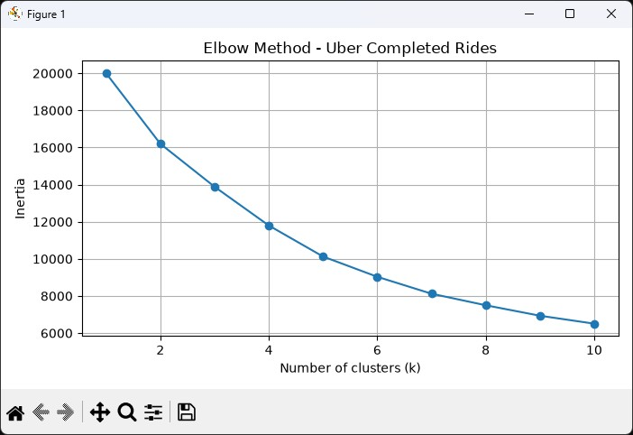
Figure 1: Elbow Method graph generated in Python.
The graph shows continuously decreasing inertia as k increases. No sharply defined elbow is present; k = 3 was chosen for the three-cluster experiment, not as a uniquely established optimum.
Step 4: Fit K-Means on the standardized dataset with k = 3 and random_state = 42. Assign each ride its predicted cluster label.
Step 5: Calculate the cluster counts, Silhouette Score, inertia, and Davies–Bouldin Index. Convert the grouped mean characteristics back to the original measurement scale for easier interpretation.
Code
Reference Python implementation corresponding to the procedure; reproducing the original output depends on dataset and library configuration.
from pathlib import Path
import pandas as pd
import matplotlib.pyplot as plt
from sklearn.cluster import KMeans
from sklearn.preprocessing import StandardScaler
from sklearn.metrics import silhouette_score, davies_bouldin_score

path = Path("uber_completed_clustering_5000.csv")
features = ["Avg VTAT", "Avg CTAT", "Booking Value", "Ride Distance"]
df = pd.read_csv(path)[features].dropna().copy()
scaler = StandardScaler()
X = scaler.fit_transform(df)

inertias = []
for k in range(1, 11):
model = KMeans(n_clusters=k, random_state=42, n_init=10)
model.fit(X)
inertias.append(model.inertia_)
plt.plot(range(1, 11), inertias, marker="o")
plt.xlabel("Number of clusters (k)")
plt.ylabel("Inertia")
plt.title("Elbow Method - Completed Rides")
plt.show()

model = KMeans(n_clusters=3, random_state=42, n_init=10)
labels = model.fit_predict(X)
df["Cluster"] = labels
print("Cluster counts:", df["Cluster"].value_counts().sort_index())
print("Inertia:", model.inertia_)
print("Silhouette:", silhouette_score(X, labels))
print("Davies-Bouldin:", davies_bouldin_score(X, labels))
print("Cluster means:\n", df.groupby("Cluster")[features].mean())

plt.scatter(df["Ride Distance"], df["Booking Value"], c=labels, s=6)
plt.xlabel("Ride Distance")
plt.ylabel("Booking Value")
plt.title("K-Means Clusters - Uber Completed Rides")
plt.show()

Output
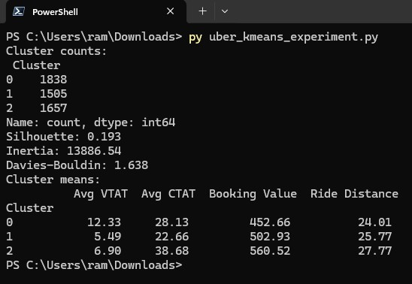
Figure 2: PowerShell output displaying cluster counts, evaluation metrics and cluster means. Output and Observations
Parameter | Observed Result
Dataset records | 5,000
Number of clusters (k) | 3
Cluster 0 | 1,838 rides (36.76%)
Cluster 1 | 1,505 rides (30.10%)
Cluster 2 | 1,657 rides (33.14%)
Silhouette Score | 0.193
Inertia | 13,886.54
Davies–Bouldin Index | 1.638
The mean attributes of each cluster in original units are:
Attribute | Cluster 0 | Cluster 1 | Cluster 2
Avg VTAT | 12.33 | 5.49 | 6.90
Avg CTAT | 28.13 | 22.66 | 38.68
Booking Value | 452.66 | 502.93 | 560.52
Ride Distance | 24.01 | 25.77 | 27.77

Cluster Visualization
Step 6: Plot the clustering results using Ride Distance on the X-axis and Booking Value on the Yaxis. Colour points by their K-Means cluster assignment.
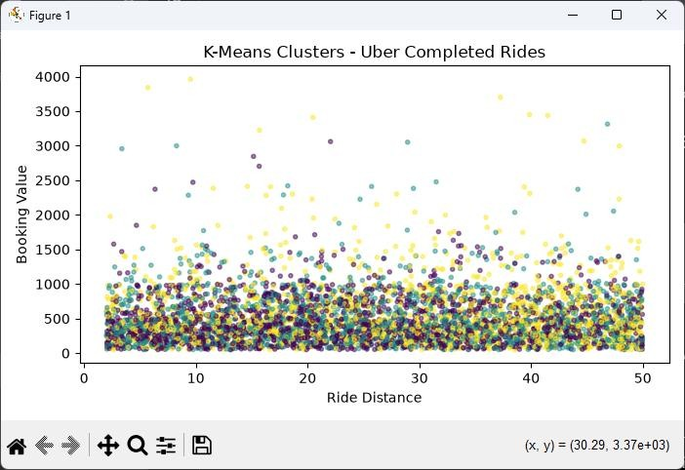
Figure 3: Scatter plot of Uber ride distance versus booking value, coloured by cluster.
Result

Inference

Conclusion

GitHub Link
https://github.com/RamPanjwani/DMBI/tree/main/Experiment-06-Python-KMeans

