Experiment No. 8

Experiment Title | To implement Association Rule Mining (Apriori Algorithm) using RapidMiner/Weka tool.
Course  Outcomes | CO4: Implement the appropriate data mining methods like classification, clustering or Frequent Pattern mining on large data sets.  CO5: Define and apply metrics to measure the performance of various data mining algorithms.
Date of Preparation |  | Date of Submission
Signature & Grade
Name: Ram Panjwani
Roll no: 32

Experiment 8 - To implement Association Rule Mining (Apriori Algorithm) using RapidMiner/Weka tool.
Aim
To implement the Apriori association rule mining algorithm using Weka on an Uber cab-booking dataset and analyze the frequent itemsets and association rules using support, confidence, and lift.
Objective
- Prepare and import the Uber booking dataset into Weka Explorer.
- Convert the required categorical fields into nominal attributes.
- Configure and execute Apriori with a minimum support of 2% and confidence of 30%.
- Examine frequent itemsets, association rules, and their measures.
- Compare Weka association results with the Python implementation in Experiment 9.
Software/Tools Required
Weka 3.8.7 on Windows; prepared CSV file exp9_weka.csv, derived from ncr_ride_bookings.csv (Uber-themed NCR ride-booking data).
Theory
Association rule mining finds combinations of attribute-value items that frequently occur together in records. A rule A => B relates an antecedent (A) to a consequent (B). In this experiment, each booking is treated as a transaction containing its vehicle type, pickup location, drop location, and booking status.

Apriori Algorithm
Apriori discovers frequent itemsets using the Apriori property: every non-empty subset of a frequent itemset must also be frequent. It then generates rules from frequent itemsets and checks their quality against selected thresholds.

Measures of Association
Measure | Meaning / formula
Support | support(A => B) = count(A and B) / total bookings
Confidence | confidence(A => B) = count(A and B) / count(A)
Lift | lift(A => B) = confidence(A => B) / support(B)
Lift above 1 indicates positive association relative to independence; lift near 1 suggests little association; lift below 1 indicates negative association relative to independence.

Dataset Description
The dataset contains 150,000 booking records. The original ncr_ride_bookings.csv was converted to a Weka-compatible exp9_weka.csv with the four categorical attributes listed below. Missing or blank predictor values were replaced with Unknown during preparation. Each row represents one booking.
Attribute | Description
Vehicle Type | Cab or vehicle category selected
Pickup Location | Starting location of the booking
Drop Location | Destination location of the booking
Booking Status | Final status of the booking
Implementation / Procedure
- Prepare exp9_weka.csv by selecting the four categorical columns from the original booking dataset and saving them in a well-quoted CSV format.
- Launch Weka GUI Chooser, open Explorer, and import exp9_weka.csv through Preprocess > Open file.
- Verify 150,000 instances and four attributes. Convert String attributes to Nominal with the StringToNominal filter (attribute range first-last).
- Open the Associate tab and select weka.associations.Apriori.
- Set lower minimum support to 0.02, minimum confidence to 0.30, upper support to 1.0, delta to 0.98, requested rules to 100, and outputItemSets to True.
- Click Start. Examine the generated 1-itemsets, 2-itemsets, and best association rules.
- Save the result buffer as Experiment_8_Apriori_Output.txt for analysis and comparison with Experiment 9.
Output
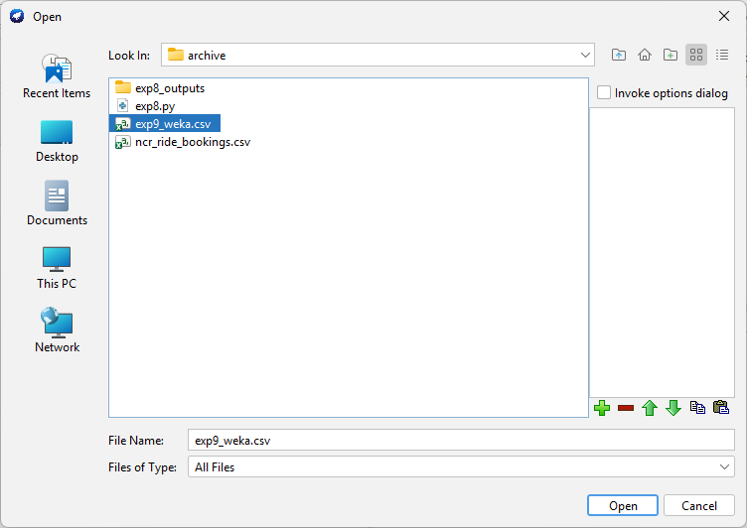  Figure 1. Selecting exp9_weka.csv. | 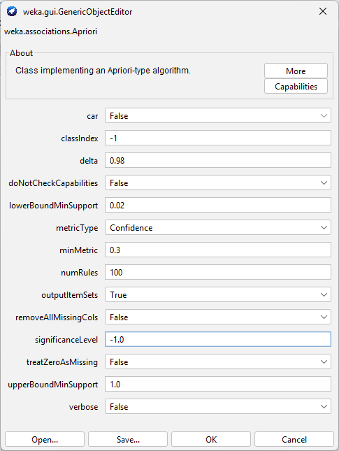  Figure 2. Apriori configuration.

Figure 3. Weka Preprocess tab: 150,000 instances and four nominal attributes.

Figure 4. Apriori execution summary and first-level frequent itemsets.

Figure 5. Two-itemsets and six reported association rules.
Parameter | Observed result
Number of booking records | 150,000
Attributes used | 4 nominal attributes
Minimum support | 0.02 = 3,000 instances
Minimum confidence | 0.30
Number of cycles | 2
Frequent 1-itemsets (L1) | 12
Frequent 2-itemsets (L2) | 11
Total frequent itemsets | 23
Reported association rules | 6

Frequent 1-Itemsets (L1)
Item | Count | Item | Count
Vehicle Type=eBike | 10,557 | Vehicle Type=Uber XL | 4,449
Vehicle Type=Go Sedan | 27,141 | Booking Status=No Driver Found | 10,500
Vehicle Type=Auto | 37,419 | Booking Status=Incomplete | 9,000
Vehicle Type=Premier Sedan | 18,111 | Booking Status=Completed | 93,000
Vehicle Type=Bike | 22,517 | Booking Status=Cancelled by Driver | 27,000
Vehicle Type=Go Mini | 29,806 | Booking Status=Cancelled by Customer | 10,500

Frequent 2-Itemsets (L2)
Each 2-itemset pairs a Vehicle Type value with a Booking Status value.
Vehicle Type + Booking Status | Count
eBike + Completed | 6,551
Go Sedan + Completed | 16,676
Go Sedan + Cancelled by Driver | 5,031
Auto + Completed | 23,155
Auto + Cancelled by Driver | 6,643
Premier Sedan + Completed | 11,252
Premier Sedan + Cancelled by Driver | 3,250
Bike + Completed | 14,034
Bike + Cancelled by Driver | 4,077
Go Mini + Completed | 18,549
Go Mini + Cancelled by Driver | 5,330

Association Rules Generated
All six rules have Booking Status=Completed as their consequent. The support, confidence, and lift below are calculated from the item counts in the saved Weka output; Weka displays rounded confidence and lift values.
Antecedent: Vehicle Type | Support | Confidence | Lift
Bike | 0.093560 | 0.623262 | 1.005262
Go Mini | 0.123660 | 0.622324 | 1.003749
Premier Sedan | 0.075013 | 0.621280 | 1.002064
eBike | 0.043673 | 0.620536 | 1.000865
Auto | 0.154367 | 0.618803 | 0.998070
Go Sedan | 0.111173 | 0.614421 | 0.991002
Result

Inference

Conclusion

GitHub Link
https://github.com/RamPanjwani/DMBI/tree/main/Experiment-08-Weka-Apriori

