Experiment No. 9

Experiment Title | To implement Association Rule Mining (Apriori Algorithm ) using Python.
Course  Outcomes | CO4: Implement the appropriate data mining methods like classification, clustering or Frequent Pattern mining on large data sets.  CO5: Define and apply metrics to measure the performance of various data mining algorithms.
Date of Preparation |  | Date of Submission
Signature & Grade
Name: Ram Panjwani
Roll no: 32

Experiment 9 - To implement Association Rule Mining (Apriori Algorithm ) using Python.
Aim
To implement the Apriori association rule mining algorithm using Python on an Uber cab-booking dataset, discover frequent itemsets, generate association rules, and interpret their support, confidence, and lift.
Objective
- Prepare categorical Uber booking records as transaction data.
- Convert each booking to a binary item-presence matrix.
- Identify frequent itemsets by applying the Apriori algorithm.
- Generate and filter association rules using confidence and lift.
- Visualize the item frequencies and rule quality; save results for analysis.
Software/Tools Required
Python 3; pandas; mlxtend; Matplotlib; Jupyter Notebook or Windows PowerShell; and the prepared Uber classification CSV from Experiments 4 and 5.
Theory
Association Rule Mining discovers relationships between items or attributes that occur together in a collection of transactions. In traditional market-basket analysis, a transaction contains purchased products. Here, each cab booking is treated as one transaction containing its categorical booking attributes.

Apriori Principle
Apriori finds frequent itemsets through the downward-closure property: if an itemset is frequent, all its non-empty subsets must also be frequent. Candidate itemsets that do not meet minimum support are pruned before larger candidates are considered.

Association Rule Measures
Measure | Definition
Support(A => B) | Transactions containing both A and B / Total transactions.
Confidence(A => B) | Support(A union B) / Support(A).
Lift(A => B) | Confidence(A => B) / Support(B).
Lift > 1 suggests positive co-occurrence relative to independence; lift = 1 suggests independence; lift < 1 suggests negative association. Association rules describe co-occurrence, not causation or guaranteed predictions.

Dataset Description
Input filename used for the completed run: ncr_ride_bookings.csv. This Uber-themed cab-booking dataset contains 150,000 booking records. The experiment uses Vehicle Type, Pickup Location, Drop Location, and Booking Status from the original CSV, consistent with the four categorical attributes selected in Experiments 4 and 5. The program also supports the prepared uber_weka_classification.csv through its default setting.
Attribute | Role in association mining
Vehicle Type | Category of selected vehicle; e.g., Vehicle Type=Auto.
Pickup Location | Categorical pickup point; e.g., Pickup Location=Andheri.
Drop Location | Categorical destination.
Booking Status | Outcome category, treated as an item rather than a class label.
Transaction definition: one CSV row = one booking. Each record contributes one item for each of the four attributes. Missing or blank attribute values are represented as Unknown. The resulting one-hot matrix contains True/False columns such as Vehicle Type=Auto and Booking Status=Completed.

Parameters Used
Parameter | Chosen value | Reason
Minimum support | 0.02 (2%) | Keep itemsets appearing in at least 2% of bookings.
Minimum confidence | 0.30 (30%) | Require a minimum conditional co-occurrence rate.
Minimum lift | 1.00 | Retain non-negatively associated rules.
Maximum itemset length | 3 | Limit complexity for a large categorical dataset.
The thresholds can be changed using command-line arguments. Lower support may reveal rarer patterns but can increase processing time and the number of candidate itemsets.
Implementation / Procedure
- Place Experiment_9_Uber_Apriori.py and ncr_ride_bookings.csv in the same folder.
- Install libraries in Python 3.11 using: py -3.11 -m pip install pandas mlxtend matplotlib
- Execute: py -3.11 exp8.py --csv ncr_ride_bookings.csv (or use the full Python filename).
- Read the four categorical attributes and replace missing/blank values with Unknown.
- Use pandas.get_dummies() to create the binary transaction matrix.
- Apply mlxtend.frequent_patterns.apriori() using minimum support 0.02 and a maximum itemset length of 3.
- Generate association rules using minimum confidence 0.30 and retain rules with lift >= 1.00.
- Save frequent itemsets, all association rules, and booking-status-consequent rules as CSV files.
Code
Filename: Experiment_9_Uber_Apriori.py. The complete executable code below is identical to the separately supplied Python file.
"""DMBI Experiment 9: Association Rule Mining using Python (Apriori).
Input: uber_weka_classification.csv (prepared in Experiments 4 and 5).
Each booking is treated as one transaction of four categorical attributes.
Run: python Experiment_9_Uber_Apriori.py
"""
from pathlib import Path
import argparse
import textwrap
import pandas as pd
import matplotlib
matplotlib.use("Agg")
import matplotlib.pyplot as plt
from mlxtend.frequent_patterns import apriori, association_rules
FEATURES = ["Vehicle Type", "Pickup Location", "Drop Location", "Booking Status"]
def readable(items):
"""Convert an itemset to stable, readable text for CSV and console output."""
return " ; ".join(sorted(items))
def main():
parser = argparse.ArgumentParser(description="Apriori on Uber booking transactions")
parser.add_argument("--csv", default="uber_weka_classification.csv")
parser.add_argument("--output", default="exp9_outputs")
parser.add_argument("--min-support", type=float, default=0.02)
parser.add_argument("--min-confidence", type=float, default=0.30)
parser.add_argument("--min-lift", type=float, default=1.0)
args = parser.parse_args()
if not (0 < args.min_support <= 1 and 0 < args.min_confidence <= 1):
parser.error("Support and confidence must be in (0, 1].")
if args.min_lift < 0:
parser.error("Minimum lift must be nonnegative.")
csv_path = Path(args.csv)
if not csv_path.is_file():
csv_path = Path(__file__).resolve().parent / args.csv
if not csv_path.is_file():
raise FileNotFoundError(
"Place uber_weka_classification.csv beside this script, "
"or supply --csv PATH."
)
output_dir = Path(args.output)
output_dir.mkdir(parents=True, exist_ok=True)
data = pd.read_csv(csv_path, usecols=FEATURES, low_memory=False)
if data.empty:
raise ValueError("The input CSV contains no booking records.")
for feature in FEATURES:
data[feature] = data[feature].fillna("Unknown").astype(str).str.strip()
data.loc[data[feature] == "", feature] = "Unknown"
# Each row is one booking/transaction. One-hot columns represent items.
transactions = pd.get_dummies(data, prefix_sep="=", dtype=bool)
frequent = apriori(
transactions, min_support=args.min_support,
use_colnames=True, max_len=3
).sort_values("support", ascending=False).reset_index(drop=True)
frequent_export = frequent.copy()
frequent_export["itemsets"] = frequent_export["itemsets"].map(readable)
frequent_export.to_csv(output_dir / "frequent_itemsets.csv", index=False)
if frequent.empty or not any(frequent["itemsets"].map(len) >= 2):
rules = pd.DataFrame()
else:
rules = association_rules(
frequent, metric="confidence", min_threshold=args.min_confidence
)
rules = rules[rules["lift"] >= args.min_lift].copy()
rules = rules.sort_values(
["lift", "confidence", "support"], ascending=False
).reset_index(drop=True)
columns = ["antecedents", "consequents", "support", "confidence", "lift"]
if rules.empty:
export_rules = pd.DataFrame(columns=columns)
booking_rules = export_rules.copy()
else:
booking_rules = rules[
rules["consequents"].map(
lambda items: len(items) == 1 and
next(iter(items)).startswith("Booking Status=")
) & ~rules["antecedents"].map(
lambda items: any(x.startswith("Booking Status=") for x in items)
)
].copy()
export_rules = rules[columns].copy()
export_rules["antecedents"] = export_rules["antecedents"].map(readable)
export_rules["consequents"] = export_rules["consequents"].map(readable)
booking_rules = booking_rules[columns].copy()
booking_rules["antecedents"] = booking_rules["antecedents"].map(readable)
booking_rules["consequents"] = booking_rules["consequents"].map(readable)
export_rules.to_csv(output_dir / "association_rules.csv", index=False)
booking_rules.to_csv(output_dir / "booking_status_rules.csv", index=False)
summary = [
"EXPERIMENT 9 - PYTHON APRIORI",
f"Input file: {csv_path}",
f"Transactions (bookings): {len(data)}",
f"Distinct item columns: {transactions.shape[1]}",
f"Minimum support: {args.min_support:.3f}",
f"Minimum confidence: {args.min_confidence:.3f}",
f"Minimum lift: {args.min_lift:.3f}",
f"Frequent itemsets: {len(frequent)}",
f"Association rules: {len(export_rules)}",
f"Booking-status consequent rules: {len(booking_rules)}",
"\nTOP FREQUENT ITEMSETS:",
frequent_export.head(10).to_string(index=False),
"\nTOP ASSOCIATION RULES:",
export_rules.head(10).to_string(index=False),
]
report = "\n".join(summary)
print(report)
(output_dir / "summary.txt").write_text(report + "\n", encoding="utf-8")
# Visualization 1: most common single items in all bookings.
singles = frequent[frequent["itemsets"].map(len) == 1].head(10)
if not singles.empty:
labels = [textwrap.fill(readable(s), 29) for s in singles["itemsets"]]
fig, ax = plt.subplots(figsize=(10, 6))
ax.barh(labels[::-1], singles["support"].to_numpy()[::-1])
ax.set_xlabel("Support (share of bookings)")
ax.set_title("Top Frequent Booking Attributes")
fig.tight_layout()
fig.savefig(output_dir / "top_frequent_items.png", dpi=180)
plt.close(fig)
# Visualization 2: association-rule support vs confidence, colored by lift.
if not rules.empty:
fig, ax = plt.subplots(figsize=(8, 5))
sc = ax.scatter(rules["support"], rules["confidence"],
c=rules["lift"], cmap="viridis", alpha=0.75)
fig.colorbar(sc, ax=ax, label="Lift")
ax.set_xlabel("Support")
ax.set_ylabel("Confidence")
ax.set_title("Apriori Association Rules: Support vs Confidence")
fig.tight_layout()
fig.savefig(output_dir / "rules_scatter.png", dpi=180)
plt.close(fig)
print(f"\nSaved files in: {output_dir.resolve()}")
if rules.empty:
print("No rules satisfy these thresholds; try a lower --min-support.")
if __name__ == "__main__":
main()
Output

Generated Output Files
File in exp9_outputs/ | Contents
summary.txt | Dataset counts, thresholds and top rules.
frequent_itemsets.csv | Frequent itemsets with support values.
association_rules.csv | Association rules passing confidence and lift filters.
booking_status_rules.csv | Rules with Booking Status on the right-hand side.
top_frequent_items.png | Bar chart of common item values.
rules_scatter.png | Support-confidence scatter plot, when rules exist.
If no rule satisfies the thresholds, empty rule CSV files are produced and the scatter plot is not generated. Adjust thresholds when necessary, and record the chosen values.
The following screenshots, charts, and tables are taken from the completed Python 3.11 run using ncr_ride_bookings.csv. The full frequent-itemset and association-rule results were read from the program-generated CSV files.

Output 1 — Terminal Execution and Frequent Itemsets
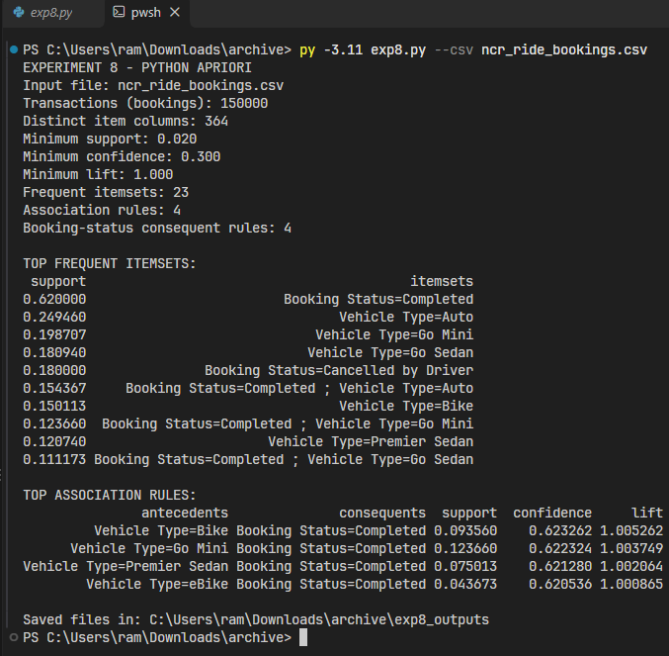
Figure 1. Actual PowerShell execution using Python 3.11, including the dataset summary and top rules.

Recorded execution summary
Measure | Observed result
Dataset file | ncr_ride_bookings.csv
Transactions processed | 150,000
Binary item columns | 364
Minimum support | 0.020 (2%)
Minimum confidence | 0.300 (30%)
Minimum lift | 1.000
Frequent itemsets | 23
Qualifying association rules | 4
Booking-status consequent rules | 4

Complete frequent itemsets (exported CSV)
All 23 frequent itemsets are included below; support is the fraction of all 150,000 bookings containing the itemset.
Support | Frequent itemset
0.620000 | Booking Status=Completed
0.249460 | Vehicle Type=Auto
0.198707 | Vehicle Type=Go Mini
0.180940 | Vehicle Type=Go Sedan
0.180000 | Booking Status=Cancelled by Driver
0.154367 | Booking Status=Completed ; Vehicle Type=Auto
0.150113 | Vehicle Type=Bike
0.123660 | Booking Status=Completed ; Vehicle Type=Go Mini
0.120740 | Vehicle Type=Premier Sedan
0.111173 | Booking Status=Completed ; Vehicle Type=Go Sedan
0.093560 | Booking Status=Completed ; Vehicle Type=Bike
0.075013 | Booking Status=Completed ; Vehicle Type=Premier Sedan
0.070380 | Vehicle Type=eBike
0.070000 | Booking Status=Cancelled by Customer
0.070000 | Booking Status=No Driver Found
0.060000 | Booking Status=Incomplete
0.044287 | Booking Status=Cancelled by Driver ; Vehicle Type=Auto
0.043673 | Booking Status=Completed ; Vehicle Type=eBike
0.035533 | Booking Status=Cancelled by Driver ; Vehicle Type=Go Mini
0.033540 | Booking Status=Cancelled by Driver ; Vehicle Type=Go Sedan
0.029660 | Vehicle Type=Uber XL
0.027180 | Booking Status=Cancelled by Driver ; Vehicle Type=Bike
0.021667 | Booking Status=Cancelled by Driver ; Vehicle Type=Premier Sedan

Output 2 — Association Rules and Metrics
The run generated 4 rules; all have Booking Status=Completed as their consequent. Full values from association_rules.csv appear in the table below.
Antecedent | Consequent | Support | Confidence | Lift
Vehicle Type=Bike | Booking Status=Completed | 0.093560 | 0.623262 | 1.005262
Vehicle Type=Go Mini | Booking Status=Completed | 0.123660 | 0.622324 | 1.003749
Vehicle Type=Premier Sedan | Booking Status=Completed | 0.075013 | 0.621280 | 1.002064
Vehicle Type=eBike | Booking Status=Completed | 0.043673 | 0.620536 | 1.000865
The 4 rows in booking_status_rules.csv are identical to association_rules.csv for this run.

Output 3 — Frequent Attribute Chart
Generated figure: exp9_outputs/top_frequent_items.png
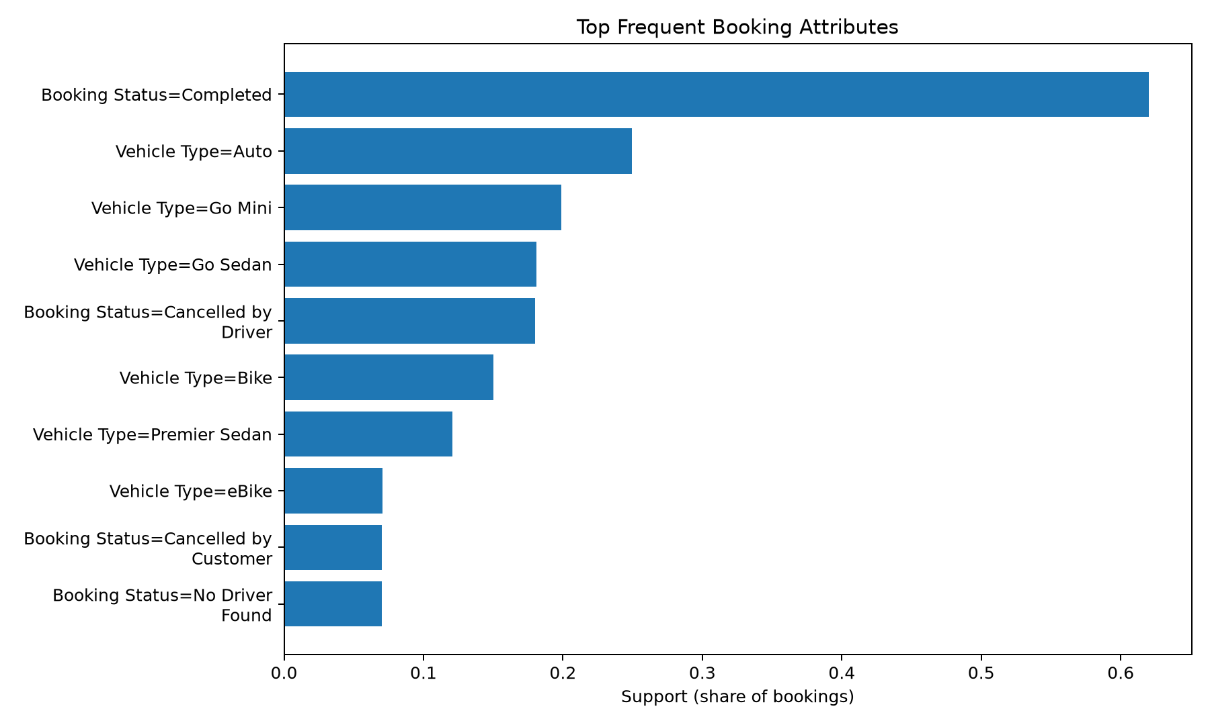
Figure 2. Support of the ten most frequent individual booking attributes.

Output 4 — Association Rule Scatter Plot
Generated figure: exp9_outputs/rules_scatter.png
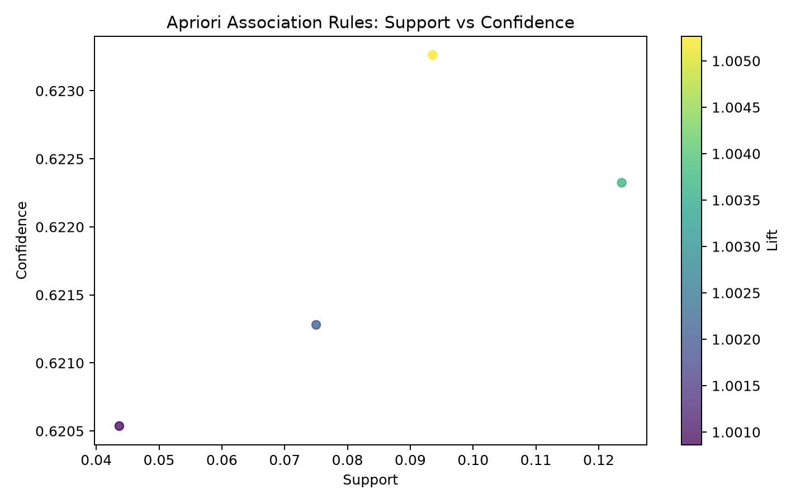
Figure 3. Four rules plotted by support and confidence; colour indicates lift.

Observations and Interpretation
All observations below are based on the recorded output of the 150,000-booking dataset using support 0.02, confidence 0.30, and lift 1.00.
Observation | Value / Interpretation
Number of transactions | 150,000 bookings
Number of distinct binary items | 364 binary item columns
Minimum support and confidence | 0.020 support; 0.300 confidence (minimum lift 1.000)
Number of frequent itemsets | 23
Number of qualifying association rules | 4 (all with Booking Status=Completed as consequent)
Highest-lift rule | Vehicle Type=Bike => Booking Status=Completed
Support of selected rule | 0.093560 (9.3560%)
Confidence of selected rule | 0.623262 (62.3262%)
Lift of selected rule | 1.005262 (very close to 1)
Result

Inference

Conclusion

GitHub Link
https://github.com/RamPanjwani/DMBI/tree/main/Experiment-09-Python-Apriori

