Experiment No. 7

Experiment Title | To implement the Clustering algorithms (k-means, Agglomerative, DBSCAN) using RapidMiner/Weka tool.
Course  Outcomes | CO4: Implement the appropriate data mining methods like classification, clustering or Frequent Pattern mining on large data sets.  CO5: Define and apply metrics to measure the performance of various data mining algorithms.
Date of Preparation |  | Date of Submission
Signature & Grade

Name: Ram Panjwani
Roll no: 32

Experiment 7 - To implement the Clustering algorithms (k-means, Agglomerative, DBSCAN) using RapidMiner/Weka tool.
Practical performed: K-Means using Weka.
Aim
To implement the K-Means clustering algorithm using the Weka tool on an Uber cab booking dataset and analyze the resulting groups of completed rides.
Objective
• To import numerical Uber ride-booking records into Weka.
• To configure and execute SimpleKMeans with three clusters.
• To interpret the resulting centroids, cluster sizes and visualization.
Software/Tools Required
Weka 3.8.7; Windows PC; Uber completed-rides CSV dataset.
Theory
Clustering is an unsupervised machine learning technique that organizes similar data records into groups called clusters without using a predefined target class. K-Means divides data into k clusters based on similarity. It repeatedly assigns each record to its nearest centroid and recalculates the centroids until the assignments stabilize or the iteration limit is reached.
The Euclidean distance measures the separation between records. The within-cluster sum of squared errors measures how closely records lie to their assigned centroids; smaller values generally indicate more compact clusters for the same data and distance setup.

Dataset Description
The dataset contains 5,000 completed Uber rides and four numeric attributes: Avg VTAT, Avg CTAT, Booking Value, and Ride Distance. These attributes represent ride-related measurements used to discover patterns in trips. No class label is used in clustering.
Attribute | Description
Avg VTAT | Average vehicle arrival time
Avg CTAT | Average customer arrival time
Booking Value | Booking amount
Ride Distance | Distance of completed ride
Implementation / Procedure
Step 1: Open Weka GUI Chooser and select Explorer. In the Preprocess tab, click Open file and import uber_completed_clustering_5000.csv. Confirm that the dataset contains 5,000 instances and 4 numeric attributes.
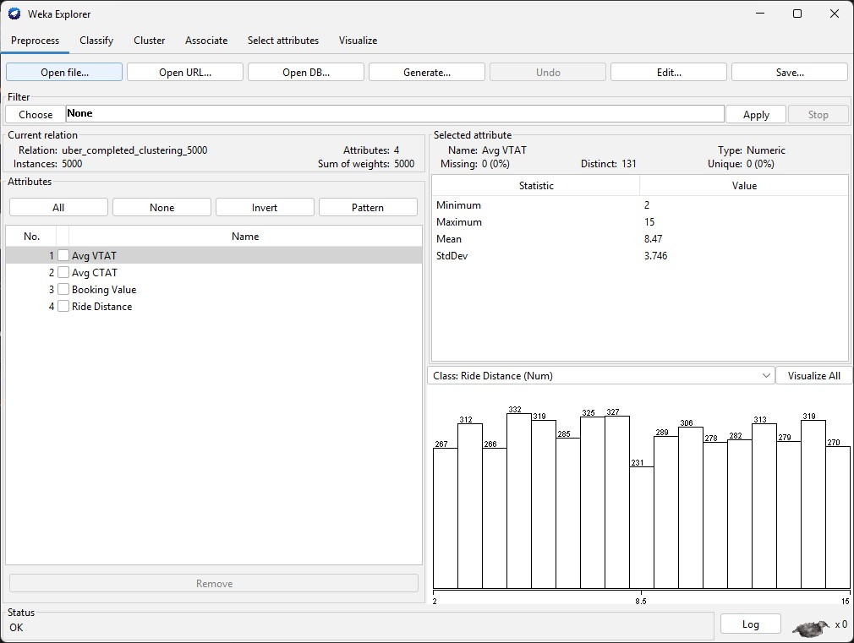
Figure 1: Imported Uber ride dataset in Weka Preprocess.
Step 2: Open the Cluster tab and select SimpleKMeans. Configure the number of clusters as 3, random seed as 42, maximum iterations as 500, Euclidean distance, and preserve instance order as True. Select Use training set and enable Store clusters for visualization.
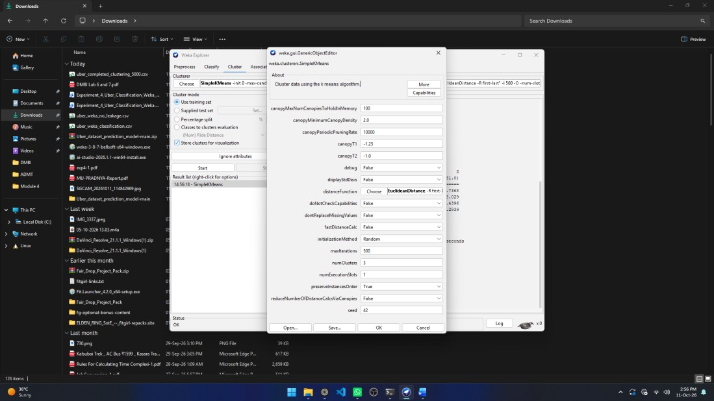
Figure 2: SimpleKMeans parameter configuration.
Step 3: Click Start. Weka trains the clustering model and shows the number of iterations, withincluster squared errors, centroids, and cluster sizes.

Cluster Visualization
Step 4: Right-click the SimpleKMeans result, select Visualize cluster assignments, and choose Ride Distance for the X-axis, Avg CTAT for the Y-axis, and Cluster for colour.
Output
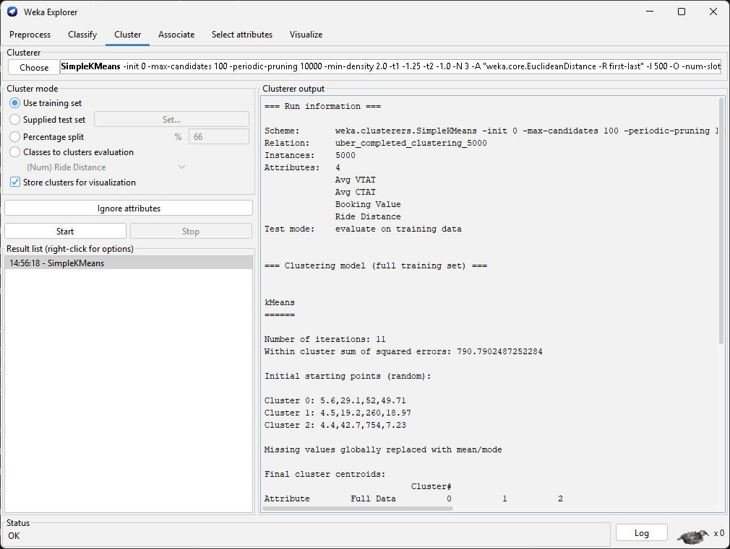
Figure 3: K-Means model run information and clustering output.
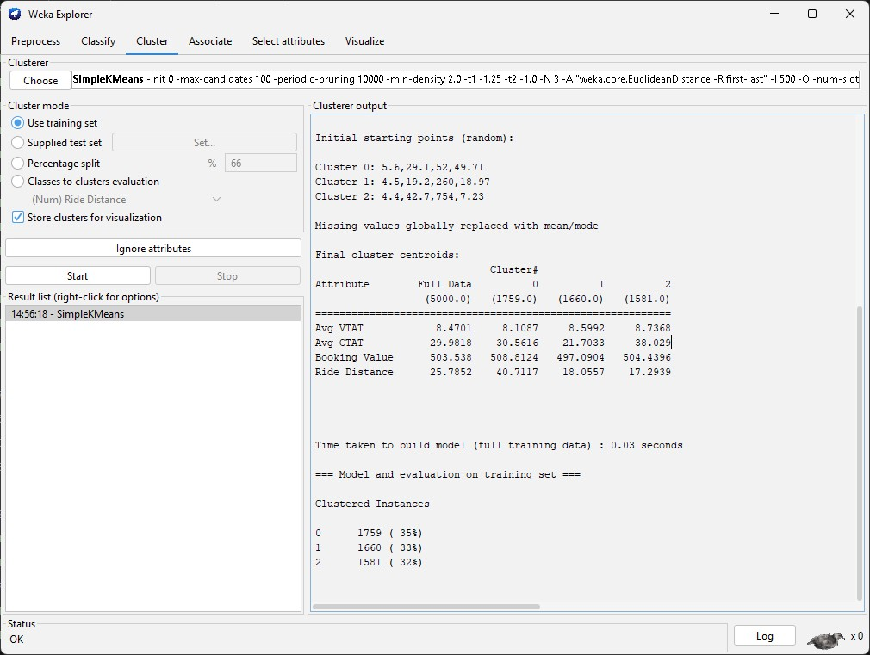
Figure 4: Final cluster centroids and cluster sizes.
Parameter | Observed Result
Number of records | 5,000
Number of clusters (k) | 3
Number of iterations | 11
Within-cluster sum of squared errors | 790.7902
Build time | 0.03 seconds
Cluster 0 | 1,759 rides (35.18%)
Cluster 1 | 1,660 rides (33.20%)
Cluster 2 | 1,581 rides (31.62%)
The final cluster centroids are shown below (values rounded to four decimal places).
Attribute | Cluster 0 | Cluster 1 | Cluster 2
Avg VTAT | 8.1087 | 8.5992 | 8.7368
Avg CTAT | 30.5616 | 21.7033 | 38.0290
Booking Value | 508.8124 | 497.0904 | 504.4396
Ride Distance | 40.7117 | 18.0557 | 17.2939
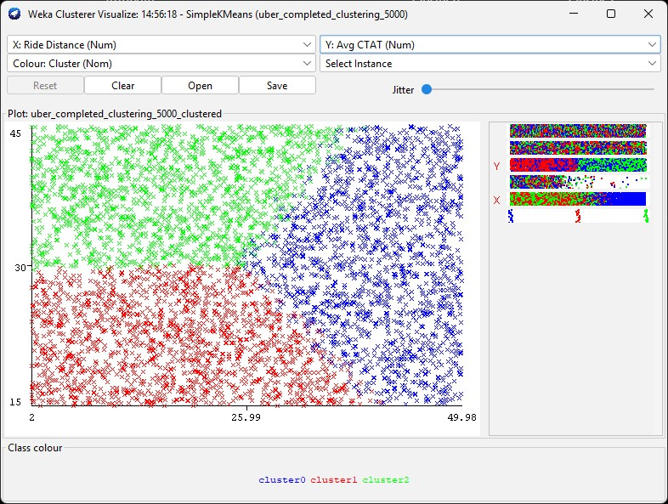
Figure 5: Cluster scatter plot showing Ride Distance versus Avg CTAT.

Result

Inference

Conclusion

GitHub Link
https://github.com/RamPanjwani/DMBI/tree/main/Experiment-07-Weka-KMeans

