EXP2
CHARACTERISTICS STUDY OF SIDE BAND POWER AND FREQUENCIES IN AM USING MATLAB
OBJECTIVE 1:
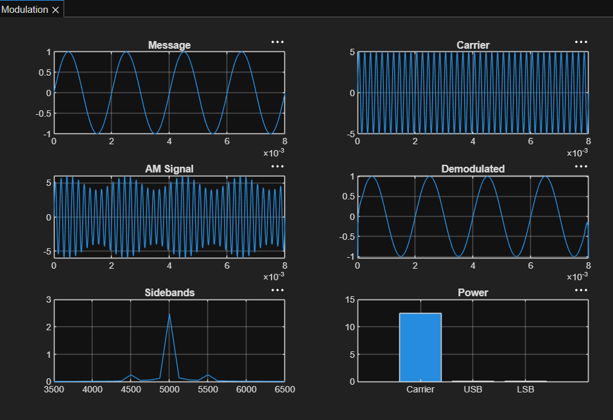

OBJECTIVE 2:
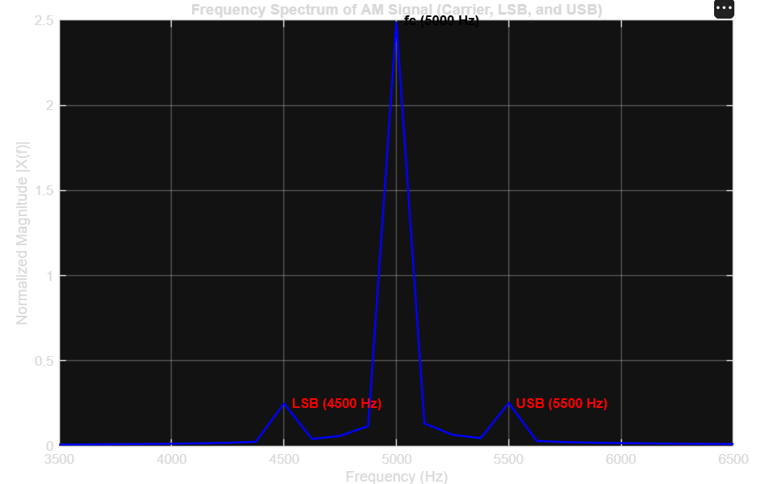

OBJECTIVE 3:
