Ex.no:9 | MINI PROJECT – SOCIAL MEDIA DATA DATA ANALYTICS

Domain and Problem Statement
Domain: Social Media Analytics & Performance Analysis
Problem Statement:
Social media platforms generate large volumes of data involving views, likes, comments, shares, content types, creators, and audience segments. Analyzing these values manually makes it difficult to understand engagement patterns and compare the performance of different platforms and content types.
Therefore, the project develops an interactive Social Media Analytics Dashboard using SQL Server, Power BI, and Tableau to analyze engagement, content performance, platform performance, audience segments, and creator performance.
Aim
To design, store, analyze, and visualize social media data using SQL Server, Power BI, and Tableau to derive meaningful insights into views, likes, comments, shares, engagement, content performance, platform performance, audience segments, creator performance, and social media trends.
Dataset Source
Source: Social Media Analytics Dataset
The dataset was prepared for social media performance analysis and stored in SQL Server before connecting it to Power BI and Tableau.
Dataset Description
The dataset was prepared before visualization by validating the required fields and organizing the information into appropriate relational tables.
The major entities used are:
Table | Purpose
Platforms | Stores platform-related information
Creators | Stores creator information
Content | Stores content-related information
Posts | Stores post-level metrics
The dataset used for the Social Media Analytics project contains social media post-level performance information. Each record represents an individual social media post and contains information about the platform, creator, content type, date and engagement metrics.
The dataset contains approximately 3,000 social media posts covering multiple years and different social media platforms.
The project uses a relational structure consisting of four tables:
- Platforms
- Creators
- Content
- Posts
The data is organized in SQL Server as SocialMediaAnalyticsDB and is used as the common data source for Power BI and Tableau.
Main Platforms
The project analyses platforms such as:
- Facebook
- Instagram
- X
- YouTube
Main Content Types
The dashboard includes content types such as:
- Article
- Image
- Reel
- Video

Data Preparation using Python
Python with Pandas is used to load, inspect, clean and transform the social media dataset before storing it in SQL Server.
The following operations are performed:
- Dataset loading
- Dataset inspection
- Missing-value detection
- Duplicate detection
- Date conversion
- Numeric data conversion
- Categorical data standardization
- Removal of duplicate records
- Creation of derived fields
- Export of cleaned dataset
IMPORT REQUIRED LIBRARIES
import pandas as pd
import numpy as np
LOAD THE DATASET
df = pd.read_csv("social_media_data.csv")
print("Dataset loaded successfully")
print(df.head())
DISPLAY DATASET SHAPE
print("Number of Rows:", df.shape[0])
print("Number of Columns:", df.shape[1])
Expected output:
Number of Rows: 3000
Number of Columns: 15
DISPLAY DATASET INFORMATION
df.info()
This is used to examine:
- Column names
- Data types
- Number of non-null values
- Memory usage
CHECK MISSING VALUES
print(df.isnull().sum())
Missing values are checked for all columns before performing further analysis.
CHECK DUPLICATE RECORDS
print("Duplicate Records:", df.duplicated().sum())
Duplicate records are removed using:
df = df.drop_duplicates()

SQL Server Database
The cleaned dataset was imported into SQL Server.
Database Name:
SocialMediaAnalyticsDB
Table Name:
Platforms
Creators
Content
Posts
The SQL Server database was then used as the common data source for both Power BI and Tableau.
The workflow therefore becomes:
SQL Server – Database Creation
CREATE DATABASE SocialMediaAnalyticsDB;
GO
USE SocialMediaAnalyticsDB;
GO
Create Platforms Table
CREATE TABLE Platforms
(
PlatformID INT PRIMARY KEY,
PlatformName VARCHAR(50)
);
Create Creators Table
CREATE TABLE Creators
(
CreatorID INT PRIMARY KEY,
CreatorName VARCHAR(100),
Region VARCHAR(50),
AudienceSegment VARCHAR(50)
);
Create Content Table
CREATE TABLE Content
(
ContentID INT PRIMARY KEY,
ContentType VARCHAR(50),
Category VARCHAR(100)
);
Create Posts Table
CREATE TABLE Posts
(
PostID INT PRIMARY KEY,
PostDate DATE,
PlatformID INT,
CreatorID INT,
ContentID INT,
Views BIGINT,
Likes BIGINT,
Comments BIGINT,
Shares BIGINT,

FOREIGN KEY (PlatformID)
REFERENCES Platforms(PlatformID),

FOREIGN KEY (CreatorID)
REFERENCES Creators(CreatorID),

FOREIGN KEY (ContentID)
REFERENCES Content(ContentID)
);

Procedure:

Step 1: Data Preparation & Preprocessing (Python / Pandas)
- Load the raw Kaggle dataset into a Jupyter Notebook / Python script using pandas.read_csv().
- Inspect for null values and handle missing data in country, children, and agent columns.
- Feature engineer
- Filter out invalid rows and export the cleaned DataFrame to MySQL using sqlalchemy and to_sql().

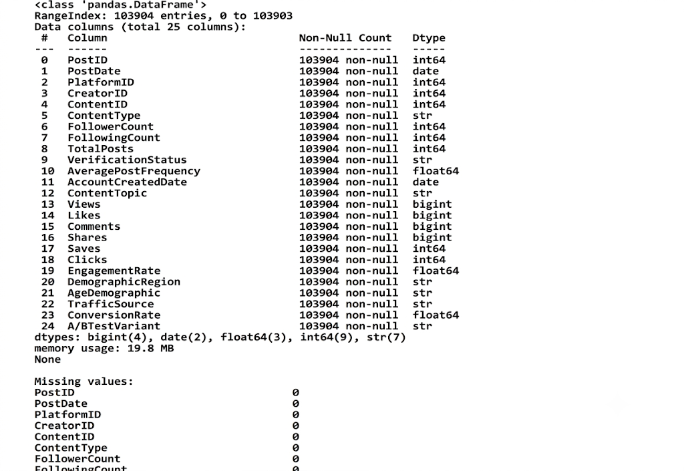

Step 2: SQL Database Connection & Data Ingestion
- Open Power BI Desktop $→$ Click Get Data $→$ Select MySQL Database.
- Enter the Server (localhost:3306) and Database Name (SocialMediaAnalyticsDB).
- Enter authentication credentials, select the cleaned flat table (Platforms Creators Content Posts), and click Transform Data to open Power Query

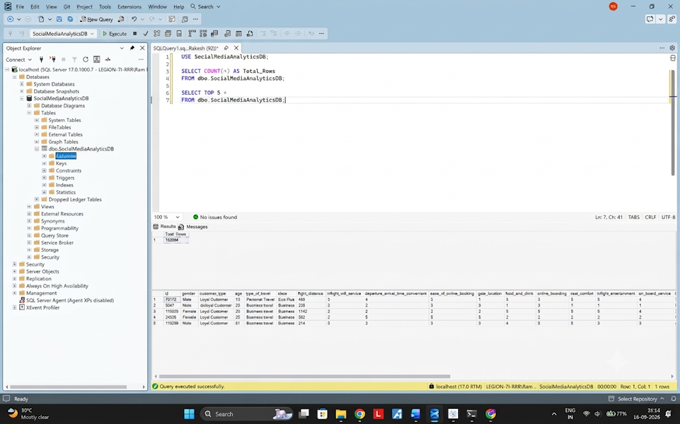

Power BI Analysis
The SQL Server database was connected to Power BI using the SQL Server connector and the Platforms Creators Content Posts table was imported.
DAX Measures
Total Views
Total Views =
SUM(Posts[Views])
Total Likes
Total Likes =
SUM(Posts[Likes])
Total Comments
Total Comments =
SUM(Posts[Comments])
Total Shares
Total Shares =
SUM(Posts[Shares])
Total Posts
Total Posts =
COUNTROWS(Posts)
Total Engagement
Total Engagement =
[Total Likes]
+ [Total Comments]
+ [Total Shares]
Engagement Rate %
Engagement Rate % =
DIVIDE(
[Total Engagement],
[Total Views],
0
)
Format this measure as a percentage.

Model View :
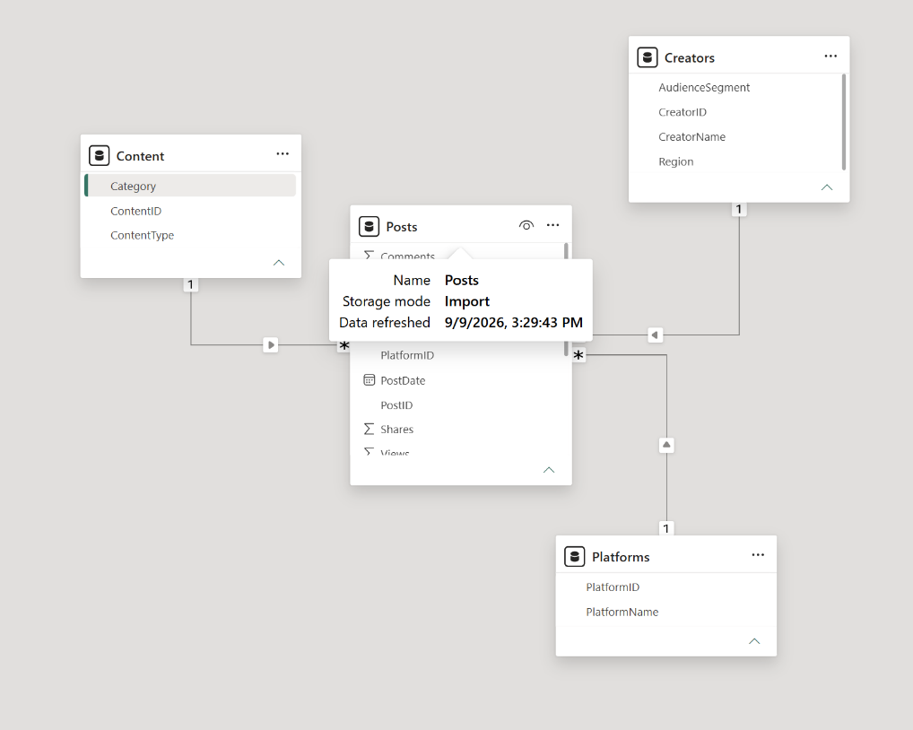
Power BI Visualizations
The dashboard contains:
KPI CARDS
The following KPI cards are used:
- Total Views
- Total Likes
- Total Comments
- Total Shares
- Total Posts
- Engagement Rate %
These provide an overall summary of social media performance.
ENGAGEMENT TREND
Chart Type:
Line Chart
Axis:
PostDate
Values:
Total Engagement
Purpose:
To identify how social media engagement changes over time.
The use of cards, slicers, advanced visuals and interactive analysis fits the DVT lab's stated Power BI capabilities, including KPI cards, slicers, advanced visualization and DAX calculations.
ENGAGEMENT BY PLATFORM
Chart Type:
Column Chart
Axis:
PlatformName
Values:
Total Engagement
This visualization compares engagement across different social media platforms.
Platforms include:
- Facebook
- Instagram
- X
- YouTube
VIEWS BY CONTENT TYPE
Chart Type:
Bar Chart
Axis:
ContentType
Values:
Total Views
This visualization compares the number of views generated by different content types.
Example content types:
- Article
- Image
- Reel
- Video
POWER BI SLICERS
The dashboard contains interactive slicers.
Slicer 1 – Post Date
Used to filter the analysis according to a selected date range.
Slicer 2 – Platform Name
Used to analyse a particular social media platform.
Slicer 3 – Content Type
Used to analyse selected content types.
These slicers interact with the dashboard visuals and allow users to dynamically explore the data.

KPI Cards :

Charts :
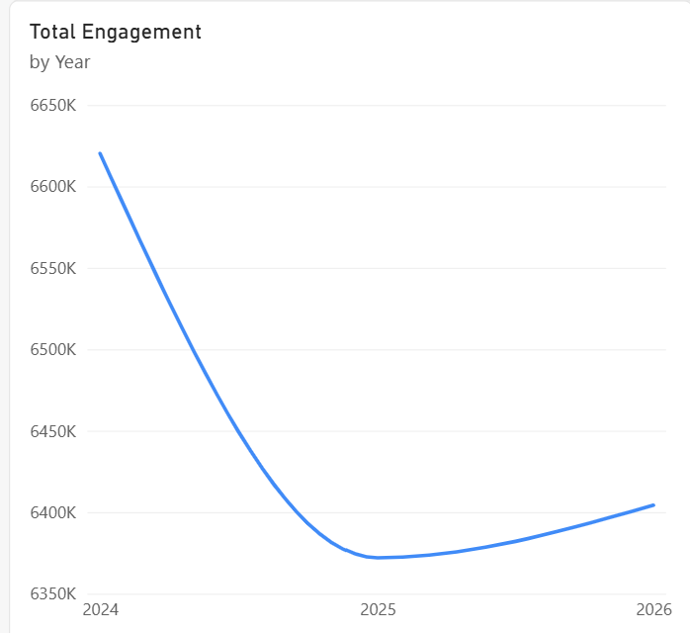
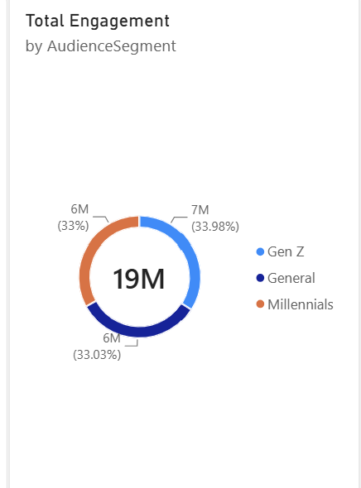
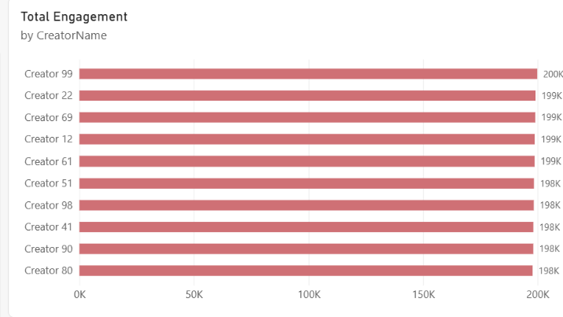
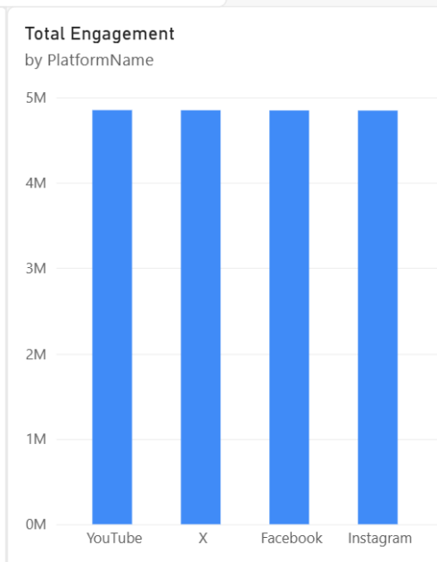
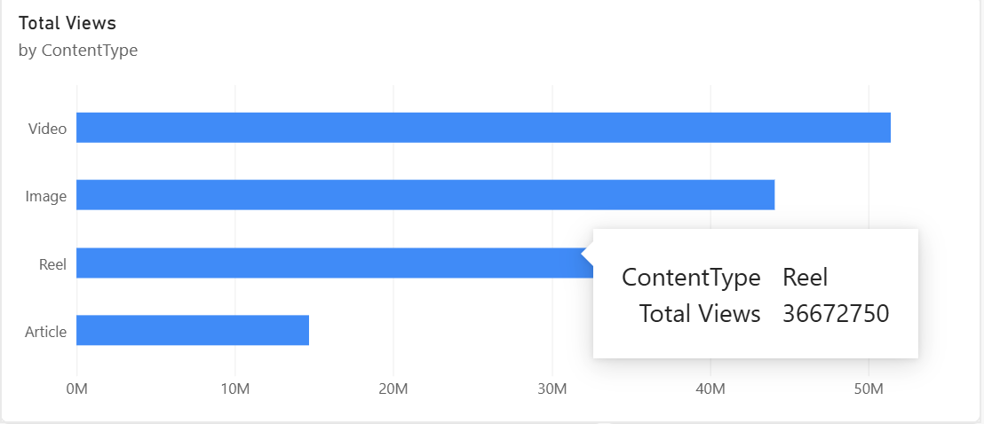

Slicers :
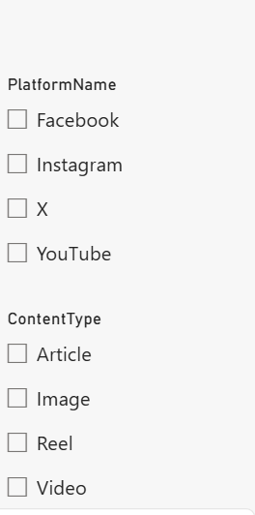

DashBoard :
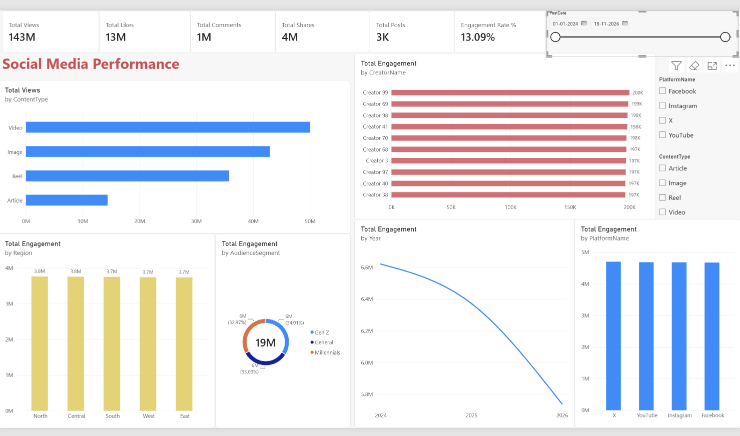

Tableau Analysis
Tableau is used as the second visualization platform for analysing the same social media data.
The Tableau workbook connects to:
SocialMediaAnalyticsDB
using the SQL Server connection.
The tables used are:
- Content
- Creators
- Platforms
- Posts
TABLEAU CALCULATED FIELDS
Total Views
SUM([Views])
Total Likes
SUM([Likes])
Total Comments
SUM([Comments])
Total Shares
SUM([Shares])
Total Engagement
SUM([Likes])
+
SUM([Comments])
+
SUM([Shares])
Engagement Rate %
(
SUM([Likes])
+
SUM([Comments])
+
SUM([Shares])
)
/
SUM([Views])
This calculated field measures the engagement generated relative to total views.
TABLEAU PARAMETER
A parameter can be used to allow users to control the minimum number of views or engagement required for analysis.
Parameter Name
Minimum Views
Data Type
Integer
Example Value
1000
The parameter can be used to dynamically filter posts based on their view count.
Example calculated field:
[Views] >= [Minimum Views]
This allows users to focus the dashboard on posts that meet a selected performance threshold

TABLEAU INTERACTIVE FEATURES
The Tableau dashboard contains:
- Date filters
- Platform filters
- Content Type filters
- Calculated fields
- Parameters
- Top 10 Creator analysis
- Interactive dashboard filtering
- Trend analysis
These features allow users to explore social media performance dynamically.

Charts :
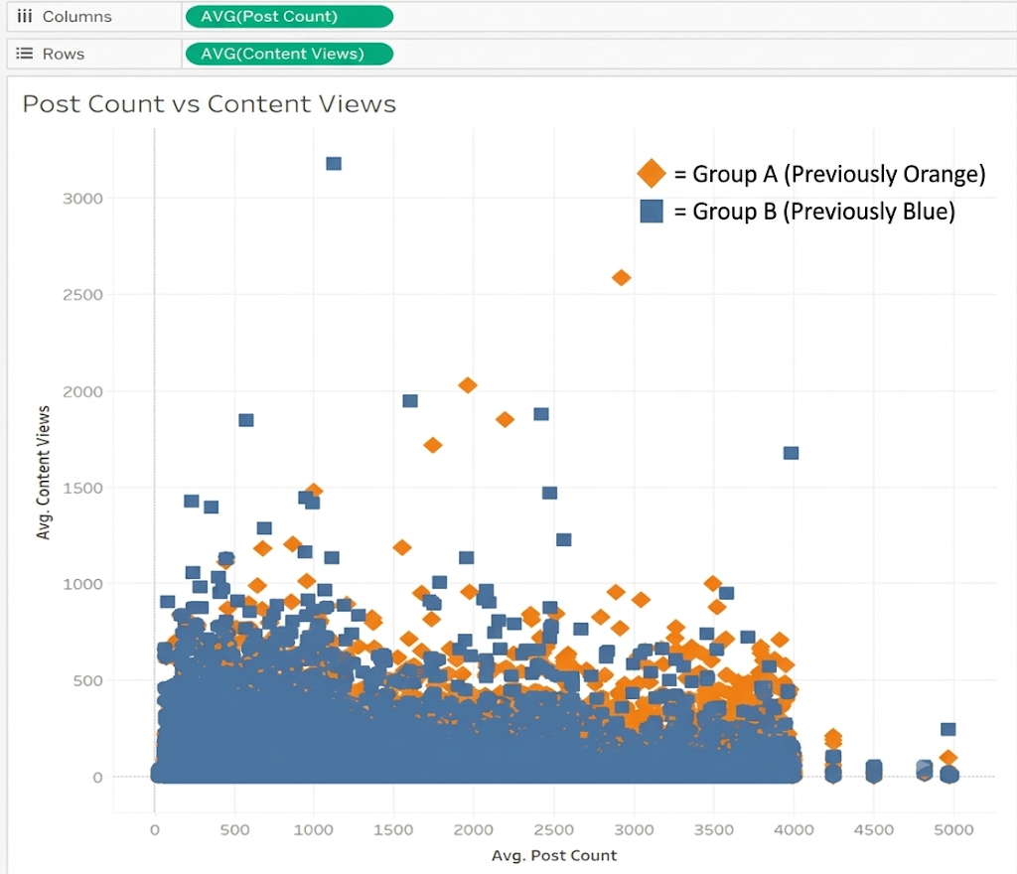
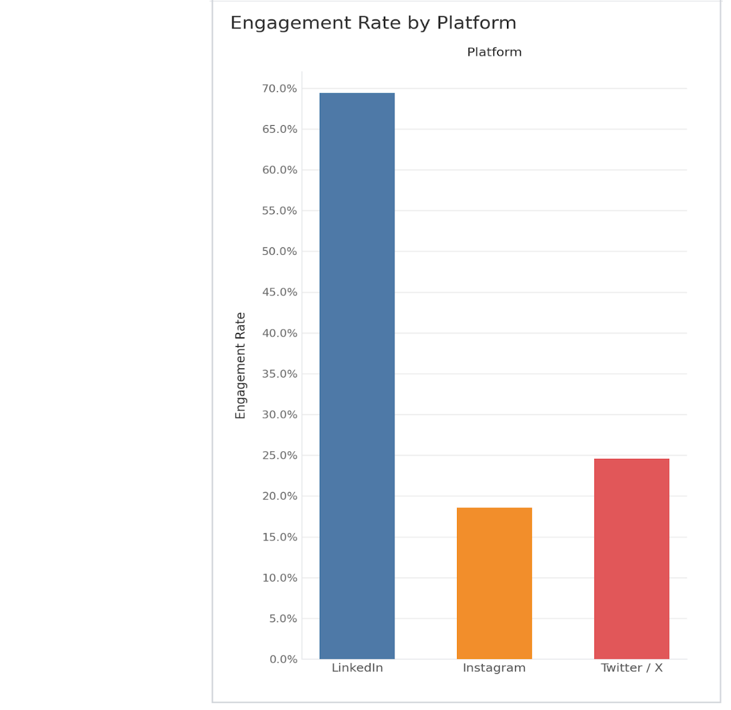

Filters :
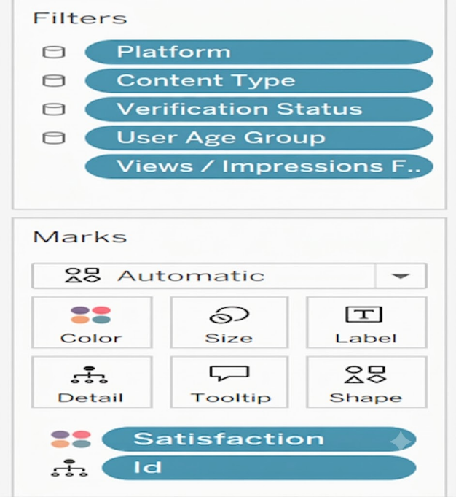
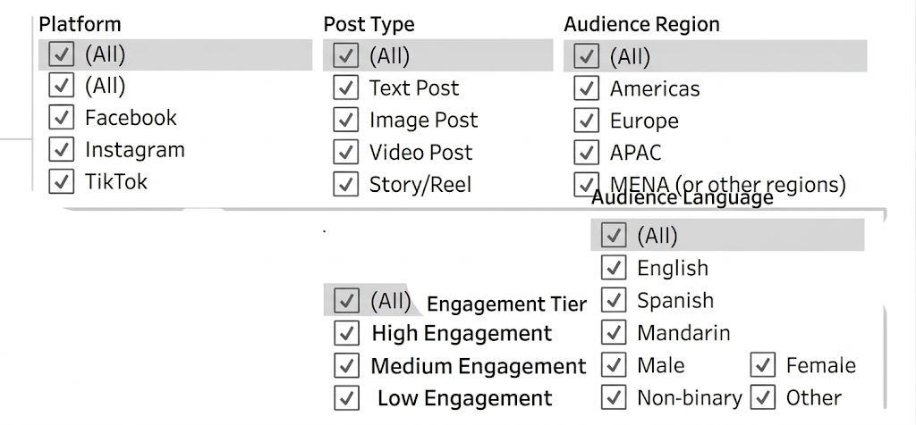

Parameters :
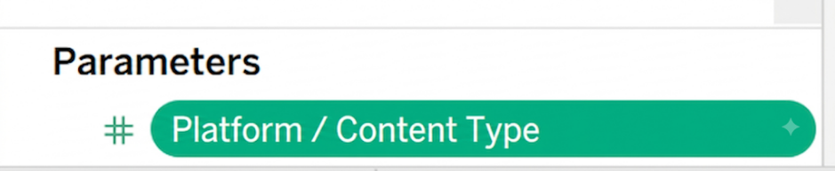
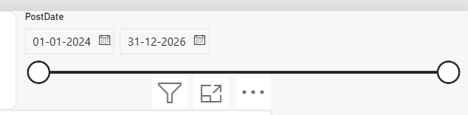
DashBoard :
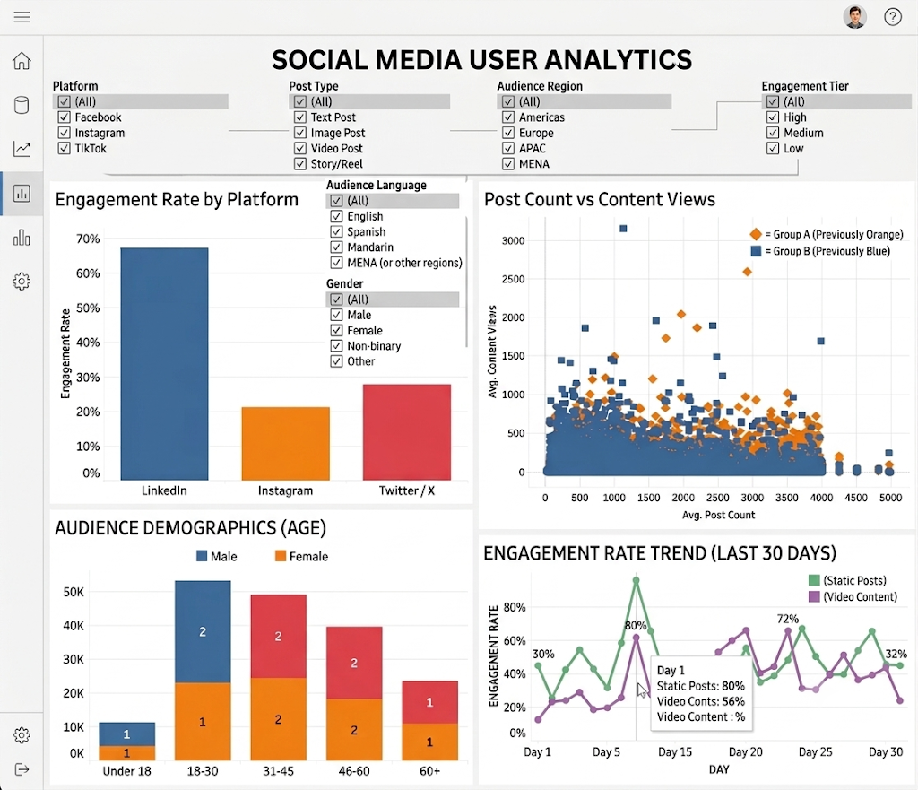

Dashboard Analysis / Observed Results
The Social Media Performance Dashboard provides an overview of the performance of social media posts using views, likes, comments, shares and engagement.
For the supplied dashboard state, the displayed metrics include approximately:
Total Views : 146,881,500
Total Engagement : 19,396,500
Total Posts : 3,000
These values represent the dashboard state shown in the supplied project and may change when filters are applied.
Conclusion
The Social Media Data Analytics mini project successfully demonstrates an end-to-end business intelligence workflow using Python, SQL Server, Power BI and Tableau. Python and Pandas are used for data inspection, cleaning and transformation. The prepared data is stored in a relational SQL Server database named SocialMediaAnalyticsDB, which contains Platforms, Creators, Content and Posts tables.
Power BI is used to create DAX measures, KPI cards, trend analysis, platform comparisons, content analysis, regional analysis, audience-segment analysis and Top 10 creator analysis. Interactive slicers and filters allow users to dynamically explore the dashboard.
Tableau is connected to the same SQL Server database and uses calculated fields, filters and parameters to create an interactive Social Media Performance Dashboard.
The project therefore provides a complete analytical solution for understanding social media views, interactions, engagement, content performance, platform performance, creator performance and audience trends.

