Ex.no:8 | MINI PROJECT – AIRLINE PASSENGER SATISFACTION DATA ANALYTICS

Domain and Problem Statement
Domain: Tourism Analytics & Airline Passenger Satisfaction
Problem Statement:
Airline companies need to understand passenger satisfaction, service quality, flight distance, travel type, passenger class, and flight delays to improve the overall travel experience. Raw passenger survey records contain multiple service ratings and travel-related attributes, making it difficult to identify satisfaction patterns directly. This project transforms airline passenger data into structured business intelligence using Python, SQL Server, Power BI, and Tableau to analyze passenger satisfaction, service-related factors, travel categories, flight distance, and delay patterns.
Aim
To clean, transform, store, analyze, and visualize airline passenger satisfaction data using Python, SQL Server, Power BI, and Tableau to derive meaningful insights into passenger satisfaction, travel class, travel type, flight distance, and flight delays.
This follows the same overall workflow as your friend's mini-project, where the aim is to move from raw transactional data through database storage and BI dashboards.
Dataset Description
Dataset Name: Airline Passenger Satisfaction Dataset
Dataset Source: Kaggle
Dataset Used: train.csv
Granularity: Each row represents an individual airline passenger record.
Number of Records: 103,904
Original Attributes: 25
Final Attributes after preprocessing: 27
Important attributes
Passenger Information
- Gender
- Age
- Customer Type
- Type of Travel
- Class
Flight Information
- Flight Distance
- Departure Delay in Minutes
- Arrival Delay in Minutes
Service Ratings
- Inflight Wifi Service
- Ease of Online Booking
- Online Boarding
- Seat Comfort
- Food and Drink
- Inflight Entertainment
- On Board Service
- Leg Room Service
- Baggage Handling
- Checkin Service
- Inflight Service
- Cleanliness
Target/Analysis Attribute
- Satisfaction
Derived Attributes
- Total Delay
- Age Group
- Distance Category

Data Preparation using Python
The dataset was loaded using Pandas and inspected for missing values, duplicate records, unnecessary columns, and data consistency.
Cleaning performed
- Removed the unnecessary Unnamed: 0 column.
- Checked duplicate records.
- Handled missing values in Arrival Delay in Minutes using the median.
- Verified that no duplicate records remained.
- Created Total Delay.
- Created Age Group.
- Created Distance Category.
- Standardized column names to lowercase with underscores.
- Saved the processed dataset as:
airline_passenger_satisfaction_cleaned.csv
Derived fields
Total Delay = Departure Delay + Arrival Delay
Age Group:
Under 18
18-30
31-45
46-60
60+
Distance Category:
Short
Medium
Long
Very Long

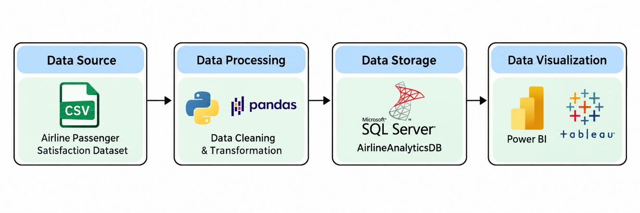
Architecture:

Program:
1)Import necessary lib
import pandas as pd
df = pd.read_csv("train.csv")
print("Dataset Shape:", df.shape)
df.head()
print(df.info())
print("\nMissing values:")
print(df.isnull().sum())
print("\nDuplicates:", df.duplicated().sum())
Step 2 — Basic cleaning
Run this in a new cell:
# Remove unnecessary index column
df = df.drop(columns=["Unnamed: 0"])
# Fill missing arrival delays with the median
df["Arrival Delay in Minutes"] = df["Arrival Delay in Minutes"].fillna(
df["Arrival Delay in Minutes"].median()
)
print("Shape after cleaning:", df.shape)
print("Missing values:", df.isnull().sum().sum())
print("Duplicates:", df.duplicated().sum())
# Total delay
df["total_delay"] = (
df["Departure Delay in Minutes"] +
df["Arrival Delay in Minutes"]
)
# Age groups
df["age_group"] = pd.cut(
df["Age"],
bins=[0, 18, 30, 45, 60, 100],
labels=["Under 18", "18-30", "31-45", "46-60", "60+"]
)
# Flight distance categories
df["distance_category"] = pd.cut(
df["Flight Distance"],
bins=[0, 1000, 2000, 4000, float("inf")],
labels=["Short", "Medium", "Long", "Very Long"]
)
print(df[["Age", "age_group", "Flight Distance",
"distance_category", "total_delay"]].head())
df.columns = (
df.columns
.str.strip()
.str.lower()
.str.replace(" ", "_")
.str.replace("/", "_")
.str.replace("-", "_")
)
print(df.columns.tolist())
df.to_csv("airline_passenger_satisfaction_cleaned.csv", index=False)

print("Cleaned dataset saved successfully!")
print("Final shape:", df.shape)

SQL Server Database
The cleaned dataset was imported into SQL Server.
Database Name:
AirlineAnalyticsDB
Table Name:
dbo.airline_passenger_satisfaction
The SQL Server database was then used as the common data source for both Power BI and Tableau.
The workflow therefore becomes:
SQL Server – Database Creation
CREATE DATABASE AirlineAnalyticsDB;
GO

USE AirlineAnalyticsDB;
GO
CREATE DATABASE IF NOT EXISTS AirlineAnalyticsDB;
Python/Jupyter:
username = "root"
password = "YOUR_MYSQL_PASSWORD"
host = "localhost"
port = 3306

# Connect to MySQL database
db_engine = create_engine(
f"mysql+pymysql://{username}:{password}@{host}:{port}/AirlineAnalyticsDB"
)

USE AirlineAnalyticsDB;
GO

SELECT COUNT(*) AS Total_Rows
FROM dbo.airline_passenger_satisfaction;
GO

SELECT TOP 5 *
FROM dbo.airline_passenger_satisfaction;
GO
Procedure:

Step 1: Data Preparation & Preprocessing (Python / Pandas)
- Load the raw Kaggle dataset into a Jupyter Notebook / Python script using pandas.read_csv().
- Inspect for null values and handle missing data in country, children, and agent columns.
- Feature engineer
- Filter out invalid rows and export the cleaned DataFrame to MySQL using sqlalchemy and to_sql().

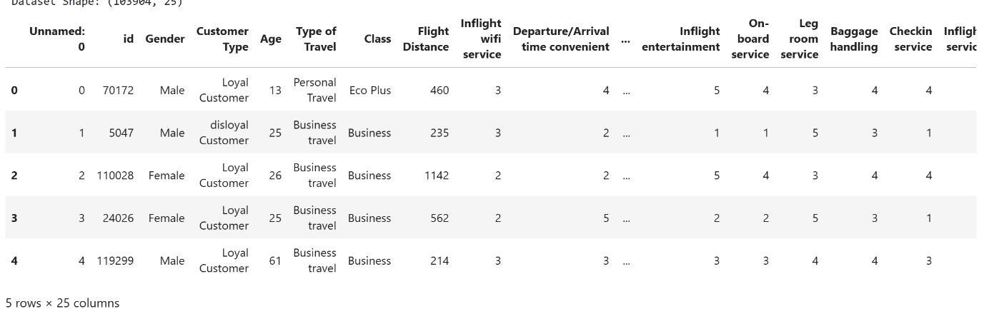

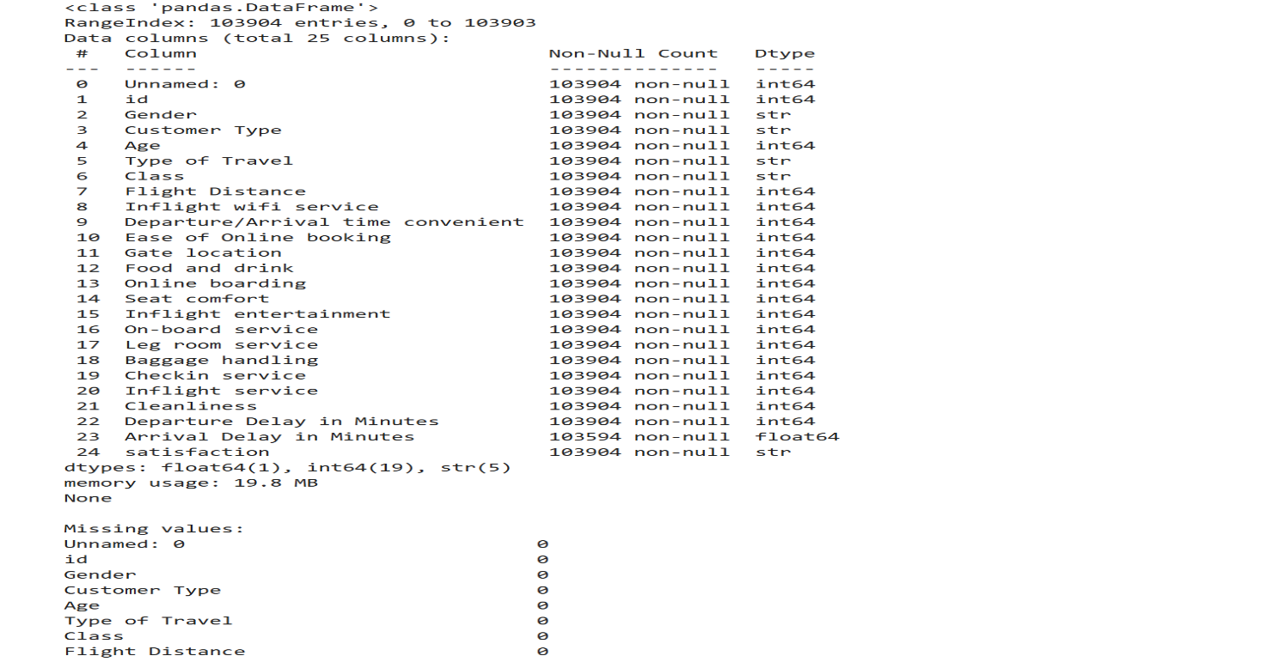

Step 2: SQL Database Connection & Data Ingestion
- Open Power BI Desktop $→$ Click Get Data $→$ Select MySQL Database.
- Enter the Server (localhost:3306) and Database Name (AirlineAnalyticsDB).
- Enter authentication credentials, select the cleaned flat table (dbo.airline_passenger_satisfaction), and click Transform Data to open Power Query

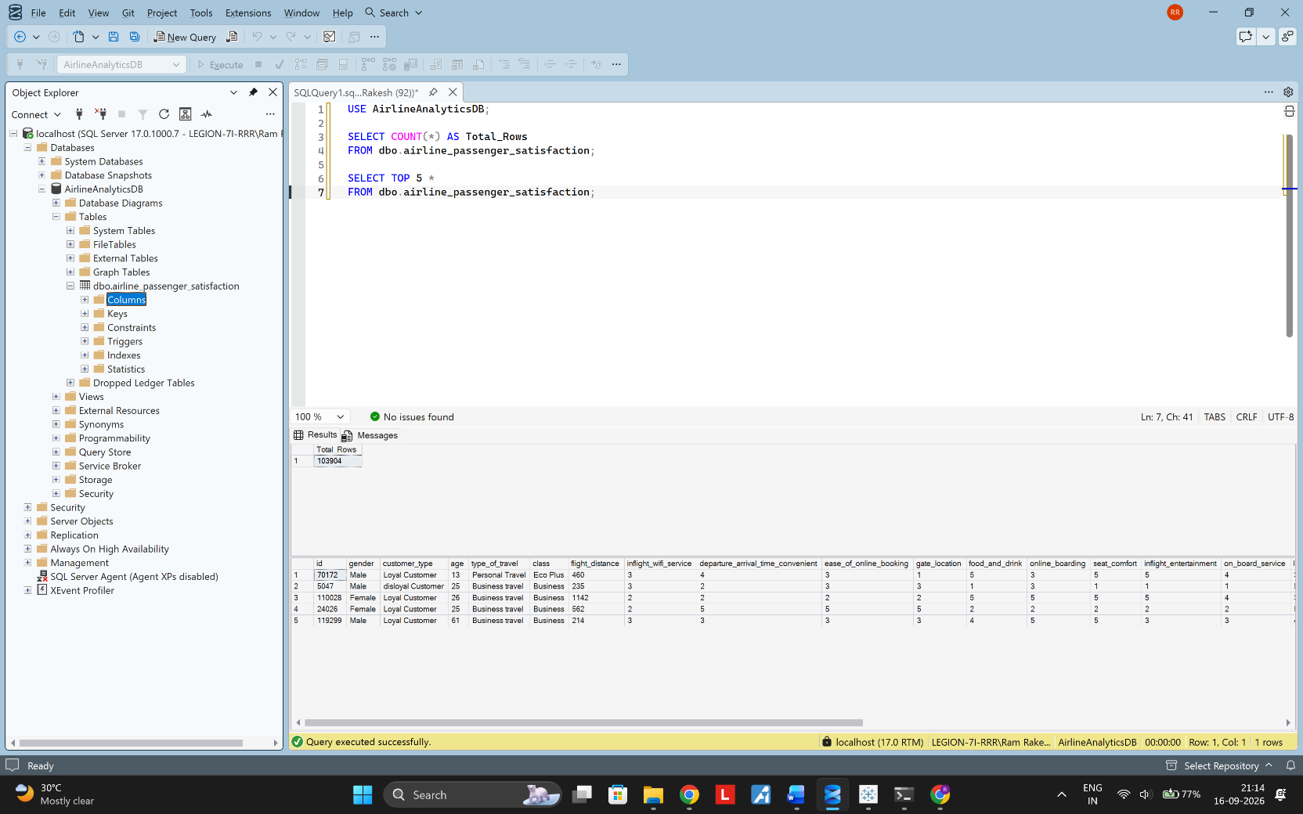

Power BI Analysis
The SQL Server database was connected to Power BI using the SQL Server connector and the airline_passenger_satisfaction table was imported.
DAX Measures
We created these measures:
Total Passengers =
COUNTROWS('airline_passenger_satisfaction')
Satisfied Passengers =
CALCULATE(
COUNTROWS('airline_passenger_satisfaction'),
'airline_passenger_satisfaction'[satisfaction] = "satisfied"
)
Satisfaction Rate =
DIVIDE(
[Satisfied Passengers],
[Total Passengers],
0
)
Average Flight Distance =
AVERAGE('airline_passenger_satisfaction'[flight_distance])
Average Total Delay =
AVERAGE('airline_passenger_satisfaction'[total_delay])
These are consistent with the friend's mini-project structure, where DAX measures are documented before developing interactive Power BI visualizations.
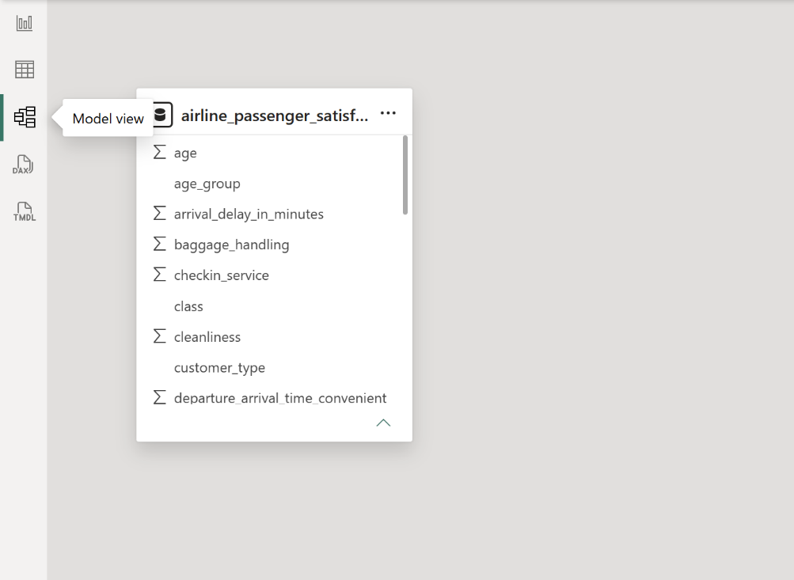
Model View :

Power BI Visualizations
The dashboard contains:
KPI Cards
- Total Passengers
- Satisfied Passengers
- Satisfaction Rate
- Average Flight Distance
- Average Total Delay
Charts
- Satisfaction by Class
- Satisfaction by Travel Type
- Passenger Distribution by Class
- Flight Distance vs Total Delay
Interactive Features
- Class slicer
- Type of Travel slicer
- Customer Type slicer
- Age Group slicer
- Key Influencers
- Drill-through/details page
The use of cards, slicers, advanced visuals and interactive analysis fits the DVT lab's stated Power BI capabilities, including KPI cards, slicers, advanced visualization and DAX calculations.
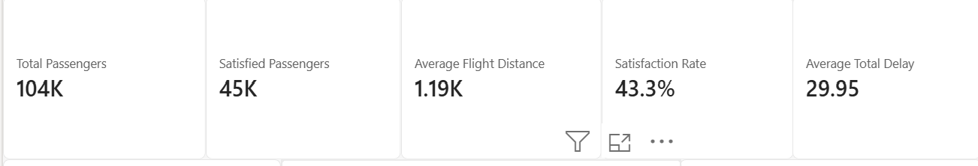
KPI Cards :
Key Influencers :
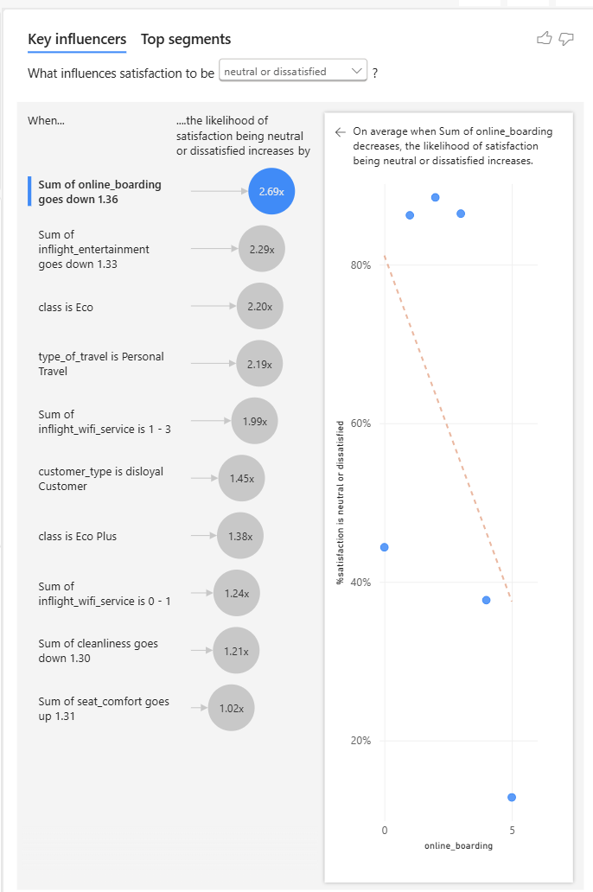
Charts :
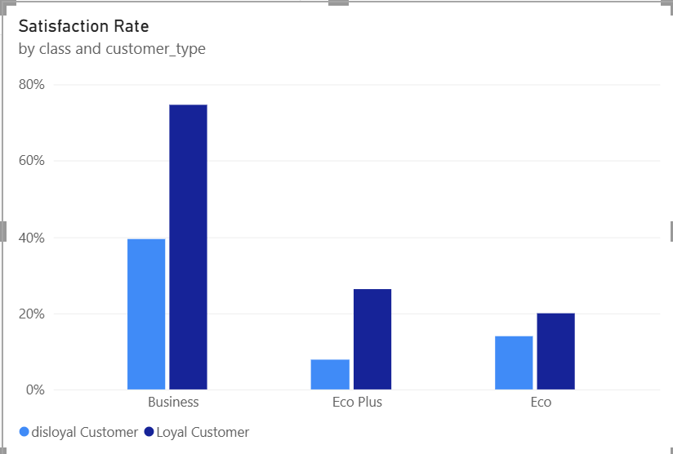
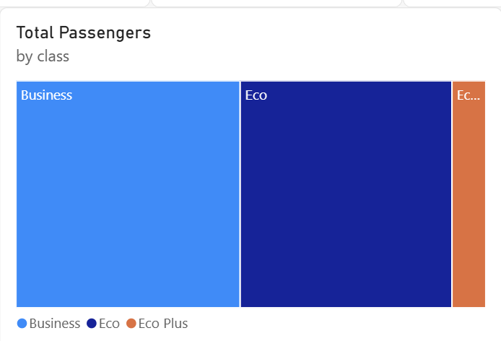
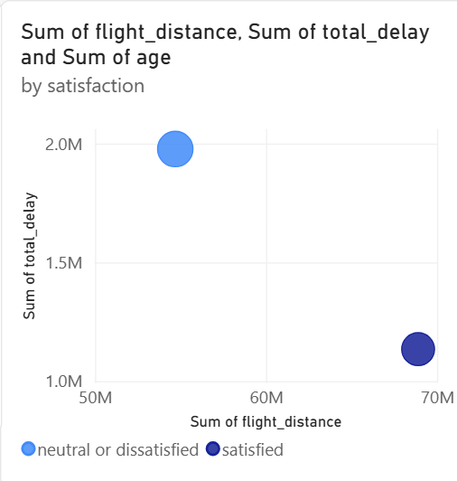
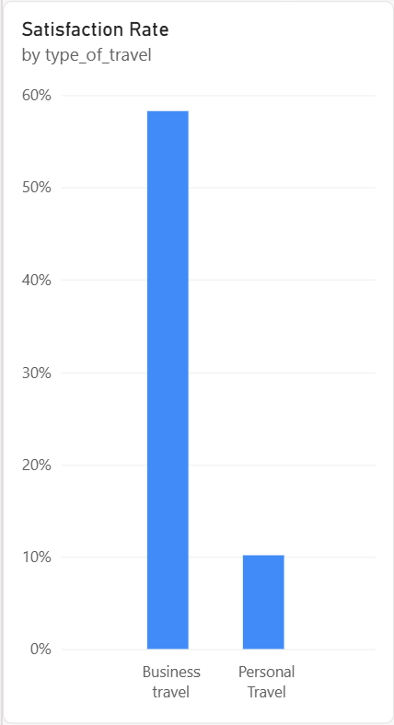
Slicers :
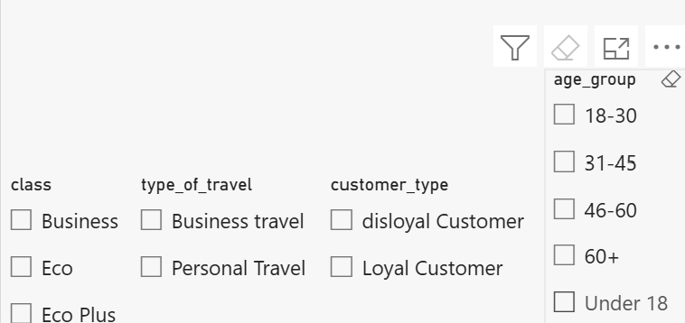

DashBoard :
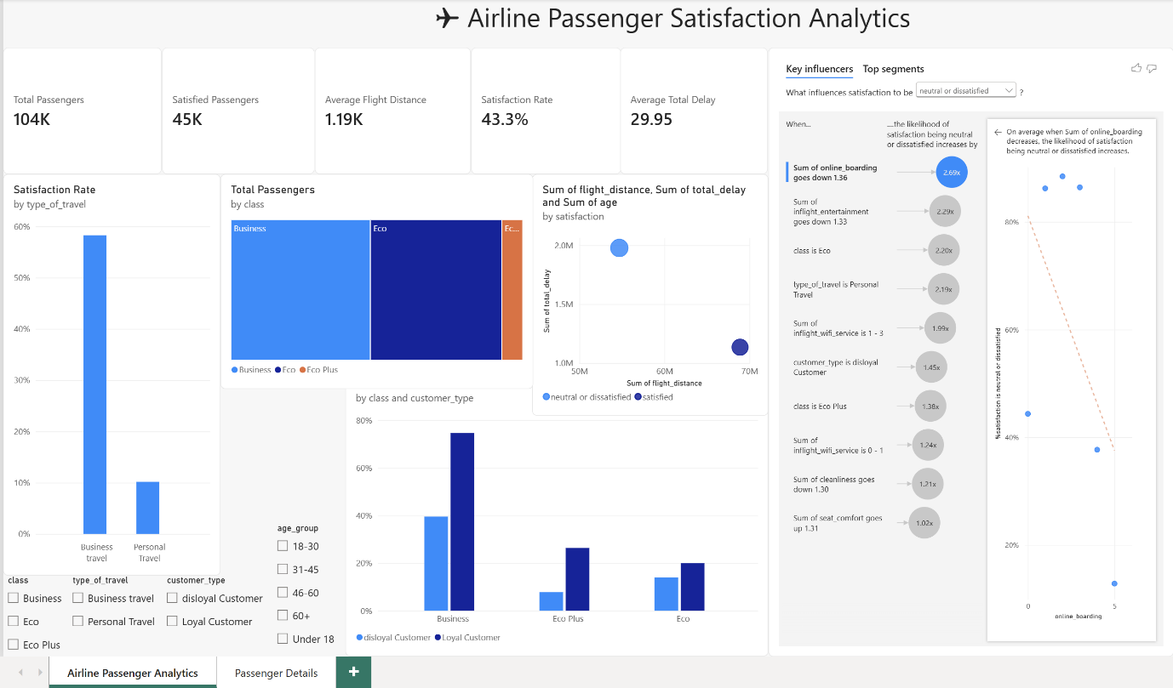
DRILL Through :
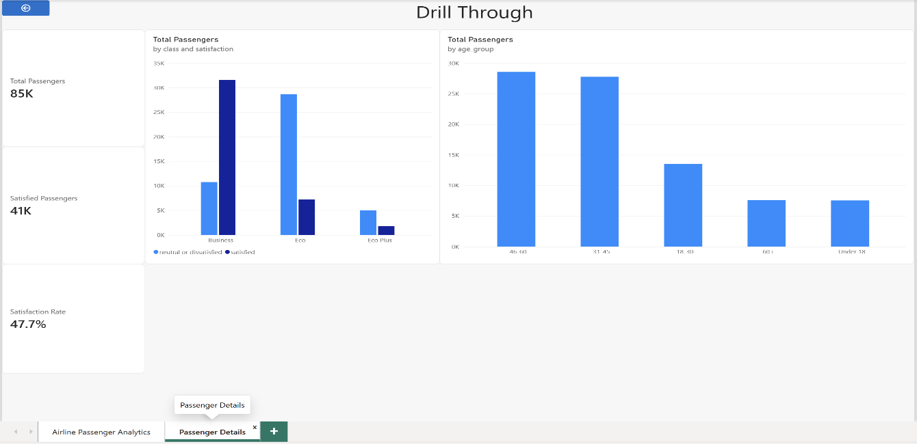

Tableau Analysis
The same SQL Server database was connected to Tableau.
The following worksheets were created:
- Satisfaction by Class
- Satisfaction by Travel Type
- Passenger Distribution by Class
- Flight Distance vs Total Delay
A Tableau calculated field was created:
1) Satisfaction Rate
Satisfaction Rate =
SUM(
IF [Satisfaction] = "satisfied" THEN 1 ELSE 0 END)/COUNT([Id])
Flight Distance Filter
Flight Distance Filter =
[Flight Distance] >= [Minimum Flight Distance]
Parameter used
Parameter Name: Minimum Flight Distance
Data Type: Integer
Minimum: 0
Maximum: 5000
Step Size: 100
The parameter allows the user to dynamically change the minimum flight-distance threshold in the Tableau analysis.
Tableau Interactive Features
The dashboard includes:
- Class filter
- Type of Travel filter
- Customer Type filter
- Age Group filter
- Minimum Flight Distance parameter
- Calculated field for flight-distance filtering
The Tableau lab manual specifically identifies filters and parameters as interactive analysis capabilities.
Charts :
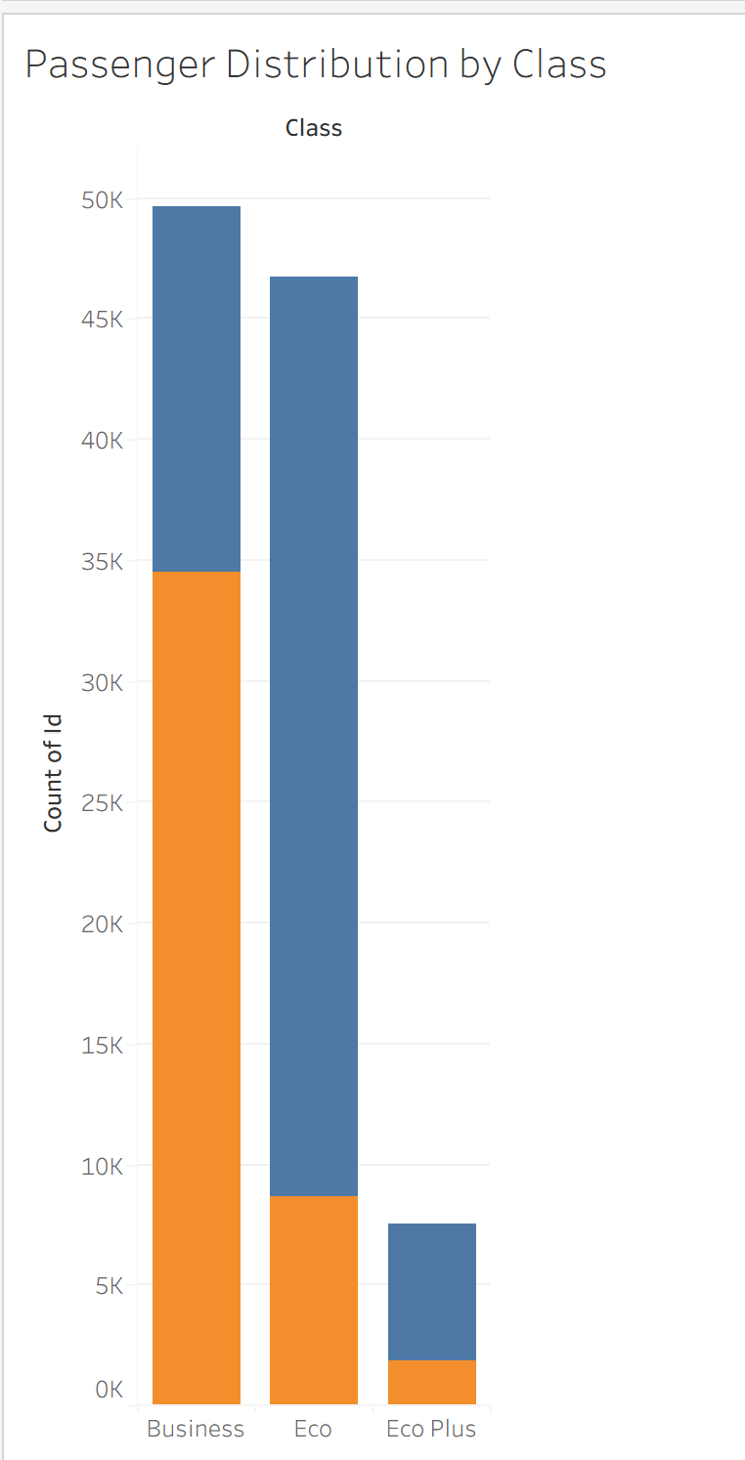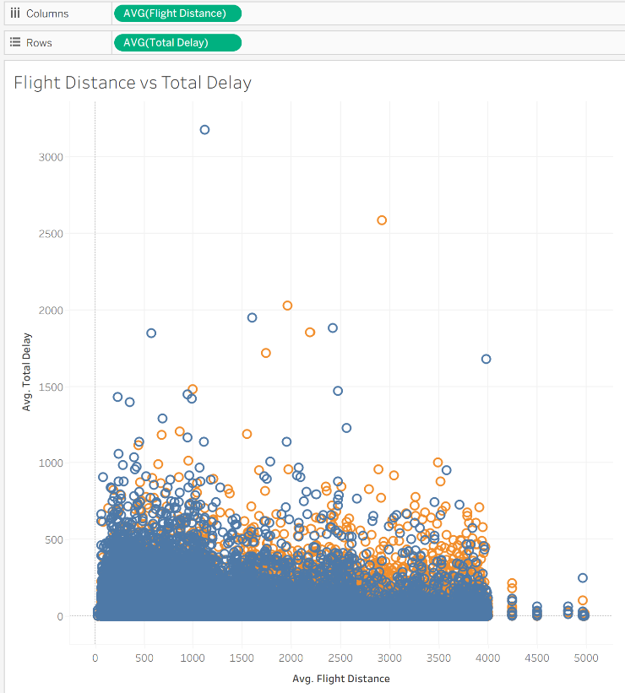
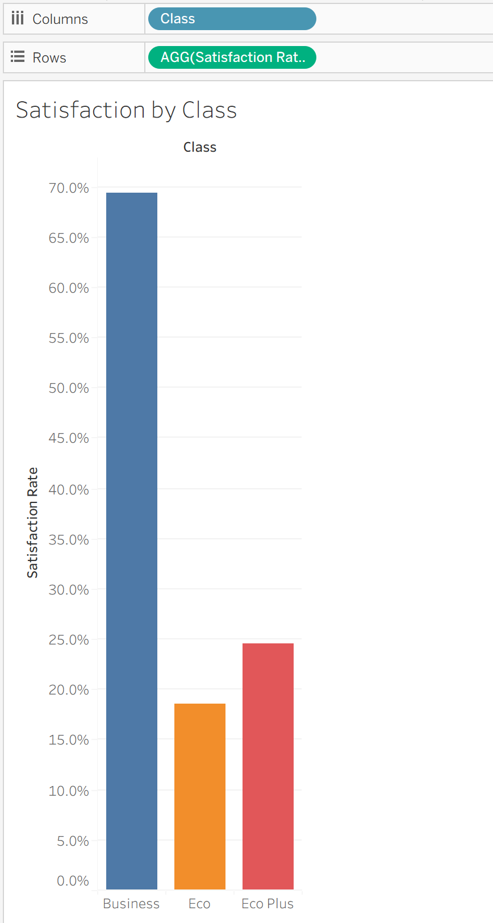
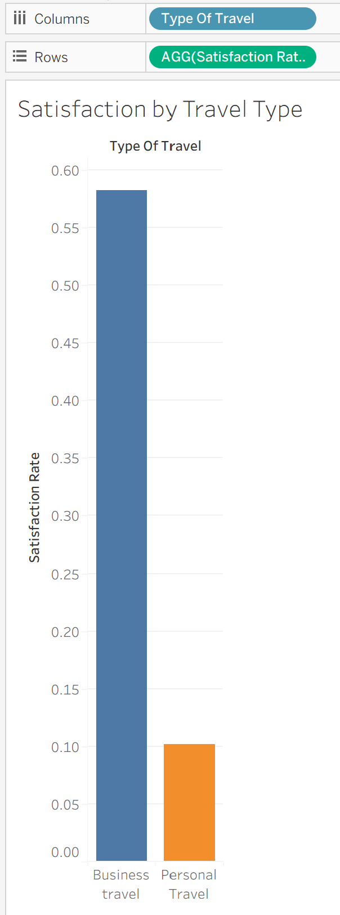
Filters :
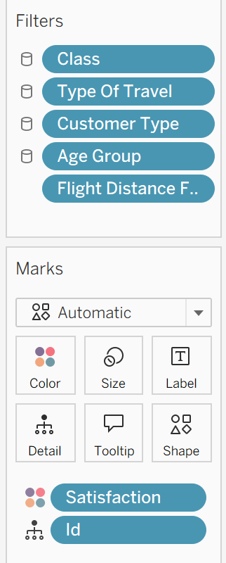
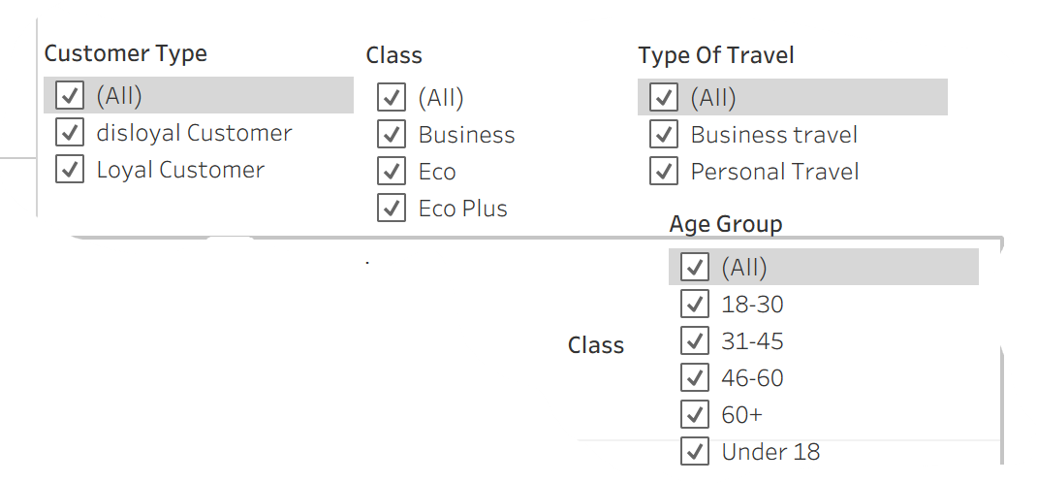
Calculated fields :
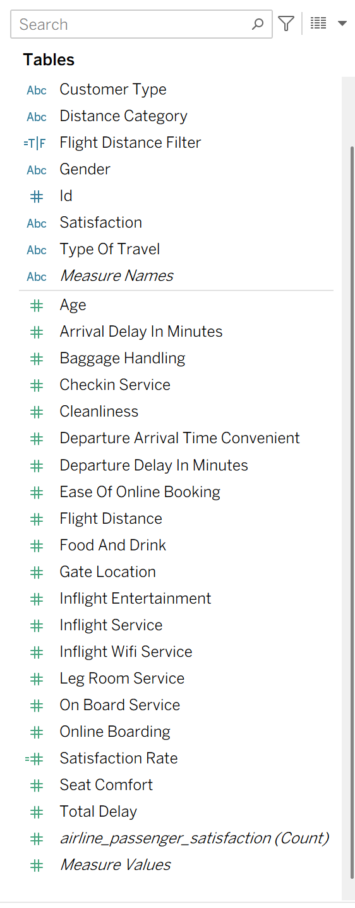
Parameters :
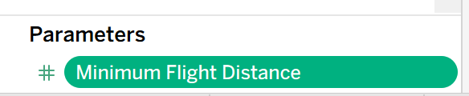
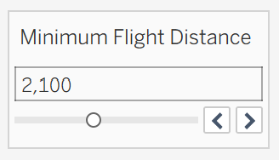
Filters Applied :
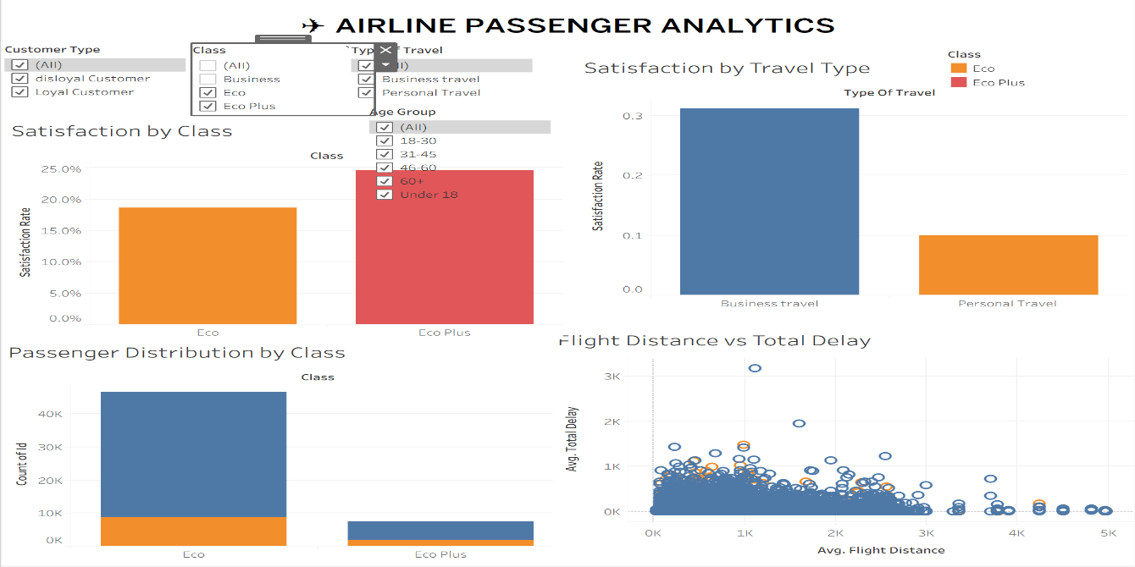
DashBoard :
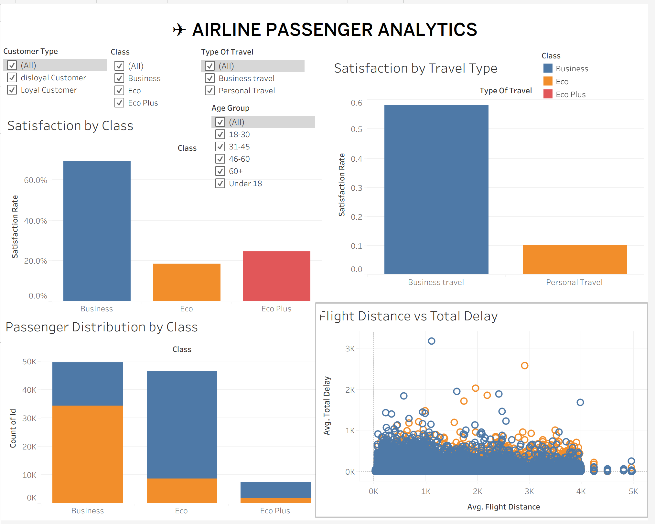

Dashboard Analysis / Observed Results
From our completed dashboard:
- Total passenger records analyzed: 103,904
- Overall satisfaction rate displayed in Power BI: 43.3%
- Average flight distance: approximately 1.19K km
- Average total delay: approximately 29.95 minutes
The class-based visualization shows noticeably different satisfaction rates across Business, Economy, and Economy Plus classes.
The travel-type visualization also shows a substantial difference between Business travel and Personal travel satisfaction rates.
The scatter visualization provides an interactive view of the relationship between flight distance and total delay, with passenger satisfaction represented through color.
The Key Influencers visual is used to investigate which passenger/service attributes are associated with the satisfaction outcome.

Conclusion
The Airline Passenger Satisfaction dataset was successfully cleaned and transformed using Python and stored in SQL Server. The SQL Server database was connected to both Power BI and Tableau for interactive analysis.
Power BI was used to create KPI cards, analytical charts, slicers, advanced analysis and interactive filtering, while Tableau was used to create worksheets, calculated fields, filters, parameters and an interactive dashboard.
The resulting dashboards provide a consolidated view of passenger satisfaction, travel class, travel type, flight distance and delay patterns.

