Does wind forecast error move GB imbalance prices?
Short note, October 2026. Elexon and NESO data, January 2024 to September 2026.

Short answer
We asked whether wind coming in below its day-ahead forecast pushes the GB imbalance price above the day-ahead market price, and what that costs a wind owner. We found no reliable link. The forecast is close to unbiased, a big shortfall does not make price spikes more likely, and for a 1 GW portfolio the cost of forecast error was about £265,000 in the first nine months of 2026, or 0.12% of revenue. We would keep selling the forecast as it stands, set credit aside for a bad day rather than an average one, and fill a few data gaps before anyone spends money on this. These are associations in public data, and the portfolio is hypothetical.

How imbalance works
Power is settled in 48 half-hour periods a day. A wind owner sells its expected output ahead of time at a price we proxy with the Market Index Price (MID). What it actually generates is different, and that gap is settled afterwards at one system price for the half-hour. If the owner generated less than it sold, it buys the gap at the system price. If it generated more, it sells the extra there. A forecast miss therefore costs the size of the miss times the gap between system price and MID, which we call the spread. Throughout, error is actual minus forecast, shortfall is the reverse (positive when wind is below forecast), and spread is system price minus MID.

Data and approach
The forecast is NESO's day-ahead wind forecast, taken from Elexon, using the last version published by 09:00 on the day before delivery. Actual wind is Elexon's total wind outturn, including estimated embedded wind. System prices, MID and demand also come from Elexon. We fitted everything on 2024 and 2025 and tested on January to September 2026. After cleaning, the panel has 36,325 half-hours over 774 days.

What we found
1. The forecast is close to unbiased. Actual wind averaged 1.2% of capacity (273 MW) above forecast, with a mean absolute error of 6.1% and an RMSE of 2.0 GW. We expected over-forecasting in high-wind periods, but the top forecast quintile has a mean error of +0.4% and its interval includes zero. As a range, 80% intervals fitted on 2024-25 contained 84.0% of 2026 half-hours (95% intervals: 94.2%) at an average width of 4.4 GW. Autumn is the exception at 66%, though that is September 2026 alone.
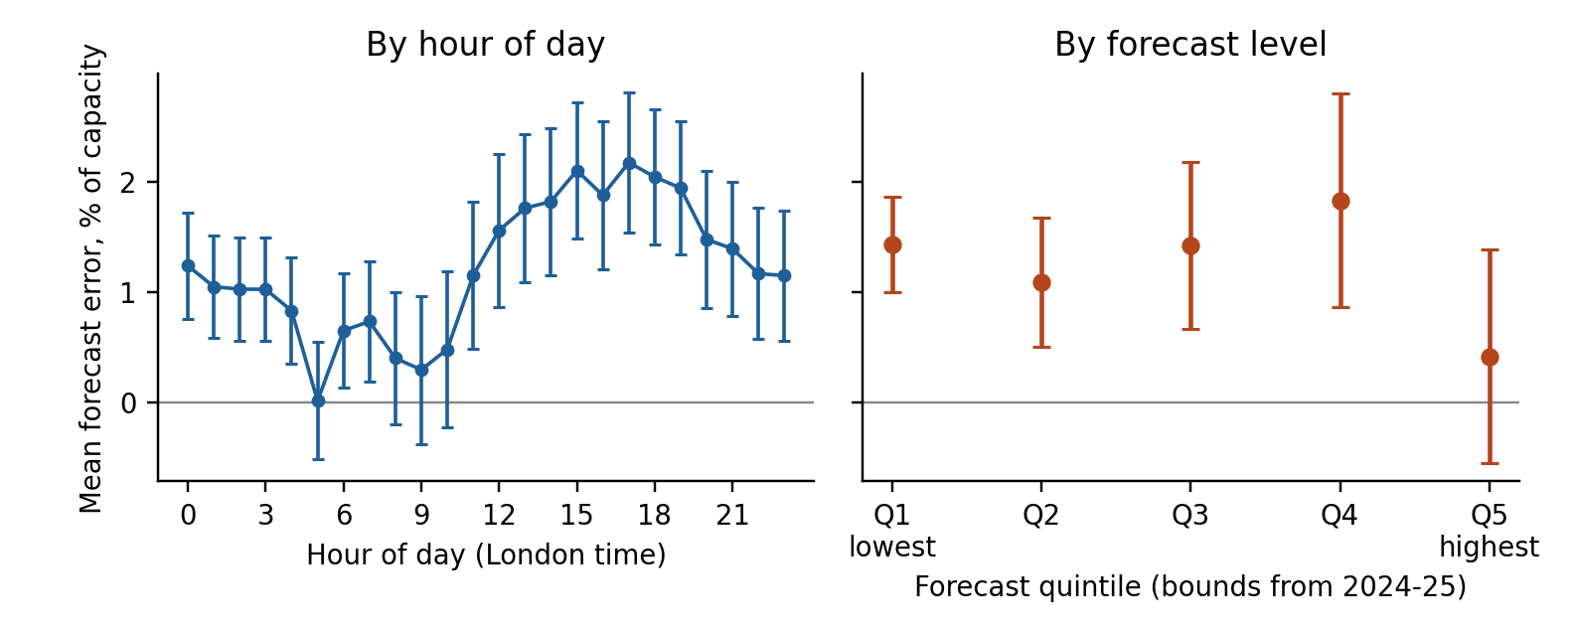
Exhibit 1. Mean forecast error (actual minus forecast) as % of capacity, with 95% intervals. Positive means wind above forecast.
2. Shortfall does not detectably move the spread. Raw averages rise with shortfall, from about -£1.1/MWh when wind beats the forecast by over 1 GW to +£2.3 when it misses by over 1 GW. Once we control for demand, MID, hour and month, the slope is -£0.33/MWh per GW, with a 95% interval of -£1.4 to +£0.6. It is -0.21 on 2024-25 and +0.11 on 2026. After a shortfall above 2 GW the spread exceeds £50 in 2.4% of half-hours, against 2.3% overall. Capping the most extreme spreads gives a small positive slope of +£0.42, but it is not significant in 2026. A positive slope shows up in summer (+£1.14), but we ran 12 splits without correction, so that is a lead to check.
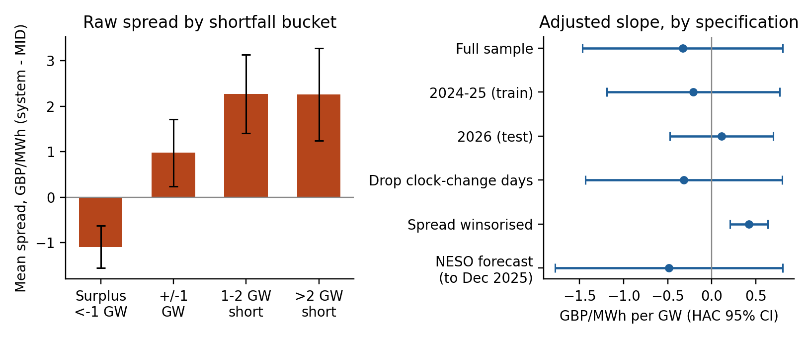
Exhibit 2. Left: mean spread by shortfall bucket. Right: the adjusted slope under different specifications, with 95% intervals.
3. Forecast error is cheap on average and costly on a bad day. Selling the forecast cost about £0.22/MWh in 2024 (141 usable days), £0.34 in 2025 and £0.11 in 2026. The 2026 total of £265,000 is 0.12% of revenue valued at MID (0.47% in 2025). Errors partly cancel: in 2025 the portfolio lost £5.5m in bad half-hours and gained £4.3m in good ones. One day, 8 January 2025, cost £263,000, a fifth of that year. We also tested selling less than the forecast. Selling the 1st-percentile volume showed a 119% saving in 2026, but only because it was long in 99% of periods while system price averaged £0.39 above MID. Capping extreme spreads turns it into a 34% loss, and no other quantile we tried gave a saving that held up.
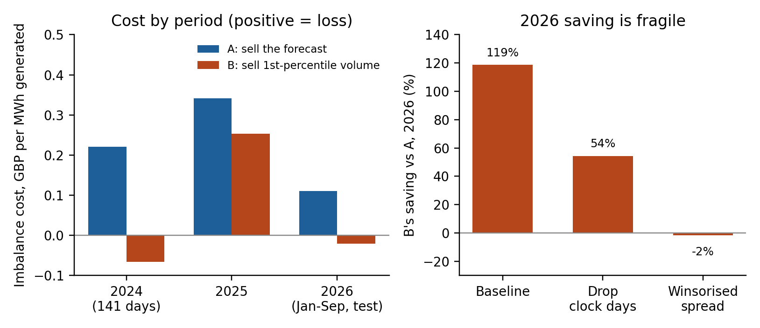
Exhibit 3. Left: imbalance cost per MWh generated for selling the forecast (A) and selling less (B). Right: B's 2026 saving under three data treatments.

What we recommend
- Keep selling the forecast. Do not shade volumes below it.
- Set credit and reserve for a bad day: about £0.3m per GW, with a normal range of roughly -70 to +120 MW per GW.
- Treat £0.36m to £1.24m per GW-year as the most any forecast improvement could save, and pay for only a small fraction of that.
- Use the 80% intervals, but assume autumn coverage is nearer 66% until we have more data.
- Fill the gaps before deciding anything on pricing: gas price, net imbalance volume, outages, demand forecast error, total wind for April to November 2024, and the real portfolio's own errors.
- Re-run each quarter, and revisit if any interval excludes zero or the imbalance pricing rules change.

What would prove us wrong
Missing controls could be hiding a real slope, since we only have month effects and MID as proxies for fuel and system conditions. Battery growth could have removed an effect that existed in 2024-25, and our 2024-25 slope (-0.21, standard error 0.50) is too imprecise to tell. A change in imbalance pricing rules would break the pooled estimate, and we have not tested one. A longer sample with more extreme spreads could show a positive slope. NESO's own forecast file (to December 2025) gave a +3.6% bias and a slope that changes sign, so a third forecast should agree with ours.

Limits and sources
We have no gas price. Elexon's total-wind series is faulty from April to November 2024, so we dropped 229 days, and the early-2024 data we kept shows errors about twice as large as later ones. We matched forecast and actual wind by level rather than from documentation: an earlier version that used metered wind only showed a false 14% over-forecast. We ignore intraday trading and balancing actions, and the portfolio has the national error profile, so real costs will be higher. We do not model rule or battery changes. Sources: Elexon Insights (day-ahead wind forecast, total wind outturn, system prices, MID from APXMIDP, demand outturn, metered wind for checks) and the NESO Data Portal (day-ahead wind forecast 2018 to present, used for capacity and a cross-check to 10 December 2025).

