What Drove UK Gilt Yields in 2026?
Global versus UK-specific: project walkthrough and interview guide (data to 30 Sep 2026)

1. The 30-second pitch
Say this first. UK gilt yields rose 68 to 103bp in 2026. I tested how much of that was global (US Treasuries, Bunds, oil) and how much was UK-specific. I fitted a regression on 2024–25, used it to predict 2026, and treated the gap as the UK-specific residual. I then bootstrapped the residuals to see whether they beat chance. The answer: global yields explain essentially all of the 10y and 30y moves, and the UK-specific residuals are small and statistically indistinguishable from noise.
Why it matters: a UK-specific view (fiscal worries, the Bank of England, politics) is only a trade if the UK part is real. If most of the move is global, you are really taking a view on US and German rates.

2. Key results at a glance
Series | Actual move | Global part | UK residual | 95% chance band | p-value
2y gilt | +103bp | +75bp | +28bp | ±84bp | 0.51
10y gilt | +83bp | +84bp | −1bp | ±71bp | 0.97
30y gilt | +68bp | +66bp | +3bp | ±85bp | 0.94
2s30s slope | −35bp | −15bp | −19bp | ±85bp | 0.66
- Every UK residual sits inside its chance band, so there is no detectable UK-specific effect.
- The curve flattened (2s30s −35bp), because the 2-year rose more than the 30-year. This is the opposite of a steepener.
- Bands are wide (about ±70–90bp) because the sample is short and daily noise adds up. “Not significant” means “cannot detect”, not “proved zero”.
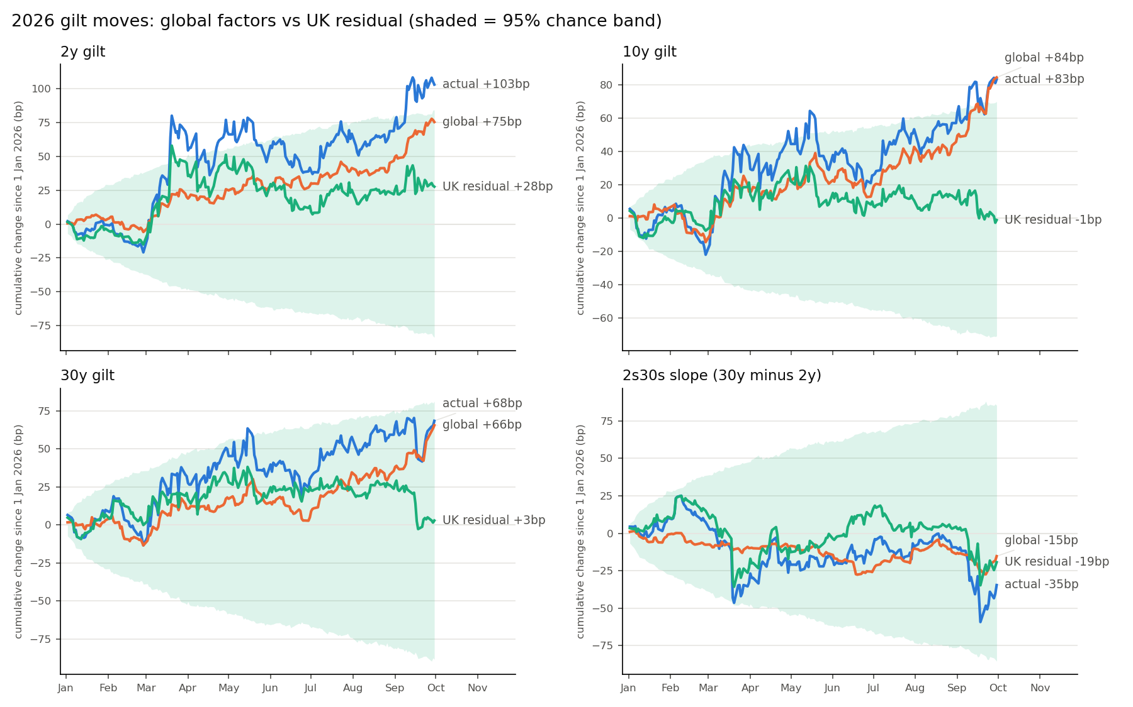
Cumulative 2026 move (blue), global part (orange), UK residual (green), with the 95% chance band (shaded). The green line stays inside the band in every panel.

3. The method, step by step
For each step: what we did, why, the trade-off, and the alternative. This is the part interviewers probe.

Step 1: Data and alignment
- What: Gilt 2y/10y/30y from the Bank of England spot curve; US 2y/10y/30y and Brent from FRED; German 10y Bund from the Bundesbank. All joined on common dates, with at most one day of forward-fill. Sample: 708 days, 2024-01-02 to 2026-09-30.
- Why: Markets have different holidays, and regression needs matching days.
- Trade-off / alternative: A forward-filled holiday creates a fake zero change; dropping those days loses data. One day of fill is the compromise. Alternative: keep only days when every market is open.

Step 2: Daily changes, not levels
- What: Yield changes in basis points; Brent as log change ×100 (about % change).
- Why: Yield levels wander (non-stationary), and regressing one wandering series on another gives impressive but meaningless fits (spurious regression). Changes are stable, so a beta reads as “a 1bp US move goes with a 0.55bp gilt move”.
- Trade-off / alternative: Merit: interpretable. Demerit: ignores any long-run level relationship. Alternative: cointegration or error-correction models.

Step 3: Timing fix (lagged US yield)
- What: Added yesterday’s US yield change as a regressor.
- Why: Gilts fix at about 4:30pm London; the US trades on for hours. US news after the London close can only hit gilts the next day.
- Trade-off / alternative: Merit: stops that effect leaking into the UK residual. Demerit: one more regressor. It was insignificant for single yields but significant for the slope. Alternative: intraday data at a common time.

Step 4: Winsorising
- What: Clipped each series to its 0.5th–99.5th percentile, using the 2024–25 estimation window only; the 2026 test data is left raw, so “actual” moves equal the true level changes.
- Why: OLS squares errors, so a few extreme days (possibly data errors) can dominate the fit.
- Trade-off / alternative: Demerit: understates genuine shocks in the estimation window. (An earlier version clipped 2026 too, which understated the 2026 moves, e.g. the slope showed −14bp instead of the true −35bp, and used future data. This was found and fixed.) Alternative: robust regression such as Huber.

Step 5: Out-of-sample design
- What: Estimated betas on 2024–25 only and applied them to 2026.
- Why: Fitting on 2026 itself would explain the year away and leave a residual near zero by construction. Fixing betas first asks “given normal behaviour, what looked unusual?”
- Trade-off / alternative: Demerit: assumes betas are stable. If they shifted in 2026, part of the “UK residual” is really a beta change. Alternative: rolling betas (but they absorb real UK effects).

Step 6: Regression and decomposition
- What: OLS of each gilt on its matching US yield (2y with 2y, 10y with 10y, 30y with 30y), the lagged US yield, Bund and Brent. HAC (Newey-West) standard errors. The prediction excludes the constant. Residual = actual − predicted.
- Why: HAC corrects standard errors for autocorrelation and clustered volatility without changing betas. The constant is average 2024–25 drift; carrying it forward would invent a trend.
- Caveat: The residual also contains noise and omitted global factors (Japan, credit), so it is an upper bound on “UK-only”.

Step 7: The 2s30s slope
- What: Slope = 30y − 2y in bp (positive = steeper), regressed on both US legs plus lags, Bund and Brent.
- Why: The slope is a difference of two yields, so both US legs are needed; otherwise a pure US front-end move shows up as a false UK effect.
- Caveat: Slope R² is only 0.17, so the model explains little of its daily moves.

Step 8: Block bootstrap
- What: Resampled blocks of 10 consecutive days from the estimation window, refitted the betas 2,000 times, and added simulated daily noise to build the range the cumulative residual would take if global factors explained everything.
- Why: It tests whether a residual beats chance. Blocks (not single days) preserve volatility clustering; single days would make the bands too narrow.
- Trade-off / alternative: The block length (10) and the number of draws are judgement calls, and I did not test sensitivity. Alternative: analytical standard errors for a sum of residuals.

4. Regression detail (10y gilt, fitted 2024–25)
Variable | Coefficient | p-value | Reading
US 10y | 0.55 | 0.000 | Strong: a 1bp US move goes with 0.55bp in gilts
US 10y (lagged) | 0.03 | 0.43 | Timing effect not detectable for the single yield
Bund 10y | 0.22 | 0.001 | Significant European spillover
Brent (log %) | 0.07 | 0.59 | No effect once yields are included
R² = 0.47: about half of daily variance is explained. Residuals are fat-tailed (kurtosis about 4), which supports using HAC errors and a bootstrap.

5. Event check
Events were checked against news reports. Sum of the daily residual over three trading days around each event (one-sigma about 7.6bp for the slope and 7.0bp for the 10y):
Event | 2s30s | 10y | 30y | 2y
20 Jul: Burnham PM, Healey Chancellor, “any flexibility” (same day) | 3.4 | 0.9 | 3.2 | 0.3
31 Jul: Budget date set (28 Oct) | 6.0 | −7.9 | −4.6 | −12.8
28 Sep: 10y gilt peak (5.41%) / Budget run-up | 1.3 | −3.8 | −2.2 | −2.9
- On 20 July the 10y rose 8bp, but the residual was only 0.9bp: the market move was largely explained by global yields, despite press framing it as UK-specific.
- The −12.8bp on the 2y (31 July) is the largest number, but with 3 events × 4 series, one result near 2 sigma is expected by chance.

6. Likely interview questions and answers
Q: Why daily changes and not levels? A: Yield levels are non-stationary, so regressing levels gives spurious fits. Changes are roughly stationary and give betas with a clear meaning.
Q: Why fit on 2024–25 and test on 2026? A: So the model can’t explain away the period I’m studying. It asks what looked unusual given normal behaviour. The risk is beta instability.
Q: Why leave out the constant in the prediction? A: The constant is average 2024–25 drift. Carrying it into 2026 would add a fake trend of roughly 0.1bp a day (about 19bp over 190 days) to the residual.
Q: What does the lagged US yield do? A: Gilts close before the US. News after London’s close hits gilts the next day. The lag captures that so it isn’t counted as UK-specific.
Q: Why HAC standard errors? A: Daily yield changes are autocorrelated with clustered volatility, so ordinary standard errors are too small. HAC fixes the t-stats without changing the betas.
Q: Why a block bootstrap? A: Resampling single days breaks volatility clustering and makes bands too narrow. Blocks of 10 days keep short-run dependence.
Q: Is the +28bp on the 2-year a UK effect? A: Not demonstrably. The +28bp is about two-thirds of a standard error (SE about 42bp, p = 0.51). It is the biggest residual, and the front end is where UK rate expectations would show up, so it is the one to watch, but I can’t claim it.
Q: Does “not significant” mean there was no UK effect? A: No. The test has low power: with about 190 test days it can only detect effects above roughly 70–90bp. Absence of evidence is not evidence of absence.
Q: What are the main weaknesses? A: Short sample (708 days), only four global factors (no Japan or credit), assumed stable betas, and fitted spot yields compared with the par yields quoted in the press.
Q: What would you do next? A: Add more global factors, test rolling betas, check block-length sensitivity (5/10/20), extend the history, and use intraday data for the timing issue.
Q: How would you use this in a trade? A: As a filter. If a move is mostly global, you are trading US or German rates, not a UK view. For sizing: daily 2s30s vol is about 4.1bp, so a 10-day one-sigma is about 13bp (this assumes independent days, which understates risk if moves trend).

7. Limitations to state up front
- Short, low-power sample: wide bands.
- Omitted global drivers: the residual is an upper bound on “UK-only”.
- Betas assumed stable between 2024–25 and 2026.
- Spot (fitted) vs par yields: levels differ slightly from press quotes.
- Sample ends 30 Sep 2026, before the 28 Oct Budget.

8. Alternatives at a glance
Alternative | Gain | Cost
More global factors (JGB, euro credit, VIX) | Cleaner, smaller UK residual | More regressors, overfitting risk
Rolling or regime betas | Handles beta instability | Absorbs real UK effects
Longer history | More statistical power | Different regime; data not loaded
Intraday common-time data | Fixes timing properly | Hard to source
Cointegration / error-correction | Uses level information | More complex, easier to misspecify
Robust (Huber) regression | Automatic outlier handling | Less transparent than clipping

9. Glossary
- bp: one hundredth of a percentage point.
- Spot vs par yield: spot is the rate on a single zero-coupon payment; par is the coupon at which a bond prices at 100. Close but not identical.
- Beta: bp of gilt move per 1bp of a global factor.
- Residual: actual minus model prediction; the unexplained part.
- Out-of-sample: tested on data not used to fit the model.
- HAC: standard errors robust to autocorrelation and changing volatility.
- Bootstrap: resampling the data many times to see how much a result varies by chance.
- Winsorise: clip extremes instead of deleting them.
- p-value: share of chance outcomes at least as extreme as the one observed; small means unlikely to be chance.
- 2s30s: 30y yield minus 2y yield; positive = steeper curve.
Code: Ram_Research.py (fully commented). Charts: gilt_decomposition.png and the exhibit files in the Data folder.

