UK curve: a Budget steepener
Ram Ridhan | 8 October 2026
Our view (personal): despite headroom roughly halving (£23.6bn to about £13bn) and a new Chancellor’s first Budget, the 30y carries no measurable UK premium (+3bp residual in 2026). The UK-specific move sits in the 2y (+28bp), on BoE hike risk. We think 2s30s (134.7bp, 6 Oct) is under-priced for fiscal risk: a steepener buys cheap insurance against slippage at the 28 Oct Budget. The statistics cannot detect a UK effect smaller than about 70–90bp, so these point estimates are suggestive, not proof.
Trade | Entry | Target | Stop | Horizon
Long 2s30s steepener (long 2y / short 30y, DV01-neutral) | ~135bp (6 Oct, BoE spot curve) | 155bp (+20bp, about 1σ of horizon vol) | 115bp (−20bp) | Exit 30 Oct, after the Budget; reward/risk 1:1
Slope levels are BoE fitted spot-curve yields, not tradable prices; implement via 2y/30y gilt futures or cash, and re-mark at execution. Daily 2s30s vol is 4.4bp (2025–26), so the 16 trading days to 30 Oct is about 18bp (1σ). Stop and target are symmetric at about 1σ: a 1:1 event trade, sized small. We exit before the 5 Nov MPC, so the trade is a pure fiscal event and carries no view on that decision.
Key points
- The long end carries no UK premium; the UK move is at the front. The slope fell 35bp year to date (168bp to 133bp at 30 Sep) as the 2y rose 103bp and the 30y 68bp. Global factors (US, Bund, Brent) explain 75bp of the 2y move and 66bp of the 30y; the UK residuals are +28bp (2y) and +3bp (30y), neither distinguishable from chance (p = 0.51 and 0.94).
- Inflation is energy-led, not domestic. CPI is 3.1% with motor fuels +23%, but core is 2.6% and services 3.4%. The BoE sees CPI near 3¾% in Q4 and just above 4% in Q1 2027, “driven primarily by elevated energy costs”, with three of nine MPC members already voting to hike. The electricity VAT cut from 1 October mechanically lowers October CPI, which caps the front end.
- The Budget is the catalyst, and the skew is towards slippage. Headroom has roughly halved since March. Slippage is the under-priced outcome because the political signals point to loosening: Burnham’s “flexibility” remark, an unfunded VAT cut on electricity, pressure to fund defence at 3% of GDP (about £10bn a year), and a sixth Chancellor in six years. Near-term supply is not the driver: BoE active gilt-sale auctions are paused pending review.
Inflation and the BoE: energy versus domestic
August CPI rose to 3.1% (2.9% in July). Energy: motor fuels are +23.0% y/y (petrol 161.3p, highest since Nov 2022) and electricity, gas and other fuels +6.0%; crude and refined products are 36–78% above July levels. Domestic: services inflation is steady at 3.4%, core 2.6% (unchanged), restaurants and hotels 4.1% and goods rose to 2.7% from 2.2% (Exhibit 2). The MPC held Bank Rate at 3.75% by 6–3 on 17 September (Greene, Mann and Pill voted for 4.00%) and judged indirect pass-through “small to date”. We read the hawkish dissent as insurance against second-round effects. That keeps hike risk priced into the 2y, which is why the UK residual sits there; because we exit on 30 Oct, we take no view on the 5 Nov decision.
Politics and the Budget
Burnham became PM on 20 Jul, said he would seek “any flexibility” within the fiscal rules, and named John Healey Chancellor the same day. The 10y rose 8bp, but our 3-day residual around that date is only 0.9bp: the market move was consistent with global yields. The Budget and the OBR forecast land together on 28 Oct. Headroom was £23.6bn at the March forecast; higher gilt yields have cut it to about £13bn (Pantheon; estimates differ by baseline), and each 25bp on yields adds about £2.5bn a year to debt-servicing costs. Pantheon estimates about £11bn of annual consolidation is needed just to rebuild March headroom. What the market needs: stay inside the fiscal rules, rebuild headroom, and avoid unfunded commitments. Credible consolidation would compress the long-end term premium (a flattener); slippage or a rules change would hit the 30y first (our steepener). We lean to slippage for the reasons in the key points, not because the data show a premium today.
Supply: QT and issuance
The MPC (decision announced 17 Sep) set a path to unwind its remaining gilt holdings by end-2034: £20bn a year of active sales alongside maturing gilts, an average £46bn a year, with £120bn of the longest-dated gilts set aside to back banknotes. Per the Bank’s market notice, the sales cover gilts maturing between 2035 and 2049 (about £146bn), “Bank APF auctions will pause in the meantime”, and progress will be reviewed before April 2027. QT sales are therefore not a factor inside our horizon. On the DMO side, the revised 2026-27 remit has a net financing requirement of £251.2bn and gilt sales of £246.2bn, including £15.0bn of long conventional gilts in three transactions. Long-end supply is modest and scheduled; the risk is a Budget-driven remit change, not current issuance.
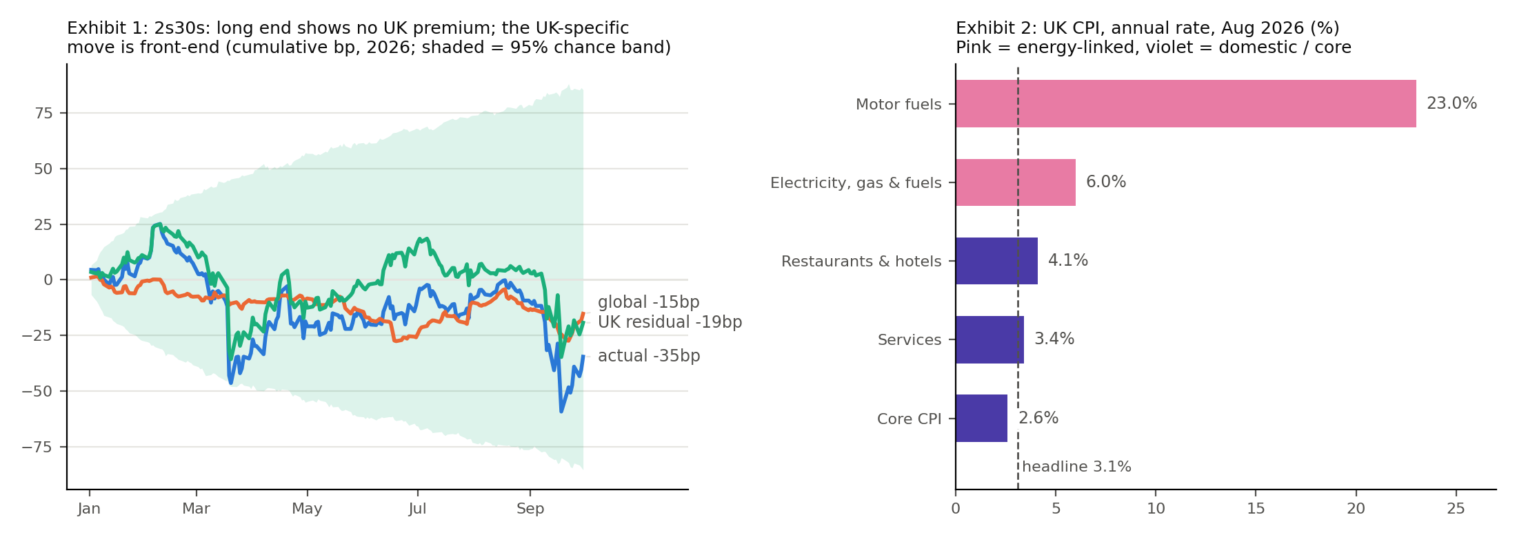
Sources: Bank of England, ONS, DMO, author’s calculations. Exhibit 1 uses 2024–25 betas applied to 2026; see Appendix for full regression results.
Trade and risks: what would make us wrong
- A credible Budget. Tax rises that rebuild headroom compress the long-end term premium (30y rallies), flattening the curve. This is the main risk, and why the position is small.
- A hawkish BoE. More hike pricing lifts the 2y faster than the 30y and flattens the curve, which is the direction of travel in 2026. We exit before the 5 Nov decision, but pricing can move before then.
- More oil. Further energy gains push hike pricing up and the front end with it.
- Global drivers dominate. The slope has low explanatory power from global factors (R² = 0.17) and daily moves are noisy, so a 20bp stop can still be hit by noise.
- Limits of the test. No 2026 residual is significant (p = 0.51 to 0.97) and the test cannot detect a UK effect below about 70–90bp. The +3bp 30y residual is therefore suggestive, not proof of no premium; the trade is an event view, not a measured mispricing.
Calendar and disclaimer
21 Oct: UK CPI (September). 28 Oct: Autumn Budget and OBR forecast. 30 Oct: planned exit. 5 Nov: MPC decision (not held). Personal views, not investment advice. Illustrative levels from the Bank of England fitted spot curve; not tradable prices.
Appendix: regression results
Specification. Daily changes in bp (Brent: log change × 100). Each gilt maturity is regressed on its matching US Treasury maturity (and its 1-day lag, because the US closes after London), the 10y Bund, and Brent. OLS on 2024-01-02 to 2025-12-31 (n = 513), HAC (Newey-West, 5 lags) standard errors; estimation-window changes winsorised at the 0.5th and 99.5th percentiles. The fitted betas (without the constant) are applied to 2026; the UK residual is actual minus predicted.

Table A1: 2026 decomposition and bootstrap test (cumulative bp)
Series | Actual 2026 | Global | UK residual | Bootstrap s.e. | 95% chance band | p-value | R²
2y gilt | +103bp | +75bp | +28bp | 42bp | -84 to +84bp | 0.51 | 0.29
10y gilt | +83bp | +84bp | -1bp | 36bp | -71 to +70bp | 0.97 | 0.47
30y gilt | +68bp | +66bp | +3bp | 42bp | -88 to +81bp | 0.94 | 0.39
2s30s slope | -35bp | -15bp | -19bp | 43bp | -85 to +85bp | 0.66 | 0.17
Chance band: 95% range of the cumulative residual under the null that global factors explain everything (2,000 block-bootstrap draws, 10-day blocks, beta and noise uncertainty). A residual outside the band would indicate a UK-specific effect. The slope model is estimated directly, so its components do not equal the differences between the leg models (global: 66 − 75 = −9bp from the legs vs −15bp direct; UK residual: 3 − 28 = −25bp vs −19bp), because the two use different regressors.
Table A2: Regression coefficients (z-statistics in parentheses)
Model (dependent variable) | US same-maturity β | US lag β | Bund 10y β | Brent β | R²
2y gilt | 0.361 (8.67) | 0.055 (1.70) | 0.190 (4.12) | 0.042 (0.43) | 0.29
10y gilt | 0.548 (13.57) | 0.028 (0.79) | 0.223 (3.28) | 0.066 (0.55) | 0.47
30y gilt | 0.533 (12.42) | 0.084 (1.63) | 0.164 (2.07) | 0.070 (0.52) | 0.39
2s30s slope | 0.322 (6.16) on US 30y; −0.218 (−3.98) on US 2y | 0.229 (4.17) on US 30y; −0.228 (−4.22) on US 2y | 0.052 (1.07) | 0.014 (0.15) | 0.17
Constants are all insignificant (p = 0.28 to 0.86) and omitted. US terms are the matched-maturity Treasury; the slope model uses both the US 30y and 2y.
Reading the table. The US yield of the same maturity is the dominant driver in every model (z = 6.2 to 13.6). The Bund adds a smaller significant effect for the 2y, 10y and 30y (p ≤ 0.04). Brent is never significant once yields are included. The slope model shows opposite-signed US 2y and 30y terms and significant lags, as expected for a difference of two yields; its low R² means most daily slope variation is unexplained.
Caveats. Short sample (513 estimation days, about 190 test days) gives wide bands, so “not significant” means a UK effect smaller than roughly 70–90bp cannot be detected. Betas are assumed stable between 2024–25 and 2026. The residual is an upper bound on “UK-only” because omitted global factors (e.g. Japan, credit) fall into it. Gilt data are fitted spot yields, which differ slightly from the par yields quoted in the press.
Sources. CPI: ONS, Consumer price inflation, August 2026 (next release 21 Oct 2026). MPC: Bank of England, Monetary Policy Summary, September 2026. QT: BoE market notice, 17 Sep 2026. Remit: DMO revised financing remit, 23 Apr 2026. Budget date: HM Treasury, Chancellor’s letter to the Treasury Select Committee, 31 Jul 2026. Burnham and Healey, 20 Jul: Bloomberg. Headroom: Pantheon Macroeconomics estimate; OBR March 2026 forecast (£23.6bn).

