Dissertation / Project / Project Work Title:
Fault Detection in Power Grid using Machine Learning

BITS ZC425T: Project Work

by

M B G Rama Krishna

201918BT513

Project Work carried out at

Capgemini Technology Services Limited, Hyderabad



BIRLA INSTITUTE OF TECHNOLOGY & SCIENCE
PILANI (RAJASTHAN)

May 2023
Dissertation / Project / Project Work Title:
Fault Detection in Power Grid using Machine Learning

BITS ZC425T: Project Work

by

M B G Rama Krishna

201918BT513

Project Work carried out at

Capgemini Technology Services Limited, Hyderabad

Submitted in partial fulfillment of B.S. Engineering Technology / Information Systems degree programme.

Under the Supervision of
Rejimon R - Consultant,
Capgemini Technology Services Limited, Bengaluru

BIRLA INSTITUTE OF TECHNOLOGY & SCIENCE
PILANI (RAJASTHAN)

May 2023

CERTIFICATE

This is to certify that the Project Work entitled Fault Detection in Power Grid using Machine Learning and submitted by M B G Rama Krishna having ID-No. 201918BT513 for the partial fulfillment of the requirements of B.Tech. Engineering Technology degree of BITS, embodies the bonafide work done by him/her under my supervision.


______________________
Signature of the Supervisor

Place: Bengaluru

Date: 15/04/2023 Rejimon R - Consultant,
Capgemini Technology Services - Bengaluru

Name, Designation & Organization &Location

Birla Institute of Technology & Science, Pilani

Work-Integrated Learning Programme Division

Second Semester 2022-2023

BITS ZC425T: Project Work

BITS ID No. : 201918BT513

NAME OF THE STUDENT : M B G Rama Krishna

EMAIL ADDRESS : 201918BT513@wilp.bits-pilani.ac.in

STUDENT’S EMPLOYING : Capgemini Technology Services Limited, Hyderabad
ORGANIZATION & LOCATION

SUPERVISOR’S NAME : Rejimon R

SUPERVISOR’S EMPLOYING : Capgemini Technology Services Limited, Bengaluru ORGANIZATION & LOCATION

SUPERVISOR’S EMAIL ADDRESS : rejimon.r@capgemini.com

PROJECT WORK TITLE : Fault Detection in Power Grid using Machine Learning

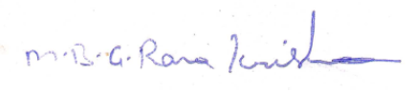
____________________
Signature of the Student

Name: M B G Rama Krishna

Date: 10/04/2023

Place: Hyderabad

______________________
Signature of the Supervisor

Name: Rejimon R

Date: 15/04/2023

Place: Bengaluru
______________________________________________________________________

ACKNOWLEDGEMENTS

We would like to take this opportunity to express our deep gratitude to the members who assisted us directly and indirectly in the completion of this project work. who may have helped us during the work carried out by them. Customarily, in WILP Dissertation Final reports, thanks are given to the following in the order given below:

· Head of the organization,
· Supervisor and Additional Examiner from the organization,
· Professional Expert / In- charge of the project,
· Faculty mentor,
· Other persons (from the organization and /or outside the organization, etc.)
Table of Contents

1. Abstract 1
2. Broad Academic Area of Work 1
3. Background 2
4. Objectives 2
5. Scope of work 2
6. Keywords 2
7. List of Figures 3
8. List of Tables 6
9. Introduction 8
10. Microgrid Model 8
11. Faults in a Microgrid and its Detection 9
12. Generation of Input Data for ANN Model 10
13. Solution through ANN Model 10
14. Summary 12
15. Conclusion 12
16. Literature References 13
16. Checklist 16
- ABSTRACT

This project explores the use of machine learning concepts, such as Artificial Neural Networks, for fault detection and location in a Power Microgrid. In microgrids, electronic equipment requires secure protection against short circuit faults to prevent de-energization of the entire system, which can have a significantly negative impact. Transient circuit faults occur when conductors encounter each other or ground, with ground faults being the primary concern and accounting for over 80% of all faults. An effective method for detecting, isolating, and protecting the power microgrid system against short circuit faults is crucial to address this issue. This project presents a highly effective approach that uses an Artificial Neural Network (ANN) to detect and locate faults before they impact other system parts, thereby providing more dependable microgrid protection. The distributed protection network covers the entire microgrid system and is connected to other protective devices in the network.

This project centres on the detection and location of faults on electric power transmission lines within the power microgrid network.

- Broad Academic Area of Work

The growth of renewable power sources has been difficult in latest years. Although these traditional power structures are appropriate substitutions for old electricity systems, negative aspects and difficulties in power technology and distribution which include overvoltage, fault safety, and frequency fluctuations are limitations that ought to be solved efficiently.

The future energy community will want to house a massive scale of disbursed generation gadgets (DGs) and facilitate the connection of a grand scale of centralized generation at suitable locations. The microgrid has been taken into consideration as an effective manner to manage the DGs and different dispensed electricity assets (DERs) at the distribution gadget stage and the user stage. Microgrids offer efficient, low-value, and easy power. These are vital infrastructure that increases reliability and resilience, lessens grid “congestion,” and heightens. Nonetheless, the safety of these microgrids stays a difficult difficulty. When a fault happens within the gadget, it creates a massive contemporary that might influence the complete machine’s working, and it can forestall the entire device.

The possibility of locating faults quickly and keeping apart that element from the alternative parts of the gadget could allow the relaxation of the electricity microgrid to continue running.

- Background

The electric electricity machine consists of so many unique complex dynamic and interacting elements, which can be always prone to disturbance or an electrical fault. using excessive potential electric producing strength flowers and concept of the grid, i.e., synchronized electric energy flowers and geographically displaced grids, required fault detection and operation of a protection device in minimum feasible time so that the power system can stay in a strong situation. The faults on electric strength device transmission strains are alleged to be first detected and then classified efficaciously and must be cleared in the least fast viable time. The protection machine used for a transmission line can also be used to provoke the opposite relays to protect the power gadget from outages. a terrific fault detection device that provides an effective, dependable, fast, and cozy way of relaying operation.

- Objectives

The objectives of my project are as follows:

- Detecting faults and identifying the location of the faults on electric power transmission lines in the power microgrid network.

- To protect the microgrid system using an Artificial Neural Networks (ANN) that will detect and find the location of the fault before it affects other parts of the system.

- Implement a machine learning model to identify the fault in Power grids.

- Scope of Work

The scope of this dissertation is to design a Machine Learning Algorithm which will detect and find the location of the fault before it affects other parts of the system.

- Keywords

- ANN - Artificial Neural Networks
- Disbursed Generation Gadgets (DGs)
- Dispensed Electricity Assets (DERs)
- Machine Learning
- MATLAB
- overvoltage, fault safety, and frequency fluctuations
- Power Microgrid
- Python

- List of Figures

Figure 1: Solar panels

Figure 2: Simplified Model of a Power Microgrid

Figure 3: When all the breakers are in the off state i.e., no-fault state.

Figure 4: The above graph is obtained when the fault is introduced while the battery controller is working.

Figure 4: The above graph is obtained when the fault is introduced while the battery controller is not working.

Figure 5: Measuring the parameters.

Figure 6: 78.26% accuracy in prediction and location of the fault

- List of Tables

Current 1
P_L 1
Current 2
P_L 2
Current 3
P_L 3
Current Ideal
P_L Ideal
Time
8.858
492
5.249
1093
1.969
1640
0.00009465
1968
1
4.429
246
2.625
546.7
0.9844
820
0.00008514
984
2
4.429
246
2.625
546.7
0.9844
820
-0.00000000009609
984
3
4.429
246
2.625
546.7
0.9844
820
-0.00000000009609
984
4
4.429
246
2.625
546.7
0.9844
820
-0.00000000009609
984
5
7.382
410
4.374
911.1
1.64
1670
0.000005178
1640
6
14.76
819.9
8.748
1822
3.28
2733
-0.00009125
3280
7
26.57
1476
15.75
3280
5.905
4919
-0.0001579
5903
8
29.53
1640
17.5
3644
6.561
5466
0.000005177
6559
9
14.76
819.9
8.749
1822
3.281
2733
0.0003462
3280
10
8.858
492
5.249
1093
1.969
1640
0.0001385
1968
11
22.12
983.9
14.9
2186
8.341
3280
4.405
3936
12
25.17
656
20.36
1458
15.98
2187
13.36
2624
13
27.72
410
24.71
911.1
21.98
1367
20.34
1640
14
28.71
246
26.9
546.7
25.26
820
24.28
984
15
26.06
328
23.65
728.9
21.46
1093
20.15
1312
16
18.79
819.9
12.78
1822
7.31
2733
4.03
3280
17
7.311
1476
-3.515
3280
-13.36
4919
-19.26
5903
18
33.96
1886
20.12
4191
7.544
6286
-0.0002698
7543
19
32.48
1804
19.25
4008
7.217
6013
-0.00006212
7215
20
32.48
1804
19.25
4008
7.217
6013
-0.0000000007047
7215
21
33.96
1886
20.12
4191
7.545
6286
-0.00002718
7543
22
26.57
1476
15.75
3280
5.905
4919
0.0001359
5903
23

Table 1: Raw Data Set

Table 2: Features to be trained.

- Introduction

The expansion of renewable energy sources has been a concern in recent years. Even though these conventional energy systems are appropriate substitutions for old power systems, disadvantages and difficulties in power generation and distribution such as overvoltage, fault protection and frequency fluctuations are barriers that should be solved as well.

The future electricity network will need to accommodate large scale of distributed.
generation units (DGs) and facilitate the connection of grand scale of centralized generation at suitable locations. Microgrid has been considered as an effective way to manage the DGs and other distributed energy resources (DERs) on the distribution system level and the user level. Microgrids provide efficient, low cost and clean energy. These are critical infrastructure that increases reliability and resilience. Also, reduce grid “congestion” and peak loads. Still, the protection of these microgrids remains a problematic issue. When a fault occurs in the system, it creates a huge current that could affect the entire system working, and it could stop the complete system. The possibility of locating faults quickly and isolating that part from the other parts of the system would allow the rest of the power microgrid to continue working.

- Microgrid Model

Specifications:

The microgrid is a single-phase AC network. Energy sources are an electricity network, a solar power generation system, and a storage battery. A battery controller controls the storage battery. It absorbs surplus power when there is excess energy in the micro-network and provides additional power if there is a power shortage in the micro-network. Three ordinary houses consume energy (maximum of 2.5 kW) as electric charges. The micro-array is connected to the power network via a transformer mounted on a post which lowers the voltage from 6.6 kV to 200 V. The solar power generation and storage battery are DC power sources that are converted to single-phase AC. The control strategy assumes that the microarray does not depend entirely on the power supplied by the power grid, and the power supplied by solar power generation and storage is always sufficient.

Simulation:

From 20h to 4h, the solar power generation is 0 W. It reaches the peak amount (5 kW) from 14h to 15h. As a typical load change in ordinary houses, the amount of electric power load reaches peak consumption at 9h (6,500 W), 19h, and 22h (7,500 W). From 0h to 12h and from 18h to 24h, the battery controller performs battery control. The battery control performs tracking control of the current so that active power which flows into system power from the secondary side of the pole transformer is set to 0. Then, the active power of the secondary side of the pole-mounted transformer is always around zero. The storage battery supplies the insufficient current when the power of the microgrid is insufficient and absorbs surplus current from the microgrid when its power surpasses the electric load. From 12h to 18h, battery control is not performed. SOC (State of Charge) of the storage battery is fixed to a constant and does not change since the charge or discharge of the storage battery is not performed by the battery controller.

When there is a power shortage in the micro-grid the system power supplies insufficient power. When there is surplus power in the microgrid surplus power is returned to the system power. At 8h, electricity load No. 3 of an ordinary house is set to OFF for 10 sec by the breaker. A spike is observed in the active power on the secondary side of the pole transformer and the electric power of the storage battery.

- Faults In a Microgrid and its Detection

Types of Faults:

There are broadly two types of faults that occur in a microgrid, Line tine Fault and Line to Ground Fault.

Most of these faults are line-to-ground faults due to component or segment failure or lightning. When a short circuit fault happens in the microgrid, the fault resistance tends to zero and the current tends to become infinite.

I f →∞, R f →0

Here I f is the fault current and R f is the fault resistance.

Key Idea for detection of faults:

In this case, three circuit breakers are introduced in the circuits before each house as shown in the figure below. They behave as faults. The properties of breakers are as follows: Breaker Resistance - 0.001ohm, Snubber Resistance - 1e6 ohm, snubber capacitance - inf. The breakers are initially at state 1 i.e., not activated. Now they are activated one by one for half an hour each time to get the dataset. Each breaker is activated at every hour of the day. So, in total, we get a total of 96 data points.

Whenever a fault occurs in any part of the system, the values of secondary current I sec and Load Power changes drastically. These changed values play a vital role in our model.

At every point secondary current (I sec) and load power value are taken into consideration along with their time of activation. The time of fault plays a significant role because of the nature of the circuit.

When the fault is introduced in the circuit a sudden surge of current is seen and a dip in the load power. When the battery controller is working the base of the surge is zero but when the battery controller is switched off the base of the surge power is different. No fault state graph and the other two graphs can be seen in Figure 3.

- Generation of Input Data for ANN Model:

We measure the values of secondary current (I sec), Load power (P L) consumed by the loads, and the time at which this data is measured for a period of 24 hours measuring after every 60 minutes. In this way, we get 23 sets of values of all these parameters. We train this dataset (link below) in our ANN model. Now using this trained dataset, the location can be known as the fault before the first house or the second house, and so on. Here the model consists of three houses, so the dataset obtained is not noticeably big, but a large dataset can be obtained by including more loads i.e., houses.

- Solution through ANN Model

The ANN model consisted of an input layer of dimension 92X27, two hidden layers and a final output layer consisting of 4 neurons (softmax layer).

The input consists of 4 features that are listed:

1. The current in the circuit.
2. The load power.
3. The time at which the breaker was switched on.
4. The result.

** Since the “Time” feature contains only 24 values and is of classification type, so we encode it (one hot encoding) thus making the overall input features equal to 27.

The input is processed using StandardScaler and then processed for training and the result is encoded.

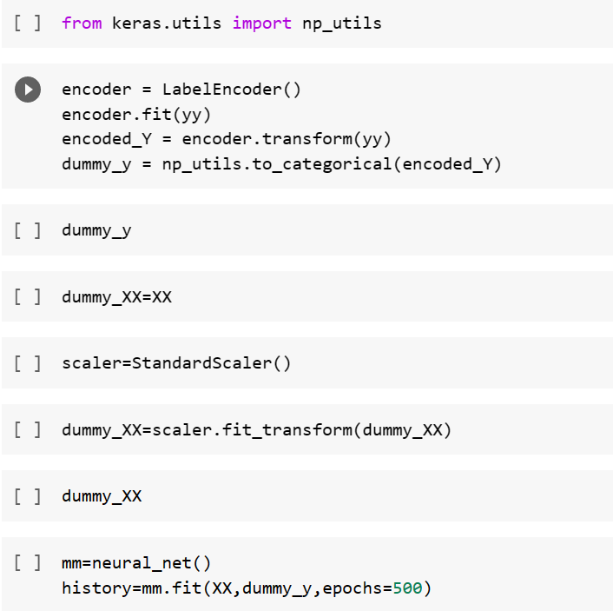

Neural Network:

The first hidden layer consists of 16 neurons and has “relu” activation function.

The second hidden layer consists of 8 neurons and has “relu” activation function.

The final output layer consists of 4 neurons.

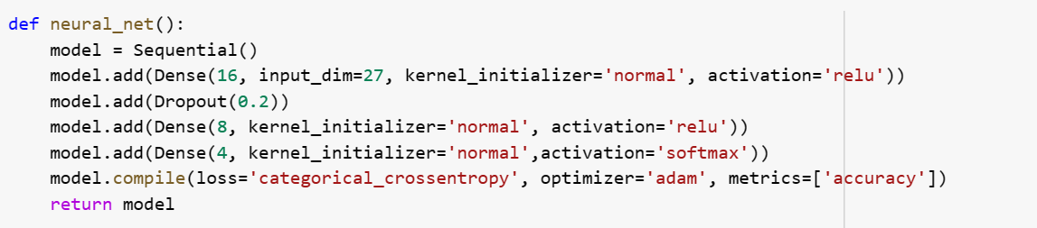



Relu function is defined as:

g(x) = max (0, x)

Then finally the model is compiled using “adam” optimizer and the nod of epochs were 500 to calculate the accuracy of the model.

To prevent overfitting a dropout layer was added after the first hidden layer.

The full code used in this model can be accessed through this link:

- Summary

The power grid is a complex and critical system that requires continuous monitoring and fault detection to ensure its stable operation. In recent years, machine learning algorithms, such as artificial neural networks (ANNs), have been applied to fault detection in power grids to improve their accuracy and efficiency.

In this approach, data from sensors and other sources are fed into the ANN model, which is trained to recognize patterns associated with normal and abnormal power grid behaviour. Once the model is trained, it can be used to predict and detect faults in real-time, allowing operators to take corrective actions before they become critical.

Overall, the use of ANN models for fault detection in power grids has shown promising results and has the potential to improve the reliability and stability of power systems. However, the development of accurate and robust models requires a significant amount of data and expertise in both power grid operation and machine learning.

- Conclusion

Based on the artificial neural network, the fault detection of microgrid was studied. A small-scale modelling of the microgrid including solar panels, battery energy storage system, loads and AC grid is simulated in MATLAB. A sudden change in the value of secondary current I sec and the load power P L is the basis for the algorithm that detects the fault location. Here we observe the spikes in the graph of I sec as the faults. These faults are generated manually by switching on each of the circuit breakers at various moments of a day. Also, the faults were studied by keeping as well as isolating the battery controller. Having generated the data at various times of a day and training the dataset in ANN fetched a decent accuracy of (70%~80 %). So having new data of power, I sec and time of the day, we can predict if there is a fault or not, and if there is, the location of the fault can be determined accurately.

- Literature References

The state of the art is the basis for any successful research project. In the current project, the literature inclined toward the new domain of conversational information retrieval is considered. The following are referred journals from the preliminary literature review.

- J.C.A. FREIRE, A.R.G. CASTRO, M.S. HOMCI, B.S. MEIGUINS, J.M. DE MORAIS, Transmission line fault classification using hidden Markov models, IEEE Access 7 (2019) 113499–113510.
- J. MORAIS, Y. PIRES, C. CARDOSO, A. KLAUTAU, A framework for evaluating the automatic classification of underlying causes of disturbances and its application to shortcircuit faults, IEEE Trans. power Deliv. 25 (4) (2010) 2083–2094.
- M.I. ZAKI, R.A. EL SEHIEMY, G.M. AMER, F.M.A. EL ENIN, Sensitive/stable complementary fault identification scheme for overhead transmission lines, IET Gener. Transm. \& Distrib. 13 (15) (2019) 3252–3263.
- S.A. ALEEM, N. SHAHID, I.H. NAQVI, Methodologies in power systems fault detection and diagnosis, Energy Syst 6 (1) (2015) 85–108. K. Chen, J. Hu, Y. Zhang, Z. Yu, J. He, Fault location in power distribution systems via deep graph convolutional networks, IEEE J. Sel. Areas Commun. 38 (1) (2019) 119–131.
- A. SABER, A. EMAM, H. ELGHAZALY, A backup protection technique for three-terminal multi-section compound transmission lines, IEEE Trans. Smart Grid 9 (6) (2017) 5653–5663. H. Tong, R.C. Qiu, D. Zhang, H. Yang, Q. Ding, X. Shi, Detection, and classification of transmission line transient faults based on graph convolutional neural network, CSEE J. Power Energy Syst. 7 (3) (2021) 456–471.
- M.F. GUO, N.C. YANG, W.F. CHEN, Deep-learning-based fault classification using Hilbert–Huang transform and convolutional neural network in power distribution systems, IEEE Sens. J. 19 (16) (2019) 6905–6913.
- H. LEE, K. KIM, J.H. PARK, G. BERE, J.J. OCHOA, T. KIM, Convolutional neural network-based false battery data detection and classification for battery energy storage systems, IEEE Trans. Energy Convers. (2021).
- M.M. TAWFIK, M.M. MORCOS, ANN-based techniques for estimating fault location on transmission lines using Prony method, IEEE Trans. Power Deliv. 16 (2) (2001) 219–224

BIRLA INSTITUTE OF TECHNOLOGY & SCIENCE, PILANI
WORK-INTEGRATED LEARNING PROGRAMMES DIVISION
Second Semester 2022-2023

BITS ZC425T Project Work EC-3 Pre-Final Evaluation Sheet

Upload Softcopy of Final Dissertation Report, Pre-Final Evaluation Sheet, and Final Presentation by April 23, 2023

ID No. : 201918BT513

NAME OF THE STUDENT : M B G Rama Krishna

EMAIL ADDRESS : 201918BT513@wilp.bits-pilani.ac.in

NAME OF THE SUPERVISOR : Rejimon R

PROJECT WORK TITLE : Fault Detection in Power Grid using Machine Learning

_________________________________________________________________

Project Work Final Evaluation (Please put a tick ( ) mark in the appropriate box)

S No. | Evaluation Component | Excellent | Good | Fair | Poor
1. | Final Project Work Report
2. | Final Seminar and Viva-Voce

S.No. | Evaluation Criteria | Excellent | Good | Fair | Poor
1 | Technical/Professional Competence
2 | Work Progress and Achievements
3 | Documentation and expression
4 | Initiative and Originality
5 | Research & Innovation
6 | Relevance to the work environment

Please ENCIRCLE the Recommended Final Grade: Excellent / Good / Fair / Poor

Remarks of the Supervisor: Overall the project work is fine. However, the project is not unique. Apart from that, the effort put in is impressive.

 | Supervisor | Additional Examiner
Name | Rejimon R | Swaroop Panchangam
Qualification | Masters of Business Administration in Human Resources | Bachelor of Commerce
Designation | Consultant | Manager
Employing Organization & Location | Capgemini Technology Services Limited, Bengaluru (Bangalore) | Capgemini Technology Services Limited, Bengaluru (Bangalore)
Phone Number | NA | NA
Mobile Number | 7502647813 | 9886184336
Email Address | rejimon.r@capgemini.com | Swaroop.panchangem@capgemini.com
Signature |  | 
Place & Date | Bengaluru 15/04/2023 | Bengaluru 15/04/2023

Checklist of items for the Final Project Work Report
This checklist is to be attached as the last page of the report.
This checklist is to be duly completed, verified, and signed by the student.
 | Is the final report neatly formatted with all the elements required for a technical Report? | Yes
 | Is the Cover page in proper format as given in Annexure A? | Yes
 | Is the Title page (Inner cover page) in proper format? | Yes
 | (a) Is the Certificate from the Supervisor in proper format?  (b) Has it been signed by the Supervisor? | Yes  Yes
 | Is the Abstract included in the report properly written within one page? Have the technical keywords been specified properly? | Yes  Yes
 | Is the title of your report appropriate? The title should be adequately descriptive, precise and must reflect the scope of the actual work done. Uncommon abbreviations / Acronyms should not be used in the title | Yes
 | Have you included the List of abbreviations / Acronyms? | Yes
 | Does the Report contain a summary of the literature survey? | Yes
 | Does the Table of Contents include page numbers?  - Are the Pages numbered properly? (Ch. 1 should start on Page # 1)  - Are the Figures numbered properly? (Figure Numbers and Figure Titles should be at the bottom of the figures)  - Are the Tables numbered properly? (Table Numbers and Table Titles should be at the top of the tables)  - Are the Captions for the Figures and Tables proper?  - Are the Appendices numbered properly? Are their titles appropriate | Yes  Yes  Yes  Yes  Yes  Yes
 | Is the conclusion of the Report based on discussion of the work? | Yes
 | Are References or Bibliography given at the end of the Report?  Have the References been cited properly inside the text of the Report?  Are all the references cited in the body of the report | Yes  Yes  Yes
 | Is the report format and content according to the guidelines? The report should not be a mere printout of a Power Point Presentation, or a user manual. Source code of software need not be included in the report. | Yes

Declaration by Student:

I certify that I have properly verified all the items in this checklist and ensured that the report is in the proper format as specified in the course handout.

Place: Hyderabad Signature of the Student

Date: 10/04/2022 Name: M B G Rama Krishna

ID No.: 201918BT513

