Name: Rameshkumar Mohanraj

Reg no: 73772126142

Degree: B.tech (AI&DS)

**SQL Lab Practice-2**

Create the following Sales table.

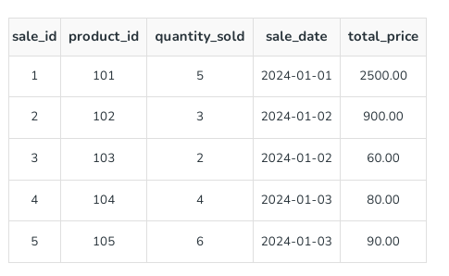

**1. Retrieve all columns from the Sales table.**

**2. Retrieve sale_id and quantity_sold from sales table.**

### 3. Retrieve the sale_id and sale_date from the Sales table.

### 4. Filter the Sales table to show only sales with a total_price greater than $100.

### 5. Retrieve the sale_id and total_price from the Sales table for sales made on January 3, 2024.

### 6. Retrieve the sale_id, product_id, and total_price from the Sales table for sales with a quantity_sold greater than 4.

**7. Retrieve all columns from the Sales table those sale_id are 1, 3 & 5.**

**8. Retrieve all columns from the Sales table those total_price between 90 and 1000.**

**9. Retrieve all columns from the Sales table those total_price not between 90 and 1000.**

**10. Retrieve all columns from the Sales table those sale_id are not in 1, 3 & 5.**

**11. Update total_price as 500 in the Sales table those sale_id are 1, 3 & 5.**

**12. delete from the Sales table those total_price not between 90 and 1000.**

**13. Sort all the records using sale_id column in ascending order.**

**14. Sort all the records using sale_id column in descending order.**

**15. Rename the sale_id column as sales_id;**

**16. Drop the column sales_id.**

**17. Rename the table as tbl_sales.**

**18. Drop the table.**

**Answers:**



