EvalSurge Product and Customer Journey
October 12, 2026 | Current implementation and proposed direction
Bring a hosted agent, provide test cases, and measure latency, errors, and optional answer quality. EvalSurge is framework agnostic: LangGraph, OpenAI Agents, CrewAI, and custom agents share an HTTP boundary. It does not build or deploy agents. Customers need not know supported concurrency before testing.

Current design
One RunCreate request carries a target alias, cases, load limits, and evaluation policy. Direct Python runs the load generator on the customer’s machine; no EvalSurge API server is needed. HTTP agents and deployed Databricks Apps differ only in their target binding. URLs, credentials, and explicitly selected profiles stay outside the request.
Optional remote SDK or /v2 REST execution uses the same request from the API host. All paths reuse one coordinator and one Locust engine at a single closed-loop concurrency level. /v1 remains compatible.

Customer journey
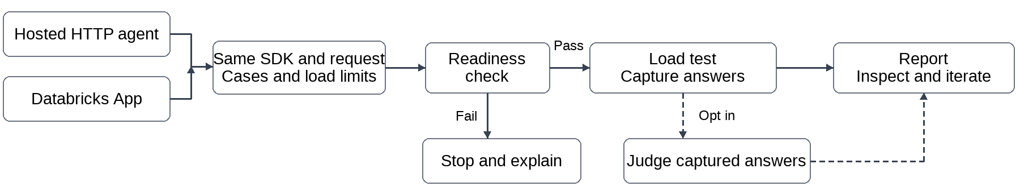
Local execution shown. One excluded first-case inference probe precedes load; failure stops the run. Judge readiness also precedes load when evaluation is enabled. Agent calls can incur costs and tool side effects.
For generic HTTP, expose a reachable POST endpoint that accepts the case JSON unchanged and returns {"outputs": "completed answer"}. Apps default to compatible DurableAgentServer /api/invocations. Install the reviewed wheel with [local] in an isolated environment; public PyPI availability is not assumed.
import evalsurge as es
agent = es.Agent.http("http://127.0.0.1:9001/invoke", protocol="http-json")
# Or: es.Agent.databricks_app("my-app", profile="SELECTED_OAUTH_PROFILE")
request = es.RunCreate(
target=es.TargetReference(connection_id="agent"),
cases=[es.Case(input={"query": "Give a short greeting."})],
load=es.Load(concurrency=2, duration_seconds=10, max_requests=10),
)
with es.EvalSurge(artifact_dir="artifacts", targets={"agent": agent}) as client:
report = client.start(request).wait(timeout=300)
print(es.format_summary(report))
Evaluation defaults off: no planner or judge calls. Opt in with explicit approved scorers or automatic constrained LLM planning. Correctness requires authoritative references. Judges reuse captured answers. Correlated agent-side MLflow traces are optional for answer judging, required for internal profiling and trace-aware judging.
Inspect coverage and gaps, then increase concurrency deliberately. Direct runs save protected requests, answers, references, and reports locally; summaries omit content. Completion is not a quality pass or a sustainable-capacity claim.

Real report example
Historical OpenAI Agents run on a deployed Databricks App, October 9–10, 2026. The local generator exercised system.ai.gpt-oss-120b with five concurrent users: 500/500 measured requests succeeded, with 0% request errors. The snapshot below shows two actual report panels.
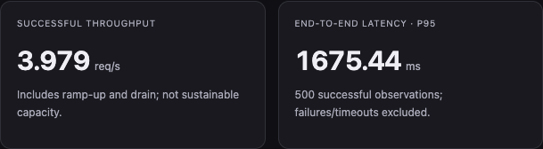
Sanitized report crop. Full read-only preview in the repository: docs/assets/real-app-report.html.
Explicit databricks-gpt-5-4-mini judges scored 50 of 500 eligible answers each: relevance 100% (50/50), correctness 86% (43/50), and zero judge errors. No automatic planner was used. One inference probe and two judge-readiness checks were excluded from load metrics.
Elapsed time was 125.652 seconds including drain. Answer-text TTFT, output-token usage, and internal traces were unavailable. This is historical evidence, not current-package quality validation, judge calibration, or sustainable capacity.

CLI today and live metrics next
evalsurge run request.json --local --settings operator.toml --wait
The CLI prints acceptance and a final summary; status exposes phases, but metrics arrive after worker exit. Add phases first, then proposed --watch polling every 1–2 seconds for elapsed time, counts, RPS, latency, and errors. Use bounded, content-free snapshots; label provisional/stale values, exclude probes, and preserve unknown TTFT, JSON, cancellation, and drain semantics. Verify observer overhead.

North star and proposed AgentBricks integration
Use one Python/CLI/REST contract: bind an agent, supply cases and load, start/watch/cancel, and receive the same typed report. Separate hosting/authentication from protocol and evidence. Extend hosting through adapters while preserving one engine, fail-fast behavior, and opt-in evaluation.
In AgentBricks 2.0, follow serve/deploy with endpoint selection, cases, traffic/cost preview, benchmark progress, and report inspection/export. The CLI would construct a binding and RunCreate and delegate to EvalSurge. Default to bounded local performance-only runs. Command spelling, ownership, and integration contracts require agreement with AgentBricks owners.

Next steps
1. Add phase progress, then live metrics with timing and overhead checks.
2. Finish wheel/App-template, quality, cancellation, and tracing validation.
3. Calibrate before warmup exclusion, sweeps, thresholds, and comparisons.
4. Agree an AgentBricks pilot and CLI contract. Material API/engine changes need an ADR and maintainer review.
5. Gate cloud execution on durable workers/storage, retention, quotas, and tenant/network controls.
Four HTTP/App real-model smokes passed with one measured request each, evaluation off. CrewAI/cloud-runner gaps remain. See docs/LIVE_MATRIX_RESULTS.md and docs/AGENT_INTEGRATION.md.

