REPORT
The project given to us was
“ Extraction of sub-trees from Hindi and Urdu dependency trees ”
But as we moved ahead with the project , we came to know the code that we developed is not entirely language dependent .We can extract and generalize a given tree bank from any given language.
Team Members
a)Rama Rohith Reddy Gangula (201525083)
b)Himakar Yanamandra (201525095)
Mentor
Irshad Bhat
Problem Statement
- Our aim of the project was to automatically extract all the possible subtrees from a given tree-bank.
- Generalizing the structures and coming up with a subtree bank representing basic structures.
- Extract all the grammar possible from a given tree bank in a consolidated manner.
Files Attached :
a)read me
b)report
c)cummulative which contains the main code
d)grammar output
e)sub trees output
Introduction
- Dependency is the notion that linguistic units, e.g. words, are connected to each other by directed links.
- The (finite) verb is taken to be the structural center of clause structure.
- All other syntactic units (words) are either directly or indirectly connected to the verb in terms of the directed links, which are called dependencies.
- Structure is determined by the relation between a word (a head) and its dependents.
- Dependency structures are flatter than constituency structures in part because they lack a finite verb phrase constituent.
- They are thus well suited for the analysis of languages with free word order.
Project Goals
- Automatically extract all subtrees possible from a given tree bank .
- Create a sub-tree bank where each group consists of sub trees based on similar POS tag,CHUNK tag,for the parent & child and dependency between them .
Method followed
- First we need to first decide how are we defining a subtree of a tree
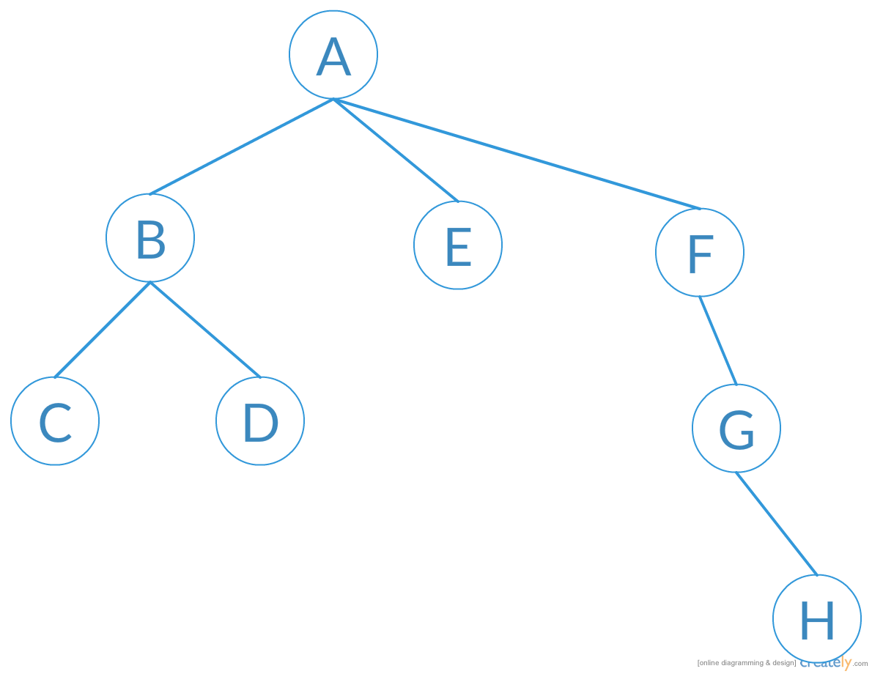

- We extract all the sub trees as
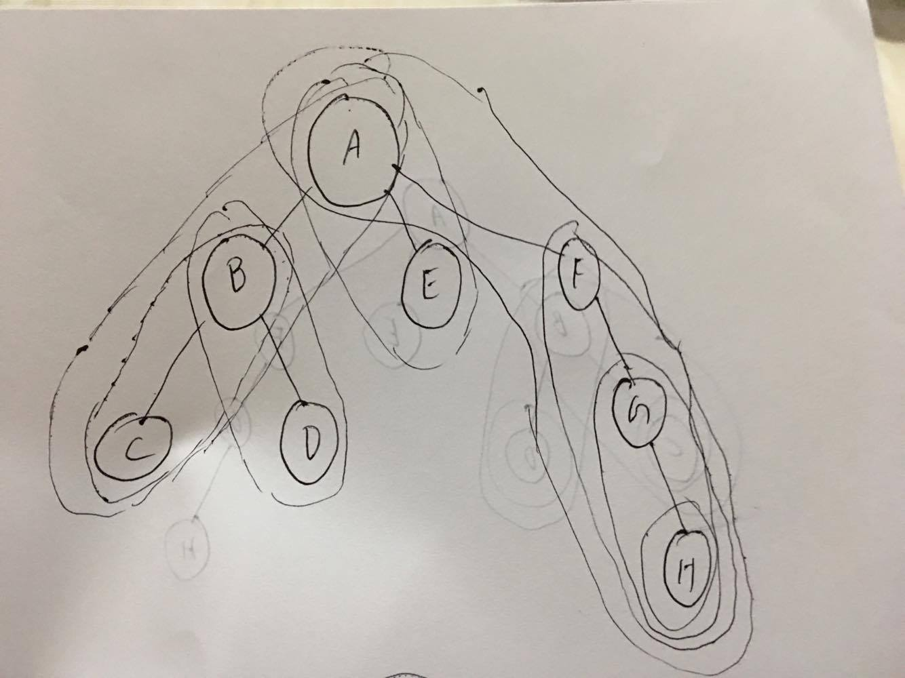

- After extracting the sub trees , we generalize them into groups
- Each group contains subtrees which have similar POS tag, Chunk tag,of the parent and child ,and the dependency between them .
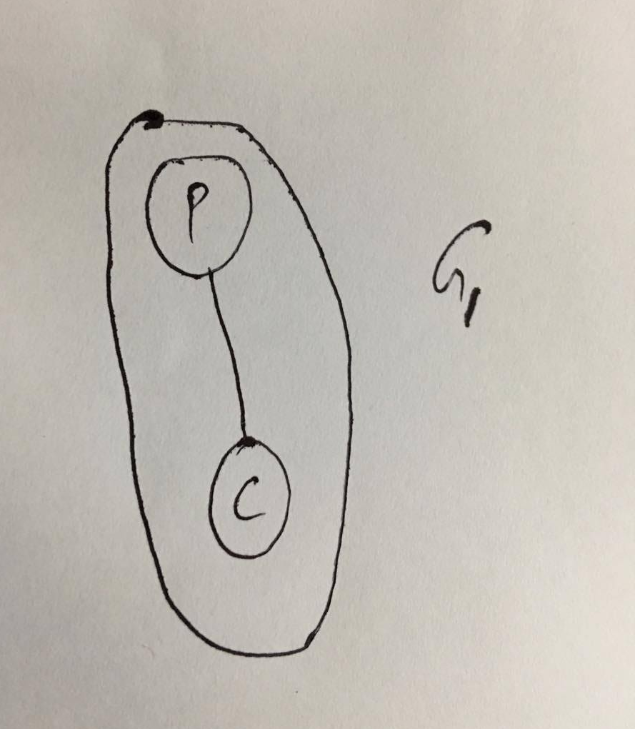
- We start with level 0 groups,each group only consists one parent and child relationship as depicted in the figure.
- We iterate the whole data set for all level zero groups checking for common instances .
- Then we move on to level 1 groups.
- Each level 1 group consists of a parent and a level 0 group .
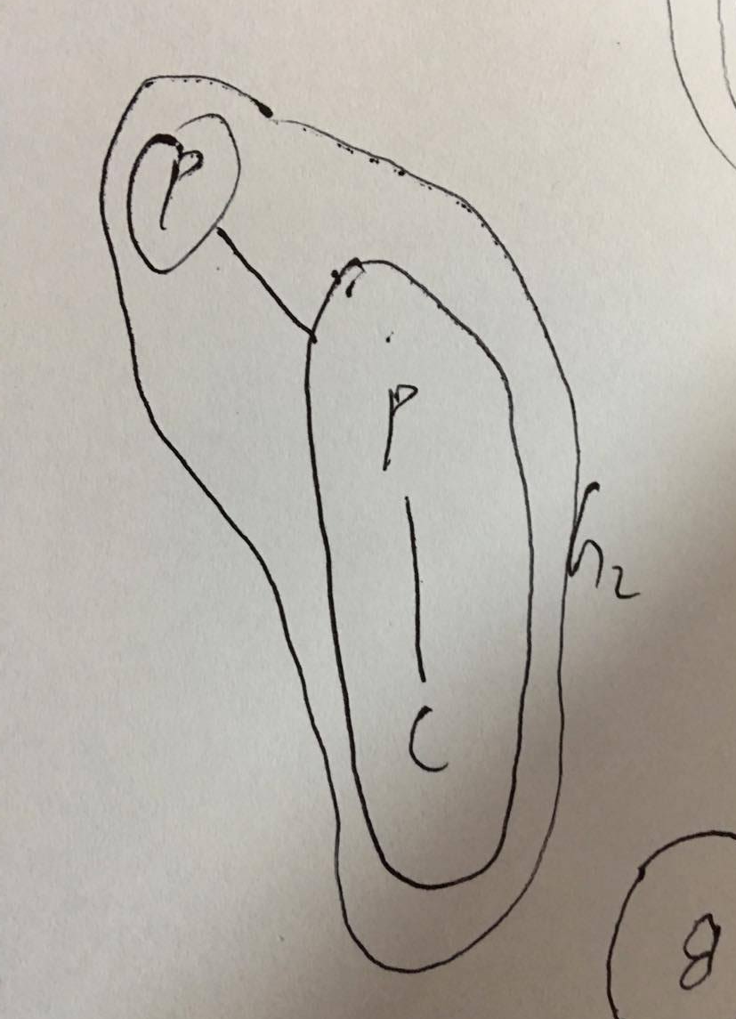
- When we are done with level 1 , we move to the next , and so on we iterate until we complete all ‘n’ levels of dependency tree of the whole tree bank.
- When we write level 1 group, we only mention the instance of group 0 instead of its whole data, thus reducing redundancy.
- If a parent has more than one child , the groups containing the all parent-child groups , denoted by the common parent.(CP)

Experiment and Results
- After we are done with generalizing the whole dataset we have taken as given above, we extract the grammar of the data set.
- This will give us a deeper understanding of a given dataset and in-turn of the language.
- The data set we have taken consists of 16,647 Hindi sentences.
- On average each sentence contains 15 words .
- We get on average 60 relations per a sentence. So the total grammar relations expected are 16,647 X 60 .
- But as many of them are common , we get a much lesser number.
- The grammar output and the subtrees out files have been attached in the folder we have submitted .
- The main aim of the project was to find the common grammar which is consolidated in the best way possible.

Here is an extract from the output data of extracted subtrees.

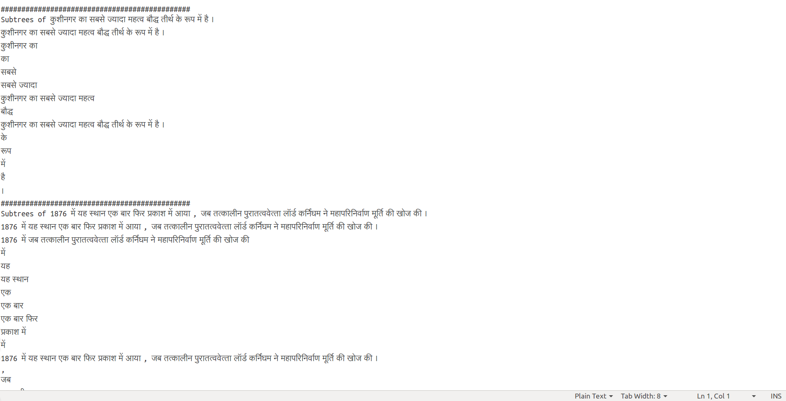

This extract is from the consolidated grammar of level 0.
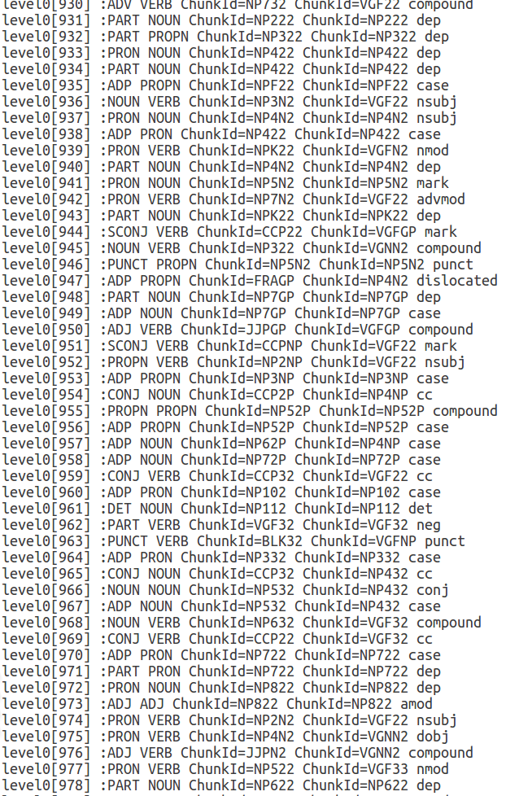

Discussion
- The types of dependencies have been found which we regularly encountered .
- We observed the trends in the grammar of the given language . I.e . Hindi in our case

Conclusion
- The problem we faced initially during the generalization of level 1 groups.
- The matching of level 0 groups and level 1 consumed a bit of time and at the same time has given us a deep understanding of the exact s tructure of the dependency tree and regular trends found.
- When a tree-bank containing a large dataset is given as input,it was a bit challenging to extract the grammar while reducing redundancy.
- All the goals set were fulfilled .
Individual Contribution
- Rama Rohit initially extracted the subtrees from the tree bank and generalized the data and coding part, while Himakar prepared the presentation slides and the project report .
- Both of us contributed for extracting all the grammar possible from the data set.

other references
https://en.wikipedia.org/wiki/Dependency_grammar
https://en.wikipedia.org/wiki/Verb_phrase
https://en.wikipedia.org/wiki/Phrase_structure_grammar

