Software Requirements Specification (SRS) Document
Project Title | B2B E-commerce Portal for IT Products and Services
Team Name | SSAD46
Team Members | T.Revanth,D.Vamsi Krishna,G.Rama Rohit,Saumya Prabodh Srivastava,Madhur Aggarwal

Brief problem statement

In the current era, setting up IT infrastructure in micro, small and medium enterprises has become a serious issue dueto inability to make right decisions. Generally, the challenges faced by such companies are delayed technical support, inefficient consulting, high maintenance and heavy budgeting.

To overcome this hurdle, MSME CLOUD has come up with an efficient way to handle the IT procurement. It useshouse of art (B2B) ecommerce solution to handle the issues quickly by saving the client’s time with a click awayservice model. This model ensures there is no latency in providing technical support with a endend expert consultingfor making efficient decisions which would eventually eliminate the budgeting, as they are offered support throughonline mode.

System requirements

1. Operating systems (Linux x86-64)

Linux distributions such as RedHat Enterprise Linux (RHEL), CentOS, Ubuntu, Debian, and so on.

2. RAM: 2GB
3. Composer
4. Web Servers
Apache 2.2 or 2.4
nginx 1.8
5. Database: MySQL 5.6
6. Language: PHP 5.5.x, where x is 22 or greater
7. PHP extensions:
- bc-math
- curl
- gd,ImageMagick 6.3.7(or later) or both
- intl
- mbstring
- mcrypt
- mhash
- openssl
- PDO/MySQL
- SimpleXML
- soap
- xml
- xsl
- zip
8. SSL
9. Mail server
Mail Transfer Agent (MTA) or an SMTP server
10. Magento can utilize the following technologies:
- Redis version 3.0 for page caching and session storage (the latter supported by Magento version 2.0.6 and later only)
- Varnish version 3.5 or latest stable 4.x version for page caching
- memcached latest stable version for session storage with either memcache or memcached PHP extensions (latest stable version)
- Magento Enterprise Edition (EE) only
  - Apache Solr 4.x
Solr search can be used as a search provider. Available for Magento Enterprise Edition (EE) only.
  - RabbitMQ 3.5
RabbitMQ can be used to publish messages to queue and to define the consumers that receive the messages asynchronously. Available for Magento EE only.
  - Three master databases
These master databases provide scalability advantages for different functional areas of the Magento application: checkout, orders, and product data. Available for Magento EE only.
11. Supported browsers
Internet Explorer and Microsoft Edge (Windows)
- Storefront: Internet Explorer 9 or later
- Magento Admin: Internet Explorer 11 or later, Microsoft Edge, latest–1
All other browsers (both storefront and Admin)
- Magento Admin: Internet Explorer 11 or later, Microsoft Edge, latest–1
- Firefox latest, latest–1 (any operating system)
- Chrome latest, latest–1 (any operating system)
- Safari latest, latest–1 (Mac OS)
- Safari Mobile for iPad 2, iPad Mini, iPad with Retina Display (iOS 7 or later), for desktop storefront
- Safari Mobile for iPhone 4 or later; iOS 7 or later, for mobile storefront
- Chrome for mobile latest–1 (Android 4 or later) for mobile storefront
where latest–1 means one major version earlier than the latest released version.

Users profile.
Adminstrator:
- Generate and update website content (products, content, promotions)
- Work with agencies to build traffic & sales via the website (PPC agency, email marketing provider, e-commerce provider, etc)
- Plan, define and implement website changes and functional improvements
- Maintain and update the online marketing plan for the website
- Monitor key performance indicators on the website and develop plans to improve them

Sub-Adminstrator:
- Assist the administrator in pursuing the activities he is involved in and remain in administrator role whenever administrator is not available.
Customer:
- Customer visits the site for buying certain IT products or for some services and provides his public profile to the site for buying certain products.
Distributor:
- His role is to inform the adminstrator about the stock related issues and ship the products to the customer and update the stocks of products in the site frequently.
Support Engineer:
- He registers himself with our portal by providing his location and availability timings and whenever he has a notification regarding support issue in nearby location then he goes there and solves the issue and updates his activity in the site.

Feature requirements (described using use cases)

No. | Use Case Name | Description | Release
 | View Items | This use case is extended by several optional use cases - customer may search for items, browse catalog, view items recommended for him/her, add items to shopping cart or wish list. All these use cases are extending use cases because they provide some optional functions allowing customer to find item. | R1
 | Search Items | Customer can search for the required products. | R1
 | Browse Items | Customer can browse the items | R1
 | View Recommended Items | Display the recommended items to specific customers | R2
 | Add to Shopping Cart | Adding the products to cart | R1
 | Add to Wish List | Adding the products to wish list for future purpose | R1
 | Make Purchase | Customer wishing to make the purchase | R2
 | Client Register | Customer Registration | R1
 | Checkout | It includes web customer should be authenticated. It could be done through user login page, user authentication cookie or single sign on. Website authentication service is used in all these use cases. | R1
 | Customer Authentication | Checking the customer authorization. | R1
 | User Sign-In | User login | R1
 | Remember Me | Remember the customer in the cookies | R1
 | Single Sign-On | Single login | R1
 | View/Update Shopping Cart | Display the cart products | R1
 | Calculate Total | Calculate the total cost of products | R1
 | Calculate Taxes and Shipping | Calculate the cost shipping and tax | R1
 | Payment by Credit | Payment through Credit/Debit | R1
 | Payment by offline | Payment through DD/ Cheque | R1
 | Authorize | The requested amount of money should be first authorized by Customer's Credit Card Bank, and if approved, is further submitted for settlement. During the settlement funds approved for the credit card transaction are deposited into the Merchant's Bank account. | R2
 | Capture | use case describes several scenarios when merchant needs to complete some previously authorized transaction - either submitted through the payment gateway or requested without using the system | R2
 | Credit | use case describes situations when customer should receive a refund for a transaction that was either successfully processed and settled through the system or for some transaction that was not originally submitted through the payment gateway. | R2
 | Void | Use case describes cases when it is needed to cancel one or several related transactions that were not yet settled. If possible, the transactions will not be sent for settlement. If the Void transaction fails, the original transaction is likely already settled. | R2
 | Verify | use case describes zero or small amount verification transactions which could also include verification of some client's data such as address | R2

Use case diagram

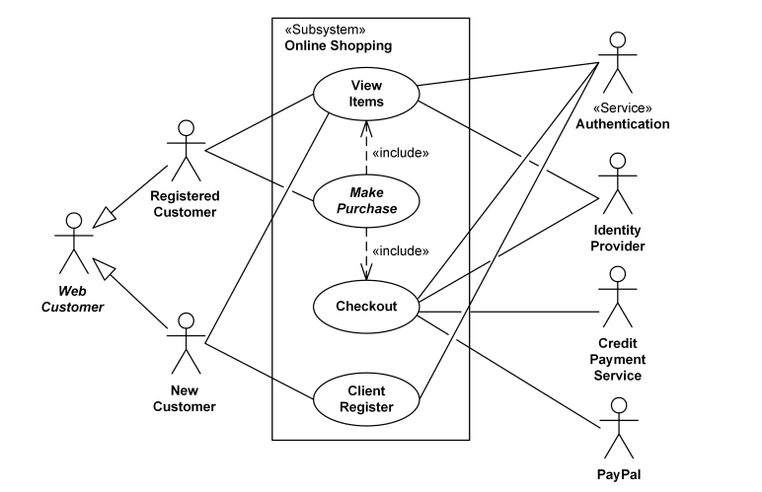1. Use case diagram for e-commerce
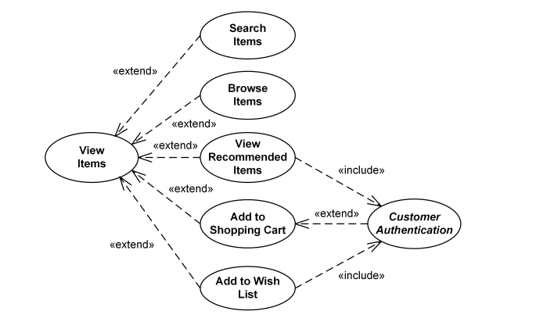
2. Use case diagram for View Items
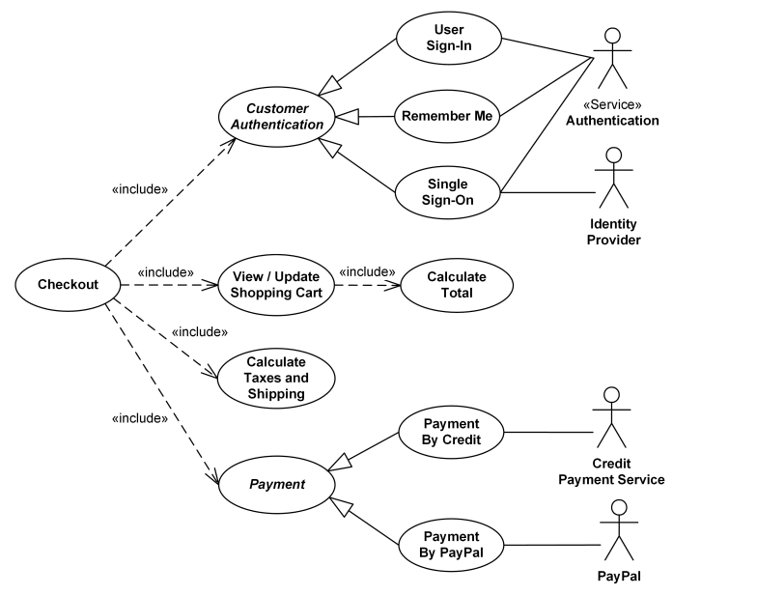
3. Use case diagram for checkout, authentication and payment.
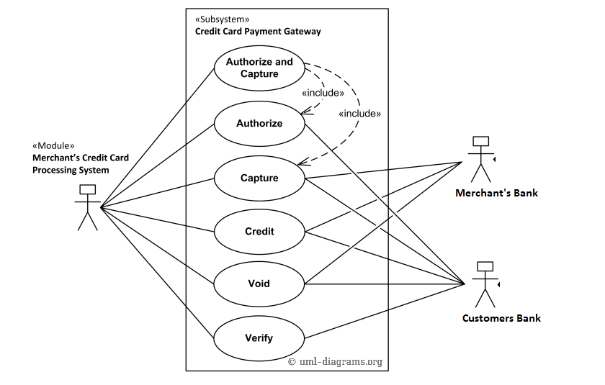
4. Use case diagram for online payment system.

Use case description
Use Case Number: | UC-07
Use Case Name: | Make Purchase
Overview: | Customer wishes to make the purchase of products in cart.
Actors: | Registered Customer,New Customer,Authentication,Identity Provider
Pre condition: | Customer has selected the make purchase option.
Flow: | Main (success) Flow:  1.Customer logins to the portal.  2.He browses/searches the items.  3.If there are items in the cart then checkout the web customer profile and move on to the next step(update cart) if checkout is successful.
Alternate Flows:
3.If there are no items in the cart an error message will be displayed that the cart is empty and asks customer to add products in the cart.
Post Condition: | If usecase is succesfull checkout usecase will be started.

Use Case Number: | UC-14
Use Case Name: | View or Update shopping cart
Overview: | Display the cart products
Actors: | Authentication,Identity Provider,Credit Payment Service,PayPal
Pre condition: | Customer has chosen the view shopping cart option or update the shopping cart.
Flow: | Main (success) Flow:  1.Customer logins to the portal.  2.He browses/searches the items.  3. He adds or edits the shopping cart.
Alternate Flows:
3.If the cart exceeds the price limit or number of items limit then usecase restarts or error message will be displayed.
Post Condition: | If cart is updated or items are added then on the option chosen by customer some other items can be added or puchase can happen.

Use Case Number: | UC-09
Use Case Name: | Checkout
Overview: | It includes web customer should be authenticated. It could be done through user login page, user authentication cookie or single sign on. Website authentication service is used in all these use cases.
Actors: | Authentication,Identity Provider,Credit Payment Service,PayPal
Pre condition: | Customer
Flow: | Main (success) Flow:  1.Customer logins to the portal.  2.He browses/searches the items.  3. He makes a purchase.  4. Then web customer will be authenticated and if authorized cutomer then total bill including the taxes and shipping will be caluculated and the customer will be moved to the payment step.
Alternate Flows:
4.If the customer is unauthorized then authentication failed message will be displayed or if the customer doen’t provide his location point or any other detail the caluculation of bill will be halted and error will be displayed.
Post Condition: | If checkout is successful then payment usecase starts.

