Process Model

A Process Model tells us about how the data is processed and how the data flows from one table to another to gather the required information. This model consists of the Functional Decomposition Diagram and Data Flow Diagram.

Functional Decomposition Diagram

A decomposition diagram shows a top-down functional decomposition of a system and exposes the system's structure. The objective of the Functional Decomposition is to break down a system step by step, beginning with the main function of a system and continuing wit h the interim levels down to the level of elementary functions. The diagram is the starting point for more detailed process diagrams, such as data flow diagrams (DFD). Figure shows the Functional Decomposition Diagram for this project.

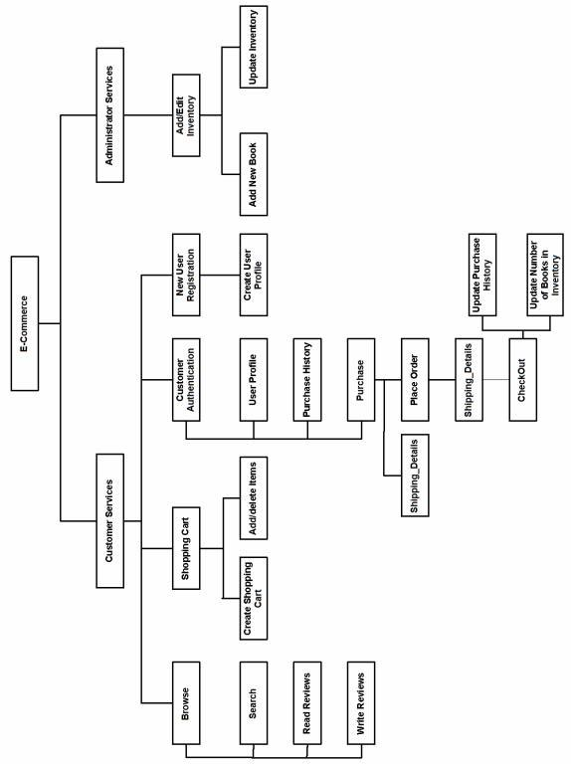

Data Flow Diagram (DFD)

Data Flow Diagrams show the flow of data from external entities into the system, and from one process to another within the system. There are four symbols for drawing a DFD:

Rectangles representing external entities, which are sources or destinations of data.

Ellipses representing processes, which take data as input, validate and process it and output it.

Arrows representing the data flows, which can either, be electronic data or physical items.
Open-ended rectangles or a Disk symbol representing data stores, including electronic stores such as databases or XML files and physical stores such as filing cabinets or stacks of paper.

Following Figures are the Data Flow Diagrams for the current system. Each process within the system is first shown as a Context Level DFD and later as a Detailed DFD. The Context Level DFD provides a conceptual view of the process and its surrounding input, output and data stores. The Detailed DFD provides a more detailed and comprehensive view of the interaction among the sub-processes within the system.

Shopping Cart Context DFD
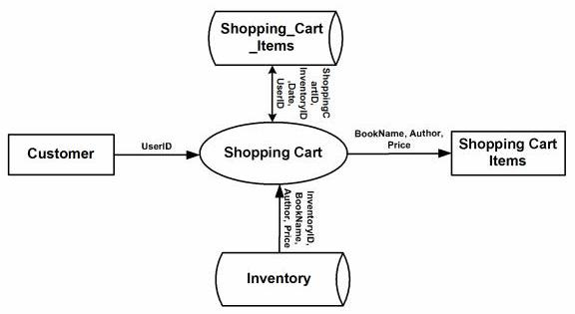

Customer – Authentication Context DFD

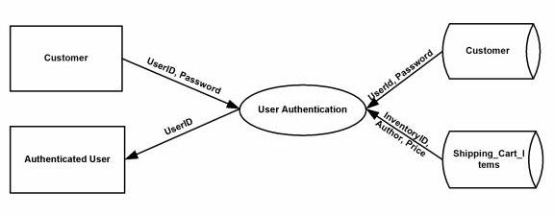

Customer – Shopping Cart Context DFD

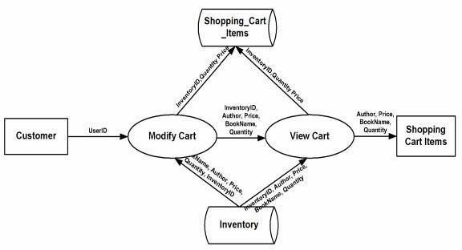
Customer-Authentication-UserProfile DFD

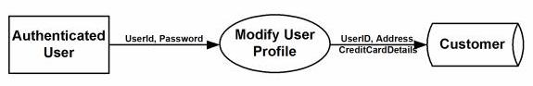

Customer-Authentication-PurchaseHistory DFD

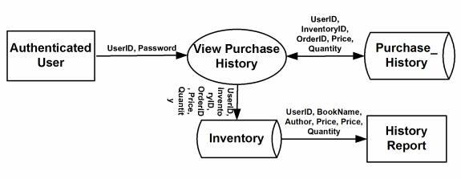

Authenticated User-Purchase Context DFD

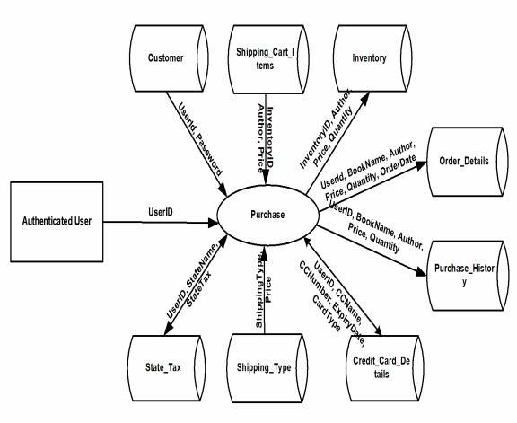
Authenticated User-Purchase DFD

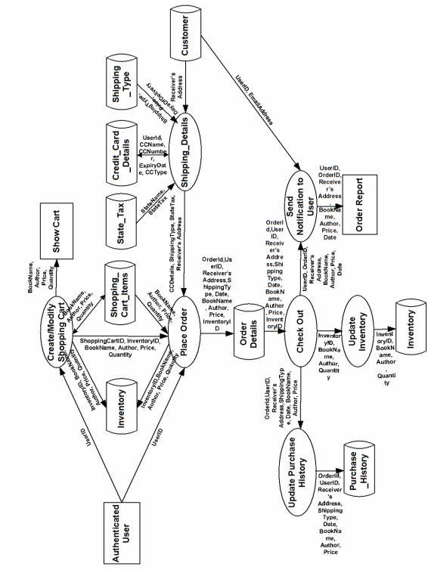
Customer-NewUserRegistration DFD

