MEDICURE-A Smart Medical Assistance and Appointment Booking System

Ms. Veena G
Department of Computer Science and Engineering Vemana Institute of Technology
Bangalore, India veenag@vemanait.edu.in

Deekshith G A (1VI22CS032) Department of Computer Science and Engineering
Vemana Institute of Technology Bangalore, India
A Charan (1VI22CS001)
Department of Computer Science and Engineering Vemana Institute of Technology
Bangalore, India
M Karthik Reddy (1VI22CS059) Department of Computer Science and Engineering
Vemana Institute of Technology Bangalore, India
Akash T N (1VI23CS401)
Department of Computer Science and Engineering Vemana Institute of Technology
Bangalore, India

Abstract—The increasing demand for fast, reliable, and easily accessible healthcare services has intensified the need for digital solutions that assist patients in locating appropriate medical facilities in real time. Traditional hospital-based information systems often rely on manual inquiries, outdated data, or physical visits to determine doctor availability, emergency services, or bed occupancy. Such delays are especially critical during medical emergencies, where timely access to care can significantly impact patient outcomes. This work presents Medicure, a mobile-based healthcare navigation platform designed to provide real-time hospital information, including bed availability, specialization- wise doctor schedules, emergency room status, and GPS-enabled routing to the nearest suitable medical facility. The system integrates location services, Google Maps and Places APIs, and a cloud-hosted database to deliver accurate and continuously updated hospital data. Users can filter hospitals based on spe- cialization, distance, and resource availability, enabling faster and informed decision-making. Hospitals and administrators update their dashboards dynamically, ensuring improved communication between healthcare providers and the public. Extensive testing demonstrates that Medicure provides low-latency responses, sup- ports scalability, and effectively reduces delays in emergency and non-emergency situations. The platform serves as a practical digital healthcare companion that enhances accessibility, trans- parency, and efficiency within modern healthcare ecosystems.
Index Terms—m-Health, hospital navigation, emergency healthcare, real-time systems, GPS routing, cloud computing, healthcare accessibility, digital health platforms.

- Introduction
The rapid evolution of mobile technology, cloud infrastruc- ture, and digital service platforms has significantly transformed the healthcare landscape. With the widespread availability of
smartphones and increasing digital literacy, users now expect faster, more reliable, and easily accessible healthcare assis- tance directly from their mobile devices. However, traditional hospital information systems still rely heavily on manual communication—such as phone inquiries, in-person visits, or static websites—to check hospital availability, emergency services, bed capacity, or doctor presence. This lack of real- time information often results in delays, inefficient decision- making, and overcrowding of certain facilities, particularly during medical emergencies.
These challenges are even more pronounced in rural, re- mote, and underserved areas, where patients frequently strug- gle to identify suitable hospitals that offer the required spe- cialization or emergency care. The absence of accurate, up- to-date navigation guidance leaves many users dependent on guesswork, outdated information boards, or time-consuming travel between hospitals. In critical conditions, such delays can significantly affect patient outcomes and strain already overburdened healthcare systems.
To address these limitations, this work proposes Medicure, a mobile-based healthcare navigation application designed to provide real-time visibility into hospital resources and guide users to the most appropriate medical facility based on their needs. The system integrates GPS services, Google Maps API, Places API, and a cloud-hosted database to deliver continu- ously updated data regarding bed availability, doctor schedules, emergency room status, and hospital specializations. Users can search for nearby hospitals, filter results based on medical needs, and receive optimized navigation routes in seconds. If a particular hospital is full or unavailable, the system suggests

alternative facilities with similar capabilities.
The platform adopts a modular architecture comprising a cloud-based backend, an intuitive mobile frontend, and an administrator portal for hospitals to update resource avail- ability in real time. This bidirectional communication en- sures transparency, minimizes misinformation, and enhances coordination between patients and healthcare providers. The design also supports extendability, allowing additional mod- ules—such as appointment scheduling, teleconsultation, or predictive analytics—to be integrated as healthcare demands evolve.
The remainder of this paper is structured as follows: Section II discusses related work in m-Health, hospital navigation sys- tems, and digital healthcare platforms. Section III defines the problem statement, scope, and objectives. Section IV details the system architecture and module-level design. Section V presents implementation details and testing outcomes. Section VI concludes the work and outlines future enhancements.

- Related Work
Recent advancements in mobile health (m-Health), digi- tal hospital navigation, and cloud-based healthcare systems have significantly improved the accessibility and efficiency of medical services. Research in this domain spans emergency response optimization, hospital recommendation systems, mo- bile patient tracking, and real-time healthcare information platforms.
Several works have explored GPS-driven hospital navigation solutions that assist users in locating nearby medical facilities based on distance or general availability. Early systems largely relied on static datasets or manual data collection, which often failed to reflect real-time hospital conditions such as bed occupancy or emergency room load. More recent models inte- grate cloud databases with location services to enable dynamic updates; however, many of these systems do not incorporate detailed specialization-level information or dynamic doctor availability, limiting their usefulness in critical scenarios.
Studies focusing on emergency care support have proposed mobile applications that identify the nearest hospitals equipped for trauma, cardiac care, or ambulance services. These systems commonly leverage Google Maps or OpenStreetMap data for routing, but they often lack advanced filtering mechanisms or mechanisms for hospital administrators to update emergency capacity in real time.
Research on hospital resource management has shown that cloud-based platforms can enhance transparency and coordi- nation between patients and healthcare providers. Firebase, Cloud Firestore, and other NoSQL databases have been used to support real-time synchronization of medical data, enabling faster decision-making for patients. However, such systems typically focus on appointment management or patient record storage rather than integrated navigation and resource visibil- ity.
Other works emphasize digital healthcare ecosystems that combine doctor availability tracking, teleconsultation, and ap-
pointment scheduling. Machine learning-based triage systems have been studied to guide patients in determining the right department or specialist based on symptoms. While these technologies improve user experience, they often operate in- dependently and do not provide unified routing or hospital comparison capabilities.
Beyond mobile applications, some studies propose IoT- enabled hospital monitoring for bed occupancy, ICU capacity, and emergency room congestion. These systems use sensors and cloud servers to maintain accurate resource counts but require significant infrastructure and are not widely deployed in public hospitals, especially in rural areas.
Although these contributions address various aspects of healthcare digitization, many existing solutions remain frag- mented—handling navigation, appointments, or hospital status separately. The system proposed in this paper aims to consol- idate these functionalities into a single mobile platform that provides real-time hospital information, resource availability, specialization-based filtering, and GPS-based routing, thereby offering a comprehensive healthcare navigation experience.

- Problem Statement, Scope and Objectives

- Problem Statement
Traditional healthcare systems often lack a unified, real-time digital mechanism that helps patients identify suitable hos- pitals during both emergency and non-emergency situations. Existing solutions generally provide static information such as hospital names or generic navigation routes, but they do not incorporate live data on bed availability, doctor presence, emergency room capacity, or specialization-specific services. As a result, patients frequently face delays, overcrowding at certain hospitals, and difficulty locating appropriate care, es- pecially in time-critical situations. Furthermore, limited com- munication between hospitals and patients leads to outdated or incomplete information. There is a need for an integrated mobile platform that provides accurate, real-time healthcare facility data and assists users in making well-informed medical decisions quickly.

- Scope
The scope of this work is to develop a demo scale social media platform that:
  - Retrieves nearby hospitals and their details using GPS, Google Maps API, and Places API.
  - Provides real-time hospital information such as bed oc- cupancy, emergency room status, and doctor availability.
  - Allows users to filter hospitals based on specialization, distance, and resource availability.
  - Enables hospitals or administrators to update service status, bed counts, and schedules through a dedicated backend portal.

  - Offers optimized navigation routes to the nearest oper- ational or suitable medical facility, particularly during emergencies.
  - Supports appointment scheduling and enhances pa- tient–hospital communication through a unified digital interface.

- Objectives
The primary objectives of the Medicure project are:
  - To design and implement a real-time hospital navigation and information retrieval system that integrates GPS services, cloud databases, and location APIs.
  - To provide an intuitive mobile interface enabling users to easily search, filter, and compare hospitals based on specialization and availability.
  - To enable hospitals to dynamically update bed status, emergency capacity, and doctor schedules through a se- cure administrator module.
  - To improve emergency response efficiency by offering fast, reliable navigation to the nearest suitable medical facility.
  - To evaluate the system based on functionality, real-time performance, usability, and scalability across different user groups and environments.
  - To support future expansion with additional modules such as teleconsultation, predictive analytics for hospital load, electronic record integration, and multilingual support.

- System Design and Architecture

- Overall Architecture
The proposed system adopts a layered architecture consist- ing of a mobile user interface layer, an application services layer, a hospital administration layer, and cloud-based data management components. The frontend is implemented as a mobile application that interacts with cloud services via secure RESTful APIs. The backend, deployed using Firebase Cloud Functions or an equivalent cloud platform, manages hospital data synchronization, real-time updates, and user authentication. The system utilizes Google Maps API, Places API, and GPS services to provide location-aware hospital recommendations and navigation.
The application integrates multiple functional modules, in- cluding:
  - Location Services Module for GPS-based hospital detec- tion and routing.
  - Hospital Information Module that retrieves real-time bed availability, emergency room status, and doctor schedules.
  - Filtering and Recommendation Engine that processes user requirements such as specialization, proximity, and availability.
  - Hospital Admin Dashboard for updating bed counts, resource availability, and service information.
A cloud database (e.g., Firebase Firestore) stores user pro- files, hospital metadata, availability statistics, and appointment records. Real-time synchronization ensures that updates made by hospital administrators are instantly reflected in all user devices.

- Data Flow
When a user interacts with the application, the following sequence occurs:
- The user opens the app, grants location access, and initiates a hospital search.
- The mobile client sends the location details to the backend, which queries Google Places API to retrieve nearby hospitals.
- The backend fetches real-time hospital data (beds, emergency capacity, doctor availability) from the cloud database.
- The recommendation engine filters and ranks hospitals based on distance, specialization, and resource availabil- ity.
- The results are returned to the mobile app, where hospitals are displayed on an interactive map and list view.
- If the user selects a hospital, the app triggers GPS navigation through Google Maps and displays relevant details.
- Hospital administrators update availability (e.g., beds, emergency status), which is instantly synchronized for all users through real-time database triggers.

- Functional and Non-Functional Requirements
Key functional requirements of the Medicure system in- clude:

  - User Authentication: Secure login and role-based access for users and hospital administrators.
  - Hospital Search and Filtering: Location-based hospital detection with filters for specialization, distance, and resource status.
  - Real-Time Availability Updates: Instant synchroniza- tion of bed counts, emergency room load, and doctor schedules.
  - GPS Navigation: Integrated routing to guide users to the nearest suitable medical center.
  - Admin Dashboard: Portal for hospitals to update status, manage services, and provide doctor schedules.
  - Appointment Management: Users can request or sched- ule appointments where applicable.
  - Emergency Assistance: One-tap shortcut to find the nearest available emergency facility.
Non-functional requirements ensure the system’s reliability and effectiveness:

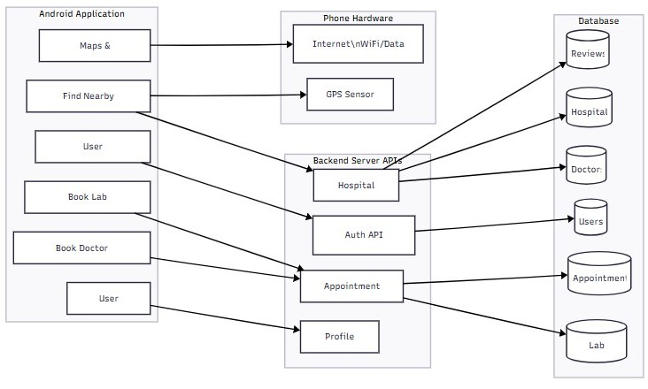

Fig. 1. System Architecture of the Medicure Platform

  - Performance: Low-latency retrieval of hospital informa- tion and fast map rendering.
  - Scalability: Ability to support increasing numbers of users, hospitals, and real-time data updates.
  - Security: Encrypted communication, secure authentica- tion, and proper access control for hospital administrators.
  - Reliability: Robust cloud infrastructure, automatic failover, and redundant data storage.
  - Usability: Intuitive, accessible design suitable for users of all demographics, including elderly and rural popula- tions.
  - Maintainability: Modular design based on clearly sep- arated functional components, enabling straightforward upgrades and extensions.

- Implementation and Testing

- Technology Stack
The frontend of the Medicure application is developed as a mobile interface using Flutter / React Native, providing a responsive, cross-platform user experience. Google Maps SDK and Places API are integrated to support interactive maps, hospital search, and navigation features. The application communicates with the backend through secure RESTful API calls.
The backend is implemented using Firebase Cloud Func- tions and Node.js, handling operations such as hospital data retrieval, user authentication, real-time synchronization, and request routing. Firebase Firestore, a NoSQL cloud database, stores hospital profiles, bed availability, doctor schedules, emergency room status, and user appointment records.
Location-based services rely on:

  - Google Maps API for navigation routes
  - Places API for hospital discovery
  - GPS modules for real-time positioning
The hospital admin portal is built as a lightweight web dashboard, enabling administrators to update resource avail- ability dynamically. Real-time database triggers ensure that
any updates made by hospitals immediately propagate to all user devices.

- Hardware and Deployment
On the client side, the application runs efficiently on stan- dard smartphones with basic hardware requirements such as a quad-core processor, 3–4 GB RAM, and a stable internet con- nection. No specialized hardware is required beyond standard GPS capability.
On the server side, the backend relies on Firebase’s cloud infrastructure, which provides autoscaling capabilities, fault tolerance, and globally distributed data centers. Real-time services in Firestore allow instant updates to be reflected across all connected devices.
Containerized components may be deployed using Docker for testing, and the backend is compatible with orchestration frameworks such as Kubernetes if scaled beyond prototype level.

- Testing Strategy
A comprehensive testing methodology was adopted to en- sure the robustness and reliability of the Medicure platform:
  - Unit Testing was conducted for hospital retrieval logic, filtering algorithms, API communication, and database synchronization functions.
  - Integration Testing validated interactions across compo- nents, including mobile app–API communication, admin dashboard updates, and Google Maps navigation work- flows.
  - Functional Testing confirmed correct behavior for hospi- tal search, filtering by specialization, emergency routing, user authentication, and real-time data updates.
  - Performance Testing measured application responsive- ness during simultaneous user queries and frequent hos- pital data updates, ensuring low latency under typical and peak loads.
  - Usability Testing was performed across devices with varying screen sizes to assess clarity, accessibility, and navigation efficiency for users of different demographics.
  - Security Testing focused on authentication, secure API access, proper validation of admin updates, and safe handling of user data transmitted through the application.
Representative test cases included scenarios such as searching for nearby hospitals, navigating to the nearest emergency room, filtering hospitals by specialization, verifying real-time bed availability updates, and simulating multiple concurrent admin updates. Results showed that the system consistently delivered fast responses, accurate routing, and stable real-time synchronization, demonstrating the platform’s reliability and practical usability.

- Results and Outputs

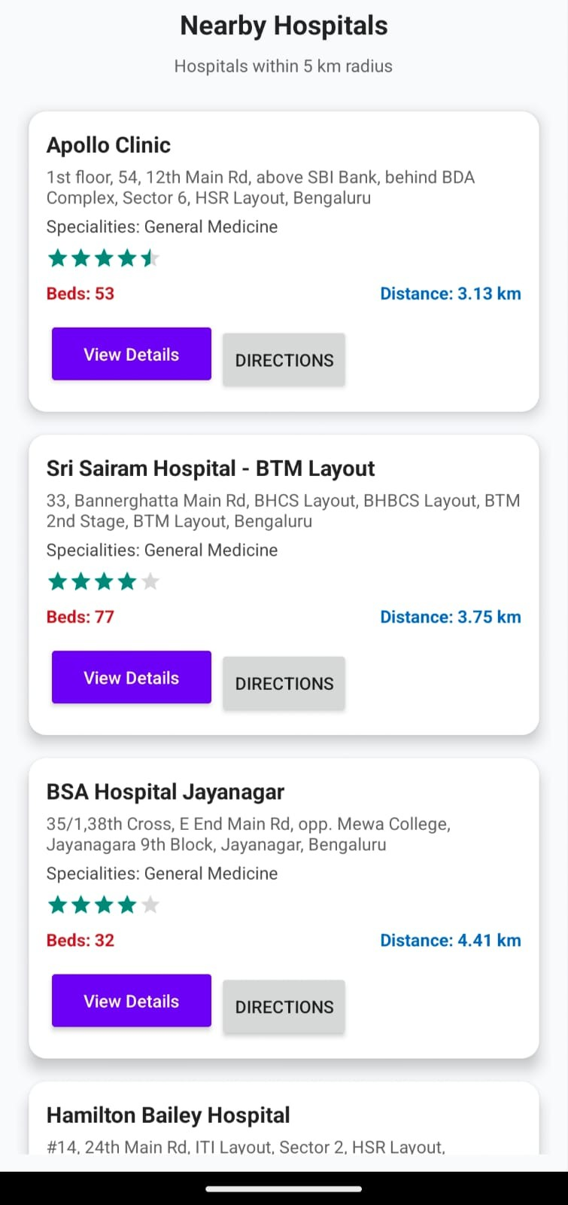
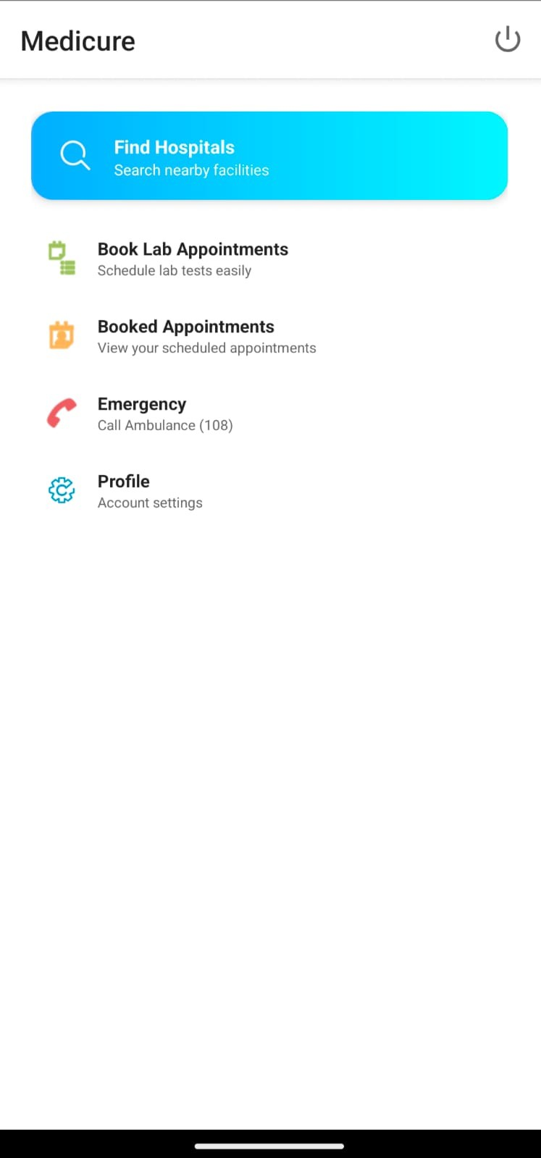
a cloud-backed real-time database, the system delivers up- to-date details on bed availability, emergency room capac- ity, specialization-based doctor presence, and overall hospital readiness. The platform enhances patient–hospital communica- tion and enables faster decision-making, reducing delays that often occur due to manual inquiries or outdated information. The prototype demonstrates that real-time healthcare re- source tracking, combined with automated navigation and user-friendly interfaces, can significantly improve accessibility and responsiveness in modern healthcare ecosystems. Testing confirms that the application provides low-latency responses, maintains reliable synchronization of hospital data, and per- forms effectively under concurrent user and admin interac-
tions.
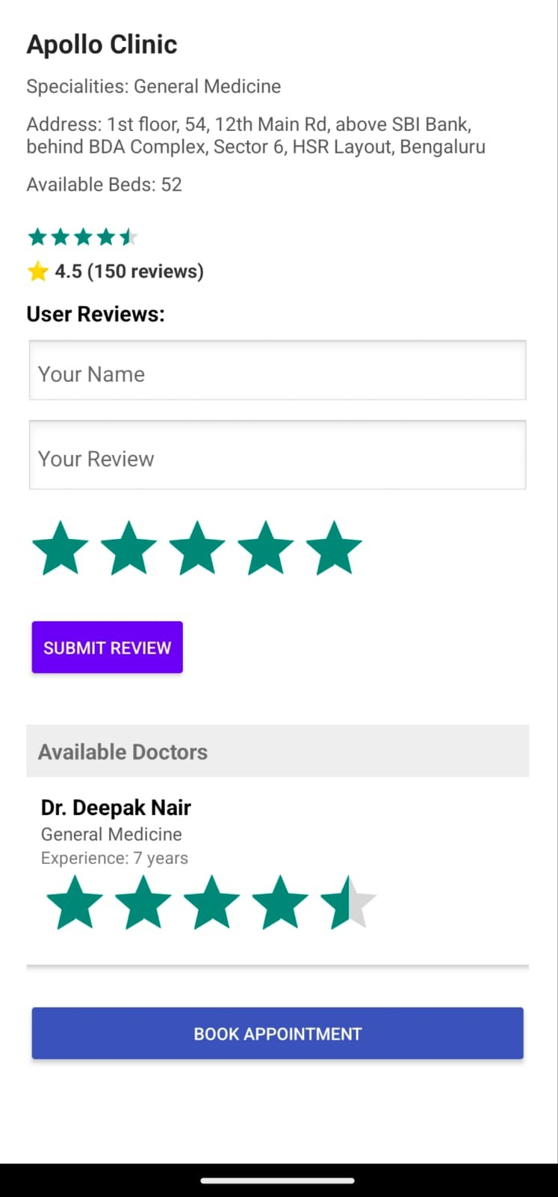
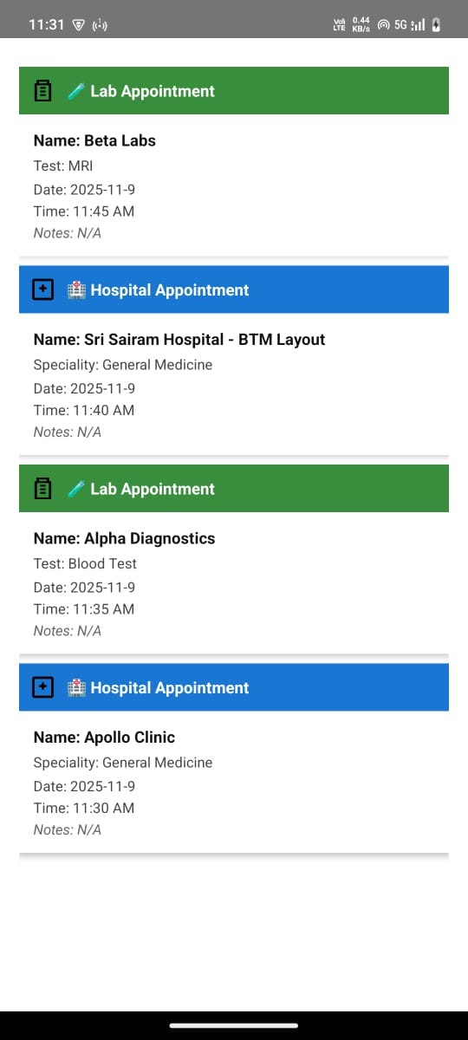
Future work includes expanding the system with additional healthcare services such as teleconsultation support, integra- tion with electronic health record (EHR) platforms, and the incorporation of predictive analytics to forecast hospital occu- pancy and emergency demand. Adding multilingual interfaces and offline support would increase usability across diverse user groups, particularly in rural regions. Further enhance- ments may also involve deploying AI-assisted symptom triage, advanced hospital recommendation algorithms, and deeper interoperability with national healthcare networks to broaden the platform’s real-world applicability and impact.

References

- R. Kumar, S. Mehta, and A. Dubey, “Mobile Health Navigation Systems for Emergency Medical Services,” Proc. Int. Conf. on Smart Healthcare Technology, 2023.
- L. Andrade et al., “Real-Time Hospital Resource Monitoring Using Cloud-Based Databases,” Journal of Medical Systems Engineering, 2024.
- P. Narayanan and K. Bhat, “GPS-Enabled Hospital Detection and Routing for Emergency Response,” Dept. of Information Science, 2023.
- S. R. Hegde et al., “Improving Healthcare Accessibility Through Mobile Applications: A Review,” Proc. Conf. on Digital Health Innovations, 2024.
- M. Choudhary and F. Rahman, “Cloud-Firestore Based Real-Time Healthcare Data Synchronization,” Int. Journal of Mobile Computing and Health Informatics, 2023.
- J. K. Sharma and R. Patel, “Location-Aware m-Health Systems: Trends and Challenges,” Dept. of Computer Engineering, 2024.
- N. S. Gupta et al., “Emergency Healthcare Decision Support Using Google Maps API,” Proc. Int. Conf. on Intelligent IoT and Healthcare Systems, 2025.

- Conclusion and Future Work
This paper presented Medicure, a mobile-based healthcare navigation platform designed to provide real-time hospital information and assist users in identifying suitable medical facilities during both routine and emergency situations. By integrating GPS services, Google Maps and Places APIs, and

