1. Video Processing Module
- Ingestion captures high-speed video feeds from webcams, RTSP streams, or local files using OpenCV
- Preprocessing resizes input frames to 640x640 resolution to standardize inputs for the detection model
- Buffering maintains a continuous 5-second circular buffer using deque to preserve pre-crash evidence
- Encoding converts raw frames into lightweight Base64 strings for low-latency transmission via ZeroMQ
Algorithm
- Capture the current frame from the video source
- Resize the frame to 640x640 pixels to match model input requirements
- Push the frame into a circular queue
- If the queue is full (exceeds 150 frames), discard the oldest frame
- Encode the processed frame to a Base64 string for transmission
2. Accident Detection Module
- Object Detection identifies multiple vehicle classes (cars, trucks, motorcycles) in real-time using the YOLOv11s deep learning model
- Tracking assigns persistent IDs to vehicles across frames using the Norfair algorithm for trajectory analysis
- Physics Engine computes kinematic metrics like deceleration and angle deviation to identify high-stress anomaly events
- Collision Logic confirms crashes by correlating Intersection over Union (IoU) data with physics-based anomaly scores
Algorithm
- Run YOLOv11 on the current frame to detect vehicle bounding boxes
- Apply Norfair tracking to assign unique IDs to each detection
- Calculate velocity, deceleration, and angle change for each tracked object
- Compute an anomaly score based on deceleration and sudden angle changes
- Confirm crash if Anomaly Score > 25.0 and objects are within interaction radius
3. Accident Classification Module
- Model Interface loads a custom Keras binary classifier using the Torch backend for GPU acceleration
- Image Preprocessing processes candidate frames by resizing them to 256x256 pixels for model compatibility
- Verification analyzes the scene to filter false positives by distinguishing valid accidents from normal traffic
- Confidence Scoring calculates probability metrics to assign severity levels (High/Critical) to the detected event
Algorithm
- Receive the candidate image (full frame or crop)
- Resize the image to 256x256 pixels
- Perform a forward pass through the basic CNN model
- If the predicted probability of "Accident" is greater than 0.8, mark severity as Critical
- Return the classification label and confidence score
4. Sector Alert Module
- Data Aggregation groups related detections into single events using a 10-minute rolling window based on Sector ID to handle multi-camera overlaps
- Sector Mapping queries the MongoDB database to link the active camera to its specific geographic sector ID
- Event Logging securely stores verified accident records, timestamps, and video evidence paths into MongoDB for historical auditing
- Notification dispatches real-time alerts to responders via SMTP Email and WhatsApp Cloud API services

Algorithm
- Receive a new alert payload containing $Timestamp_{new}$, $CameraID$, and detection confidence
- Retrieve SectorID associated with the $CameraID$ from the system configuration
- Query database for the latest active alert matching this SectorID
- Calculate time difference ∆T = $Timestamp_{new} - Timestamp_{last_alert}$
- If active alert exists AND ∆T < 10 \text{minutes}$:
  - Merge: Update the existing alert record with new evidence (photos/timestamps)
  - Suppress: Do not send a new notification
- Else (No active alert OR ∆T > 10 \text{ minutes}$):
  - Create: Insert a new unique Accident Event document into MongoDB
  - Dispatch: Trigger Email and WhatsApp notifications to responders mapped to SectorID
Datasets Used
- TAD – Traffic Accident Detection (Video Surveillance)
Large-scale video dataset from highway surveillance cameras; supports image, video, and object detection tasks and serves as a benchmark for ITS research.
- CNN Accident Detection Dataset (91%) – Kaggle
Image-based dataset for accident vs non-accident classification using CNN models.
- Accident Detection Dataset (93%) – Kaggle
Binary image classification dataset with labeled road scenes for deep learning-based accident detection.
- Custom Dataset
Mixed dataset (CCTV videos, extracted frames, metadata) created to improve real-world robustness and system validation.

Proposed System
- AI-Driven Detection: Replaces manual monitoring with automated YOLOv11 multi-vehicle analysis.
- Dual-Check Accuracy: Combines Physics-Based anomaly scores with CNN Verification to reduce false alarms.
- Instant Sector Alerts: Automatically maps incidents to geographic sectors and notifies responders immediately.
- Evidence Locking: Captures and secures pre-crash buffer and snapshot evidence without human intervention.
- Real-Time Dashboard: Provides a centralized Live Command Center for managing multiple camera feeds and responder dispatch.
Advantages
- Zero-Latency Response: Eliminates human delays, triggering alerts within seconds of crash impact.
- High Reliability: Filtered verification pipeline drastically reduces false positives from normal traffic.
- Scalable Automation: Monitors unlimited cameras continuously 24/7 without fatigue.
- Actionable Intelligence: Delivers precise location and evidence directly to responders' phones.
- Resource Efficiency: Automation allows security personnel to focus on response rather than observation.

Accident Alert: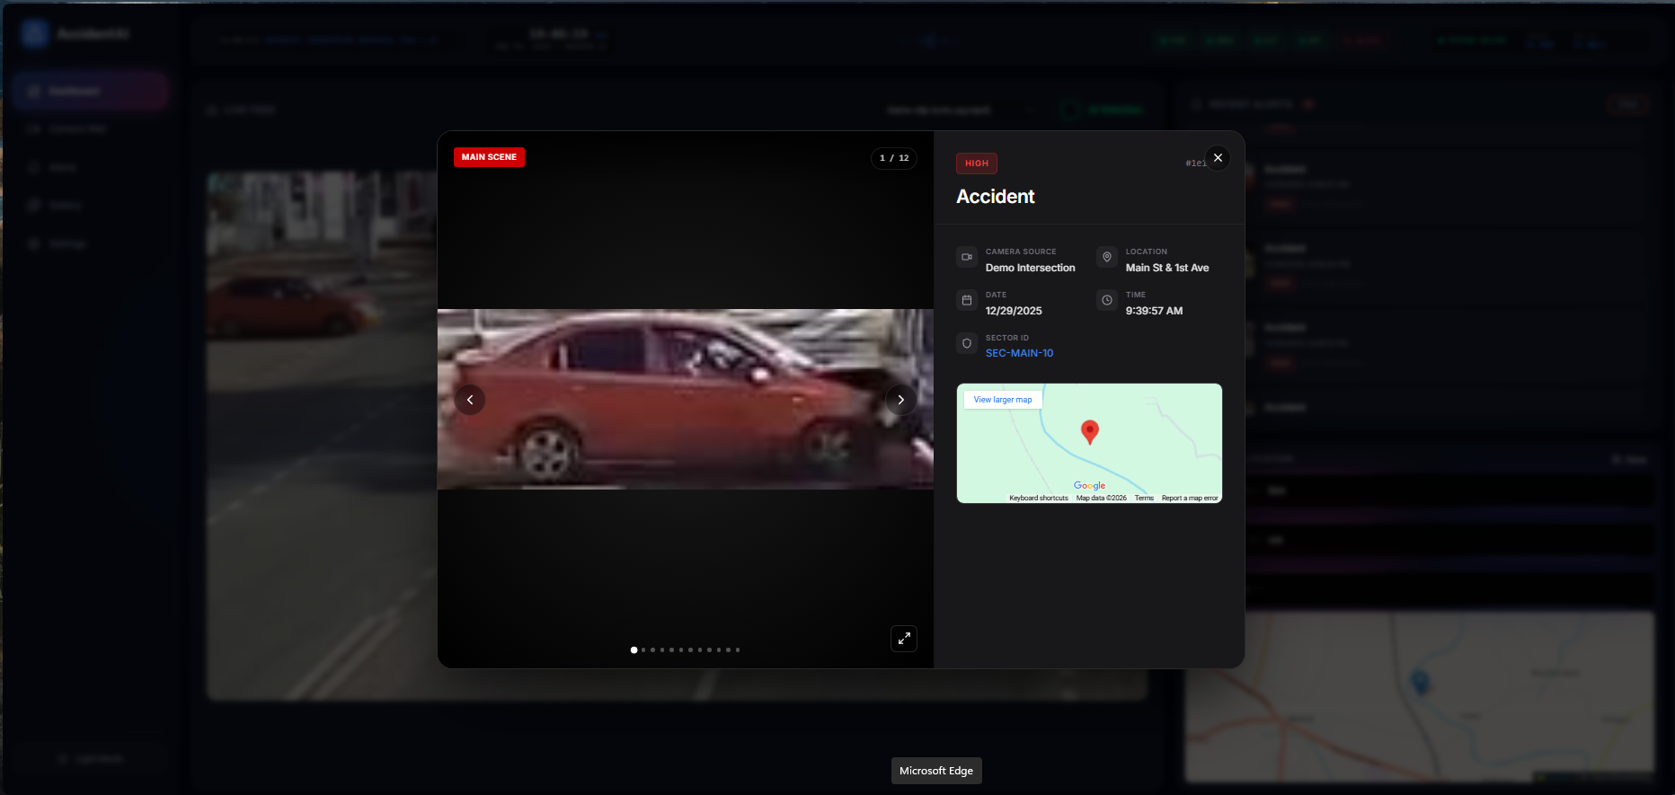
Dashboard:
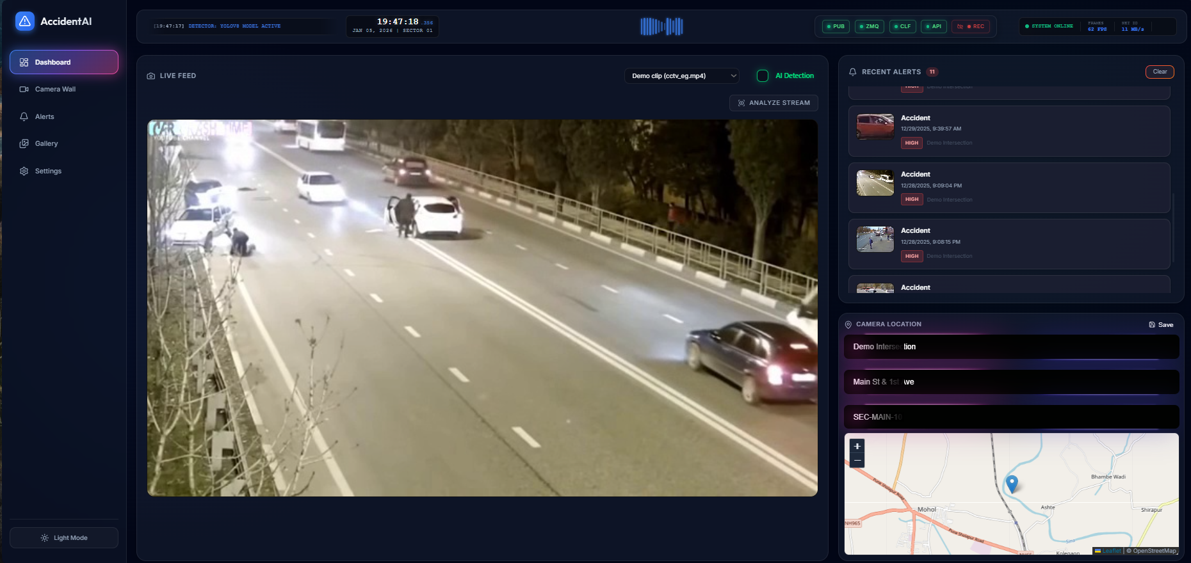
Settings:
