EvalAI
AI-Powered Exam Evaluation System
Project Documentation
Version | 1.0
Repository | github.com/Rama-chandran-M/lrn_02
Document Date | 26 April 2026

1. Project Overview
EvalAI is a web-based application that automates the grading of student answer sheets using AI. The system accepts scanned or digital answer sheets and a teacher-supplied answer key as PDF files, processes them through an OCR and language model pipeline, and produces a structured evaluation report — including per-question scores, correct answers, and a performance summary with identified strengths and weaknesses.

The project is structured as a decoupled system: a Python FastAPI backend handles all processing and AI interactions, while a React (TypeScript) frontend provides the user interface. Both single-student and batch (multiple-student) evaluation modes are supported.

1.1 Key Capabilities
- Upload one or multiple student answer sheets in PDF format alongside an answer key PDF
- Automatic text extraction from PDFs using Mistral OCR
- AI-driven answer structuring and evaluation using Google Gemini
- Real-time progress updates streamed to the browser during processing
- Parallel processing of multiple student papers using a thread pool
- Detailed per-question breakdown showing score, status, student answer, and correct answer
- Overall summary with total score, percentage, and qualitative feedback

1.2 Tech Stack
Layer | Technology | Purpose
Backend | Python 3.10+, FastAPI | REST API, pipeline orchestration
OCR | Mistral OCR API | Extract text from PDF answer sheets
LLM | Google Gemini (via LangChain) | Structure and evaluate answers
Frontend | React 18, TypeScript, Vite | User interface
Streaming | StreamingResponse (FastAPI) | Real-time progress to browser
Concurrency | ThreadPoolExecutor, threading | Parallel student processing

2. Architecture Overview
The application follows a straightforward client-server architecture. The React frontend communicates with the FastAPI backend over HTTP. All AI processing happens on the backend; the frontend is purely responsible for file collection, displaying progress, and rendering results.

2.1 High-Level Flow
The following describes what happens from the moment a user clicks Run Evaluation to when the results appear on screen:

- The user uploads student PDF(s) and the answer key PDF through the browser.
- The frontend sends a multipart POST request to the backend (/evaluate or /evaluate-multiple).
- The backend validates the uploaded files (format, size).
- The answer key PDF is sent to the Mistral OCR API to extract its text content.
- The extracted text is passed to Gemini (via LangChain) with the Answer Key Prompt to produce a structured JSON representation of the expected answers.
- For each student paper: OCR extracts the student's text, Gemini structures the student answers using the Structuring Prompt, and then a second Gemini call compares student answers to the answer key using the Evaluation Prompt.
- Each processing step emits a server-sent event that the browser reads and displays as a progress update.
- Once all steps complete, the final evaluation JSON is sent to the frontend and rendered as a report.

2.2 Backend Module Structure

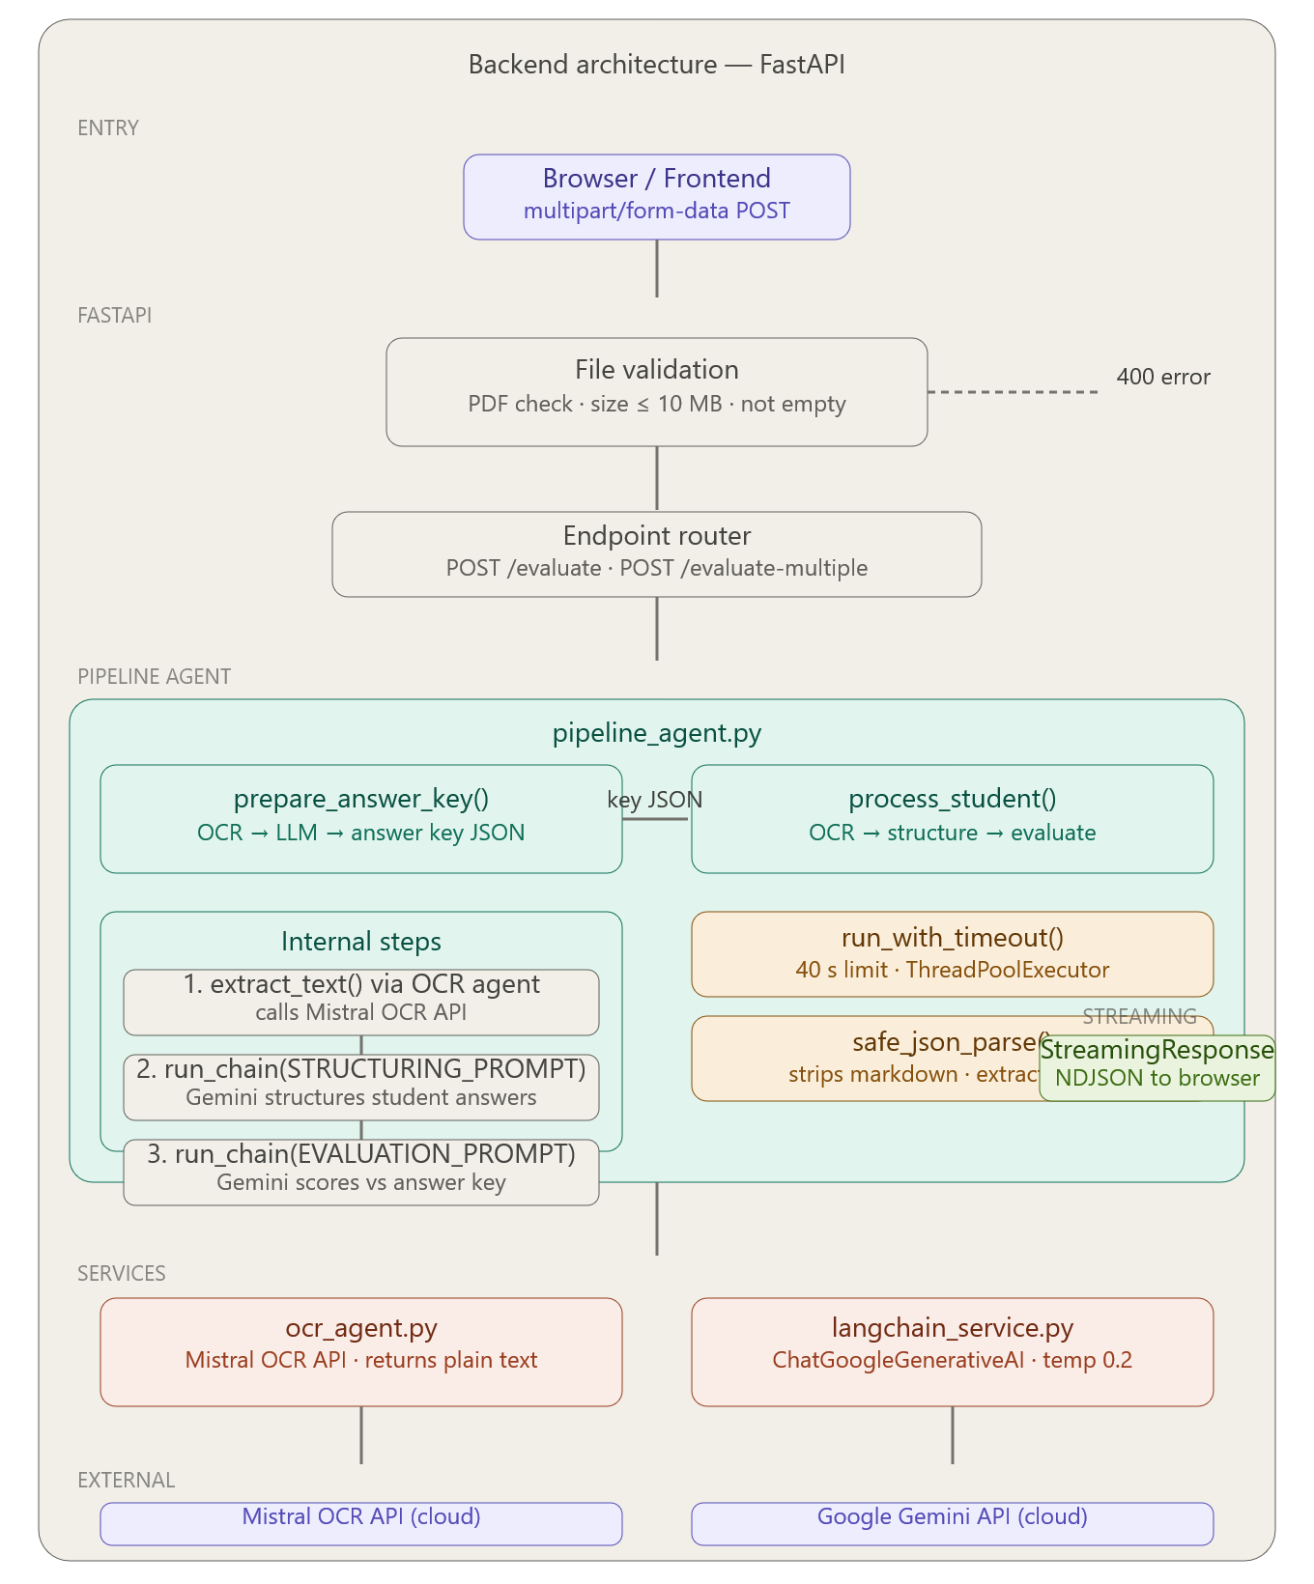
The backend is organised into the following directories and files:

File / Folder | Responsibility
main.py | FastAPI app entry point, endpoint definitions, CORS, file validation
agents/pipeline_agent.py | Core pipeline logic: orchestrates OCR, structuring, and evaluation steps
agents/ocr_agent.py | Wraps the Mistral OCR API call; returns plain text from a PDF
services/langchain_service.py | Initialises the Gemini LLM via LangChain; runs prompt-response chains
services/gemini_service.py | Direct Gemini API wrapper with retry logic for rate-limit handling
prompts/answer_key_prompt.py | Prompt template for structuring answer key text into JSON
prompts/structuring_prompt.py | Prompt template for structuring student answer text into JSON
prompts/evaluation_prompt.py | Prompt template for comparing student answers against the answer key
config/settings.py | Loads API keys and model names from environment variables

2.3 Frontend Module Structure

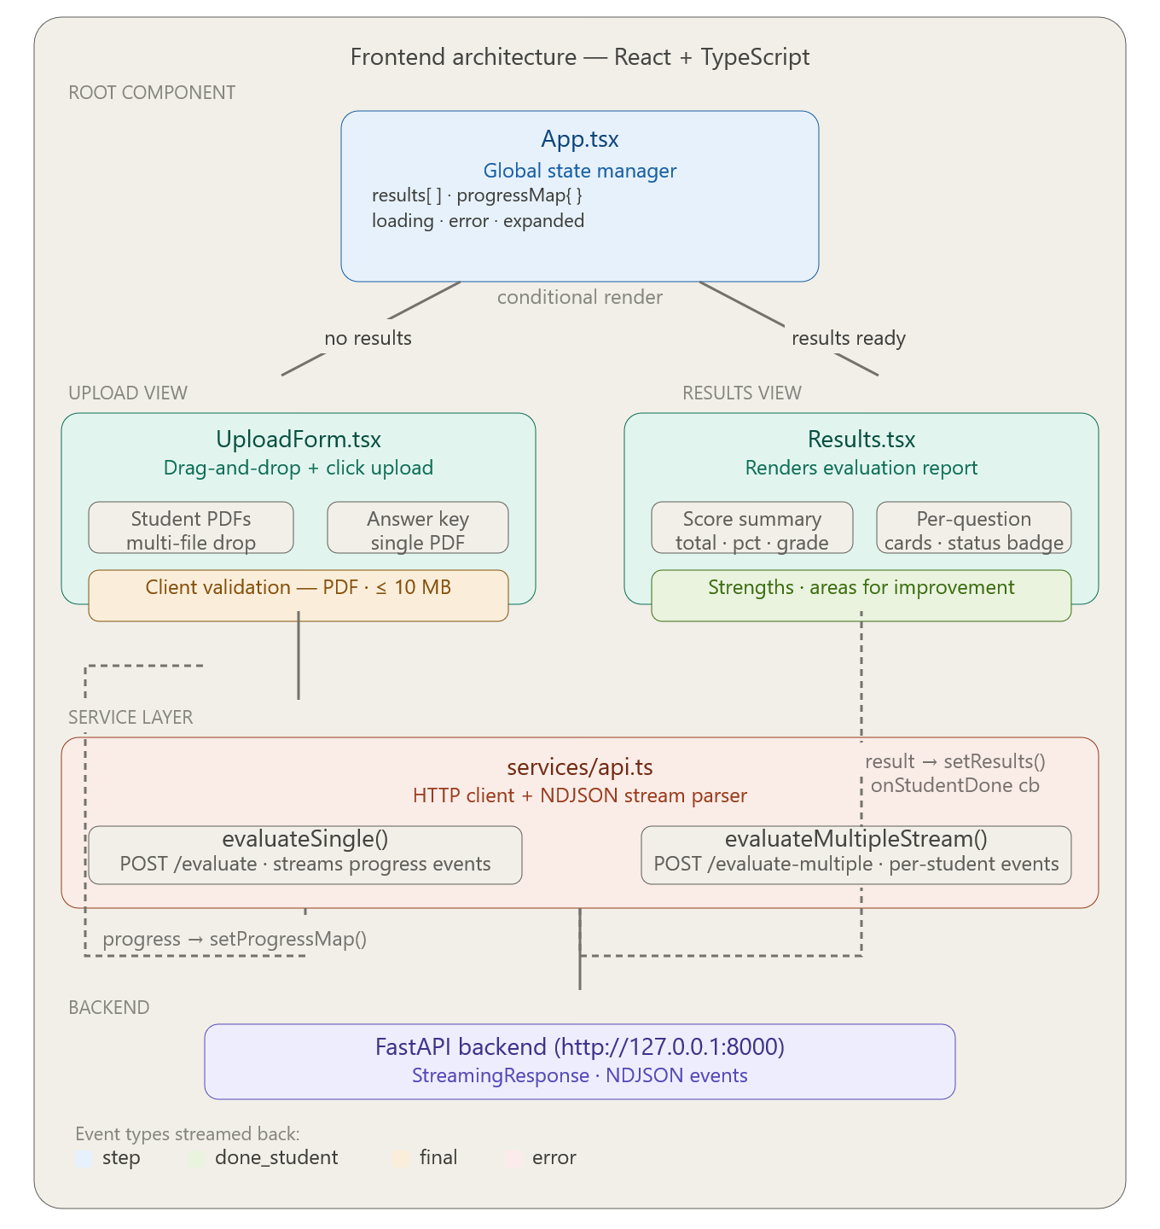

File | Responsibility
App.tsx | Root component; manages global state (results, progress, loading, errors); handles single vs. multiple evaluation routing
components/UploadForm.tsx | Drag-and-drop file input for student sheets and answer key; client-side PDF validation
components/Results.tsx | Renders the evaluation report: score summary, strengths/weaknesses, per-question breakdown
services/api.ts | HTTP client functions that call the backend endpoints and parse the NDJSON stream

2.4 Data Flow — Single Student Evaluation
Below is the data flow for a single-student evaluation request, showing the component involved at each stage and what is passed between them:

- Browser sends multipart POST with student PDF and answer key PDF to POST /evaluate
- Backend saves both files to temporary disk locations
- pipeline_agent.prepare_answer_key: runs OCR on answer key, calls Gemini with ANSWER_KEY_PROMPT, returns structured JSON
- pipeline_agent.process_student: runs OCR on student sheet, calls Gemini with STRUCTURING_PROMPT, then calls Gemini again with EVALUATION_PROMPT comparing both JSONs
- Each step publishes a progress event to a queue; a background thread flushes the queue as NDJSON lines via StreamingResponse
- Frontend reads each NDJSON line, updates the progress display, and on completion renders the Results component

2.5 Data Flow — Multiple Student Evaluation
For batch evaluation the flow is extended with parallelism:

- Answer key is processed once using prepare_answer_key and the resulting JSON is shared across all student tasks
- A ThreadPoolExecutor with max_workers=3 is used to process up to three student papers concurrently
- Each student's progress and result are pushed to a shared queue with the student filename as an identifier
- The frontend identifies events by the student field and updates the correct progress card
- Once all students are processed, a final event containing all results is emitted
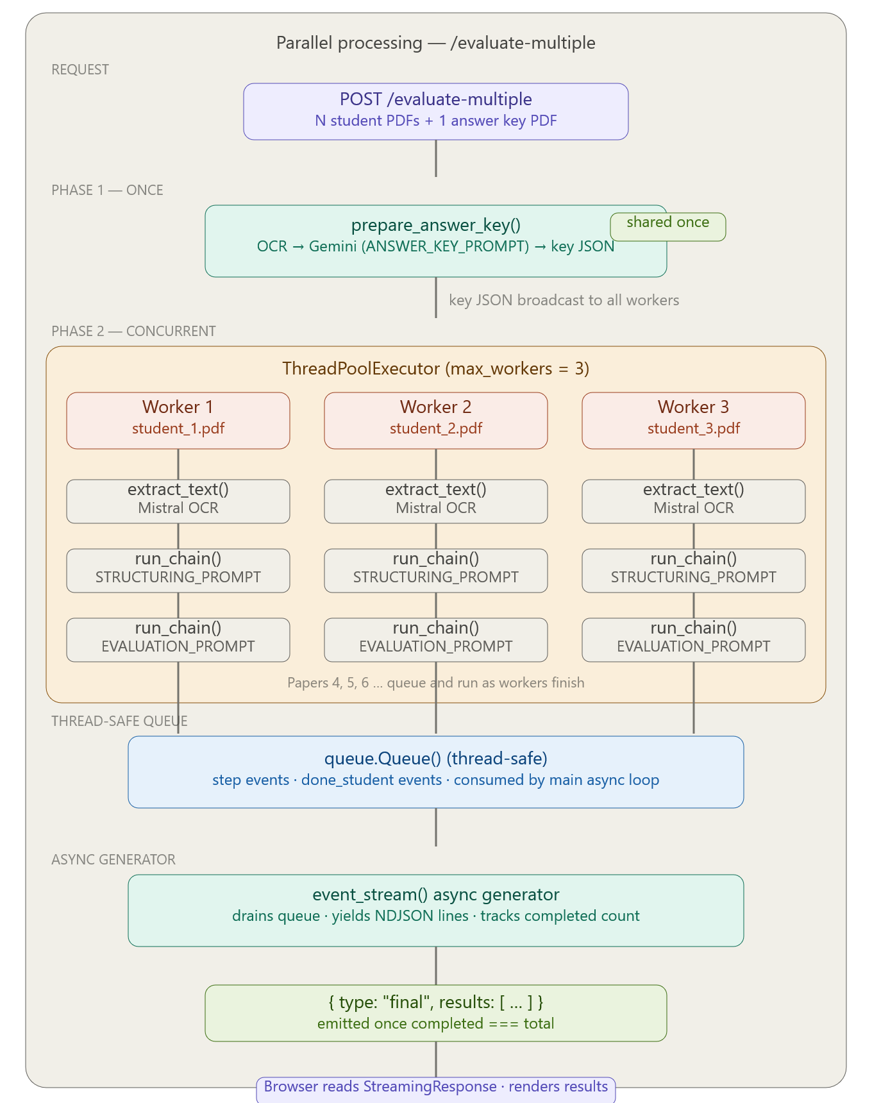

3. Setup Instructions
This section covers everything needed to get the project running locally from scratch. Follow the backend setup first, then the frontend.

3.1 Prerequisites
Ensure the following are installed on your machine before proceeding:

- Python 3.10 or higher
- Node.js 18 or higher and npm
- Git
- A Mistral AI API key (sign up at mistral.ai)
- A Google AI API key with access to the Gemini model (available via Google AI Studio)

3.2 Clone the Repository
Open a terminal and run:

git clone https://github.com/Rama-chandran-M/lrn_02.git
cd lrn_02

3.3 Backend Setup
3.3.1 Create and Activate a Virtual Environment
It is strongly recommended to use a virtual environment to isolate dependencies.

On macOS / Linux:
python3 -m venv venv
source venv/bin/activate

On Windows:
python -m venv venv
venv\Scripts\activate

3.3.2 Install Python Dependencies
With the virtual environment active, install all required packages:

pip install fastapi uvicorn python-multipart
pip install langchain langchain-google-genai google-generativeai
pip install mistralai requests

3.3.3 Configure Environment Variables
Create a file named .env in the project root (or set these as system environment variables). The application reads them through config/settings.py:

MISTRAL_API_KEY=your_mistral_api_key_here
GEMINI_API_KEY=your_google_gemini_api_key_here
GEMINI_MODEL=gemini-1.5-flash

Replace the placeholder values with your actual keys. Do not commit this file to version control.

3.3.4 Start the Backend Server
uvicorn main:app --reload --host 127.0.0.1 --port 8000

The API will be available at http://127.0.0.1:8000. You can verify it is running by visiting that address in a browser, which should return:
{ "message": "API is running" }

3.4 Frontend Setup
3.4.1 Navigate to the Frontend Directory
The frontend source is expected to be in a subdirectory (e.g., frontend or client). Adjust the path according to your project structure:

cd frontend

3.4.2 Install Node Dependencies
npm install

3.4.3 Start the Development Server
npm run dev

The frontend will be available at http://localhost:5173 (Vite default). Open this URL in your browser.

3.5 Running Both Together
You need two terminal windows running simultaneously — one for the backend and one for the frontend. The frontend is pre-configured to call http://127.0.0.1:8000 for all API requests, so both must be running at the same time.

4. Usage Instructions

4.1 Evaluating a Single Student
- Open the application in your browser at http://localhost:5173.
- In the Student Answer Sheets section, click the upload area or drag and drop one student PDF (max 10 MB).
- In the Answer Key section, upload the corresponding answer key PDF.
- Click Run Evaluation.
- A progress card will appear showing each processing step as it completes (OCR, structuring, evaluation).
- Once complete, the screen transitions to the Evaluation Report showing the score, percentage, strengths, weaknesses, and a question-by-question breakdown.
- Click New Evaluation to go back and evaluate another paper.

4.2 Evaluating Multiple Students
- Click the student upload area and select multiple PDF files at once (or drag several files at the same time).
- Upload the single answer key PDF as usual.
- Click Run Evaluation.
- A progress card for each student will appear and update in real time as their papers are processed. Up to three papers are processed in parallel.
- Once all students are done, an expandable list appears. Click any student name to expand their full evaluation report.
- Click New Evaluation to start over.

4.3 File Requirements
The following constraints apply to uploaded files:

- Only PDF files are accepted. Other formats will be rejected with an error message.
- Maximum file size is 10 MB per file.
- The answer key should clearly number questions and state expected answers or model answers.
- Student sheets should follow a similar structure so that question numbers can be matched correctly.
- Handwritten answers are supported as long as the handwriting is legible enough for OCR to process.

4.4 Understanding the Results
Each evaluation report contains the following sections:

- Total Score and Percentage — the aggregate marks earned out of the maximum possible
- Strengths — topics or question types where the student performed well, as identified by Gemini
- Areas for Improvement — topics where the student lost marks or did not attempt questions
- Question Breakdown — a card for every question in the paper showing:
  - Status badge: Correct, Partial, Incorrect, or Not Attempted
  - The question title or stem
  - The student's written answer
  - The correct answer from the key
  - The marks awarded out of the total marks for that question

5. API Reference
The backend exposes two endpoints. Both return responses as a stream of newline-delimited JSON objects (NDJSON), which the frontend reads incrementally.

5.1 GET /
Health check endpoint. Returns a simple JSON message confirming the API is running. No parameters required.

5.2 POST /evaluate
Evaluates a single student's answer sheet against the answer key.

Request format: multipart/form-data

Field | Type | Description
student_file | File (PDF) | The student's answer sheet
answer_key_file | File (PDF) | The teacher's answer key

Stream events emitted:

- { "type": "step", "message": "...", "progress": 0-100 } — progress update
- { "summary": {...}, "evaluation": [...] } — final result object (no type field)
- { "type": "error", "message": "..." } — error during processing

5.3 POST /evaluate-multiple
Evaluates multiple student papers against the same answer key in parallel.

Request format: multipart/form-data

Field | Type | Description
student_files | File[] (PDF) | One or more student answer sheets
answer_key_file | File (PDF) | The teacher's answer key (single file)

Stream events emitted:

- { "type": "step", "student": "filename.pdf", "message": "...", "progress": 0-100 }
- { "type": "done_student", "student": "filename.pdf", "result": {...}, "error": null }
- { "type": "final", "results": [...] } — emitted once all students are complete
- { "type": "error", "message": "..." } — if a critical error occurs

6. Error Handling
The system handles errors at multiple levels to ensure the user always receives a meaningful message rather than a raw exception.

6.1 File Validation (Frontend)
Before any upload begins, the frontend validates each file client-side. It rejects non-PDF files and anything larger than 10 MB, showing an inline error message immediately without making a network request.

6.2 File Validation (Backend)
The backend performs its own validation on all uploaded files regardless of what the frontend sends. It checks for missing files, empty filenames, non-PDF extensions, and file size exceeding 10 MB. Any violation returns HTTP 400 with a descriptive message.

6.3 Pipeline Errors
During processing, errors are categorised and translated into human-readable messages before being sent to the frontend:

- OCR_ERROR — the Mistral OCR API failed to extract text from a PDF, or returned empty content
- PARSE_ERROR — the Gemini model returned a response that could not be parsed as valid JSON
- API_ERROR — the Gemini API request timed out (default timeout: 40 seconds) or failed to execute
- All other errors — caught by a top-level handler and reported as a generic failure message

6.4 Timeout Handling
Every Gemini API call is wrapped in a concurrent.futures.ThreadPoolExecutor with a 40-second timeout. If the call does not complete within this window it is treated as an API_ERROR and the user is asked to retry. The Gemini service also includes automatic retries (up to 3 attempts) specifically for rate-limit (HTTP 429) responses, with a progressively increasing wait between attempts.

7. Known Limitations and Notes
- The frontend API base URL is hardcoded to http://127.0.0.1:8000 in services/api.ts. This must be updated for any deployment beyond local development.
- CORS is currently set to allow all origins (*). This should be restricted to the frontend's actual origin before deploying to production.
- The system depends on Gemini returning valid JSON. Poorly worded or ambiguous answer keys may cause parse errors.
- Heavily handwritten or low-quality scanned PDFs may produce inaccurate OCR output, which will affect evaluation quality.
- Batch processing is limited to three concurrent student papers (max_workers=3). Larger batches will queue and process sequentially beyond that limit.
- There is no authentication or user session management. All users who can reach the backend can submit evaluations.
- The application is marked Beta and is intended for local or internal use in its current state.

8. Dependencies

8.1 Backend
Package | Purpose
fastapi | Web framework for building the REST API
uvicorn | ASGI server to run FastAPI
python-multipart | Multipart form data parsing for file uploads
langchain | LLM orchestration framework
langchain-google-genai | LangChain integration for Gemini models
google-generativeai | Official Google Generative AI Python SDK
mistralai / requests | HTTP client for calling the Mistral OCR API

8.2 Frontend
Package | Purpose
react | UI library
typescript | Typed JavaScript
vite | Frontend build tool and dev server

