**GIT & GIT HUB**

For creating repository we should new and give some name if we want we can give description, we can also save privacy settings like private and public, and we can also create read me file which contain the info of our project and click create option.

We created out repository and we can open it from our home page by selecting repository option and your repositories will be visible and we can select the necessary one.

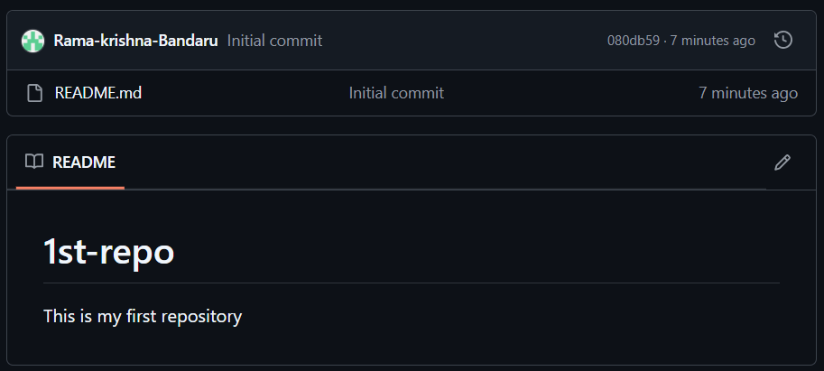

Here it is created our repository as we selected create readme file option, so we can see that file here and the content inside file is our description (if we given any).

We can see as initial commit means we created one file so it is considered as first change in git.

If we want to edit the readme file we can see small pencil option  by clicking, it will open the file

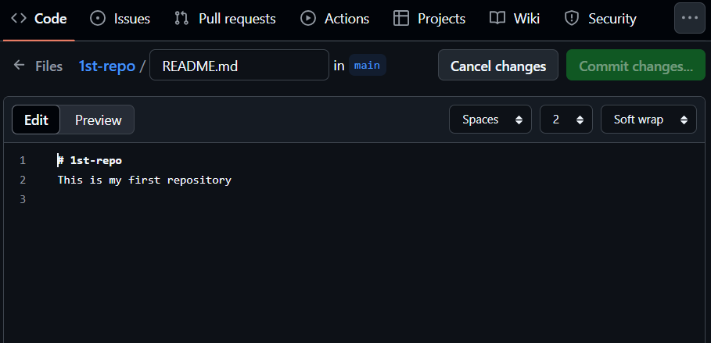

So we can do any type of changes here. Now the commit button is disable if we write anything it will get activated, after completing our changes we can use this button to save the changes. After clicking it will display one pop-up

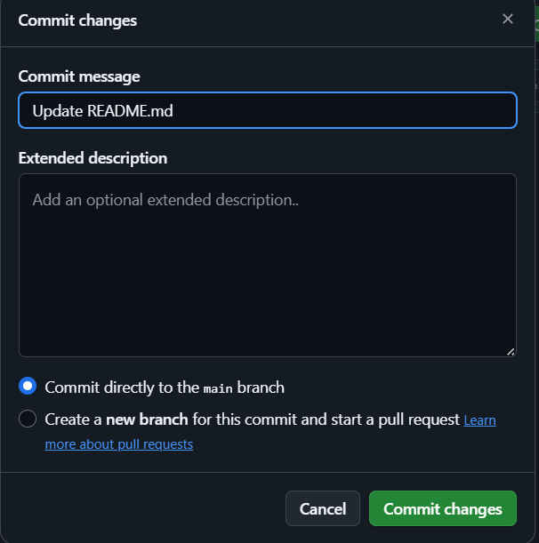

In commit message we will give what the changes we have done or a name of the change and we can enter the detail info of the changes if we want and click the commit changes button.

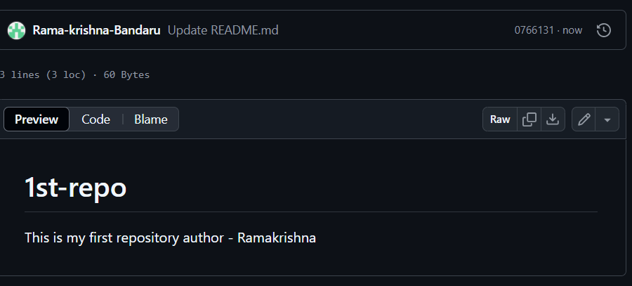

Now we done with update. If we click the code option

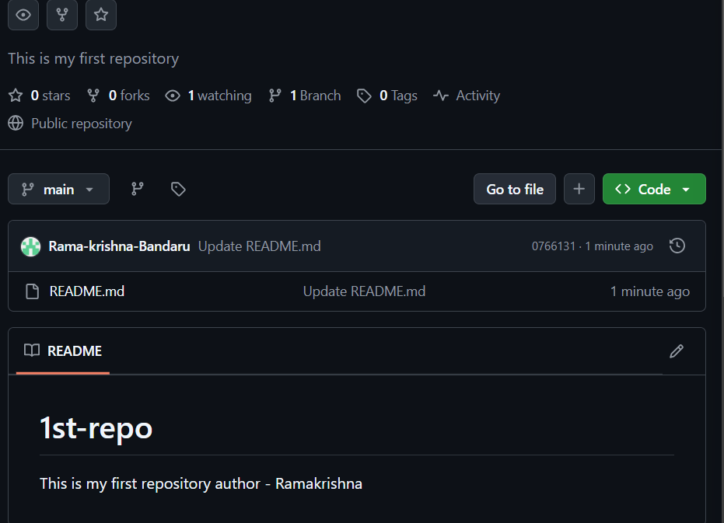

Now in the place of initial commit we can see as Update README.md (it is the name we given to the change or commit.)

GIT:

For connecting with our git hub account we should install one git into our system and we should set that git by connecting to our git hub account (This process is called configuring).

They are two types of configurations

* Global : If we want to change anything with the same email or account
* Local : if we want to change anything with different email or account to another account.

(If there is nothing wrong is going on while config then it is going on properly if it display some thing then we have did some error either in syntax or in account details.)

**Global:**

Open the git or cmd terminal and write the following commands to configure the git

* git config –global user.name “<user name of our account>”
* git config –global user.email “<email id by which the git hub is created>”

**Local:**

If we want to check the details we can use one code

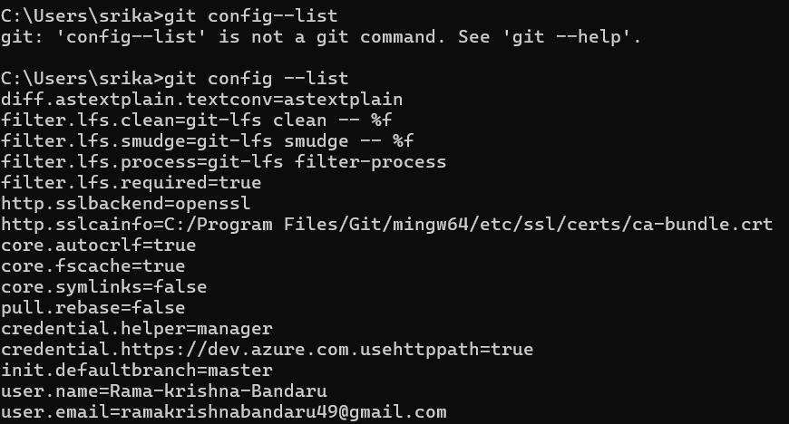

It will give the details like the user-name and user-email id

Now we created the connection.

GIT basic commands:

* Clone : It is used to copy something into our system from git hub using the link

“git clone <link from Git Hub>

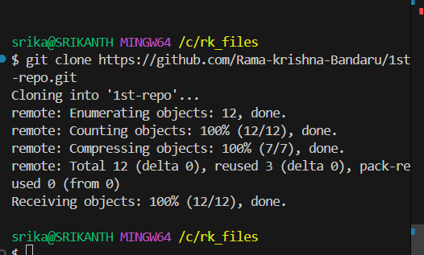

You can get link from your Git Hub account. Go to you profile and select your repository name after entering into you repository you can see one ‘<> code’ button click on it you will get one dropdown and copy that https link.

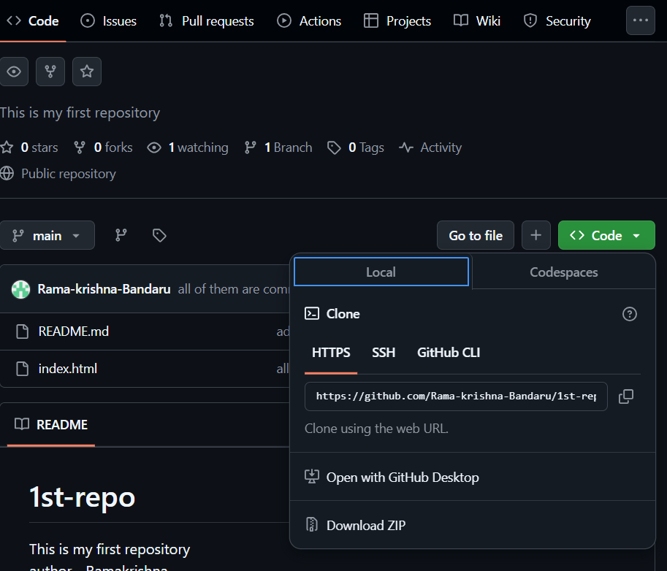

* Status : Display the status of the code. It will show like if we modified some thing or forgot to add or commit the changes to git for example

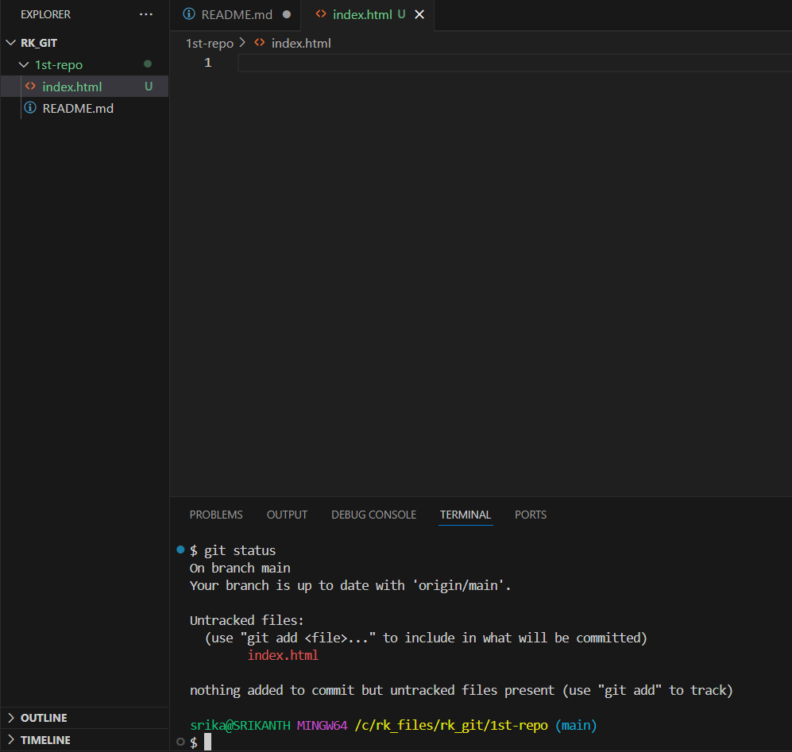

I created a file in side the 1st_repo which was cloned from the git. In that file I have add one another html doc now I got one symbol like “U” beside the name of the file that means it was untracked. If I get the symbol like “M” then it is represent like we have modified and these two changes are not synced with the git hub.

To sync out local laptop and git hub repository first we should **add(then the status will change to staged) those changes and we should commit(then the status will change to unchanged) and we push these changes into the git hub so we can reflect the changes in our git hub account also.**

* Add : adds new or changed files in your working directory to the git staging area

“git add <file name>” for a specific file

(Or)

“git add .” for all the changed files

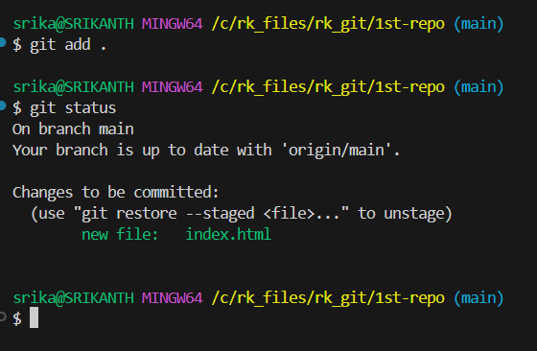

* Commit : It is the record of change. Used to save the files which are recently added

“git commit -m”

(Where -m means we will give some message if the command runs successfully then it will display the message which have given)

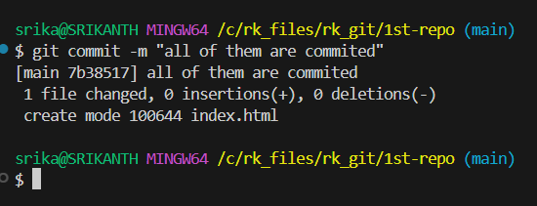

Now we will check the status of the files

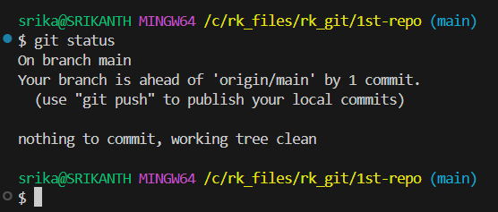

It is showing as everything is committed and now changes to do but we are one step ahead than our git hub account. It means we basically added and saved the changes in our local machine now we want to save the same changes in out Gut Hub account also.

We can do this by using the push command.

* Push : Upload local repo content to remote(means our Git Hub account) repo

“git push origin main”

Here ‘Origin’ is name of our repo(remote) and ‘main’ is our branch name.

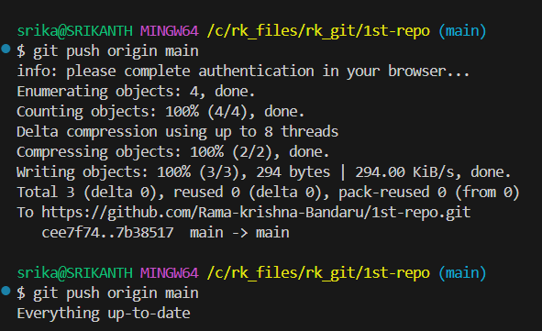

Once you done with push and if it is for the first time then you can see this type of content. If completely fine and every thing is sync with the Git Hub the you will see the second message.

After doing these steps we should refresh our browser to see all the changes in the Git Hub.

Until here we tried to clone our files from Remote to Local (From Git Hub to our Laptop).

If we want to do the reverse procedure then you should follow the below steps. This is called initializing Git repo.

Note:

If we want to change any thing in read me we need to some html key words for example we did changes in first file by adding one line, but while displaying it is showing in a single line to change that we can use <br> break tag to break the lines.