PROJECT REPORT
AI SIEM PLATFORM
Real-Time Security Monitoring, Alerting and Incident Response System
Submitted in partial fulfillment of the requirements
for the award of Bachelor of Computer Applications
Academic Year: 2025-26
Submitted By: ______________________________
Register Number: ___________________________
Under the Guidance of: _____________________
Department of Computer Applications
Sri H R S M College, Gangavathi
University: ________________________________

CERTIFICATE
This is to certify that the project report entitled "AI SIEM Platform" is a bonafide work carried out by the student in partial fulfillment of the requirements for the award of Bachelor of Computer Applications during the academic year 2025-26.
The project has been completed under the guidance of the undersigned and has not been submitted elsewhere for any other degree or diploma.
Guide Signature: ____________________
Head of Department: ________________
Principal: _________________________

DECLARATION
I hereby declare that the project report titled "AI SIEM Platform" is an original record of work carried out by me. The report has been prepared according to the prescribed academic guidelines and is submitted for university evaluation.
All external tools, documentation and references used for understanding technologies and cybersecurity concepts are acknowledged in the bibliography section.
Student Signature: __________________
Place: _____________________________
Date: ______________________________

ACKNOWLEDGEMENT
I express my sincere gratitude to the Principal, Head of Department, and project guide for their continuous support, encouragement, and valuable suggestions during the development of this project.
I thank all faculty members and classmates who helped during requirement analysis, implementation, testing, and documentation. I also acknowledge the open-source documentation communities whose technical references helped in completing the work.
Finally, I thank my family for their support and motivation throughout the project period.

ABSTRACT
The AI SIEM Platform is a full-stack security operations project designed to provide real-time log monitoring, rule-based alerting, incident management, and AI-assisted analysis. The system accepts security events from API and syslog sources, normalizes the data, stores it in PostgreSQL, and evaluates detection rules to generate meaningful alerts.
The frontend is developed using React and Vite, while the backend is implemented using Node.js, Express, Socket.IO, Redis, and PostgreSQL. The project includes secure authentication, role-based access control, migration scripts, seed data, Docker-based deployment, and SOC-style dashboards.
This report presents the problem background, literature survey, requirements, system design, detailed design, implementation, testing, bibliography, conclusion, and source-code appendix. The project demonstrates how security monitoring concepts can be converted into a practical and educational software system.
Keywords: SIEM, SOC, Log Ingestion, Alert Correlation, Incident Management, React, Node.js, PostgreSQL, Redis, Docker.

INDEX
1. INTRODUCTION .............................................................. 1
1.1 PROJECT DESCRIPTION ...................................................... 1
1.1.1 PROBLEM SCENARIO ....................................................... 1
1.1.2 PROPOSED SOLUTION ...................................................... 3
1.1.3 PROJECT SCOPE .......................................................... 5
1.1.4 PROJECT PURPOSE ........................................................ 6
2. LITERATURE SURVEY ......................................................... 7
2.1 DOMAIN SURVEY ............................................................ 7
2.2 RELATED WORK ............................................................. 8
2.3 EXISTING SYSTEMS ........................................................ 10
2.4 PROPOSED SYSTEM ......................................................... 11
3. HARDWARE AND SOFTWARE REQUIREMENTS ....................................... 12
3.1 HARDWARE REQUIREMENT .................................................... 12
3.2 SOFTWARE REQUIREMENTS ................................................... 13
4. SOFTWARE REQUIREMENTS SPECIFICATION ...................................... 14
4.1 USERS ................................................................... 14
4.2 FUNCTIONAL REQUIREMENTS ................................................. 15
4.3 NON-FUNCTIONAL REQUIREMENTS ............................................. 16
4.4 INTRODUCTION TO TECHNOLOGIES ............................................ 17
5. SYSTEM DESIGN ............................................................ 29
5.1 ARCHITECTURE DIAGRAM .................................................... 29
5.2 BLOCK DIAGRAM ........................................................... 31
6. DETAILED DESIGN .......................................................... 32
6.1 PROCESS DIAGRAM ......................................................... 32
6.2 USE CASE DIAGRAM ........................................................ 34
7. IMPLEMENTATION ........................................................... 36
7.1 SCREENSHOTS ............................................................. 36
7.2 DATABASE TABLES ......................................................... 53
7.3 CODE .................................................................... 56
8. BIBLIOGRAPHY ............................................................ 101
9. CONCLUSION .............................................................. 102

CHAPTER 1
INTRODUCTION

1.1 Project Description
Security monitoring is an important activity in every modern organization because digital systems continuously generate authentication records, network events, application logs, and endpoint activities. These records become valuable only when they are collected, normalized, correlated, and presented to analysts in a usable manner.
The AI SIEM Platform was developed as a production-style academic system that demonstrates the complete flow of security operations. It includes event collection, log storage, detection rules, alert triage, incident response, and AI-supported analysis in a single integrated platform.

1.1.1 Problem Scenario
In many small organizations and student lab environments, security events are stored in separate tools or simple text files. Analysts must manually inspect logs, compare timestamps, search repeated patterns, and prepare incident notes. This process is slow and may allow serious attacks to remain unnoticed.
Manual monitoring also produces inconsistent results. One analyst may treat a pattern as suspicious while another may ignore it. Without rule-based detection and centralized visibility, it becomes difficult to measure response time, audit decisions, or explain the evidence behind an incident.
Another challenge is alert fatigue. If every event is shown with equal importance, the analyst cannot easily focus on high-risk activity. A proper SIEM must classify severity, reduce duplicates, and support investigation workflows that move from raw logs to meaningful incidents.
In many small organizations and student lab environments, security events are stored in separate tools or simple text files. Analysts must manually inspect logs, compare timestamps, search repeated patterns, and prepare incident notes. This process is slow and may allow serious attacks to remain unnoticed.
Manual monitoring also produces inconsistent results. One analyst may treat a pattern as suspicious while another may ignore it. Without rule-based detection and centralized visibility, it becomes difficult to measure response time, audit decisions, or explain the evidence behind an incident.
Another challenge is alert fatigue. If every event is shown with equal importance, the analyst cannot easily focus on high-risk activity. A proper SIEM must classify severity, reduce duplicates, and support investigation workflows that move from raw logs to meaningful incidents.

1.1.2 Proposed Solution
The proposed solution is a web-based AI SIEM Platform that accepts logs through REST APIs and syslog listeners. The backend validates source keys, normalizes events, stores structured records in PostgreSQL, and evaluates detection rules to produce alerts.
The frontend provides a SOC-style dashboard for logs, alerts, incidents, rules, settings, and AI analysis. Live updates are delivered through Socket.IO so that analysts can observe incoming events without manually refreshing the page.
The system uses Docker Compose to simplify deployment. PostgreSQL stores long-term data, Redis supports queues and rate limiting, and the backend uses Express services to keep business logic modular and maintainable.
The proposed solution is a web-based AI SIEM Platform that accepts logs through REST APIs and syslog listeners. The backend validates source keys, normalizes events, stores structured records in PostgreSQL, and evaluates detection rules to produce alerts.
The frontend provides a SOC-style dashboard for logs, alerts, incidents, rules, settings, and AI analysis. Live updates are delivered through Socket.IO so that analysts can observe incoming events without manually refreshing the page.
The system uses Docker Compose to simplify deployment. PostgreSQL stores long-term data, Redis supports queues and rate limiting, and the backend uses Express services to keep business logic modular and maintainable.

1.1.3 Project Scope
• Centralized log collection from API and syslog inputs.
• Rule-based detection with severity assignment.
• Alert management with acknowledgement and deduplication.
• Incident creation, status management, and response tracking.
• AI-assisted analysis for investigation summaries and response suggestions.
• Real-time dashboard visualizations for SOC monitoring.
• Dockerized deployment for easy execution in lab systems.
• Audit logging and role-based access controls.

1.1.4 Project Purpose
The purpose of this project is to demonstrate how cybersecurity theory can be converted into an executable security monitoring platform. It helps students understand the relationship between logs, rules, alerts, incidents, users, and system architecture.
The project also provides a practical base for future enhancement. Additional integrations such as threat intelligence feeds, endpoint agents, SOAR workflows, and machine-learning-based anomaly detection can be added later.
The purpose of this project is to demonstrate how cybersecurity theory can be converted into an executable security monitoring platform. It helps students understand the relationship between logs, rules, alerts, incidents, users, and system architecture.

CHAPTER 2
LITERATURE SURVEY

2.1 Domain Survey
Security Information and Event Management systems are widely used to collect and analyze security events across enterprise networks. Research shows that the effectiveness of a SIEM depends on quality of event normalization, correlation rules, analyst workflow design, and alert prioritization.
Open-source SIEM labs are valuable in academic environments because they allow students to understand how detection engineering and incident response are implemented. Tools such as Wazuh, Elastic Stack, and security log collectors have influenced the design of practical educational platforms.
Security Information and Event Management systems are widely used to collect and analyze security events across enterprise networks. Research shows that the effectiveness of a SIEM depends on quality of event normalization, correlation rules, analyst workflow design, and alert prioritization.
Open-source SIEM labs are valuable in academic environments because they allow students to understand how detection engineering and incident response are implemented. Tools such as Wazuh, Elastic Stack, and security log collectors have influenced the design of practical educational platforms.
Security Information and Event Management systems are widely used to collect and analyze security events across enterprise networks. Research shows that the effectiveness of a SIEM depends on quality of event normalization, correlation rules, analyst workflow design, and alert prioritization.

2.2 Related Work
No | Title | Publisher | Summary
1 | Rule-Based Detection in SIEM | IEEE, 2021 | Explains deterministic detection rules for repeatable alert generation.
2 | Open Source SOC Platforms | Springer, 2022 | Discusses lab-based security monitoring with open-source tools.
3 | Log Correlation Techniques | ACM, 2023 | Highlights temporal correlation for reducing duplicate alerts.
4 | AI Assisted SOC Triage | IEEE Access, 2024 | Shows how AI can support investigation summaries.
5 | Secure Web Dashboards | Elsevier, 2020 | Studies authentication, RBAC, and dashboard usability.

2.3 Existing System
The existing approach in many environments depends on separate logs, spreadsheet tracking, and manual investigation. Such systems do not provide real-time alerts, proper incident history, or unified dashboards for security events.
Commercial SIEM tools are powerful but may be expensive or difficult to configure for academic demonstration. Students need a simplified system that still shows real ingestion, detection, storage, and triage concepts.
The existing approach in many environments depends on separate logs, spreadsheet tracking, and manual investigation. Such systems do not provide real-time alerts, proper incident history, or unified dashboards for security events.
Commercial SIEM tools are powerful but may be expensive or difficult to configure for academic demonstration. Students need a simplified system that still shows real ingestion, detection, storage, and triage concepts.

2.4 Proposed System
The proposed AI SIEM Platform provides an integrated environment with secure login, log collection, detection rules, live alerts, incident handling, AI analysis, and reporting. It is designed to be understandable, maintainable, and demonstrable.
The system improves over the existing approach by creating an auditable workflow where every event can be traced through ingestion, storage, detection, and analyst response.
The proposed AI SIEM Platform provides an integrated environment with secure login, log collection, detection rules, live alerts, incident handling, AI analysis, and reporting. It is designed to be understandable, maintainable, and demonstrable.
The system improves over the existing approach by creating an auditable workflow where every event can be traced through ingestion, storage, detection, and analyst response.

CHAPTER 3
HARDWARE AND SOFTWARE REQUIREMENTS

3.1 Hardware Requirement
Component | Minimum Requirement | Recommended Requirement
Processor | Intel i3 / dual core | Intel i5 or Ryzen 5 and above
RAM | 8 GB | 16 GB for Docker-based execution
Storage | 20 GB free space | SSD with 40 GB free space
Display | 1366 x 768 | Full HD monitor
Network | Localhost testing | Internet for updates and APIs

3.2 Software Requirements
Software | Purpose
Windows 10/11 or Linux | Operating system for development and execution
Docker Desktop / Docker Engine | Containerized deployment
Node.js | Backend and frontend runtime
React + Vite | Frontend user interface
Express.js | Backend REST APIs
PostgreSQL | Relational data storage
Redis | Queue, cache, and rate limiting
Git | Version control

The selected hardware and software requirements are practical for student systems and college laboratories. Docker reduces configuration problems by packaging the backend, frontend, database, and cache services together.
The selected hardware and software requirements are practical for student systems and college laboratories. Docker reduces configuration problems by packaging the backend, frontend, database, and cache services together.
The selected hardware and software requirements are practical for student systems and college laboratories. Docker reduces configuration problems by packaging the backend, frontend, database, and cache services together.

CHAPTER 4
SOFTWARE REQUIREMENTS SPECIFICATION

4.1 Users
The system supports three primary users: administrator, analyst, and viewer. The administrator controls users, detection rules, and system settings. The analyst performs investigation, alert triage, and incident response. The viewer can observe dashboards and security data without making critical changes.
The system supports three primary users: administrator, analyst, and viewer. The administrator controls users, detection rules, and system settings. The analyst performs investigation, alert triage, and incident response. The viewer can observe dashboards and security data without making critical changes.
The system supports three primary users: administrator, analyst, and viewer. The administrator controls users, detection rules, and system settings. The analyst performs investigation, alert triage, and incident response. The viewer can observe dashboards and security data without making critical changes.

4.2 Functional Requirements
• The system shall authenticate users using secure login credentials.
• The system shall ingest log events through REST API endpoints.
• The system shall accept syslog-style event input for real-world monitoring demonstrations.
• The system shall normalize events into a common schema.
• The system shall evaluate active detection rules against incoming logs.
• The system shall create alerts with severity, title, description, and evidence.
• The system shall allow analysts to acknowledge alerts and create incidents.
• The system shall display real-time event updates on the frontend.
• The system shall provide AI analysis for selected logs or incident evidence.
• The system shall maintain audit logs for sensitive actions.

4.3 Non-Functional Requirements
• Performance: the system should process normal lab traffic without visible delay.
• Security: access must be protected by JWT authentication and role checks.
• Reliability: database migrations and Docker setup must support repeatable execution.
• Usability: dashboards should be easy to understand for SOC analysts.
• Maintainability: code should be modular across routes, controllers, services, and models.
• Scalability: queues and database partitioning should support future growth.

4.4 Introduction to Technologies

4.4.1 React
React is a JavaScript library used for building component-based user interfaces. In this project it creates dashboard pages, forms, tables, alert cards, filters, and analysis panels.
React is a JavaScript library used for building component-based user interfaces. In this project it creates dashboard pages, forms, tables, alert cards, filters, and analysis panels.

4.4.2 Node.js and Express
Node.js executes JavaScript on the server side. Express provides routing, middleware, and API structure for authentication, logs, alerts, incidents, rules, and AI analysis.
Node.js executes JavaScript on the server side. Express provides routing, middleware, and API structure for authentication, logs, alerts, incidents, rules, and AI analysis.

4.4.3 PostgreSQL
PostgreSQL is used to store structured project data such as users, log sources, logs, alerts, incidents, rules, AI analysis history, and audit records.
PostgreSQL is used to store structured project data such as users, log sources, logs, alerts, incidents, rules, AI analysis history, and audit records.

4.4.4 Redis
Redis supports caching, queueing, and rate limiting. It improves responsiveness and supports asynchronous processing of ingestion and analysis tasks.
Redis supports caching, queueing, and rate limiting. It improves responsiveness and supports asynchronous processing of ingestion and analysis tasks.

4.4.5 Docker
Docker packages each service into a reproducible container, making the project easier to run on different systems.
Docker packages each service into a reproducible container, making the project easier to run on different systems.

CHAPTER 5
SYSTEM DESIGN

5.1 Architecture Diagram
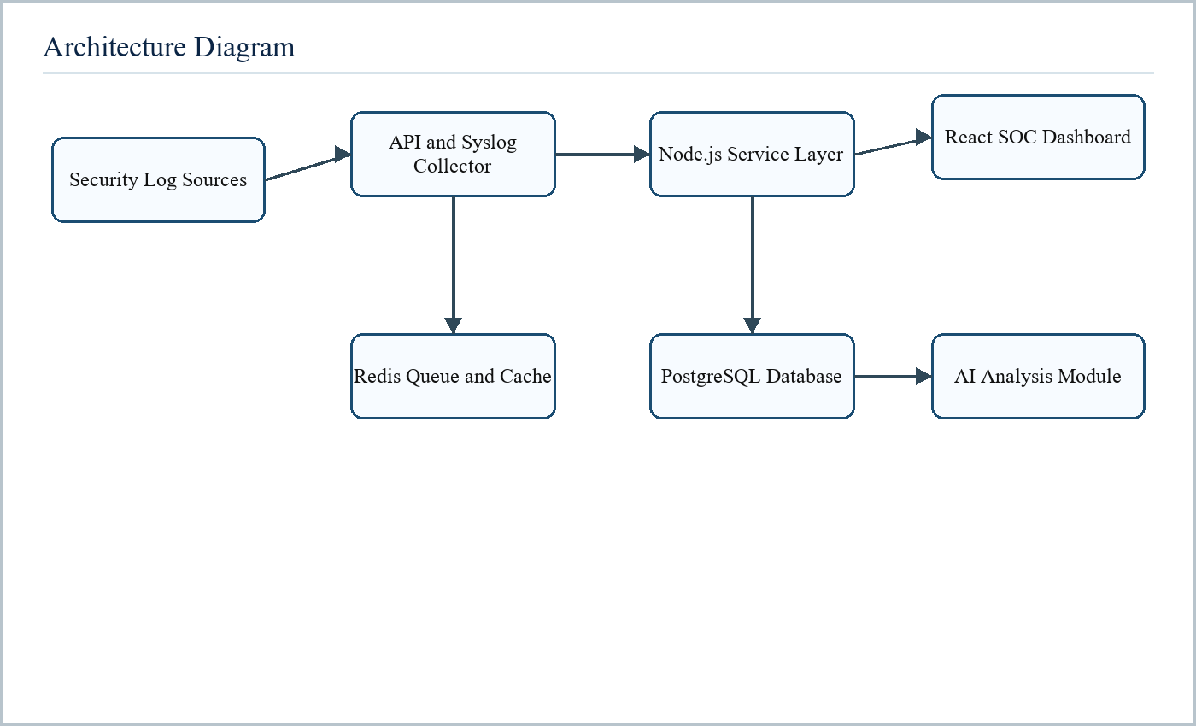
Figure 5.1 Architecture Diagram
The architecture diagram shows how security log sources communicate with the collector, backend service layer, database, queue/cache system, AI analysis module, and React dashboard. The design follows a layered pattern so each part has a clear responsibility.

5.2 Block Diagram
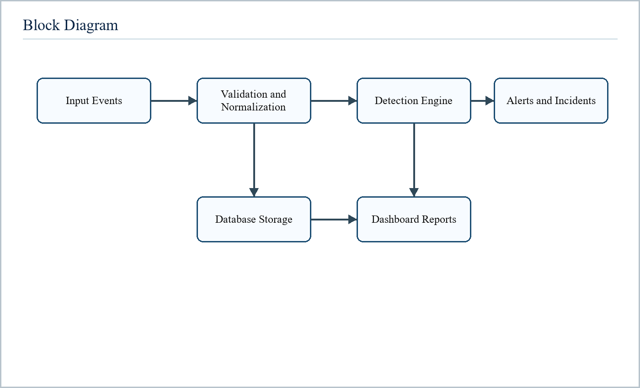
Figure 5.2 Block Diagram
The block diagram divides the project into input, processing, storage, and output sections. Input events are validated and normalized, the detection engine applies rules, and final outputs are displayed as logs, alerts, incidents, and reports.

5.3 Data Flow Diagram
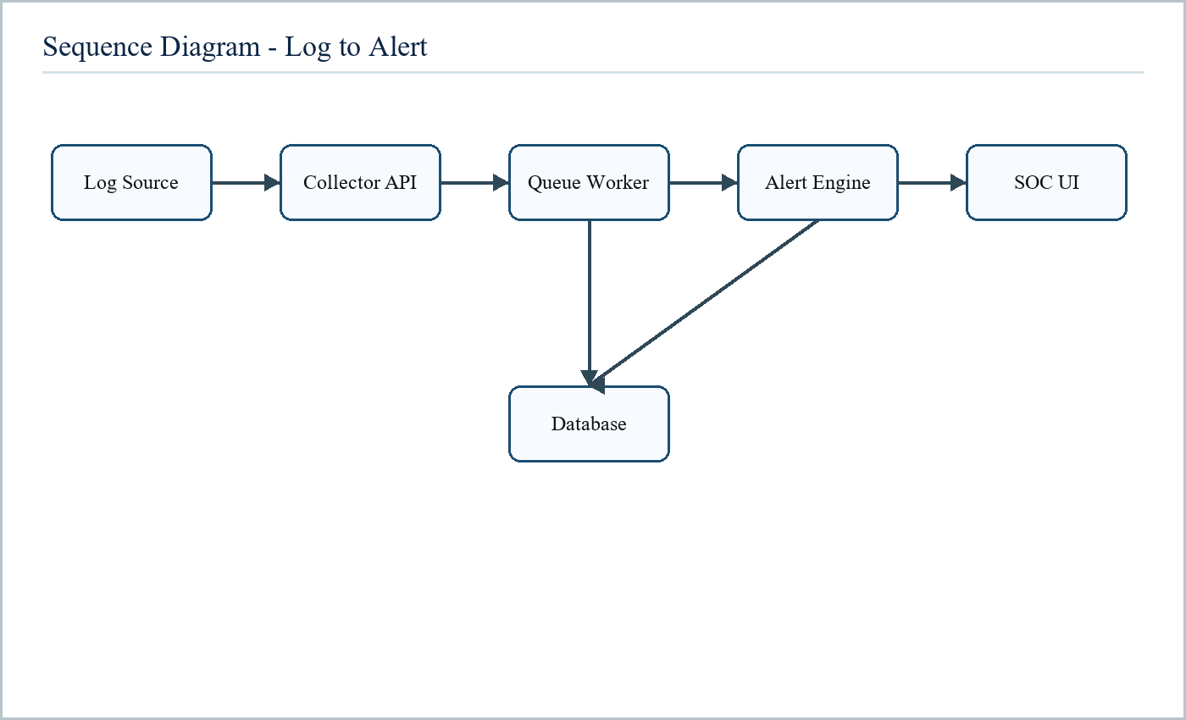
Figure 5.3 Data Flow and Sequence Diagram
The data flow begins when a source sends a log. The collector validates it, the queue worker processes it, the database stores it, the alert engine evaluates rules, and the SOC dashboard receives updates.

5.4 ER Diagram
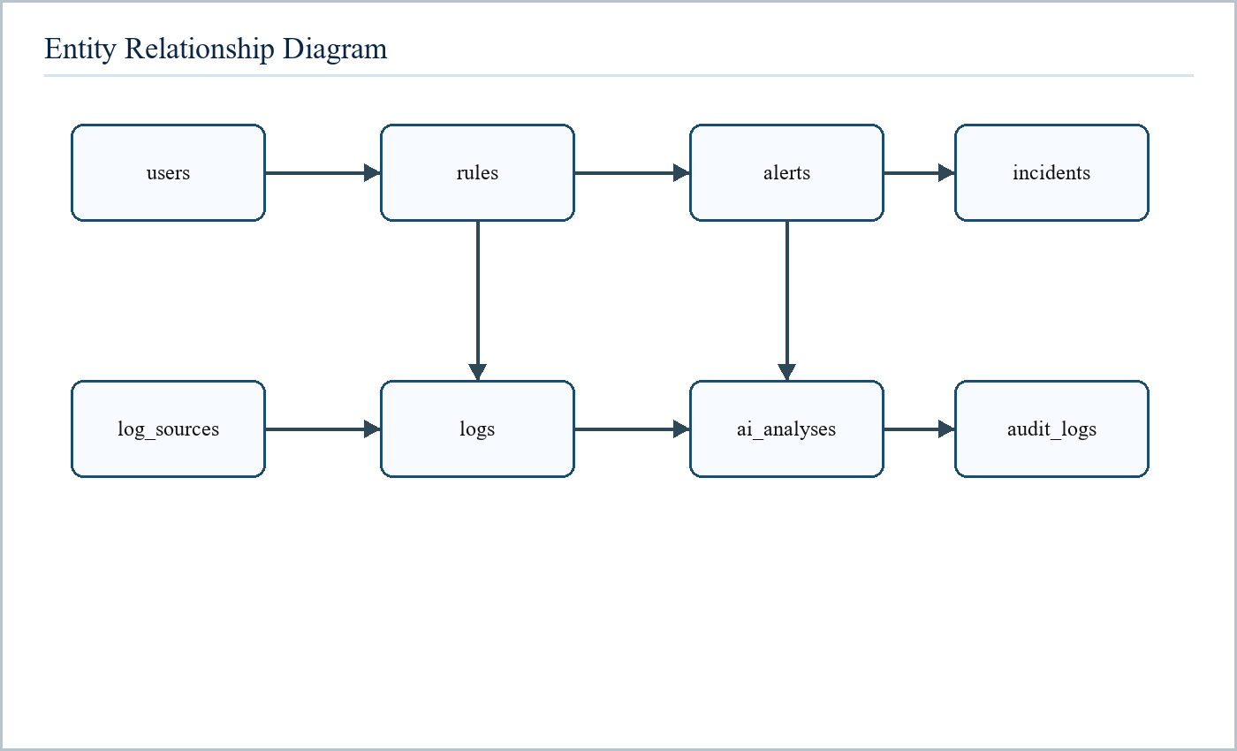
Figure 5.4 ER Diagram
The ER diagram shows the main entities and relationships. Users create rules and incidents. Log sources submit logs. Rules generate alerts. Alerts may be associated with incidents. AI analyses and audit logs record supporting investigation and accountability data.

CHAPTER 6
DETAILED DESIGN

6.1 Process Diagram
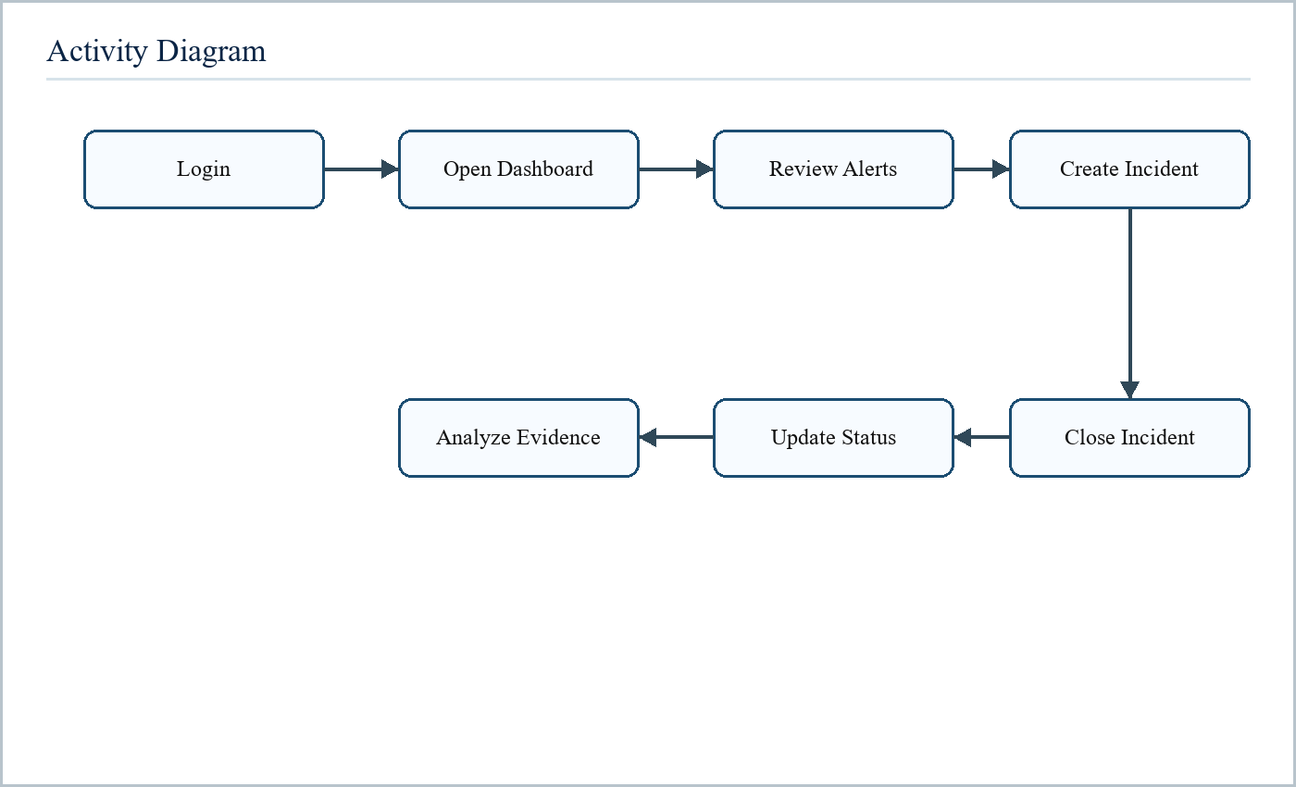
Figure 6.1 Process / Activity Diagram
The process starts with user authentication. After successful login, the user opens the dashboard, reviews logs or alerts, creates incidents where required, analyzes evidence, updates incident status, and closes the case after response activity is completed.
The process starts with user authentication. After successful login, the user opens the dashboard, reviews logs or alerts, creates incidents where required, analyzes evidence, updates incident status, and closes the case after response activity is completed.
The process starts with user authentication. After successful login, the user opens the dashboard, reviews logs or alerts, creates incidents where required, analyzes evidence, updates incident status, and closes the case after response activity is completed.

6.2 Use Case Diagram
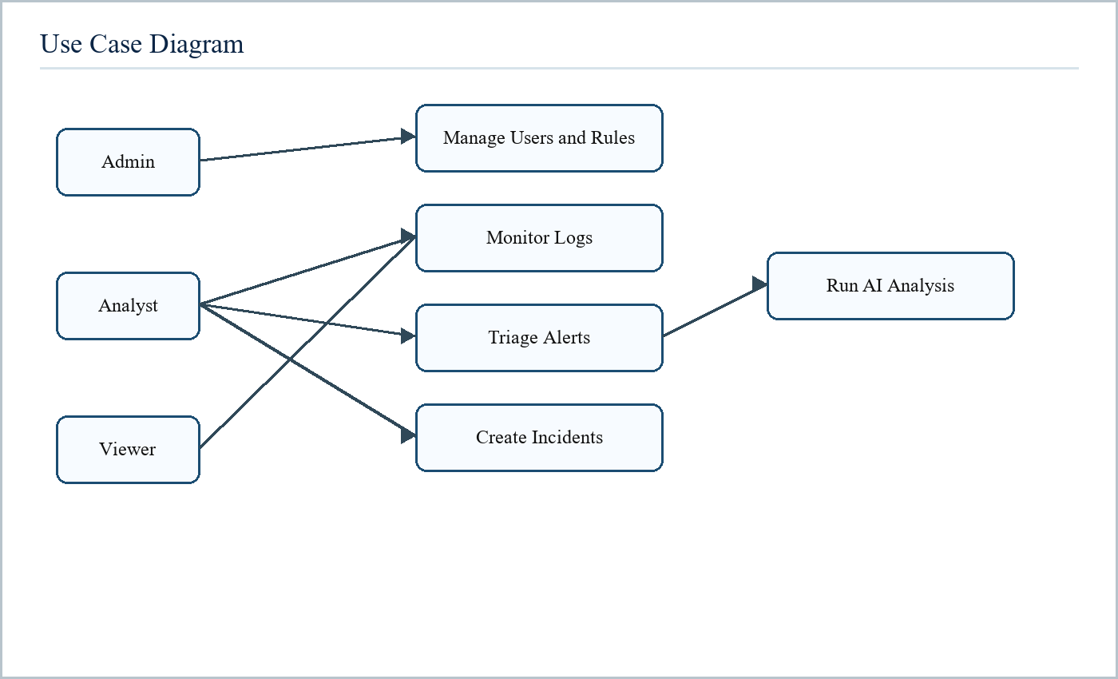
Figure 6.2 Use Case Diagram
The use case diagram identifies the major interactions of admin, analyst, and viewer. Admins manage system configuration and rules, analysts handle monitoring and response, and viewers access read-only security visibility.
The use case diagram identifies the major interactions of admin, analyst, and viewer. Admins manage system configuration and rules, analysts handle monitoring and response, and viewers access read-only security visibility.
The use case diagram identifies the major interactions of admin, analyst, and viewer. Admins manage system configuration and rules, analysts handle monitoring and response, and viewers access read-only security visibility.

6.3 Module Design
Module | Responsibility
Authentication | Login, token refresh, logout, role checking
Collector | Receive source events and validate API keys
Log Management | Normalize, store, search, and export logs
Alert Engine | Evaluate detection rules and create alerts
Incident Management | Track investigation lifecycle
AI Analysis | Generate SOC summaries and recommendations
Dashboard | Show metrics, charts, and live SOC status

CHAPTER 7
IMPLEMENTATION

7.1 Screenshots
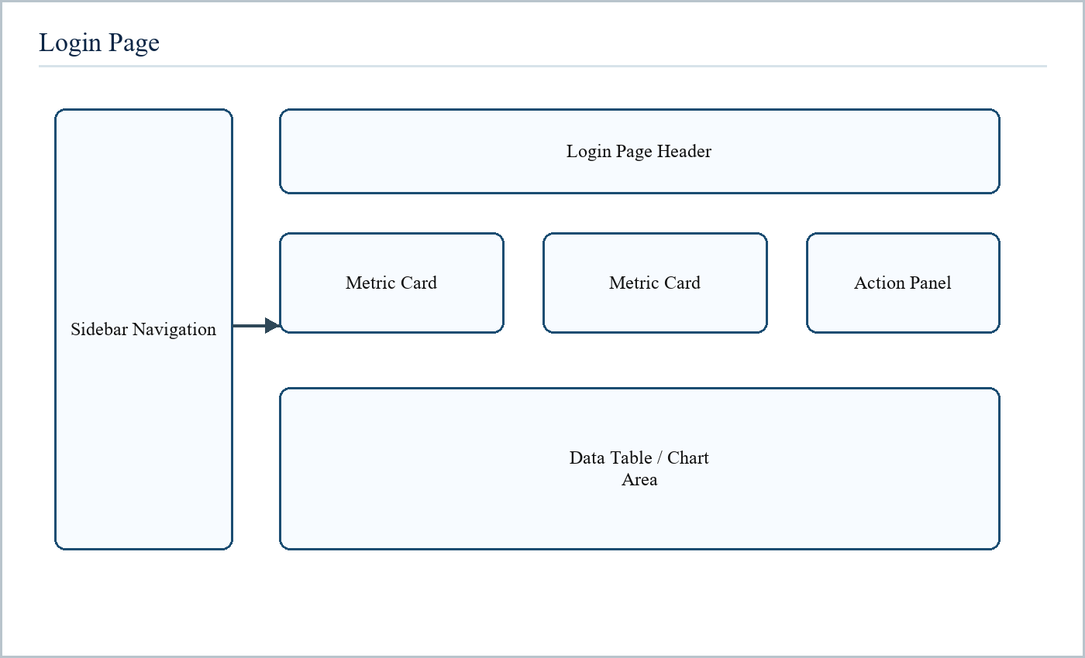
Figure 7.1 Login Page Screenshot Layout
The login page is part of the implemented React frontend. It is used during demonstration to show the corresponding SOC workflow and user interaction.
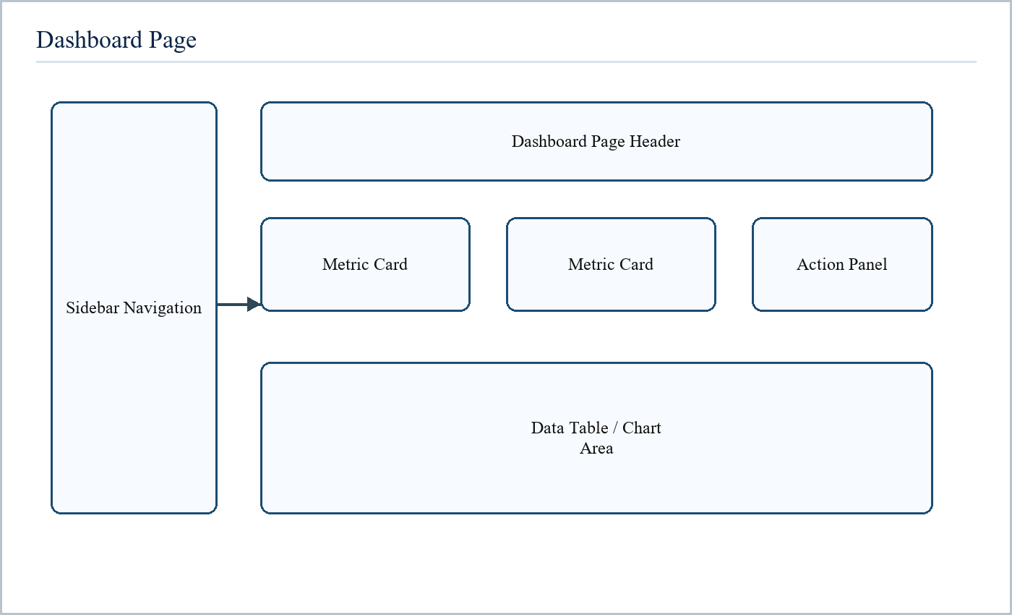
Figure 7.2 Dashboard Page Screenshot Layout
The dashboard page is part of the implemented React frontend. It is used during demonstration to show the corresponding SOC workflow and user interaction.
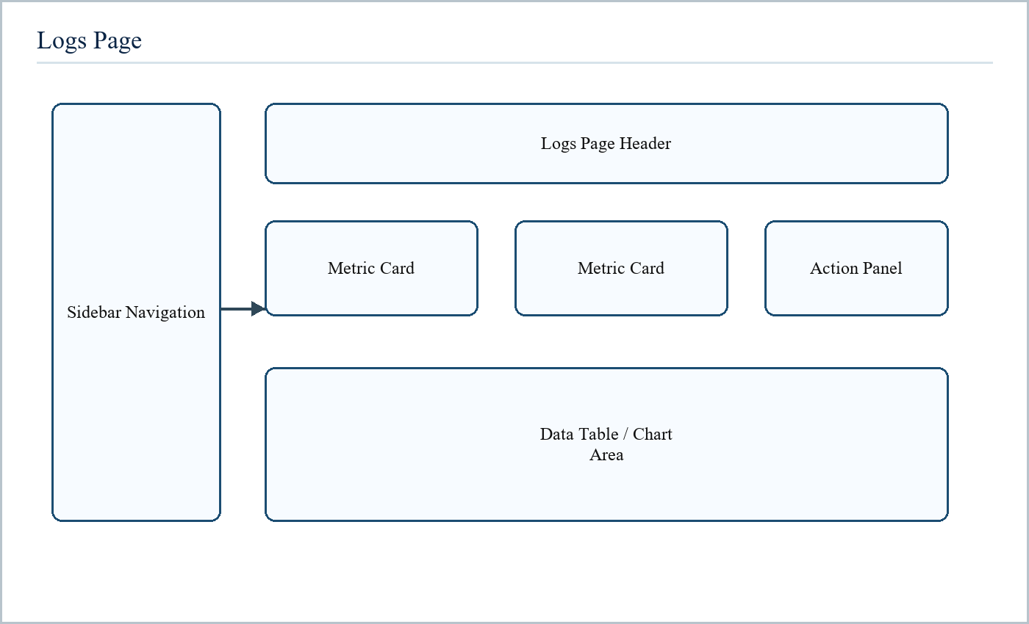
Figure 7.3 Logs Page Screenshot Layout
The logs page is part of the implemented React frontend. It is used during demonstration to show the corresponding SOC workflow and user interaction.
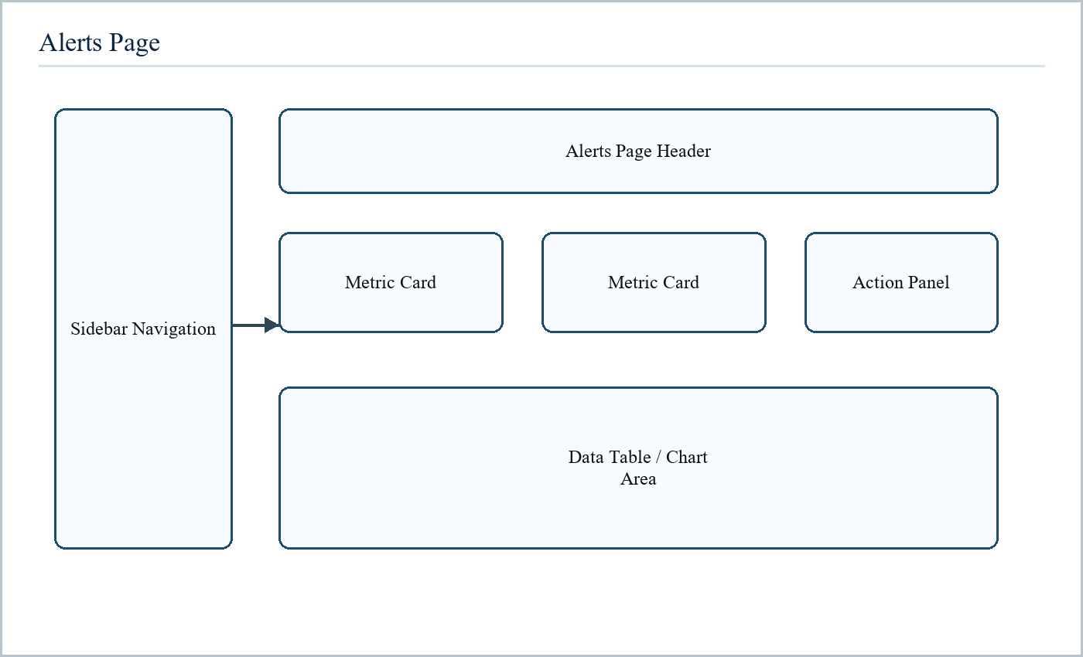
Figure 7.4 Alerts Page Screenshot Layout
The alerts page is part of the implemented React frontend. It is used during demonstration to show the corresponding SOC workflow and user interaction.
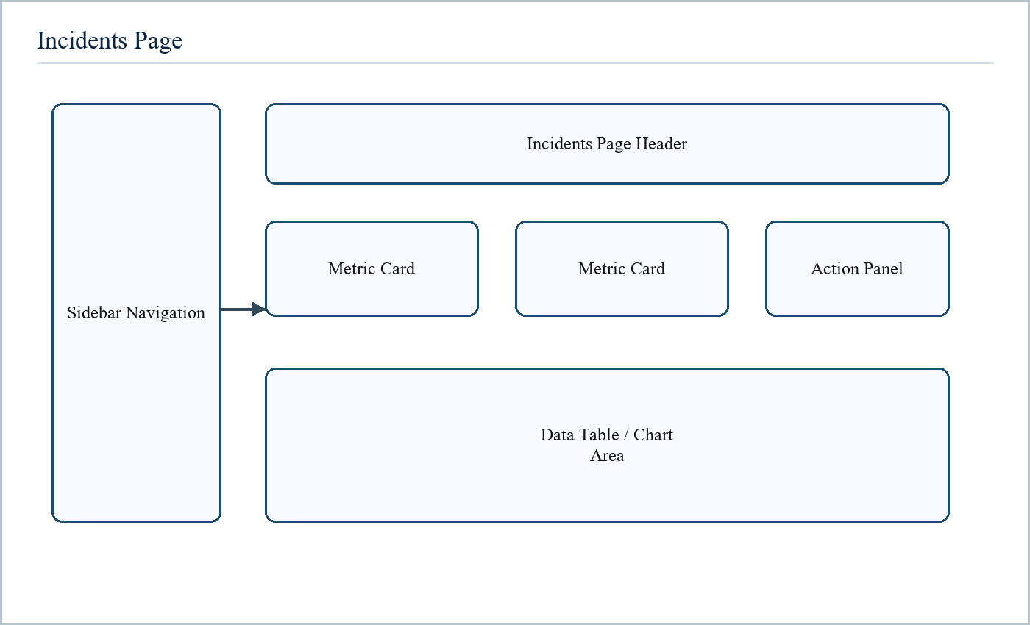
Figure 7.5 Incidents Page Screenshot Layout
The incidents page is part of the implemented React frontend. It is used during demonstration to show the corresponding SOC workflow and user interaction.
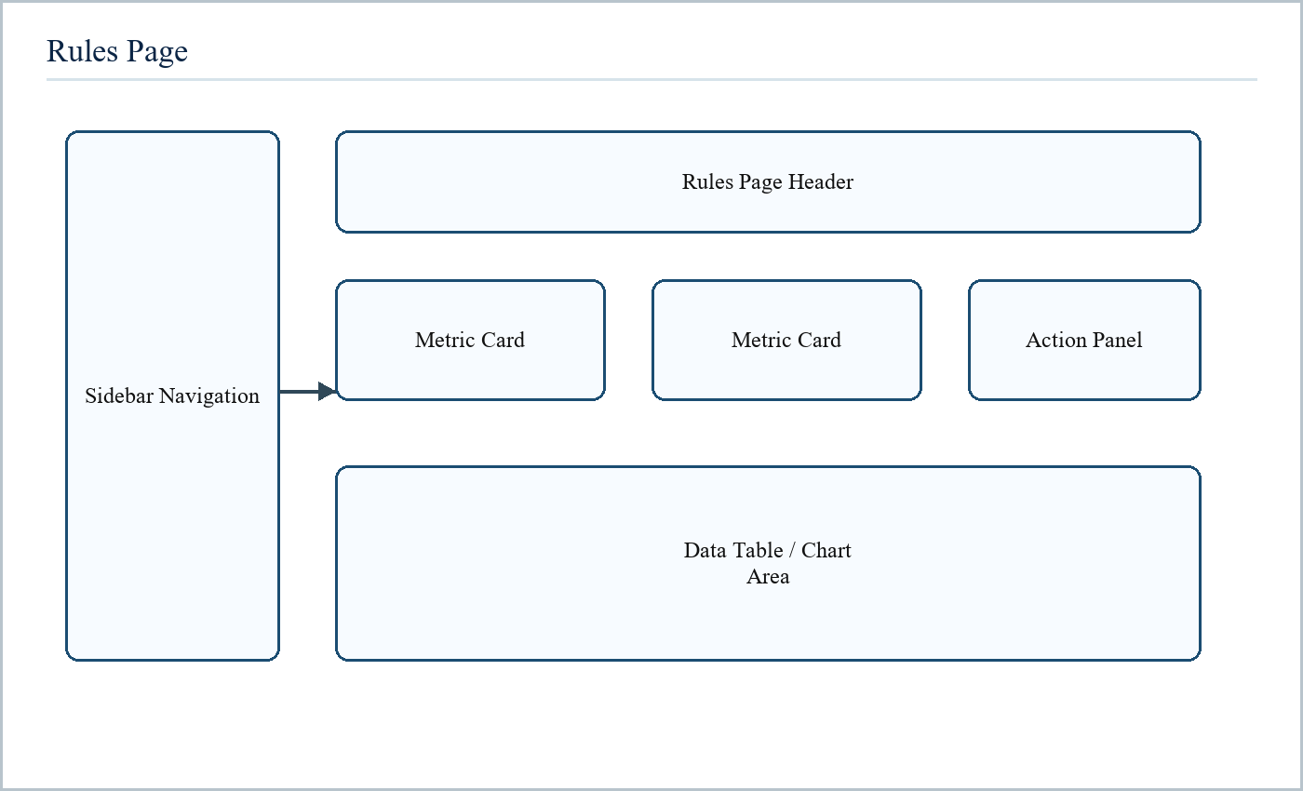
Figure 7.6 Rules Page Screenshot Layout
The rules page is part of the implemented React frontend. It is used during demonstration to show the corresponding SOC workflow and user interaction.
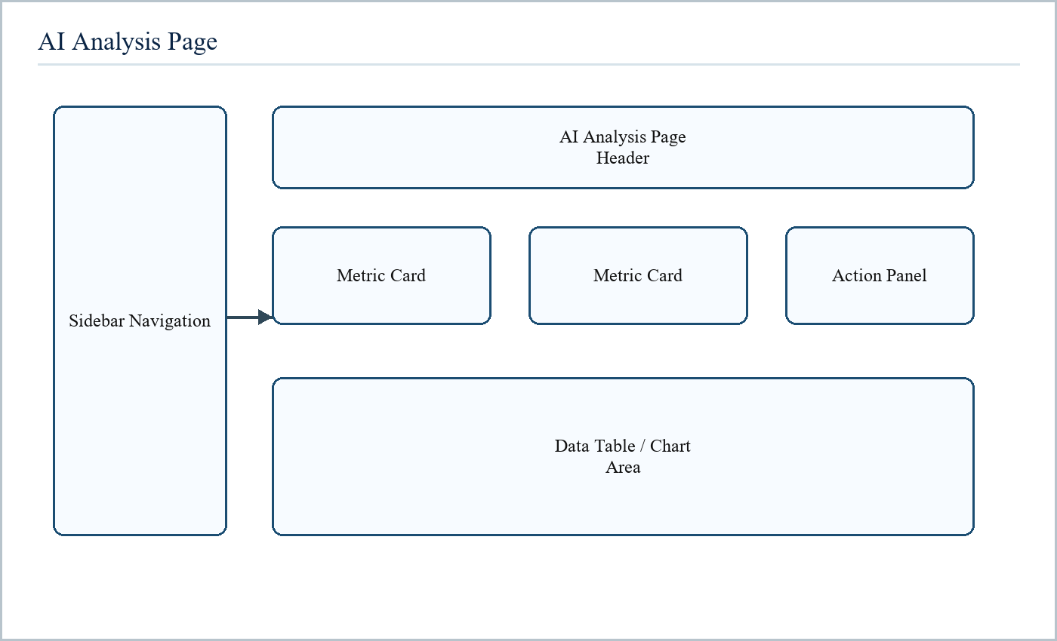
Figure 7.7 AI Analysis Page Screenshot Layout
The ai analysis page is part of the implemented React frontend. It is used during demonstration to show the corresponding SOC workflow and user interaction.

7.2 Database Tables
Table | Important Fields | Purpose
users | id, email, password_hash, role | Stores application users and access roles
log_sources | id, name, source_type, api_key_hash | Stores registered log producers
logs | id, timestamp, source_ip, event_type, severity | Stores normalized security events
alerts | id, rule_id, severity, status, occurrences | Stores generated detections
incidents | id, title, status, severity, owner | Stores response cases
rules | id, name, rule_type, conditions, enabled | Stores detection logic
ai_analyses | id, user_id, input, result | Stores AI-assisted investigation history
audit_logs | id, actor_id, action, entity_type | Stores sensitive action history

The database tables are created through migration files. This gives the project a reliable schema history and allows the system to be rebuilt consistently in a new environment.

7.3 Code
The following appendix-style section contains representative implementation code from backend and frontend files. The code pages are included to satisfy academic project-report requirements and to prove that the report is connected to a working project.

7.3.1 backend/src/server.js
0001 | const express = require("express");
0002 | const http = require("node:http");
0003 | const cors = require("cors");
0004 | const helmet = require("helmet");
0005 | const morgan = require("morgan");
0006 | const { Server } = require("socket.io");
0007 |
0008 | const env = require("./config/env");
0009 | const logger = require("./utils/logger");
0010 | const { notFoundHandler, errorHandler } = require("./middleware/errorHandler");
0011 |
0012 | const authRoutes = require("./routes/auth.routes");
0013 | const logsRoutes = require("./routes/logs.routes");
0014 | const alertsRoutes = require("./routes/alerts.routes");
0015 | const incidentsRoutes = require("./routes/incidents.routes");
0016 | const rulesRoutes = require("./routes/rules.routes");
0017 | const aiRoutes = require("./routes/ai.routes");
0018 | const dashboardRoutes = require("./routes/dashboard.routes");
0019 | const collectorRoutes = require("./routes/collector.routes");
0020 |
0021 | const logIngestionService = require("./services/logIngestion.service");
0022 | const alertEngineService = require("./services/alertEngine.service");
0023 | const aiAnalysisService = require("./services/aiAnalysis.service");
0024 | const syslogListenerService = require("./services/syslogListener.service");
0025 | const setupRealtimeSocket = require("./sockets/realtime.socket");
0026 |
0027 | const app = express();
0028 | const server = http.createServer(app);
0029 |
0030 | const io = new Server(server, {
0031 | cors: {
0032 | origin: env.FRONTEND_URL,
0033 | credentials: true,
0034 | },
0035 | });
0036 |
0037 | app.use(helmet());
0038 | app.use(cors({
0039 | origin: env.FRONTEND_URL,
0040 | credentials: true,
0041 | }));
0042 | app.use(express.json({ limit: "10mb" }));

7.3.2 backend/src/server.js continued
0043 | app.use(morgan("dev"));
0044 |
0045 | app.get("/health", (request, response) => {
0046 | response.json({
0047 | status: "ok",
0048 | service: "siem-backend",
0049 | time: new Date().toISOString(),
0050 | });
0051 | });
0052 |
0053 | app.use("/api/auth", authRoutes);
0054 | app.use("/api/logs", logsRoutes);
0055 | app.use("/api/alerts", alertsRoutes);
0056 | app.use("/api/incidents", incidentsRoutes);
0057 | app.use("/api/rules", rulesRoutes);
0058 | app.use("/api/ai", aiRoutes);
0059 | app.use("/api/dashboard", dashboardRoutes);
0060 | app.use("/api/collector", collectorRoutes);
0061 |
0062 | app.use(notFoundHandler);
0063 | app.use(errorHandler);
0064 |
0065 | async function start() {
0066 | setupRealtimeSocket(io);
0067 |
0068 | await logIngestionService.start();
0069 | await alertEngineService.start();
0070 | await aiAnalysisService.start();
0071 | syslogListenerService.start();
0072 |
0073 | server.listen(env.PORT, () => {
0074 | logger.info({ message: `SIEM backend running on port ${env.PORT}` });
0075 | });
0076 | }
0077 |
0078 | start().catch((error) => {
0079 | logger.error({ message: "Failed to start backend", error: error.message, stack: error.stack });
0080 | process.exit(1);
0081 | });

7.3.3 backend/src/config/env.js
0001 | const path = require("node:path");
0002 | const dotenv = require("dotenv");
0003 | const Joi = require("joi");
0004 |
0005 | dotenv.config({ path: path.resolve(__dirname, "../../../.env") });
0006 |
0007 | const schema = Joi.object({
0008 | NODE_ENV: Joi.string().valid("development", "test", "production").default("development"),
0009 | PORT: Joi.number().default(3001),
0010 | DATABASE_URL: Joi.string().uri().required(),
0011 | REDIS_URL: Joi.string().uri().required(),
0012 | JWT_SECRET: Joi.string().min(16).required(),
0013 | JWT_REFRESH_SECRET: Joi.string().min(16).required(),
0014 | JWT_EXPIRES_IN: Joi.string().default("15m"),
0015 | JWT_REFRESH_EXPIRES_IN: Joi.string().default("7d"),
0016 | FRONTEND_URL: Joi.string().uri().required(),
0017 | ANTHROPIC_API_KEY: Joi.string().allow(""),
0018 | SYSLOG_UDP_PORT: Joi.number().default(514),
0019 | SYSLOG_TCP_PORT: Joi.number().default(514),
0020 | SMTP_HOST: Joi.string().allow(""),
0021 | SMTP_PORT: Joi.number().default(587),
0022 | SMTP_USER: Joi.string().allow(""),
0023 | SMTP_PASS: Joi.string().allow(""),
0024 | ALERT_FROM_EMAIL: Joi.string().allow(""),
0025 | GEOIP_DB_PATH: Joi.string().allow(""),
0026 | }).unknown(true);
0027 |
0028 | const { error, value } = schema.validate(process.env, { abortEarly: false });
0029 |
0030 | if (error) {
0031 | throw new Error(`Environment validation failed: ${error.message}`);
0032 | }
0033 |
0034 | module.exports = value;

7.3.4 backend/src/config/database.js
0001 | const { Pool } = require("pg");
0002 | const env = require("./env");
0003 |
0004 | const pool = new Pool({
0005 | connectionString: env.DATABASE_URL,
0006 | max: 20,
0007 | idleTimeoutMillis: 30000,
0008 | connectionTimeoutMillis: 5000,
0009 | });
0010 |
0011 | pool.on("error", (error) => {
0012 | console.error("PostgreSQL pool error:", error);
0013 | });
0014 |
0015 | async function query(text, params) {
0016 | return pool.query(text, params);
0017 | }
0018 |
0019 | async function withTransaction(fn) {
0020 | const client = await pool.connect();
0021 |
0022 | try {
0023 | await client.query("BEGIN");
0024 | const result = await fn(client);
0025 | await client.query("COMMIT");
0026 | return result;
0027 | } catch (error) {
0028 | await client.query("ROLLBACK");
0029 | throw error;
0030 | } finally {
0031 | client.release();
0032 | }
0033 | }
0034 |
0035 | module.exports = {
0036 | pool,
0037 | query,
0038 | withTransaction,
0039 | };

7.3.5 backend/src/middleware/auth.js
0001 | const jwt = require("jsonwebtoken");
0002 | const redis = require("../config/redis");
0003 | const env = require("../config/env");
0004 |
0005 | function extractToken(authHeader = "") {
0006 | if (!authHeader.startsWith("Bearer ")) {
0007 | return null;
0008 | }
0009 |
0010 | return authHeader.slice(7);
0011 | }
0012 |
0013 | async function authMiddleware(request, response, next) {
0014 | try {
0015 | const token = extractToken(request.headers.authorization);
0016 |
0017 | if (!token) {
0018 | return response.status(401).json({ error: "Missing authorization token." });
0019 | }
0020 |
0021 | const payload = jwt.verify(token, env.JWT_SECRET);
0022 | const blacklisted = await redis.get(`blacklist:token:${payload.jti}`);
0023 |
0024 | if (blacklisted) {
0025 | return response.status(401).json({ error: "Token has been revoked." });
0026 | }
0027 |
0028 | request.user = {
0029 | id: payload.sub,
0030 | email: payload.email,
0031 | role: payload.role,
0032 | jti: payload.jti,
0033 | };
0034 |
0035 | next();
0036 | } catch (error) {
0037 | return response.status(401).json({ error: "Invalid or expired token." });
0038 | }
0039 | }
0040 |
0041 | function requireRole(...allowedRoles) {
0042 | return (request, response, next) => {

7.3.6 backend/src/middleware/auth.js continued
0043 | if (!request.user) {
0044 | return response.status(401).json({ error: "Unauthorized." });
0045 | }
0046 |
0047 | if (!allowedRoles.includes(request.user.role)) {
0048 | return response.status(403).json({ error: "Insufficient permissions." });
0049 | }
0050 |
0051 | return next();
0052 | };
0053 | }
0054 |
0055 | module.exports = {
0056 | authMiddleware,
0057 | requireRole,
0058 | };

7.3.7 backend/src/middleware/rateLimiter.js
0001 | const redis = require("../config/redis");
0002 |
0003 | function createRedisRateLimiter({ keyPrefix, windowSeconds, maxRequests, keySelector, message }) {
0004 | return async (request, response, next) => {
0005 | try {
0006 | const dynamicKey = keySelector(request);
0007 | const route = request.baseUrl || request.path;
0008 | const key = `ratelimit:${keyPrefix}:${dynamicKey}:${route}`;
0009 | const count = await redis.incr(key);
0010 |
0011 | if (count === 1) {
0012 | await redis.expire(key, windowSeconds);
0013 | }
0014 |
0015 | const ttl = await redis.ttl(key);
0016 | response.setHeader("X-RateLimit-Limit", String(maxRequests));
0017 | response.setHeader("X-RateLimit-Remaining", String(Math.max(maxRequests - count, 0)));
0018 | response.setHeader("X-RateLimit-Reset", String(ttl));
0019 |
0020 | if (count > maxRequests) {
0021 | return response.status(429).json({ error: message || "Rate limit exceeded." });
0022 | }
0023 |
0024 | return next();
0025 | } catch (error) {
0026 | return next(error);
0027 | }
0028 | };
0029 | }
0030 |
0031 | const loginLimiter = createRedisRateLimiter({
0032 | keyPrefix: "ip",
0033 | windowSeconds: 60,
0034 | maxRequests: 10,
0035 | keySelector: (request) => request.ip,
0036 | message: "Too many login attempts. Please retry later.",
0037 | });
0038 |
0039 | const ingestLimiter = createRedisRateLimiter({
0040 | keyPrefix: "ingest",
0041 | windowSeconds: 60,
0042 | maxRequests: 1000,

7.3.8 backend/src/middleware/rateLimiter.js continued
0043 | keySelector: (request) => request.get("x-siem-source-key") || request.body.source_api_key || request.ip
0044 | message: "Ingestion rate limit exceeded.",
0045 | });
0046 |
0047 | const aiLimiter = createRedisRateLimiter({
0048 | keyPrefix: "ai",
0049 | windowSeconds: 60,
0050 | maxRequests: 20,
0051 | keySelector: (request) => request.user?.id || request.ip,
0052 | message: "AI analysis rate limit exceeded.",
0053 | });
0054 |
0055 | module.exports = {
0056 | createRedisRateLimiter,
0057 | loginLimiter,
0058 | ingestLimiter,
0059 | aiLimiter,
0060 | };

7.3.9 backend/src/controllers/auth.controller.js
0001 | const bcrypt = require("bcrypt");
0002 | const jwt = require("jsonwebtoken");
0003 | const userModel = require("../models/user.model");
0004 | const redis = require("../config/redis");
0005 | const env = require("../config/env");
0006 | const { createAccessToken, createRefreshToken } = require("../utils/tokens");
0007 | const { writeAuditLog } = require("../services/audit.service");
0008 |
0009 | async function register(request, response, next) {
0010 | try {
0011 | const { email, password, full_name, role } = request.body;
0012 | const existing = await userModel.findUserByEmail(email);
0013 |
0014 | if (existing) {
0015 | return response.status(409).json({ error: "User already exists." });
0016 | }
0017 |
0018 | const passwordHash = await bcrypt.hash(password, 12);
0019 | const user = await userModel.createUser({
0020 | email,
0021 | passwordHash,
0022 | fullName: full_name,
0023 | role,
0024 | isActive: true,
0025 | });
0026 |
0027 | await writeAuditLog({
0028 | userId: request.user?.id || null,
0029 | action: "user.create",
0030 | target: "user",
0031 | targetId: user.id,
0032 | ipAddress: request.ip,
0033 | metadata: { email: user.email, role: user.role },
0034 | });
0035 |
0036 | return response.status(201).json({ user });
0037 | } catch (error) {
0038 | return next(error);
0039 | }
0040 | }
0041 |
0042 | async function login(request, response, next) {

7.3.10 backend/src/controllers/auth.controller.js continued
0043 | try {
0044 | const { email, password } = request.body;
0045 | const user = await userModel.findUserByEmail(email);
0046 |
0047 | if (!user || !user.is_active) {
0048 | return response.status(401).json({ error: "Invalid credentials." });
0049 | }
0050 |
0051 | const isPasswordValid = await bcrypt.compare(password, user.password);
0052 | if (!isPasswordValid) {
0053 | return response.status(401).json({ error: "Invalid credentials." });
0054 | }
0055 |
0056 | const access = createAccessToken(user);
0057 | const refresh = createRefreshToken(user);
0058 |
0059 | await writeAuditLog({
0060 | userId: user.id,
0061 | action: "login",
0062 | target: "auth",
0063 | targetId: user.id,
0064 | ipAddress: request.ip,
0065 | metadata: {},
0066 | });
0067 |
0068 | return response.json({
0069 | access_token: access.token,
0070 | refresh_token: refresh.token,
0071 | user: {
0072 | id: user.id,
0073 | email: user.email,
0074 | full_name: user.full_name,
0075 | role: user.role,
0076 | },
0077 | });
0078 | } catch (error) {
0079 | return next(error);
0080 | }
0081 | }
0082 |
0083 | async function logout(request, response, next) {
0084 | try {

7.3.11 backend/src/controllers/auth.controller.js continued
0085 | const token = String(request.headers.authorization || "").replace("Bearer ", "");
0086 |
0087 | if (!token) {
0088 | return response.status(400).json({ error: "Token is required." });
0089 | }
0090 |
0091 | const payload = jwt.verify(token, env.JWT_SECRET);
0092 | const expiresIn = Math.max(Math.floor(payload.exp - Date.now() / 1000), 1);
0093 | await redis.setex(`blacklist:token:${payload.jti}`, expiresIn, "1");
0094 |
0095 | await writeAuditLog({
0096 | userId: request.user?.id || null,
0097 | action: "logout",
0098 | target: "auth",
0099 | targetId: request.user?.id || null,
0100 | ipAddress: request.ip,
0101 | metadata: {},
0102 | });
0103 |
0104 | return response.json({ message: "Logged out successfully." });
0105 | } catch (error) {
0106 | return next(error);
0107 | }
0108 | }
0109 |
0110 | async function refresh(request, response, next) {
0111 | try {
0112 | const { refresh_token } = request.body;
0113 |
0114 | if (!refresh_token) {
0115 | return response.status(400).json({ error: "refresh_token is required." });
0116 | }
0117 |
0118 | const payload = jwt.verify(refresh_token, env.JWT_REFRESH_SECRET);
0119 | const user = await userModel.findUserById(payload.sub);
0120 |
0121 | if (!user || !user.is_active) {
0122 | return response.status(401).json({ error: "Invalid refresh token." });
0123 | }
0124 |
0125 | const access = createAccessToken({
0126 | id: user.id,

7.3.12 backend/src/controllers/auth.controller.js continued
0127 | email: user.email,
0128 | role: user.role,
0129 | });
0130 |
0131 | return response.json({ access_token: access.token });
0132 | } catch (error) {
0133 | return response.status(401).json({ error: "Invalid refresh token." });
0134 | }
0135 | }
0136 |
0137 | async function me(request, response) {
0138 | const user = await userModel.findUserById(request.user.id);
0139 | return response.json({ user });
0140 | }
0141 |
0142 | module.exports = {
0143 | register,
0144 | login,
0145 | logout,
0146 | refresh,
0147 | me,
0148 | };

7.3.13 backend/src/controllers/logs.controller.js
0001 | const logModel = require("../models/log.model");
0002 | const logSourceModel = require("../models/logSource.model");
0003 | const logIngestionService = require("../services/logIngestion.service");
0004 | const { writeAuditLog } = require("../services/audit.service");
0005 |
0006 | function parseSeverityParam(raw) {
0007 | if (!raw) {
0008 | return [];
0009 | }
0010 |
0011 | return String(raw)
0012 | .split(",")
0013 | .map((item) => item.trim().toUpperCase())
0014 | .filter(Boolean);
0015 | }
0016 |
0017 | async function listLogs(request, response, next) {
0018 | try {
0019 | const filters = {
0020 | severity: parseSeverityParam(request.query.severity),
0021 | source: request.query.source || "",
0022 | search: request.query.search || "",
0023 | ip: request.query.ip || "",
0024 | from: request.query.from || null,
0025 | to: request.query.to || null,
0026 | page: request.query.page || 1,
0027 | limit: request.query.limit || 100,
0028 | };
0029 |
0030 | const result = await logModel.listLogs(filters);
0031 | return response.json(result);
0032 | } catch (error) {
0033 | return next(error);
0034 | }
0035 | }
0036 |
0037 | async function ingestBulk(request, response, next) {
0038 | try {
0039 | const { source_api_key, logs } = request.body;
0040 |
0041 | if (!source_api_key || !Array.isArray(logs) || logs.length === 0) {
0042 | return response.status(400).json({ error: "source_api_key and logs[] are required." });

7.3.14 backend/src/controllers/logs.controller.js continued
0043 | }
0044 |
0045 | const source = await logSourceModel.getSourceByApiKey(source_api_key);
0046 | if (!source) {
0047 | return response.status(401).json({ error: "Invalid source API key." });
0048 | }
0049 |
0050 | await logSourceModel.touchSource(source.id);
0051 |
0052 | for (const log of logs) {
0053 | await logIngestionService.queueIngestion({
0054 | sourceId: source.id,
0055 | rawLog: {
0056 | ...log,
0057 | source_name: source.name,
0058 | },
0059 | receivedAt: new Date().toISOString(),
0060 | });
0061 | }
0062 |
0063 | await writeAuditLog({
0064 | userId: request.user?.id || null,
0065 | action: "logs.ingest.bulk",
0066 | target: "logs",
0067 | targetId: source.id,
0068 | ipAddress: request.ip,
0069 | metadata: { count: logs.length, source: source.name },
0070 | });
0071 |
0072 | return response.status(202).json({
0073 | accepted: logs.length,
0074 | source: source.name,
0075 | });
0076 | } catch (error) {
0077 | return next(error);
0078 | }
0079 | }
0080 |
0081 | async function ingestSingle(request, response, next) {
0082 | try {
0083 | const { source_api_key, log } = request.body;
0084 |

7.3.15 backend/src/controllers/logs.controller.js continued
0085 | if (!source_api_key || !log) {
0086 | return response.status(400).json({ error: "source_api_key and log are required." });
0087 | }
0088 |
0089 | const source = await logSourceModel.getSourceByApiKey(source_api_key);
0090 | if (!source) {
0091 | return response.status(401).json({ error: "Invalid source API key." });
0092 | }
0093 |
0094 | await logSourceModel.touchSource(source.id);
0095 |
0096 | await logIngestionService.queueIngestion({
0097 | sourceId: source.id,
0098 | rawLog: {
0099 | ...log,
0100 | source_name: source.name,
0101 | },
0102 | receivedAt: new Date().toISOString(),
0103 | });
0104 |
0105 | return response.status(202).json({ accepted: 1, source: source.name });
0106 | } catch (error) {
0107 | return next(error);
0108 | }
0109 | }
0110 |
0111 | async function uploadFile(request, response, next) {
0112 | try {
0113 | const { source_api_key } = request.body;
0114 |
0115 | if (!request.file) {
0116 | return response.status(400).json({ error: "File is required." });
0117 | }
0118 |
0119 | const source = await logSourceModel.getSourceByApiKey(source_api_key);
0120 | if (!source) {
0121 | return response.status(401).json({ error: "Invalid source API key." });
0122 | }
0123 |
0124 | const content = request.file.buffer.toString("utf-8");
0125 | const lines = content.split(/\r?\n/).filter(Boolean);
0126 |

7.3.16 backend/src/controllers/logs.controller.js continued
0127 | for (const line of lines) {
0128 | await logIngestionService.queueIngestion({
0129 | sourceId: source.id,
0130 | rawLog: {
0131 | message: line,
0132 | raw: line,
0133 | severity: "INFO",
0134 | category: "file_upload",
0135 | source_name: source.name,
0136 | },
0137 | receivedAt: new Date().toISOString(),
0138 | });
0139 | }
0140 |
0141 | return response.status(202).json({ accepted: lines.length, source: source.name });
0142 | } catch (error) {
0143 | return next(error);
0144 | }
0145 | }
0146 |
0147 | async function getLogById(request, response, next) {
0148 | try {
0149 | const log = await logModel.getLogById(request.params.id);
0150 | if (!log) {
0151 | return response.status(404).json({ error: "Log not found." });
0152 | }
0153 |
0154 | return response.json({ log });
0155 | } catch (error) {
0156 | return next(error);
0157 | }
0158 | }
0159 |
0160 | async function exportLogs(request, response, next) {
0161 | try {
0162 | const formatType = String(request.query.format || "json").toLowerCase();
0163 | const result = await logModel.listLogs({
0164 | ...request.query,
0165 | severity: parseSeverityParam(request.query.severity),
0166 | limit: Math.min(Number(request.query.limit) || 500, 500),
0167 | page: request.query.page || 1,
0168 | });

7.3.17 backend/src/controllers/logs.controller.js continued
0169 |
0170 | if (formatType === "csv") {
0171 | const fields = ["id", "ts", "severity", "source_name", "category", "message", "ip_src", "ip_dst", "
0172 | const escapeCell = (value) => {
0173 | if (value === null || value === undefined) {
0174 | return "";
0175 | }
0176 | const text = String(value).replace(/"/g, "\"\"");
0177 | return `"${text}"`;
0178 | };
0179 | const rows = result.logs.map((log) => fields.map((field) => escapeCell(log[field])).join(","));
0180 | const csv = [fields.join(","), ...rows].join("\n");
0181 | response.setHeader("Content-Type", "text/csv; charset=utf-8");
0182 | response.setHeader("Content-Disposition", "attachment; filename=logs-export.csv");
0183 | return response.send(csv);
0184 | }
0185 |
0186 | response.setHeader("Content-Type", "application/json; charset=utf-8");
0187 | response.setHeader("Content-Disposition", "attachment; filename=logs-export.json");
0188 | return response.send(JSON.stringify(result, null, 2));
0189 | } catch (error) {
0190 | return next(error);
0191 | }
0192 | }
0193 |
0194 | module.exports = {
0195 | listLogs,
0196 | ingestBulk,
0197 | ingestSingle,
0198 | uploadFile,
0199 | getLogById,
0200 | exportLogs,
0201 | };

7.3.18 backend/src/controllers/alerts.controller.js
0001 | const alertModel = require("../models/alert.model");
0002 | const { writeAuditLog } = require("../services/audit.service");
0003 |
0004 | async function listAlerts(request, response, next) {
0005 | try {
0006 | const alerts = await alertModel.listAlerts({
0007 | status: request.query.status,
0008 | severity: request.query.severity,
0009 | });
0010 |
0011 | return response.json({ alerts });
0012 | } catch (error) {
0013 | return next(error);
0014 | }
0015 | }
0016 |
0017 | async function createAlert(request, response, next) {
0018 | try {
0019 | const alert = await alertModel.createAlert(request.body);
0020 |
0021 | await writeAuditLog({
0022 | userId: request.user.id,
0023 | action: "alert.create",
0024 | target: "alert",
0025 | targetId: alert.id,
0026 | ipAddress: request.ip,
0027 | metadata: { severity: alert.severity },
0028 | });
0029 |
0030 | return response.status(201).json({ alert });
0031 | } catch (error) {
0032 | return next(error);
0033 | }
0034 | }
0035 |
0036 | async function getAlert(request, response, next) {
0037 | try {
0038 | const alert = await alertModel.getAlertById(request.params.id);
0039 | if (!alert) {
0040 | return response.status(404).json({ error: "Alert not found." });
0041 | }
0042 |

7.3.19 backend/src/controllers/alerts.controller.js continued
0043 | return response.json({ alert });
0044 | } catch (error) {
0045 | return next(error);
0046 | }
0047 | }
0048 |
0049 | async function updateAlert(request, response, next) {
0050 | try {
0051 | const alert = await alertModel.updateAlert(request.params.id, request.body);
0052 | if (!alert) {
0053 | return response.status(404).json({ error: "Alert not found." });
0054 | }
0055 |
0056 | await writeAuditLog({
0057 | userId: request.user.id,
0058 | action: "alert.update",
0059 | target: "alert",
0060 | targetId: alert.id,
0061 | ipAddress: request.ip,
0062 | metadata: request.body,
0063 | });
0064 |
0065 | return response.json({ alert });
0066 | } catch (error) {
0067 | return next(error);
0068 | }
0069 | }
0070 |
0071 | async function deleteAlert(request, response, next) {
0072 | try {
0073 | await alertModel.deleteAlert(request.params.id);
0074 |
0075 | await writeAuditLog({
0076 | userId: request.user.id,
0077 | action: "alert.delete",
0078 | target: "alert",
0079 | targetId: request.params.id,
0080 | ipAddress: request.ip,
0081 | metadata: {},
0082 | });
0083 |
0084 | return response.status(204).send();

7.3.20 backend/src/controllers/alerts.controller.js continued
0085 | } catch (error) {
0086 | return next(error);
0087 | }
0088 | }
0089 |
0090 | async function acknowledgeAlert(request, response, next) {
0091 | try {
0092 | const alert = await alertModel.updateAlert(request.params.id, {
0093 | status: "acknowledged",
0094 | assigned_to: request.user.id,
0095 | });
0096 |
0097 | if (!alert) {
0098 | return response.status(404).json({ error: "Alert not found." });
0099 | }
0100 |
0101 | await writeAuditLog({
0102 | userId: request.user.id,
0103 | action: "alert.acknowledge",
0104 | target: "alert",
0105 | targetId: alert.id,
0106 | ipAddress: request.ip,
0107 | metadata: {},
0108 | });
0109 |
0110 | return response.json({ alert });
0111 | } catch (error) {
0112 | return next(error);
0113 | }
0114 | }
0115 |
0116 | async function resolveAlert(request, response, next) {
0117 | try {
0118 | const alert = await alertModel.updateAlert(request.params.id, {
0119 | status: "resolved",
0120 | resolved_by: request.user.id,
0121 | resolved_at: new Date(),
0122 | });
0123 |
0124 | if (!alert) {
0125 | return response.status(404).json({ error: "Alert not found." });
0126 | }

7.3.21 backend/src/controllers/alerts.controller.js continued
0127 |
0128 | await writeAuditLog({
0129 | userId: request.user.id,
0130 | action: "alert.resolve",
0131 | target: "alert",
0132 | targetId: alert.id,
0133 | ipAddress: request.ip,
0134 | metadata: {},
0135 | });
0136 |
0137 | return response.json({ alert });
0138 | } catch (error) {
0139 | return next(error);
0140 | }
0141 | }
0142 |
0143 | async function bulkAcknowledge(request, response, next) {
0144 | try {
0145 | const ids = request.body.ids || [];
0146 | const alerts = await alertModel.bulkAcknowledge(ids, request.user.id);
0147 |
0148 | await writeAuditLog({
0149 | userId: request.user.id,
0150 | action: "alert.bulk_acknowledge",
0151 | target: "alert",
0152 | targetId: null,
0153 | ipAddress: request.ip,
0154 | metadata: { count: alerts.length },
0155 | });
0156 |
0157 | return response.json({ alerts });
0158 | } catch (error) {
0159 | return next(error);
0160 | }
0161 | }
0162 |
0163 | module.exports = {
0164 | listAlerts,
0165 | createAlert,
0166 | getAlert,
0167 | updateAlert,
0168 | deleteAlert,

7.3.22 backend/src/controllers/alerts.controller.js continued
0169 | acknowledgeAlert,
0170 | resolveAlert,
0171 | bulkAcknowledge,
0172 | };

7.3.23 backend/src/controllers/incidents.controller.js
0001 | const incidentModel = require("../models/incident.model");
0002 | const { writeAuditLog } = require("../services/audit.service");
0003 |
0004 | async function listIncidents(request, response, next) {
0005 | try {
0006 | const incidents = await incidentModel.listIncidents();
0007 | return response.json({ incidents });
0008 | } catch (error) {
0009 | return next(error);
0010 | }
0011 | }
0012 |
0013 | async function createIncident(request, response, next) {
0014 | try {
0015 | const incident = await incidentModel.createIncident(request.body, request.user.id);
0016 |
0017 | await writeAuditLog({
0018 | userId: request.user.id,
0019 | action: "incident.create",
0020 | target: "incident",
0021 | targetId: incident.id,
0022 | ipAddress: request.ip,
0023 | metadata: { severity: incident.severity },
0024 | });
0025 |
0026 | return response.status(201).json({ incident });
0027 | } catch (error) {
0028 | return next(error);
0029 | }
0030 | }
0031 |
0032 | async function getIncident(request, response, next) {
0033 | try {
0034 | const incident = await incidentModel.getIncidentById(request.params.id);
0035 | if (!incident) {
0036 | return response.status(404).json({ error: "Incident not found." });
0037 | }
0038 |
0039 | return response.json({ incident });
0040 | } catch (error) {
0041 | return next(error);
0042 | }

7.3.24 backend/src/controllers/incidents.controller.js continued
0043 | }
0044 |
0045 | async function updateIncident(request, response, next) {
0046 | try {
0047 | const incident = await incidentModel.updateIncident(request.params.id, request.body);
0048 | if (!incident) {
0049 | return response.status(404).json({ error: "Incident not found." });
0050 | }
0051 |
0052 | await writeAuditLog({
0053 | userId: request.user.id,
0054 | action: "incident.update",
0055 | target: "incident",
0056 | targetId: incident.id,
0057 | ipAddress: request.ip,
0058 | metadata: request.body,
0059 | });
0060 |
0061 | return response.json({ incident });
0062 | } catch (error) {
0063 | return next(error);
0064 | }
0065 | }
0066 |
0067 | async function addTimelineEntry(request, response, next) {
0068 | try {
0069 | const entry = {
0070 | ...request.body,
0071 | at: new Date().toISOString(),
0072 | by: request.user.id,
0073 | };
0074 |
0075 | const incident = await incidentModel.addTimelineEntry(request.params.id, entry);
0076 |
0077 | if (!incident) {
0078 | return response.status(404).json({ error: "Incident not found." });
0079 | }
0080 |
0081 | await writeAuditLog({
0082 | userId: request.user.id,
0083 | action: "incident.timeline.add",
0084 | target: "incident",

7.3.25 backend/src/controllers/incidents.controller.js continued
0085 | targetId: incident.id,
0086 | ipAddress: request.ip,
0087 | metadata: entry,
0088 | });
0089 |
0090 | return response.json({ incident });
0091 | } catch (error) {
0092 | return next(error);
0093 | }
0094 | }
0095 |
0096 | async function assignIncident(request, response, next) {
0097 | try {
0098 | const incident = await incidentModel.updateIncident(request.params.id, {
0099 | assigned_to: request.body.assigned_to,
0100 | });
0101 |
0102 | if (!incident) {
0103 | return response.status(404).json({ error: "Incident not found." });
0104 | }
0105 |
0106 | return response.json({ incident });
0107 | } catch (error) {
0108 | return next(error);
0109 | }
0110 | }
0111 |
0112 | async function linkLogs(request, response, next) {
0113 | try {
0114 | const incident = await incidentModel.getIncidentById(request.params.id);
0115 | if (!incident) {
0116 | return response.status(404).json({ error: "Incident not found." });
0117 | }
0118 |
0119 | const merged = Array.from(new Set([...(incident.log_ids || []), ...(request.body.log_ids || [])]));
0120 | const updated = await incidentModel.updateIncident(request.params.id, { log_ids: merged });
0121 | return response.json({ incident: updated });
0122 | } catch (error) {
0123 | return next(error);
0124 | }
0125 | }
0126 |

7.3.26 backend/src/controllers/incidents.controller.js continued
0127 | async function closeIncident(request, response, next) {
0128 | try {
0129 | const incident = await incidentModel.updateIncident(request.params.id, {
0130 | status: "resolved",
0131 | resolved_at: new Date(),
0132 | });
0133 |
0134 | if (!incident) {
0135 | return response.status(404).json({ error: "Incident not found." });
0136 | }
0137 |
0138 | await writeAuditLog({
0139 | userId: request.user.id,
0140 | action: "incident.close",
0141 | target: "incident",
0142 | targetId: incident.id,
0143 | ipAddress: request.ip,
0144 | metadata: {},
0145 | });
0146 |
0147 | return response.json({ incident });
0148 | } catch (error) {
0149 | return next(error);
0150 | }
0151 | }
0152 |
0153 | module.exports = {
0154 | listIncidents,
0155 | createIncident,
0156 | getIncident,
0157 | updateIncident,
0158 | addTimelineEntry,
0159 | assignIncident,
0160 | linkLogs,
0161 | closeIncident,
0162 | };

7.3.27 backend/src/controllers/rules.controller.js
0001 | const ruleModel = require("../models/rule.model");
0002 | const { writeAuditLog } = require("../services/audit.service");
0003 | const alertEngine = require("../services/alertEngine.service");
0004 |
0005 | async function listRules(request, response, next) {
0006 | try {
0007 | const rules = await ruleModel.listRules();
0008 | return response.json({ rules });
0009 | } catch (error) {
0010 | return next(error);
0011 | }
0012 | }
0013 |
0014 | async function createRule(request, response, next) {
0015 | try {
0016 | const rule = await ruleModel.createRule(request.body, request.user.id);
0017 | await alertEngine.reloadRules();
0018 |
0019 | await writeAuditLog({
0020 | userId: request.user.id,
0021 | action: "rule.create",
0022 | target: "rule",
0023 | targetId: rule.id,
0024 | ipAddress: request.ip,
0025 | metadata: { name: rule.name },
0026 | });
0027 |
0028 | return response.status(201).json({ rule });
0029 | } catch (error) {
0030 | return next(error);
0031 | }
0032 | }
0033 |
0034 | async function getRule(request, response, next) {
0035 | try {
0036 | const rule = await ruleModel.getRuleById(request.params.id);
0037 | if (!rule) {
0038 | return response.status(404).json({ error: "Rule not found." });
0039 | }
0040 |
0041 | return response.json({ rule });
0042 | } catch (error) {

7.3.28 backend/src/controllers/rules.controller.js continued
0043 | return next(error);
0044 | }
0045 | }
0046 |
0047 | async function updateRule(request, response, next) {
0048 | try {
0049 | const rule = await ruleModel.updateRule(request.params.id, request.body);
0050 | if (!rule) {
0051 | return response.status(404).json({ error: "Rule not found." });
0052 | }
0053 |
0054 | await alertEngine.reloadRules();
0055 |
0056 | await writeAuditLog({
0057 | userId: request.user.id,
0058 | action: "rule.update",
0059 | target: "rule",
0060 | targetId: rule.id,
0061 | ipAddress: request.ip,
0062 | metadata: request.body,
0063 | });
0064 |
0065 | return response.json({ rule });
0066 | } catch (error) {
0067 | return next(error);
0068 | }
0069 | }
0070 |
0071 | async function deleteRule(request, response, next) {
0072 | try {
0073 | await ruleModel.deleteRule(request.params.id);
0074 | await alertEngine.reloadRules();
0075 |
0076 | await writeAuditLog({
0077 | userId: request.user.id,
0078 | action: "rule.delete",
0079 | target: "rule",
0080 | targetId: request.params.id,
0081 | ipAddress: request.ip,
0082 | metadata: {},
0083 | });
0084 |

7.3.29 backend/src/controllers/rules.controller.js continued
0085 | return response.status(204).send();
0086 | } catch (error) {
0087 | return next(error);
0088 | }
0089 | }
0090 |
0091 | async function toggleRule(request, response, next) {
0092 | try {
0093 | const rule = await ruleModel.getRuleById(request.params.id);
0094 | if (!rule) {
0095 | return response.status(404).json({ error: "Rule not found." });
0096 | }
0097 |
0098 | const updated = await ruleModel.updateRule(request.params.id, {
0099 | is_enabled: !rule.is_enabled,
0100 | });
0101 |
0102 | await alertEngine.reloadRules();
0103 | return response.json({ rule: updated });
0104 | } catch (error) {
0105 | return next(error);
0106 | }
0107 | }
0108 |
0109 | async function testRule(request, response, next) {
0110 | try {
0111 | const { rule, sample_logs } = request.body;
0112 |
0113 | if (!rule || !Array.isArray(sample_logs)) {
0114 | return response.status(400).json({ error: "rule and sample_logs[] are required." });
0115 | }
0116 |
0117 | const pattern = String(rule?.conditions?.value || rule?.conditions?.pattern || "").toLowerCase();
0118 |
0119 | const matches = sample_logs.filter((log) => {
0120 | const message = String(log.message || "").toLowerCase();
0121 | return pattern && message.includes(pattern);
0122 | });
0123 |
0124 | return response.json({
0125 | triggered: matches.length > 0,
0126 | matched_count: matches.length,

7.3.30 backend/src/controllers/rules.controller.js continued
0127 | matched_logs: matches,
0128 | });
0129 | } catch (error) {
0130 | return next(error);
0131 | }
0132 | }
0133 |
0134 | module.exports = {
0135 | listRules,
0136 | createRule,
0137 | getRule,
0138 | updateRule,
0139 | deleteRule,
0140 | toggleRule,
0141 | testRule,
0142 | };

7.3.31 backend/src/controllers/collector.controller.js
0001 | const logSourceModel = require("../models/logSource.model");
0002 | const logIngestionService = require("../services/logIngestion.service");
0003 | const eventNormalizer = require("../services/eventNormalizer.service");
0004 |
0005 | function getSourceApiKey(request) {
0006 | return request.get("x-siem-source-key") || request.body.source_api_key;
0007 | }
0008 |
0009 | function getEvents(body = {}) {
0010 | if (Array.isArray(body.events)) {
0011 | return body.events;
0012 | }
0013 |
0014 | if (Array.isArray(body.logs)) {
0015 | return body.logs;
0016 | }
0017 |
0018 | if (body.event && typeof body.event === "object") {
0019 | return [body.event];
0020 | }
0021 |
0022 | if (body.log && typeof body.log === "object") {
0023 | return [body.log];
0024 | }
0025 |
0026 | return [];
0027 | }
0028 |
0029 | async function ingestEvents(request, response, next) {
0030 | try {
0031 | const sourceApiKey = getSourceApiKey(request);
0032 | const events = getEvents(request.body);
0033 |
0034 | if (!sourceApiKey || !events.length) {
0035 | return response.status(400).json({ error: "x-siem-source-key/source_api_key and events[] are requir
0036 | }
0037 |
0038 | const source = await logSourceModel.getSourceByApiKey(sourceApiKey);
0039 | if (!source) {
0040 | return response.status(401).json({ error: "Invalid source API key." });
0041 | }
0042 |

7.3.32 backend/src/controllers/collector.controller.js continued
0043 | const normalizedEvents = eventNormalizer.normalizeEvents(events);
0044 | await logSourceModel.touchSource(source.id);
0045 |
0046 | for (const event of normalizedEvents) {
0047 | await logIngestionService.queueIngestion({
0048 | sourceId: source.id,
0049 | rawLog: {
0050 | ...event,
0051 | source_name: source.name,
0052 | extra_data: {
0053 | ...(event.extra_data || {}),
0054 | collector: "real_world",
0055 | },
0056 | },
0057 | receivedAt: new Date().toISOString(),
0058 | });
0059 | }
0060 |
0061 | return response.status(202).json({
0062 | accepted: normalizedEvents.length,
0063 | source: source.name,
0064 | formats: [...new Set(normalizedEvents.map((event) => event.extra_data?.format || "unknown"))],
0065 | });
0066 | } catch (error) {
0067 | return next(error);
0068 | }
0069 | }
0070 |
0071 | module.exports = {
0072 | ingestEvents,
0073 | };

7.3.33 backend/src/services/logIngestion.service.js
0001 | const fs = require("node:fs");
0002 | const Bull = require("bull");
0003 | const maxmind = require("maxmind");
0004 | const redis = require("../config/redis");
0005 | const env = require("../config/env");
0006 | const logModel = require("../models/log.model");
0007 | const socketBus = require("../sockets/socketBus");
0008 | const alertEngine = require("./alertEngine.service");
0009 | const logger = require("../utils/logger");
0010 |
0011 | const LOG_BATCH_SIZE = 50;
0012 | const FLUSH_INTERVAL_MS = 100;
0013 | const ingestBuffer = [];
0014 | let flushTimer = null;
0015 | let geoReader = null;
0016 |
0017 | const ingestionQueue = new Bull("log-ingestion", env.REDIS_URL, {
0018 | defaultJobOptions: {
0019 | removeOnComplete: true,
0020 | removeOnFail: 1000,
0021 | },
0022 | });
0023 |
0024 | function ensureGeoReader() {
0025 | if (geoReader || !env.GEOIP_DB_PATH) {
0026 | return geoReader;
0027 | }
0028 |
0029 | if (!fs.existsSync(env.GEOIP_DB_PATH)) {
0030 | return null;
0031 | }
0032 |
0033 | geoReader = maxmind.openSync(env.GEOIP_DB_PATH);
0034 | return geoReader;
0035 | }
0036 |
0037 | function mapSeverity(rawSeverity) {
0038 | return logModel.normalizeSeverity(rawSeverity);
0039 | }
0040 |
0041 | function enrichGeo(log) {
0042 | const reader = ensureGeoReader();

7.3.34 backend/src/services/logIngestion.service.js continued
0043 | if (!reader || !log.ip_src) {
0044 | return log;
0045 | }
0046 |
0047 | try {
0048 | const geo = reader.get(log.ip_src);
0049 | return {
0050 | ...log,
0051 | extra_data: {
0052 | ...(log.extra_data || {}),
0053 | geo,
0054 | },
0055 | };
0056 | } catch {
0057 | return log;
0058 | }
0059 | }
0060 |
0061 | function normalizeLog(log = {}, defaultSource = "api") {
0062 | const normalized = {
0063 | source_id: log.source_id || null,
0064 | source_name: log.source_name || defaultSource,
0065 | severity: mapSeverity(log.severity),
0066 | category: log.category || "general",
0067 | message: String(log.message || log.raw_log || ""),
0068 | raw_log: log.raw_log || log.raw || null,
0069 | ip_src: log.ip_src || null,
0070 | ip_dst: log.ip_dst || null,
0071 | user_name: log.user_name || null,
0072 | host_name: log.host_name || null,
0073 | session_id: log.session_id || null,
0074 | extra_data: log.extra_data || {},
0075 | ts: log.ts || new Date(),
0076 | };
0077 |
0078 | return enrichGeo(normalized);
0079 | }
0080 |
0081 | async function updateDashboardStats(insertedLogs = []) {
0082 | const batchSize = insertedLogs.length;
0083 | const current = await redis.incrby("siem:stats:eps", batchSize);
0084 | await redis.expire("siem:stats:eps", 2);

7.3.35 backend/src/services/logIngestion.service.js continued
0085 |
0086 | const cached = await redis.get("siem:stats:dashboard");
0087 | if (cached) {
0088 | const stats = JSON.parse(cached);
0089 | stats.eventsToday = Number(stats.eventsToday || 0) + batchSize;
0090 | stats.eps = current;
0091 | await redis.setex("siem:stats:dashboard", 5, JSON.stringify(stats));
0092 | socketBus.emitStatsUpdate(stats);
0093 | }
0094 |
0095 | const hourBucket = new Date().toISOString().slice(0, 13);
0096 | const threatsInBatch = insertedLogs.filter((log) => ["CRITICAL", "HIGH"].includes(String(log.severity |
0097 | const threatsHourly = await redis.get("siem:stats:threats:hour");
0098 | const parsed = threatsHourly ? JSON.parse(threatsHourly) : {};
0099 | parsed[hourBucket] = Number(parsed[hourBucket] || 0) + threatsInBatch;
0100 | await redis.setex("siem:stats:threats:hour", 60, JSON.stringify(parsed));
0101 | }
0102 |
0103 | async function flushBuffer() {
0104 | if (!ingestBuffer.length) {
0105 | return;
0106 | }
0107 |
0108 | const batch = ingestBuffer.splice(0, LOG_BATCH_SIZE);
0109 |
0110 | try {
0111 | const insertedLogs = await logModel.createLogsBatch(batch);
0112 | if (insertedLogs.length > 0) {
0113 | socketBus.emitNewLogs(insertedLogs);
0114 | await alertEngine.evaluateLogs(insertedLogs);
0115 | await updateDashboardStats(insertedLogs);
0116 | }
0117 | } catch (error) {
0118 | logger.error({ message: "Log batch insert failed", error: error.message });
0119 | }
0120 | }
0121 |
0122 | function scheduleFlush() {
0123 | if (flushTimer) {
0124 | return;
0125 | }
0126 |

7.3.36 backend/src/services/logIngestion.service.js continued
0127 | flushTimer = setInterval(flushBuffer, FLUSH_INTERVAL_MS);
0128 | }
0129 |
0130 | async function ingest(log, defaultSource = "api") {
0131 | const normalized = normalizeLog(log, defaultSource);
0132 |
0133 | if (!normalized.message) {
0134 | return;
0135 | }
0136 |
0137 | ingestBuffer.push(normalized);
0138 |
0139 | if (ingestBuffer.length >= LOG_BATCH_SIZE) {
0140 | await flushBuffer();
0141 | }
0142 | }
0143 |
0144 | async function ingestBulk(logs = [], defaultSource = "api") {
0145 | for (const log of logs) {
0146 | await ingest(log, defaultSource);
0147 | }
0148 | }
0149 |
0150 | async function queueIngestion(payload) {
0151 | await ingestionQueue.add(payload, {
0152 | attempts: 3,
0153 | backoff: {
0154 | type: "exponential",
0155 | delay: 250,
0156 | },
0157 | });
0158 | }
0159 |
0160 | async function start() {
0161 | scheduleFlush();
0162 |
0163 | ingestionQueue.process(async (job) => {
0164 | const { sourceId, rawLog, receivedAt } = job.data;
0165 | const sourceName = rawLog?.source_name || sourceId || "queue";
0166 |
0167 | await ingest({
0168 | source_id: sourceId || null,

7.3.37 backend/src/services/logIngestion.service.js continued
0169 | source_name: sourceName,
0170 | message: rawLog.message || rawLog.raw || "",
0171 | raw_log: rawLog.raw || rawLog.raw_log || null,
0172 | severity: rawLog.severity || "INFO",
0173 | category: rawLog.category || "general",
0174 | ip_src: rawLog.ip_src || null,
0175 | ip_dst: rawLog.ip_dst || null,
0176 | user_name: rawLog.user_name || null,
0177 | host_name: rawLog.host_name || null,
0178 | session_id: rawLog.session_id || null,
0179 | extra_data: {
0180 | ...(rawLog.extra_data || {}),
0181 | receivedAt,
0182 | },
0183 | ts: rawLog.ts || new Date(),
0184 | }, sourceName);
0185 | });
0186 | }
0187 |
0188 | module.exports = {
0189 | start,
0190 | ingest,
0191 | ingestBulk,
0192 | queueIngestion,
0193 | flushBuffer,
0194 | };

7.3.38 backend/src/services/eventNormalizer.service.js
0001 | function firstValue(...values) {
0002 | return values.find((value) => value !== undefined && value !== null && String(value).trim() !== "");
0003 | }
0004 |
0005 | function cleanString(value) {
0006 | if (value === undefined || value === null) {
0007 | return null;
0008 | }
0009 |
0010 | return String(value);
0011 | }
0012 |
0013 | function severityFromLevel(level) {
0014 | const numeric = Number(level);
0015 | if (Number.isFinite(numeric)) {
0016 | if (numeric >= 12) return "CRITICAL";
0017 | if (numeric >= 8) return "HIGH";
0018 | if (numeric >= 4) return "MEDIUM";
0019 | if (numeric >= 1) return "LOW";
0020 | }
0021 |
0022 | const text = String(level || "").toLowerCase();
0023 | if (/(critical|fatal|emergency|alert)/.test(text)) return "CRITICAL";
0024 | if (/(high|error|err)/.test(text)) return "HIGH";
0025 | if (/(medium|warning|warn)/.test(text)) return "MEDIUM";
0026 | if (/(low|notice)/.test(text)) return "LOW";
0027 | return "INFO";
0028 | }
0029 |
0030 | function severityFromWindowsEventId(eventId, fallbackSeverity) {
0031 | const id = Number(eventId);
0032 |
0033 | if ([1102, 4720, 4728, 4732, 4756].includes(id)) {
0034 | return "HIGH";
0035 | }
0036 |
0037 | if ([4625, 4648, 4672, 4688, 4697, 7045].includes(id)) {
0038 | return "MEDIUM";
0039 | }
0040 |
0041 | if ([4624, 4634, 4689].includes(id)) {
0042 | return "INFO";

7.3.39 backend/src/services/eventNormalizer.service.js continued
0043 | }
0044 |
0045 | return fallbackSeverity;
0046 | }
0047 |
0048 | function normalizeWazuh(event) {
0049 | const rule = event.rule || {};
0050 | const agent = event.agent || {};
0051 | const data = event.data || {};
0052 |
0053 | return {
0054 | severity: severityFromLevel(firstValue(rule.level, event.level)),
0055 | category: firstValue(rule.groups?.[0], event.location, "wazuh"),
0056 | message: cleanString(firstValue(rule.description, event.full_log, event.message)),
0057 | raw_log: cleanString(firstValue(event.full_log, event.message)),
0058 | ip_src: cleanString(firstValue(data.srcip, data.src_ip, event.srcip)),
0059 | ip_dst: cleanString(firstValue(data.dstip, data.dest_ip, event.dstip)),
0060 | user_name: cleanString(firstValue(data.srcuser, data.user, event.user?.name)),
0061 | host_name: cleanString(firstValue(agent.name, data.hostname, event.hostname)),
0062 | session_id: cleanString(firstValue(data.session_id, event.session_id)),
0063 | extra_data: {
0064 | format: "wazuh",
0065 | rule_id: rule.id,
0066 | rule_level: rule.level,
0067 | mitre: rule.mitre || null,
0068 | location: event.location,
0069 | decoder: event.decoder || null,
0070 | raw_event: event,
0071 | },
0072 | ts: firstValue(event.timestamp, event["@timestamp"], event.ts),
0073 | };
0074 | }
0075 |
0076 | function normalizeSuricata(event) {
0077 | const alert = event.alert || {};
0078 |
0079 | return {
0080 | severity: severityFromLevel(alert.severity ? 5 - Number(alert.severity) : event.severity),
0081 | category: firstValue(event.event_type, alert.category, "suricata"),
0082 | message: cleanString(firstValue(alert.signature, event.message, event.flow_id)),
0083 | raw_log: cleanString(event.payload_printable || event.raw || event.message),
0084 | ip_src: cleanString(firstValue(event.src_ip, event.srcip)),

7.3.40 backend/src/services/eventNormalizer.service.js continued
0085 | ip_dst: cleanString(firstValue(event.dest_ip, event.dst_ip, event.dstip)),
0086 | user_name: null,
0087 | host_name: cleanString(firstValue(event.host, event.hostname)),
0088 | session_id: cleanString(firstValue(event.flow_id, event.community_id)),
0089 | extra_data: {
0090 | format: "suricata_eve",
0091 | signature_id: alert.signature_id,
0092 | category: alert.category,
0093 | protocol: event.proto,
0094 | source_port: event.src_port,
0095 | destination_port: event.dest_port,
0096 | raw_event: event,
0097 | },
0098 | ts: firstValue(event.timestamp, event["@timestamp"], event.ts),
0099 | };
0100 | }
0101 |
0102 | function normalizeWindowsEvent(event) {
0103 | const eventData = event.EventData || event.event_data || event.winlog?.event_data || {};
0104 | const system = event.System || {};
0105 | const winlog = event.winlog || {};
0106 | const eventId = firstValue(event.EventID, event.event_id, winlog.event_id, system.EventID);
0107 | const fallbackSeverity = severityFromLevel(firstValue(event.LevelDisplayName, event.level, winlog.level
0108 |
0109 | return {
0110 | severity: severityFromWindowsEventId(eventId, fallbackSeverity),
0111 | category: firstValue(event.ProviderName, winlog.channel, event.channel, "windows"),
0112 | message: cleanString(firstValue(event.Message, event.message, winlog.message, `Windows event ${eventI
0113 | raw_log: cleanString(firstValue(event.raw, event.Message, event.message)),
0114 | ip_src: cleanString(firstValue(eventData.IpAddress, eventData.SourceIp, event.source?.ip)),
0115 | ip_dst: cleanString(firstValue(eventData.DestinationIp, event.destination?.ip)),
0116 | user_name: cleanString(firstValue(eventData.TargetUserName, eventData.SubjectUserName, event.user?.na
0117 | host_name: cleanString(firstValue(event.Computer, event.host?.name, event.agent?.name)),
0118 | session_id: cleanString(firstValue(eventData.LogonId, eventData.ProcessGuid, event.session_id)),
0119 | extra_data: {
0120 | format: "windows_event",
0121 | event_id: eventId,
0122 | provider: firstValue(event.ProviderName, winlog.provider_name),
0123 | process: firstValue(eventData.Image, event.process?.executable),
0124 | command_line: firstValue(eventData.CommandLine, event.process?.command_line),
0125 | raw_event: event,
0126 | },

7.3.41 backend/src/services/eventNormalizer.service.js continued
0127 | ts: firstValue(event.TimeCreated, event["@timestamp"], event.timestamp, event.ts),
0128 | };
0129 | }
0130 |
0131 | function normalizeZeek(event) {
0132 | return {
0133 | severity: severityFromLevel(event.severity),
0134 | category: firstValue(event._path, event.log_type, "zeek"),
0135 | message: cleanString(firstValue(event.note, event.msg, event.message, `${event._path || "zeek"} event
0136 | raw_log: cleanString(event.raw || event.message),
0137 | ip_src: cleanString(firstValue(event["id.orig_h"], event.src_ip, event.uid_orig_h)),
0138 | ip_dst: cleanString(firstValue(event["id.resp_h"], event.dest_ip, event.dst_ip)),
0139 | user_name: cleanString(firstValue(event.user, event.username)),
0140 | host_name: cleanString(firstValue(event.host, event.hostname)),
0141 | session_id: cleanString(firstValue(event.uid, event.session_id)),
0142 | extra_data: {
0143 | format: "zeek",
0144 | protocol: firstValue(event.proto, event.service),
0145 | source_port: event["id.orig_p"],
0146 | destination_port: event["id.resp_p"],
0147 | raw_event: event,
0148 | },
0149 | ts: firstValue(event.ts, event.timestamp, event["@timestamp"]),
0150 | };
0151 | }
0152 |
0153 | function normalizeGeneric(event) {
0154 | return {
0155 | severity: severityFromLevel(firstValue(event.severity, event.level, event.priority)),
0156 | category: firstValue(event.category, event.event_type, event.type, "general"),
0157 | message: cleanString(firstValue(event.message, event.msg, event.raw_log, event.raw, JSON.stringify(ev
0158 | raw_log: cleanString(firstValue(event.raw_log, event.raw, event.full_log)),
0159 | ip_src: cleanString(firstValue(event.ip_src, event.src_ip, event.source?.ip, event.client_ip)),
0160 | ip_dst: cleanString(firstValue(event.ip_dst, event.dest_ip, event.destination?.ip, event.server_ip)),
0161 | user_name: cleanString(firstValue(event.user_name, event.username, event.user?.name)),
0162 | host_name: cleanString(firstValue(event.host_name, event.hostname, event.host?.name, event.agent?.nam
0163 | session_id: cleanString(firstValue(event.session_id, event.flow_id, event.uid)),
0164 | extra_data: {
0165 | ...(event.extra_data || {}),
0166 | format: "generic_json",
0167 | raw_event: event,
0168 | },

7.3.42 backend/src/services/eventNormalizer.service.js continued
0169 | ts: firstValue(event.ts, event.timestamp, event["@timestamp"], event.time),
0170 | };
0171 | }
0172 |
0173 | function detectFormat(event = {}) {
0174 | if (event.rule && (event.agent || event.manager || event.decoder)) return "wazuh";
0175 | if (event.event_type && (event.alert || event.flow || event.dns)) return "suricata";
0176 | if (event.EventID || event.winlog || event.EventData || event.event_data) return "windows";
0177 | if (event._path || event.uid || event["id.orig_h"]) return "zeek";
0178 | return "generic";
0179 | }
0180 |
0181 | function normalizeEvent(event = {}) {
0182 | const format = detectFormat(event);
0183 |
0184 | if (format === "wazuh") return normalizeWazuh(event);
0185 | if (format === "suricata") return normalizeSuricata(event);
0186 | if (format === "windows") return normalizeWindowsEvent(event);
0187 | if (format === "zeek") return normalizeZeek(event);
0188 | return normalizeGeneric(event);
0189 | }
0190 |
0191 | function normalizeEvents(events = []) {
0192 | return events.map(normalizeEvent);
0193 | }
0194 |
0195 | module.exports = {
0196 | normalizeEvent,
0197 | normalizeEvents,
0198 | detectFormat,
0199 | };

7.3.43 backend/src/services/alertEngine.service.js
0001 | const crypto = require("node:crypto");
0002 | const redis = require("../config/redis");
0003 | const ruleModel = require("../models/rule.model");
0004 | const alertModel = require("../models/alert.model");
0005 | const socketBus = require("../sockets/socketBus");
0006 | const notifier = require("./notifier.service");
0007 | const { detectSimpleCorrelation } = require("./correlation.service");
0008 | const logger = require("../utils/logger");
0009 |
0010 | let enabledRules = [];
0011 | let reloader = null;
0012 | const recentLogs = [];
0013 | const MAX_RECENT_LOGS = 5000;
0014 |
0015 | function toString(value) {
0016 | return String(value || "");
0017 | }
0018 |
0019 | function matchesField(fieldValue, operator, expected) {
0020 | const actual = toString(fieldValue).toLowerCase();
0021 | const exp = toString(expected).toLowerCase();
0022 |
0023 | if (operator === "equals") {
0024 | return actual === exp;
0025 | }
0026 |
0027 | if (operator === "regex") {
0028 | return new RegExp(expected, "i").test(toString(fieldValue));
0029 | }
0030 |
0031 | return actual.includes(exp);
0032 | }
0033 |
0034 | async function evaluatePatternRule(rule, log) {
0035 | const conditions = rule.conditions || {};
0036 | const field = conditions.field || "message";
0037 | const operator = conditions.operator || "contains";
0038 | const value = conditions.value || conditions.pattern || "";
0039 |
0040 | return matchesField(log[field], operator, value);
0041 | }
0042 |

7.3.44 backend/src/services/alertEngine.service.js continued
0043 | async function evaluateRegexRule(rule, log) {
0044 | const pattern = rule.conditions?.pattern || rule.conditions?.value;
0045 | if (!pattern) {
0046 | return false;
0047 | }
0048 |
0049 | return new RegExp(pattern, "i").test(toString(log.message));
0050 | }
0051 |
0052 | async function evaluateFieldMatchRule(rule, log) {
0053 | const { field, operator = "contains", value } = rule.conditions || {};
0054 | if (!field) {
0055 | return false;
0056 | }
0057 |
0058 | return matchesField(log[field], operator, value);
0059 | }
0060 |
0061 | async function evaluateThresholdRule(rule, log) {
0062 | const conditions = rule.conditions || {};
0063 | const field = conditions.field || "message";
0064 | const operator = conditions.operator || "contains";
0065 | const value = conditions.value || "";
0066 | const threshold = Number(conditions.threshold || 1);
0067 | const timeWindowSeconds = Number(conditions.timeWindowSeconds || 60);
0068 |
0069 | if (!matchesField(log[field], operator, value)) {
0070 | return false;
0071 | }
0072 |
0073 | const discriminator = toString(log.ip_src || log.user_name || log.source_name || "global");
0074 | const key = `threshold:${rule.id}:${discriminator}`;
0075 | const count = await redis.incr(key);
0076 |
0077 | if (count === 1) {
0078 | await redis.expire(key, timeWindowSeconds);
0079 | }
0080 |
0081 | return count >= threshold;
0082 | }
0083 |
0084 | async function evaluateCorrelationRule(rule, log) {

7.3.45 backend/src/services/alertEngine.service.js continued
0085 | const detection = detectSimpleCorrelation(log, recentLogs);
0086 |
0087 | if (!detection.triggered) {
0088 | return false;
0089 | }
0090 |
0091 | return true;
0092 | }
0093 |
0094 | function buildAlertPayload(rule, log) {
0095 | return {
0096 | title: `${rule.name} triggered`,
0097 | severity: rule.severity,
0098 | status: "open",
0099 | source_name: log.source_name,
0100 | detail: `${rule.description || "Detection rule triggered"}. Message: ${log.message}`,
0101 | rule_id: rule.id,
0102 | log_ids: [log.id],
0103 | occurrence: 1,
0104 | };
0105 | }
0106 |
0107 | async function runActions(actions = [], alert, log) {
0108 | for (const action of actions) {
0109 | if (!action || !action.type) {
0110 | continue;
0111 | }
0112 |
0113 | if (action.type === "webhook" && action.url) {
0114 | await notifier.sendWebhook(action.url, { alert, log });
0115 | }
0116 |
0117 | if (action.type === "email" && action.email) {
0118 | await notifier.sendEmail(action.email, `SIEM Alert: ${alert.title}`, alert.detail || "");
0119 | }
0120 | }
0121 | }
0122 |
0123 | async function triggerAlert(rule, log) {
0124 | const hash = crypto.createHash("sha256").update(`${rule.id}:${log.source_name}:${log.message}`).digest(
0125 | const dedupKey = `alert:dedup:${rule.id}:${hash}`;
0126 | const existingAlertId = await redis.get(dedupKey);

7.3.46 backend/src/services/alertEngine.service.js continued
0127 |
0128 | if (existingAlertId) {
0129 | const alert = await alertModel.incrementAlertOccurrence(existingAlertId);
0130 | if (alert) {
0131 | socketBus.emitNewAlert(alert);
0132 | }
0133 | return alert;
0134 | }
0135 |
0136 | const alertPayload = buildAlertPayload(rule, log);
0137 | const alert = await alertModel.createAlert(alertPayload);
0138 | await redis.setex(dedupKey, 300, alert.id);
0139 |
0140 | await runActions(rule.actions || [], alert, log);
0141 | socketBus.emitNewAlert(alert);
0142 | return alert;
0143 | }
0144 |
0145 | async function evaluateRule(rule, log) {
0146 | const type = String(rule.type || "pattern").toLowerCase();
0147 |
0148 | if (type === "pattern") {
0149 | return evaluatePatternRule(rule, log);
0150 | }
0151 |
0152 | if (type === "threshold") {
0153 | return evaluateThresholdRule(rule, log);
0154 | }
0155 |
0156 | if (type === "regex") {
0157 | return evaluateRegexRule(rule, log);
0158 | }
0159 |
0160 | if (type === "field_match") {
0161 | return evaluateFieldMatchRule(rule, log);
0162 | }
0163 |
0164 | if (type === "correlation") {
0165 | return evaluateCorrelationRule(rule, log);
0166 | }
0167 |
0168 | return false;

7.3.47 backend/src/services/alertEngine.service.js continued
0169 | }
0170 |
0171 | async function evaluateLog(log) {
0172 | recentLogs.unshift(log);
0173 | if (recentLogs.length > MAX_RECENT_LOGS) {
0174 | recentLogs.length = MAX_RECENT_LOGS;
0175 | }
0176 |
0177 | for (const rule of enabledRules) {
0178 | try {
0179 | const matched = await evaluateRule(rule, log);
0180 | if (matched) {
0181 | await triggerAlert(rule, log);
0182 | }
0183 | } catch (error) {
0184 | logger.error({ message: "Rule evaluation failed", ruleId: rule.id, error: error.message });
0185 | }
0186 | }
0187 | }
0188 |
0189 | async function evaluateLogs(logs = []) {
0190 | for (const log of logs) {
0191 | await evaluateLog(log);
0192 | }
0193 | }
0194 |
0195 | async function reloadRules() {
0196 | enabledRules = await ruleModel.listEnabledRules();
0197 | }
0198 |
0199 | async function start() {
0200 | await reloadRules();
0201 |
0202 | if (!reloader) {
0203 | reloader = setInterval(async () => {
0204 | try {
0205 | await reloadRules();
0206 | } catch (error) {
0207 | logger.error({ message: "Rule reload failed", error: error.message });
0208 | }
0209 | }, 60000);
0210 | }

7.3.48 backend/src/services/alertEngine.service.js continued
0211 | }
0212 |
0213 | module.exports = {
0214 | start,
0215 | evaluateLogs,
0216 | reloadRules,
0217 | };

7.3.49 backend/src/services/correlation.service.js
0001 | function correlationKey(log) {
0002 | const ip = log.ip_src || "unknown";
0003 | const user = log.user_name || "unknown";
0004 | return `${ip}:${user}`;
0005 | }
0006 |
0007 | function detectSimpleCorrelation(log, history = []) {
0008 | const windowMs = 120000;
0009 | const now = new Date(log.ts || Date.now()).getTime();
0010 | const key = correlationKey(log);
0011 |
0012 | const recent = history.filter((item) => {
0013 | const itemTs = new Date(item.ts).getTime();
0014 | return correlationKey(item) === key && now - itemTs <= windowMs;
0015 | });
0016 |
0017 | const failedAuthCount = recent.filter((item) => {
0018 | const message = String(item.message || "").toLowerCase();
0019 | return message.includes("failed") && message.includes("login");
0020 | }).length;
0021 |
0022 | const successAfterFailures = failedAuthCount >= 5 && String(log.message || "").toLowerCase().includes("
0023 |
0024 | if (successAfterFailures) {
0025 | return {
0026 | triggered: true,
0027 | title: "Suspicious authentication sequence detected",
0028 | detail: "Multiple failed login attempts followed by a successful login from same entity.",
0029 | };
0030 | }
0031 |
0032 | return { triggered: false };
0033 | }
0034 |
0035 | module.exports = {
0036 | detectSimpleCorrelation,
0037 | };

7.3.50 backend/src/services/aiAnalysis.service.js
0001 | const Bull = require("bull");
0002 | const Anthropic = require("@anthropic-ai/sdk");
0003 | const env = require("../config/env");
0004 | const db = require("../config/database");
0005 | const logger = require("../utils/logger");
0006 |
0007 | const aiQueue = new Bull("ai-analysis", env.REDIS_URL, {
0008 | limiter: {
0009 | max: 20,
0010 | duration: 60000,
0011 | },
0012 | defaultJobOptions: {
0013 | removeOnComplete: true,
0014 | removeOnFail: 1000,
0015 | },
0016 | });
0017 |
0018 | const anthropic = env.ANTHROPIC_API_KEY ? new Anthropic({ apiKey: env.ANTHROPIC_API_KEY }) : null;
0019 |
0020 | const systemPrompt = `You are an expert SOC analyst and threat intelligence specialist with deep knowledg
0021 | - MITRE ATT&CK framework (all tactics and techniques)
0022 | - Common attack patterns: brute force, SQLi, XSS, RCE, lateral movement, privilege escalation, data exfil
0023 | - Malware families and C2 infrastructure patterns
0024 | - Compliance frameworks: SOC2, PCI-DSS, HIPAA, ISO27001, NIST
0025 | - Digital forensics and incident response (DFIR)
0026 | - Log analysis across: firewalls, IDS/IPS, endpoints, web proxies, authentication systems
0027 |
0028 | When analyzing, always provide:
0029 | 1. Executive Summary (2-3 sentences)
0030 | 2. Detailed Findings with severity ratings
0031 | 3. MITRE ATT&CK Mapping (Tactic ? Technique ? Sub-technique)
0032 | 4. Indicators of Compromise (structured list)
0033 | 5. Immediate Response Actions (prioritized)
0034 | 6. Long-term Remediation Recommendations
0035 | 7. Confidence Score (0-100%) for your assessment
0036 |
0037 | Format with clear markdown sections. Be specific and actionable.`;
0038 |
0039 | const userPrompts = {
0040 | threat_hunt: "Perform a comprehensive threat hunt over these security events.",
0041 | anomaly: "Detect statistical and behavioral anomalies in these events.",
0042 | forensics: "Conduct forensic analysis and reconstruct a probable attack chain.",

7.3.51 backend/src/services/aiAnalysis.service.js continued
0043 | compliance: "Assess events against SOC2, PCI-DSS, HIPAA, ISO27001, and NIST controls.",
0044 | ioc: "Extract all IOCs and return both explanation and structured IOC list.",
0045 | triage: "Triage and prioritize these alerts for SOC workflow.",
0046 | incident: "Investigate this incident and provide a full incident response report.",
0047 | };
0048 |
0049 | const severityRank = {
0050 | CRITICAL: 4,
0051 | HIGH: 3,
0052 | MEDIUM: 2,
0053 | LOW: 1,
0054 | INFO: 0,
0055 | };
0056 |
0057 | const techniqueHints = [
0058 | {
0059 | pattern: /mimikatz|sekurlsa|credential dump|credential dumping/i,
0060 | tactic: "Credential Access",
0061 | technique: "OS Credential Dumping",
0062 | id: "T1003",
0063 | },
0064 | {
0065 | pattern: /sql injection|union select|select .* from|waf blocked sqli/i,
0066 | tactic: "Initial Access",
0067 | technique: "Exploit Public-Facing Application",
0068 | id: "T1190",
0069 | },
0070 | {
0071 | pattern: /brute force|failed login|failed logon|failed to log on|account failed to log on|multiple fa
0072 | tactic: "Credential Access",
0073 | technique: "Brute Force",
0074 | id: "T1110",
0075 | },
0076 | {
0077 | pattern: /suspicious login|impossible travel|login success after failures/i,
0078 | tactic: "Initial Access",
0079 | technique: "Valid Accounts",
0080 | id: "T1078",
0081 | },
0082 | {
0083 | pattern: /powershell|encodedcommand|invoke-|downloadstring/i,
0084 | tactic: "Execution",

7.3.52 backend/src/services/aiAnalysis.service.js continued
0085 | technique: "Command and Scripting Interpreter: PowerShell",
0086 | id: "T1059.001",
0087 | },
0088 | {
0089 | pattern: /c2|command and control|beacon|callback/i,
0090 | tactic: "Command and Control",
0091 | technique: "Application Layer Protocol",
0092 | id: "T1071",
0093 | },
0094 | ];
0095 |
0096 | function getTextContent(response) {
0097 | if (!response?.content?.length) {
0098 | return "No analysis output returned.";
0099 | }
0100 |
0101 | return response.content.map((block) => block.text || "").join("\n");
0102 | }
0103 |
0104 | function parseInputEvents(inputText) {
0105 | return inputText
0106 | .split(/\r?\n/)
0107 | .map((line) => line.trim())
0108 | .filter(Boolean)
0109 | .map((line) => {
0110 | try {
0111 | return JSON.parse(line);
0112 | } catch {
0113 | return { message: line, raw_log: line };
0114 | }
0115 | });
0116 | }
0117 |
0118 | function uniqueValues(values) {
0119 | return [...new Set(values.filter(Boolean))];
0120 | }
0121 |
0122 | function extractIps(text) {
0123 | return uniqueValues(text.match(/\b(?:\d{1,3}\.){3}\d{1,3}\b/g) || []);
0124 | }
0125 |
0126 | function getHighestSeverity(events) {

7.3.53 backend/src/services/aiAnalysis.service.js continued
0127 | return events
0128 | .map((event) => String(event.severity || "INFO").toUpperCase())
0129 | .sort((a, b) => (severityRank[b] ?? 0) - (severityRank[a] ?? 0))[0] || "INFO";
0130 | }
0131 |
0132 | function getTechniqueMatches(inputText) {
0133 | return techniqueHints.filter((hint) => hint.pattern.test(inputText));
0134 | }
0135 |
0136 | function buildOfflineAnalysis({ analysisType, inputText }) {
0137 | const events = parseInputEvents(inputText);
0138 | const highestSeverity = getHighestSeverity(events);
0139 | const criticalCount = events.filter((event) => String(event.severity || "").toUpperCase() === "CRITICAL
0140 | const highCount = events.filter((event) => String(event.severity || "").toUpperCase() === "HIGH").lengt
0141 | const messages = events.map((event) => event.message || event.raw_log || JSON.stringify(event));
0142 | const ips = uniqueValues(events.flatMap((event) => [event.ip_src, event.ip_dst, ...extractIps(event.mes
0143 | const users = uniqueValues(events.map((event) => event.user_name || event.user));
0144 | const hosts = uniqueValues(events.map((event) => event.host_name || event.host || event.hostname));
0145 | const categories = uniqueValues(events.map((event) => event.category));
0146 | const sources = uniqueValues(events.map((event) => event.source_name));
0147 | const techniques = getTechniqueMatches(inputText);
0148 | const topEvents = events
0149 | .slice()
0150 | .sort((a, b) => (severityRank[String(b.severity || "INFO").toUpperCase()] ?? 0) - (severityRank[Strin
0151 | .slice(0, 5);
0152 |
0153 | const likelyCompromise = highestSeverity === "CRITICAL" || criticalCount > 0;
0154 | const summary = likelyCompromise
0155 | ? `The submitted evidence contains ${criticalCount || highCount} high-priority event(s) and should be
0156 | : `The submitted evidence contains ${events.length} event(s) with highest severity ${highestSeverity}
0157 |
0158 | const mitreRows = techniques.length
0159 | ? techniques.map((item) => `- ${item.tactic} -> ${item.technique} (${item.id})`).join("\n")
0160 | : "- No confident MITRE mapping detected from the submitted text.";
0161 |
0162 | const findingRows = topEvents.length
0163 | ? topEvents
0164 | .map((event, index) => `- ${index + 1}. [${String(event.severity || "INFO").toUpperCase()}] ${eve
0165 | .join("\n")
0166 | : "- No parseable events were provided.";
0167 |
0168 | const iocRows = [

7.3.54 backend/src/services/aiAnalysis.service.js continued
0169 | ips.length ? `- IP addresses: ${ips.join(", ")}` : "- IP addresses: none observed",
0170 | users.length ? `- Users: ${users.join(", ")}` : "- Users: none observed",
0171 | hosts.length ? `- Hosts: ${hosts.join(", ")}` : "- Hosts: none observed",
0172 | sources.length ? `- Sources: ${sources.join(", ")}` : "- Sources: none observed",
0173 | categories.length ? `- Categories: ${categories.join(", ")}` : "- Categories: none observed",
0174 | ].join("\n");
0175 |
0176 | return `## AI Analysis (Offline SOC Mode)
0177 |
0178 | Anthropic API key is not configured, so the platform generated deterministic SOC analysis from the submit
0179 |
0180 | Requested analysis type: ${analysisType}
0181 |
0182 | ## Executive Summary
0183 | ${summary}
0184 |
0185 | ## Detailed Findings
0186 | - Events reviewed: ${events.length}
0187 | - Highest severity: ${highestSeverity}
0188 | - Critical events: ${criticalCount}
0189 | - High events: ${highCount}
0190 | ${findingRows}
0191 |
0192 | ## MITRE ATT&CK Mapping
0193 | ${mitreRows}
0194 |
0195 | ## Indicators of Compromise
0196 | ${iocRows}
0197 |
0198 | ## Immediate Response Actions
0199 | 1. Isolate affected endpoint(s), especially ${hosts[0] || "the host(s) named in the alert"}, if credentia
0200 | 2. Disable or reset credentials for ${users[0] || "affected user accounts"} and review recent authenticat
0201 | 3. Block or investigate external IPs ${ips.filter((ip) => !ip.startsWith("10.") && !ip.startsWith("192.16
0202 | 4. Preserve related logs, EDR telemetry, process trees, and web/WAF request details for incident evidence
0203 | 5. Escalate to incident response if the same host, user, or source appears across multiple alert categori
0204 |
0205 | ## Long-term Remediation Recommendations
0206 | - Tune detection rules for repeated credential access, SQL injection, and suspicious login chains.
0207 | - Enforce MFA and privileged access controls for sensitive users and systems.
0208 | - Patch and harden public web applications, then validate WAF coverage with controlled tests.
0209 | - Add endpoint containment and credential rotation steps to the incident runbook.
0210 |

7.3.55 backend/src/services/aiAnalysis.service.js continued
0211 | ## Confidence Score
0212 | 75% based on parsed fields, keyword detection, and severity context. Configure ANTHROPIC_API_KEY for mode
0213 | }
0214 |
0215 | async function saveAnalysis({ userId, analysisType, inputData, outputData, tokensUsed, relatedLogs, incid
0216 | const query = `
0217 | INSERT INTO ai_analyses (user_id, analysis_type, input_data, output_data, tokens_used, related_logs,
0218 | VALUES ($1,$2,$3,$4,$5,$6,$7)
0219 | RETURNING *
0220 | `;
0221 |
0222 | const values = [
0223 | userId,
0224 | analysisType,
0225 | inputData,
0226 | outputData,
0227 | tokensUsed,
0228 | relatedLogs || [],
0229 | incidentId || null,
0230 | ];
0231 |
0232 | const { rows } = await db.query(query, values);
0233 | return rows[0];
0234 | }
0235 |
0236 | async function analyzeWithClaude({ analysisType, inputText, userId, relatedLogs = [], incidentId = null,
0237 | if (!anthropic) {
0238 | const fallback = buildOfflineAnalysis({ analysisType, inputText });
0239 |
0240 | const saved = await saveAnalysis({
0241 | userId,
0242 | analysisType,
0243 | inputData: inputText,
0244 | outputData: fallback,
0245 | tokensUsed: 0,
0246 | relatedLogs,
0247 | incidentId,
0248 | });
0249 |
0250 | return {
0251 | analysis_id: saved.id,
0252 | result: fallback,

7.3.56 backend/src/services/aiAnalysis.service.js continued
0253 | tokens_used: 0,
0254 | };
0255 | }
0256 |
0257 | const response = await anthropic.messages.create({
0258 | model,
0259 | max_tokens: 4000,
0260 | system: systemPrompt,
0261 | messages: [
0262 | {
0263 | role: "user",
0264 | content: `${userPrompts[analysisType] || userPrompts.triage}\n\n${inputText}`,
0265 | },
0266 | ],
0267 | });
0268 |
0269 | const outputText = getTextContent(response);
0270 | const usage = response.usage || { input_tokens: 0, output_tokens: 0 };
0271 | const tokensUsed = Number(usage.input_tokens || 0) + Number(usage.output_tokens || 0);
0272 |
0273 | const saved = await saveAnalysis({
0274 | userId,
0275 | analysisType,
0276 | inputData: inputText,
0277 | outputData: outputText,
0278 | tokensUsed,
0279 | relatedLogs,
0280 | incidentId,
0281 | });
0282 |
0283 | return {
0284 | analysis_id: saved.id,
0285 | result: outputText,
0286 | tokens_used: tokensUsed,
0287 | };
0288 | }
0289 |
0290 | async function queueAnalysis(payload) {
0291 | const job = await aiQueue.add(payload, {
0292 | attempts: 2,
0293 | backoff: {
0294 | type: "exponential",

7.3.57 backend/src/services/aiAnalysis.service.js continued
0295 | delay: 1000,
0296 | },
0297 | });
0298 |
0299 | return job.id;
0300 | }
0301 |
0302 | async function getAnalysisHistory(userId) {
0303 | const query = `
0304 | SELECT *
0305 | FROM ai_analyses
0306 | WHERE user_id = $1
0307 | ORDER BY created_at DESC
0308 | LIMIT 100
0309 | `;
0310 |
0311 | const { rows } = await db.query(query, [userId]);
0312 | return rows;
0313 | }
0314 |
0315 | async function getAnalysisById(id, userId) {
0316 | const query = `
0317 | SELECT *
0318 | FROM ai_analyses
0319 | WHERE id = $1 AND user_id = $2
0320 | LIMIT 1
0321 | `;
0322 |
0323 | const { rows } = await db.query(query, [id, userId]);
0324 | return rows[0] || null;
0325 | }
0326 |
0327 | async function start() {
0328 | aiQueue.process(async (job) => {
0329 | const { analysisType, inputText, userId, relatedLogs, incidentId, model } = job.data;
0330 | try {
0331 | return await analyzeWithClaude({ analysisType, inputText, userId, relatedLogs, incidentId, model })
0332 | } catch (error) {
0333 | logger.error({ message: "AI queue job failed", error: error.message });
0334 | throw error;
0335 | }
0336 | });

7.3.58 backend/src/services/aiAnalysis.service.js continued
0337 | }
0338 |
0339 | module.exports = {
0340 | start,
0341 | analyzeWithClaude,
0342 | queueAnalysis,
0343 | getAnalysisHistory,
0344 | getAnalysisById,
0345 | };

7.3.59 backend/src/models/log.model.js
0001 | const format = require("pg-format");
0002 | const db = require("../config/database");
0003 |
0004 | const ALLOWED_SEVERITIES = ["CRITICAL", "HIGH", "MEDIUM", "LOW", "INFO"];
0005 |
0006 | function normalizeSeverity(severity = "INFO") {
0007 | const safeSeverity = String(severity).toUpperCase();
0008 | return ALLOWED_SEVERITIES.includes(safeSeverity) ? safeSeverity : "INFO";
0009 | }
0010 |
0011 | async function createLogsBatch(logs) {
0012 | if (!Array.isArray(logs) || logs.length === 0) {
0013 | return [];
0014 | }
0015 |
0016 | const values = logs.map((log) => [
0017 | log.source_id || null,
0018 | log.source_name || "unknown",
0019 | normalizeSeverity(log.severity),
0020 | log.category || null,
0021 | log.message,
0022 | log.raw_log || null,
0023 | log.ip_src || null,
0024 | log.ip_dst || null,
0025 | log.user_name || null,
0026 | log.host_name || null,
0027 | log.session_id || null,
0028 | JSON.stringify(log.extra_data || {}),
0029 | log.ts || new Date(),
0030 | ]);
0031 |
0032 | const query = format(
0033 | `INSERT INTO logs
0034 | (source_id, source_name, severity, category, message, raw_log, ip_src, ip_dst, user_name, host_name,
0035 | VALUES %L
0036 | RETURNING id, source_name, severity, category, message, ip_src, ip_dst, user_name, host_name, ts`,
0037 | values,
0038 | );
0039 |
0040 | const { rows } = await db.query(query);
0041 | return rows;
0042 | }

7.3.60 backend/src/models/log.model.js continued
0043 |
0044 | function buildLogsFilterQuery(filters = {}) {
0045 | const clauses = [];
0046 | const values = [];
0047 | let index = 1;
0048 |
0049 | if (filters.severity?.length) {
0050 | clauses.push(`severity = ANY($${index}::text[])`);
0051 | values.push(filters.severity.map((item) => normalizeSeverity(item)));
0052 | index += 1;
0053 | }
0054 |
0055 | if (filters.source) {
0056 | clauses.push(`source_name ILIKE $${index}`);
0057 | values.push(`%${filters.source}%`);
0058 | index += 1;
0059 | }
0060 |
0061 | if (filters.search) {
0062 | clauses.push(`to_tsvector('english', message) @@ plainto_tsquery('english', $${index})`);
0063 | values.push(filters.search);
0064 | index += 1;
0065 | }
0066 |
0067 | if (filters.ip) {
0068 | clauses.push(`(CAST(ip_src AS TEXT) = $${index} OR CAST(ip_dst AS TEXT) = $${index})`);
0069 | values.push(filters.ip);
0070 | index += 1;
0071 | }
0072 |
0073 | if (filters.from) {
0074 | clauses.push(`ts >= $${index}`);
0075 | values.push(filters.from);
0076 | index += 1;
0077 | }
0078 |
0079 | if (filters.to) {
0080 | clauses.push(`ts <= $${index}`);
0081 | values.push(filters.to);
0082 | index += 1;
0083 | }
0084 |

7.3.61 backend/src/models/log.model.js continued
0085 | const where = clauses.length ? `WHERE ${clauses.join(" AND ")}` : "";
0086 | return { where, values, index };
0087 | }
0088 |
0089 | async function listLogs(filters = {}) {
0090 | const page = Math.max(Number(filters.page) || 1, 1);
0091 | const limit = Math.min(Math.max(Number(filters.limit) || 100, 1), 500);
0092 | const offset = (page - 1) * limit;
0093 |
0094 | const { where, values, index } = buildLogsFilterQuery(filters);
0095 |
0096 | const dataQuery = `
0097 | SELECT id, source_id, source_name, severity, category, message, raw_log, ip_src, ip_dst, user_name, h
0098 | FROM logs
0099 | ${where}
0100 | ORDER BY ts DESC
0101 | LIMIT $${index} OFFSET $${index + 1}
0102 | `;
0103 |
0104 | const countQuery = `
0105 | SELECT COUNT(*)::int AS total
0106 | FROM logs
0107 | ${where}
0108 | `;
0109 |
0110 | const dataValues = [...values, limit, offset];
0111 | const [dataResult, countResult] = await Promise.all([
0112 | db.query(dataQuery, dataValues),
0113 | db.query(countQuery, values),
0114 | ]);
0115 |
0116 | return {
0117 | logs: dataResult.rows,
0118 | total: countResult.rows[0]?.total || 0,
0119 | page,
0120 | limit,
0121 | };
0122 | }
0123 |
0124 | async function getLogById(id) {
0125 | const query = `
0126 | SELECT id, source_id, source_name, severity, category, message, raw_log, ip_src, ip_dst, user_name, h

7.3.62 backend/src/models/log.model.js continued
0127 | FROM logs
0128 | WHERE id = $1
0129 | LIMIT 1
0130 | `;
0131 |
0132 | const { rows } = await db.query(query, [id]);
0133 | return rows[0] || null;
0134 | }
0135 |
0136 | module.exports = {
0137 | normalizeSeverity,
0138 | createLogsBatch,
0139 | listLogs,
0140 | getLogById,
0141 | };

7.3.63 backend/src/models/alert.model.js
0001 | const db = require("../config/database");
0002 |
0003 | async function createAlert(payload) {
0004 | const query = `
0005 | INSERT INTO alerts (title, severity, status, source_name, detail, rule_id, log_ids, occurrence, assig
0006 | VALUES ($1, $2, COALESCE($3, 'open'), $4, $5, $6, $7, COALESCE($8, 1), $9)
0007 | RETURNING *
0008 | `;
0009 |
0010 | const values = [
0011 | payload.title,
0012 | payload.severity,
0013 | payload.status || "open",
0014 | payload.source_name || null,
0015 | payload.detail || null,
0016 | payload.rule_id || null,
0017 | payload.log_ids || [],
0018 | payload.occurrence || 1,
0019 | payload.assigned_to || null,
0020 | ];
0021 |
0022 | const { rows } = await db.query(query, values);
0023 | return rows[0];
0024 | }
0025 |
0026 | async function listAlerts(filters = {}) {
0027 | const clauses = [];
0028 | const values = [];
0029 | let idx = 1;
0030 |
0031 | if (filters.status) {
0032 | clauses.push(`status = $${idx}`);
0033 | values.push(filters.status);
0034 | idx += 1;
0035 | }
0036 |
0037 | if (filters.severity) {
0038 | clauses.push(`severity = $${idx}`);
0039 | values.push(filters.severity);
0040 | idx += 1;
0041 | }
0042 |

7.3.64 backend/src/models/alert.model.js continued
0043 | const where = clauses.length ? `WHERE ${clauses.join(" AND ")}` : "";
0044 | const query = `
0045 | SELECT *
0046 | FROM alerts
0047 | ${where}
0048 | ORDER BY created_at DESC
0049 | LIMIT 500
0050 | `;
0051 |
0052 | const { rows } = await db.query(query, values);
0053 | return rows;
0054 | }
0055 |
0056 | async function getAlertById(id) {
0057 | const { rows } = await db.query("SELECT * FROM alerts WHERE id = $1 LIMIT 1", [id]);
0058 | return rows[0] || null;
0059 | }
0060 |
0061 | async function updateAlert(id, updates = {}) {
0062 | const fields = [];
0063 | const values = [];
0064 | let idx = 1;
0065 |
0066 | const allowed = ["status", "assigned_to", "title", "detail", "severity", "occurrence"];
0067 |
0068 | for (const key of allowed) {
0069 | if (Object.prototype.hasOwnProperty.call(updates, key)) {
0070 | fields.push(`${key} = $${idx}`);
0071 | values.push(updates[key]);
0072 | idx += 1;
0073 | }
0074 | }
0075 |
0076 | if (fields.length === 0) {
0077 | return getAlertById(id);
0078 | }
0079 |
0080 | values.push(id);
0081 | const query = `
0082 | UPDATE alerts
0083 | SET ${fields.join(", ")}, updated_at = NOW()
0084 | WHERE id = $${idx}

7.3.65 backend/src/models/alert.model.js continued
0085 | RETURNING *
0086 | `;
0087 |
0088 | const { rows } = await db.query(query, values);
0089 | return rows[0] || null;
0090 | }
0091 |
0092 | async function deleteAlert(id) {
0093 | await db.query("DELETE FROM alerts WHERE id = $1", [id]);
0094 | }
0095 |
0096 | async function bulkAcknowledge(ids = [], userId = null) {
0097 | if (!ids.length) {
0098 | return [];
0099 | }
0100 |
0101 | const query = `
0102 | UPDATE alerts
0103 | SET status = 'acknowledged', assigned_to = COALESCE(assigned_to, $2), updated_at = NOW()
0104 | WHERE id = ANY($1::uuid[])
0105 | RETURNING *
0106 | `;
0107 |
0108 | const { rows } = await db.query(query, [ids, userId]);
0109 | return rows;
0110 | }
0111 |
0112 | async function incrementAlertOccurrence(id) {
0113 | const query = `
0114 | UPDATE alerts
0115 | SET occurrence = occurrence + 1, updated_at = NOW()
0116 | WHERE id = $1
0117 | RETURNING *
0118 | `;
0119 |
0120 | const { rows } = await db.query(query, [id]);
0121 | return rows[0] || null;
0122 | }
0123 |
0124 | module.exports = {
0125 | createAlert,
0126 | listAlerts,

7.3.66 backend/src/models/alert.model.js continued
0127 | getAlertById,
0128 | updateAlert,
0129 | deleteAlert,
0130 | bulkAcknowledge,
0131 | incrementAlertOccurrence,
0132 | };

7.3.67 backend/src/models/incident.model.js
0001 | const db = require("../config/database");
0002 |
0003 | async function getNextIncidentId(client = db) {
0004 | const query = `
0005 | SELECT COALESCE(MAX(CAST(SUBSTRING(id FROM 5) AS INTEGER)), 0) + 1 AS next_id
0006 | FROM incidents
0007 | `;
0008 |
0009 | const { rows } = await client.query(query);
0010 | const value = String(rows[0].next_id).padStart(3, "0");
0011 | return `INC-${value}`;
0012 | }
0013 |
0014 | async function createIncident(payload, creatorId) {
0015 | return db.withTransaction(async (client) => {
0016 | const id = await getNextIncidentId(client);
0017 | const query = `
0018 | INSERT INTO incidents (id, title, description, severity, status, assigned_to, alert_ids, log_ids, a
0019 | VALUES ($1,$2,$3,$4,COALESCE($5, 'open'),$6,$7,$8,$9,COALESCE($10, '[]'::jsonb),$11)
0020 | RETURNING *
0021 | `;
0022 |
0023 | const values = [
0024 | id,
0025 | payload.title,
0026 | payload.description || null,
0027 | payload.severity,
0028 | payload.status || "open",
0029 | payload.assigned_to || null,
0030 | payload.alert_ids || [],
0031 | payload.log_ids || [],
0032 | payload.ai_summary || null,
0033 | JSON.stringify(payload.timeline || []),
0034 | creatorId,
0035 | ];
0036 |
0037 | const { rows } = await client.query(query, values);
0038 | return rows[0];
0039 | });
0040 | }
0041 |
0042 | async function listIncidents() {

7.3.68 backend/src/models/incident.model.js continued
0043 | const { rows } = await db.query("SELECT * FROM incidents ORDER BY created_at DESC LIMIT 500");
0044 | return rows;
0045 | }
0046 |
0047 | async function getIncidentById(id) {
0048 | const { rows } = await db.query("SELECT * FROM incidents WHERE id = $1 LIMIT 1", [id]);
0049 | return rows[0] || null;
0050 | }
0051 |
0052 | async function updateIncident(id, updates = {}) {
0053 | const fields = [];
0054 | const values = [];
0055 | let idx = 1;
0056 |
0057 | const allowed = ["title", "description", "severity", "status", "assigned_to", "alert_ids", "log_ids", "
0058 |
0059 | for (const key of allowed) {
0060 | if (Object.prototype.hasOwnProperty.call(updates, key)) {
0061 | fields.push(`${key} = $${idx}`);
0062 | values.push(updates[key]);
0063 | idx += 1;
0064 | }
0065 | }
0066 |
0067 | if (!fields.length) {
0068 | return getIncidentById(id);
0069 | }
0070 |
0071 | values.push(id);
0072 | const query = `
0073 | UPDATE incidents
0074 | SET ${fields.join(", ")}, updated_at = NOW()
0075 | WHERE id = $${idx}
0076 | RETURNING *
0077 | `;
0078 |
0079 | const { rows } = await db.query(query, values);
0080 | return rows[0] || null;
0081 | }
0082 |
0083 | async function addTimelineEntry(id, entry) {
0084 | const query = `

7.3.69 backend/src/models/incident.model.js continued
0085 | UPDATE incidents
0086 | SET timeline = timeline || $2::jsonb, updated_at = NOW()
0087 | WHERE id = $1
0088 | RETURNING *
0089 | `;
0090 |
0091 | const payload = JSON.stringify([entry]);
0092 | const { rows } = await db.query(query, [id, payload]);
0093 | return rows[0] || null;
0094 | }
0095 |
0096 | module.exports = {
0097 | createIncident,
0098 | listIncidents,
0099 | getIncidentById,
0100 | updateIncident,
0101 | addTimelineEntry,
0102 | };

7.3.70 frontend/src/App.jsx
0001 | import { useEffect } from "react";
0002 | import { Navigate, Route, Routes } from "react-router-dom";
0003 | import Layout from "./components/layout/Layout";
0004 | import useAuthStore from "./store/useAuthStore";
0005 | import { connectSocket, disconnectSocket } from "./hooks/useSocket";
0006 | import Login from "./pages/Login";
0007 | import Dashboard from "./pages/Dashboard";
0008 | import Logs from "./pages/Logs";
0009 | import Alerts from "./pages/Alerts";
0010 | import Incidents from "./pages/Incidents";
0011 | import AIAnalysis from "./pages/AIAnalysis";
0012 | import Rules from "./pages/Rules";
0013 | import Settings from "./pages/Settings";
0014 |
0015 | function ProtectedRoute({ children }) {
0016 | const user = useAuthStore((state) => state.user);
0017 |
0018 | if (!user) {
0019 | return <Navigate to="/login" replace />;
0020 | }
0021 |
0022 | return <Layout>{children}</Layout>;
0023 | }
0024 |
0025 | export default function App() {
0026 | const user = useAuthStore((state) => state.user);
0027 | const loadMe = useAuthStore((state) => state.loadMe);
0028 |
0029 | useEffect(() => {
0030 | loadMe();
0031 | }, [loadMe]);
0032 |
0033 | useEffect(() => {
0034 | if (user) {
0035 | connectSocket();
0036 | return;
0037 | }
0038 |
0039 | disconnectSocket();
0040 | }, [user]);
0041 |
0042 | return (

7.3.71 frontend/src/App.jsx continued
0043 | <Routes>
0044 | <Route path="/login" element={user ? <Navigate to="/dashboard" replace /> : <Login />} />
0045 |
0046 | <Route
0047 | path="/dashboard"
0048 | element={(
0049 | <ProtectedRoute>
0050 | <Dashboard />
0051 | </ProtectedRoute>
0052 | )}
0053 | />
0054 |
0055 | <Route
0056 | path="/logs"
0057 | element={(
0058 | <ProtectedRoute>
0059 | <Logs />
0060 | </ProtectedRoute>
0061 | )}
0062 | />
0063 |
0064 | <Route
0065 | path="/alerts"
0066 | element={(
0067 | <ProtectedRoute>
0068 | <Alerts />
0069 | </ProtectedRoute>
0070 | )}
0071 | />
0072 |
0073 | <Route
0074 | path="/incidents"
0075 | element={(
0076 | <ProtectedRoute>
0077 | <Incidents />
0078 | </ProtectedRoute>
0079 | )}
0080 | />
0081 |
0082 | <Route
0083 | path="/ai-analysis"
0084 | element={(

7.3.72 frontend/src/App.jsx continued
0085 | <ProtectedRoute>
0086 | <AIAnalysis />
0087 | </ProtectedRoute>
0088 | )}
0089 | />
0090 |
0091 | <Route
0092 | path="/rules"
0093 | element={(
0094 | <ProtectedRoute>
0095 | <Rules />
0096 | </ProtectedRoute>
0097 | )}
0098 | />
0099 |
0100 | <Route
0101 | path="/settings"
0102 | element={(
0103 | <ProtectedRoute>
0104 | <Settings />
0105 | </ProtectedRoute>
0106 | )}
0107 | />
0108 |
0109 | <Route path="*" element={<Navigate to={user ? "/dashboard" : "/login"} replace />} />
0110 | </Routes>
0111 | );
0112 | }

7.3.73 frontend/src/pages/Dashboard.jsx
0001 | import { useEffect, useState } from "react";
0002 | import MetricCard from "../components/dashboard/MetricCard";
0003 | import EventVolumeChart from "../components/dashboard/EventVolumeChart";
0004 | import SeverityDonut from "../components/dashboard/SeverityDonut";
0005 | import ThreatMap from "../components/dashboard/ThreatMap";
0006 | import AssetGrid from "../components/dashboard/AssetGrid";
0007 | import { fetchStats, fetchTimeline, fetchTopSources, fetchSeverity, fetchAssets } from "../api/dashboard.
0008 | import { fetchAlerts } from "../api/alerts.api";
0009 | import { getSocket } from "../hooks/useSocket";
0010 |
0011 | export default function Dashboard() {
0012 | const [stats, setStats] = useState({ critical: 0, openAlerts: 0, eps: 0, blocked: 0 });
0013 | const [timeline, setTimeline] = useState([]);
0014 | const [topSources, setTopSources] = useState([]);
0015 | const [severity, setSeverity] = useState([]);
0016 | const [assets, setAssets] = useState([]);
0017 | const [recentAlerts, setRecentAlerts] = useState([]);
0018 |
0019 | const load = async () => {
0020 | const [statsData, timelineData, sourcesData, severityData, assetsData, alertsData] = await Promise.al
0021 | fetchStats(),
0022 | fetchTimeline(),
0023 | fetchTopSources(),
0024 | fetchSeverity(),
0025 | fetchAssets(),
0026 | fetchAlerts({ severity: "CRITICAL" }),
0027 | ]);
0028 |
0029 | setStats(statsData);
0030 | setTimeline(timelineData.timeline || []);
0031 | setTopSources(sourcesData.sources || []);
0032 | setSeverity(severityData.severity || []);
0033 | setAssets(assetsData.assets || []);
0034 | setRecentAlerts((alertsData.alerts || []).slice(0, 5));
0035 | };
0036 |
0037 | useEffect(() => {
0038 | load();
0039 | }, []);
0040 |
0041 | useEffect(() => {
0042 | const socket = getSocket();

7.3.74 frontend/src/pages/Dashboard.jsx continued
0043 | if (!socket) {
0044 | return undefined;
0045 | }
0046 |
0047 | const onStats = (payload) => {
0048 | setStats((current) => ({ ...current, ...payload }));
0049 | };
0050 |
0051 | socket.on("stats_update", onStats);
0052 | return () => {
0053 | socket.off("stats_update", onStats);
0054 | };
0055 | }, []);
0056 |
0057 | return (
0058 | <div className="space-y-6">
0059 | <div className="grid grid-cols-1 gap-4 md:grid-cols-2 xl:grid-cols-4">
0060 | <MetricCard title="Critical Threats" value={stats.critical} color="red" trend={12} />
0061 | <MetricCard title="Open Alerts" value={stats.openAlerts} color="amber" />
0062 | <MetricCard title="Events/sec" value={stats.eps} color="blue" />
0063 | <MetricCard title="Threats Blocked" value={stats.blocked} color="green" />
0064 | </div>
0065 |
0066 | <div className="grid grid-cols-1 gap-4 xl:grid-cols-2">
0067 | <EventVolumeChart data={timeline} />
0068 | <SeverityDonut data={severity} />
0069 | </div>
0070 |
0071 | <div className="grid grid-cols-1 gap-4 xl:grid-cols-2">
0072 | <ThreatMap sources={topSources} />
0073 | <AssetGrid assets={assets} />
0074 | </div>
0075 |
0076 | <section className="rounded-xl border border-slate-800 bg-slate-900/70 p-4">
0077 | <h3 className="mb-3 text-sm font-semibold">Recent Critical Alerts</h3>
0078 | <div className="space-y-2">
0079 | {recentAlerts.map((alert) => (
0080 | <article key={alert.id} className="rounded-lg border border-slate-700 bg-slate-800/70 p-3">
0081 | <p className="font-medium">{alert.title}</p>
0082 | <p className="text-sm text-slate-300">{alert.detail}</p>
0083 | </article>
0084 | ))}

7.3.75 frontend/src/pages/Dashboard.jsx continued
0085 | {recentAlerts.length === 0 ? <p className="text-sm text-slate-400">No critical alerts.</p> : nu
0086 | </div>
0087 | </section>
0088 | </div>
0089 | );
0090 | }

7.3.76 frontend/src/pages/Logs.jsx
0001 | import { useEffect } from "react";
0002 | import { useNavigate } from "react-router-dom";
0003 | import LogFilters from "../components/logs/LogFilters";
0004 | import LogStream from "../components/logs/LogStream";
0005 | import useLogsStore from "../store/useLogsStore";
0006 | import useLiveLogs from "../hooks/useLiveLogs";
0007 |
0008 | export default function Logs() {
0009 | const navigate = useNavigate();
0010 | const logs = useLogsStore((state) => state.logs);
0011 | const filters = useLogsStore((state) => state.filters);
0012 | const selectedIds = useLogsStore((state) => state.selectedIds);
0013 | const isStreaming = useLogsStore((state) => state.isStreaming);
0014 | const fetchLogs = useLogsStore((state) => state.fetchLogs);
0015 | const setFilter = useLogsStore((state) => state.setFilter);
0016 | const toggleSelected = useLogsStore((state) => state.toggleSelected);
0017 | const toggleStreaming = useLogsStore((state) => state.toggleStreaming);
0018 |
0019 | useLiveLogs();
0020 |
0021 | useEffect(() => {
0022 | fetchLogs({ page: 1, limit: 100 });
0023 | }, [fetchLogs]);
0024 |
0025 | const selectedLogs = logs.filter((log) => selectedIds.includes(log.id));
0026 |
0027 | return (
0028 | <div className="space-y-4">
0029 | <LogFilters
0030 | filters={filters}
0031 | onChange={setFilter}
0032 | onSearch={() => fetchLogs({ ...filters, page: 1 })}
0033 | onToggleStreaming={toggleStreaming}
0034 | isStreaming={isStreaming}
0035 | selectedCount={selectedIds.length}
0036 | onAnalyzeSelected={() => navigate("/ai-analysis", { state: { selectedLogs } })}
0037 | />
0038 |
0039 | <LogStream logs={logs} selectedIds={selectedIds} onSelect={toggleSelected} />
0040 | </div>
0041 | );
0042 | }

7.3.77 frontend/src/pages/Alerts.jsx
0001 | import { useEffect, useMemo, useState } from "react";
0002 | import AlertCard from "../components/alerts/AlertCard";
0003 | import AlertTriage from "../components/alerts/AlertTriage";
0004 | import useAlertsStore from "../store/useAlertsStore";
0005 | import useAlerts from "../hooks/useAlerts";
0006 | import { ackAlert, resolveAlert, bulkAck } from "../api/alerts.api";
0007 |
0008 | export default function Alerts() {
0009 | const alerts = useAlertsStore((state) => state.alerts);
0010 | const fetchAlerts = useAlertsStore((state) => state.fetchAlerts);
0011 | const [selectedIds, setSelectedIds] = useState([]);
0012 |
0013 | useAlerts();
0014 |
0015 | useEffect(() => {
0016 | fetchAlerts();
0017 | }, [fetchAlerts]);
0018 |
0019 | const alertIds = useMemo(() => alerts.map((alert) => alert.id), [alerts]);
0020 |
0021 | useEffect(() => {
0022 | setSelectedIds((current) => current.filter((id) => alertIds.includes(id)));
0023 | }, [alertIds]);
0024 |
0025 | const toggleSelect = (id) => {
0026 | setSelectedIds((current) => (
0027 | current.includes(id) ? current.filter((item) => item !== id) : [...current, id]
0028 | ));
0029 | };
0030 |
0031 | return (
0032 | <div className="space-y-4">
0033 | <AlertTriage
0034 | selectedCount={selectedIds.length}
0035 | onBulkAcknowledge={async () => {
0036 | await bulkAck(selectedIds);
0037 | await fetchAlerts();
0038 | }}
0039 | />
0040 |
0041 | <div className="space-y-3">
0042 | {alerts.map((alert) => (

7.3.78 frontend/src/pages/Alerts.jsx continued
0043 | <div key={alert.id} className="rounded-xl border border-slate-800 bg-slate-900/70 p-2">
0044 | <label className="mb-2 flex items-center gap-2 px-2 text-xs text-slate-300">
0045 | <input type="checkbox" checked={selectedIds.includes(alert.id)} onChange={() => toggleSelec
0046 | Select for bulk triage
0047 | </label>
0048 | <AlertCard
0049 | alert={alert}
0050 | onAcknowledge={async (id) => {
0051 | await ackAlert(id);
0052 | await fetchAlerts();
0053 | }}
0054 | onResolve={async (id) => {
0055 | await resolveAlert(id);
0056 | await fetchAlerts();
0057 | }}
0058 | />
0059 | </div>
0060 | ))}
0061 | </div>
0062 | </div>
0063 | );
0064 | }

CHAPTER 8
BIBLIOGRAPHY
• Node.js Documentation, https://nodejs.org/docs/
• Express.js Documentation, https://expressjs.com/
• React Documentation, https://react.dev/
• Vite Documentation, https://vitejs.dev/
• PostgreSQL Documentation, https://www.postgresql.org/docs/
• Redis Documentation, https://redis.io/docs/
• Socket.IO Documentation, https://socket.io/docs/v4/
• Docker Documentation, https://docs.docker.com/
• OWASP Cheat Sheet Series, https://cheatsheetseries.owasp.org/
• MITRE ATT&CK Framework, https://attack.mitre.org/
• Wazuh Documentation, https://documentation.wazuh.com/
• NIST Cybersecurity Framework, https://www.nist.gov/cyberframework
The bibliography includes official documentation and standard cybersecurity references used to understand implementation patterns, secure coding practices, deployment concepts, and SOC workflows.
The bibliography includes official documentation and standard cybersecurity references used to understand implementation patterns, secure coding practices, deployment concepts, and SOC workflows.

CHAPTER 9
CONCLUSION
The AI SIEM Platform successfully demonstrates a complete security monitoring workflow using modern full-stack technologies. It collects logs, stores normalized events, evaluates rules, generates alerts, supports incident tracking, and offers AI-assisted analysis.
The project is suitable for academic evaluation because it combines software engineering, database design, cybersecurity concepts, real-time communication, containerized deployment, and documentation. The implementation is modular and can be extended with additional sources, dashboards, or response automation.
Future enhancements may include threat intelligence enrichment, user behavior analytics, email/SMS notification improvements, SIEM rule marketplace support, advanced reporting, and integration with endpoint agents.
The AI SIEM Platform successfully demonstrates a complete security monitoring workflow using modern full-stack technologies. It collects logs, stores normalized events, evaluates rules, generates alerts, supports incident tracking, and offers AI-assisted analysis.
The project is suitable for academic evaluation because it combines software engineering, database design, cybersecurity concepts, real-time communication, containerized deployment, and documentation. The implementation is modular and can be extended with additional sources, dashboards, or response automation.
Future enhancements may include threat intelligence enrichment, user behavior analytics, email/SMS notification improvements, SIEM rule marketplace support, advanced reporting, and integration with endpoint agents.
The AI SIEM Platform successfully demonstrates a complete security monitoring workflow using modern full-stack technologies. It collects logs, stores normalized events, evaluates rules, generates alerts, supports incident tracking, and offers AI-assisted analysis.

