**DOCUMENTATION FOR RHYTHMIC TUNES**

# 1. Introduction

* **Project Title: Rhythmic Tunes: Your Melodic Companion**
* **Team Leader: RAMA.P**
* **Team members:**

1. **D.RETHIKA**
2. **DR.DEEPA SRI**
3. **J.SHEREYA**
4. **M.VISHALI**

# 2.Project Overview

* **Purpose:** Rhythmic Tunes is a base music streaming application.it provides an immersive experience centered on rhythm and beat creation, aiming to be a melodics companion for music enthusiasts
* **Features:**
* Music streaming and easy search.
* Interactive beat creation.
* Personalized music recommendations
* custom playlist creation.

# 3.Architecture

* **Component Structure:**
* App.js- Root component managing layout and routing
* Header.js—Navigation bar with search functionality
* SongList—Displays a list of available songs
* SongCard.js—Individual card showing song details and controls
* Playlist.js—manages user-created playlist
* Mediaplayer.js—provides audio playback controls
* Footer.js—Display copyright and app links

**State Management:**

* Context API—used for managing global states such as theme preferences,playlist data, and bookmarked songs
* Routing**:** Implemented for seamless navigation between music categories,playlist view,and song details

# 4. Setup Instructions

* **Prerequisites:**

▪ -Node.js(v18 or higher)

-npm or yam

* **Installation:**

1 .Clone the Repository:

’’’bash

git clone <https://github.com/Rama2006p/rhythmic-tune.git> cd rhythmic-tunes

,,,

2.Install Dependencies:

’’’bash

npm install

,,,

3.Create’.env’ file (for API keys or environment variables):

’’’env

REACT_APP_MUSIC_APL_KEY=your_api key_here

,,,

4.Run the Application:

’’’bash

npm

’’’

# 5. Folder Structure

/src

├── /components

│ ├── Header.js

│ ├── Songlist.js

│ ├── songcard.

| |----playlist.js

| |---mediaplayer.js

| |---footer.js

├── /pages

│ ├── Home.js

│ ├── Discover.js

│ ├── Playlist.js

| |----Favorites.js

├── /assets

├── images

├── icons

├── styles

└── /utills

# 6. Running the Application

# ● Frontend server command:

’’’bash

Npm start

’’’

# 7. Component Documentation

Key Components:

Header:provides navigation,search functionally,and theme toggling

Song list:Display categorized or searched songs I a structured format

Songcard:Display individual song details with play/pause control

Mediaplayer:Controls audio playback,volumes,and track navigation

Reusable components:

Button components:Used for action like”play,” ”Add to playlist”

Modal component:Displays songs details or display creation forms

# 8. State Management

Global State:Managed via context API for bookmarks,playlists,and theme controls

Local State:Managed using React’s useState()’for track progress,user interactions,and dynamic updated

# 9 User Interface

-Clean,minimalistic UI designed for seamless navigation

-fully responsive layout with smooth transitions

-Light/Dark mode toggle for personalized visual confort

# 

# 10. Styling

* **CSS Frameworks/Libraries:**

Tailwind CSS -- Used for last and modern UI design

* **Theming:** -Integrated theme switcher for enhanced user experince

# 11. Testing

* **Testing Strategy:**

-jest for unit testing

-React testing library for comprehensive components testing

**Code Coverage:**

**-Ensured high code coverage with jest reports**

**12.Screenshots or Demo**

**screenhots:**

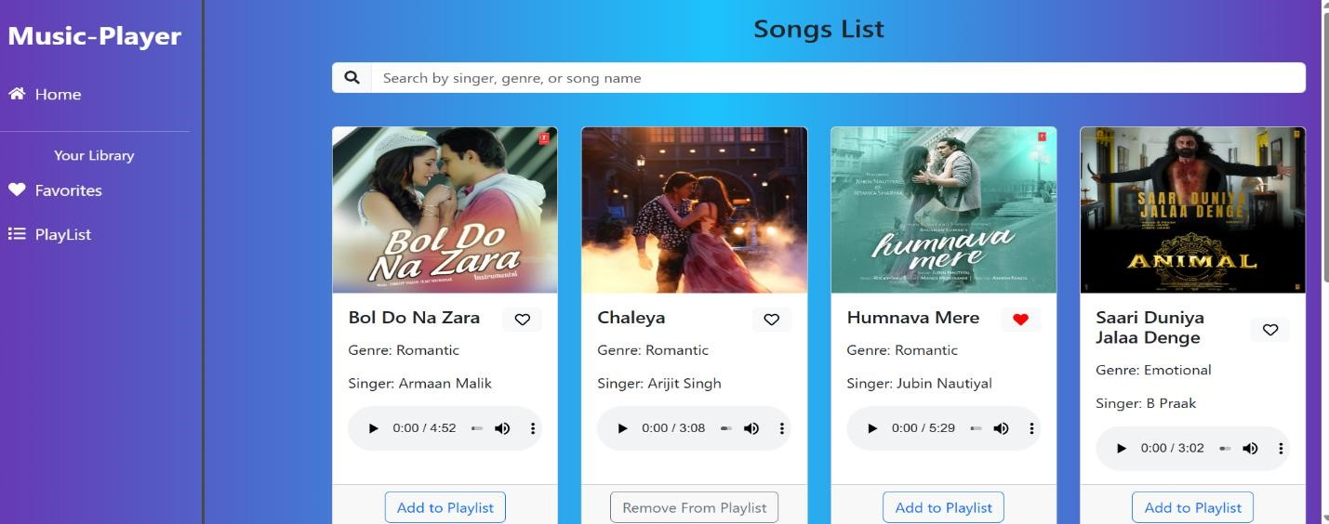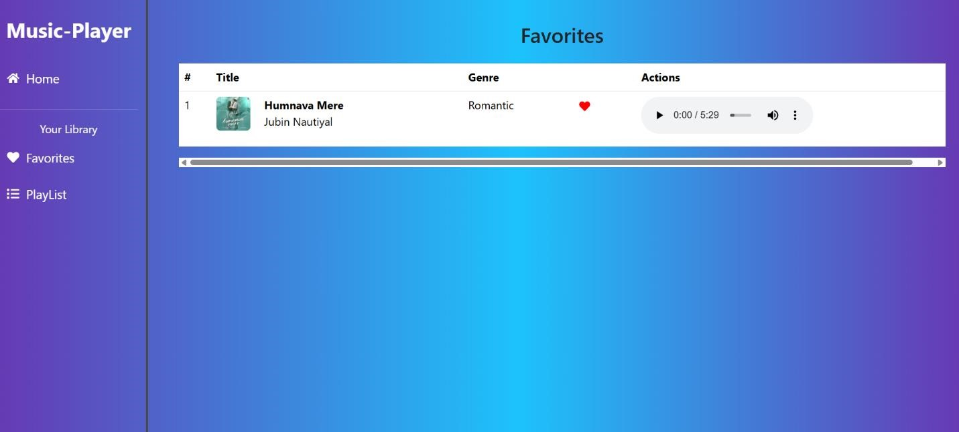

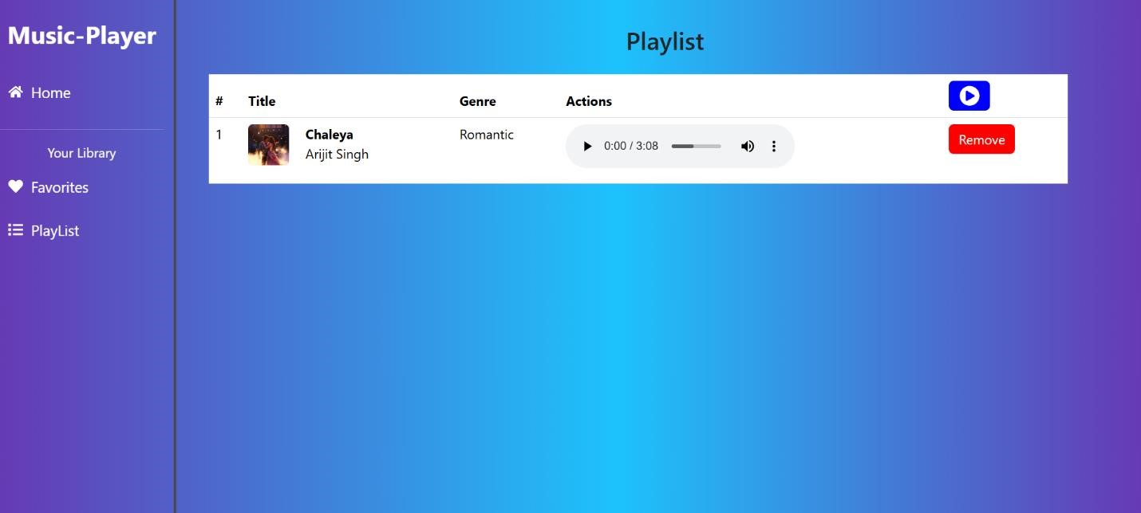

**14. Project Link**

● **Link :**

# 14. Known Issues

Issues

-occasional delays in song loading due to API limts

-Playlist feature may require additional optimization for large data sets

# 15. Future Enhancements

● Rhythmic Tunes is a dynamic and interactive music streaming platform designed to provide a seamless and engaging user experience. Its use of modern web technologies like React.js ensures a fast, scalable, and responsive application.