Imagine floating in the vast expanse of space, surrounded by endless darkness, with distant stars scattered like tiny specks of light. In the midst of this cosmic expanse lies our solar system, home to planets, moons, and asteroids, all held together by the force of gravity. This interconnected system extends unimaginable distances, from the rocky inner planets to the icy outskirts of its edges.

Our solar system consists of eight planets - Mercury, Venus, Earth, Mars, Jupiter, Saturn, Uranus, and Neptune - alongside five recognized dwarf planets: Ceres, Pluto, Haumea, Makemake, and Eris. These celestial bodies, each with its unique characteristics and history, orbit the Sun, the blazing center of our cosmic neighborhood. The Sun, residing within one of the spiral arms of the Milky Way galaxy, exerts a tremendous influence on everything within the solar system.  
  
The sun, the closest star to Earth, is the driving force behind all solar activity. Its gravitational pull keeps planets in their orbits, and the immense energy it generates powers life on Earth, affecting seasons, ocean currents, weather patterns, and even the mesmerizing polar auroras at the poles. Beyond Earth, solar activity extends into the realm of space weather, where solar storms can disrupt satellites, communication systems, and power grids. As technology advances and becomes an integral part of our lives, understanding space weather and the solar cycle has become essential for protecting modern infrastructure.

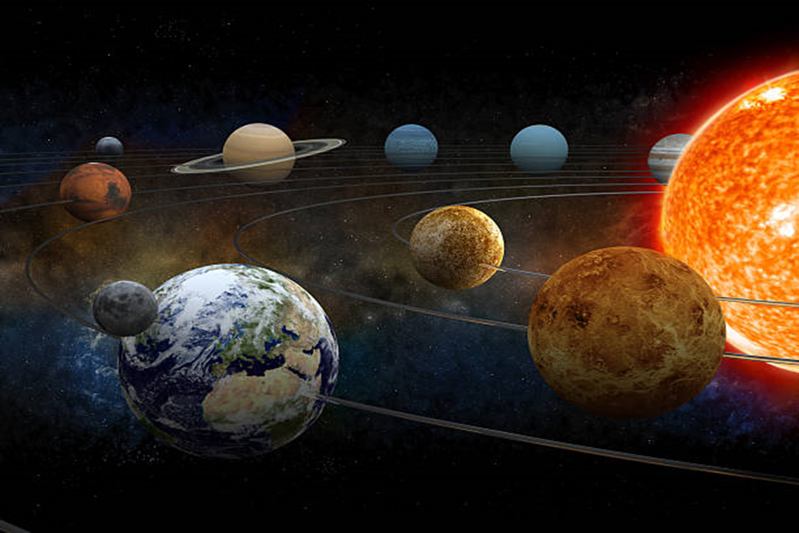

Historical events, such as the power outage in Quebec in 1989 due to a geomagnetic storm and the loss of several Starlink satellites in 2022 due to increased atmospheric drag, highlight the importance of monitoring solar activity. Scientists worldwide track the solar cycle, a roughly 11-year period characterized by fluctuations in solar activity, to predict and prepare for potential impacts on Earth.  
  
It is best to monitor solar activity through sunspots, solar flares, and coronal mass ejections (CMEs), all of which can impact Earth's magnetic field. Solar observatories such as the National Solar Observatory (NSO) provide important information on solar activity density. Space telescopes like NASA's Solar and Heliospheric Observatory (SOHO) and the Solar Dynamics Observatory (SDO) capture high-resolution images and data on solar flares and CMEs, offering clearer insight into solar activity beyond Earth's atmosphere. Ground-based instruments measure solar radio emissions and changes in the sun's magnetic field, while missions like NASA's Parker Solar Probe and the European Space Agency's Solar Orbiter study solar wind and its effects on Earth's magnetic envelope.  
  
These tools, in conjunction with international cooperation, allow scientists to exchange real-time data about space weather. Organizations such as the International Space Environment Service (ISES) and the Global Data Center SILSO help disseminate information about solar activity, enabling accurate predictions about space weather. This collective knowledge helps mitigate the risks posed by solar storms to Earth's technological infrastructure.

The general term applied to this solar storm is space weather, which is caused by disruptions in the sun's magnetic field. Ultimately, it releases a massive amount of energy and solar material into space, which can affect planets, satellites, and spacecraft. Some attributed causes of solar storms include:  
Solar flares: These sudden releases of magnetic energy on the sun's surface launch massive bursts of radiation into space. Sometimes, these flares intersect with Earth's atmosphere, negatively impacting wireless communications and navigation.

Coronal Mass Ejections (CMEs): These are massive plasma and magnetic field expulsion events from the Sun's corona. CMEs can send billions of tons of solar material into space, and when directed towards Earth, they can result in geomagnetic storms that may impact power grids and satellites.  
Solar winds: A stream of charged particles emanating from the Sun. If solar winds intensify, they can interact with Earth's magnetic field, causing disruptions in terrestrial magnetic activity.  
Coronal holes: These are regions on the sun where the magnetic field opens up, allowing solar winds to escape more efficiently. These solar wind currents can reach Earth and cause geomagnetic storms.  
Solar storms are events that occur due to interactions between these types of phenomena and Earth's magnetic field, sometimes disrupting technology and posing a risk to astronauts and their spacecraft.

A live example of the impact of solar activity on Earth occurred in May 2024, when a historic geomagnetic storm affected the world. This event was classified as a G5 storm – the most intense on a wide scale – and was triggered by a series of solar coronal mass ejections (CMEs) between May 3rd and May 9th. These CMEs released immense energy into space, resulting in the stunning auroras being visible far beyond the polar regions where they are typically observed. The auroras were visible in parts of the continental United States and even as far south as India, a rare occurrence that enthralled sky watchers across the globe.



The NASA Solar Dynamics Observatory recorded 82 significant solar flares during this period, with the storm reaching its peak on May 10th. In response to this powerful event, the National Oceanic and Atmospheric Administration (NOAA) issued a rare storm warning, prompting emergency measures to protect satellites and communication systems from damage. The geomagnetic storm excited both professional photographers and citizen scientists, many of whom documented the auroras and contributed data to projects like Aurorasaurus. This project, which utilizes public reports to map auroral activity, provides valuable insights for scientists studying the effects of geomagnetic storms on Earth.  
  
Solar storms, often referred to as geomagnetic storms when they interact with Earth's magnetic field, can manifest in various forms. Solar flares are intense bursts of radiation resulting from the release of energy from the Sun's magnetic fields, while coronal mass ejections (CMEs) involve massive expulsion of plasma and magnetic fields from the Sun's outer layer, or corona. When these charged particles collide with Earth's magnetic envelope, they can trigger geomagnetic storms, potentially disrupting communication systems, satellite operations, and even power grids through induced currents.

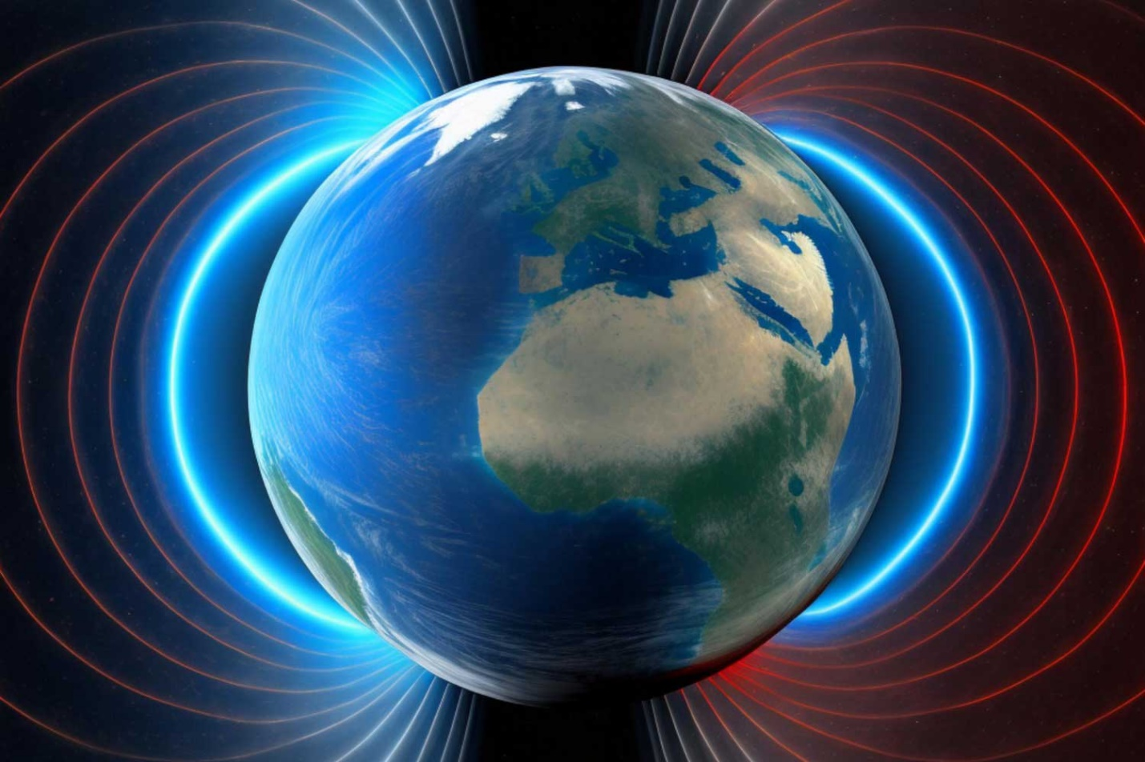  
  
The geomagnetic storm in May 2024 not only produced stunning auroras, but also had a tangible impact on technology. The increased atmospheric density resulting from the storm The NASA Solar Dynamics Observatory recorded 82 significant solar flares during this period, with the storm reaching its peak on May 10th. In response to this powerful event, the National Oceanic and Atmospheric Administration (NOAA) issued a rare storm warning, prompting emergency measures to protect satellites and communication systems from damage. The geomagnetic storm excited both professional photographers and citizen scientists, many of whom documented the auroras and contributed data to projects like Aurorasaurus. This project, which utilizes public reports to map auroral activity, provides valuable insights for scientists studying the effects of geomagnetic storms on Earth.  
  
Solar storms, often referred to as geomagnetic storms when they interact with Earth's magnetic field, can manifest in various forms. Solar flares are intense bursts of radiation resulting from the release of energy from the Sun's magnetic fields, while coronal mass ejections (CMEs) involve massive expulsion of plasma and magnetic fields from the Sun's outer layer, or corona. When these charged particles collide with Earth's magnetic envelope, they can trigger geomagnetic storms, potentially disrupting communication systems, satellite operations, and even power grids through induced currents.

The geomagnetic storm in May 2024 not only produced stunning auroras, but also had a tangible impact on technology. The increased atmospheric density resulting from the storm forced low Earth orbit satellites to use their thrusters to maintain their positions, highlighting the risks that solar activity poses to satellite infrastructure. Additionally, this event shed light on the vulnerability of the growing number of small commercial satellites in space, particularly susceptible to atmospheric drag and other disturbances during solar storms.

forced low Earth orbit satellites to use their thrusters to maintain their positions, highlighting the risks that solar activity poses to satellite infrastructure. Additionally, this event shed light on the vulnerability of the growing number of small commercial satellites in space, particularly susceptible to atmospheric drag and other disturbances during solar storms.  
  
With the continued exploration of space, astronauts on future missions to the moon or Mars will face similar risks from solar radiation, emphasizing the importance of developing preventive strategies. Solar storms can also affect other celestial bodies, such as Mars, which lacks a strong magnetic field. Understanding these effects will be crucial as humanity ventures deeper into space.  
  
The risks posed by solar storms require improved prediction, preparedness, and flexibility. Enhancing real-time data sharing between agencies such as NASA and the National Oceanic and Atmospheric Administration, along with better satellite design and operational protocols, can help mitigate damage. Satellites must be strengthened against radiation, and operators should have emergency plans to avoid disruptions during geomagnetic events. On the ground, electrical grids and communication systems need reinforcement to withstand induced currents from geomagnetic storms, which can cause widespread outages.  
  
Mitigating the effects of solar storms and addressing the risks they pose requires a multifaceted approach that combines technology, infrastructure improvement, and global cooperation. The following strategies have been identified as key for mitigating the effects of solar storms:

Continuous monitoring of solar activity using observatories and space missions is of utmost importance for predicting and preparing for solar storms. Tools such as NASA's Solar Dynamics Observatory (SDO), the Parker Solar Probe, and the European Space Agency's Solar Orbiter provide real-time data on solar flares, coronal mass ejections (CMEs), and solar winds. These insights enable scientists and agencies like NOAA to issue early warnings, giving satellite operators and infrastructure managers time to implement protective measures.  
  
Satellite protection and operational protocols:  
To mitigate damage to the infrastructure of satellites during geomagnetic storms, satellites must be designed with enhanced protection against solar radiation. Operators should have emergency protocols in place, such as satellite repositioning or using defenses to counter increased atmospheric drag caused by geomagnetic storms. This is particularly important for the growing number of small commercial satellites, which are more vulnerable to disruptions during such events.  
  
Strengthening the terrestrial infrastructure:  
Solar storms can induce strong currents in electrical grids, leading to widespread outages and damage to communication systems. To mitigate these effects, it is advisable to enhance critical infrastructure, including power grids and communication networks, to withstand the impact of geomagnetic storms. This may involve implementing protective technologies, such as ground magnetic storm detectors and transformers designed to prevent excessive current loads.

International cooperation and data exchange:  
Space weather poses a global challenge, and international cooperation is necessary for managing the risks posed by solar storms. Agencies such as NASA, the National Oceanic and Atmospheric Administration (NOAA), and the International Space Environment Service (ISES) play a crucial role in sharing real-time data and research findings, enabling accurate predictions and timely responses. Strengthening these partnerships can enhance overall preparedness for future events.

Public awareness campaigns will also play a crucial role in educating communities about the potential effects of solar storms and the importance of preparedness. By combining technological innovation, proactive strategies, and international cooperation, we can better prepare for future geomagnetic storms and their impacts.  
The geomagnetic storm in May 2024 served as a strong reminder of the complex relationship between solar activity and its effects on Earth. While the stunning auroras delighted millions, the storm also revealed vulnerabilities in satellite infrastructure and power grids. As our reliance on technology grows, understanding space weather and predicting it becomes crucial. By enhancing monitoring, designing more resilient satellites, and improving preparedness, we can mitigate the risks posed by solar storms. Through a combination of advanced technology, international cooperation, and public education, we can better protect our planet, safeguard our technological infrastructure, and enhance human exploration and utilization of space.

