Description:

|  |  |
| --- | --- |
| Entity | Attribute |
| Customer_info | Customer_id(int), Customer_name(Varchar(255)), First_sale_date(Date) |
| Product_info | Part_Number(int), quantity(int), Cost(float) |
| Sales_info | Item_sold(int), Date(Date), Price(int), Profit(float) |
| Store_info | Employee_id(int), Employee_name(varchar(255)), Employee_role(varchar(255)) |
| Supplier_info | Supplier_name(varchar(255)), Delivery_time(Date), Next_delivery_date(Date), Expected_qty(int) |

|  |
| --- |
| Primary Keys |
| 1. Customer_id |
| 1. Employee_id |

Only two primary keys are present, one from the Customer info Table and the other from the Store info Table. The database has no foreign keys. We generated a total of 5 tables in the database, the list of which can be seen in the above description. There are three numbers of data entries in each table.

Execution Queries:

SELECT Customer_name,Customer_id, Total_Sales_Number from customer_info where Total_Sales_Number >100 ORDER BY `customer_info`.`Customer_name` ASC

Outcomes:

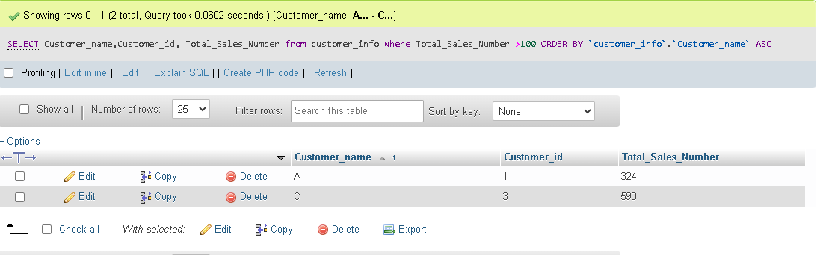

SELECT Part_Number,Quantity,Cost FROM product_info where product_info.Quantity<=40 GROUP BY Part_Number,cost, Quantity ASC

Outcomes:

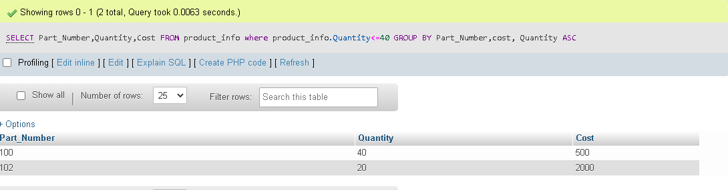

SELECT SUM(Profit) as total_profit FROM sales_info WHERE Date>'2021/12/09';

Outcomes:

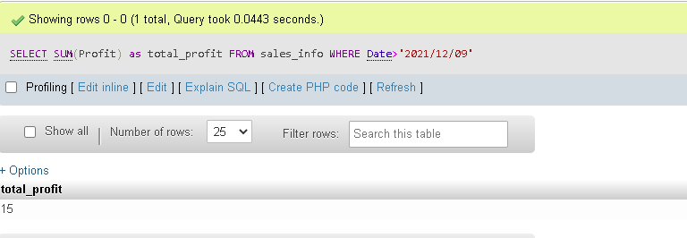

SELECT * FROM store_info where Employee_name LIKE 'R%';

Outcomes:

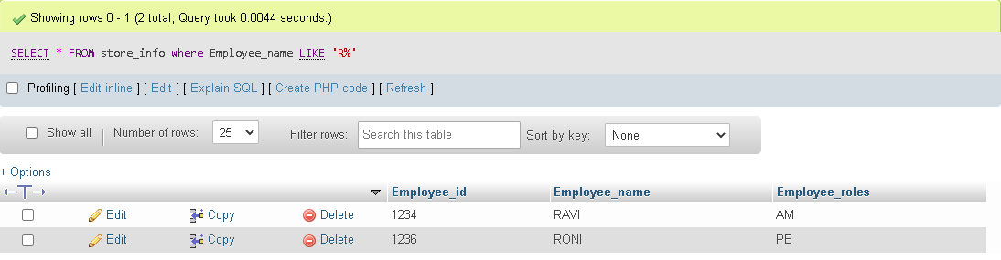

SELECT AVG(Expected_qty) as Average_expectation from supplier_info where Next_delivery_date>'2022/11/04';

Outcomes:

