**44-599: Introduction to Data Visualization**

**Worksheet**

**Worksheet for drawing Gauge chart using QlikView and Symbol map using Tableau.**

The following Excel sheet consists of information about Crime rate in USA of the year 2014.



Download the excel file and save the file with the proper name.

**To visualize data with gauge chart using QlikView.**

**Goal 1: Draw a gauge chart showing crime rate of USA.**

1. Download the QlikView tool from the below link provided:

<http://www.qlik.com/us/try-or-buy/download-qlikview>

1. After downloading open the tool on your desktop. Home Screen will be appeared. Click on edit script to load the data

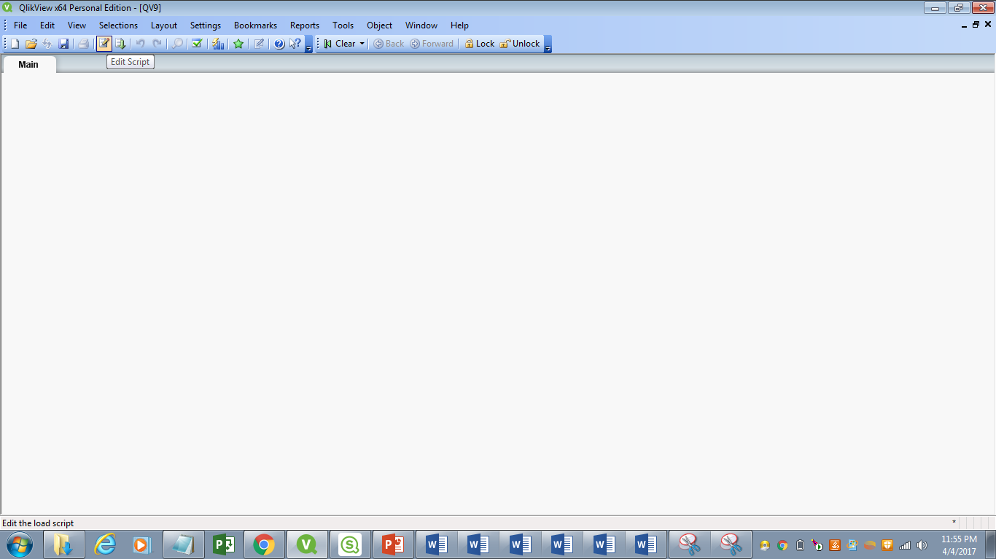

1. After clicking edit script a screen will be appeared as shown below. Click on table files to upload data into the tool, when the data is uploaded click on finish button. Check the relative paths box if it is unchecked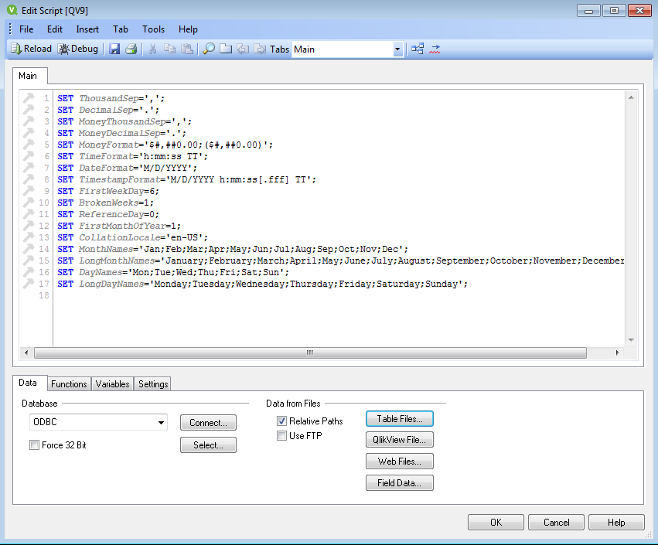
2. After data has uploaded the following screen will be shown click on the reload button at the top left of the screen and then save your QlikView file by giving proper path. You will notice all the fields that are present in the data

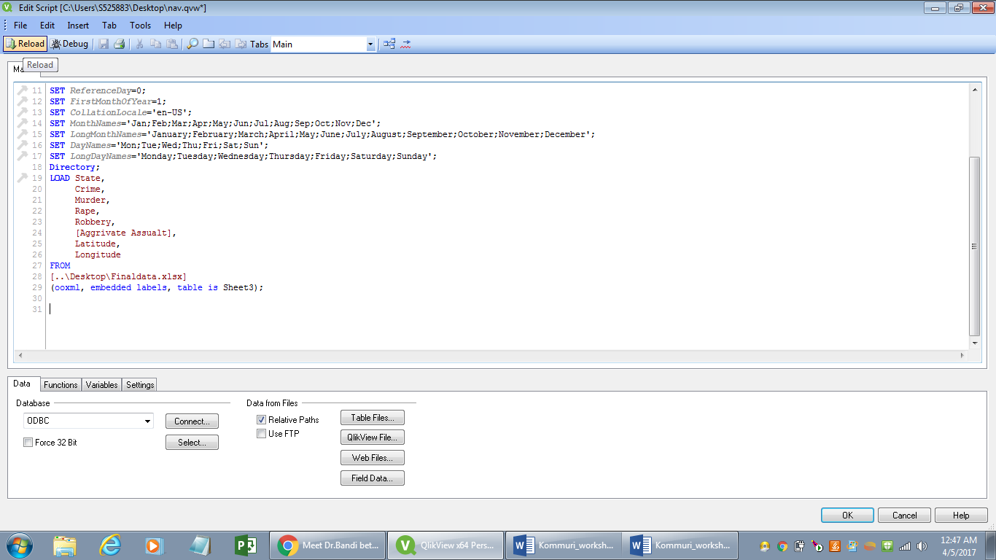

1. Now you will get blank page on the screen. Right Click on it and select ‘New Sheet Object’ you will get another drop down from there and select chart. You will get the following window now select the appropriate chart type, here we are going to select gauge chart

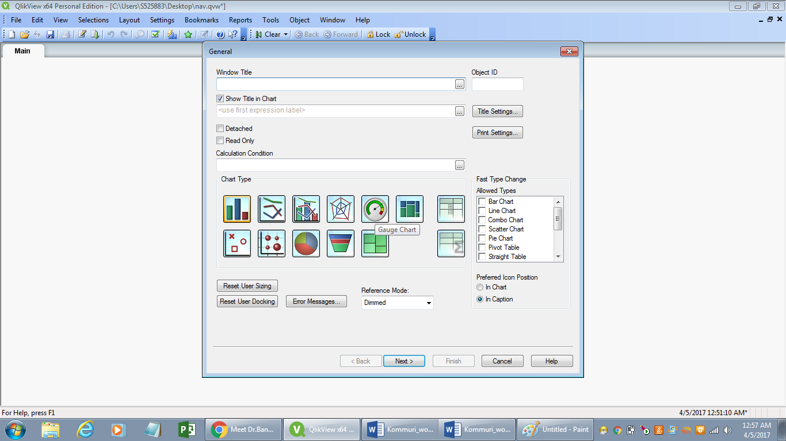

1. When you select the gauge chart add the dimension as crime in the dimensions tab and click on next you will be redirected to edit expressions tab where write the expression as ‘Crime’ as you are visualizing crime rate. Now click on finish button where you can see partially done gauge chart

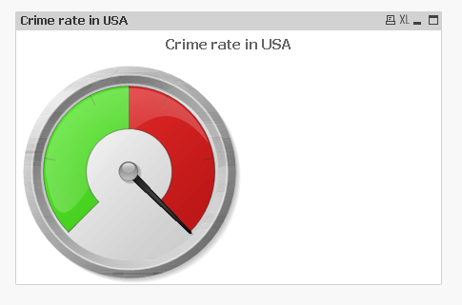

1. Here you can edit gauge chart as you like, Right click on the chart and click on properties and go to presentation tab at the top and edit the chart by increasing its segments and also by showing labels on the gauge chart
2. After you have customized you will observe the following gauge chart. To show the exact label on the gauge chart, right click on gauge chart go to presentation tab, you will find **Text in Chart** where you can write **“= Crime**” and then exact label is shown on chart

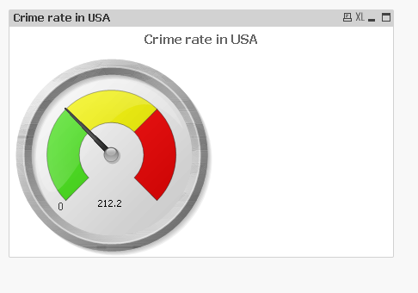

1. Now to select the state right click on the blank page and click on **New Sheet object** and select **list box.** Here give the title as State and in the field select **state** as field and click OK. You will find the graph in this way

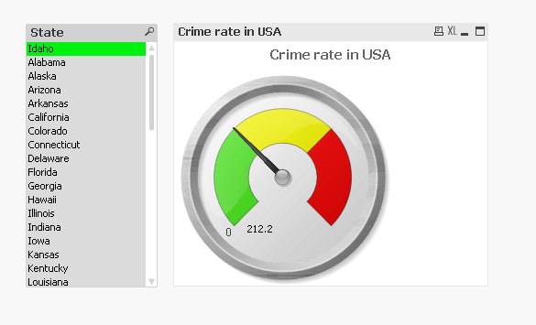

1. Now save your work anywhere you want on your PC

**To visualize data with filled map and pie chart using Tableau**

**Goal 2: To visualize the different categories of crimes (rape, murder, robbery) of 50 different states in USA of the year 2014 using Symbol map in Tableau**

The following excel sheet consists of processed data which is required for the map download the file and name it with proper naming convention.



1. In Tableau, load the excel file from the data source.
2. On the Data Source page, click **Sheet 1** to go to a new worksheet. Rename the sheet with the appropriate name.
3. In the Data pane, under Dimensions, double-click **State**. Now a sample map is created.
4. On the Marks card, click the Mark-type drop-down and select the **Filled Map** mark type.

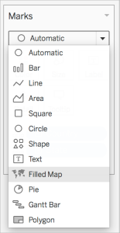

1. From Measures, drag **Category** to **Color** on the Marks card.
2. From Measures, drag **Latitude (generated)** to the **Rows** shelf, and place it to the right of the other Latitude field.

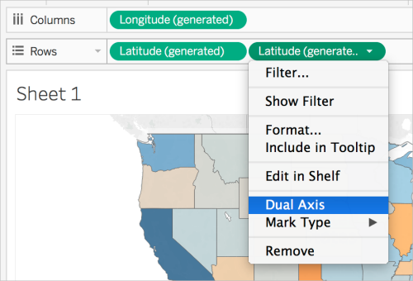

You should now have two identical map views.

1. On the Rows shelf, right-click the second **Latitude** field and select **Dual Axis**.

The second map is now layered on top of the first map. There are now three drop-downs on the Marks card: one for each map view, and one for both views (all). These are three separate marks cards that you can use to control the visual detail for each of the map views.

1. On the Marks card, click one of the**Latitude (generated)** tabs, and then click the Mark type drop-down and select the **Pie**mark type.

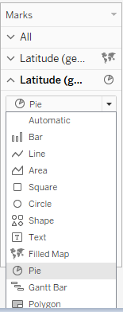

1. From Measures, drag **Count** to **Tooltip** on the Latitude (generated) Marks card you selected.

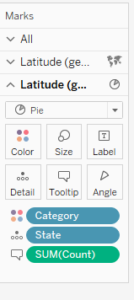

1. From Dimensions, drag **Category** to **Color** on the same Marks card.

If the size of the pie charts is too small, click Size on the Marks card to adjust the size.

The map view now shows the data regarding robbery, murder, rape of each state in USA.

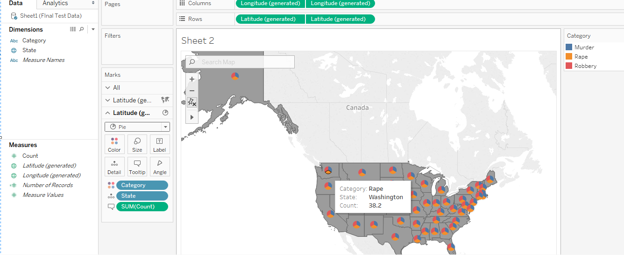

Save the data by using proper naming convention.