ˆ_ **Project Information**

**DA Assignment-1**

■ **Bar Chart – Total Sales by Product Line**

**Caption:**

This bar chart represents the total sales generated by each product line across all branches.It shows that *Food and Beverages*, *Electronic Accessories*, and *Fashion Accessories* are among the top contributors in revenue.

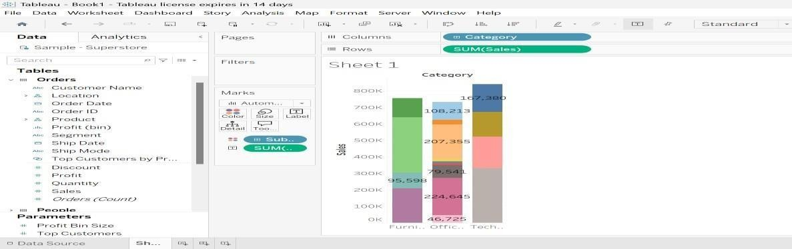

■2**Pie Chart–Payment Method Distribution Caption:**

This pie chart displays the distribution of customer payment methods.The three payment methods include *Cash*, *Credit Card*, and *Ewallet*, with

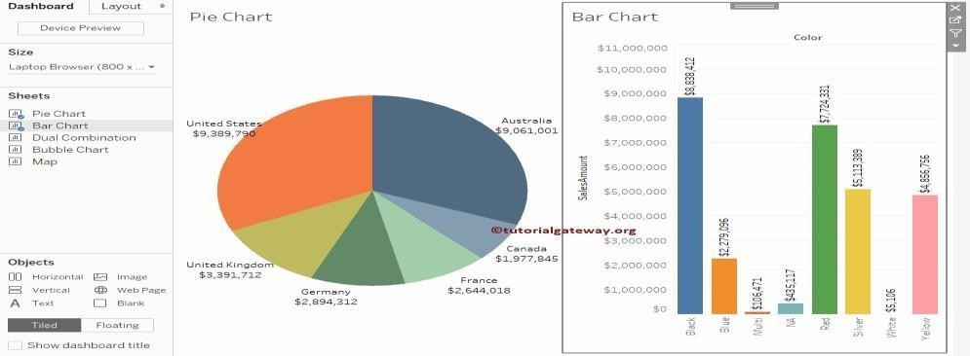

Cash being the most frequently used.

■ **Stacked Bar Chart–Gender-wise Sales across Branches**

**Caption:**

This stacked bar chart compares total sales from male and female customers in each branch(A,B, and C).The height of each bar shows total revenue, while the segments show gender contribution.

*Insight:*All branches maintain a balanced customer base across genders, with slight variances.

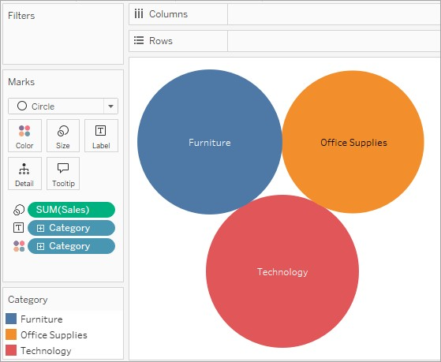

■f**Bubble Chart–Rating vs Gross Income Caption:**

This bubble chart shows the relationship between customer rating and gross income.Bubble size represents total transaction value, and colors indicate customer types (Member vs Normal).

*Insight:*Higher-rated transactions are often associated with higher income and are largely from

Member customers.