ˆ_ **Project Information**

**DA Assignment-2**

■ **Donut Chart – Branch-wise Sales Contribution**

**Caption: this is made by me as gif type…**

This donut chart displays the total sales contribution from each branch(A,B,C).The center highlights the overall sales volume while the segments show the proportional share by branch.

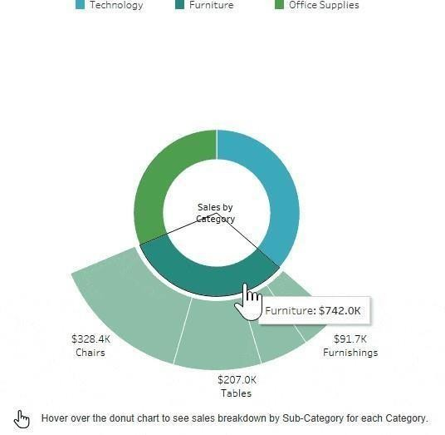

■2**Area Chart–Monthly Sales Trend Caption:**

This area chart visualizes the total sales over the three months(January to March 2019). It uses color shading to show branch-level contribution across time.

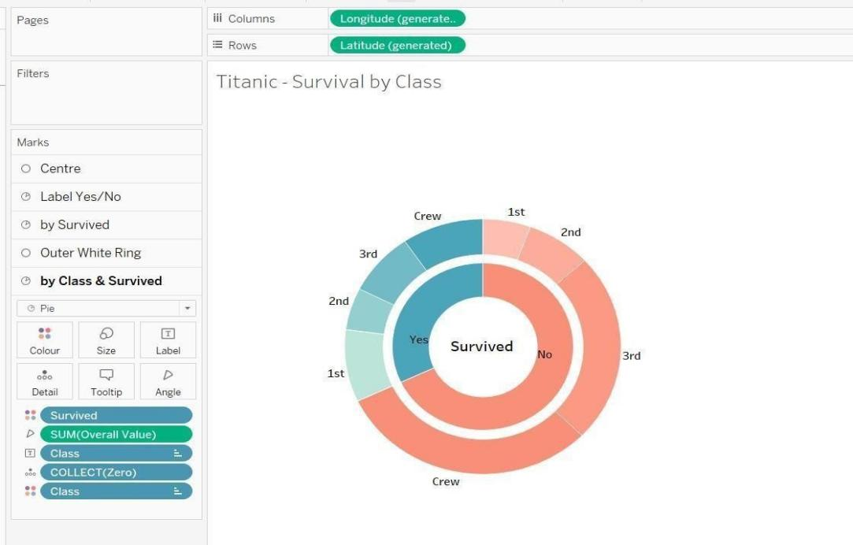

■3**Text Table–Product Line Sales Summary Caption:**

**converted into gif by me…**

This text table provides a detailed breakdown of sales, quantity sold,gross income,and average customer rating per product line and customer type.



.

■ **Word Cloud–Most Purchased Product Lines**

**Caption:**

This word cloud illustrates the popularity of different product lines based on the number of items purchased. Font size reflects quantity sold.

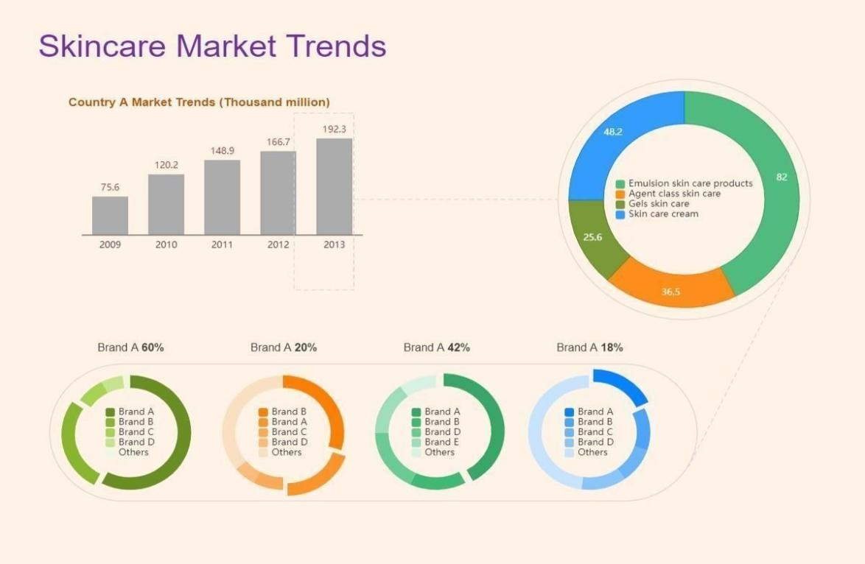

■6**Funnel Chart–Payment Method Usage**

**Caption:**

This funnel chart visualizes the volume of sales through each payment method.It narrows from the most to least used method.