ˆ_ **Project Information**

**DA Assignment-3**

DatasetLink:

<https://drive.google.com/file/d/1UmrCVmQFQYorNUTw414G3xot6rm46BwR/view>

# ¡]#■1.KPI-Focused Interface

Shows key metrics—Total Sales,Gross Income,Quantity—with trend indicators,gauges,and symbol charts. Great for a high-level snapshot of branch-wise performance.

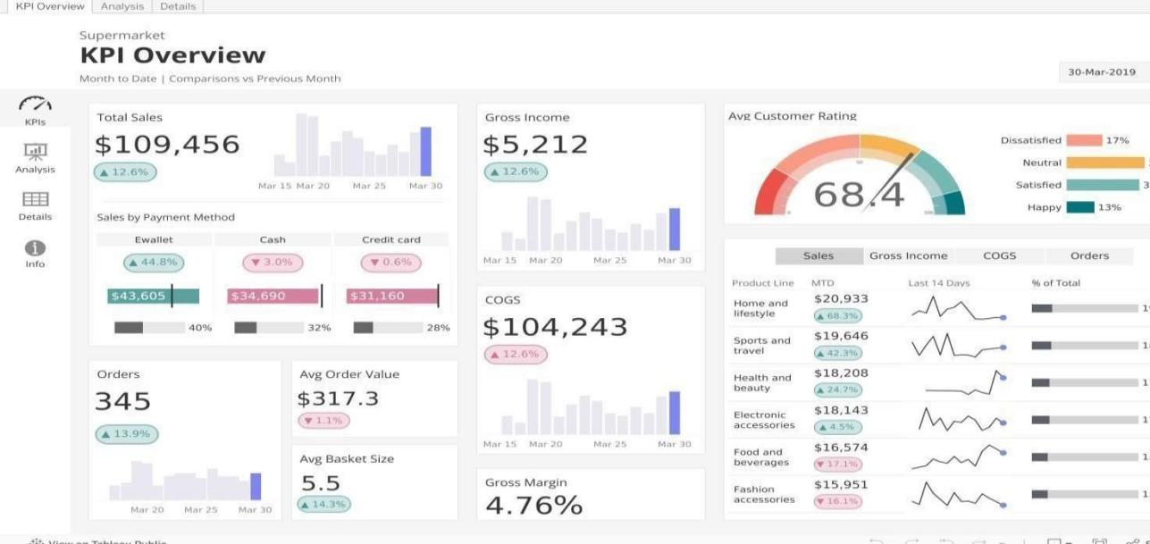

# ■#Z2.Multi-Component Retail Dashboard

Combines area charts,bar charts,and filterable lists in a clean layout.Offers dynamic filtering by branch, category, or time period.

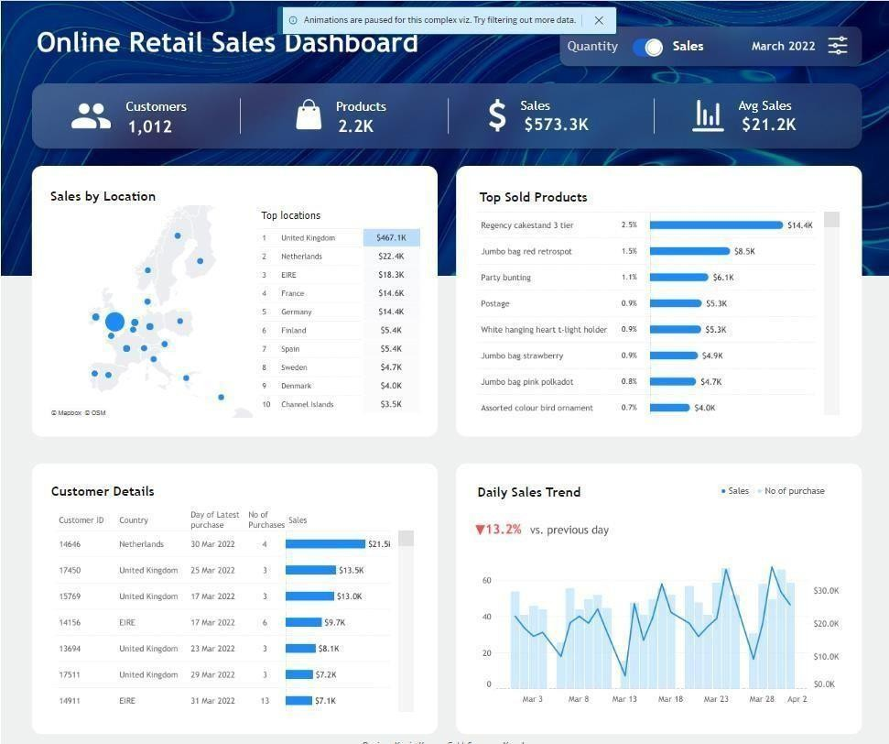

# ■ ■ ª_]¸ 3.Time-Based Sales&Payments View

Includes monthly time lines with stacked bars and side panels for payment methods or product lines—ideal for trend and distribution analysis.

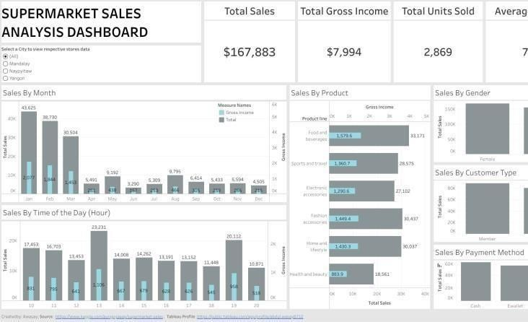

# ’●4.Dark-Themed Executive Dashboard

Features slick aesthetics with bar trends, KPIs,and product-level insights—perfect for management reporting.

