Design Document
Find Street Crime Web App
Prepared for coursework / project documentation
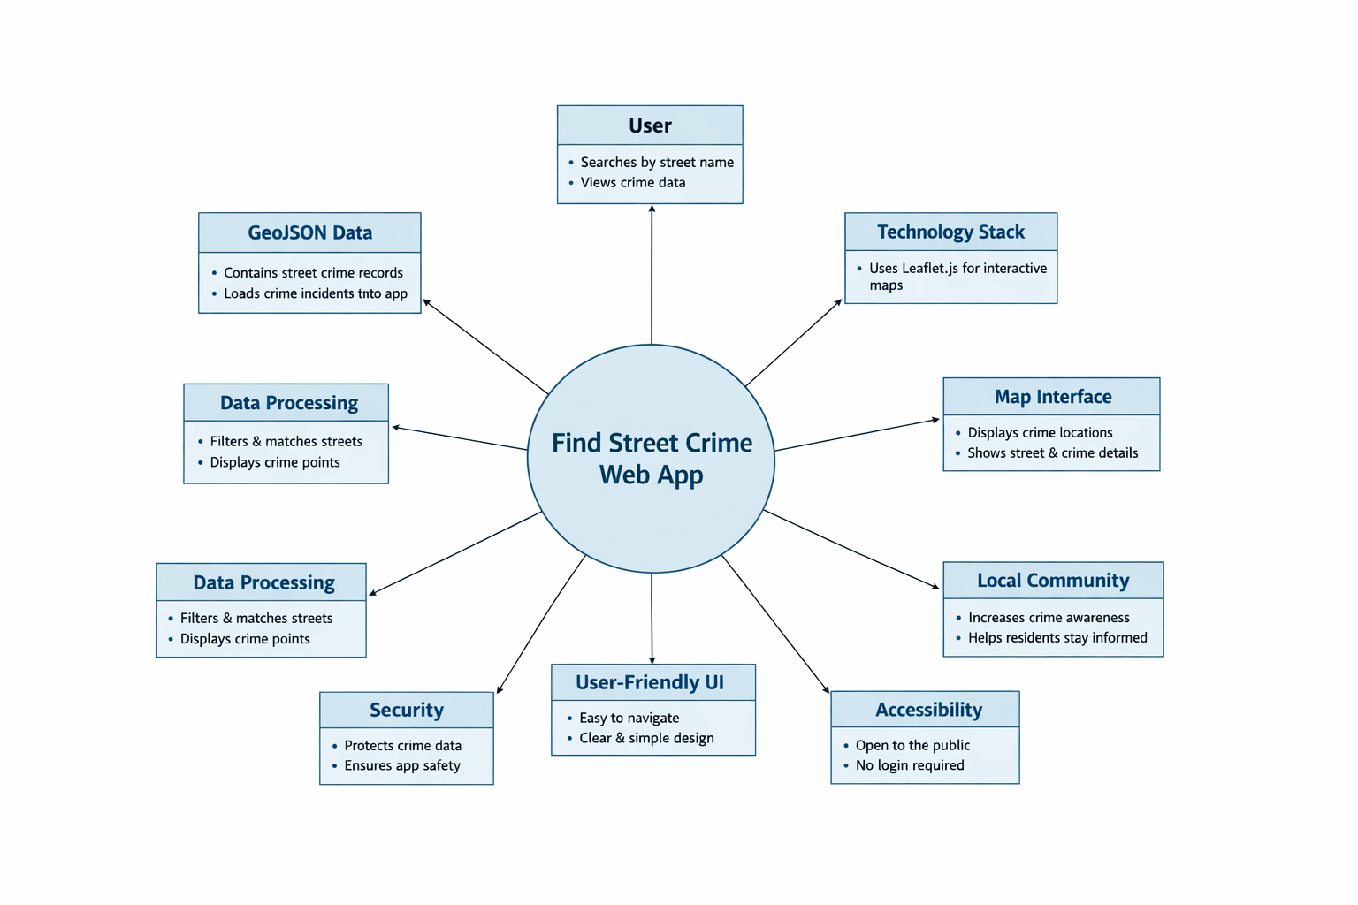
Figure 1. Context diagram for the Find Street Crime web app.

User Interface design
The Find Street Crime web application is designed to be simple, clear, and easy to use. The application allows users to search for crime incidents by street name and view the results on an interactive map. The design focuses on making crime data easier to understand by presenting it visually rather than as raw data.

Design goals
- Allow users to search for street crime incidents by entering a street name.
- Display search results on an interactive map.
- Allow users to click map markers to view crime details.
- Keep the interface clean and minimal so the map remains the main focus.
- Support desktop and mobile screen sizes.
- Use clear labels and simple controls for accessibility and usability.

Key sections of the wireframe

Header section
Contains the application title and a short description of the system purpose.

Search section
Includes a street-name input field and a search button so users can start a query quickly.

Map section
Shows crime incidents as markers on an interactive Leaflet map.

Marker popup section
Displays the street name and crime category when a user clicks a marker.

Accessibility and usability
Uses clear labels, straightforward controls, and a layout that remains readable across devices.

Wireframe / diagram

Figure 1. Proposed design context for the Find Street Crime app.

