Implementation Document
Find Street Crime Web App
Prepared for coursework / project documentation
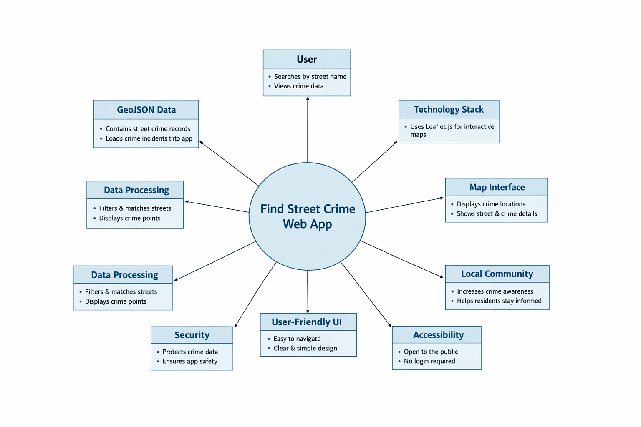
Figure 1. Context diagram for the Find Street Crime web app.

Introduction
The web application enables users to search for street crime incidents and view matching results on an interactive map. Users enter a street name into the search field, and the application filters the crime dataset to display relevant incidents. Each result is shown as a map marker, and clicking a marker displays details about the selected incident, including the street name and crime category.

Dataset
- The system uses a GeoJSON dataset containing street crime information.
- The dataset stores coordinates, street-name information, and crime categories.
- The dataset is loaded locally by the web application at runtime.

Known issues
- If the GeoJSON file is incomplete or corrupted, the application may fail to display incidents correctly.
- Searching for a non-existent street name returns no results.
- Multiple incidents may share the same street name and appear as several markers.

Software architecture
The application follows a layered architecture style, separating the user interface, business logic, and data access responsibilities.
Layer | Purpose
User interface layer | Provides the search box, search button, and interactive map visible to the user.
Business logic layer | Processes the search input, filters the dataset, and controls marker and popup behaviour.
Data access layer | Loads and exposes the GeoJSON dataset used by the application.

Technology stack
- HTML for structure
- CSS for styling
- JavaScript for search logic and behaviour
- Leaflet.js for the interactive map
- GeoJSON for data storage

Use cases

Use Case 1: Searching by Street Name
- Open the application in a web browser.
- Locate the street-name search field.
- Enter a street name, for example “High Street”.
- Click the Search button.
- The system filters the dataset and displays matching crime incidents on the map.

Use Case 2: Viewing Crime Details on the Map
- Perform a street search.
- View the markers displayed on the map.
- Click on a marker.
- Read the popup information shown on screen.

Use Case 3: Searching with No Exact Match
- Enter a street name that does not exist in the dataset.
- Click the Search button.
- The system processes the search.
- No matching incidents are displayed on the map.

Application diagram


