Project Proposal
Find Street Crime Web App
Planning section written by: [Your Name]

Business Case
Problem statement
The problem addressed by this project is that people may find it difficult to quickly access clear and understandable street crime information for a specific location. Crime data is often available in public datasets, but this information can be difficult for ordinary users to read, search, and interpret.
In many cases, the data is presented in a technical format that is not easy to explore visually, which makes it harder for residents and visitors to understand crime patterns in their local area.
This project solves that problem by creating a web application called Find Street Crime, which allows users to search for a street name and view related crime incidents on an interactive map. This makes the information easier to access, easier to understand, and more useful for people who want a simple overview of crime categories in a chosen area.
Business benefits
- Users will be able to search for crime information by street name in a quick and simple way.
- The application will display crime incidents visually on an interactive map, making the data easier to understand.
- It will improve public access to crime information without requiring users to read raw datasets.
- It will save users time by allowing them to search directly for relevant street locations.
- It will provide a user-friendly way to explore crime categories in different areas.
- It will support better awareness of local safety issues for residents, visitors, and communities.
- It will demonstrate how geographic data can be transformed into a useful and practical information system.
Options Considered
- Manually searching through public crime data files; however, this is time-consuming and difficult for users who are not familiar with raw datasets.
- Using general websites that publish crime information; however, they may not provide a simple street-based search function or an easy interactive map view.
- Downloading and analysing GeoJSON data directly; however, this requires technical knowledge and is not suitable for everyday users.
- Using a text-only display of crime records; however, this would not be as clear or user-friendly as an interactive map.
Expected Risks
- Ensuring the search function correctly matches street names from the dataset.
- Handling large amounts of geographic data efficiently so the application remains responsive.
- Making sure the map loads correctly on different browsers and devices.
- Ensuring markers and popup information are displayed accurately.
- Avoiding confusion where several incidents appear close together on the map.
- Managing possible issues if the dataset is incomplete, outdated, or changed in future.
- Making sure the interface is simple, clear, and easy to use.
- Reducing loading or performance problems when many results are shown at once.
- Ensuring the application remains reliable when external libraries or map services are used.
Project Scope
This project is a web-based street crime mapping application designed to help users search for and explore crime incidents by street location.
Users can enter a street name into the search field, and the application will display matching crime incidents on an interactive map. Each result includes key information, such as the street name and crime category, displayed through popup interaction.
The system uses a GeoJSON dataset and a map-based interface to present information in a way that is easier to interpret than raw data files. The overall purpose of the project is to improve access to crime information through a simple, visual, and user-friendly system.
Objectives
- To design and build a simple and effective street crime search application.
- To provide an easy way for users to search for crime incidents by location.
- To display crime data clearly using an interactive map interface.
- To improve the accessibility and understanding of public crime information.
- To create a system that is functional, user-friendly, and visually clear.
Success Criteria
- Users can enter a street name and receive matching crime results.
- Crime incidents are displayed correctly on the map.
- Popup information shows the correct street name and crime category.
- The application is easy to use and visually understandable.
- The system performs reliably without major loading or display issues.
- Users are able to access and understand local crime information more easily than by using raw data alone.
Key System Features
Feature | Description
Street search | Users search for crime information by entering a street name.
Interactive map | Matching incidents are shown visually on a digital map.
Popup details | Each result shows details such as street name and crime category.
GeoJSON dataset | Crime data is loaded from a geographic data file for display.

Context Diagram
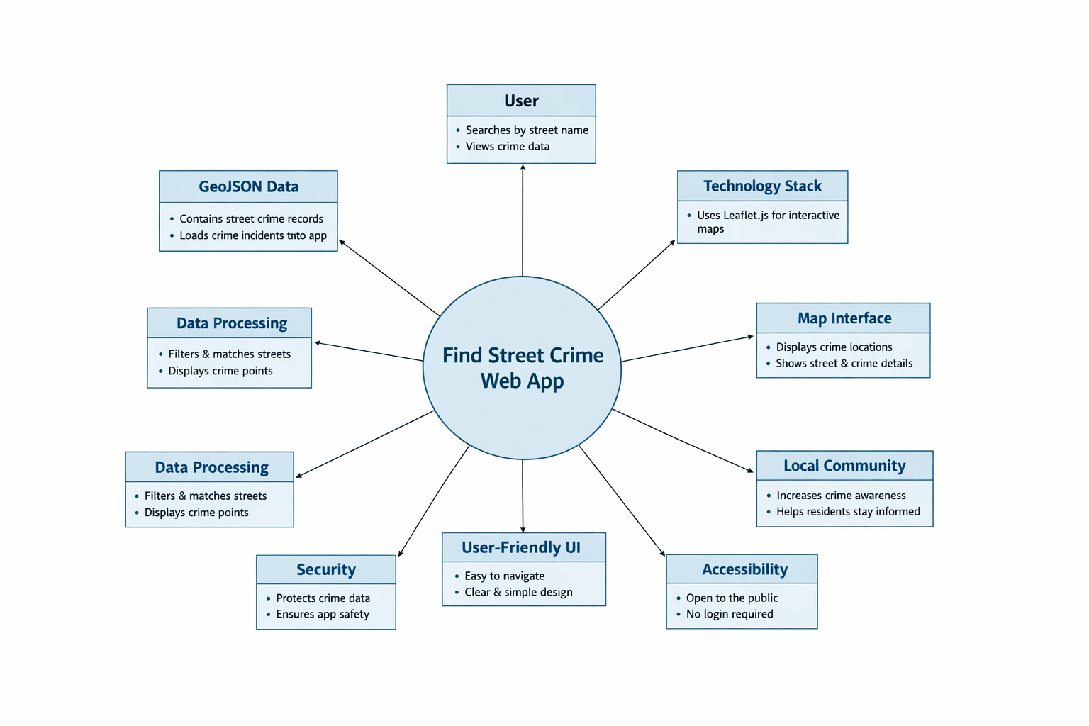
Figure 1. Context diagram for the Find Street Crime Web App.

