Testing Document
Find Street Crime Web App
Prepared for coursework / project documentation
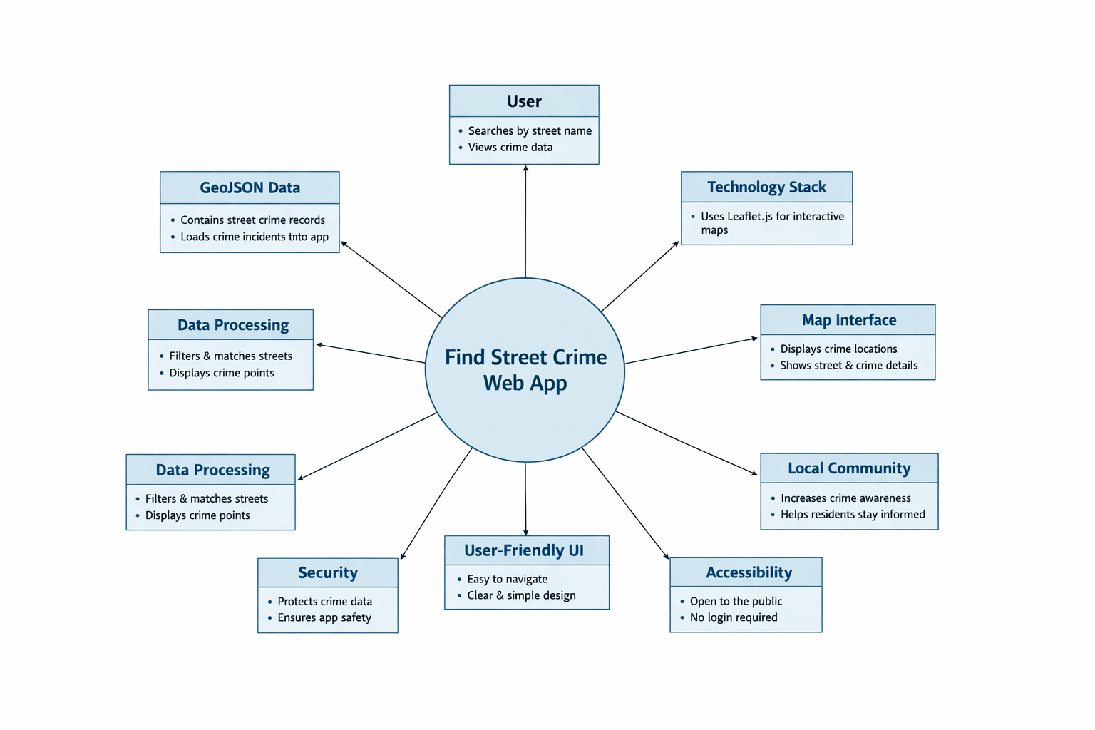
Figure 1. Context diagram for the Find Street Crime web app.

Test Plan
Use-Case ID | Requirement ID | Test Case | Status
UC1 | FR1, FR3 | Search by street name returns matching results. | Pass
UC1 | FR2, FR4 | Matching incidents are displayed as markers on the map. | Pass
UC2 | FR5, FR6, FR7 | Clicking a marker displays a popup with street name and crime category. | Pass
UC1 | FR8 | Partial street-name search returns relevant matches. | Pass
UC3 | FR3 | GeoJSON dataset loads successfully when the app starts. | Pass
UC1 | NFR1, NFR2 | Search results display within a reasonable time. | Pass
UC1 | NFR3, NFR4 | Application is usable in a web browser across different screen sizes. | Pass
UC2 | NFR5 | Map remains interactive while viewing results and popups. | Pass

Test descriptions

Search by Street Name
Field | Content
Description | Enter a street name and verify that matching crime incidents are displayed.
Prerequisites | GeoJSON crime data is loaded successfully.
Test data | A street name that exists in the dataset.
Expected result | Matching incidents appear as markers on the map.

Marker Popup Details
Field | Content
Description | Click a displayed marker and verify the popup information.
Prerequisites | Search results are visible on the map.
Test data | Any displayed marker.
Expected result | The popup shows the correct street name and crime category.

Search with No Matching Result
Field | Content
Description | Enter a street name that does not exist in the dataset.
Prerequisites | GeoJSON data is loaded.
Test data | An invalid or non-existent street name.
Expected result | No matching markers are displayed.

Responsive Layout Test
Field | Content
Description | Verify that the interface remains usable on different screen sizes.
Prerequisites | Application is accessible in a browser.
Test data | Desktop and mobile-sized browser views.
Expected result | The search area and map remain readable and usable.

Requirements Traceability Matrix
Requirement ID | Description | Use-Case ID
FR1 | Search by street name. | UC1
FR2 | Display incidents on an interactive map. | UC1
FR3 | Load crime data from a GeoJSON file. | UC3
FR4 | Display markers for matching incidents. | UC1
FR5 | Show popup on marker click. | UC2
FR6 | Display street name in popup. | UC2
FR7 | Display crime category in popup. | UC2
NFR4 | Responsive layout across devices. | UC1

