AUDEX LOGISTIC LABS
Intelligence in Motion
WEBSITE COPY — VERSION 2 | PRODUCTION DRAFT

This is the revised, designer-ready website copy for Audex Logistic Labs. Each section includes UI structure instructions (marked ↳ UI) to support direct handoff to designers and developers.
Diagrams sourced from product PPTs are embedded in the relevant product sections — exactly as modern enterprise SaaS websites include them.

PAGE 1 — HOMEPAGE

SECTION: HERO
[Designer note: Full-width dark section. Left: text + CTAs. Right: animated supply chain network graphic. Bottom: trust logo strip. Background: deep navy with subtle moving node-line animation.]
↳ UI: Left column (60%): eyebrow label → headline → subhead → CTA buttons | Right column (40%): animated SVG logistics network | Below fold: scrolling client logo strip
EYEBROW
India's Enterprise Supply Chain Intelligence Company
Your Logistics Is Bleeding Revenue.
We Find the Leak. We Seal It.
Audex connects two decades of on-the-ground supply chain expertise with a purpose-built intelligence platform — giving enterprise operations the visibility, control and cost discipline they've never had before.
▶ Book a Free Diagnostic
[ See the Freight Audit Platform → ]

SECTION: TRUST METRICS BAR
[Designer note: Four-column stat strip. Dark background. Numbers large. Labels small. No borders — just spacing.]
↳ UI: 4-column horizontal strip: big number top, label below | Subtle dividers between columns
3–8%  Freight spend recovered per client | 41%  Cost reduction — real client data | 94%  Shipment ETA accuracy | 20+ Yrs  Operator depth before any algorithm

SECTION: THE PROBLEM
[Designer note: Light section. Left-aligned. Two-column layout: text left, visual metaphor right (e.g., money leaking from a supply chain diagram).]
↳ UI: Text-heavy left column | Right column: simple SVG showing leak/drain metaphor | 3 pain-point cards below in a grid
Most logistics budgets look fine on paper.
The P&L tells a different story.
Because logistics is a small percentage of total revenue, it rarely gets the scrutiny it deserves. And that's precisely why it quietly drains 3–8% of freight spend — through billing errors, wrong transporter choices, under-filled trucks and SLA failures that teams have simply learned to absorb.
India's logistics cost sits at 14% of GDP — nearly double the global average of 8%. That gap is not infrastructure. It's operational inefficiency. Audex exists to close it.

SECTION: WHO WE ARE (BRIEF)
[Designer note: Compact 3-pillar card strip. White background. Each pillar: icon + title + one sentence. No long paragraphs here.]
↳ UI: 3 equal cards side by side: icon top, bold title, one-line description | Below: two trust badges (GST-ready, SaaS & On-Prem)
Operator-grade. Intelligence-led.
We are not a platform looking for a use case. Audex was built by practitioners who spent two decades inside India's most demanding supply chains — before writing a single line of code.
CONSULTING · TECHNOLOGY · INTELLIGENCE
Three capabilities. One integrated platform. Every module deploys independently — and becomes smarter the moment your second one goes live.

SECTION: FLAGSHIP PRODUCT (MARGA DARSHAK CALLOUT)
[Designer note: Dark feature banner. Full-width. Left: product name + one-liner + CTA. Right: key outcome stat. Background: navy with subtle grid.]
↳ UI: Split banner: left text, right large metric number | Below: small 'explore full platform' link
Marga Darshak®
Intelligent Transportation Orchestration.
From order to POD — one platform that eliminates manual dispatch decisions, maximises truck fill rates and automates freight billing across every LSP.
Real client result: ₹30.84 Lakh saved in a single month. 41.3% freight cost reduction.
▶ Explore Marga Darshak →
[ See All Products → ]

SECTION: INDUSTRIES (STRIP)
[Designer note: Horizontal scrolling chip/badge row on mobile. 6-column grid on desktop. Each chip: industry name. Click goes to vertical page.]
↳ UI: Chip/tag style horizontal strip — Pharma · Retail · Manufacturing · E-Commerce · LSP · Garments · Automotive | Hover reveals one-line descriptor
Built for the way each industry actually runs.
- Pharma & Nutraceuticals — Cold-chain integrity, compliance, distributor visibility
- Retail & Consumer Goods — Multi-location inventory, real-time stock intelligence
- Manufacturing — Inbound vendor networks, production coordination, outbound distribution
- E-Commerce — Catalogue-to-last-mile, carrier selection, reverse logistics
- Logistics Service Providers — The only ERP built logistics-first
- Garments & Apparel — Seasonal demand, multi-warehouse, export logistics
- Automotive — JIT supply chains, spare parts, multi-tier supplier coordination

SECTION: WHO WE HELP
[Designer note: Role-based card section. 4 cards. Each: role title, quoted pain, one-line Audex answer, CTA. Light background. Clean grid.]
↳ UI: 2×2 card grid. Card: role label (bold) → italic quote → answer → CTA link | Cards have subtle border/shadow
Your role. Your problem.
The answer isn't always the same.
CFO / Finance Leader
"How much are we being overcharged on freight? Honestly — I have no idea."
Audex audits every freight invoice against contracted rates. Clients recover 3–8% of annual freight spend within 90 days — with a clean audit trail finance teams can actually use.
[ Get a Free Freight Audit ROI Estimate → ]
Supply Chain Head
"I'm managing SLA fires every day. I need real control, not another dashboard."
Real-time network intelligence, predictive dispatch planning and automated transporter performance management — across every lane, depot and last-mile partner.
[ Request a Supply Chain Diagnostic → ]
CEO / Founder
"My team says logistics is fine. My margins say something very different."
An independent, expert-led review of your entire supply chain — quantified in rupees, fixed without disrupting live operations.
[ Find Out What Logistics Is Really Costing You → ]
Internal Auditor
"Freight billing is too complex. My team can't audit what they can't decode."
Automated invoice validation, real-time exception surfacing, audit-ready reports — no logistics expertise required from your team.
[ See the Freight Audit Platform → ]

SECTION: TESTIMONIALS
[Designer note: 3-card testimonial strip. Light grey background. Each: quote (italic), name, title, company. Subtle card styling.]
↳ UI: Horizontal card strip (3 cards) | Quote in italic large text | Attribution below | Company logo space on right
"Audex's billing application manages our invoicing for ocean freight forwarding, contract logistics and transportation. Integrated on web services, it delivers customised, high-quality service."
— Asst. General Manager — IT | Yusen Logistics India Pvt. Ltd.
"The customised reverse logistics tracking and transportation application is highly recommended to LSP and LSU organisations. Team Audex has shown tremendous strength in implementation and support."
— CEO | Delex Cargo India Pvt. Ltd.
"Audex is our systems integrator and GPS applications vendor of choice on a pan-India basis. The solution has significantly reduced our transportation management queries."
— Asst. Vice President | ILFS Transportation Networks Ltd.

SECTION: HOMEPAGE FINAL CTA
[Designer note: Full-width dark CTA block. Centred. Large headline. One primary CTA, one secondary. No distractions.]
↳ UI: Dark navy band, full width | Headline centred | Two buttons: primary (filled) + secondary (outline)
Your logistics is costing more than you know.
Twenty minutes. One conversation. We'll show you exactly where the money is going — and what it takes to recover it.
▶ Book My Free Diagnostic
[ Or start with a Freight Audit Assessment → ]

PAGE 2 — ABOUT US

HERO
[Designer note: Dark hero. Text left. Abstract visual right — network of nodes representing connected supply chains.]
↳ UI: Left: headline + 2 sentences | Right: abstract SVG visual | Below: 3 anchor links to sections: Story / Leadership / Values
Built by Operators.
For the enterprises they know best.
Audex was built because its founders spent two decades watching good enterprises haemorrhage money their logistics teams didn't know existed. That frustration became a company.

OUR STORY
[Designer note: Single column. Conversational, not corporate. 3 short paragraphs max.]
Our founders spent 20+ years inside the messiest parts of Indian supply chains — implementing, troubleshooting and rebuilding logistics networks across Retail, Pharma, Textiles and Manufacturing.
They saw the same story everywhere: enterprises running on outdated frameworks, absorbing inflated freight bills as a cost of doing business, and treating SLA failures as a permanent operational condition.
Nobody was fixing the root cause. So they built Audex — not as software, but as a practice. One that diagnoses before it prescribes, and builds solutions that keep improving over time.
"We built Audex to put domain expertise and technology to work on the real problem — not to pitch software, but to find the leaks and permanently seal them."
— Mitesh Bhandari, Co-Founder & CEO

MISSION & VISION
[Designer note: Two-column card layout. Mission left, Vision right. Clean, minimal.]
↳ UI: 2-column: Mission card (left) | Vision card (right) | Each: label + 2 sentences
MISSION
Diagnose, fix and future-proof enterprise logistics — with intelligence at the core. TMS, WMS and Freight Audits unified so supply chains start creating competitive advantage.
VISION
India's most trusted supply chain orchestration platform. Reducing logistics spend from 14% to 8% of GDP — one enterprise at a time.

PHILOSOPHY
[Designer note: Single bold statement + 4 short cards. Not a wall of text.]
↳ UI: Large italic headline | 4 horizontal cards below: title + one sentence each
We diagnose before we prescribe.
Audex works the way a specialist doctor approaches a patient — rigorous diagnosis before any recommendation. No standard templates. No generic playbooks.
- Diagnose first — no solution is proposed without a complete picture
- Treat root causes — quick fixes damage the system long-term
- Build immunity — solutions designed so problems do not return
- Customise everything — no two supply chains are the same; neither are our solutions

VALUES (BRIEF)
[Designer note: 5-item horizontal strip or icon+label grid. Minimal. One line per value.]
↳ UI: Icon + title + one sentence. 5 items. Horizontal on desktop, stacked on mobile.
- Domain depth over shortcuts — operator experience before any algorithm, every time
- Customisation as standard — built around your supply chain, not ours
- Radical transparency — we show exactly what is leaking and what it costs to fix
- Technology with purpose — every feature must earn its place by solving a real problem
- Mission-aligned growth — tied directly to India's National Logistics Policy goals

LEADERSHIP
[Designer note: Two founder cards. Photo + name + title + 3-bullet bio + LinkedIn. Horizontal on desktop.]
↳ UI: 2-column card. Each: photo placeholder (left) + bio (right). LinkedIn button. Clean white card on light grey background.
Two founders. Two perspectives. One shared conviction.
VISHWESH PAKHARE — Co-Founder & CTO
- 23+ years as Techno-Functional expert, blockchain and supply chain
- Led end-to-end implementations in freight audit, warehouse technology and logistics transformation
- Architect of platforms that connect primary-to-last-mile logistics across complex multi-stakeholder networks
MITESH BHANDARI — Co-Founder & CEO
- Scaled a retail distribution network from 20 to 700+ outlets — hands-on in inventory, logistics and last-mile
- LP in Multiples Alternate Asset Management and Pi Ventures
- Chief Secretary, JITO Incubation & Innovation Foundation
[Designer note: Replace photo placeholders with professional headshots before publishing. Add LinkedIn profile links.]

PAGE 3 — PRODUCTS & TECHNOLOGY

PAGE INTRO
[Designer note: Dark hero with product module icons arranged in a connected platform diagram. Text minimal.]
↳ UI: Hero: headline + subhead | Below: visual platform map showing TMS → WMS → Freight Audit → Analytics → AI Layer, all connected
A modular enterprise stack.
Every module works standalone. Every module works better together.
Cloud or on-premises. No rip-and-replace. Deploy what you need now — and scale into the full platform as your operations demand.

PRODUCT 1 — MARGA DARSHAK (TMS)
[Designer note: Product hero: dark left panel with product name + tagline. Right: product screenshot or platform diagram (use Marga Darshak AS-IS flow from PPT).]
↳ UI: Split layout: Left = dark panel with name/tagline/outcome stat | Right = embedded architecture diagram | Below: capability grid (3×2 cards)
Marga Darshak®
Intelligent Transportation Orchestration.
Sanskrit for Pathfinder. Marga Darshak eliminates manual dispatch decisions, maximises truck fill rates, automates freight billing and tracks every shipment from order to POD — across 25+ LSPs simultaneously.

ARCHITECTURE DIAGRAM — INCLUDE IN PRODUCT PAGE
[Designer note: INCLUDE THIS DIAGRAM on the Marga Darshak product page. It clearly shows the end-to-end platform flow and is the kind of architecture visual modern SaaS product pages use.]
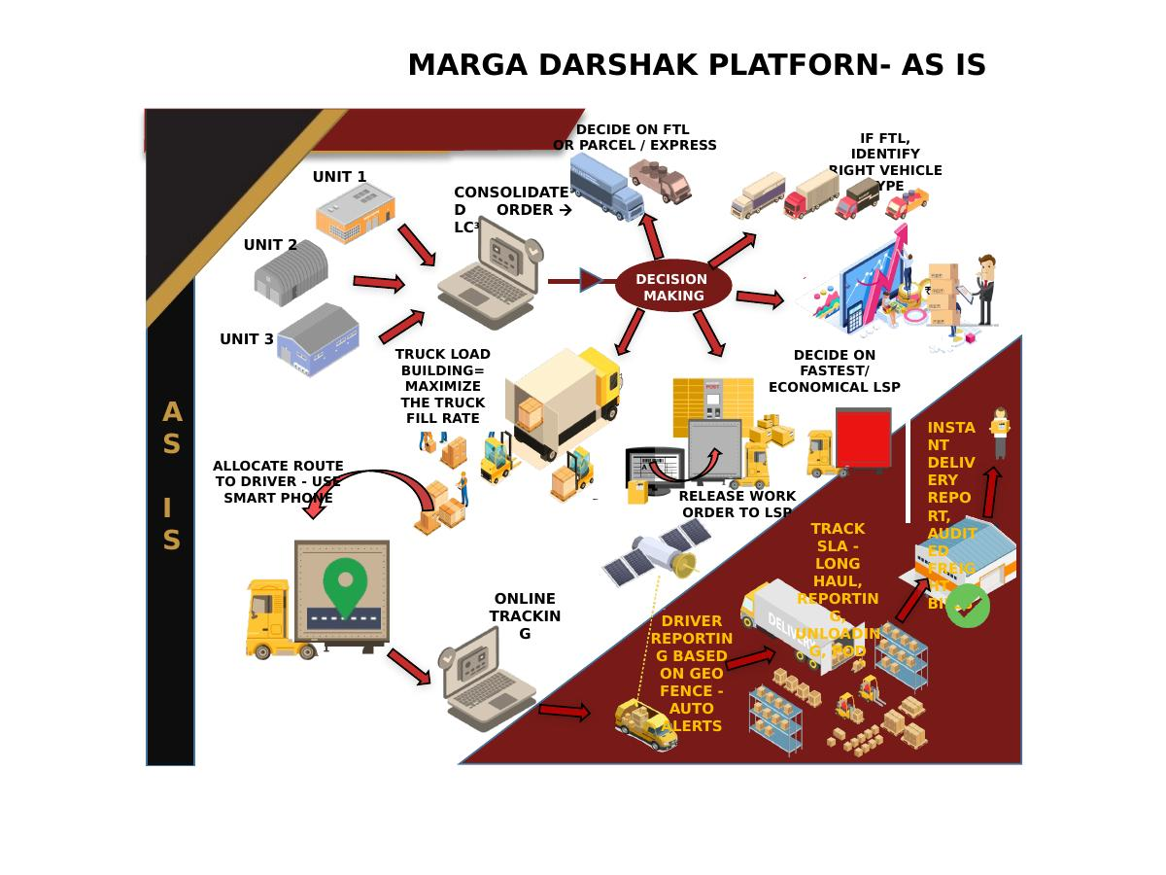
[Designer note: Caption: 'Marga Darshak Platform — End-to-End Transportation Orchestration Flow']

KEY CAPABILITIES — MARGA DARSHAK
[Designer note: 6-card capability grid. Each card: bold title + 2-line description. No bullet walls.]
↳ UI: 2×3 or 3×2 card grid. Icon + title + 2 sentences per card. Light background.
Intelligent LSP Selection
Evaluates all rate contracts and selects the most economical or fastest transporter for every consignment. Decision time: under 5 minutes for 100 pick slips.
Load Consolidation (LC3)
Clubs multiple orders for the same destination under a single LR — maximising truck fill rate and cutting per-unit freight cost.
Automated eWaybill Generation
Batch eWaybill generation via GSP API. 100+ invoices processed in under 10 minutes. GST-compliant. No manual entry.
Real-Time SLA Tracking
End-to-end tracking across pickup → long haul → delivery → POD. Geo-fence alerts. Automatic SLA breach flags before customers notice.
Freight Bill Automation
Invoices generated on POD, validated against contract rates, pushed through approval hierarchy — with reverse integration to Oracle/SAP financials.
Multi-LSP Management
Manages 25+ LSPs simultaneously — forward and reverse logistics, performance scoring, spot-buying, claim settlement and demurrage automation.

CASE STUDY CALLOUT — MARGA DARSHAK
[Designer note: Two outcome stat cards side by side. Use real numbers. Dark background.]
₹30.84L  Saved in one month — Fashion Retailer | 41.3%  Total freight cost reduction | 33%  Daily transport cost cut — Fortune-500 FMCG | ₹3.70 Cr  Projected annual savings (single lever)
▶ Request a Marga Darshak Demo →

PLATFORM ARCHITECTURE DIAGRAM — 4PL OVERVIEW
[Designer note: INCLUDE THIS DIAGRAM on the platform overview / 'How It Works' section. Shows the full Audex 4PL ecosystem — TMS, WMS, Vendor Portal, LSP Dashboard, Analytics, AI layer.]
↳ UI: Full-width diagram section. Title: 'The Audex Platform Architecture'. Diagram below. Caption text beneath.
The Audex Platform — How It Connects.
From vendor portal to LSP dashboard to analytics layer — a single orchestration platform connecting every node in your supply chain.
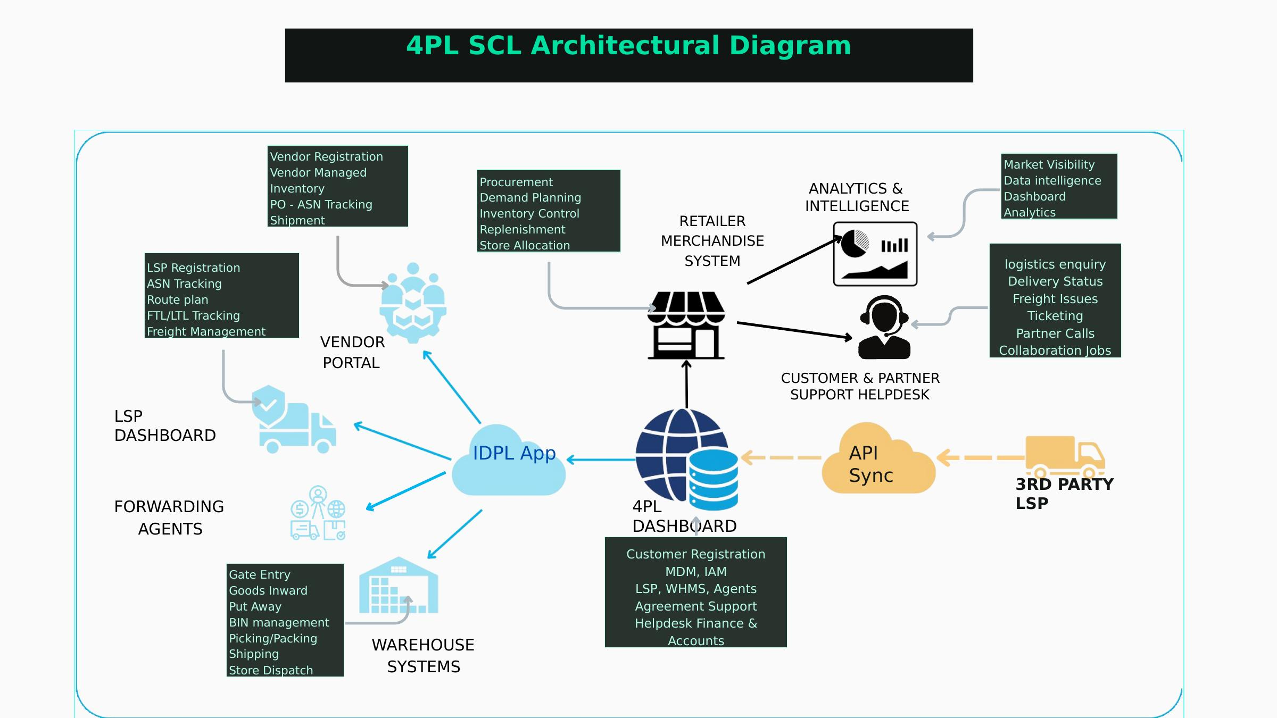
[Designer note: Caption: 'Audex 4PL Supply Chain Orchestration Architecture — TMS, WMS, Analytics, API Integrations']

PRODUCT 2 — FREIGHT AUDIT PLATFORM
[Designer note: Product card with outcome metrics prominent. Shorter than Marga Darshak — this is a supporting product page.]
Freight Audit Platform.
Every invoice. Every overcharge. Every rupee recovered.
Validates 100% of freight invoices against contracted rates — not a sample. Flags billing discrepancies, quantifies SLA breaches and generates audit-ready reports that finance teams can act on without needing logistics expertise.
3–8%  Annual freight spend recovered | 90 days  Typical time to first recovery | 100%  Invoice coverage — no sampling
▶ Book a Freight Audit Assessment — Free ROI Estimate →

PRODUCT 3 — WMS
Warehouse Management System.
From chaotic receipts to intelligent fulfilment.
Multi-client WMS with predictive replenishment intelligence. Covers gate entry, put-away, BIN management, picking/packing and dispatch — with real-time inventory deduction and full 3PL-ready architecture.
- Multi-location, multi-client, 3PL-ready from day one
- Intelligent replenishment triggers based on real consumption patterns
- Native integration with Marga Darshak for seamless dispatch continuity
▶ Explore the WMS →

PRODUCT 4 — ERP FOR LOGISTICS
ERP for Logistics.
Built logistics-first. Not adapted.
Finance, operations and compliance in one system — with an intelligence layer that surfaces operational insights automatically. Built specifically for LSPs, 3PLs and enterprises with complex freight structures.
▶ Request an ERP Demo →

PRODUCT 5 — POD & LAST-MILE
POD & Last-Mile.
Gate-to-doorstep visibility. Zero manual follow-up.
Digital proof-of-delivery, exception management, reverse logistics orchestration and customer-facing delivery status — from dispatch to confirmation.
▶ Explore Last-Mile Solutions →

AUDEX LABS — INTELLIGENCE LAYER
[Designer note: Feature grid section — not a full page. 6 model cards in a 2×3 grid. Each: model name + one-line description. Positioned as 'what powers everything else'.]
↳ UI: Dark background. Grid of 6 cards. Each: number (01–06) + model name + one sentence + outcome stat where available.
Audex Labs.
The intelligence layer powering every product.
Six production models, co-built with the operators who use them. Not theoretical AI. Systems that perform on the real-world operational day.
01 Predictive ETA — 94% accuracy
Forecasts multimodal arrival times in real time. Fewer missed SLAs. Fewer reactive calls.
02 Dynamic Freight Pricing
Rate intelligence across millions of lane transactions. Every shipment priced with data, not gut instinct.
03 Autonomous Routing
Balances cost, carbon and SLA simultaneously. Routing decisions in seconds, not hours.
04 Document Intelligence
Automated extraction across Bills of Lading, freight invoices and customs documents.
05 Cargo Vision
Computer-vision quality and damage detection at warehouse intake. Exceptions flagged before they become claims.
06 Marga Co-Pilot
Ask your supply chain anything in plain language. Get answers that drive decisions.

PAGE 4 — CONSULTING SERVICES

PAGE INTRO
[Designer note: Two-service page. Introduce the consulting philosophy first (2 sentences), then the two services as distinct sections.]
Operator-led advisory. Measurable outcomes.
Two practices. Both designed to pay for themselves quickly. Both delivered by practitioners — not analysts working from benchmarks.
Every engagement starts with a diagnostic. No prescription without a diagnosis.

SERVICE 1 — SUPPLY CHAIN CONSULTING
Supply Chain Consulting.
Expert diagnosis. Structured intervention. Permanent improvement.
We have solved real supply chain problems for real enterprises — across retail, pharma, textiles and manufacturing. That experience is what separates a consulting report from a consulting result.
WHAT WE DO
- Supply chain network design — warehouse locations, LSP mix, distribution routes
- Process optimisation — cost reduction across procurement, transport, warehousing and inventory
- Technology selection and implementation — right tools for your specific supply chain
- Resilience and risk management — supplier diversification, contingency frameworks, real-time risk monitoring
- Benchmarking and diagnostics — compare performance against industry standards, then build an improvement programme
HOW AN ENGAGEMENT WORKS
- Weeks 1–2: Diagnostic — map the current state, identify cost drivers, quantify the bleed
- Weeks 3–4: Findings — evidence-backed picture of what's working, what isn't, what it costs
- Weeks 5–8: Intervention — prioritised roadmap with measurable targets and implementation support
- Ongoing: Review — quarterly check-ins to track progress and adapt
▶ Request a Supply Chain Diagnostic →

SERVICE 2 — FREIGHT & LOGISTICS AUDIT
Freight & Logistics Audit.
Forensic billing intelligence. Systematic recovery.
Most enterprises are being overcharged on freight — systematically, at scale, without their knowledge. Transporters bill beyond contract rates. SLA penalties go unclaimed. Because logistics is a small P&L line, the overcharges accumulate undetected.
WHAT THE AUDIT COVERS
- Freight bill validation — every invoice against contracted rates and surcharges
- SLA breach documentation — every missed window, late pickup and dwell-time violation
- Contract gap analysis — rate card anomalies and renewal risk
- Transporter performance profiling — billing accuracy and SLA adherence scoring
- Recovery programme management — structured dispute resolution with full documentation
3–8%  Annual freight spend recovered | 90 Days  Typical time to first recovery | $2M+  Annual savings — FMCG client engagement
▶ Book a Freight Audit Assessment — Free ROI Estimate →

PAGE 5 — INDUSTRY VERTICALS

PAGE INTRO
[Designer note: Industry selector page. 7 industry tiles in a grid. Click expands or links to subpage. Each subpage is concise — not a brochure.]
↳ UI: 7-tile grid (or horizontal scrollable row on mobile). Each: icon + name + hover descriptor | Click → industry subpage
Purpose-built for each industry.
Not adapted from generic platforms. Each solution was built from operator experience inside that industry. The difference shows.
Pharma & Nutraceuticals
Cold-chain compliance, serialisation, distributor traceability — without compromising freight cost control.
[ Talk to a Pharma Logistics Specialist → ]
Retail & Consumer Goods
Multi-location inventory visibility, intelligent replenishment and freight discipline for margin-sensitive retail operations.
[ Request a Retail Logistics Assessment → ]
Manufacturing
Inbound vendor networks, production-aligned dispatch and outbound distribution — with full ERP integration.
[ Explore Manufacturing Logistics Solutions → ]
Logistics Service Providers
The only ERP built logistics-first. Finance, operations and compliance in one system.
[ Talk to an LSP Solutions Specialist → ]
E-Commerce
Carrier selection, last-mile tracking, returns orchestration and freight audit — for the pace online retail demands.
[ Explore E-Commerce Logistics Solutions → ]
Garments & Apparel
Seasonal demand planning, multi-warehouse visibility and export logistics — with zero margin for delay.
[ Talk to a Garments Logistics Specialist → ]
Automotive
JIT supply chains, spare parts distribution and multi-tier supplier coordination — precision-grade.
[ Explore Automotive Logistics Solutions → ]

PAGE 6 — CASE STUDIES

PAGE INTRO
Results, not claims.
Every engagement here is drawn from real client operations. Numbers are unembellished.

CASE STUDY 1 — BRANDED FASHION RETAILER
[Designer note: Case study card format. Logo placeholder left. Summary stats right. Detail below in 3 paragraphs: Profile → Problem → Result.]
↳ UI: Hero metric strip (3–4 stats) | Below: 3-column text: Client Profile | Problem | What We Did | Result
41% Freight Cost Reduction — Leading Fashion Retailer
5 Regional Distribution Centres · 25 LSPs · 12,000 distributors · 40,000+ LRs/month
THE PROBLEM
Transporter selection was entirely manual. No mechanism to evaluate all available rate contracts simultaneously, club shipments for the same destination, or benchmark decisions against historical performance.
THE INTERVENTION
Marga Darshak deployed across all 5 RDCs. LSP optimisation algorithm activated (Lever 2 only — load consolidation not yet deployed).
THE RESULT — One Month Snapshot
₹74.63L  Freight — customer-selected LSP | ₹43.78L  Freight — Marga Darshak recommended | ₹30.84L  Monthly savings | 41.3%  Cost reduction
Annual projected savings with one lever: ₹3.70 Crore. Full platform activation expected to deliver substantially higher savings.
[ Request a Similar Assessment → ]

CASE STUDY 2 — FORTUNE-500 FMCG MNC
33% Daily Transport Cost Reduction — Fortune-500 FMCG
3 manufacturing units · 6 tonnes of FMCG products daily · Pan-India distribution
THE PROBLEM
Three 9-tonne trucks at ₹30K each dispatched daily. No load-building intelligence. Empty truck space a fixed, unmeasured cost.
THE RESULT
3 → 2  Trucks daily after LC3 optimisation | ₹30K  Direct daily cost eliminated | 33%  Immediate transport cost reduction
Achieved with Levers 1 and 4 only partially activated.
[ Talk to Us About Load Optimisation → ]

CASE STUDY 3 — FMCG SUPPLY CHAIN REDESIGN
$2M+ Annual Savings — FMCG Supply Chain Redesign
Large FMCG enterprise with complex national distribution — over-invested in warehouse capacity to compensate for inefficient freight routing.
THE INTERVENTION
Audex redesigned the network — right-sized warehouse locations, rationalised the LSP panel, restructured primary freight routes. Warehousing and transport treated as an integrated system, not separate cost lines.
$2M+  Annual savings delivered | Ongoing  Retained advisory and monitoring

PAGE 7 — INSIGHTS

PAGE INTRO
[Designer note: Blog listing page. Card grid. Each card: title, 2-line description, 'Read the full article' link.]
↳ UI: 2-column card grid. Each card: category tag + title + 2-sentence description + 'Read article →' link | No author photo needed — Audex brand
Operator-grade thinking.
Analysis and perspective from the Audex team — on supply chain strategy, logistics technology and the operational decisions that shape enterprise margins.

The 3–8% Nobody Is Talking About
How freight billing errors quietly drain enterprise margins — and what a structured audit programme actually recovers.
Read the full article →
What 41% Freight Cost Reduction Actually Looks Like
A detailed breakdown of one of India's largest fabric retailers achieving a 41.3% cost reduction in a single month — the data, the method and the levers activated.
Read the full article →
India's 14% Problem — What NLP 2022 Means for Every CFO
India's logistics cost gap is not an infrastructure problem. It's an operational efficiency problem — and it lives on your P&L.
Read the full article →
Why AI in Logistics Keeps Underdelivering
The issue is rarely the technology. It's the absence of operator-grade domain expertise informing how models are built and deployed.
Read the full article →
The Internal Auditor's Guide to Freight Billing
A practical framework for finance and audit teams who want systematic control of freight spend — without becoming logistics experts.
Read the full article →
Cold Chain or Cost Chain? The Hidden Trade-Off in Pharma Logistics
Pharmaceutical enterprises often accept inflated freight costs as the price of compliance. The data shows a different path.
Read the full article →

PAGE 8 — CAREERS

HERO
[Designer note: Minimal page. Premium, not corporate. Mission-forward.]
↳ UI: Dark hero: headline + 2 sentences | Below: 3 'what we look for' cards | Below: open roles (or link to jobs board)
Build the intelligence layer of India's supply chain.
Audex operates at the intersection of deep domain expertise, enterprise software and supply chain consulting. We're solving one of the most consequential problems in Indian business.

We value operators first. People who've worked inside the problems they want to solve. Whether your background is logistics, finance, software or consulting — instinct matters more than credentials here.
CURRENT FOCUS AREAS
- Backend & Data Engineers — enterprise systems, logistics data pipelines, ML models
- Supply Chain Consultants — 3+ years implementation or advisory experience
- Freight Audit Specialists — billing, contract management or procurement background
- Enterprise Sales — complex B2B logistics or SCM sales experience
- Customer Success — enterprise software implementation and adoption
▶ View Open Positions →
[ Send a Speculative Application → ]
Audex is an equal opportunity employer.

PAGE 9 — CONTACT

HERO
[Designer note: Clean, focused page. 3 contact options as cards. No form overload. Genuine conversation framing.]
↳ UI: Dark intro band: headline + subhead | Below: 3 contact option cards side by side | Bottom: address + email
Let's begin with a diagnostic.
Not a sales call. Not a product demo. A genuine conversation about your logistics operations — where the costs are, where the control gaps exist and what a realistic improvement looks like.

BOOK A SUPPLY CHAIN DIAGNOSTIC — FREE
A 45–60 minute structured conversation with an Audex expert. We map your logistics structure, identify likely cost drivers and give you a clear picture of what an engagement might recover — before you commit to anything.
▶ Book a Diagnostic →
START A FREIGHT AUDIT ASSESSMENT
Tell us your annual freight spend. We'll estimate what a structured audit typically recovers for operations at your scale — using real client data.
▶ Get a Free ROI Estimate →
REQUEST A PLATFORM DEMO
See Marga Darshak or the Freight Audit Platform in a live demonstration — using your own logistics scenarios.
▶ Request a Demo →

AUDEX LOGISTIC LABS PRIVATE LIMITED
mitesh@audexglobal.com | vishwesh@audexglobal.com | www.audexglobal.com
[Designer note: Add registered address, phone number and Google Maps embed before publishing.]

APPENDIX — NAVIGATION & CTA LIBRARY

Navigation Structure
- Home
- About Us → Story · Mission & Vision · Leadership · Values
- Products → Marga Darshak · WMS · Freight Audit Platform · ERP for Logistics · POD & Last-Mile · Analytics · Audex Labs
- Consulting → Supply Chain Consulting · Freight & Logistics Audit
- Industries → Pharma · Retail · Manufacturing · E-Commerce · LSP · Garments · Automotive
- Case Studies
- Insights
- Careers
- Contact

CTA Copy Library
HIGH-INTENT
- Book a Free Supply Chain Diagnostic →
- Start a Freight Audit Assessment — Free ROI Estimate →
- Request a Marga Darshak Demo →
- Find Out What Your Logistics Is Really Costing You →
PRODUCT EXPLORATION
- Explore Marga Darshak →
- See the Freight Audit Platform →
- Explore the Intelligence Layer →
- View Platform Architecture →
INDUSTRY / CONSULTING
- Talk to a [Industry] Logistics Specialist →
- Request a [Industry] Logistics Assessment →
NURTURE
- Read the Case Study →
- Download the Product Overview →
- Connect with a Specialist →

AUDEX LOGISTIC LABS PRIVATE LIMITED
Intelligence in Motion
www.audexglobal.com

