**The Battle of Neighbourhoods**

**IBM Applied Data Science Capstone**

***Identifying the Better Location to Open a Hotel/Resort in Visakhapatnam, Andhra Pradesh, India***

By: Rama Kishore Darlapudi

December 2019

***The city of Destination, Vishakhapatnam, Andhra Pradesh, India***

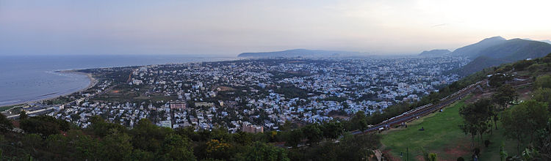

**Introduction**

Vishakhapatnam is one of the fastest growing tire2 cities in Andhra Pradesh and it is named as city of destination for its unique attraction towards the tourism. Since the city is expanding at a faster phase and the tourism has increased a lot in the past 3 to 4 years the city is struggling to provide the accommodation to the increasing tourists at a faster phase. The accommodations are concentrated at a given place and so the commutation is another important aspect to consider while opening a new hotel or resorts. Since the city is on the shore of Bay of Bengal the demand for the beach resorts is also increasing in the recent years. The infrastructure developers also struggling to know the best places to start hotels and resorts which are going to be success in terms of services and getting the better business deals. Also, the city is small in terms of areas and lot of other places in and around this city are also have good places to visit and have a peaceful holiday and vacations.

**Business Problem**

The key objective of this study is to analyze and identify the best locations in Visakhapatnam city to start a new hotel or resort. Provide a solution to this problem by using tools and techniques of data science and advanced machine learning algorithms and provide insights to the local government officials and infrastructure develops to identify the best locations to improve the hotels and resorts to meet the demand for emerging tourism destination.

**Benefited Parties**

This project is mainly helping the government officials and infrastructure developers to identify the better locations not only in the Visakhapatnam city but also the places which are close by and safe to the tourists in terms of commutation, safety and reachability to various places of interest.