Creating the SQL database In Azure portal:

* Go to Azure portal --->type SQL database---->create a database

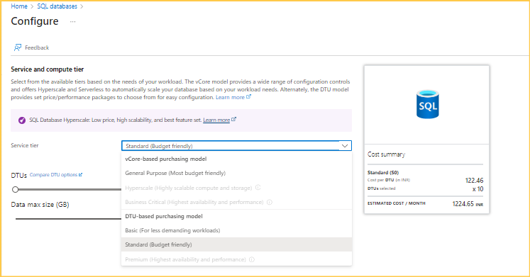

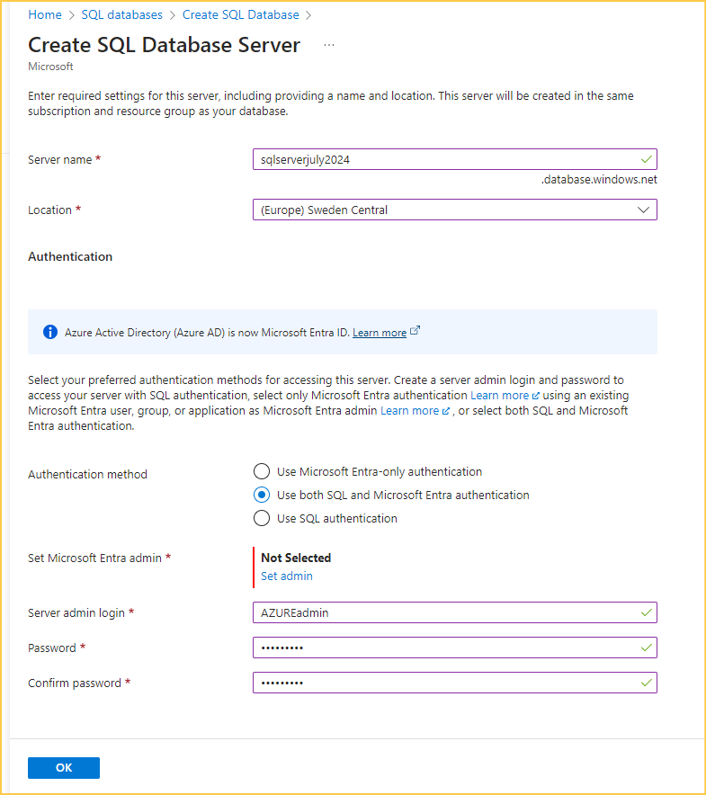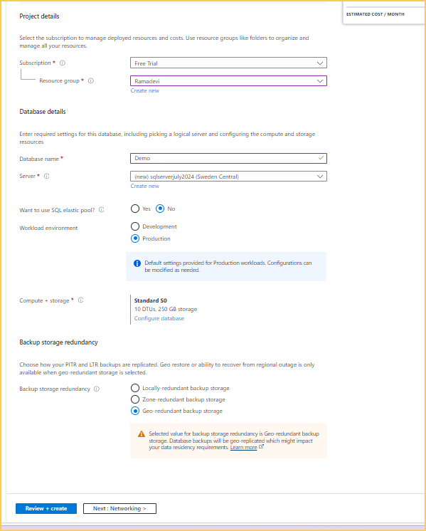

* Review and create

**Connecting the server to the SSMS**

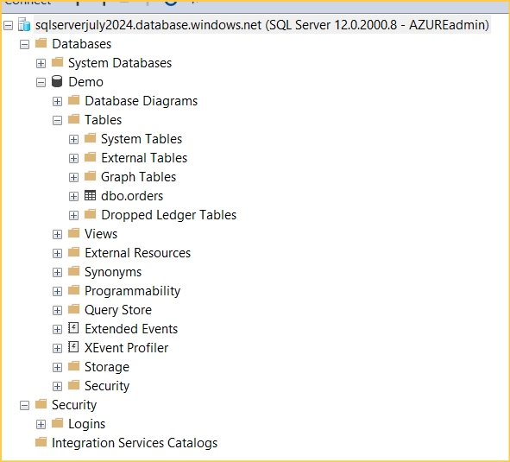

Backups and restore

* Automatic backups
* Manual backups

Backup retention:

* Based on the different service tiers backup retention may vary
* For basic service tiers---7 days
* For standard and premium service tiers---35 days (about 1 month 4 and a half days)
* We change it by using the long-term retention up to 10 years

**Configuring the long-term backup retentions for Azure SQL database**

**Automatic Backups**

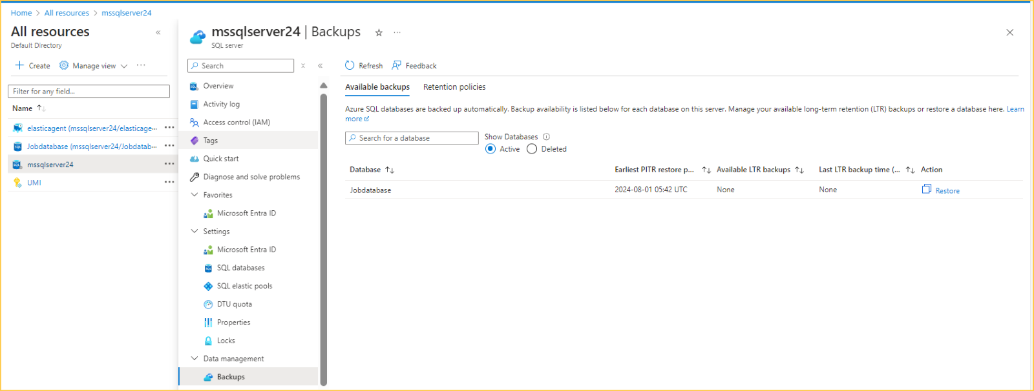

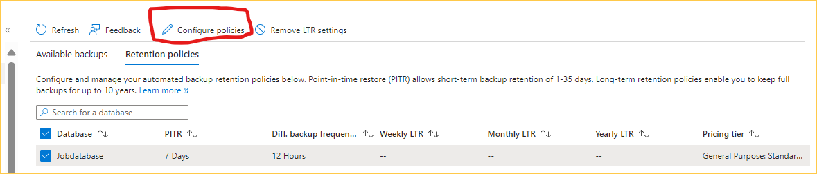

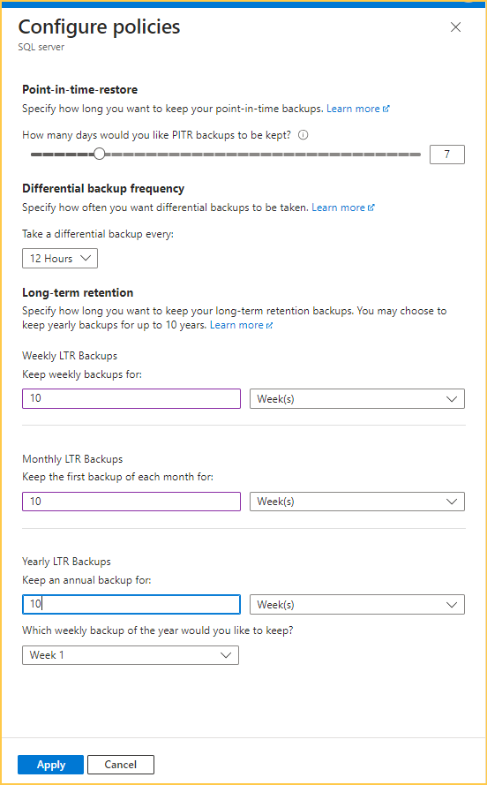

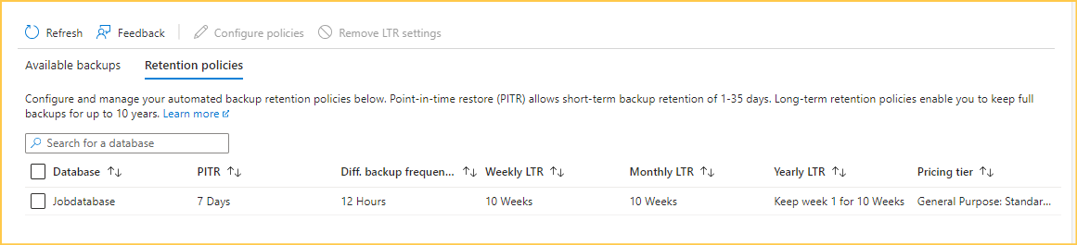

Manual backups:

Backing up an Azure SQL Database Using SQL Server Management Studio (SSMS)

* Connect the Azure SQL database with SSMS
* Taking back up to azure storage account

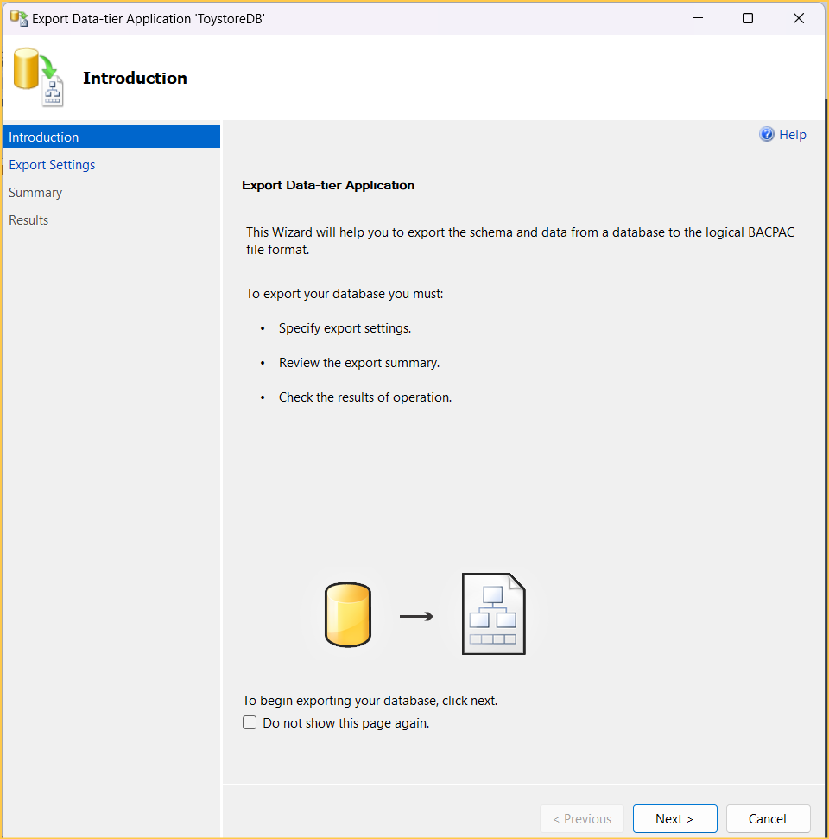

Click next

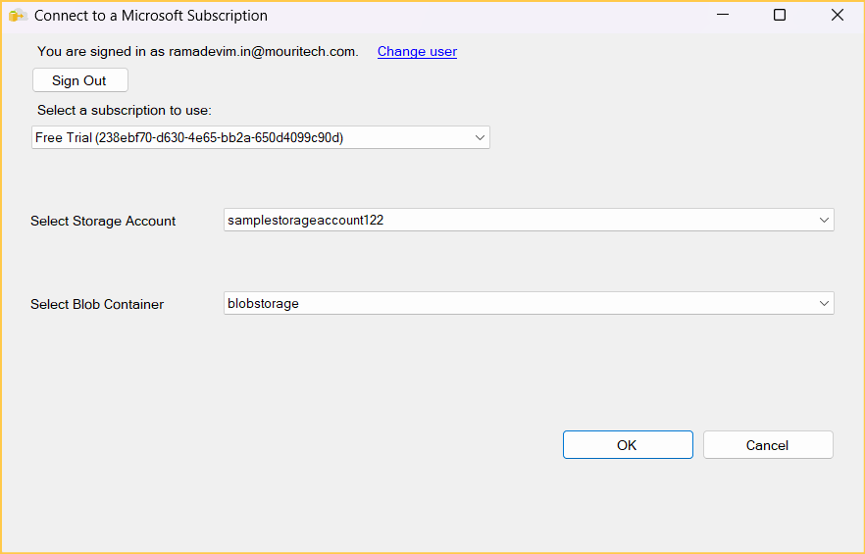 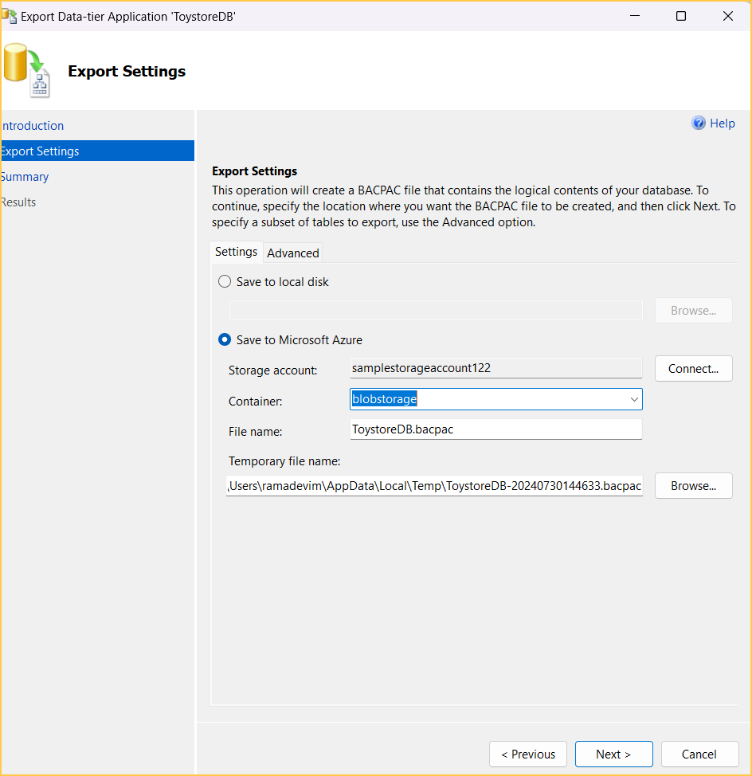

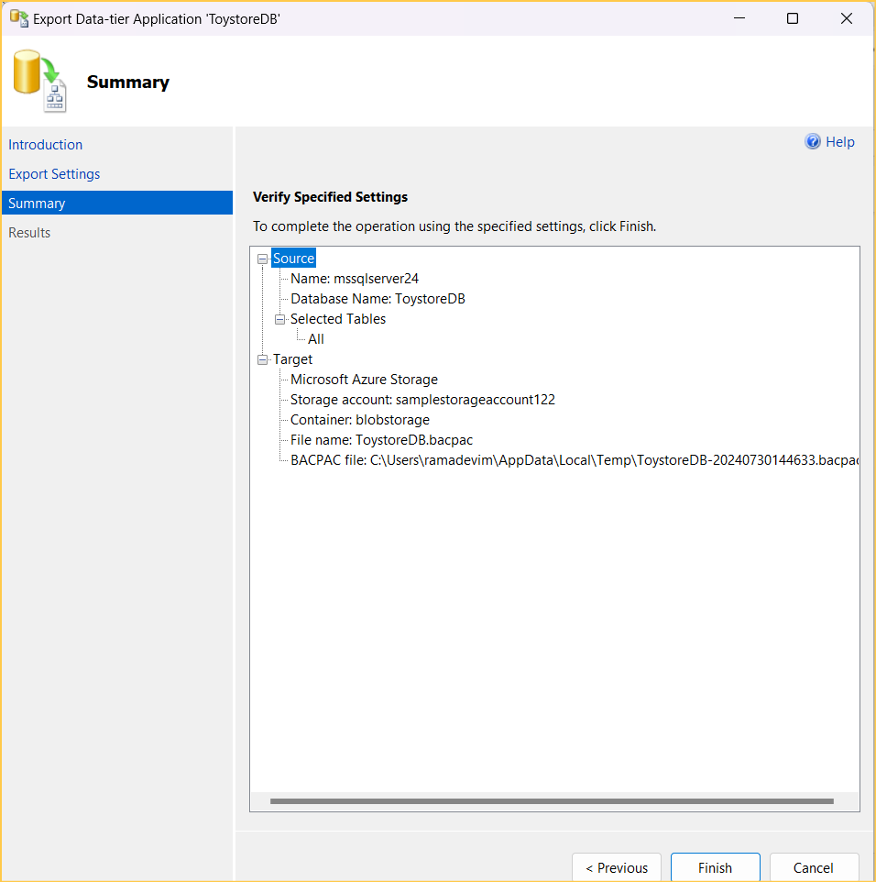

* Open the storage account in Azure portal check the backup file

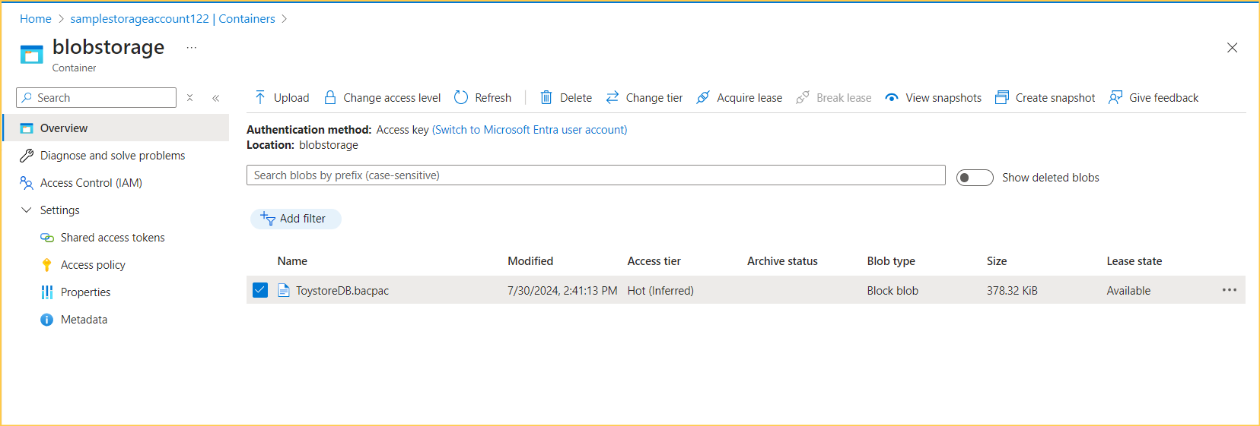

* Restoring a database using the azure portal
* Restore by importing the bacpac file to another server in SSMS

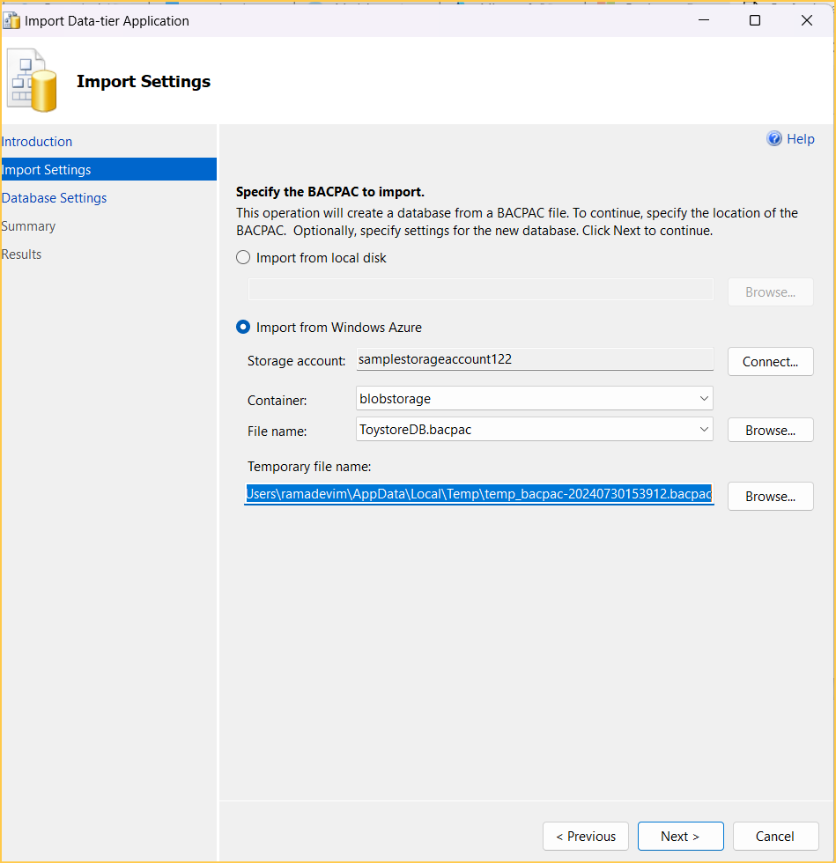

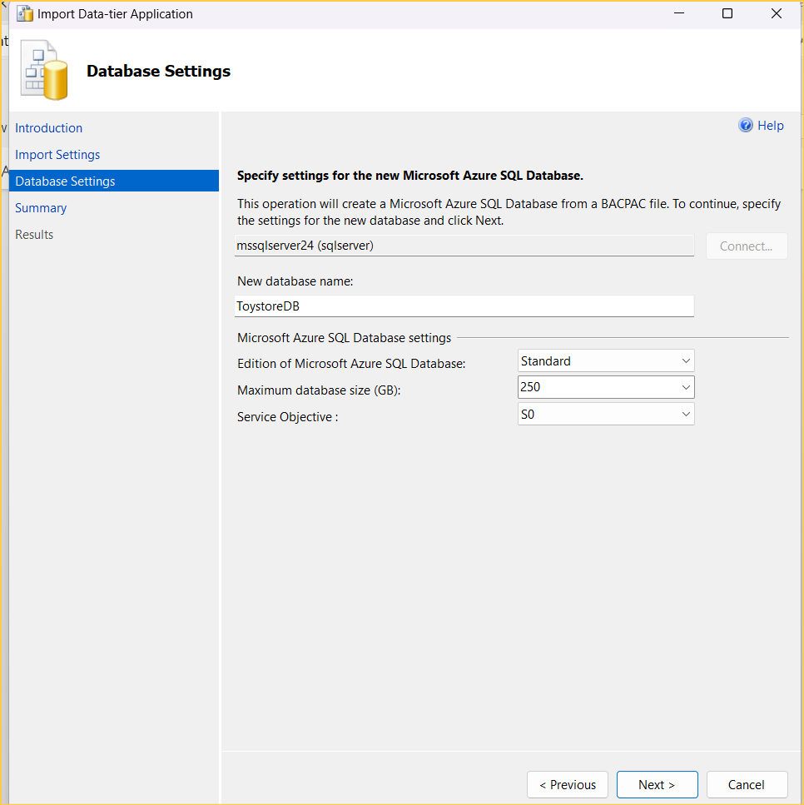

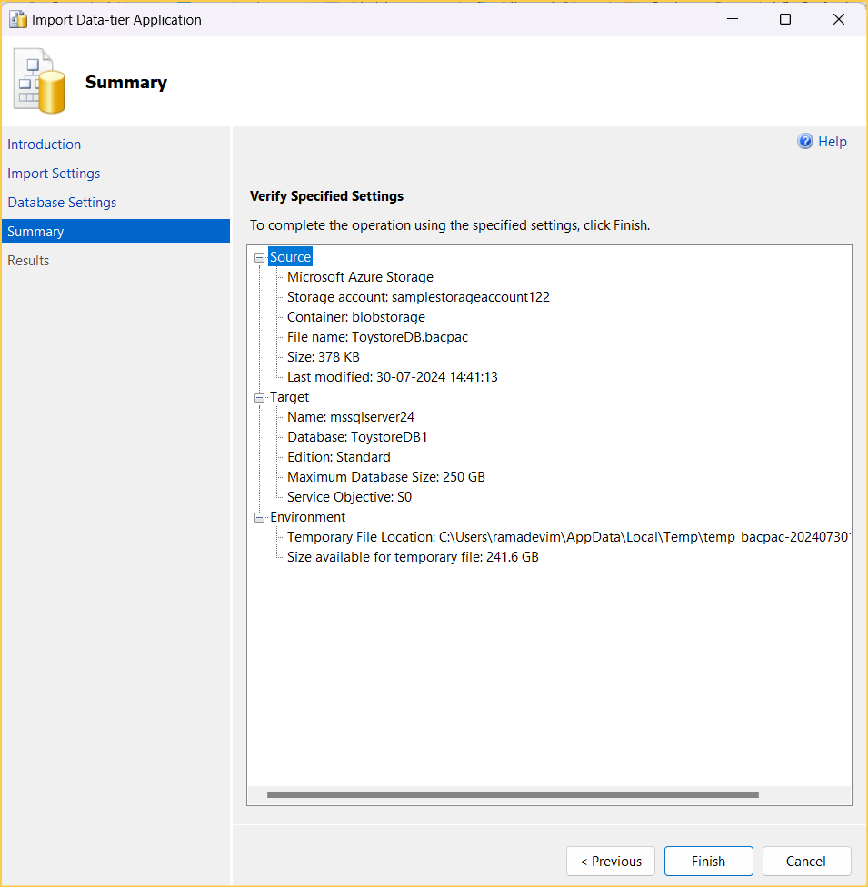

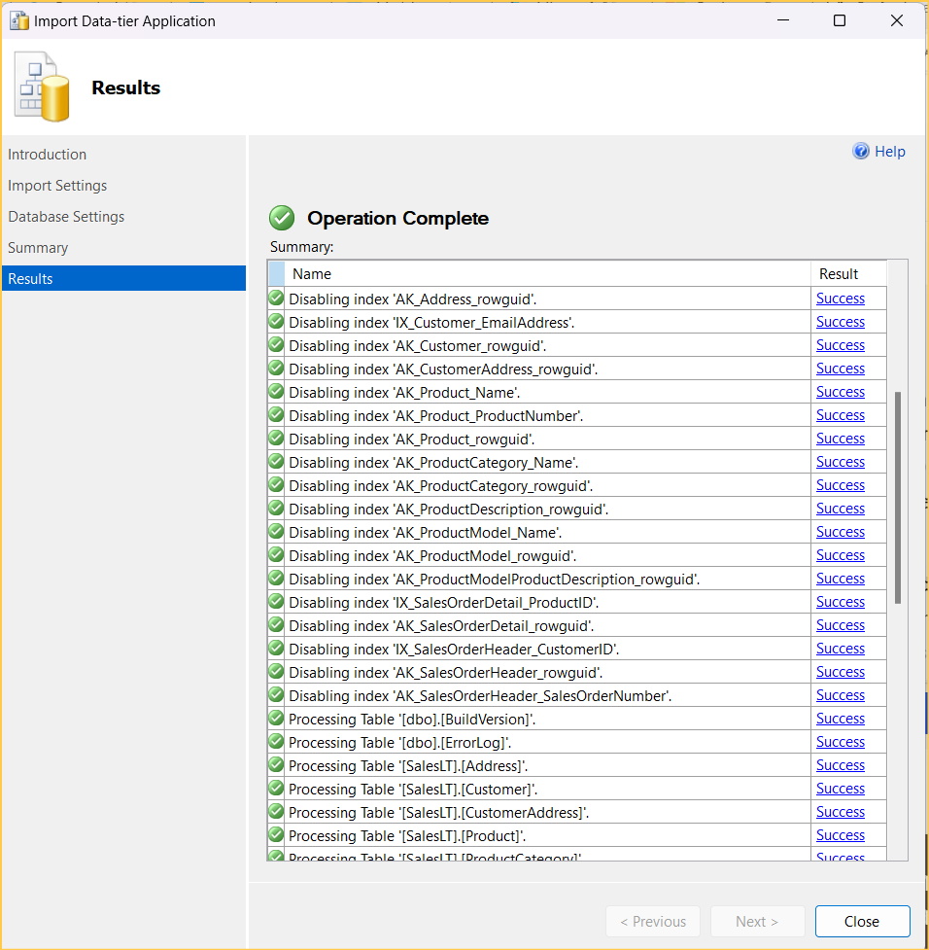

Import using the Azure portal

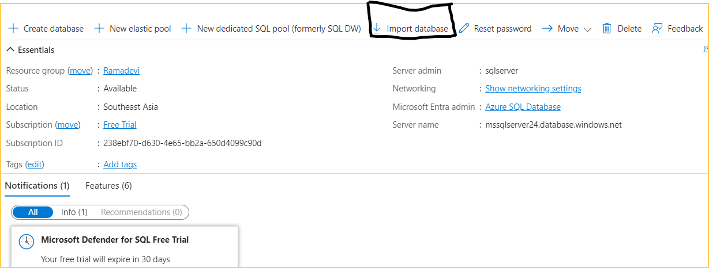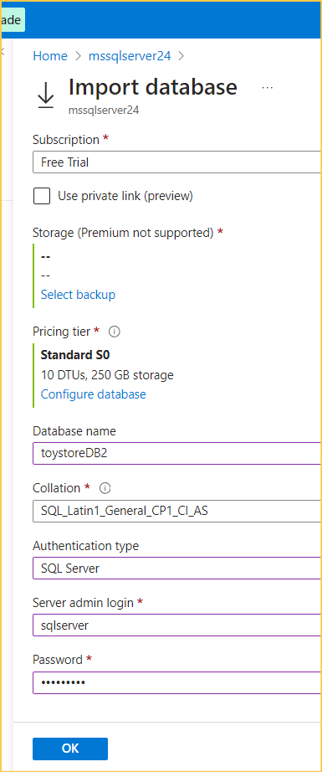

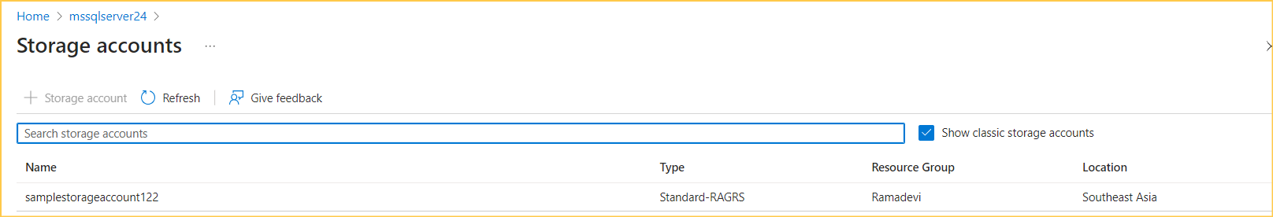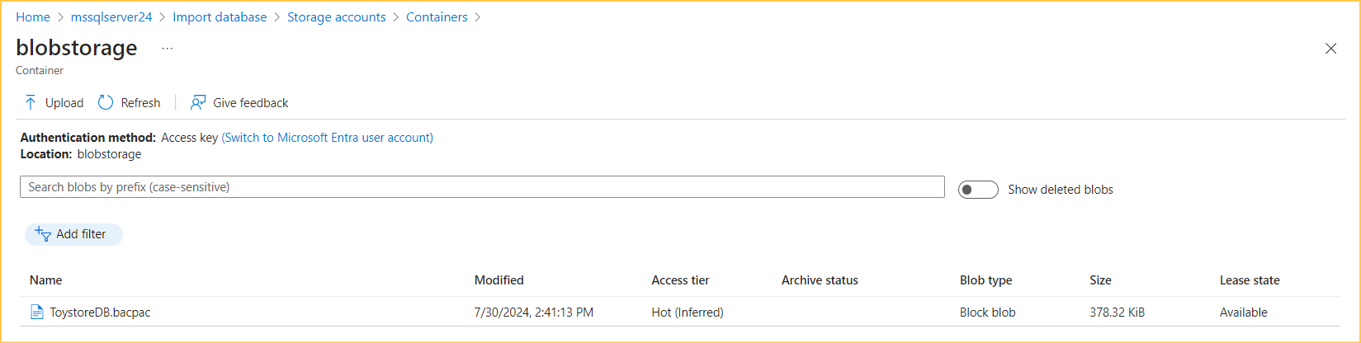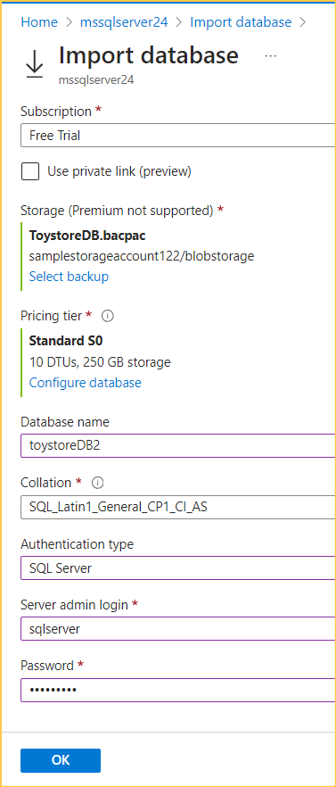

**Restoring**

**Restoring types:**

* Point-in-time Restore
* Restore a deleted database
* Geo-Restore a database
* Restore a database from Azure Vault
* Import a BACPAC

**Point-in-time Restore**

* Restore command isn't supported in Azure SQL Database, but the PITR can be performed using the Azure portal, PowerShell, Azure CLI, or Azure SDK.
* The PITR uses the automatic Full and Log backup.
* A database can only be restored on the same Azure SQL server as the original database with a different name.

Restoring using the Azure Portal

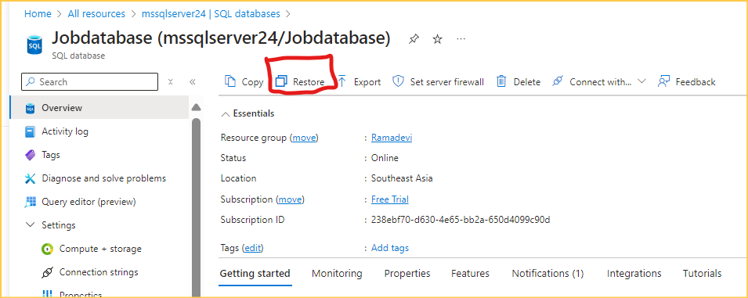

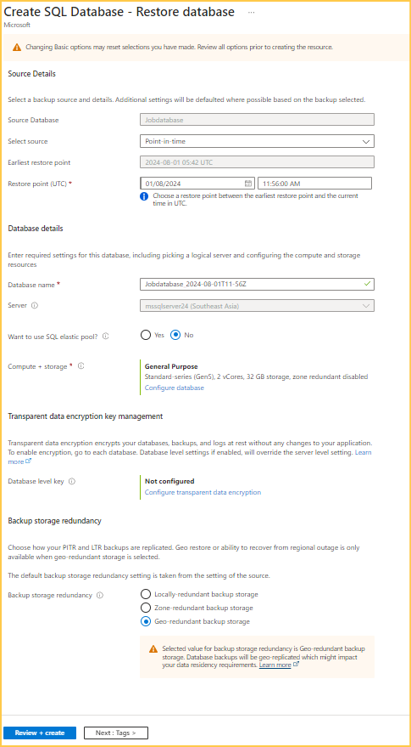

**Long term retention backup:**

* **It also same as PITR**
* **Here selects source as Longterm backup it will shows the list of backups from a long time**

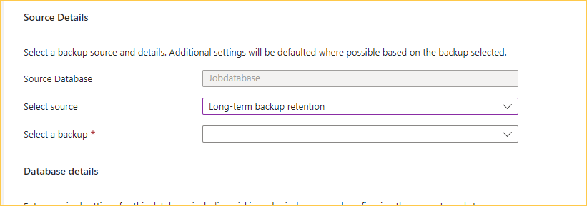

**Restore from deleted databases:**

**In azure portal we have list of databases we can restore the database**

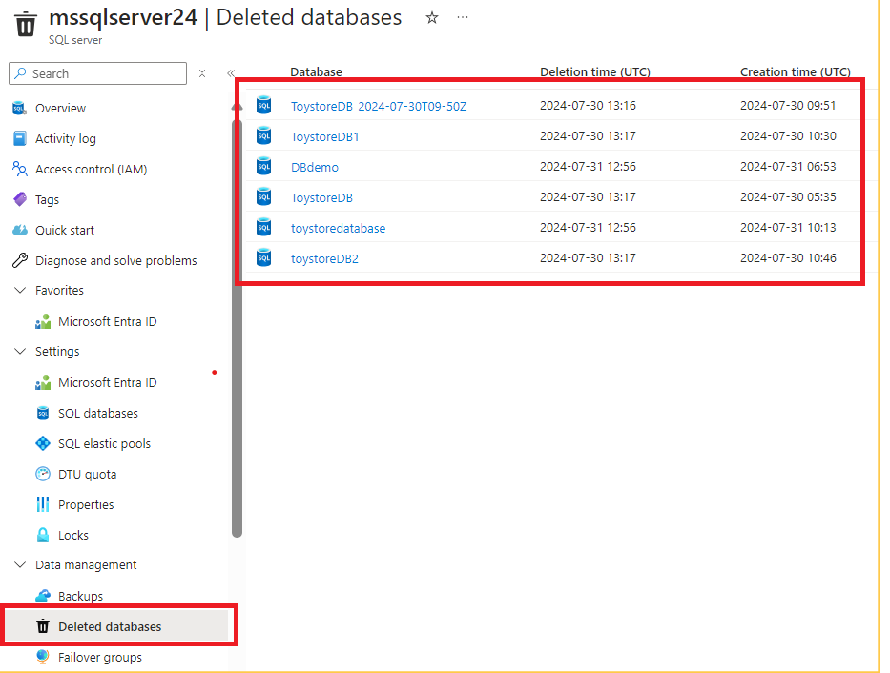

* Select the database we want to restore

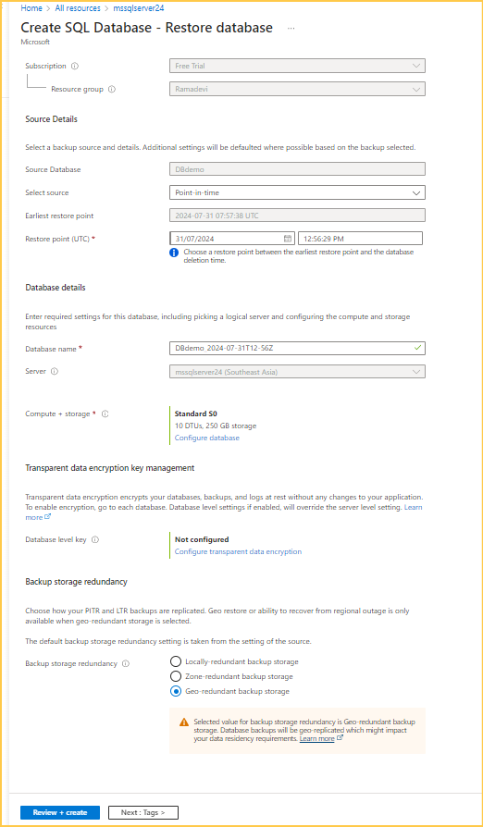Tha deleted database is restored successfully