SQL Server Studio Name :

Open MySQL Microsoft server studion and create database:

CREATE DATABASE db_Churn

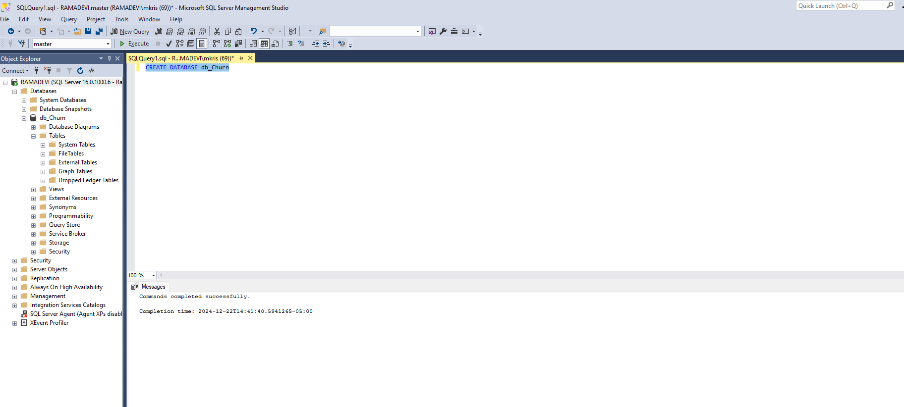

Db_Churn->Tasks->Import Flat File

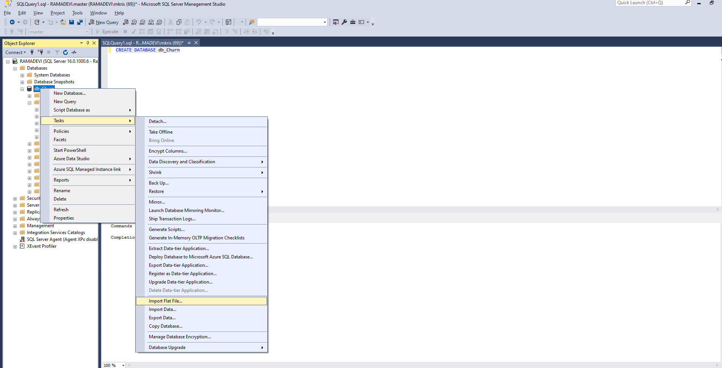

In ETL Steps,

Mark Allow Nulls,

Keep Customer Id as primary key and remove allow nulls

Change the columns with data type as bit to nvarchar(50)

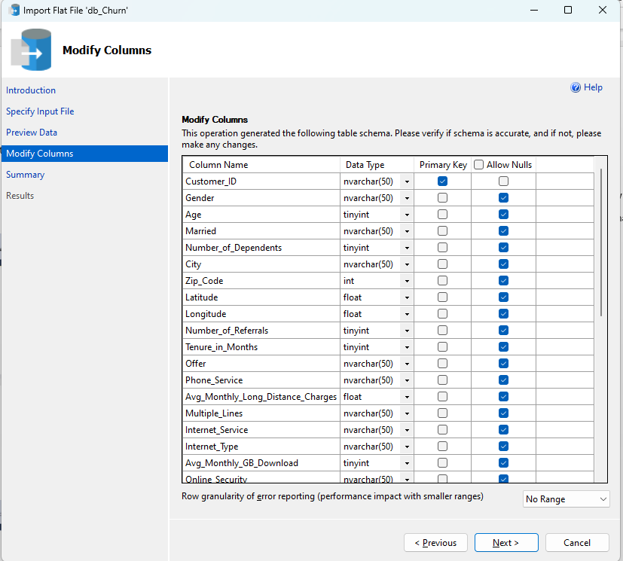

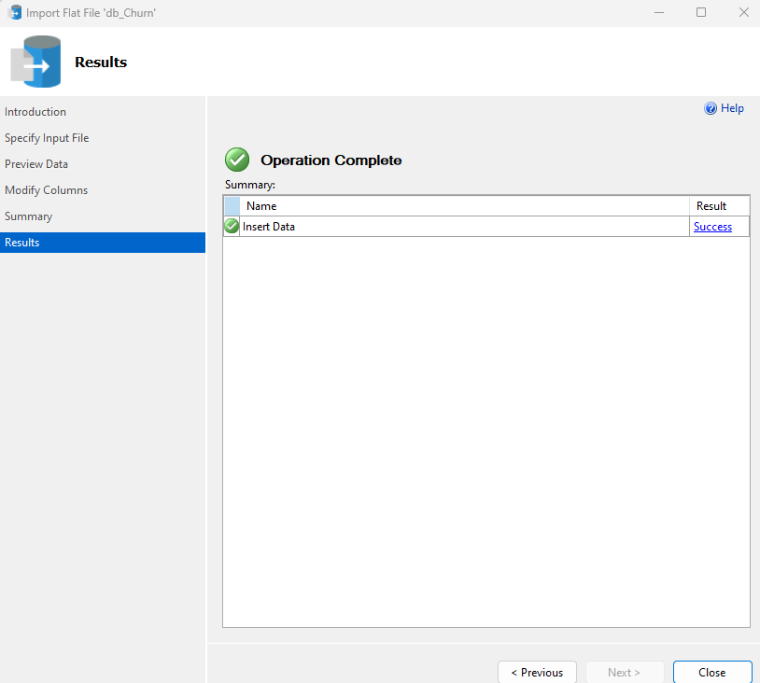

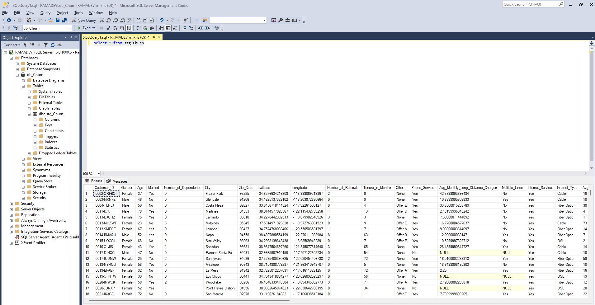

Data Exploration:

Gender column:

Select Gender , Count(Gender) as TotalCount,

Count(Gender) * 100.0 / (Select Count(*) from stg_Churn) as Percentage

From stg_Churn

Group By Gender

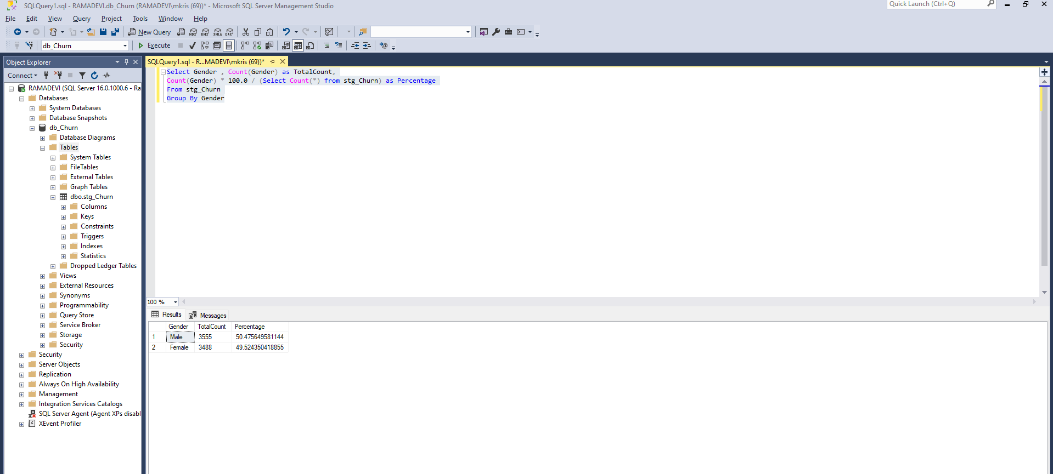

Contract Column:

Select Contract , Count(Contract) as TotalCount,

Count(Contract) * 100.0 / (Select Count(*) from stg_Churn) as Percentage

From stg_Churn

Group By Contract

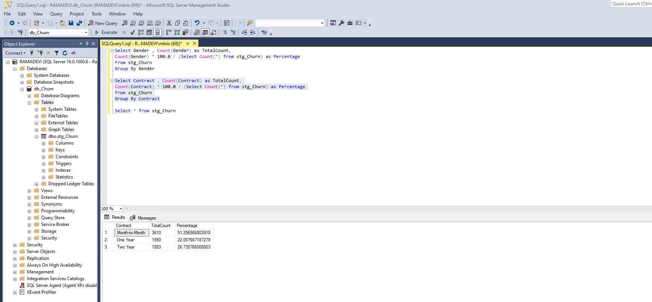

Customer_Status:

Select Customer_Status, Count(Customer_Status) as TotalCount, SUM(Total_Revenue) as TotalRev,

SUM(Total_Revenue)/(Select sum(Total_Revenue) from stg_Churn)*100 as RevPercentage

from stg_Churn

Group By Customer_Status

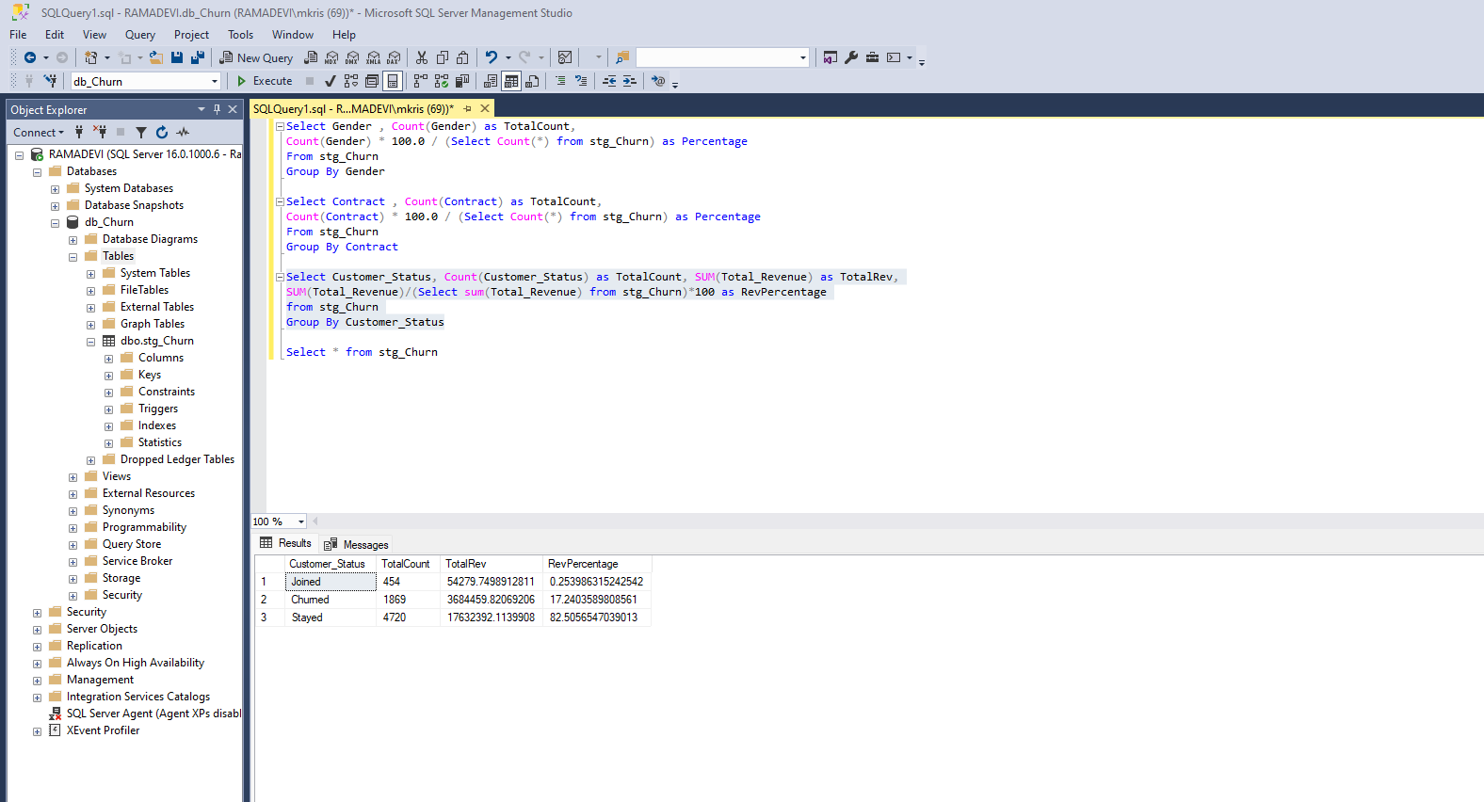

City:

Select City, Count(City) as TotalCount,

Count(City)*100.0/(Select count(*) from stg_Churn) as Percentage

from stg_Churn

Group by City

Order by Percentage desc

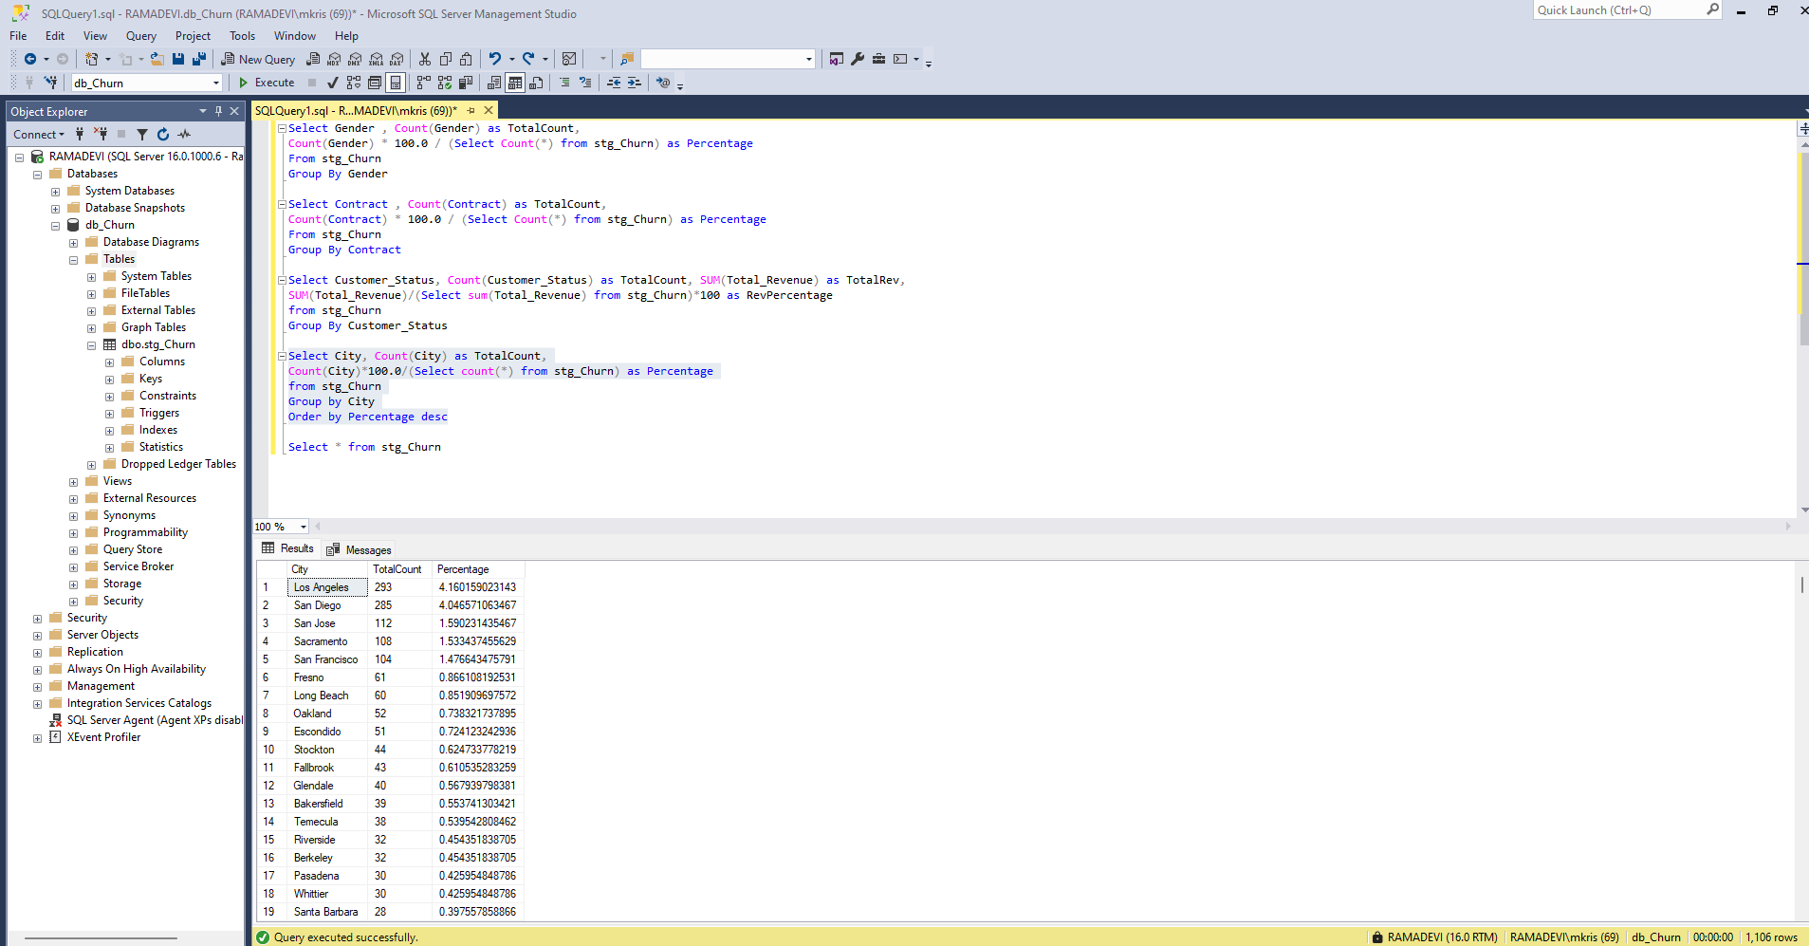

Distinct Internet Types:

Select distinct Internet_Type

from stg_Churn

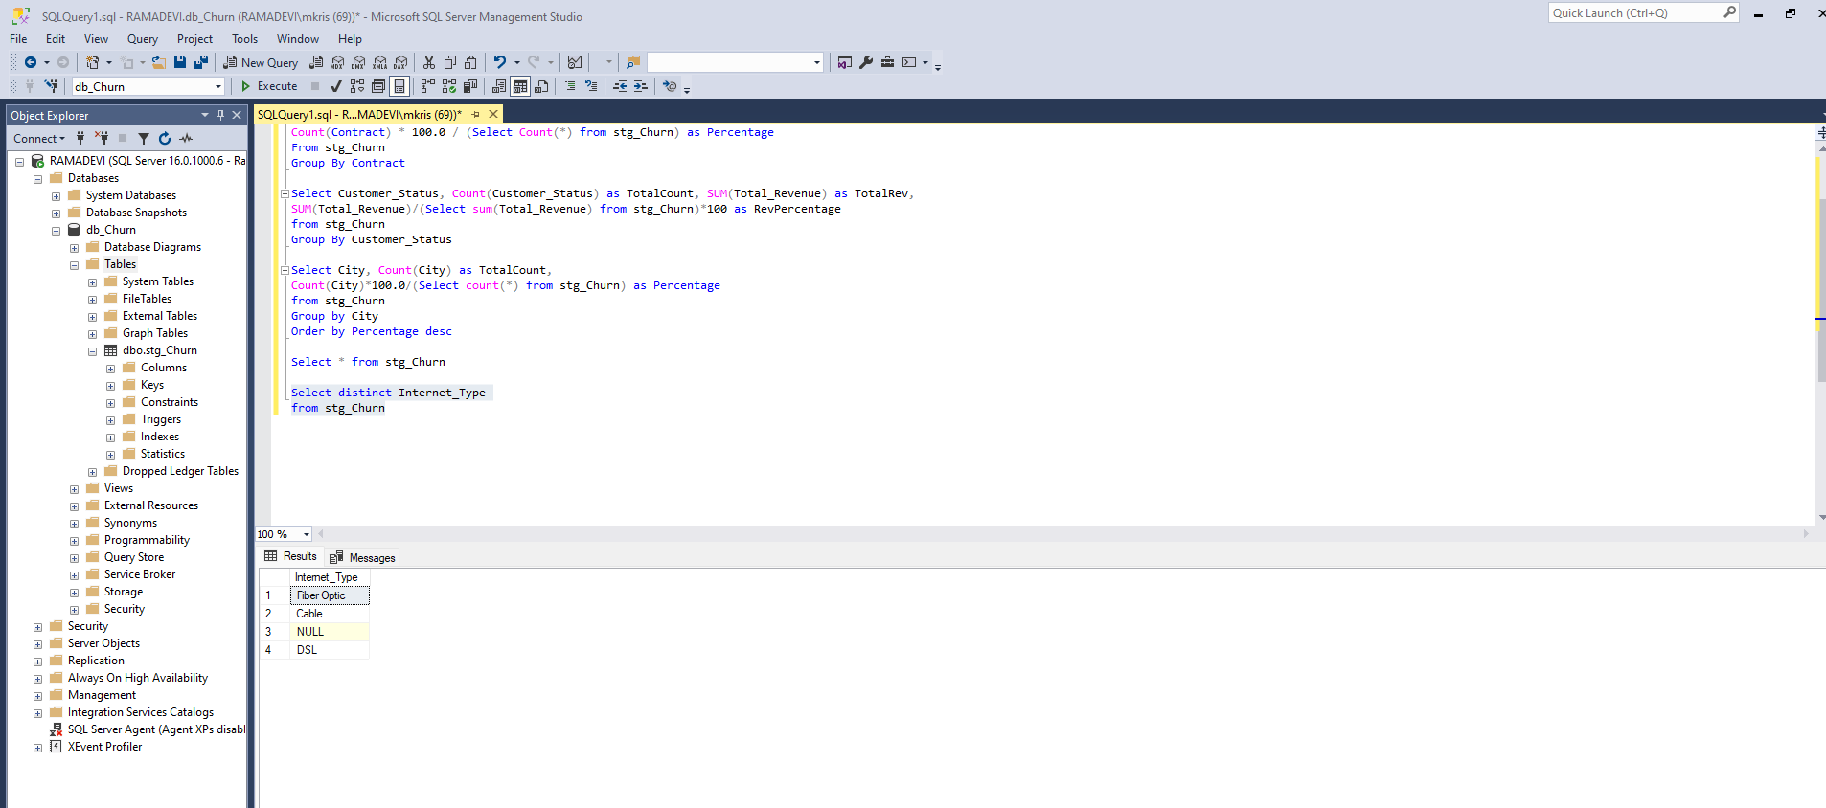

Data Exploration – Check Nulls:

SELECT

SUM(CASE WHEN Customer_ID IS NULL THEN 1 ELSE 0 END) AS Customer_ID_Null_Count,

SUM(CASE WHEN Gender IS NULL THEN 1 ELSE 0 END) AS Gender_Null_Count,

SUM(CASE WHEN Age IS NULL THEN 1 ELSE 0 END) AS Age_Null_Count,

SUM(CASE WHEN Married IS NULL THEN 1 ELSE 0 END) AS Married_Null_Count,

SUM(CASE WHEN Number_of_Dependents IS NULL THEN 1 ELSE 0 END) AS Number_of_Dependents_Null_Count,

SUM(CASE WHEN City IS NULL THEN 1 ELSE 0 END) AS City_Null_Count,

SUM(CASE WHEN Zip_Code IS NULL THEN 1 ELSE 0 END) AS Zip_Code_Null_Count,

SUM(CASE WHEN Latitude IS NULL THEN 1 ELSE 0 END) AS Latitude_Null_Count,

SUM(CASE WHEN Longitude IS NULL THEN 1 ELSE 0 END) AS Longitude_Null_Count,

SUM(CASE WHEN Number_of_Referrals IS NULL THEN 1 ELSE 0 END) AS Number_of_Referrals_Null_Count,

SUM(CASE WHEN Tenure_in_Months IS NULL THEN 1 ELSE 0 END) AS Tenure_in_Months_Null_Count,

SUM(CASE WHEN Offer IS NULL THEN 1 ELSE 0 END) AS Offer_Null_Count,

SUM(CASE WHEN Phone_Service IS NULL THEN 1 ELSE 0 END) AS Phone_Service_Null_Count,

SUM(CASE WHEN Avg_Monthly_Long_Distance_Charges IS NULL THEN 1 ELSE 0 END) AS Avg_Monthly_Long_Distance_Charges_Null_Count,

SUM(CASE WHEN Multiple_Lines IS NULL THEN 1 ELSE 0 END) AS Multiple_Lines_Null_Count,

SUM(CASE WHEN Internet_Service IS NULL THEN 1 ELSE 0 END) AS Internet_Service_Null_Count,

SUM(CASE WHEN Internet_Type IS NULL THEN 1 ELSE 0 END) AS Internet_Type_Null_Count,

SUM(CASE WHEN Avg_Monthly_GB_Download IS NULL THEN 1 ELSE 0 END) AS Avg_Monthly_GB_Download_Null_Count,

SUM(CASE WHEN Online_Security IS NULL THEN 1 ELSE 0 END) AS Online_Security_Null_Count,

SUM(CASE WHEN Online_Backup IS NULL THEN 1 ELSE 0 END) AS Online_Backup_Null_Count,

SUM(CASE WHEN Device_Protection_Plan IS NULL THEN 1 ELSE 0 END) AS Device_Protection_Plan_Null_Count,

SUM(CASE WHEN Premium_Tech_Support IS NULL THEN 1 ELSE 0 END) AS Premium_Tech_Support_Null_Count,

SUM(CASE WHEN Streaming_TV IS NULL THEN 1 ELSE 0 END) AS Streaming_TV_Null_Count,

SUM(CASE WHEN Streaming_Movies IS NULL THEN 1 ELSE 0 END) AS Streaming_Movies_Null_Count,

SUM(CASE WHEN Streaming_Music IS NULL THEN 1 ELSE 0 END) AS Streaming_Music_Null_Count,

SUM(CASE WHEN Unlimited_Data IS NULL THEN 1 ELSE 0 END) AS Unlimited_Data_Null_Count,

SUM(CASE WHEN Contract IS NULL THEN 1 ELSE 0 END) AS Contract_Null_Count,

SUM(CASE WHEN Paperless_Billing IS NULL THEN 1 ELSE 0 END) AS Paperless_Billing_Null_Count,

SUM(CASE WHEN Payment_Method IS NULL THEN 1 ELSE 0 END) AS Payment_Method_Null_Count,

SUM(CASE WHEN Monthly_Charge IS NULL THEN 1 ELSE 0 END) AS Monthly_Charge_Null_Count,

SUM(CASE WHEN Total_Charges IS NULL THEN 1 ELSE 0 END) AS Total_Charges_Null_Count,

SUM(CASE WHEN Total_Refunds IS NULL THEN 1 ELSE 0 END) AS Total_Refunds_Null_Count,

SUM(CASE WHEN Total_Extra_Data_Charges IS NULL THEN 1 ELSE 0 END) AS Total_Extra_Data_Charges_Null_Count,

SUM(CASE WHEN Total_Long_Distance_Charges IS NULL THEN 1 ELSE 0 END) AS Total_Long_Distance_Charges_Null_Count,

SUM(CASE WHEN Total_Revenue IS NULL THEN 1 ELSE 0 END) AS Total_Revenue_Null_Count,

SUM(CASE WHEN Customer_Status IS NULL THEN 1 ELSE 0 END) AS Customer_Status_Null_Count,

SUM(CASE WHEN Churn_Category IS NULL THEN 1 ELSE 0 END) AS Churn_Category_Null_Count,

SUM(CASE WHEN Churn_Reason IS NULL THEN 1 ELSE 0 END) AS Churn_Reason_Null_Count

FROM stg_Churn;

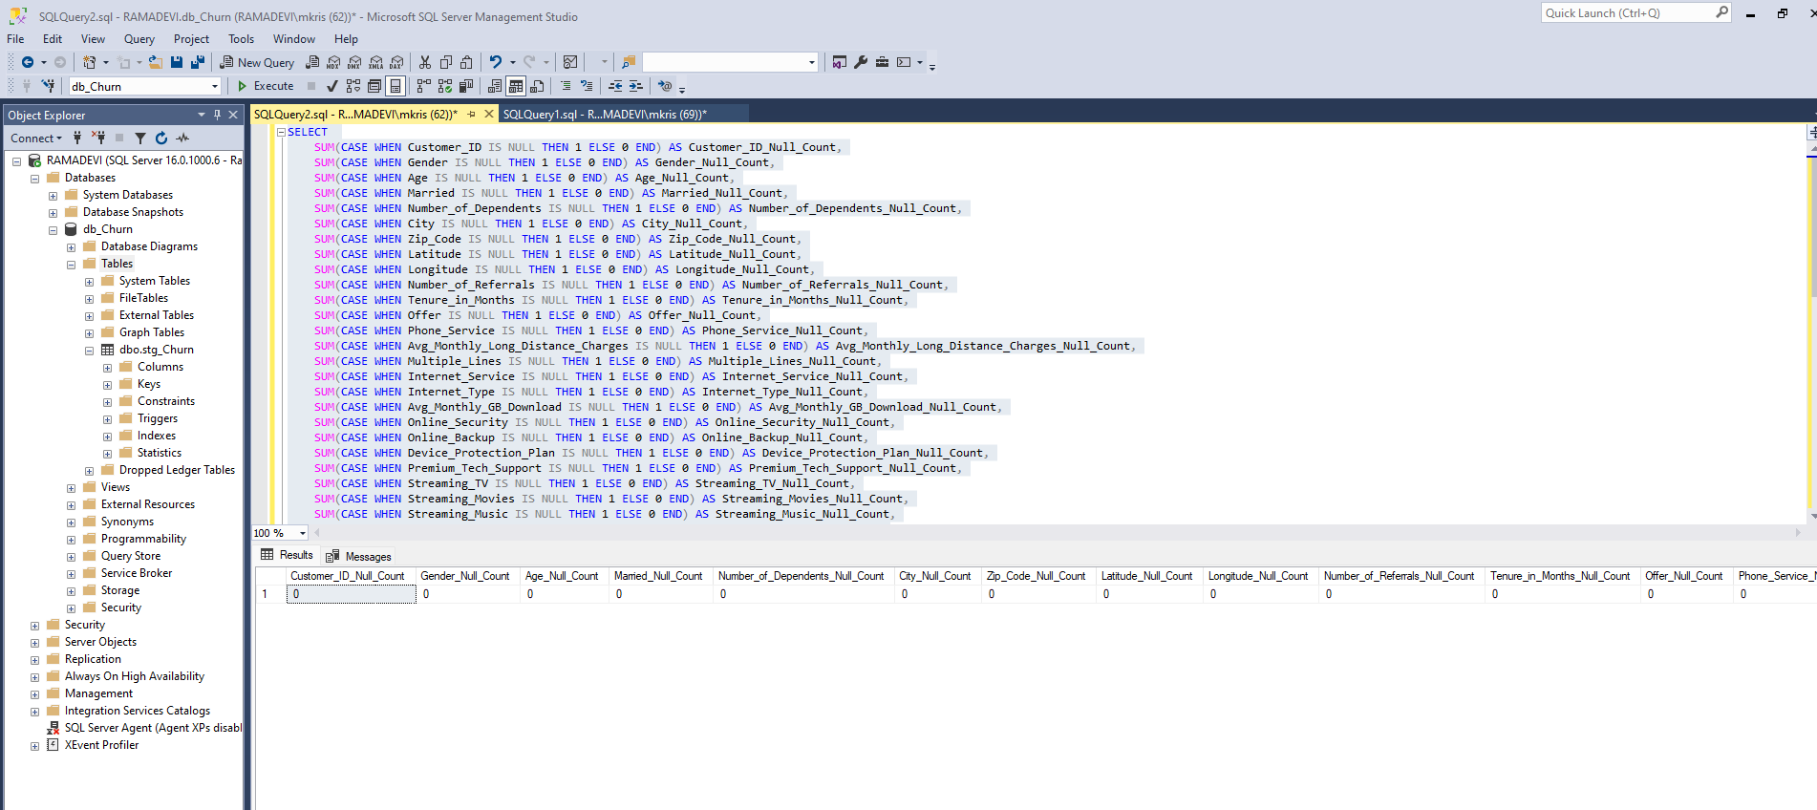

Remove null and insert the new data into Prod table:

SELECT

Customer_ID,

Gender,

Age,

Married,

Number_of_Dependents,

City,

Zip_Code,

Latitude,

Longitude,

Number_of_Referrals,

Tenure_in_Months,

Offer,

Phone_Service,

ISNULL(Avg_Monthly_Long_Distance_Charges,0.00) AS Avg_Monthly_Long_Distance_Charges,

ISNULL(Multiple_Lines, 'No') AS Multiple_Lines,

Internet_Service,

ISNULL(Internet_Type, 'None') AS Internet_Type,

ISNULL(Avg_Monthly_GB_Download,0) AS Avg_Monthly_GB_Download,

ISNULL(Online_Security, 'No') AS Online_Security,

ISNULL(Online_Backup, 'No') AS Online_Backup,

ISNULL(Device_Protection_Plan, 'No') AS Device_Protection_Plan,

ISNULL(Premium_Tech_Support, 'No') AS Premium_Tech_Support,

ISNULL(Streaming_TV, 'No') AS Streaming_TV,

ISNULL(Streaming_Movies, 'No') AS Streaming_Movies,

ISNULL(Streaming_Music, 'No') AS Streaming_Music,

ISNULL(Unlimited_Data, 'No') AS Unlimited_Data,

Contract,

Paperless_Billing,

Payment_Method,

Monthly_Charge,

Total_Charges,

Total_Refunds,

Total_Extra_Data_Charges,

Total_Long_Distance_Charges,

Total_Revenue,

Customer_Status,

ISNULL(Churn_Category, 'Others') AS Churn_Category,

ISNULL(Churn_Reason , 'Others') AS Churn_Reason

INTO [db_Churn].[dbo].[prod_Churn]

FROM [db_Churn].[dbo].[stg_Churn];

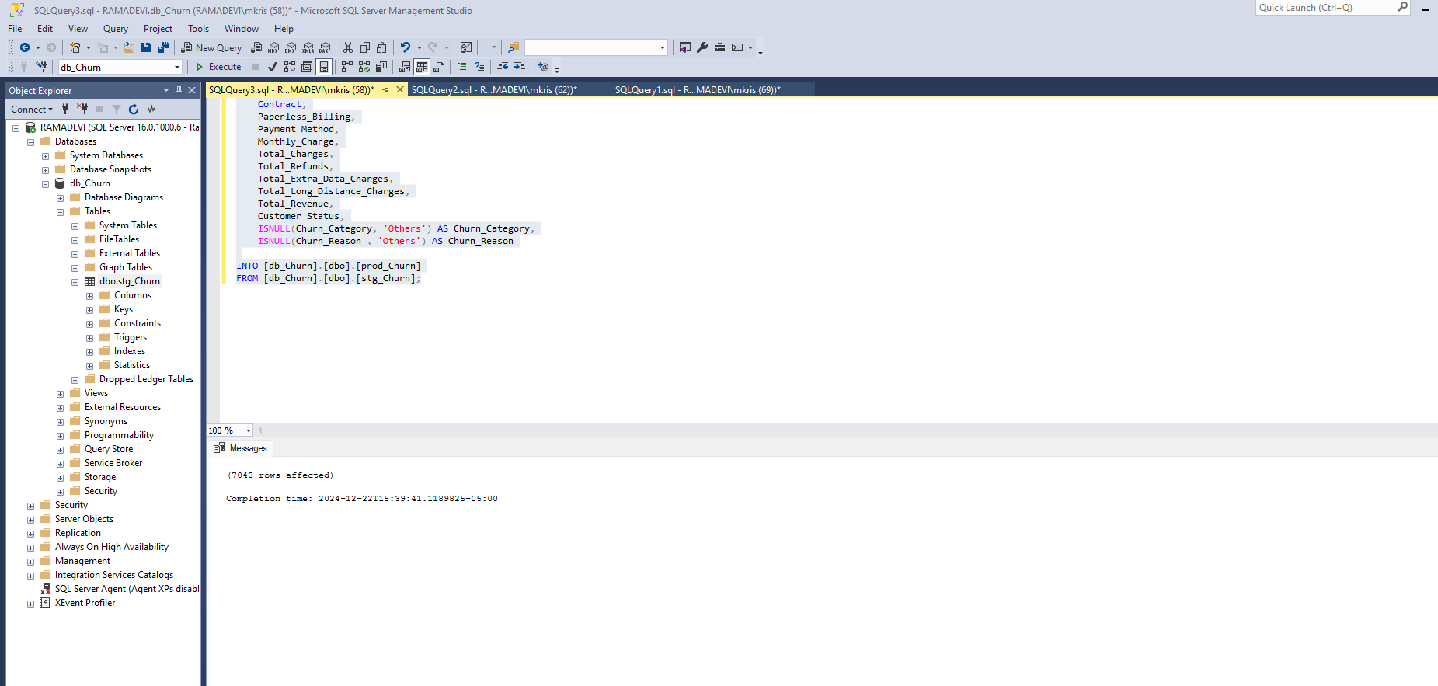

**Create View for Power BI**

Create View vw_ChurnData as

select * from prod_Churn where Customer_Status In ('Churned', 'Stayed')

Create View vw_JoinData as

select * from prod_Churn where Customer_Status = 'Joined'

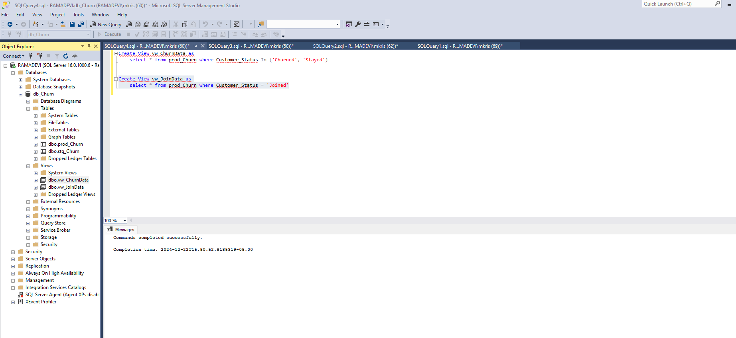

Power BI Steps:

Import the data from SQL Server and load it

Tranform data in Power BI:

1. Create a new conditional column, if cust status is churned, then 1 else 0

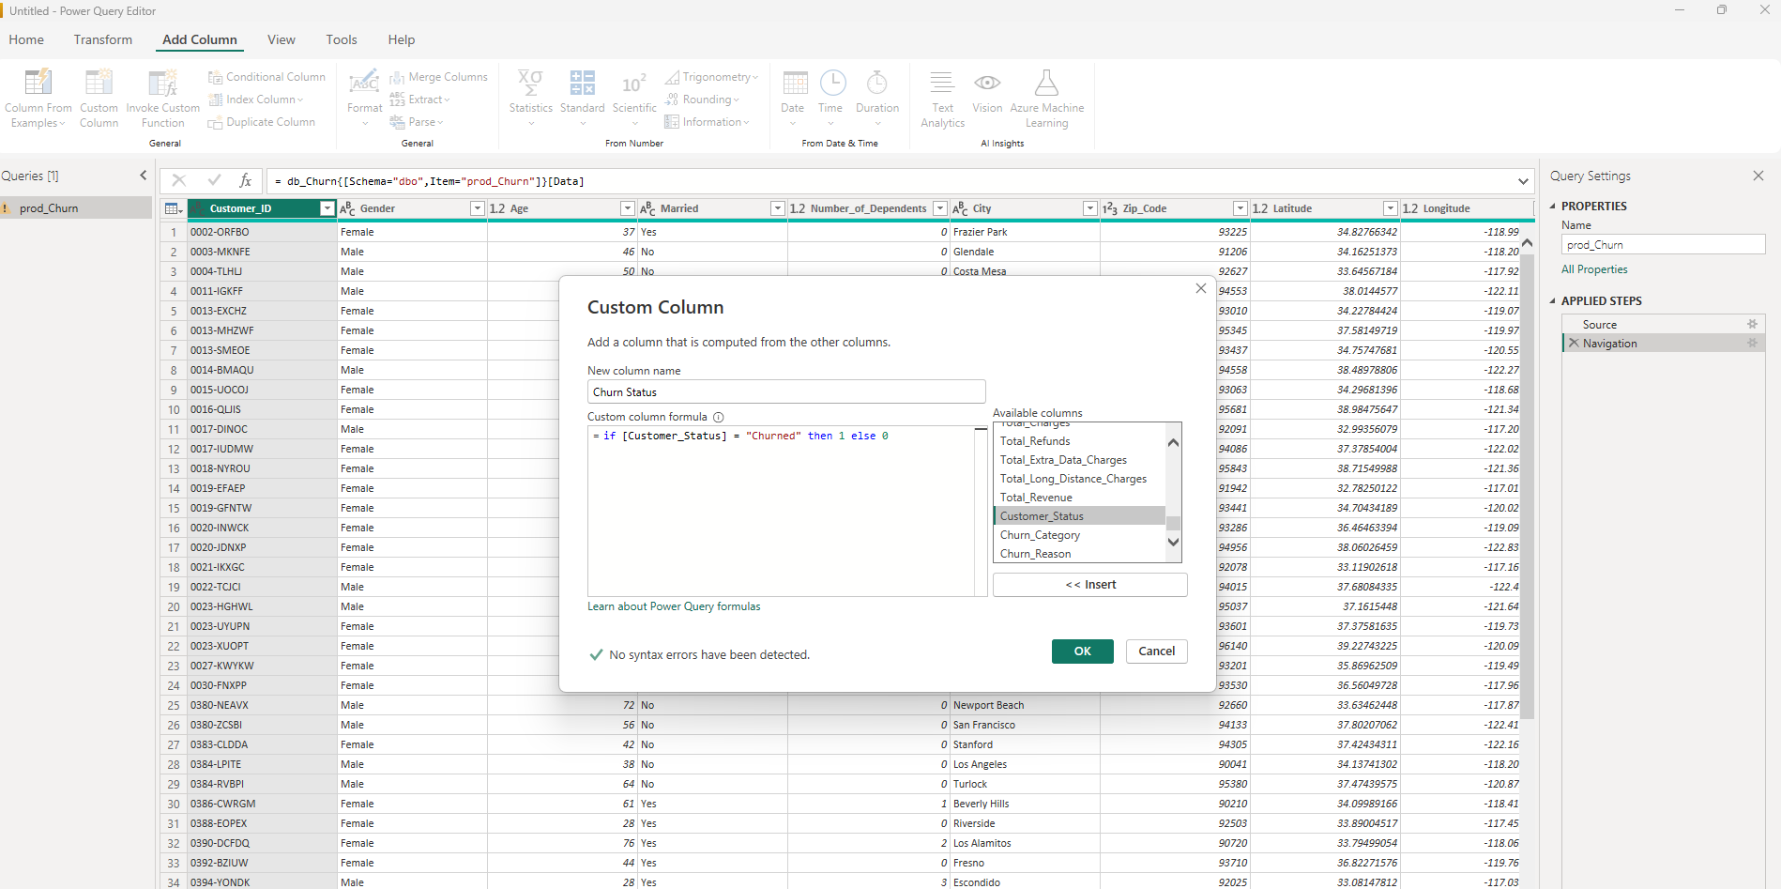

1. Change the data type of Churn Status to Whole Number
2. if [Monthly_Charge] < 20 then "<20"

else if [Monthly_Charge] < 50 then "20-50" else if

[Monthly_Charge] < 100 then "50-100" else ">100"

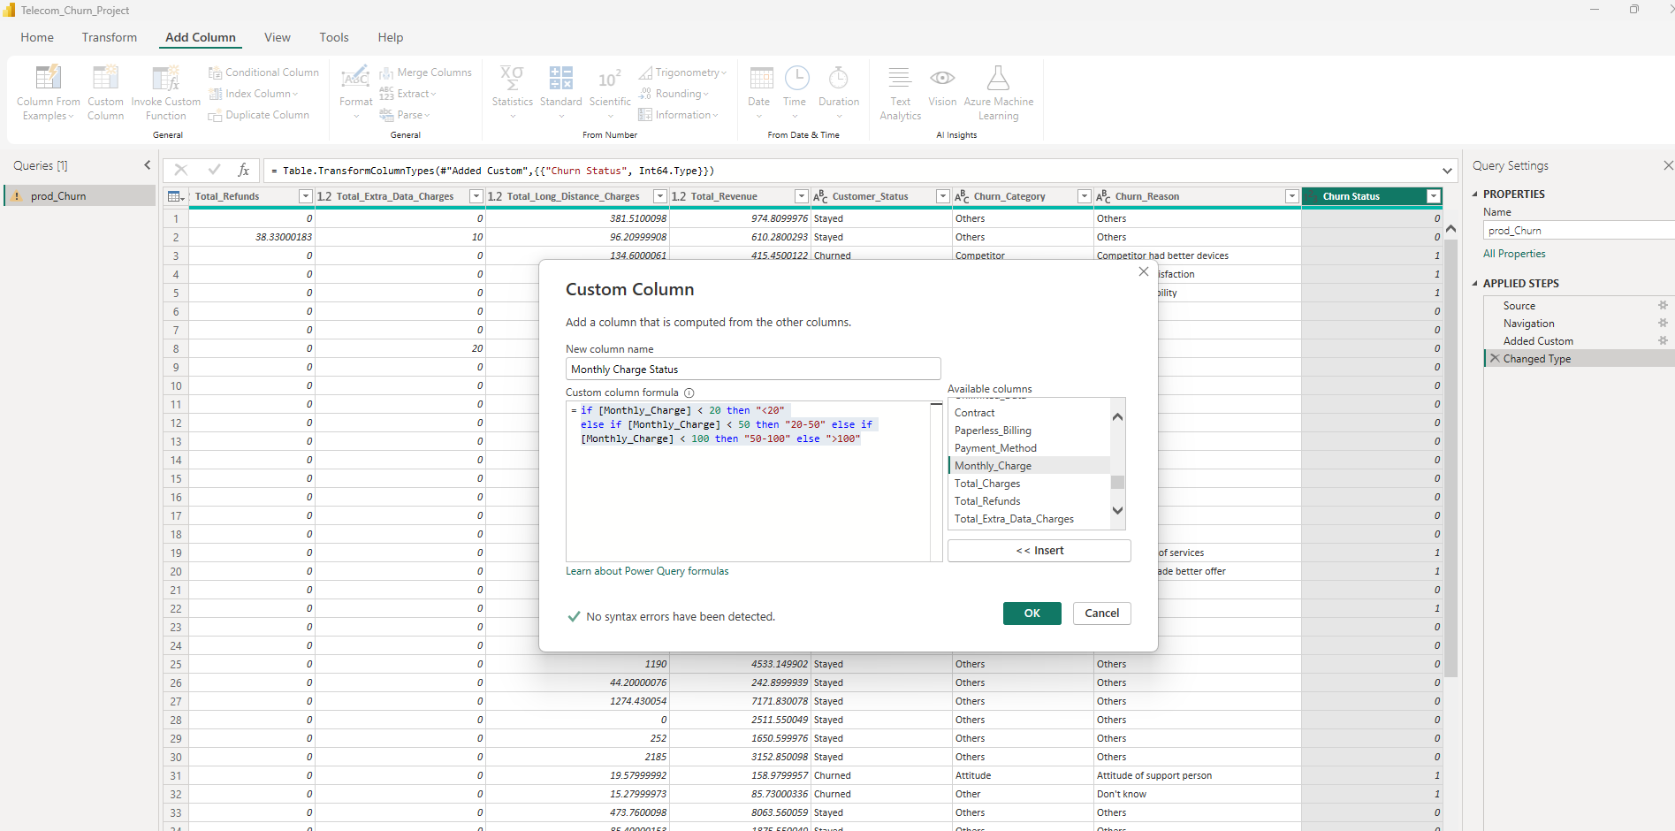

1. **Create below measures:**

**Summary Page - Measures**

Total Customers = Count(prod_Churn[Customer_ID])

New Joiners = CALCULATE(COUNT(prod_Churn[Customer_ID]), prod_Churn[Customer_Status] = "Joined")

Total Churn = SUM(prod_Churn[Churn Status])

Churn Rate = [Total Churn] / [Total Customers]

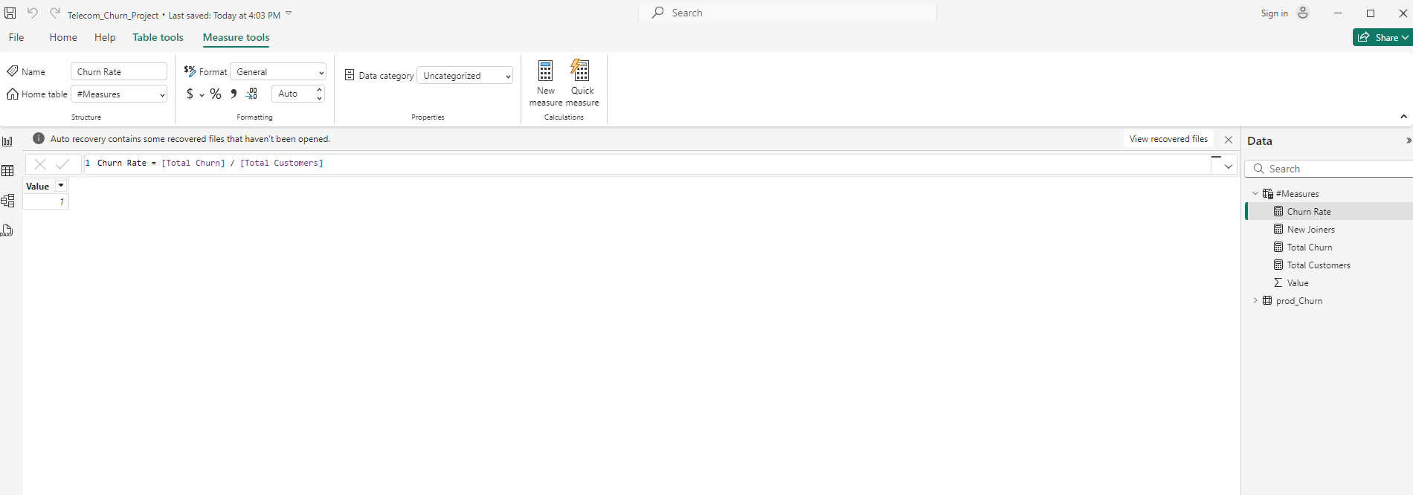

1. Display below measures as Card Visualizations

* Total Customers
* New Joiners
* Total Churn
* Churn Rate

(Format the card values in % and comma separated values)

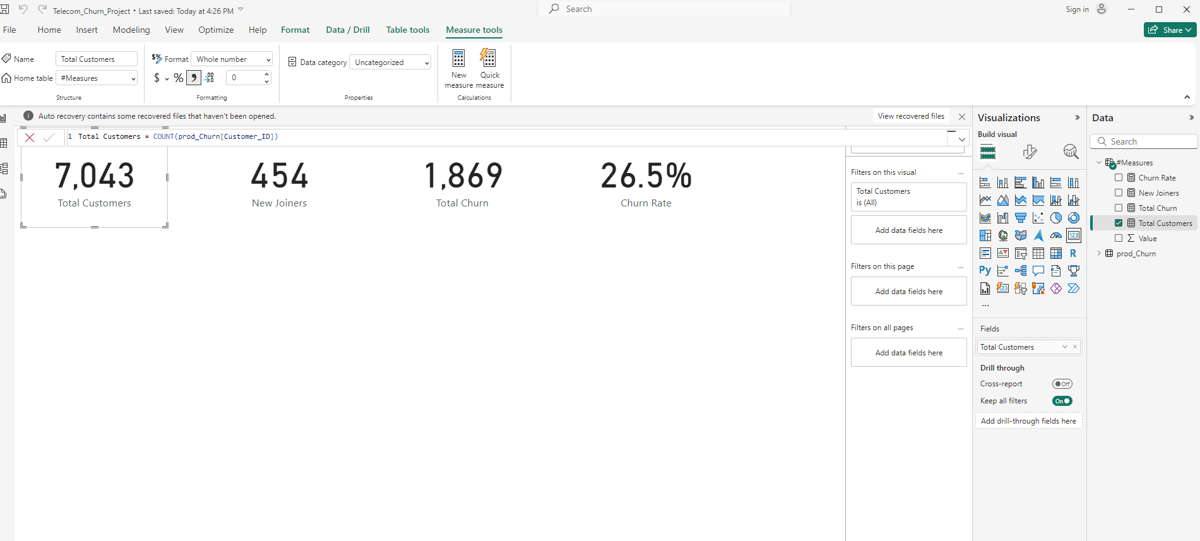

1. Show Gender and Total Churn as Donut Chart. Choose Value display units as none.

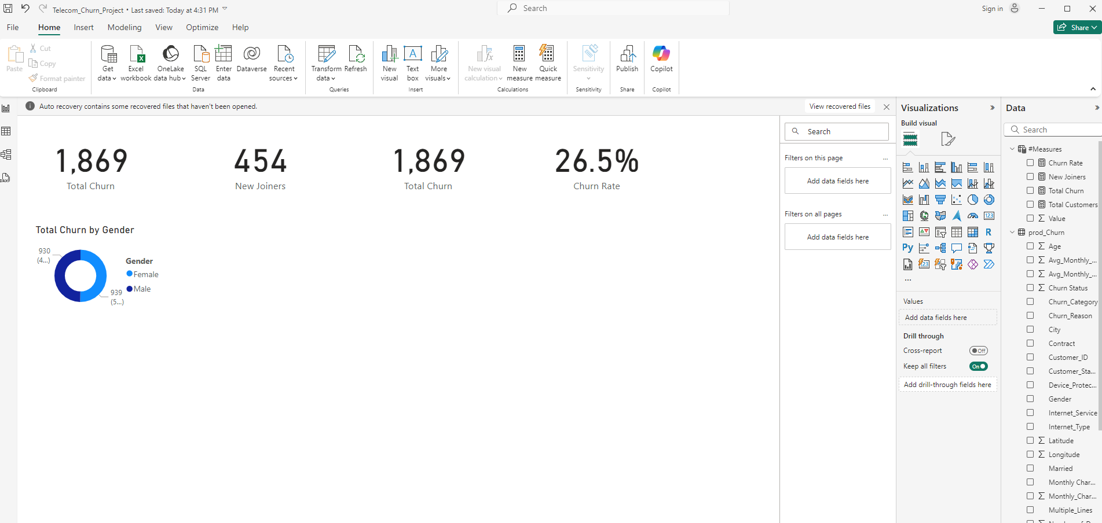

1. Created Total Customers and Churn rate by Age Group -> Line and Stacked bar chart (For this created a reference table named reference_AgeGrp with below changes )

1. Keep only Age column and remove duplicates

2. Age Group = if [Age] < 20 then "< 20" else if [Age] < 36 then "20 - 35" else if [Age] < 51 then "36 - 50" else "> 50"

1. Created Churn rate by Payment Method -> Clustered Bar Chart
2. Created Churn rate by Contract -> Clustered Bar Chart

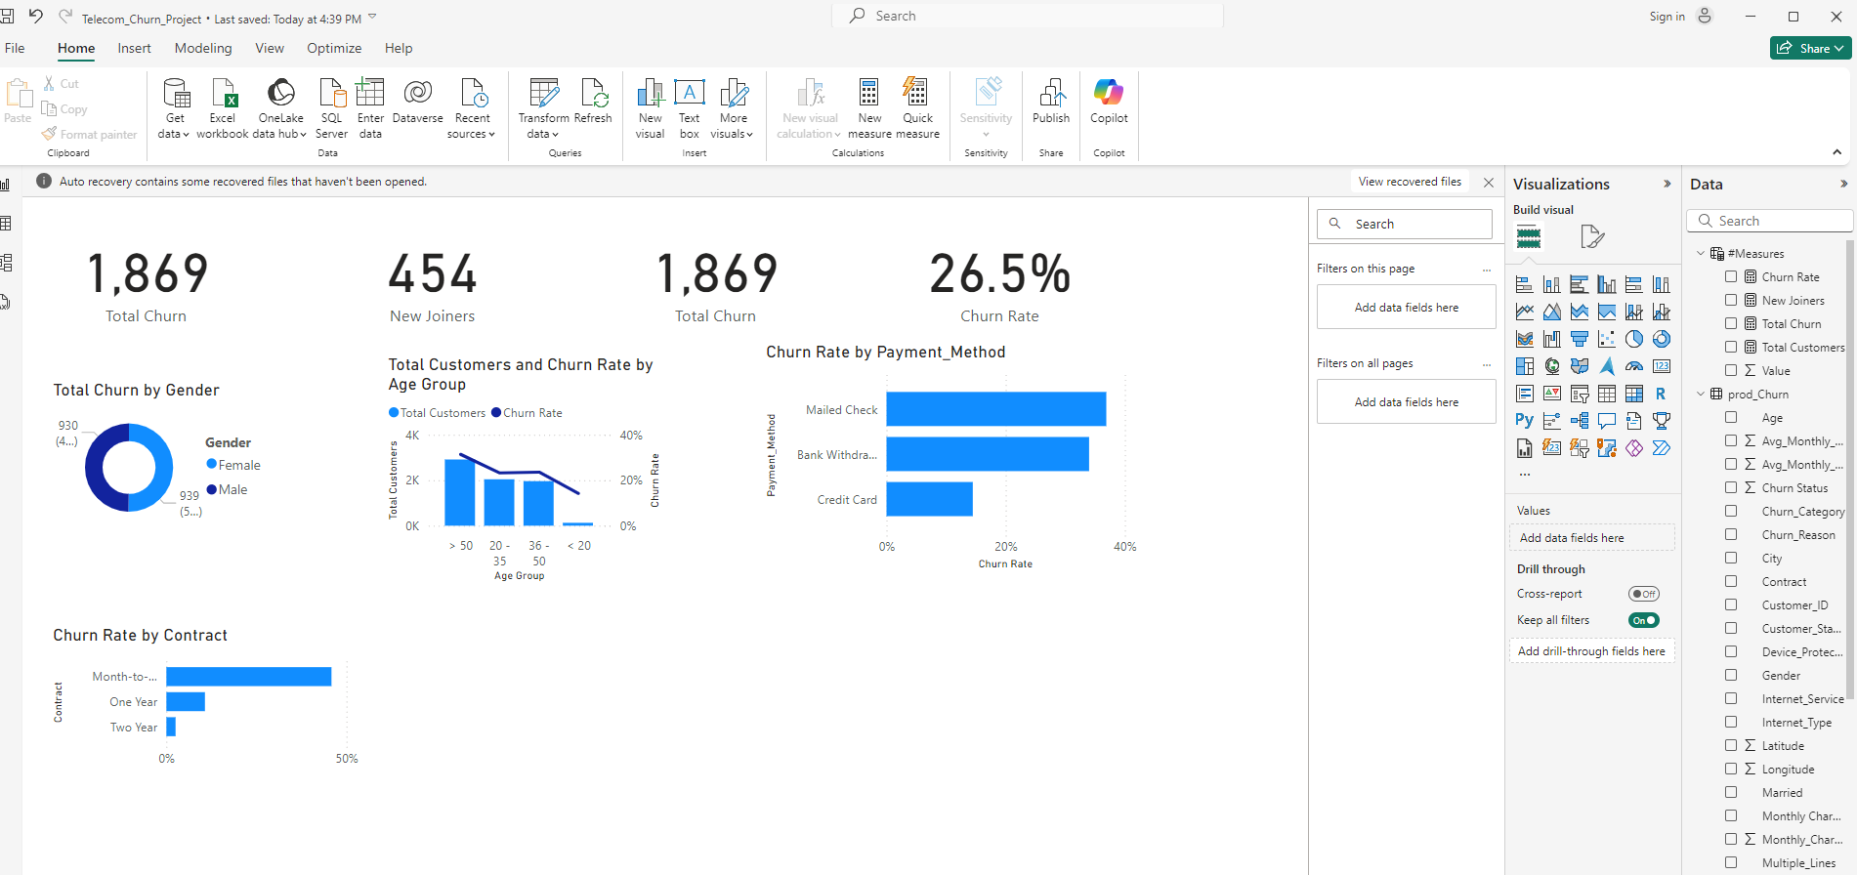

1. In reference_AgeGrp table, add another column

* AgeGrpSorting = if [Age Group] = "< 20" then 1 else if [Age Group] = "20 - 35" then 2 else if [Age Group] = "36 - 50" then 3 else 4
* Change data type of AgeGrpSorting

1. In reference_TenureGrp table, add another column

* TenureGrpSorting = if [Tenure Group] = "< 6 Months" then 1 else if [Tenure Group] = "6-12 Months" then 2 else if [Tenure Group] = "12-18 Months" then 3 else if [Tenure Group] = "18-24 Months " then 4 else 5
* Change data type of TenureGrpSorting

1. City and Churn rate clustered bar chart -> Filter Top N cities

DashBoard Images:

