1. Exercise on propositional/ predicate logic & Induction [20 Points]

a. Express the following sentences in propositional/ first order logic. Be sure to define all propositional components (e.g., predicate function, constants, and variables).

1. Some mammals live in water.
2. A person can activate roles R1 or R2 but not both.
3. If Cowboys does not reach Super Bowl then I will not watch the Super Bowl. iv. A directory is older than the directories and the files that it contains.

Solution:

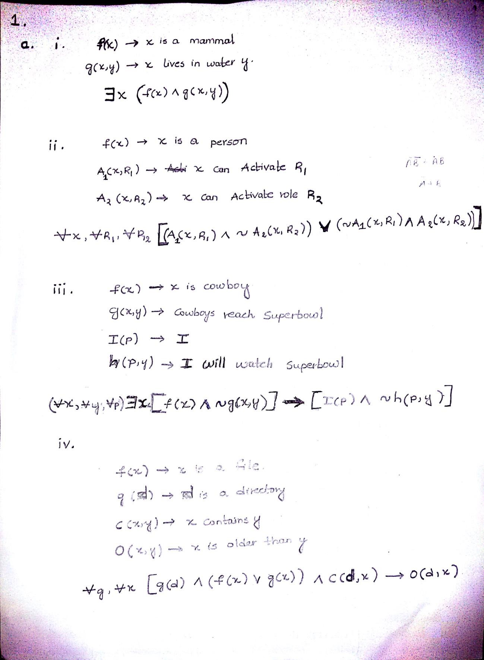

1. Prove by using Induction the following [10 Points]

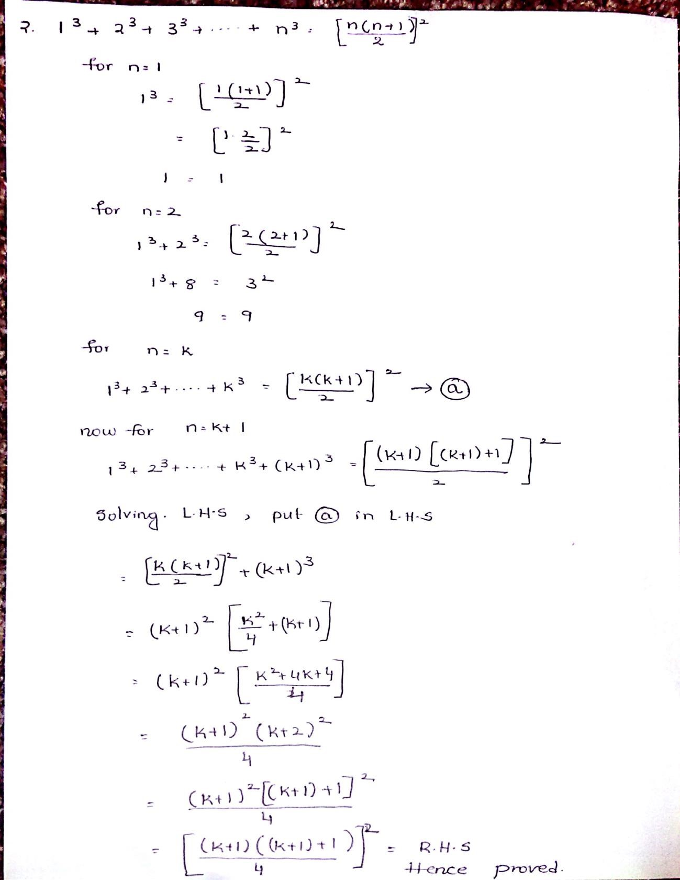

1. Partial order lattice and hasse diagram

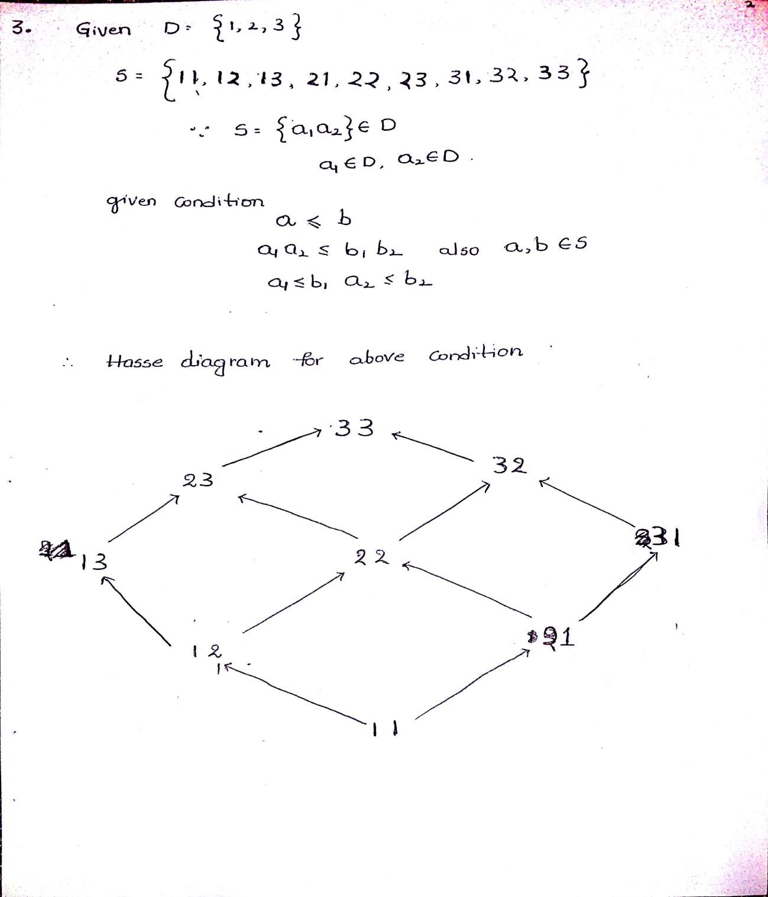

1. Turing machine:

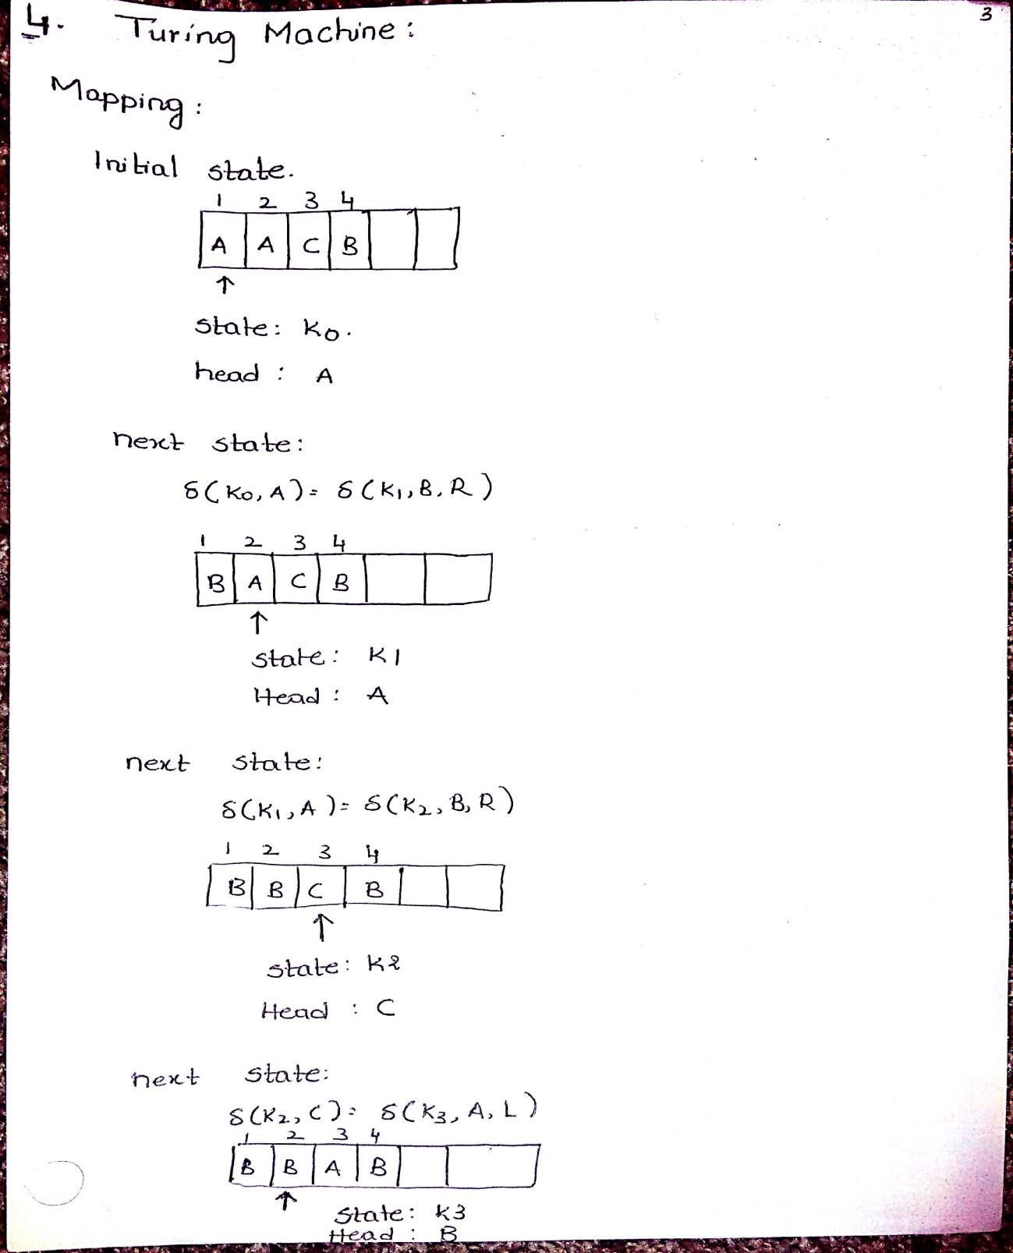

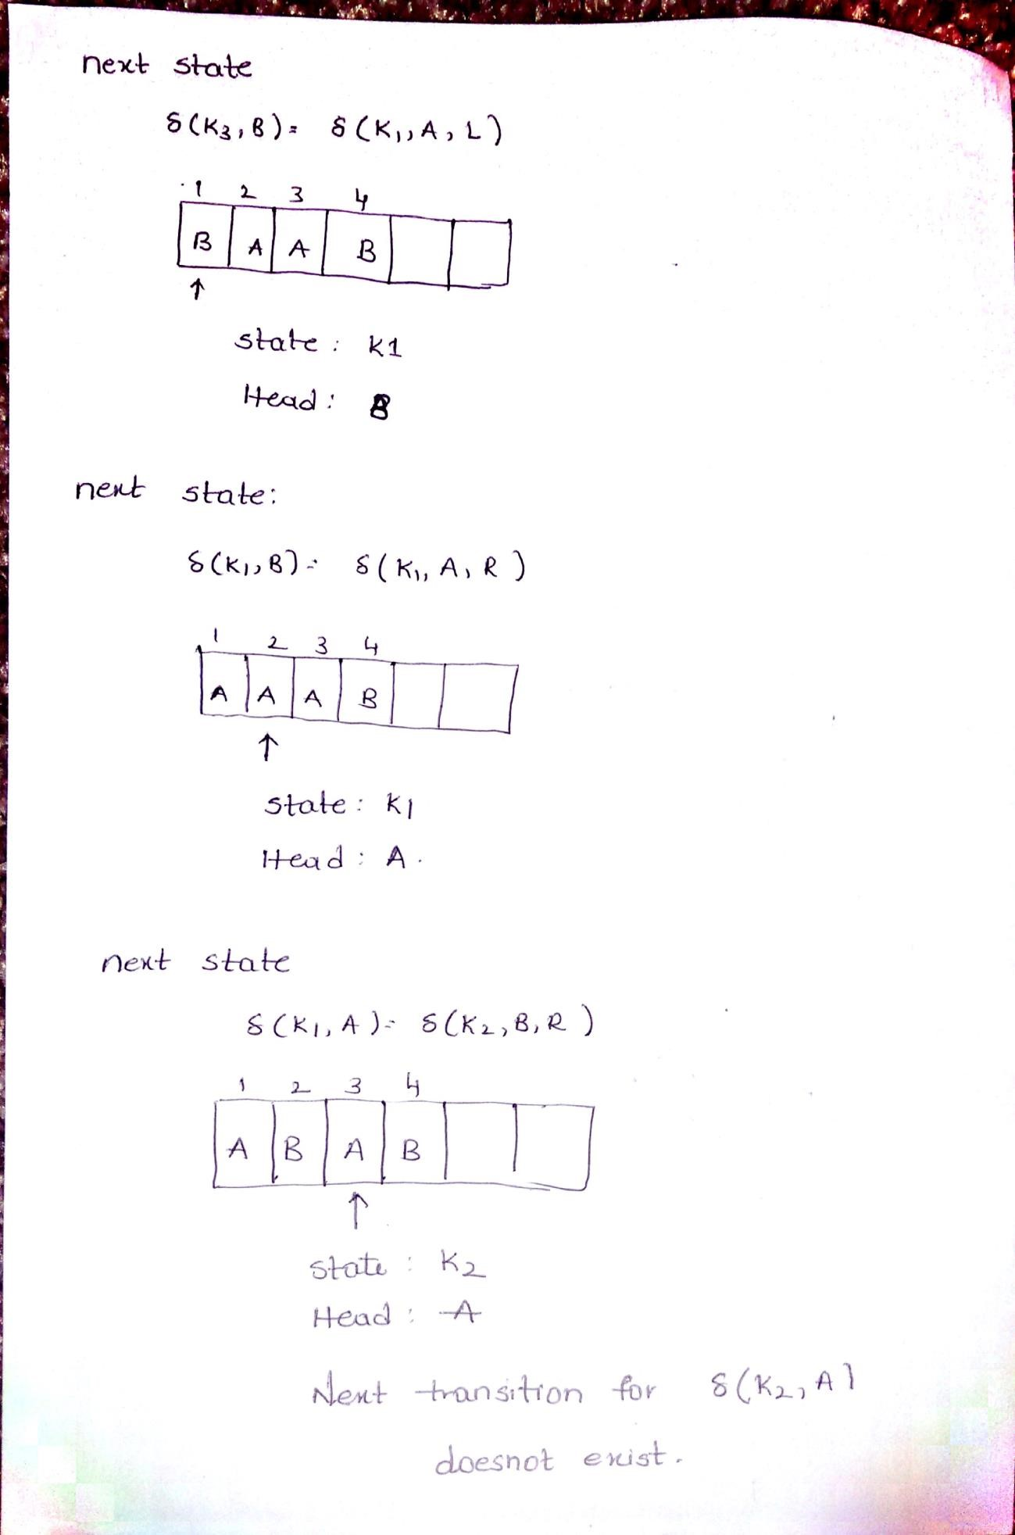

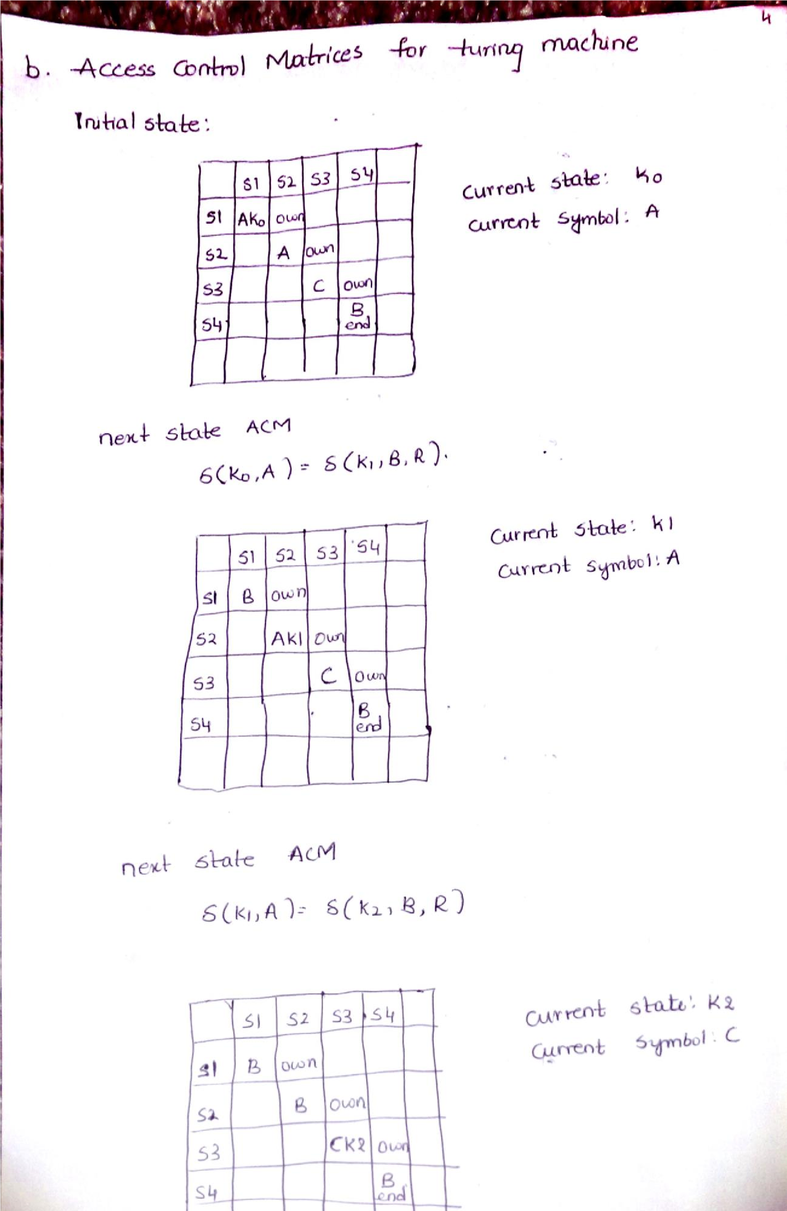

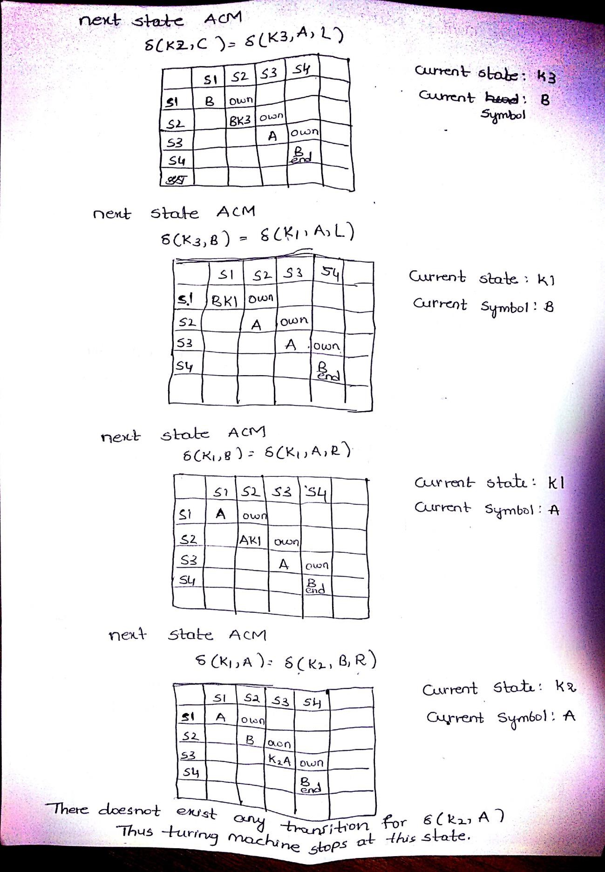

1. Is denial of service attacks possible with systems shared through internet and do they violate principle of least common mechanism.

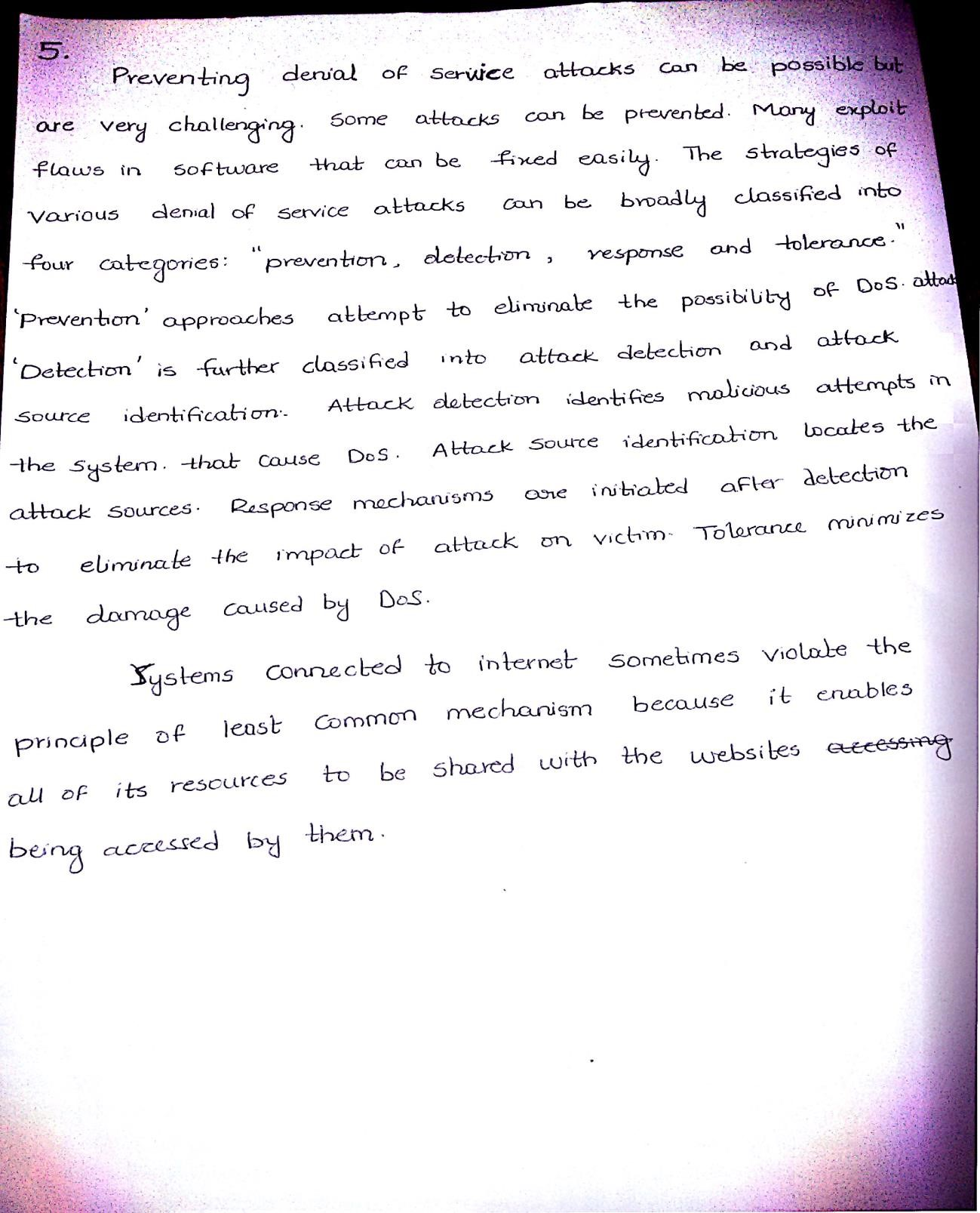

1. Commands:

