- What is Kernel Panic and Why do kernel panics occur??
- Kernel panic is the action taken by an operating system kernel when it encounters a fatal eror from which it can't safely recover. The term is usually used in reference to Unix and Unix-like operating systems such as Linux and BSD. It is similar to the condition of Windows operating systems known as the blue screen of death.
- When an operating system panics, it displays an error message on the screen, and writes the contents of kernel memory to disk for later debuggin. It then halts all CPU operation. It then either reboots automatically or waits for the user to manually reboot the machine, depending on how the operating system is configured.
- A kernel panic is different than a system crash. With a crash, the kernel detects an abnormal condition, and forcefully terminates software execution. It does so to minimize the likelihood of data loss or another corruption of the state of the machine. However, in a kernel panic, the kernel itself terminates abnormally.
Kernel panics occur:
- If the initramfs file gets corrupted.
- If initramfs is not created properly for the specified kernel. Every kernel version has its own corresponding initramfs.
- If the installed kernel is not supported or not installed correctly.
- If recent patches have some flaws.
- If a module has been installed from online or another source, but the initrd image is not created with the latest installed module.
- What is Root file systems?
- The contents of the root filesystem must be adequate to boot, restore, recover, and/or repair the system.
- To boot a system, enough software and data must be present on the root partition to mount other filesystems. This includes utilities, configuration, boot loader information, and other essential start-up data. /usr, /opt, and /var are designed such that they may be located on other partitions or filesystems.
- To enable recovery and/or repair of a system, those utilities needed by an experienced maintainer to diagnose and reconstruct a damaged system must be present on the root filesystem.
- To restore a system, those utilities needed to restore from system backups (on floppy, tape, etc.) must be present on the root filesystem.
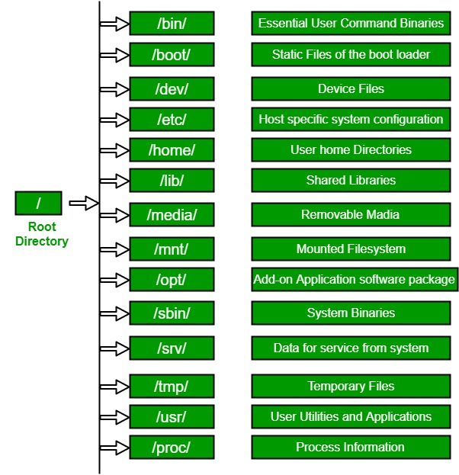

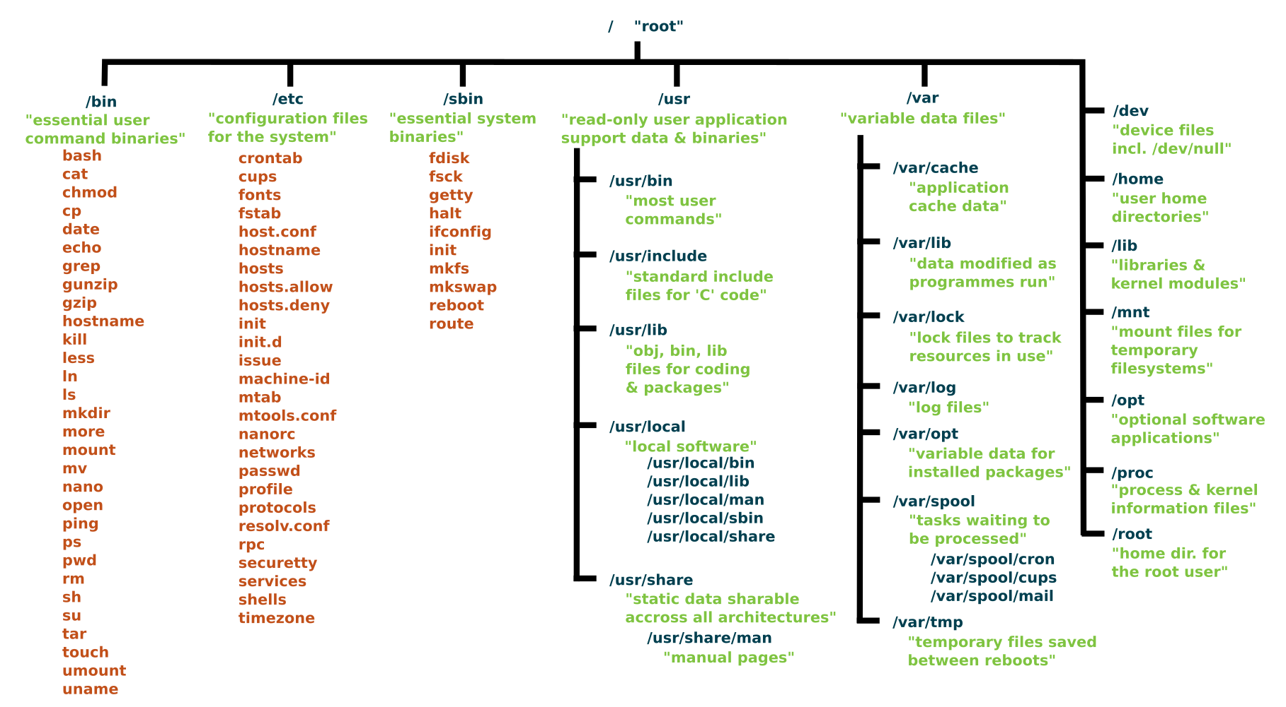
How to register a service in the systemd process?
      - vim point.sh – ( create a file at any location.(remember the path of file.)
      - chmod +x point.sh – Permission has to be included using chmod as shown for the file.
      - cd /etc/systemd/system – Enter into the root and into the systemd and system directories.
      - sudo vim point.service - Create a file name with service extension as shown.
      - sudo systemctl start point – By enter the command start service.
      - sudo systemctl status point – Check status of service log using command status.
      - tail /var/log/syslog - Checking the logs manually by entering the command.
      - sudo journalctl -u point – Checking the logs using journalctl command.
      - sudo journalctl -u point -f - Logs are started by using the command.
      - sudo systemctl stop point – By using the stop command serive is stopped.
      - sudo systemctl enable point - ( After the stoping if we want to start by using enable starting service )
      - sudo vim point.service – Reopening the service file.
      - sudo systemctl daemon-reload – ( If any changes are done in the service file we have to reload the service again )
      - sudo systemctl restart point – ( After Reloading the daemon we have to restart the service using restart command )
      - sudo systemctl status point
      - sudo systemctl edit point --full - ( By using this command we can edit service file and changes can be saved. )
      - systemctl - ( To check the system control this command is used.)
      - To remove a snippet, run:
      - {
$ sudo rm -r /etc/systemd/system/httpd.service.d
To apply changes to unit files without rebooting the system, execute: The ‘daemon-reload’ option reloads all unit files and recreates the entire dependency tree.
}
What are the ways to reduce the booting time?
- Disable Fast Startup. ...
- Adjust Paging File Settings.
- Turn Off the Linux Subsystem.
- Update Graphics Drivers.
- Disable Some Startup Programs.
- Run an SFC Scan.
- If All Else Fails, Perform a Reset.
- Upgrade Your Storage Drive.
How Drivers communicate with the Applications ?
- The process of communication between user application and driver uses packets IRP that are created by the I/O Manager on the basis of the generated request type. The process of handling requests from the user's application in which the IRP packet is generated.

