- Steps for MavenJava Automation:
Maven Java Automation Steps:
Step 1: Open Jenkins (localhost:8080)
├── Click on "New Item" (left side menu
Step 2: Create Freestyle Project (e.g., MavenJava_Build)
├── Enter project name (e.g., MavenJava_Build)
├── Click "OK"
└── Configure the project:
├── Description: "Java Build demo"
├── Source Code Management:
└── Git repository URL: [GitMavenJava repo URL]
├── Branches to build: */Main or */master
└── Build Steps:
├── Add Build Step -> "Invoke top-level Maven targets"
└── Maven version: MAVEN_HOME
└── Goals: clean
├── Add Build Step -> "Invoke top-level Maven targets"
└── Maven version: MAVEN_HOME
└── Goals: install
└── Post-build Actions:
├── Add Post Build Action -> "Archive the artifacts"
└── Files to archive: **/*
├── Add Post Build Action -> "Build other projects"
└── Projects to build: MavenJava_Test
└── Trigger: Only if build is stable
└── Apply and Save

└── Step 3: Create Freestyle Project (e.g., MavenJava_Test)
├── Enter project name (e.g., MavenJava_Test)
├── Click "OK"
└── Configure the project:
├── Description: "Test demo"
├── Build Environment:
└── Check: "Delete the workspace before build starts"
├── Add Build Step -> "Copy artifacts from another project"
└── Project name: MavenJava_Build
└── Build: Stable build only // tick at this
└── Artifacts to copy: **/*
├── Add Build Step -> "Invoke top-level Maven targets"
└── Maven version: MAVEN_HOME
└── Goals: test
└── Post-build Actions:
├── Add Post Build Action -> "Archive the artifacts"
└── Files to archive: **/*
└── Apply and Save

└── Step 4: Create Pipeline View for Maven Java project
├── Click "+" beside "All" on the dashboard
├── Enter name: MavenJava_Pipeline
├── Select "Build pipeline view" // tick here
|--- create
└── Pipeline Flow:
├── Layout: Based on upstream/downstream relationship
├── Initial job: MavenJava_Build
└── Apply and Save OK

└── Step 5: Run the Pipeline and Check Output
├── Click on the trigger to run the pipeline
├── click on the small black box to open the console to check if the build is success
Note :
- If build is success and the test project is also automatically triggered with name
“MavenJava_Test”
- The pipeline is successful if it is in green color as shown ->check the console of the test project
- The test project is successful and all the artifacts are archived successfully
II. Maven Web Automation Steps:
└── Step 1: Open Jenkins (localhost:8080)
├── Click on "New Item" (left side menu)

└── Step 2: Create Freestyle Project (e.g., MavenWeb_Build)
├── Enter project name (e.g., MavenWeb_Build)
├── Click "OK"
└── Configure the project:
├── Description: "Web Build demo"
├── Source Code Management:
└── Git repository URL: [GitMavenWeb repo URL]
├── Branches to build: */Main or master
└── Build Steps:
├── Add Build Step -> "Invoke top-level Maven targets"
└── Maven version: MAVEN_HOME
└── Goals: clean
├── Add Build Step -> "Invoke top-level Maven targets"
└── Maven version: MAVEN_HOME
└── Goals: install
└── Post-build Actions:
├── Add Post Build Action -> "Archive the artifacts"
└── Files to archive: **/*
├── Add Post Build Action -> "Build other projects"
└── Projects to build: MavenWeb_Test
└── Trigger: Only if build is stable
└── Apply and Save

└── Step 3: Create Freestyle Project (e.g., MavenWeb_Test)
├── Enter project name (e.g., MavenWeb_Test)
├── Click "OK"
└── Configure the project:
├── Description: "Test demo"
├── Build Environment:
└── Check: "Delete the workspace before build starts"
├── Add Build Step -> "Copy artifacts from another project"
└── Project name: MavenWeb_Build
└── Build: Stable build only
└── Artifacts to copy: **/*
├── Add Build Step -> "Invoke top-level Maven targets"
└── Maven version: MAVEN_HOME
└── Goals: test
└── Post-build Actions:
├── Add Post Build Action -> "Archive the artifacts"
└── Files to archive: **/*
├── Add Post Build Action -> "Build other projects"
└── Projects to build: MavenWeb_Deploy
└── Apply and Save

└── Step 4: Create Freestyle Project (e.g., MavenWeb_Deploy)
├── Enter project name (e.g., MavenWeb_Deploy)
├── Click "OK"
└── Configure the project:
├── Description: "Web Code Deployment"
├── Build Environment:
└── Check: "Delete the workspace before build starts"
├── Add Build Step -> "Copy artifacts from another project"
└── Project name: MavenWeb_Test
└── Build: Stable build only
└── Artifacts to copy: **/*
└── Post-build Actions:
├── Add Post Build Action -> "Deploy WAR/EAR to a container"
└── WAR/EAR File: **/*.war
└── Context path: Webpath
└── Add container -> Tomcat 9.x remote
└── Credentials: Username: admin, Password: 1234
── Tomcat URL: https://localhost:8085/
└── Apply and Save

└── Step 5: Create Pipeline View for MavenWeb
├── Click "+" beside "All" on the dashboard
├── Enter name: MavenWeb_Pipeline
├── Select "Build pipeline view"
└── Pipeline Flow:
├── Layout: Based on upstream/downstream relationship
├── Initial job: MavenWeb_Build
└── Apply and Save

└── Step 6: Run the Pipeline and Check Output
├── Click on the trigger “RUN” to run the pipeline
Note:
- After Click on Run -> click on the small black box to open the console to check if the build is success
- Now we see all the build has success if it appears in green color
├── Open Tomcat homepage in another tab
├── Click on the "/webpath" option under the manager app
Note:
- It ask for user credentials for login ,provide the credentials of tomcat.
- It provide the page with out project name which is highlighted.
- After clicking on our project we can see output.

Week 9: Pipeline Creation using script

General :
Description :- provide the description of the project
Build triggers: here we can provide with build triggers of you choice

CODE:

pipeline {
agent any
tools{
jdk 'JAVA_HOME'
maven 'MAVEN_HOME'
}
stages {
stage('git repo & clean') {
steps {
bat "rmdir /s /q Harshitha_Jenkins_Maven || exit 0"
bat "git clone https://github.com/Harshitha-Macha/Harshitha_Jenkins_Maven.git"
bat "mvn clean -f Harshitha_Jenkins_Maven/pom.xml"
}
}
stage('install') {
steps {
bat "mvn install -f Harshitha_Jenkins_Maven/pom.xml"
}
}
stage('test') {
steps {
bat "mvn test -f Harshitha_Jenkins_Maven/pom.xml"
}
}
stage('package') {
steps {
bat "mvn package -f Harshitha_Jenkins_Maven/pom.xml"
}
}
}
}

LAB ACTION PLAN FOR WEEK 10

Working with minikube and Nagios
- Hands-on practice of creating, running and scaling pods in minikube.
- Running Nginx server on specified port number by explaining the Nginx monitoring tool
- Running Nagios server and Understanding the Monitoring tool using Docker.
- AWS-free Trier account Creation steps
- Upload the screenshots for the tasks
Kubernetes:
Kubernetes is a tool that automates how we run and manage applications inside the container.
Dockers will only run containers, if in any case the container fails/stopped/killed, the docker will not help us, here is where Kubernetes plays an important role, Kubernetes cluster will be responsible in creating a new container and managing various containers.
POD: In Kubernetes, a Pod is the smallest deployable unit that you can create and manage.
Minikube:
Minikube creates a VM on your local machine and deploys a simple Kubernetes cluster with one node. It's a lightweight implementation. Minikube is a version of Kubernetes.
Nagios:
Nagios is an open-source IT infrastructure monitoring tool. It monitors
- Servers
- Network devices
- Applications and services
It alerts admnistrators when issues occur and notifies when they are resolved.

Step 1: Install Prerequisites
Before installing Minikube, ensure the following are installed:
- Virtualization Support:
  - Verify virtualization is enabled:
- Hypervisor:
  - Minikube supports multiple hypervisors (e.g., Hyper-V, VirtualBox, or Docker as a driver).
  - Install one of the following:
    - Hyper-V (pre-installed on Windows 10/11 Pro or Enterprise).
    - Docker Desktop (if you want to use Docker as the driver).

Step 2: Download Minikube
- Open a PowerShell or Command Prompt with administrator privileges.
- Download the latest Minikube executable using this command:
- curl -LO https://storage.googleapis.com/minikube/releases/latest/minikube-installer.exe
- Install Minikube by running the installer:
- .\minikube-installer.exe

Step 3: Add Minikube to PATH
If Minikube is not automatically added to your PATH during installation:
- Open System Properties → Environment Variables.
- Add the directory where Minikube is installed (e.g., C:\Program Files\Minikube) to your PATH variable.

Step 4: Start Minikube
- Open a terminal (PowerShell or CMD). Do the following commands
- Start Minikube with a specified driver (e.g., Hyper-V, Docker, or VirtualBox). For example:
  - Hyper-V:
  - minikube start --driver=hyperv
  - Docker:
  - minikube start --driver=docker
- Verify Minikube is running:
- minikube status

Step 5: Interact with Minikube

kubectl is a command-line tool used in Kubernetes to interact with and manage Kubernetes clusters.
Once Minikube is running:
- Use kubectl to interact with the cluster.
  - Install kubectl if not already installed:
  - minikube kubectl -- get pods -A
  - Or download it separately from the official Kubernetes site.
- Open the Minikube dashboard (optional):
- minikube dashboard

Optional: Check Your Installation
Run the following to verify the installation:
Minikube version
kubectl version --client

Troubleshooting
- If Minikube fails to start:
  - Ensure your hypervisor (Hyper-V/Docker/VirtualBox) is installed and running.
  - Check the Minikube logs:
  - minikube logs
- Updating Minikube:
- minikube update-check
- minikube update
Minikube Automation Steps
Step 1: Start Minikube Cluster
- Open your terminal and run the command:
minikube start
Step 2: Create and Manage Deployment
- Create an application in Kubernetes:
  - Command:
kubectl create deployment mynginx --image=nginx

if already created then
kubectl set image deployment/myngnix nginx=nginx:latest
  - Verify the deployment using: Kubernetes responds by showing you a list that includes the names of your deployment groups
kubectl get deployments
    - Ensure mynginx appears in the output.
Check the following commands:
  - kubectl get pods
  - kubectl describe pods
- Expose Deployment as a Service:
  - Command:
kubectl expose deployment mynginx --type=NodePort --port=80 --target-port=80
Step 3: Scale the Deployment
Command:Scales the Nginx deployment to 4 replicas (pods).
kubectl scale deployment mynginx --replicas=4
kubectl get service myngnix
Step 4: Access the Nginx App
- Using Port Forwarding:
  - Command:
kubectl port-forward svc/mynginx 8081:80

    - Access the app via http://localhost:8081.
If Error, use this option, Using Minikube Tunnel:
  - Start the tunnel:
minikube tunnel
  - Retrieve the service URL:
minikube service mynginx --url
  - Open the provided URL in your browser.
  - Open the kubernets dashboard
- Open the minikube dashboard
Minikube dashboard
Step 5: Stop and Clean Up
- Stop Nginx Deployment:
  - Commands:
kubectl delete deployment mynginx
kubectl delete service mynginx
- Stop Minikube (Optional):
  - Command:
minikube stop
- Delete Minikube Cluster (Optional):
  - Command:minikube delete
Nagios Automation Steps
Step 1: Pull the Nagios Docker Image
- Open a terminal and run:
docker pull jasonrivers/nagios:latest
Step 2: Run Nagios
- Command:
docker run --name nagiosdemo -p 8888:80 jasonrivers/nagios:latest
Step 3: Access Nagios Dashboard
- Open your browser and navigate to:
http://localhost:8888
  - Login Credentials:
    - Username: nagiosadmin
    - Password: nagios
  - Once logged in, explore:
    - Hosts: View systems being monitored.
    - Services: Check tasks being monitored (e.g., CPU usage).
    - Alerts: Access recent notifications.
Step 4: Monitoring Host Details
- Navigate to the Host Information Page:
  - Select a host from the Hosts menu.
- Key Details:
  - Host Status: Indicates if the system is UP or DOWN.
  - Metrics: View CPU usage, memory status, and network activity.
  - Actions: Reschedule checks, disable notifications, or schedule downtime.
Step 5: Stop and Remove Nagios
- Stop the Container:
  - Command:
docker stop nagiosdemo
- Delete the Container:
  - Command:
docker rm nagiosdemo
- Remove the Image (Optional):
  - List images:
docker images
  - Delete the Nagios image:
docker rmijasonrivers/nagios:latest

- Observe the docker containers in DockerHub, we can see the latest Nagios Installed running on port:8888

-------------------------------------------------------------------------------------------------------------------------------
Steps for AWS-free trier account creation
- open https://aws.amazon.com
- click on create AWS account
- Provide email id and name details for AWS account creation then a screen will appear as below
- Enter verification code received in your mail
- Provide your contact details and agree Terms and conditions, then click on create
- Provide billing details, click on verify and continue
- Amazon chagres 2 rs and it will be credit back into your account once verification is over
- Once payment success a screen appear as below, provide your working contact number after selecting country, and click on send SMS after entering the details
- Provide verification code received in your mobile
- Now select basic plan and click on complete sign up
- Now a screen appear as follows then click on AWS management console
- You will navigating to the aws page ..where you need to Select role as Academic/Researcher and interest as DevOps and click on submit
- Sign into AWS console as Root user
- A console screen appears aws will appear

Week 11 :
Run this command in ngrok command prompt:(replace <your_token> with yours):

ngrok config add-authtoken <your_token> // syntax:
Example command
ngrok config add-authtoken 34ejJvRYKqtjvBUEYEnxudIbpb7_33i6pYx8BJ2cZ1TpwasWq

Step-6
Start a Tunnel for Jenkins
- Check on which port is your Jenkins running . for this give in browers or url localhost:8081
For me Jenkins is running on 8081
- Go to ngrok command prompt and type below command
- ngork http 8081 //Always use this command to start a tunnel for jenkins .
Type in ngrok command prompt:
Next it shows this public jenkins URL generated by ngrok that can be pasted into github repo for Webhooks.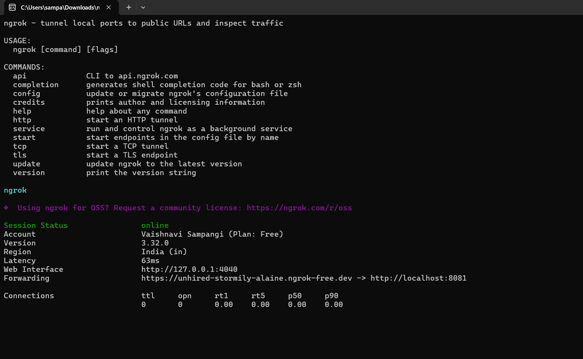

Copy this URL only highlighted part

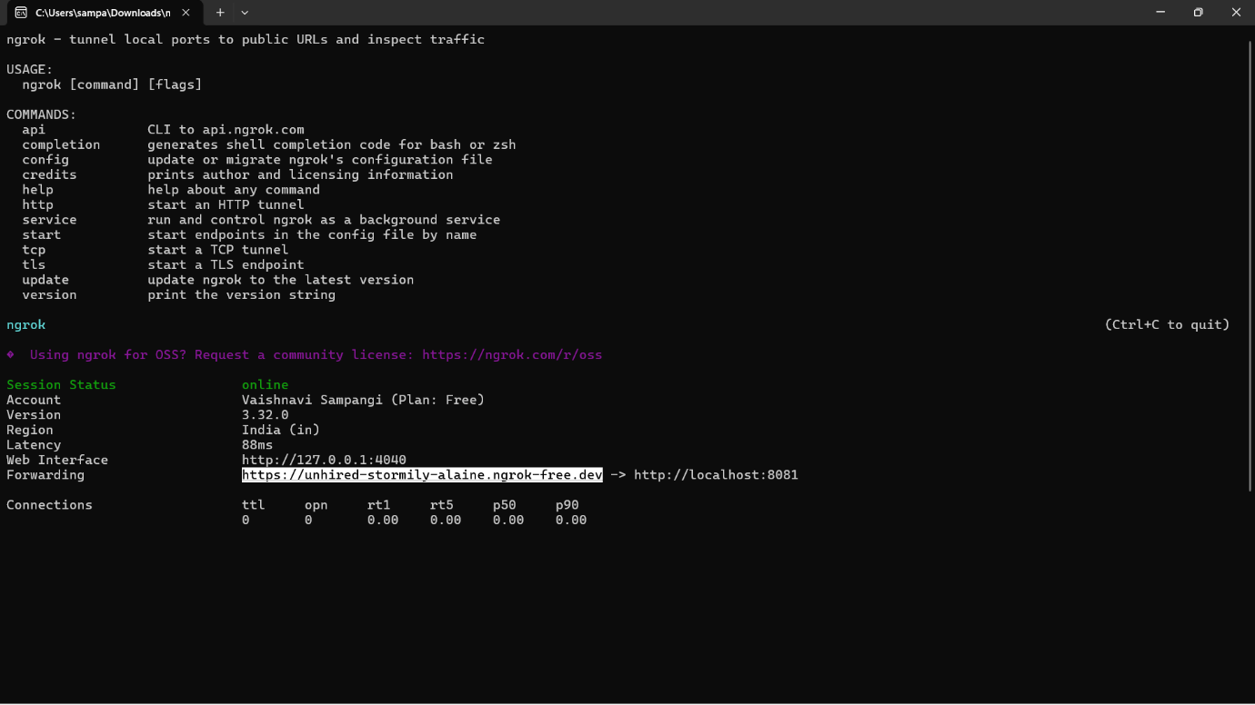

Step-7: Configure Webhook in GitHub
- Go to your GitHub repository.
- Navigate to Settings → Webhooks.
- Click “Add webhook”.
- In the Payload URL field:
  - Enter the Jenkins webhook URL in the format:
http://<jenkins-server-url>/github-webhook/
Ex: https://unhired-stormily-alaine.ngrok-free.dev/github-webhook/

Note: If Jenkins is running on localhost, GitHub cannot access it directly
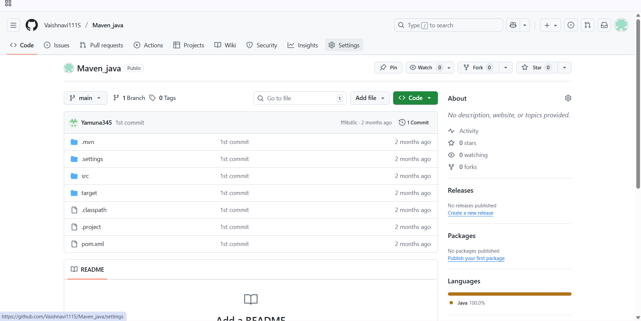
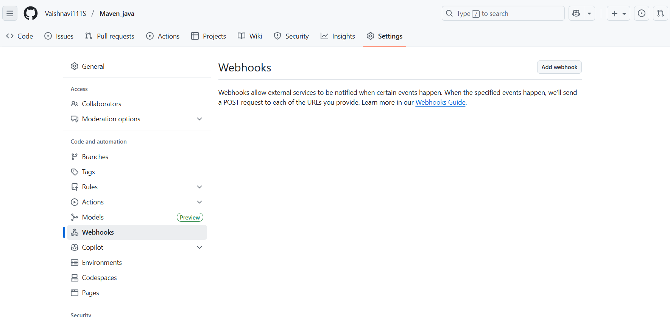

Step-8:
    - Add url https://unhired-stormily-alaine.ngrok-free.dev/github-webhook/
    - Set content Type to application/json
    - Under “Which events would you like to trigger this webhook?”, select:
Just the push event.
- Click “Add webhook” to save.

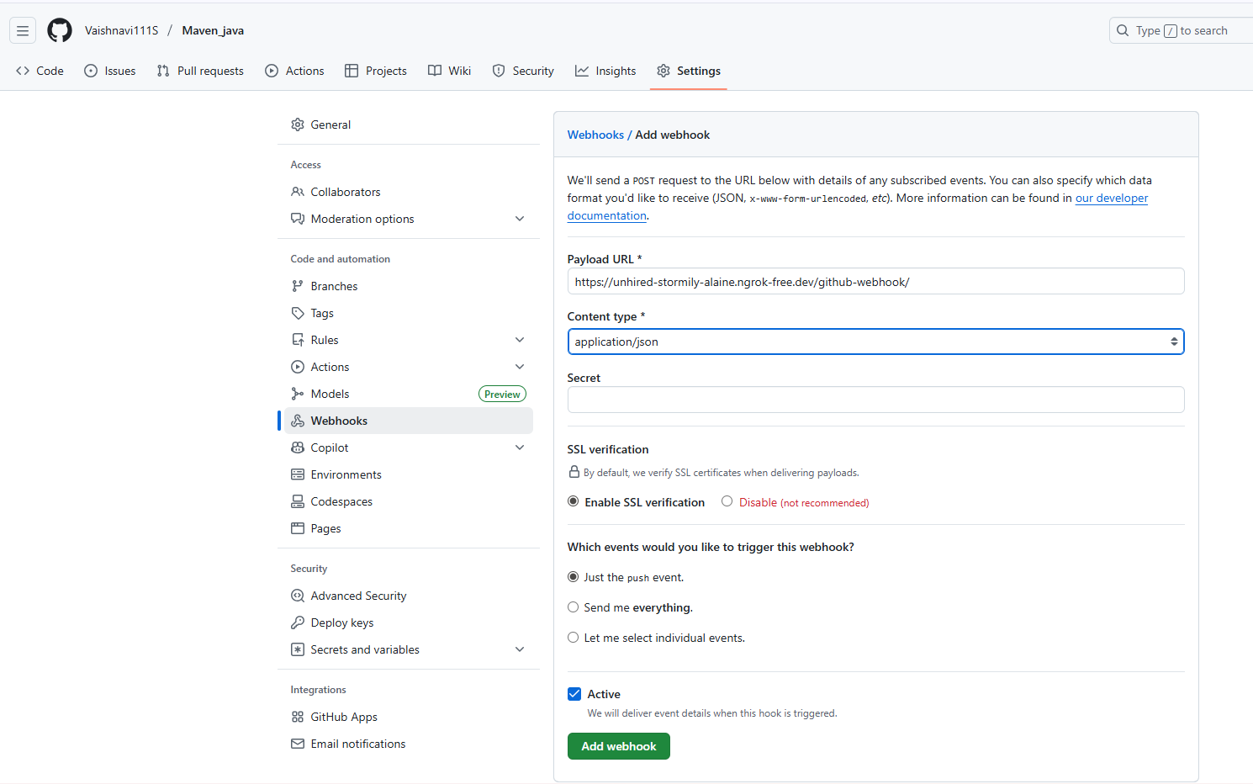

Step 10: Configure Jenkins to Accept GitHub Webhooks
- Open Jenkins Dashboard.

- Select the job (freestyle or pipeline) you’ve already created.

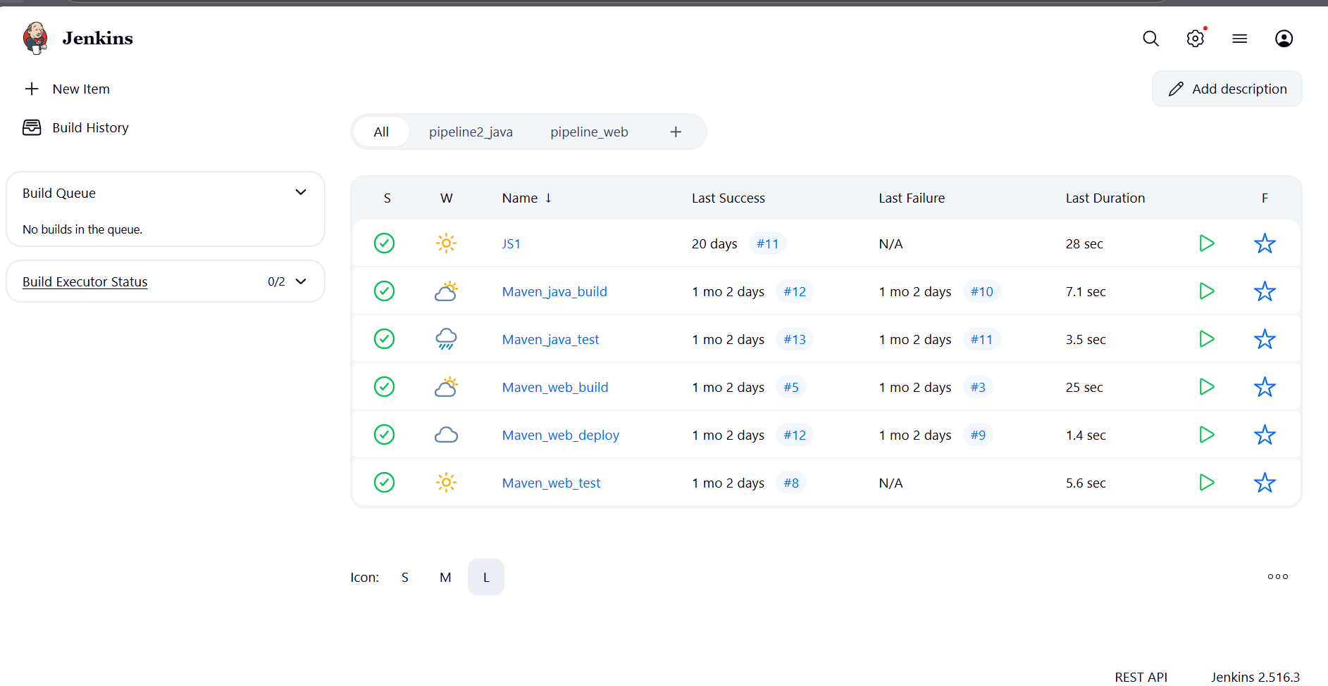
- Click Configure.
- Scroll down to the Build Triggers section.
- Check the box: ✅GitHub hook trigger for GITScm polling
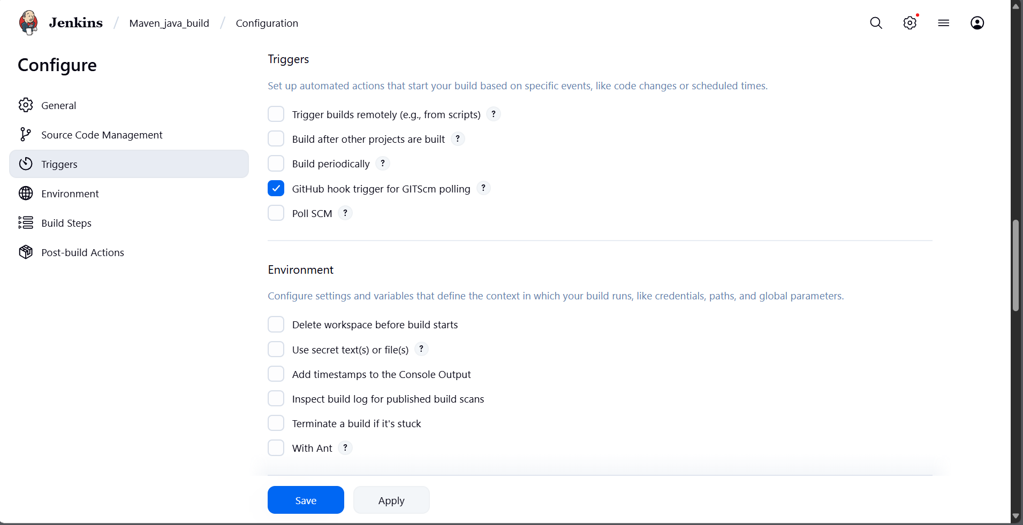
- Click Save.

Step 11: Test the Setup
- Make any code update in your local repo and push it to GitHub.
- Once pushed, GitHub will trigger the webhook.
- Jenkins will automatically detect the change and start the build pipeline.
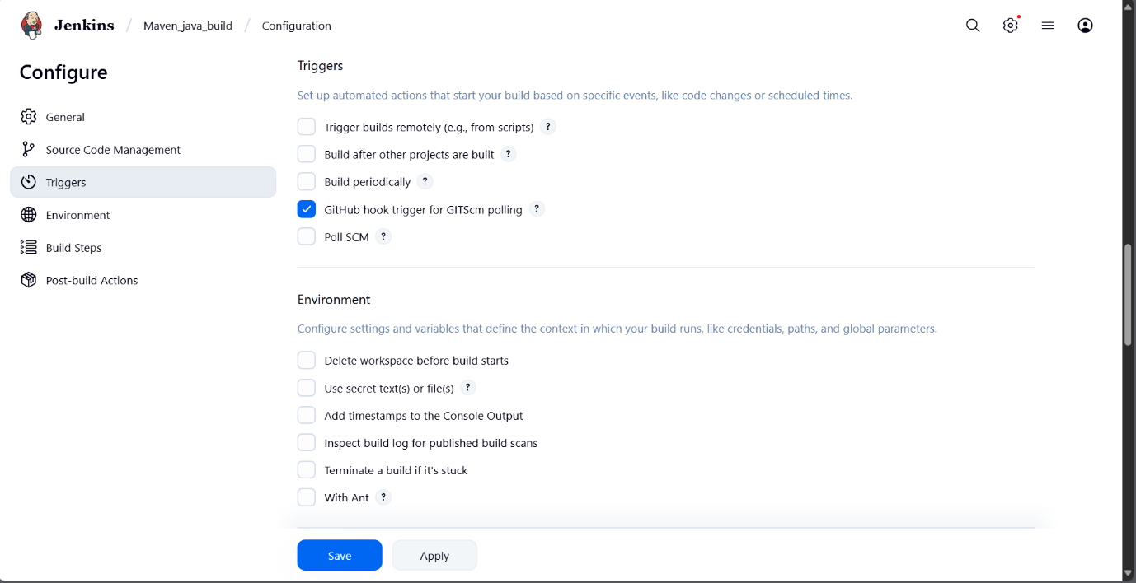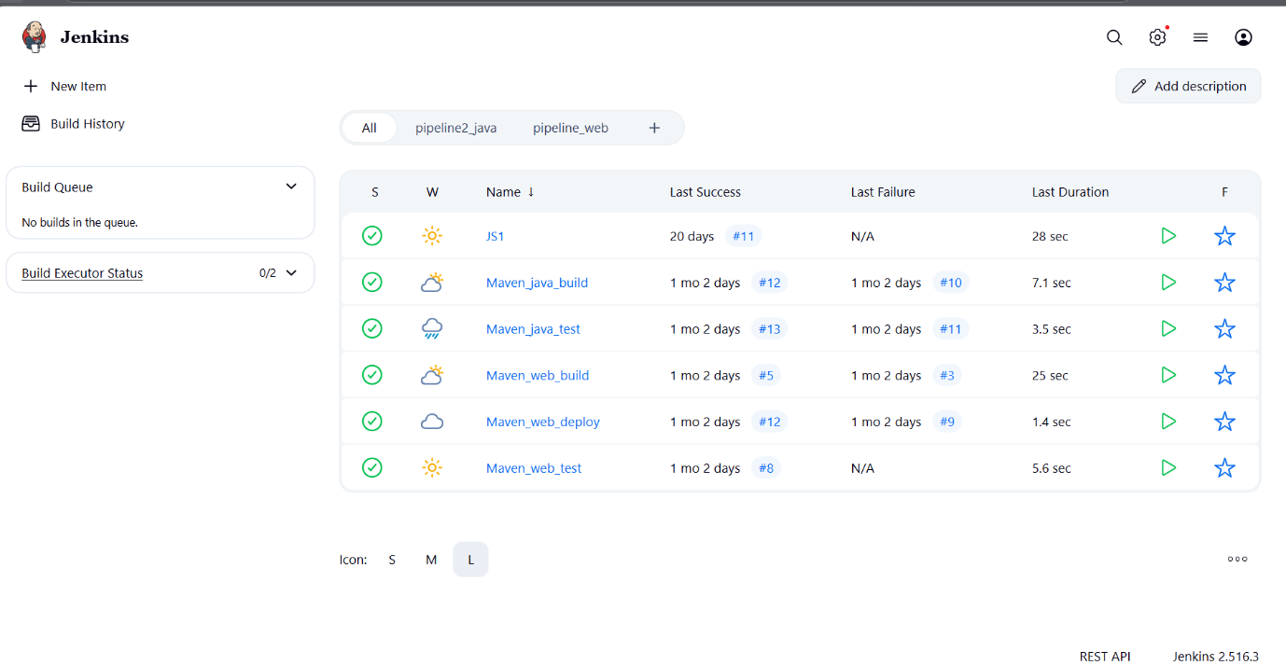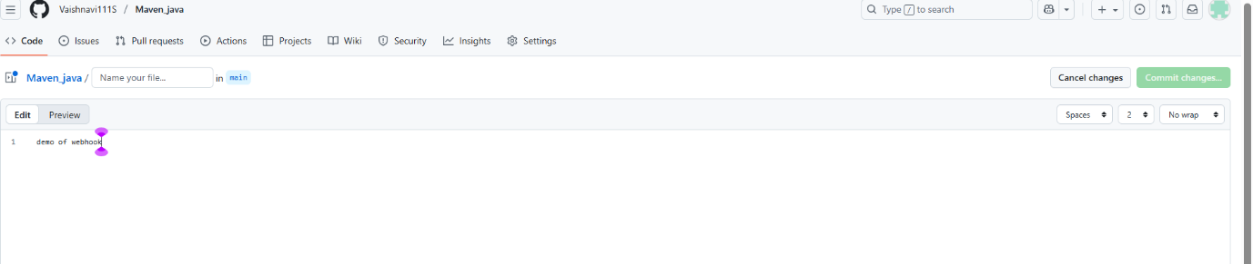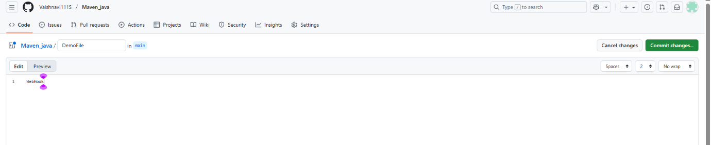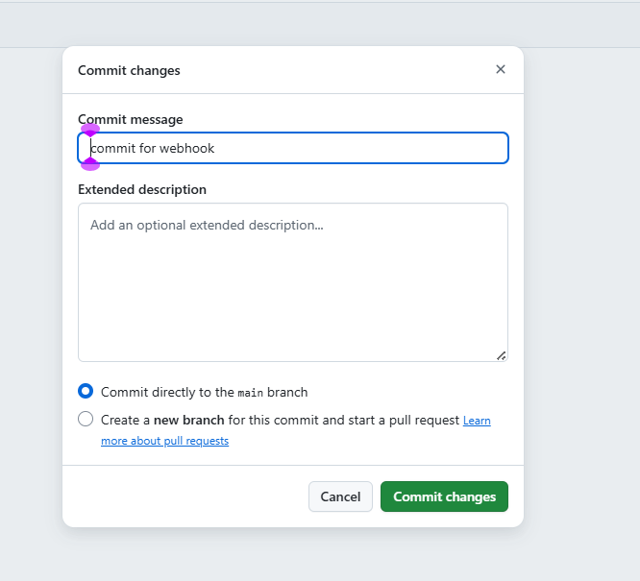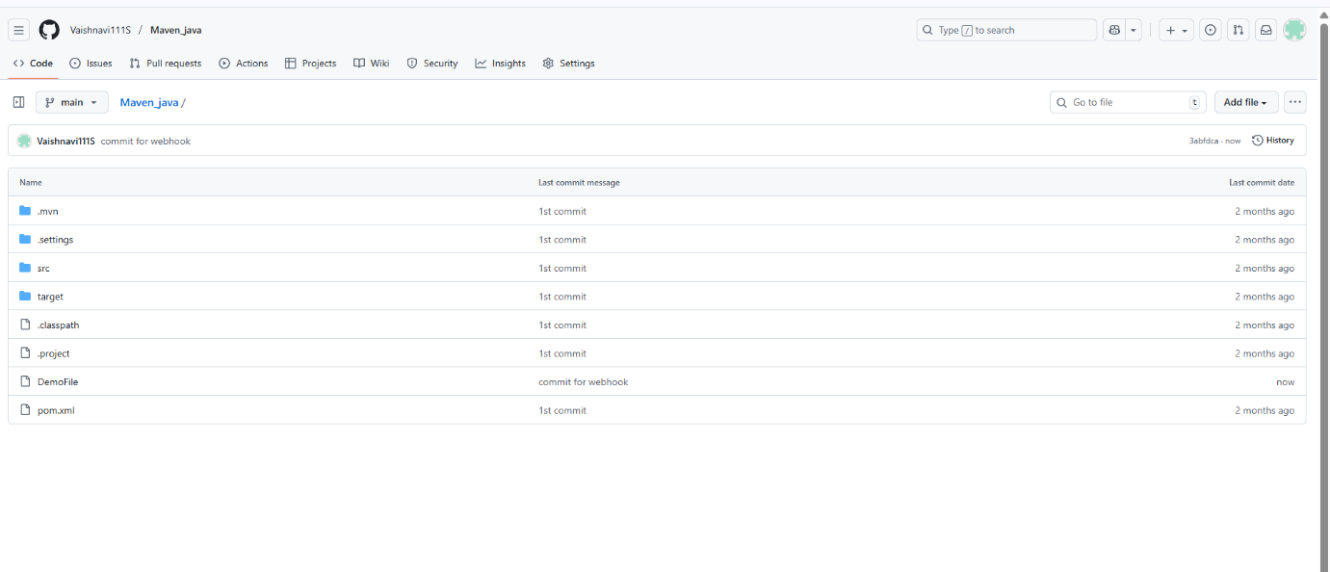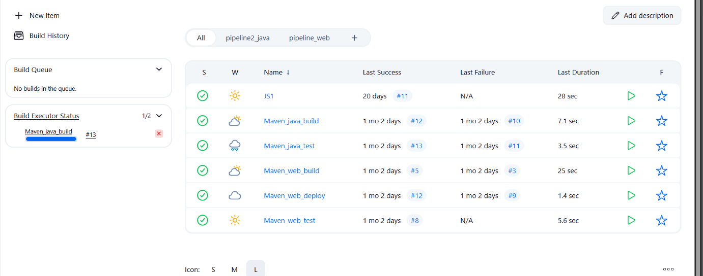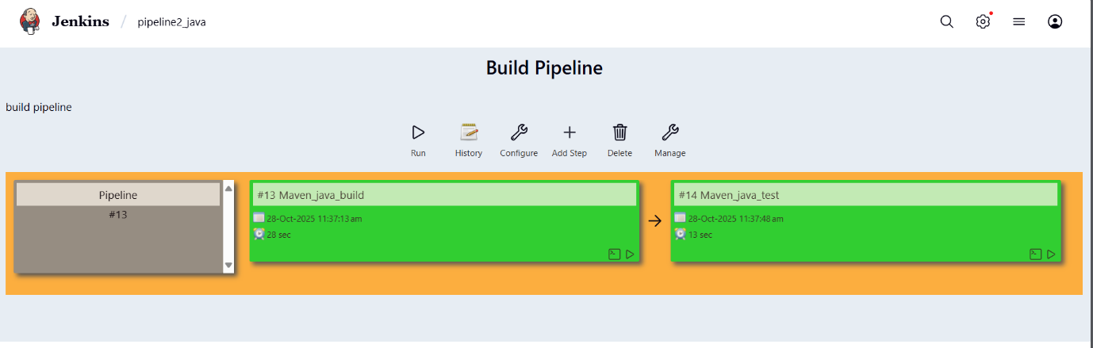

outcome
- You’ve successfully connected GitHub and Jenkins using webhooks.
- Every time you push code to GitHub, Jenkins will automatically start building your project without manual intervention.

EXCERCISE-2

Setting Up Jenkins Email Notification Setup (Using Gmail with App Password)
Creation of app password
1. Gmail: Enable App Password (for 2-Step Verification)
i. Go to: https://myaccount.google.com
ii. Enable 2-Step Verification
- Navigate to:
  - Security → 2-Step Verification
  - Turn it ON
  - Complete the OTP verification process (via phone/email)
iii. Generate App Password for Jenkins
- Go to:
  - Security → App passwords
- Select:
  - App: Other (Custom name)
  - Name: Jenkins-Demo
- Click Generate
- Copy the 16-digit app password
  - Save it in a secure location (e.g., Notepad)
2. Jenkins Plugin Installation
i. Open Jenkins Dashboard
ii. Navigate to:
- Manage Jenkins → Manage Plugins
iii. Install Plugin:
- Search for and install:
  - Email Extension Plugin

3. Configure Jenkins Global Email Settings
i. Go to:
- Manage Jenkins → Configure System

A. E-mail Notification Section
Field | Value
SMTP Server | smtp.gmail.com
Use SMTP Auth | ✅ Enabled
User Name | Your Gmail ID (e.g., archanareddykmit@gmail.com)
Password | Paste the 16-digit App Password
Use SSL | ✅ Enabled
SMTP Port | 465
Reply-To Address | Your Gmail ID (same as above)
➤ Test Configuration
- Click: Test configuration by sending test e-mail
- Provide a valid email address to receive a test mail
- ✅ Should receive email from Jenkins

B. Extended E-mail Notification Section
Field | Value
SMTP Server | smtp.gmail.com
SMTP Port | 465
Use SSL | ✅ Enabled
Credentials | Add Gmail ID and App Password as Jenkins credentials
Default Content Type | text/html or leave default
Default Recipients | Leave empty or provide default emails
Triggers | Select as per needs (e.g., Failure)

4. Configure Email Notifications for a Jenkins Job
i. Go to:
- Jenkins → Select a Job → Configure

ii. In the Post-build Actions section:
- Click: Add post-build action → Editable Email Notification
A. Fill in the fields:
Field | Value
Project Recipient List | Add recipient email addresses (comma-separated)
Content Type | Default (text/plain) or text/html
Triggers | Select events (e.g., Failure, Success, etc.)
Attachments | (Optional) Add logs, reports, etc.

iii. Click Save

Now your Jenkins job is set up to send email notifications based on the build status!

WEEK-12

1 DEPLOYMENT OF INDEX.HTML USING EC2 INSTANCE in AWS
Step 1: Login to AWS /canvas account
➢ Go to course invitation mail and click on start
➢ Opens the aws academy, select the student login and enter the email and password details
➢ Click on Modules
➢ Scroll down and select Lunch AWS Academy Lab-
➢ Click on start Lab and wait AWS becomes from red to green AWS

Click on AWS

Step 2: Click on EC2 to create instance

Click on Launch Instance

Stage 1 --Name (Giving name to the machine) ubuntu
Stage 2 -- Select AMI ( Note: Select free tier eligible ) ubuntu server
Give name and select ubuntu under application

Select this free tier option of Ubuntu from here

Stage 3 -- Architecture as 64-bit
Make sure AMI and Architecture are there as shown

Stage 4 -- Instance type ---- t2.micro(default 1 CPU,1 GB RAM)

Stage 5 -- Create a new keypair---a keypair will downloaded with extension .pem
Store key in folder AWS
First Click on create-new key pair

Give KeyPair name and click on create key pair

Save the .pem file in folder AWS on desktop

Stage 6 -- Network Setting ----Create Security group -- ( It deals with ports )
(Note for understanding We have 0 to 65535 ports. Every port is dedicated to special purpose)
HERE select https and http (which allow to load your web pages while execution)
In network setting check all the checkboxes

Stage 7 -- Storage - 8GB ( Observation - we have root - it is same as C Drive) it default 8 GB

Stage 8 --- click on launch instance

Now click on the instances

Wait for the Success message to apper in green color

You can see MyExampleWebServer is Running and wait for it to initialize

You have to get 2 tests passes.
Important:---- Now check the box and click on connect.
Do this step:---once it is created select that instance
(Tick in checkbox) and click on connect

Thus your EC2 instance is running on server.

Step 4: Now you can connect local system to server (EC2 instance) using secure shell SSH.

For this, Here copy the ssh – i command from SSH client connect tab and paste later
Next We can use powershell /gitbash /webconsole in administrative mode, to connect to ubuntu machine.
Step a: Copy the path of .pem file that you saved earlier in folder AWS eg. as here D:\SUNNY\SELABWEB\AWS

Step b: Open Powershell in administrative mode and navigate to that path.
Type: cd < path>
eg. cd D:\SUNNY\SELABWEB\AWS here specify your .pem path

Step c: Go to SSh and copy the command ssh which is present at the below

Note: To connect to above terminals we need to go into the path of the keypair.and
paste the ssh -i command from the aws console

Step d: Run the pasted ssh -i command in the terminal

Step 5: Run the following commands to install s/w
1. Update all softwares in Ubuntu by command
sudo apt update

2. Install docker by command
sudo apt-get install docker.io

3. Install git by command
sudo apt install git

4. Install nano( text editor) by command
Sudo apt install nano

Step 6: Now we want to create an application, push it into git, create docker image of it and run it

Step a: Create basic index.html file in folder Example and save it

Step b: Open git Bash in folder Example by right clicking with mouse

Step c: In git bash run the following commands
git init
git add .
Git commit –m “first commit”

Step d: Create git repository (here with name AWS)

Step e: Copy command one by one from above repository and run as below
git branch –M main
git remote add origin <https url>
git push –u origin main

Step f: refresh repository and You can now see index.html in github

Step g: Copy http path

Step h: Clone the repository with copied http path by command in command prompt git clone <copied http url>
Step i: Navigate to the cloned folder. Type cd AWS as below, next ls to

Step j: create Dockerfile in above command prompt in ububtu ie in power shell
Nano Dockerfile

Step k: Write the following data in Dockerfile and click ctrl+o Enter and then ctrl-x

Step L: Build docker image by executing the following command
sudo docker build –t mywebapp .

Thus image is created
Step m: run the image and map it to port 80
sudo docker run –d –p 80:80 mywebapp

Step n: Go to instances and click on instance here

Step o: Copy public ipv4 address

Step p: Paste it in the browser to get below output
Note : if https :__ won’t work then type just http:___

Important do it without fail. Step Q: stop container

Run the following command to stop the container
i. sudo docker ps
ii. sudo docker stop <container-id>

iii. Go back to instances and click on option instance. Once load as below, then Click on Instance state and select terminate instances

Click on Terminated (deleted)

iv. Now click on End lab

End of exercise 1 (DEPLOYMENT of index.html using EC2 instance in AWS) consisting of:
1. creating EC2 instance to install Ubuntu, docker, git , and nano.
2. creating web application (index.html) using Visual studio
3. Pushing index.html to github and cloning the it
4. Creating Dockerfile to build image for running index.html on nginx server
5. Run it as container using docker command and get the output on browser
6. Terminate the instance
7. End lab

2 MAVEN WEB PROJECT DEPLOYMENT IN AWS

Click on start lab

Click on AWS

Click on EC2

Click on launch instance

Give name

Create new key

Check all the boxes under network and click on launch instance

Click on instances

Wait until you get 2 tests passes

Click on connect after checking the box

Copy ssh command

Open the terminal, Navigate to the path

Run the ssh command

Run the following commands

Open MAVEN WEB PROJECT REPO in github and copy http link

Clone the repository

If your repository is in main run following

If not goto your github repo
Click on settings
Under default branch section click on the icon shown and you’re your master branch as default and execute above commands

Build docker image

Run the container

Copy public ipv4

Enter this url in browser and click enter

If your app is not running goto security and Click on security groups

Click on edit inbound rules

Click on add rule give port as 9090 and 0.0.0.0/0 click on save

And refresh the page to check whether the web page has loaded or not

If it is loaded you have successfully deployed you maven web project In your ec2 instance

Run the following commands to stop the container

Terminate your instance

End your lab

